**Assessment 15– Docker**

**Trainee Name : Gargi Sharma**

**Mentor Name : Mr. Ravi Kumar**

**College Name : UPES**

1. Set the base image to Ubuntu
   1. Add File Author / Maintainer
   2. Install Nginx
   3. Install necessary tools: vim wget curl net-tools
   4. Remove the default Nginx configuration file
   5. Copy a configuration file from the current directory
   6. Expose ports (80)
   7. Set the default command to execute Nginx when creating a new container.

ANS. Dockerfile

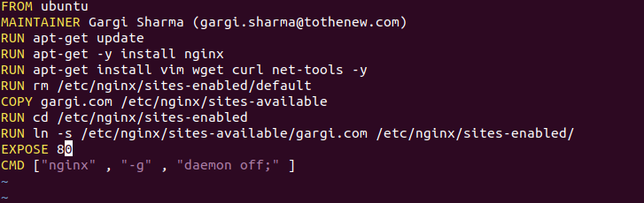

Build the container

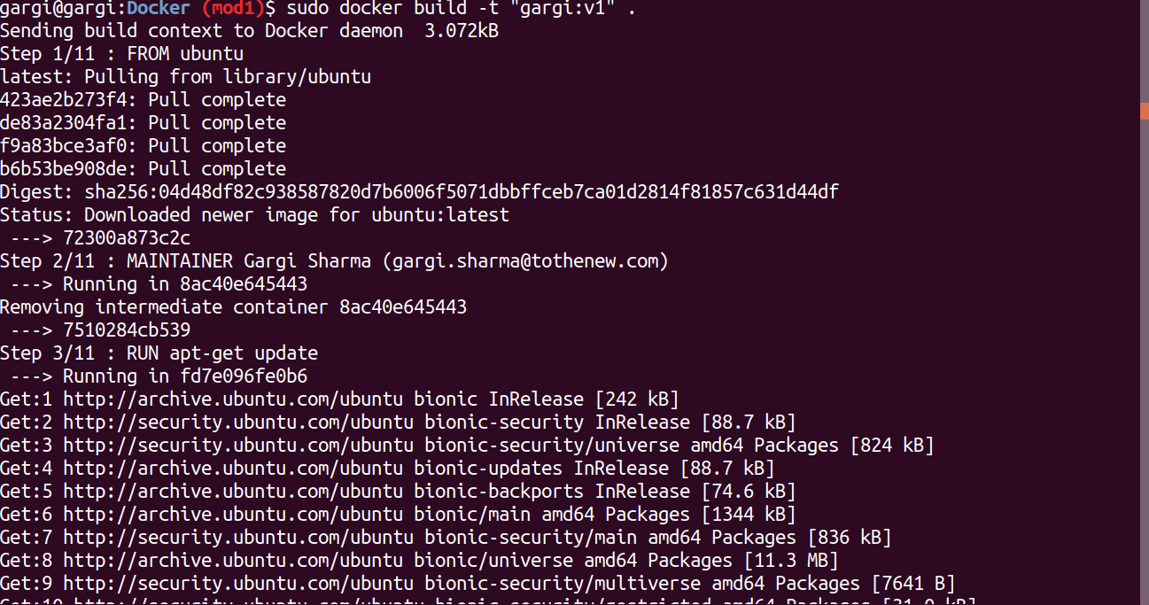

Run Image

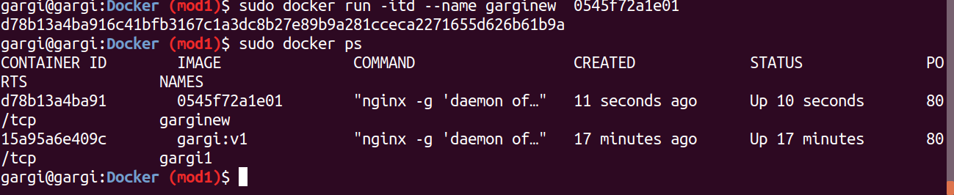

Enter into the container



Curl localhost inside container

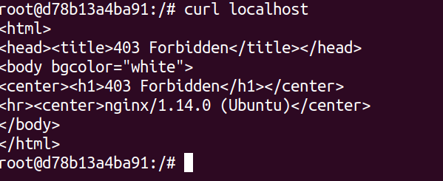

Curl ip of container from local machine

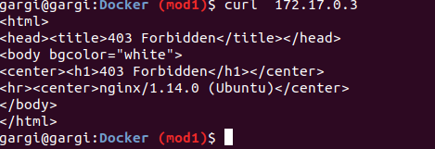

1. What is the difference between 'RUN', 'CMD', & 'ENTRYPOINT' in dockerfile?

We choose CMD if we need to provide a default command and.or arguments that can be overwritten from command line when docker container runs. On the other hand we use ENTRYPOINT when building executable Docker image and we need a particular command to always be executed. And we use RUN instructions to build our image by adding layers on top of initial image.

1. How to connect a docker client to docker daemon running on another host?

Step 1: Launch an ubuntu instance

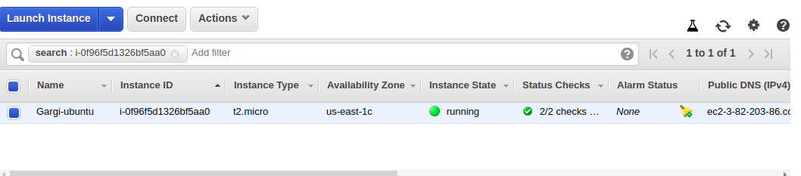

Step2: ssh into the instance and install docker

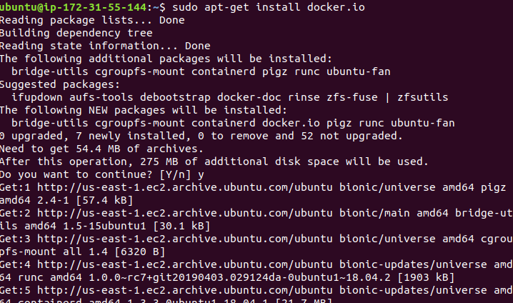

Step3: Create a directory to store the configuration file:sudo mkdir **-p** /etc/systemd/system/docker.service.d

Now create a new file to store daemon options: sudo vim /etc/systemd/system/docker.service.d/options.conf

Now paste the following configuration ,save and exit:

**[**Service]

ExecStart**=**

ExecStart**=**/usr/bin/dockerd **-H** unix:// **-H** tcp://0.0.0.0:2375

Now reload the docker daemon: sudo systemctl daemon-reload

Now restart docker: sudo systemctl restart docker

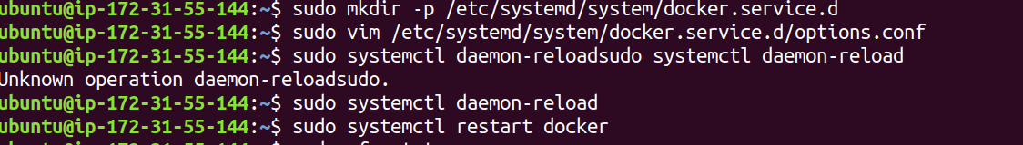

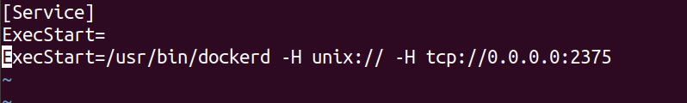

Step 4: Now open the port 2375 in the security group of the instance and allow the same port in ufw firewall also. Once done execute the following command from the localhost.

**DOCKER_HOST=tcp://(public ip of instance):2375 docker info.**

This will list the docker daemon information of the remote instances.

