**Assessment 21 – EKS1**

**Trainee Name : Gargi Sharma**

**Mentor Name : Mr. Akansh Gupta**

**College Name : UPES**

1. Create eks cluster using eksctl

During creation, Specify

* Cluster name
* Kubernetes version
* Control plane role
* Subnets for Control Plane
* Control Plane security Group
* Add tag: owner, purpose on Control Plane
* Node Group Name
* Node Instance Role
* Subnets for Node Group
* Node Instance SSH key pair
* Node Instance Security Group
* Node Instance Instance Type
* Node Instance Disk
* Add tag: owner, purpose on Node Group
* Node Group Size: min, max

YAML file:

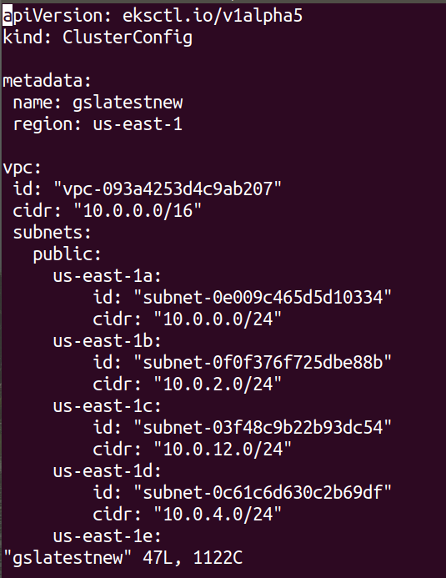

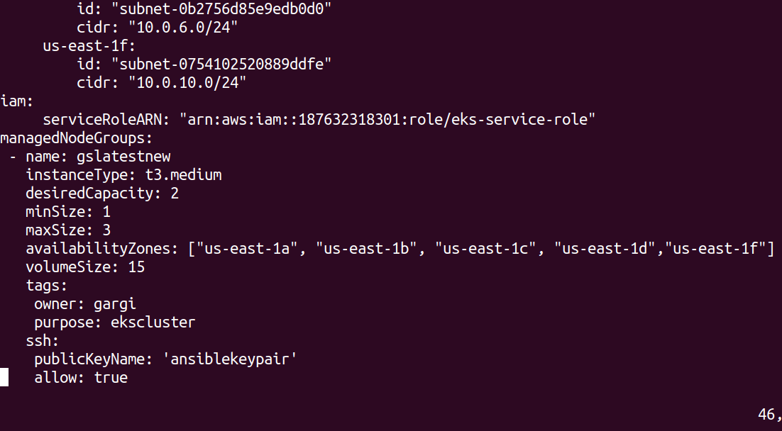

Create the cluster.

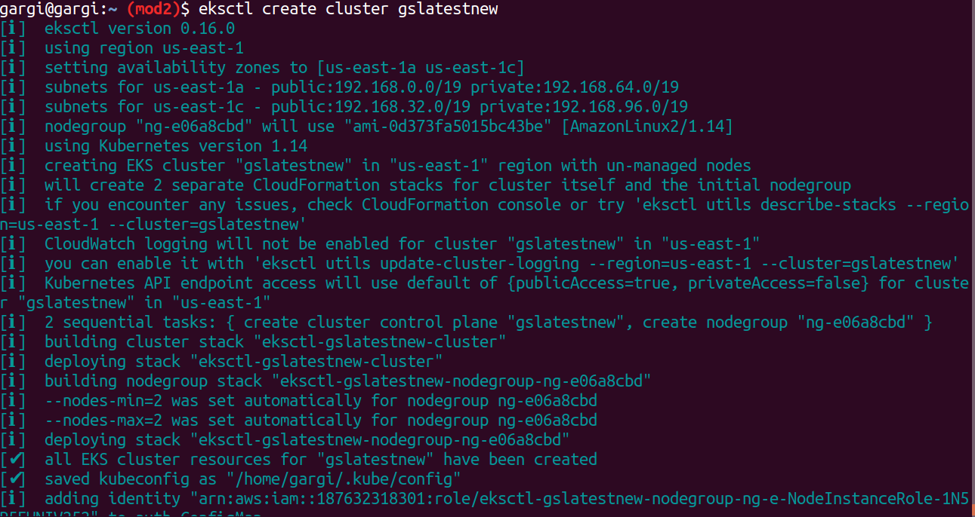

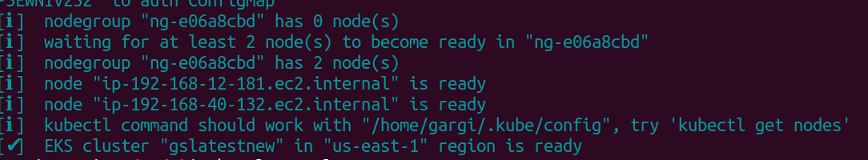

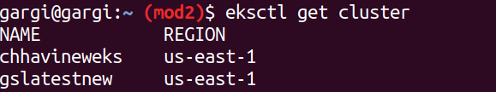

1. Authentication Management
   1. Add new 2 IAM user into the cluster

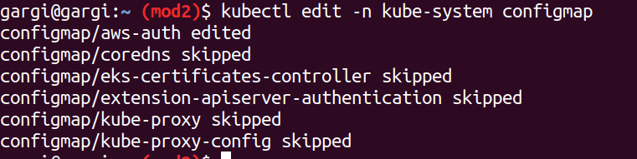

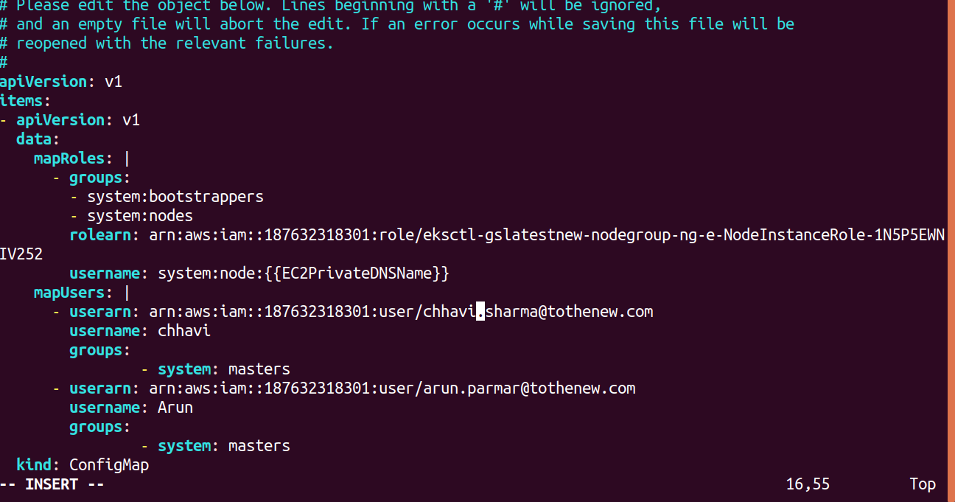

b. Enable a EC2 server to access Cluster master API without using access/secret key

Create a policy and select EKS as service.

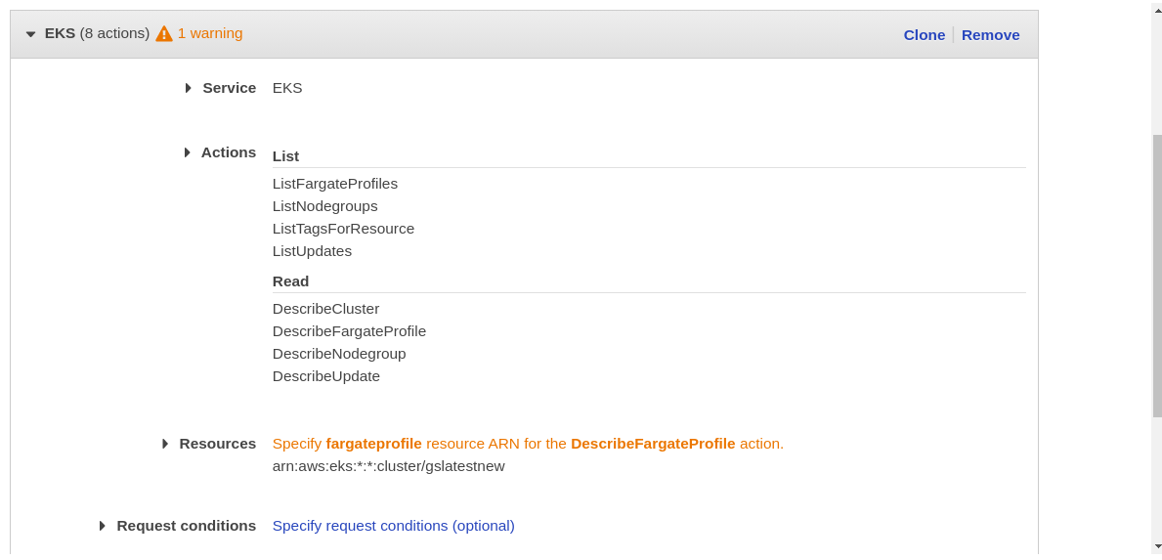

Create a role and attach the policy.

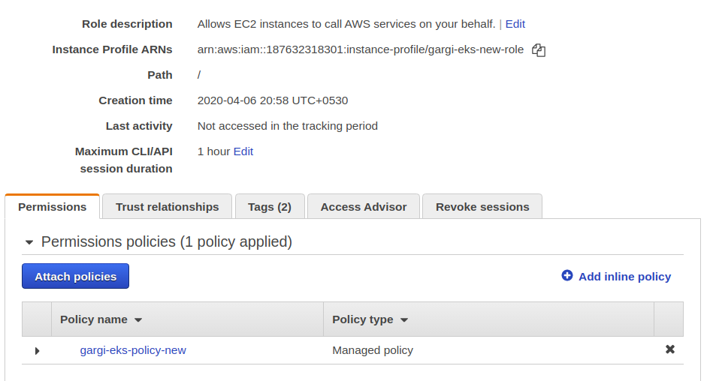

Now attach this role to an ec2 instance.

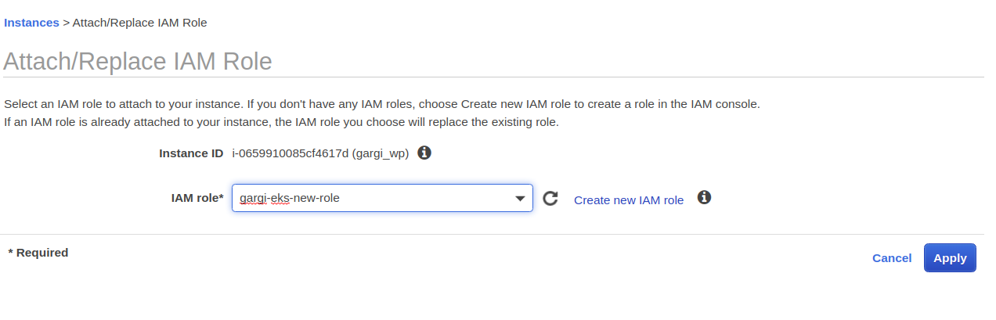

SSH into the instance and run the following command.

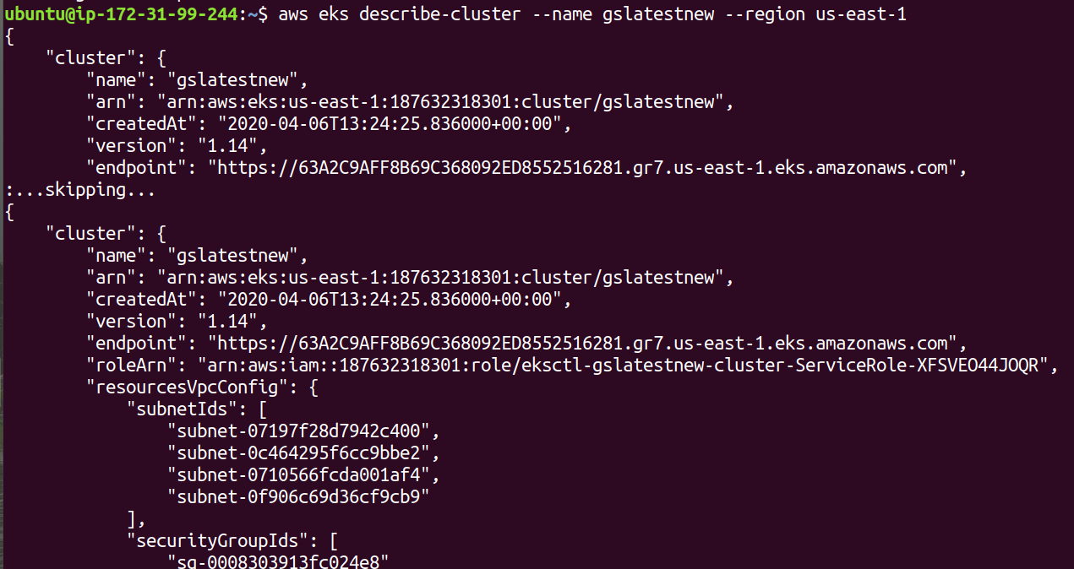

1. Eksctl command to terminate the stack

