**Assessment 24– Setting up PHP**

**Application**

**Trainee Name : Gargi Sharma**

**Mentor Name : Mr. Akansh Gupta**

**College Name : UPES**

1. **Setup Wordpress with Apache + php fpm.**

Install LAMP stack on local. Wordpress requires LAMP stack to be installed.

Apache2:

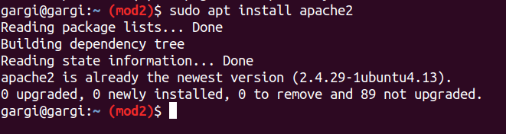

Mysql server:

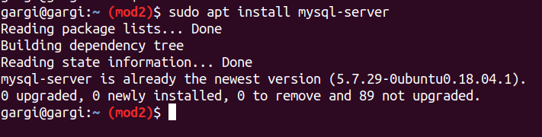

PHP:

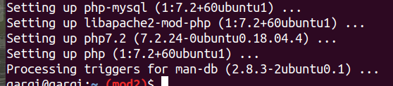

Check if apache is rendering .php:

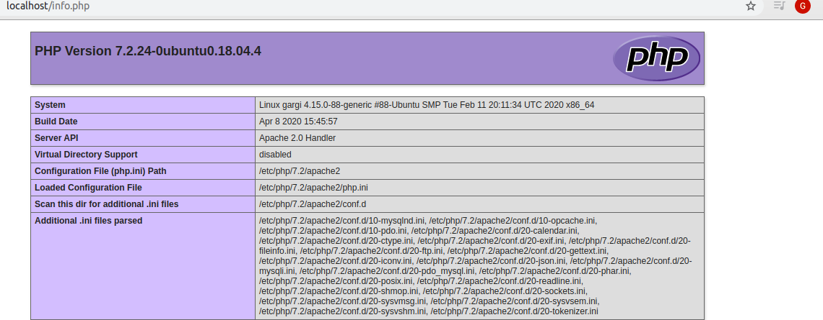

Create a mysql database and user for wordpress:

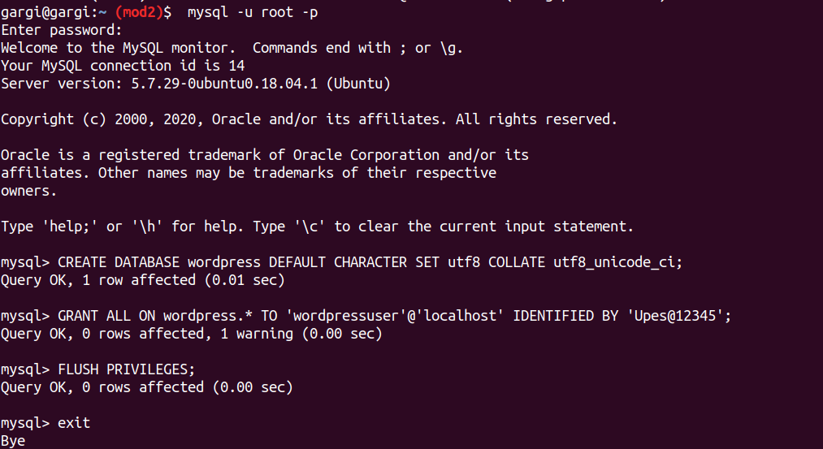

Installing additional php extentions:



## Adjusting Apache’s Configuration to Allow for .htaccess Overrides and Rewrites:

Edit wordpress.conf

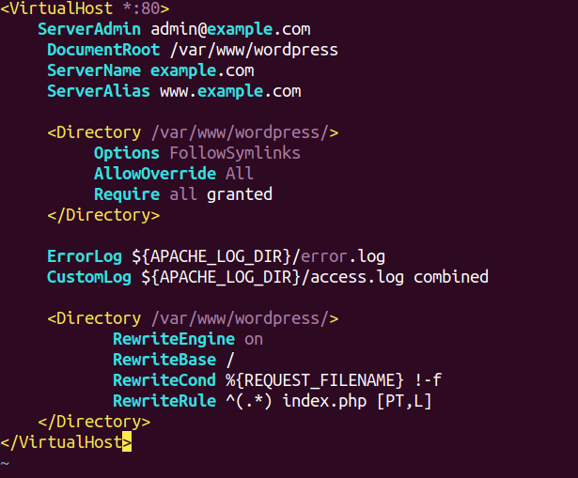

Also create a document root -> /var/www/wordpress

Restart apache2.

Downloading Wordpress:

cd /tmp

*curl -O https://wordpress.org/latest.tar.gz*

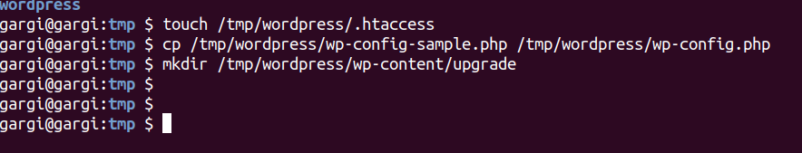

Configuring the wordpress directory:

Update ownership and file permissions:

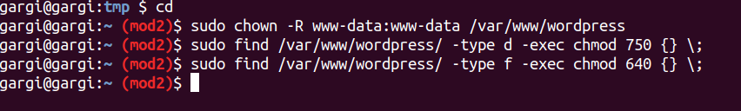

Setting up wp-config.php file:

Generate secure values :

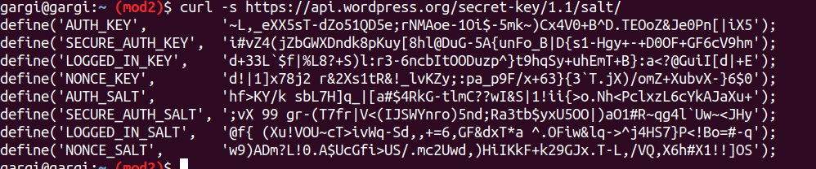

Open the wordpress.php file and paste the secure values generated through previous command:

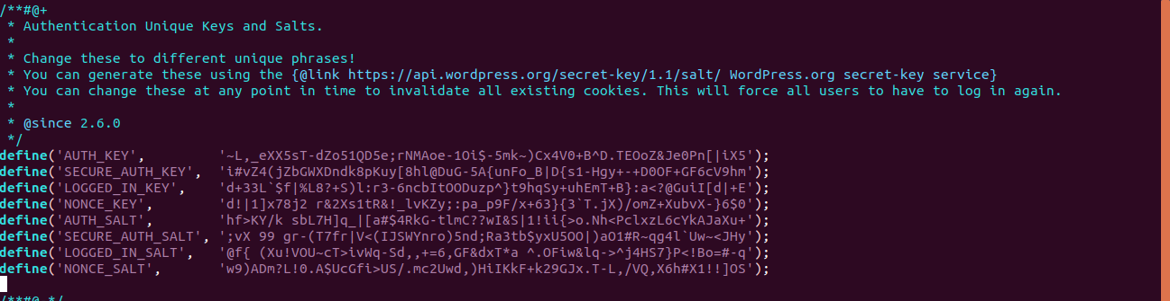

Modify some of the database connection settings:

Edit wp-config.php: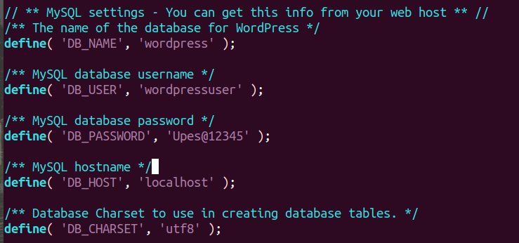

Now save and exit. Then restart apache2. Browse localhost.

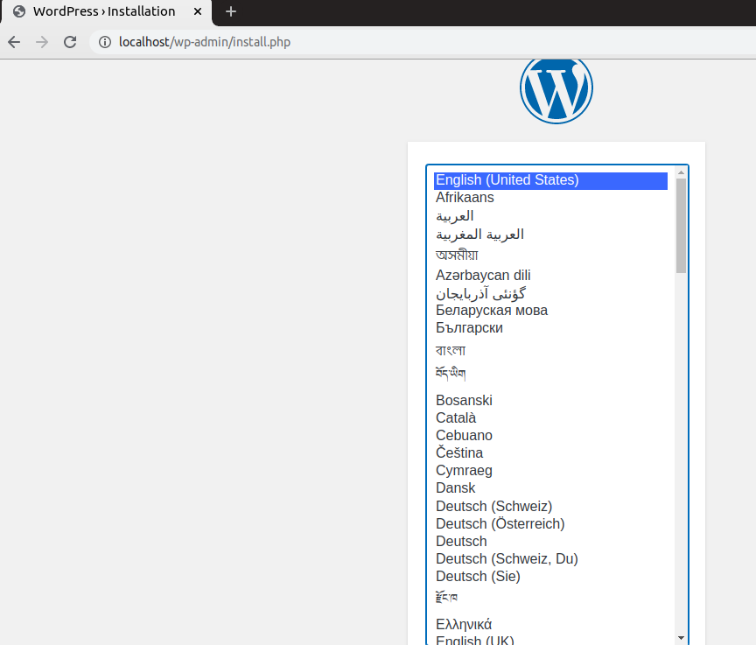

1. **Setup Drupal with Nginx and Perform FPM Configuration**

**STEP 1:** Install Nginx

Install PHP-5.3.29 with PHP-FPM

Install MySQL

**Step-2:**To create a database named "drupal" that is accessible by user "drupaluser" with password .

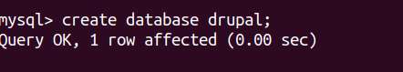

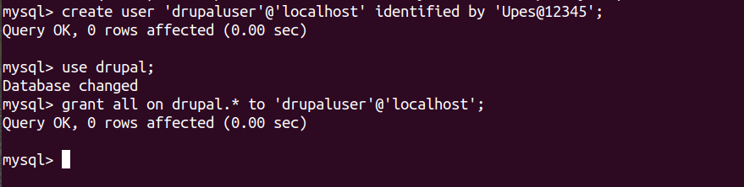

**STEP 3:** Install and configure Drupal







Configure nginx:

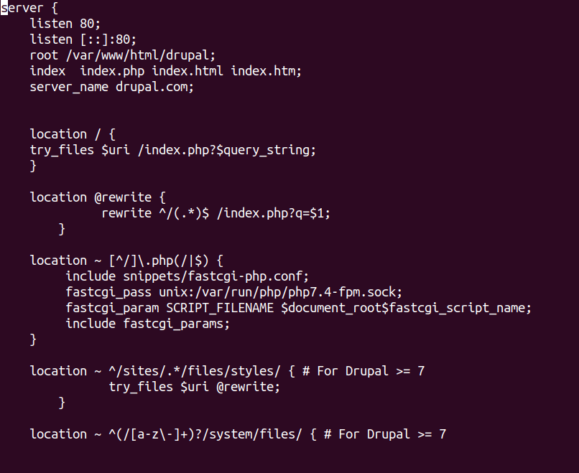

**Step4: Check on browser**

