**Assessment 13– S3,Route53,DNS**

**Trainee Name : Gargi Sharma**

**Mentor Name : Mr. Akansh Gupta**

**College Name : UPES**

1. **Create a private hosted zone named "**[**ttn-internal.com**](http://ttn-internal.com/)**" attached to the default vpc. and created a cname record "**[**myloadbalance.ttn-internal.com**](http://myloadbalance.ttn-internal.com/)**" for any load balancer pointed to its dns. Do reverse lookup for the record from any instance of the vpc and share the result.**

Step1: Create a VPC

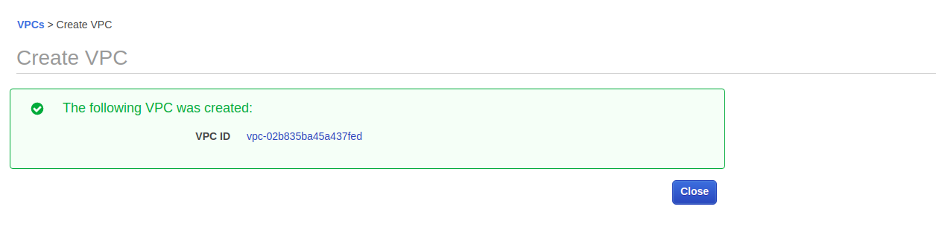

Step2: Create a load balancer in this VPC

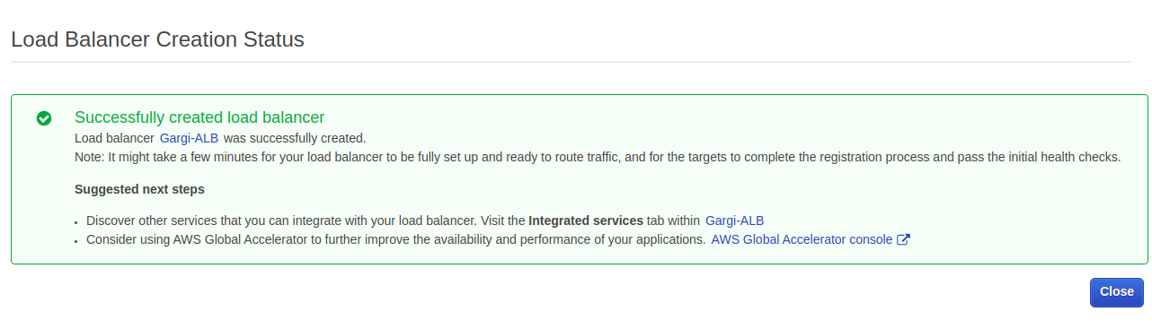

Step3: Enable DNS resolution for VPC

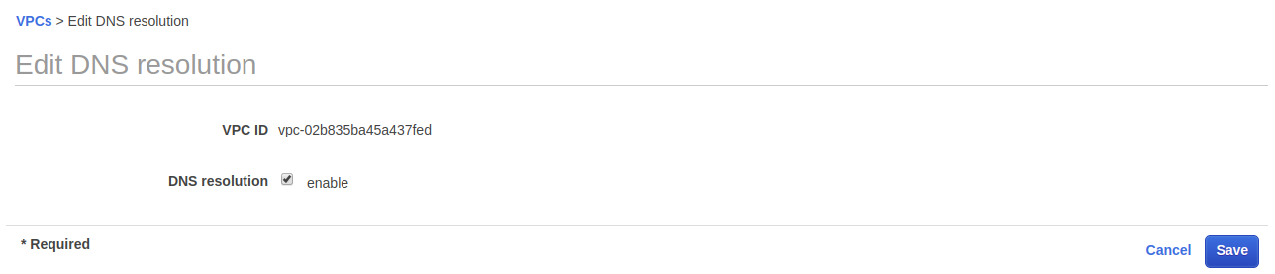

Step4: Enable DNS hostname for VPC

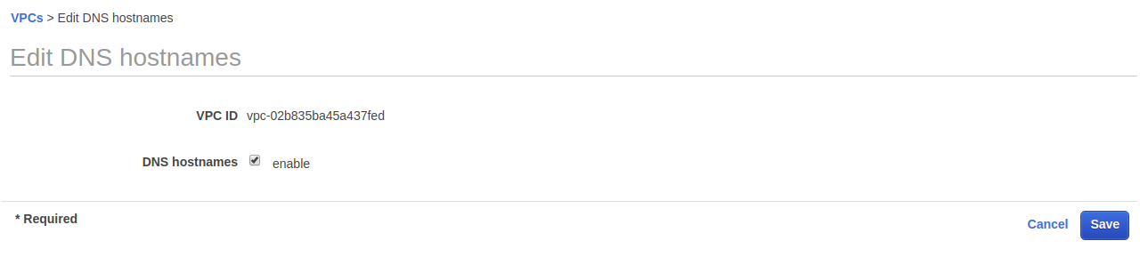

Step5: Go to route53 service and create private hosted zone

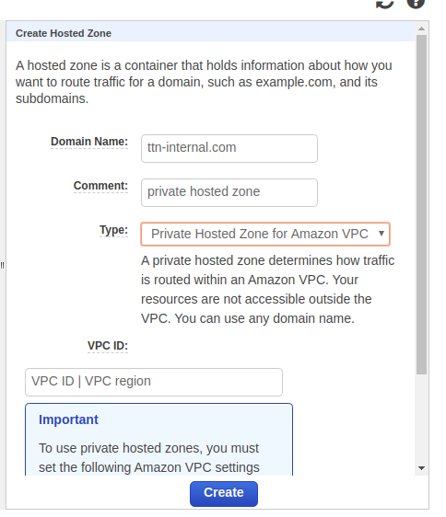

Step6: Now click on create recordsets and create c name recordset and copy the DNS of load balancer here.

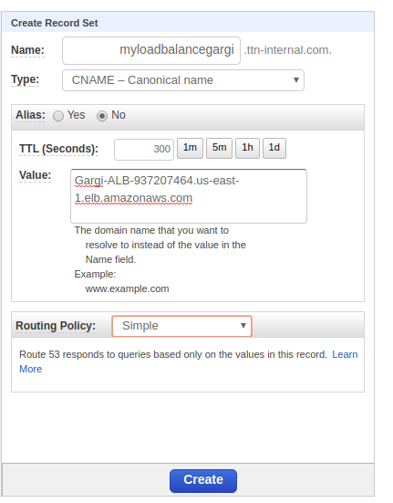

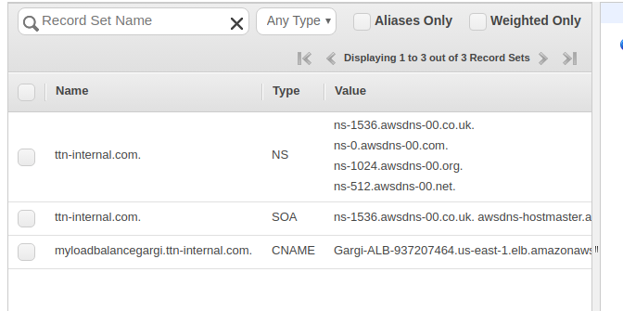

Step7: Now ssh into the instance and perform reverse lookup. It gives the ip of the load balancer.

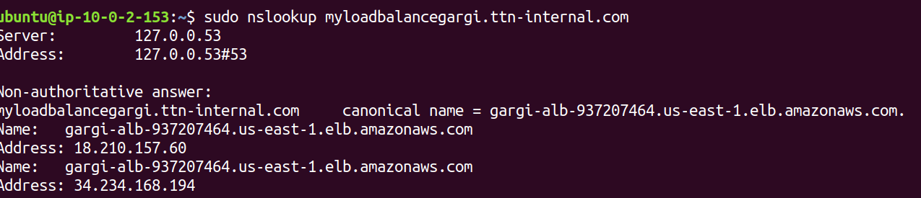

1. **Create a non-public S3 bucket and give appropriate permissions to a server to download objects from the bucket but not to put or delete anything in it.**

Step1: Give an appropriate name to the S3 bucket.

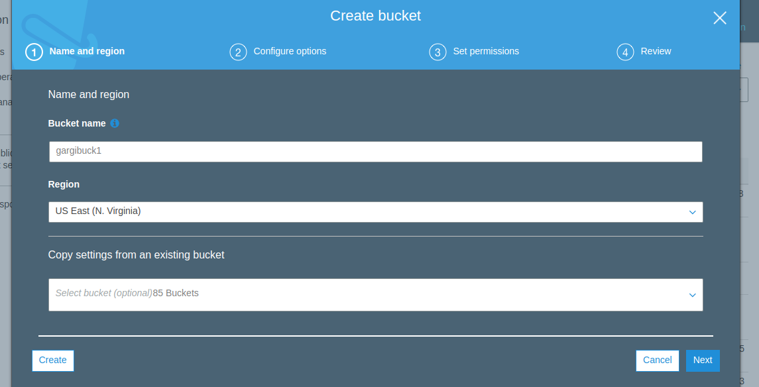

Step2: Configure options(add tags)

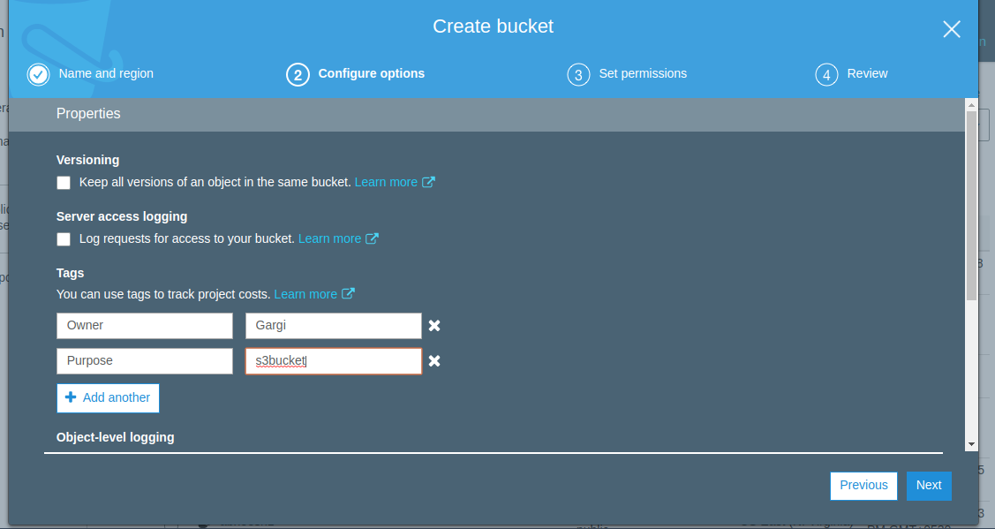

Step3: To make the bucket private, block all public ips. Also upload an object ,that will be fetched later ,into the bucket.

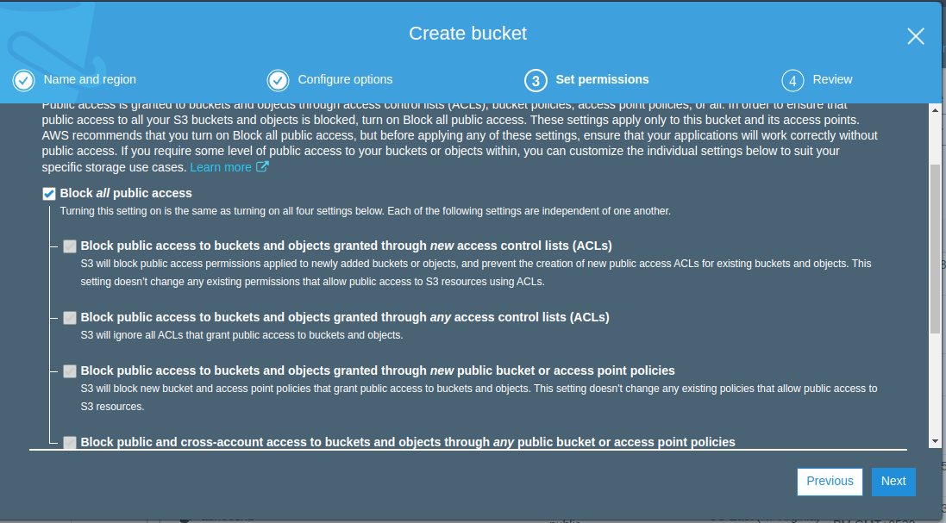

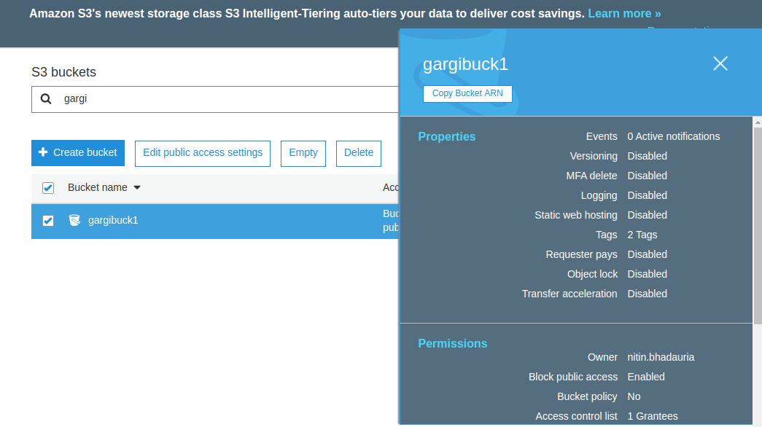

Step4: Create a new policy for S3 (download)

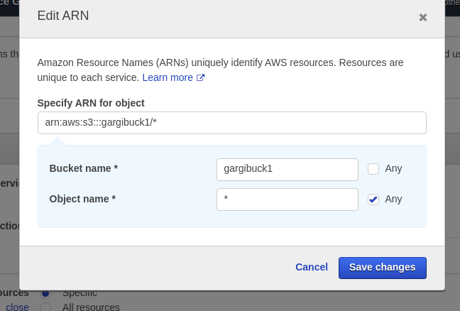

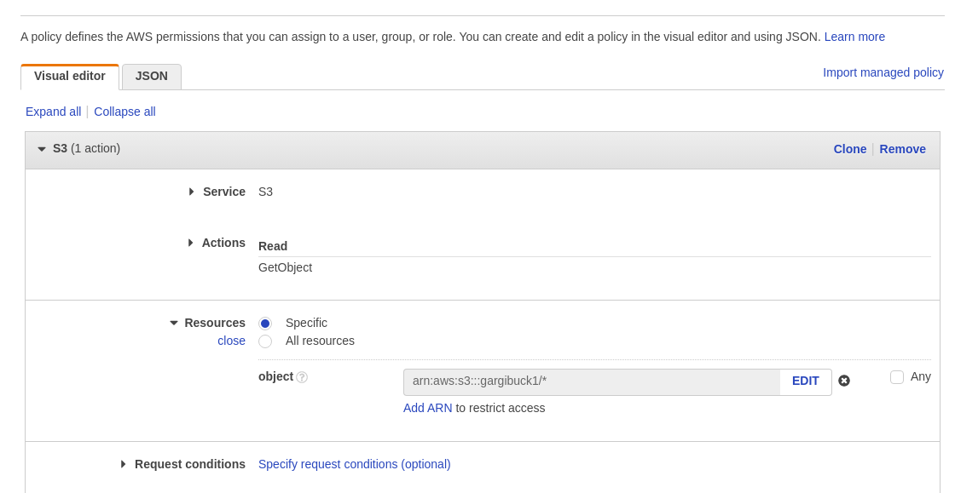

Step5: Now create a role and attach the policy to the role.

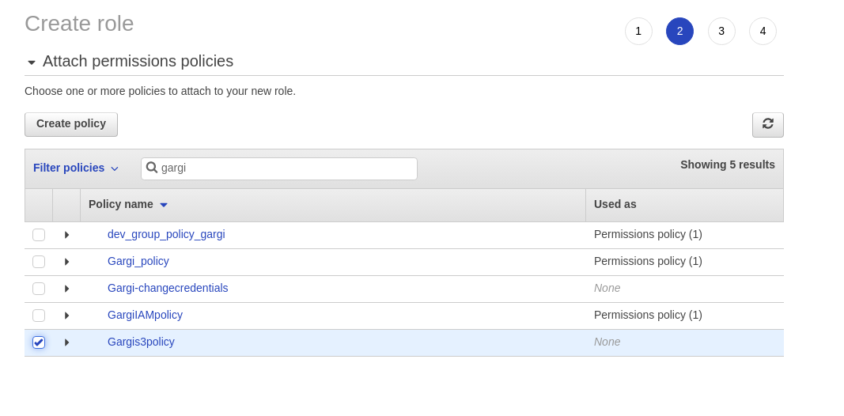

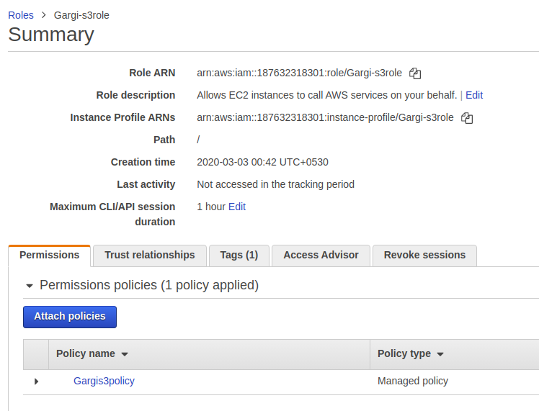

Step6:Now attach IAM role to the instance

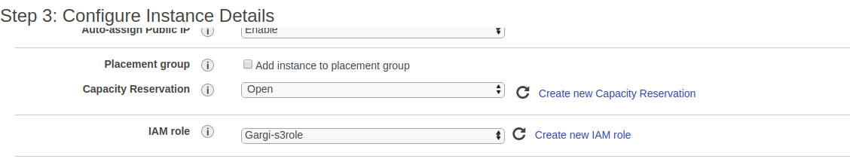

Step7: Now ssh into the instance . If you ls your s3 bucket, it will show error but if you try to download an object, it will be downloaded.



Now execute the following command: aws s3api get-object --bucket gargis3buck --key “accessKeys.csv” new. It should get the object from the bucket.

