**Assessment 25 – Terraform-2**

**Trainee Name : Gargi Sharma**

**Mentor Name : Mr. Akansh Gupta**

**College Name : UPES**

1. **Launch an ASG in AWS and do Rolling Deployment with change in User Data in LaunchConfig using terraform.**

Create a directory structure like this:

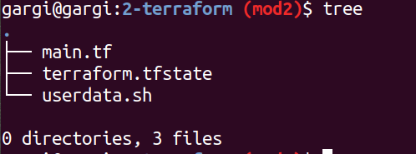

Now edit the main.tf file to create ASG:

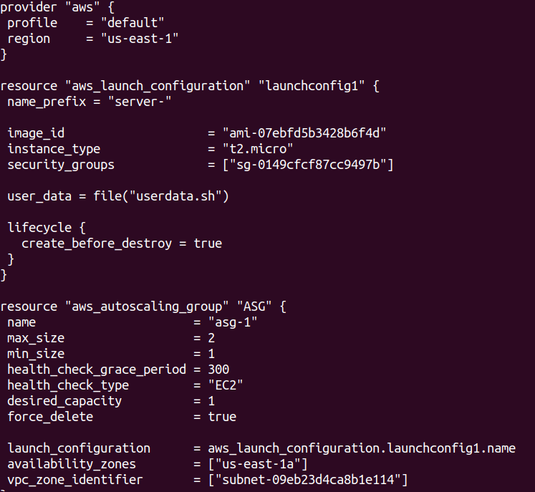

Userdata.sh:

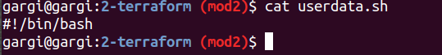

Terraform init->plan->apply

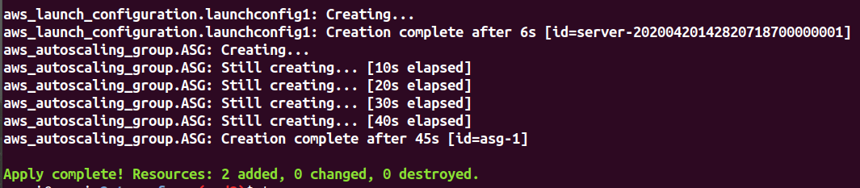

Check on console:

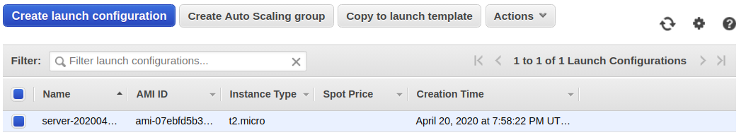

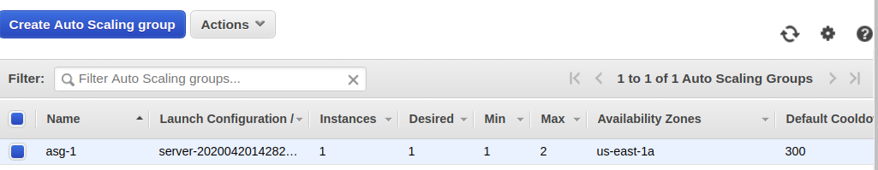

Change userdata:

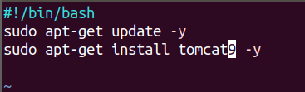

Change main.tf(change the name of asg and launch config as new asg and launch config will be created whenever we make some change in userdata):

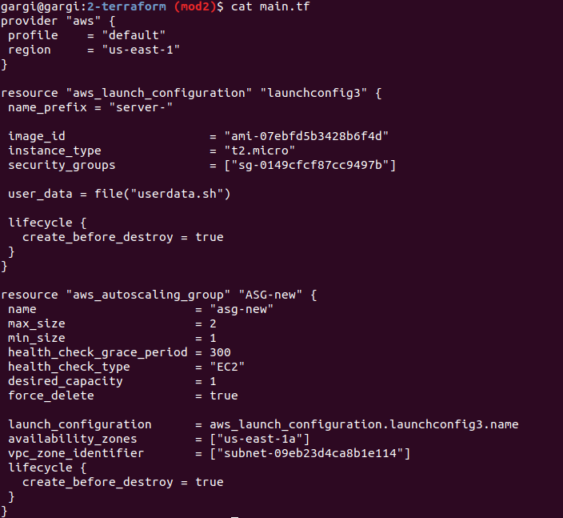

Terraform init->plan->apply.

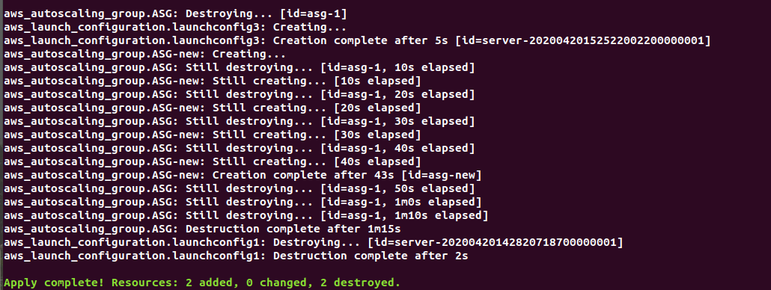

Check on console:

ASG:

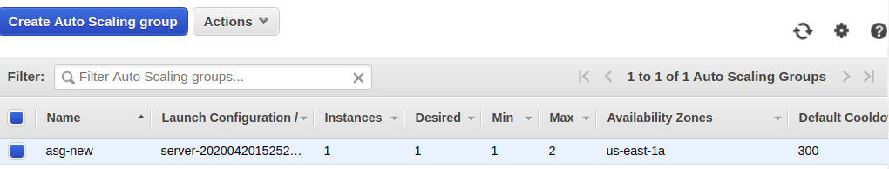

Launch Configuration:

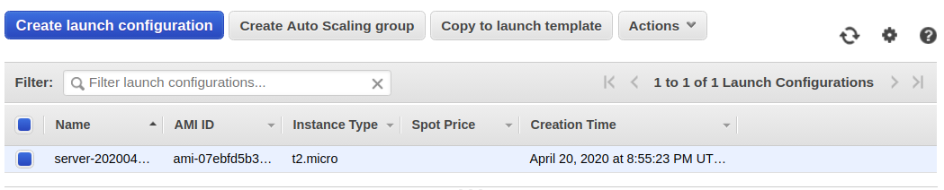

1. **Deploy a sample nginx/tomcat/react service on it.**

Userdata.sh file:



Main.tf:



Terraform init->plan->apply



Check on console:

ASG:



Launch Configuration:



1. **Attach a LB and create R53 endpoint pointing to lab, service should be accessible from the endpoint.**

Edit main.tf:

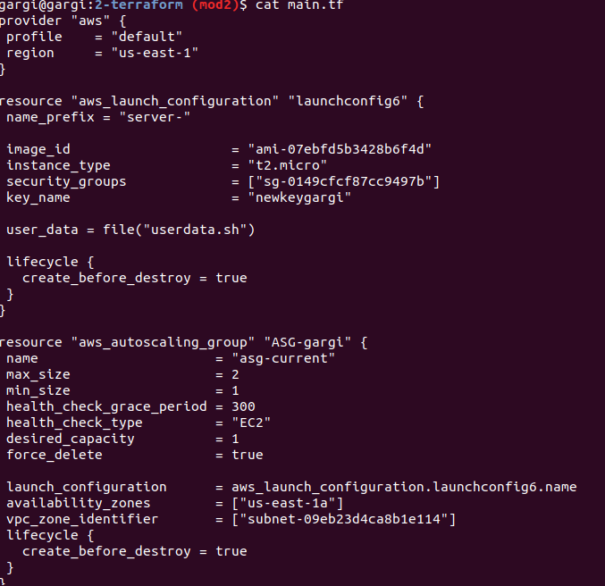

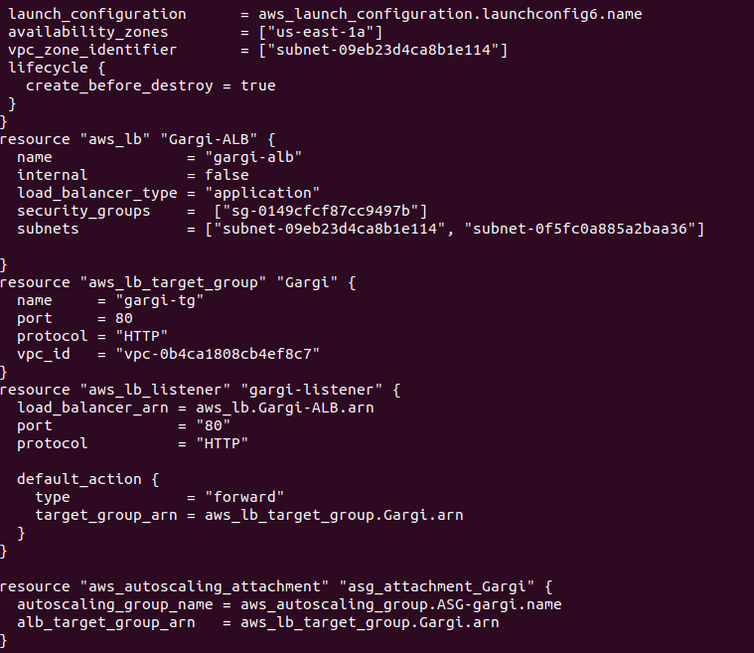

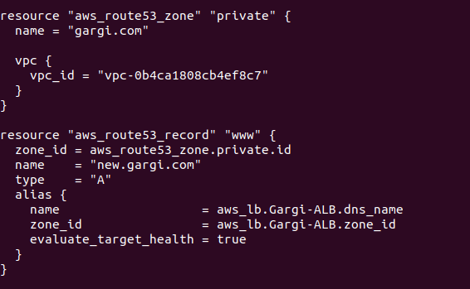

Now terraform init->plan->apply:

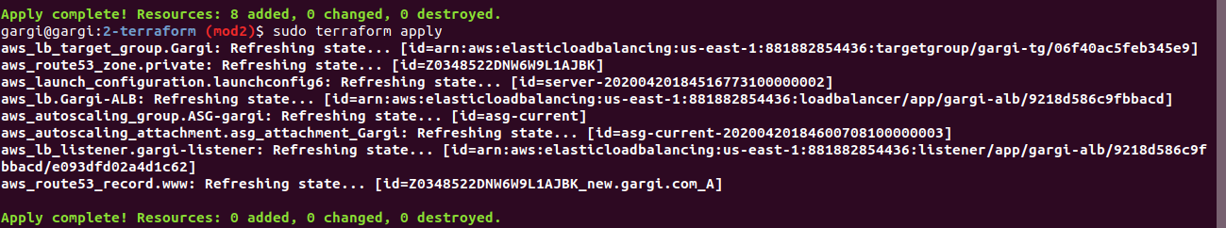

Check on console:

ASG:

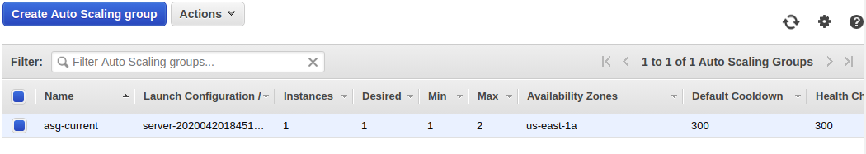

Launch Configuration:

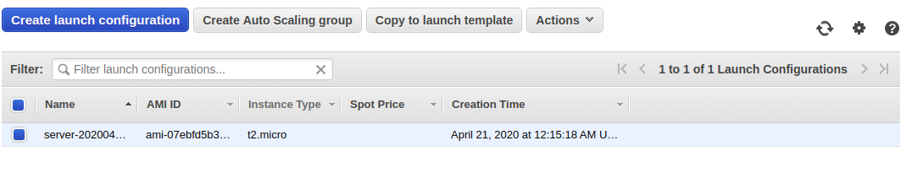

Now hit the DNS name of load balancer:

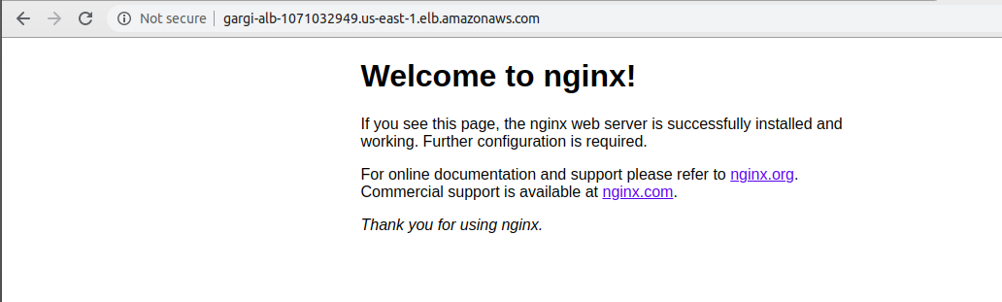

Now ssh into the instance and curl the Route53 domain:

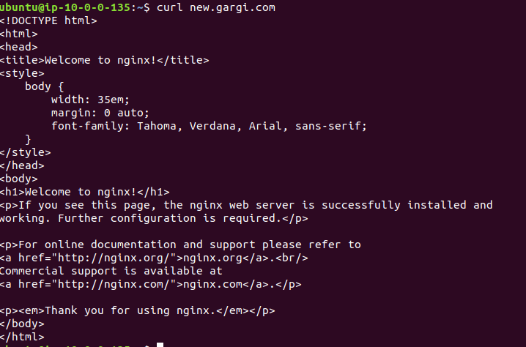

1. **Variablize all parameters and pass values as env.tfvars file.**

Edit main.tf:

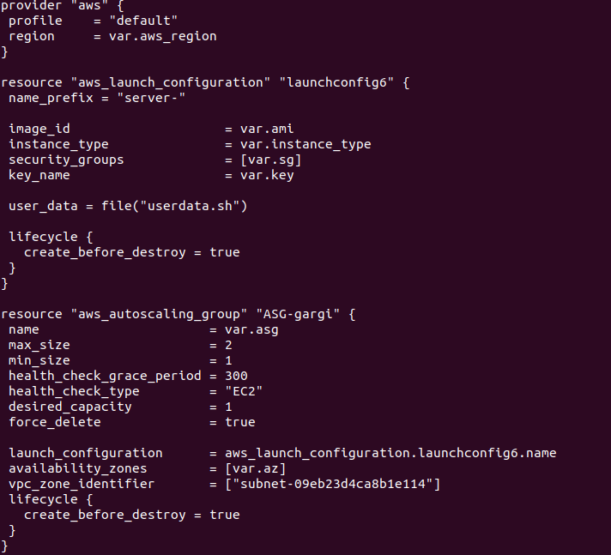

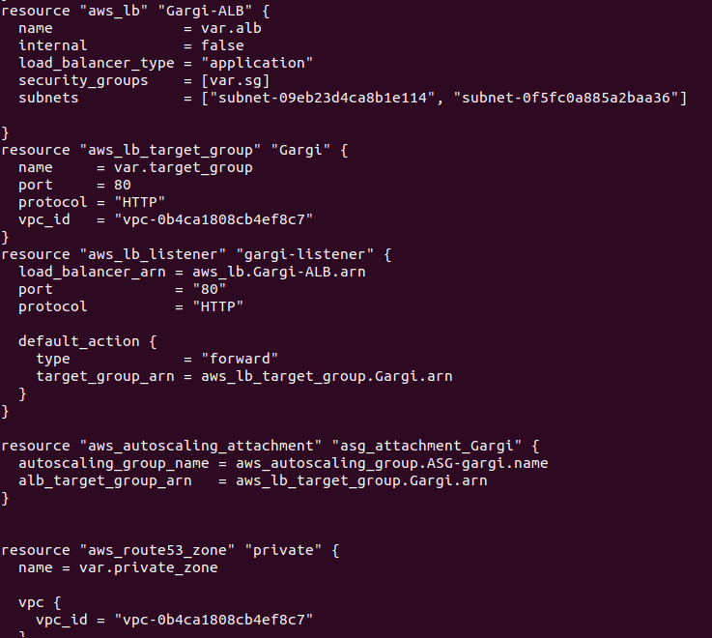

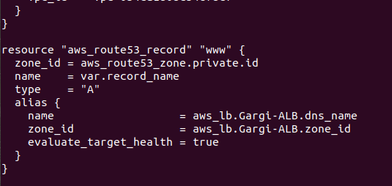

Now create a variable.tf file to define variables:

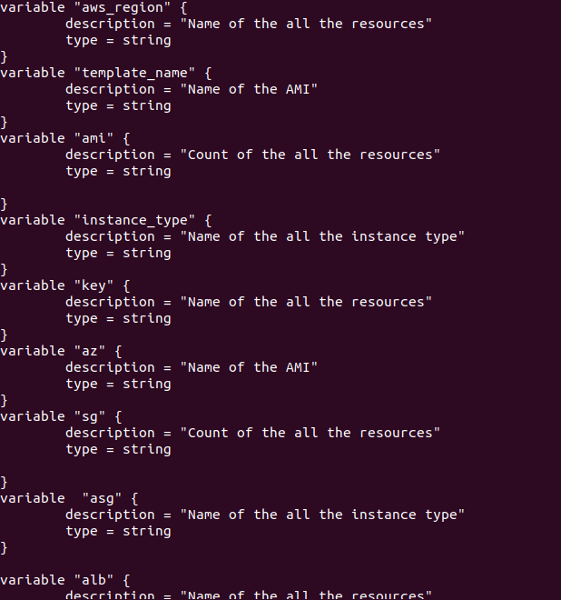

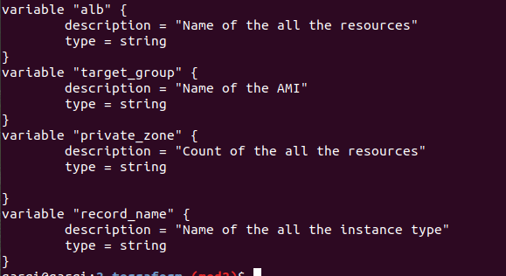

Now create env.tfvars to pass values of the defined variables:

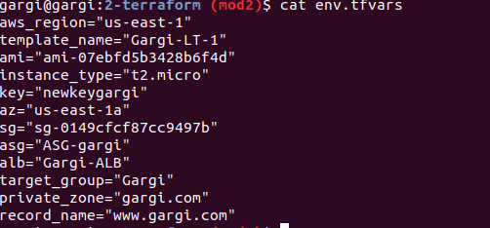

Terraform plan --var-file=”env.tfvars”-> terraform apply --var-file=”env.tfvars”

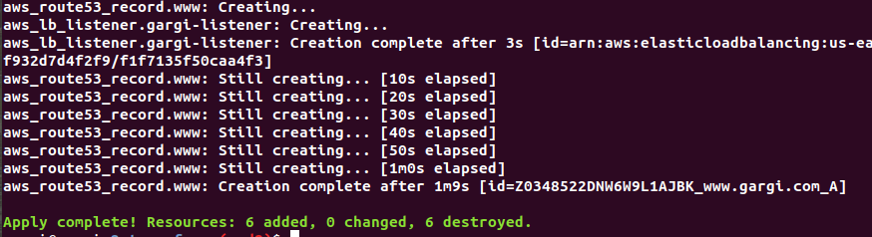

Check on console:

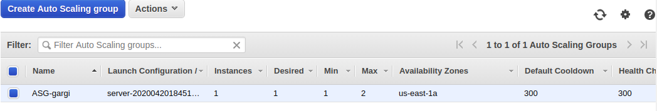

1. **Create ASG from Launch Template and use a mix of on demand and on spot instance type in the ASG. Instance Type for On Demand and Spot should be different.Enable Spot Feature to use multiple instance type if requested instance type is not available.**

Main.tf:

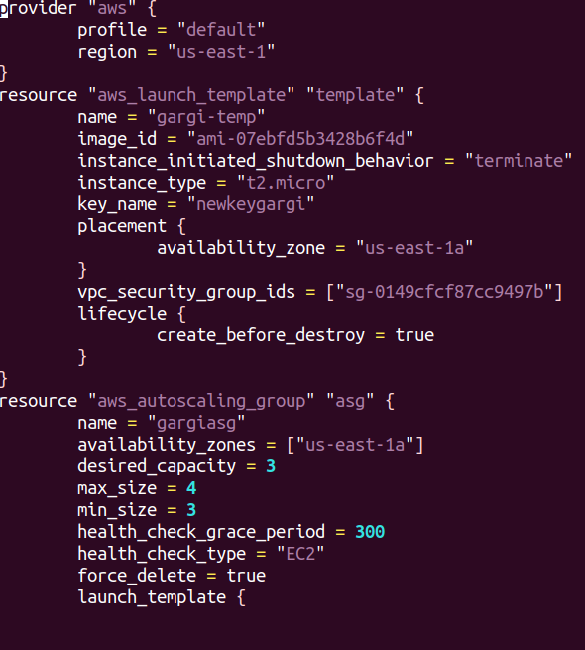

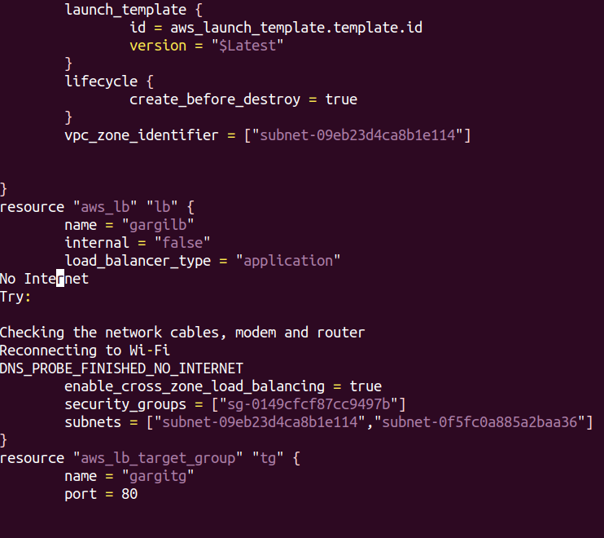

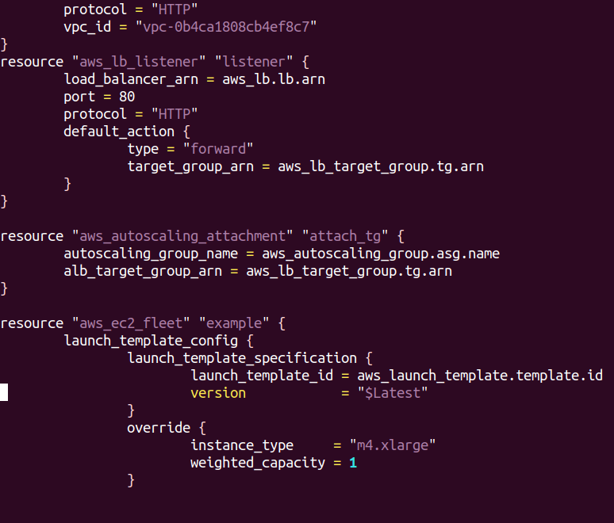

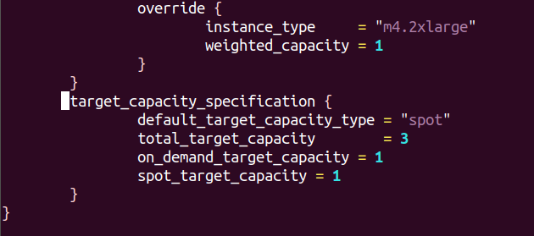

Terraform init->plan->apply

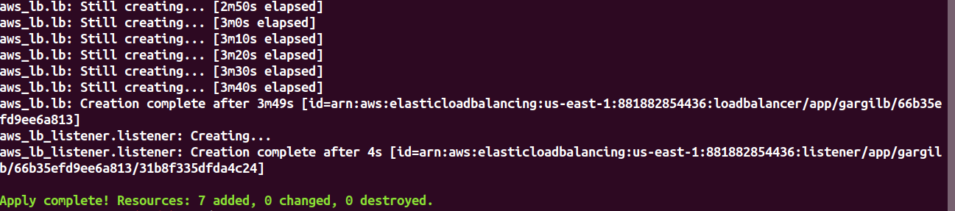

Check on console:

ASG:

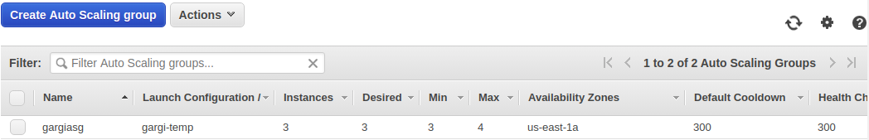

Instances:

New1, new2 and new3 instances are the ones created in ASG.

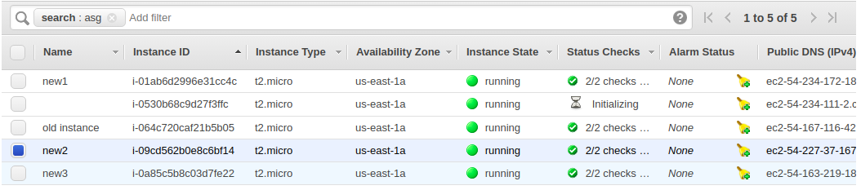

Spot Instances:

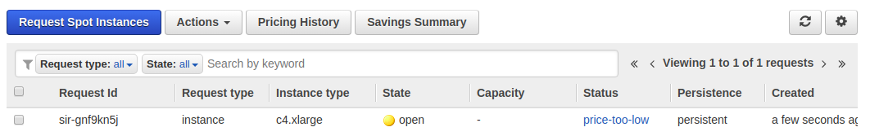

To enable Spot Feature to use multiple instance type if requested instance type is not available:

