Department of Computer Science
Punjabi University Patiala



ASSIGNMENT OF RELATIONAL DATABASE MANAGEMENT SYSTEM

(LAB-III) MCAM-1206L

Submitted by- Ishika Garg (21071208),
Shairya Sharma (21071225),
Ssembuya Abdurahumani (21071291).

Submitted to- Dr. Gurpreet Singh Josan , Dr. Sukhjeet Kaur Ranade
Course – MCA (Semester - 2nd)
Section- A
Topic- Management Information System for Online Marriage Bureau

ER DIAGRAM :
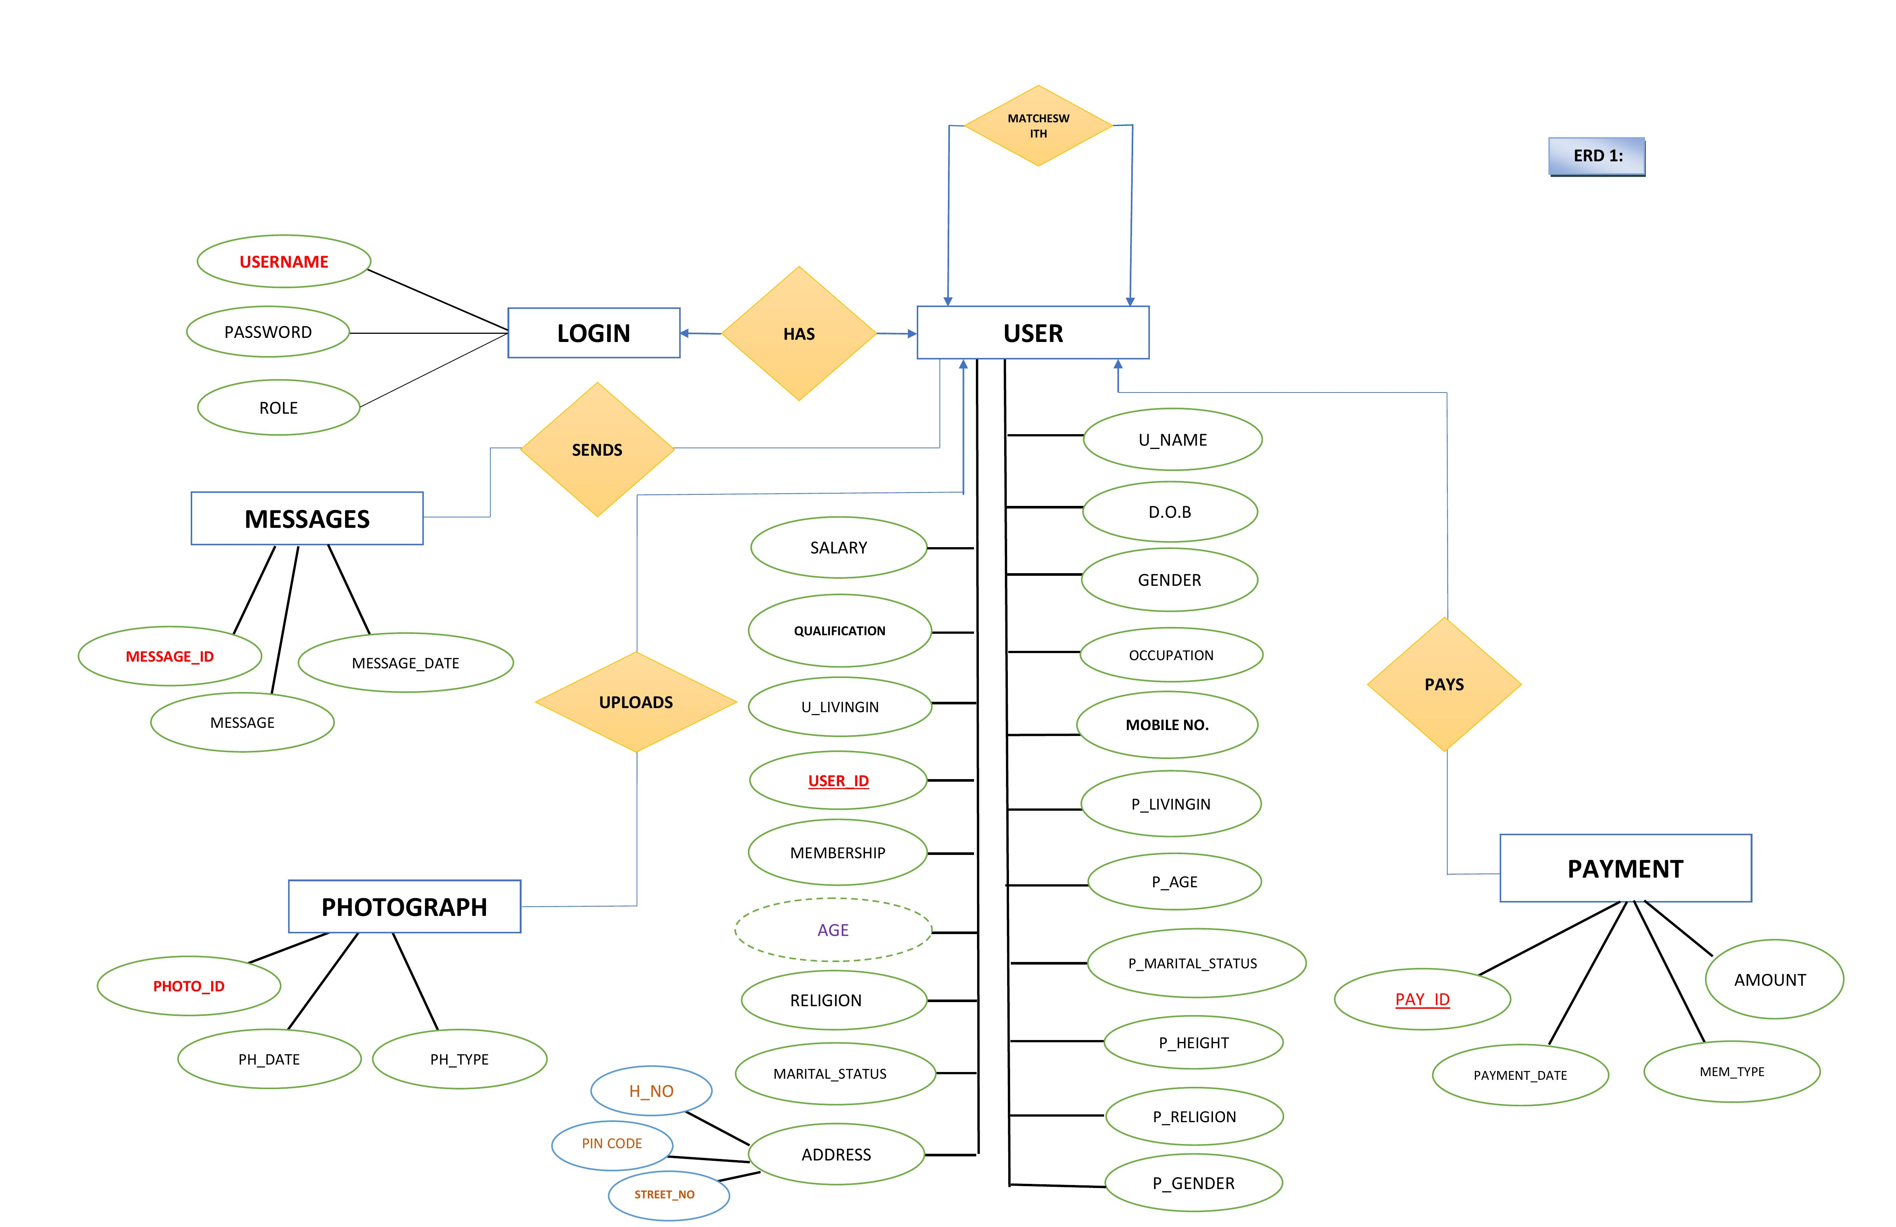
ERD 2 :

A
DVERTISER

ADVERTISE

ADVERTISEMENT

ADV_NAME

ADV_ID

DURATION

LOCATION

ADVT_ID

MARRIAGE BUREAU
The Marriage Bureau ERD is a system where we enables user to register and find his/her ideal match as per their preferences. Here we made ERD 1 of five (5) entities with five (5) relationships that link each entity to the other.
In ERD 2, there is one (1) relationship between two (2) entities.
Here, we describe 2 E-R Models:
- USER ( Registered Person )
- ADVERTISTER ( Who advertise his advertisements on the site )

❖ ENTITIES OF ERD 1
- Login
- User
- Messages
- Payment
- Photograph

- ENTITIES OF ERD 2
- Advertiser
- Advertisement

❖ RELATION SET

(ERD 1)
- Has (After Login it direct towards User)
- Match with (User profile gets match with other users)
- Sends ( When user sends messages to his/her match)
- Pays (User buying membership)
- Uploads ( User uploads their photographs for their profile )

(ERD 2)
➢ Advertise (advertiser advertising his advertisement)

❖ ATTRIBUTES ➢ Login
- Username
- Password
- Role ( i.e. Either as User / Admin )

➢ User
- User_Id
- U_name
- Qualification
- Password
- DOB
- U_LivingIn
- Gender
- Address 9. Occupation
- Mobile No.
- Religion
- Marital_Status
- Membership
- Salary

( User preferences for his/her partner )
- P_Age
- P_Religion
- P_LivingIn
- P_Height
- P_Marital_Status
- P_Gender

Here, ( P ) stands for – Partner and ( U ) stands for User , details.
➢ Payment
- Pay_Id
- Amount
- Mem_Type
- Payment_ Date

➢ Messages
- Message_ID
- Message
- Message_Date

➢ Photograph
- Photo_Id
- PH_Date ( Photo graph uploaded date )
- PH_Type (photograph type i.e. PNG , JPG , JPEG )

( ATTRIBUTES IN ERD 2 )

➢ Advertiser
- Adv_Id
- Location
- Duration

➢ Advertisement
- Adv_Name
- Advt_Id

PRIMARY KEYS
ERD 1 -
  - Username
  - User_Id
  - Pay_Id
  - Photo_id
  - Message_id
ERD 2 –
  - ADV_ID
  - ADVT_ID

- DERIVED ATTRIBUTE


➢ Age

❖ COMPOSITE ATTRIBUTES

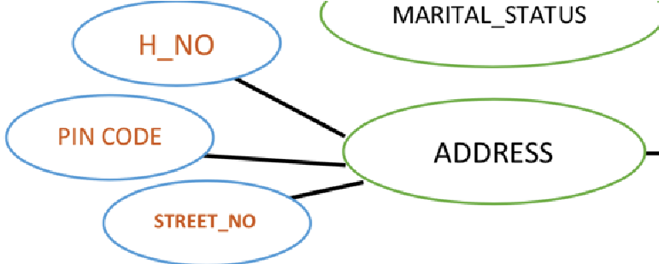

➢ Address
- H_No
- Pin Code
- Street

❖ CARDINALITY CONSTRAINT
ERD1 :
- One to one ( User has one login to his account )
- One to Many ( User can make many payments as per his/her membership )
- One to Many ( One user can upload many pictures at once )
- Many to Many ( User can send many messages to partner, and vice versa)

- One to one ( User can find there match as per his/her preferences and result into successful search )

ERD 2 :
- One to Many ( Advertiser can display various advertisements )

