Department of Computer Science

Punjabi University Patiala



***ASSIGNMENT OF RELATIONAL DATABASE MANAGEMENT SYSTEM***

***(LAB-III) MCAM-1206L***

*Submitted by-* ***Ishika Garg*** *(21071208),*

***Shairya Sharma*** *(21071225),*

***Ssembuya Abdurahumani*** *(21071291).*

*Submitted to-* ***Dr. Gurpreet Singh Josan, Dr. Sukhjeet Kaur Ranade***

*Course – MCA (Semester - 2nd)*

*Section- A*

*Topic-* ***Management Information System for Online Marriage Bureau***

**(QUERIES IMLEMENTATION)**

***Executing Every Table:***

**User:-**

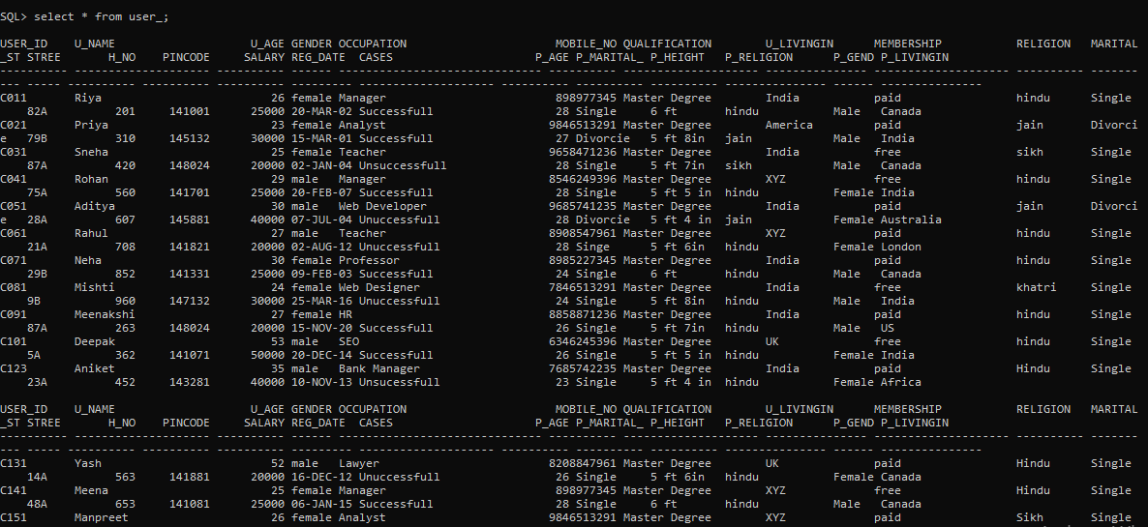

**Login:-**

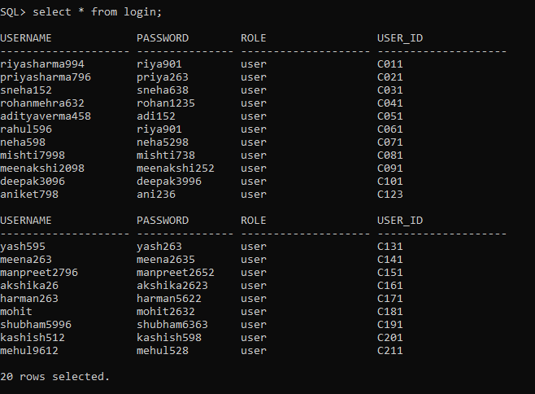

**Messages:-**

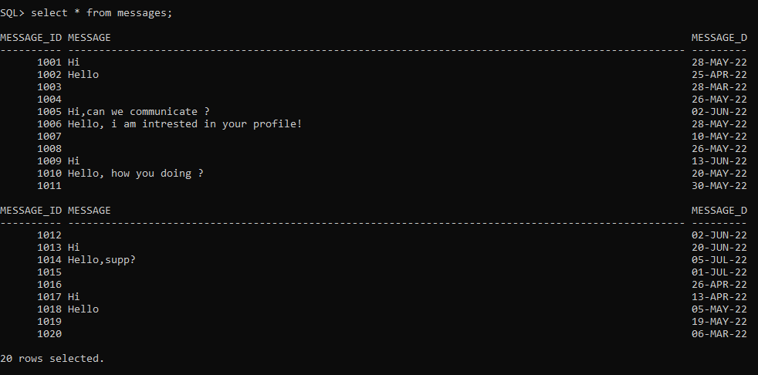

**Photograph:-**

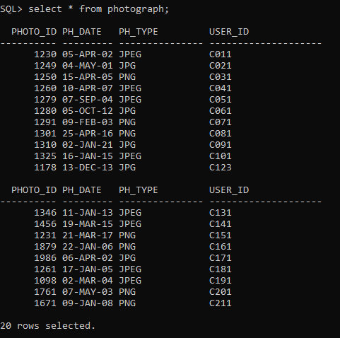

**Payment:-**

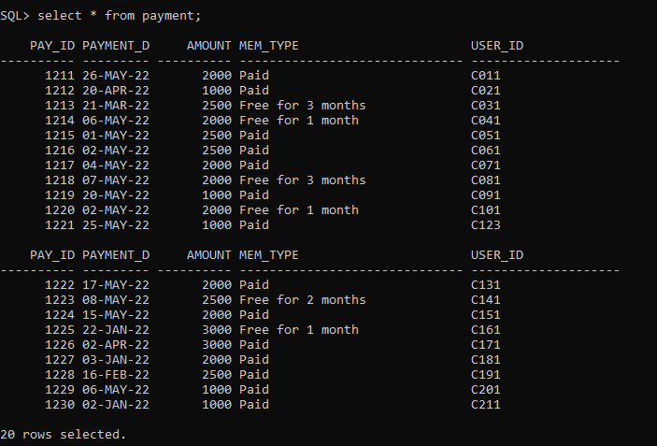

**Sends:-**

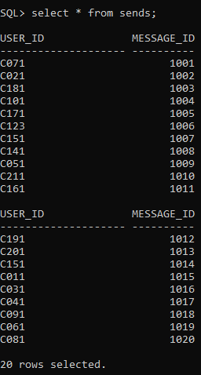

**Matches_with:-**

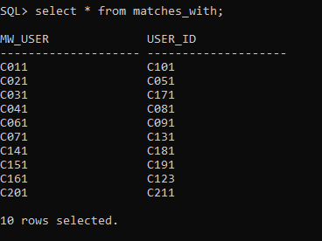

**Advertiser:-**

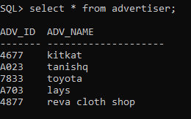

**Advertisement:-**

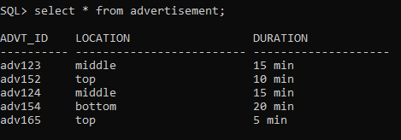

**Advertise:-**

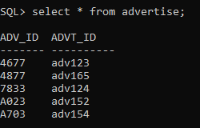

***Queries to be Performed on Tables :***

**A) Display the details of customer registered between ‘2002’ and ‘2008’.**

select * from user_ where reg_date between '01-January-2002' and '31-December-2008';

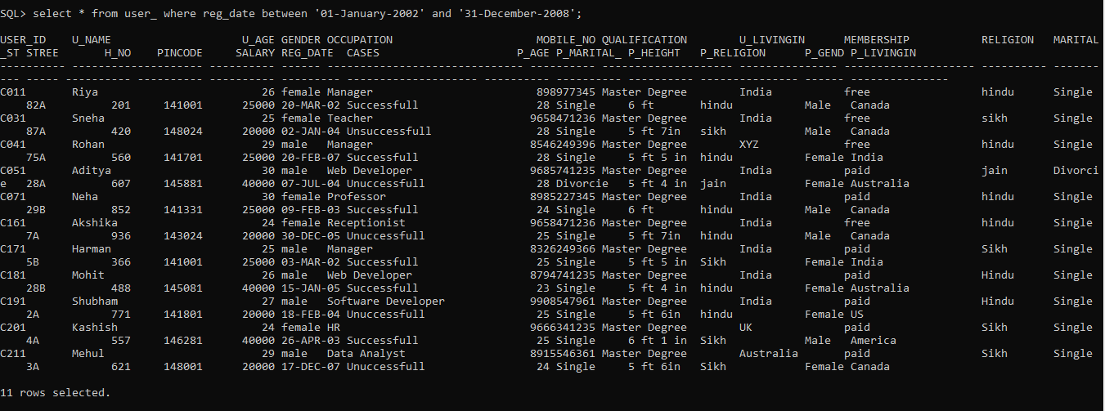

**B) Change the category of customer to ‘paid member’ whose id=’C011’;**

UPDATE user_ SET membership='paid' WHERE user_id='C011';

select * from user_;



**Updated list:**

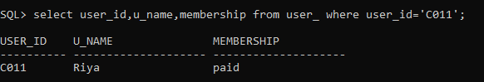

**D) Display the number of advertiser who display at position=’TOP’**

SELECT * from advertisement where location = 'top';

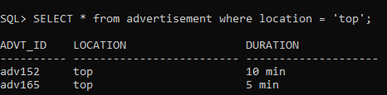

**G) Change the status of customer with id C123 with Unsuccessful**

UPDATE user_ SET Cases='Unsucessfull' WHERE user_id='C123';

select * from user_ ;



UPDATED LIST:-

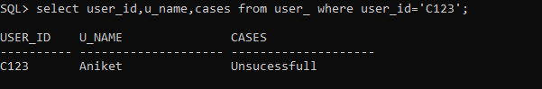

**H) List the bride details which are between age 24-26 in city “XYZ”;**

Select u_name,u_age,gender,u_livingin,occupation,religion,marital_status from User_ where Gender ='female' and u_livingin='XYZ' and u_age between 24 and 26;



**I) List the name of grooms who has Master’s Degree and has salary > 40000/month**

select u_name,gender,qualification,salary from user_ where gender ='male' and qualification ='Master Degree' and salary >40000;



**J) List the details of grooms with age more than 50 living in UK**

select u_name,u_age,u_livingin,gender from user_ where u_age>50 and u_livingin ='UK' and gender='male';

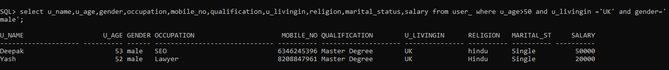

**K) List total brides registered on system**

select count(Gender) from user_ where Gender ='female';

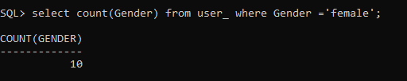

**L) List advertisement duration of advertiser whose id is ‘adv123’ :**

select duration from advertisement where advt_id = ‘adv123’;

