The Sun: A 20-Question Tiered Quiz
THE SUN: A 20-QUESTION TIERED QUIZ

Introduction
This quiz covers fundamental to advanced concepts about our Sun, aligned with NGSS HS-ESS1-1. Questions progress from basic recall (Tier 1) to analytical (Tier 2) and synthesis/evaluation (Tier 3).

Solar Structure Diagram
[Image: astronomy_for_mere_mortals_page37_img2.png will be inserted here]

Quiz Questions
1. (Tier 1) What is the primary composition of the Sun? [NGSS HS-ESS1-1]
2. (Tier 1) Which layer of the Sun is visible during a total solar eclipse?
3. (Tier 1) What nuclear process powers the Sun? [NGSS HS-ESS1-1]
4. (Tier 2) Why can't the Sun be made of ice despite having similar density to ice?
5. (Tier 2) Explain why temperature increases above the photosphere.
6. (Tier 2) How do sunspots demonstrate differential rotation? [NGSS HS-ESS1-1]
7. (Tier 3) Calculate the Sun's gravitational influence if its mass were halved.
8. (Tier 3) Predict how solar activity would change if rotation rate doubled.

[Image: astronomy_for_mere_mortals_page36_img2.png will be inserted here]

9. (Tier 2) Analyze how an elongated sunspot would appear during solar rotation.
10. (Tier 3) Design an experiment to measure solar rotation without sunspots.
11. (Tier 1) What causes the 11-year solar cycle?
12. (Tier 2) Compare solar wind effects on Earth vs. Mars.

Answer Key
1. Primarily hydrogen (74%) and helium (24%)
2. Corona
3. Nuclear fusion (proton-proton chain)
4. Ice would vaporize at solar temperatures
5. Magnetic heating in the chromosphere/corona
6. Equatorial regions rotate faster than polar regions
7. Fg would decrease by factor of 4
8. Increased magnetic activity, shorter solar cycles

NGSS Alignment
HS-ESS1-1: Questions 1,3,6 address nuclear processes and solar dynamics that influence planetary systems.
--- Images ---
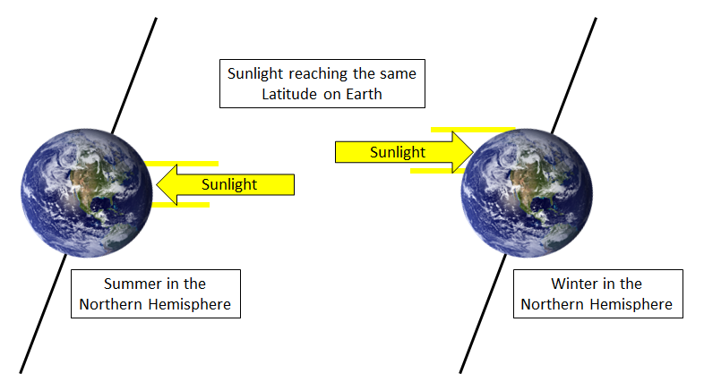
Image: astronomy_for_mere_mortals_page37_img2.png
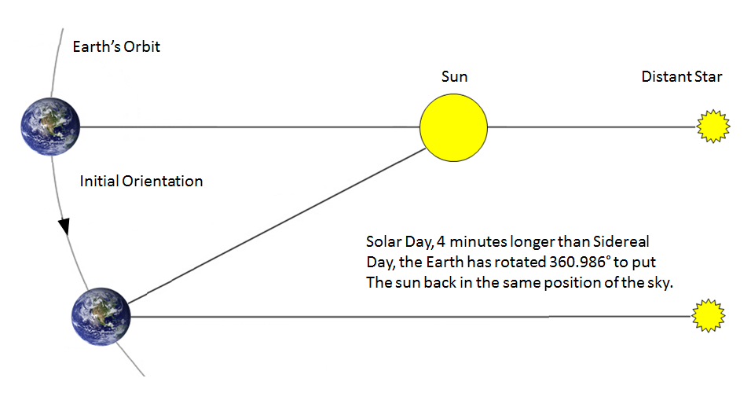
Image: astronomy_for_mere_mortals_page36_img2.png

