ECLIPSE

package mongodb;

import com.mongodb.client.MongoClient;
import com.mongodb.client.MongoClients;
import com.mongodb.client.MongoCollection;
import com.mongodb.client.MongoDatabase;

import com.mongodb.client.model.Filters;
import com.mongodb.client.model.Updates;
import com.mongodb.client.model.UpdateOptions;

import org.bson.Document;

public class MongoUpdateOperators {

public static void main(String[] args) {

// Connect MongoDB
MongoClient mongoClient =
MongoClients.create("mongodb://localhost:27017");

// Database
MongoDatabase database =
mongoClient.getDatabase("CollegeDB");

// Collection
MongoCollection<Document> collection =
database.getCollection("Students");

// =====================
// UPSERT
// =====================

collection.updateOne(
Filters.eq("id", 101),
Updates.set("name", "John"),
new UpdateOptions().upsert(true)
);

System.out.println("Upsert Operation Done");

// Add fields for demo
collection.updateOne(
Filters.eq("id", 101),
Updates.set("department", "CSE")
);

collection.updateOne(
Filters.eq("id", 101),
Updates.set("cgpa", 8.7)
);

// =====================
// UNSET
// =====================

collection.updateOne(
Filters.eq("id", 101),
Updates.unset("department")
);

System.out.println("Unset Operation Done");

// =====================
// RENAME
// =====================

collection.updateOne(
Filters.eq("id", 101),
Updates.rename("cgpa", "grade")
);

System.out.println("Rename Operation Done");

// Show Final Document
Document doc =
collection.find(Filters.eq("id", 101)).first();

System.out.println("\nFinal Document:");
System.out.println(doc.toJson());

mongoClient.close();
}
}

CONSOLE
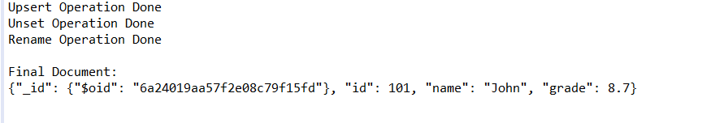

MongoDB COMPASS
