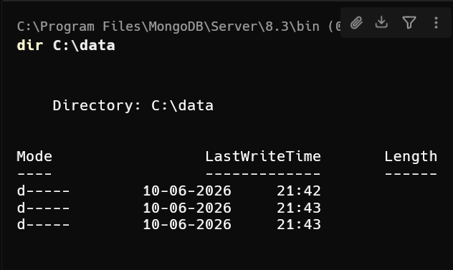

Node 1:
.\mongod.exe --replSet myReplSet --dbpath C:\data\db0 --port 27017
Node 2:
.\mongod.exe --replSet myReplSet --dbpath C:\data\db1 --port 27018
Node 3:
.\mongod.exe --replSet myReplSet --dbpath C:\data\db2 --port 27019

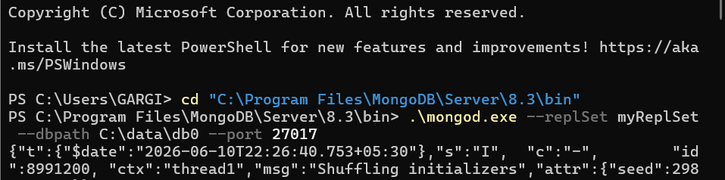

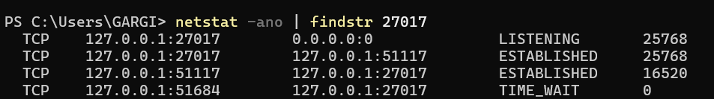

rs.initiate({
_id: "myReplSet",
members: [
{ _id: 0, host: "localhost:27017" },
{ _id: 1, host: "localhost:27018" },
{ _id: 2, host: "localhost:27019" }
]
})

