Conference Registration Management System

Software Requirements Specification



Submitted By

Lakshya Garg (B16CS012)

Shashank Mohabia (B16CS035)

Revision History

|  |  |  |  |
| --- | --- | --- | --- |
| **Date** | **Version** | **Description** | **People** |
| 18 Feb 2018 | 1.0 | First draft | Lakshya Garg (B16CS012)  Shashank Mohabia (B16CS035) |
| 11 Mar 2018 | 2.0 | Project extended from single conference registration to multiple conferences | Lakshya Garg (B16CS012)  Shashank Mohabia (B16CS035) |
| 24 April 2018 | 3.0 | Updated class diagram | Lakshya Garg (B16CS012)  Shashank Mohabia (B16CS035) |

Table of Contents

1. Introduction 4

1.1 Purpose 4

1.2 Scope 4

1.3 Constraints 4

1.4 Assumptions and Dependencies 4

1.5 Definitions, Acronyms and Abbreviations 4

1.6 References 5

2. Overall Description 5

2.1 Product Functions 5

2.2 User Characteristics 11

3. Specific Requirements 11

3.1 Use case description 11

3.2 Design Constraints 13

Software Requirements Specification

# Introduction

## Purpose

## The purpose of this document is to provide a detailed description of the development and operation of the Conference Registration Management System. It will also include the system constraints, user interface, and the response of the system to various external factors.

## Scope

## This software system is designed to help both the attendees and the organizers to eliminate the process of offline registration of any conference to smoothen the overall user as well as admin experience of registration. This software can be used by any organization to conduct conferences or events like conferences.

## Organizers can use this software to create a new conference and a portal for registration of each conference. The software has functionality to create two types of user i.e. normal user and a super user (admin/organizers). The super users have higher privileges as compared to a normal user.

## A normal user can register for the conference created by a super user. After logging into the software, a user can see the conference details, register for it and make payments within a stipulated time decided by the super user. The software also checks whether the seats are available for registration.

## The super user has access to grant super user status or revoke it for any user. The former can also view all the details of the registrants.

## Constraints

* + 1. No refunds and seat cancellation is possible.

## Assumptions and Dependencies

* + 1. The number of seats available are fixed and known.
    2. There are different types of registrations with different types of payment amounts.
    3. The registrations are closed even when not all the registered users have paid the fee.
    4. Registration is closed before a week of the commencement of the conference.

## Definitions, Acronyms and Abbreviations

|  |  |
| --- | --- |
| **Term** | **Definition** |
| User | Any type of user who is registered in the software. |
| Super user | A user with excess privileges i.e. the organizers/admin. |
| Normal user | All users other than super users i.e. the attendees. |

## References

[1] IEEE, *IEEE STD 830-1998 IEEE Recommended Practice for Software Requirements*

[2] UML @ Classroom: An Introduction to Object-Oriented Modeling -  Christian Huemer and Gerti Kappel

# Overall Description

## Product Functions

### Functional Requirements

This software is expected to ship with the following functionalities:

* For normal users
  + Register and login in the software’s authentication module
  + View the conference details
  + Choose to pay for the given conference after registration
  + View user profile
* For super users
  + Register and login in the software’s authentication module
  + Create a new conference
  + View and edit conference details
  + View registration details
  + Grant/revoke super user status
  + View user profile

#### Use Case Diagram

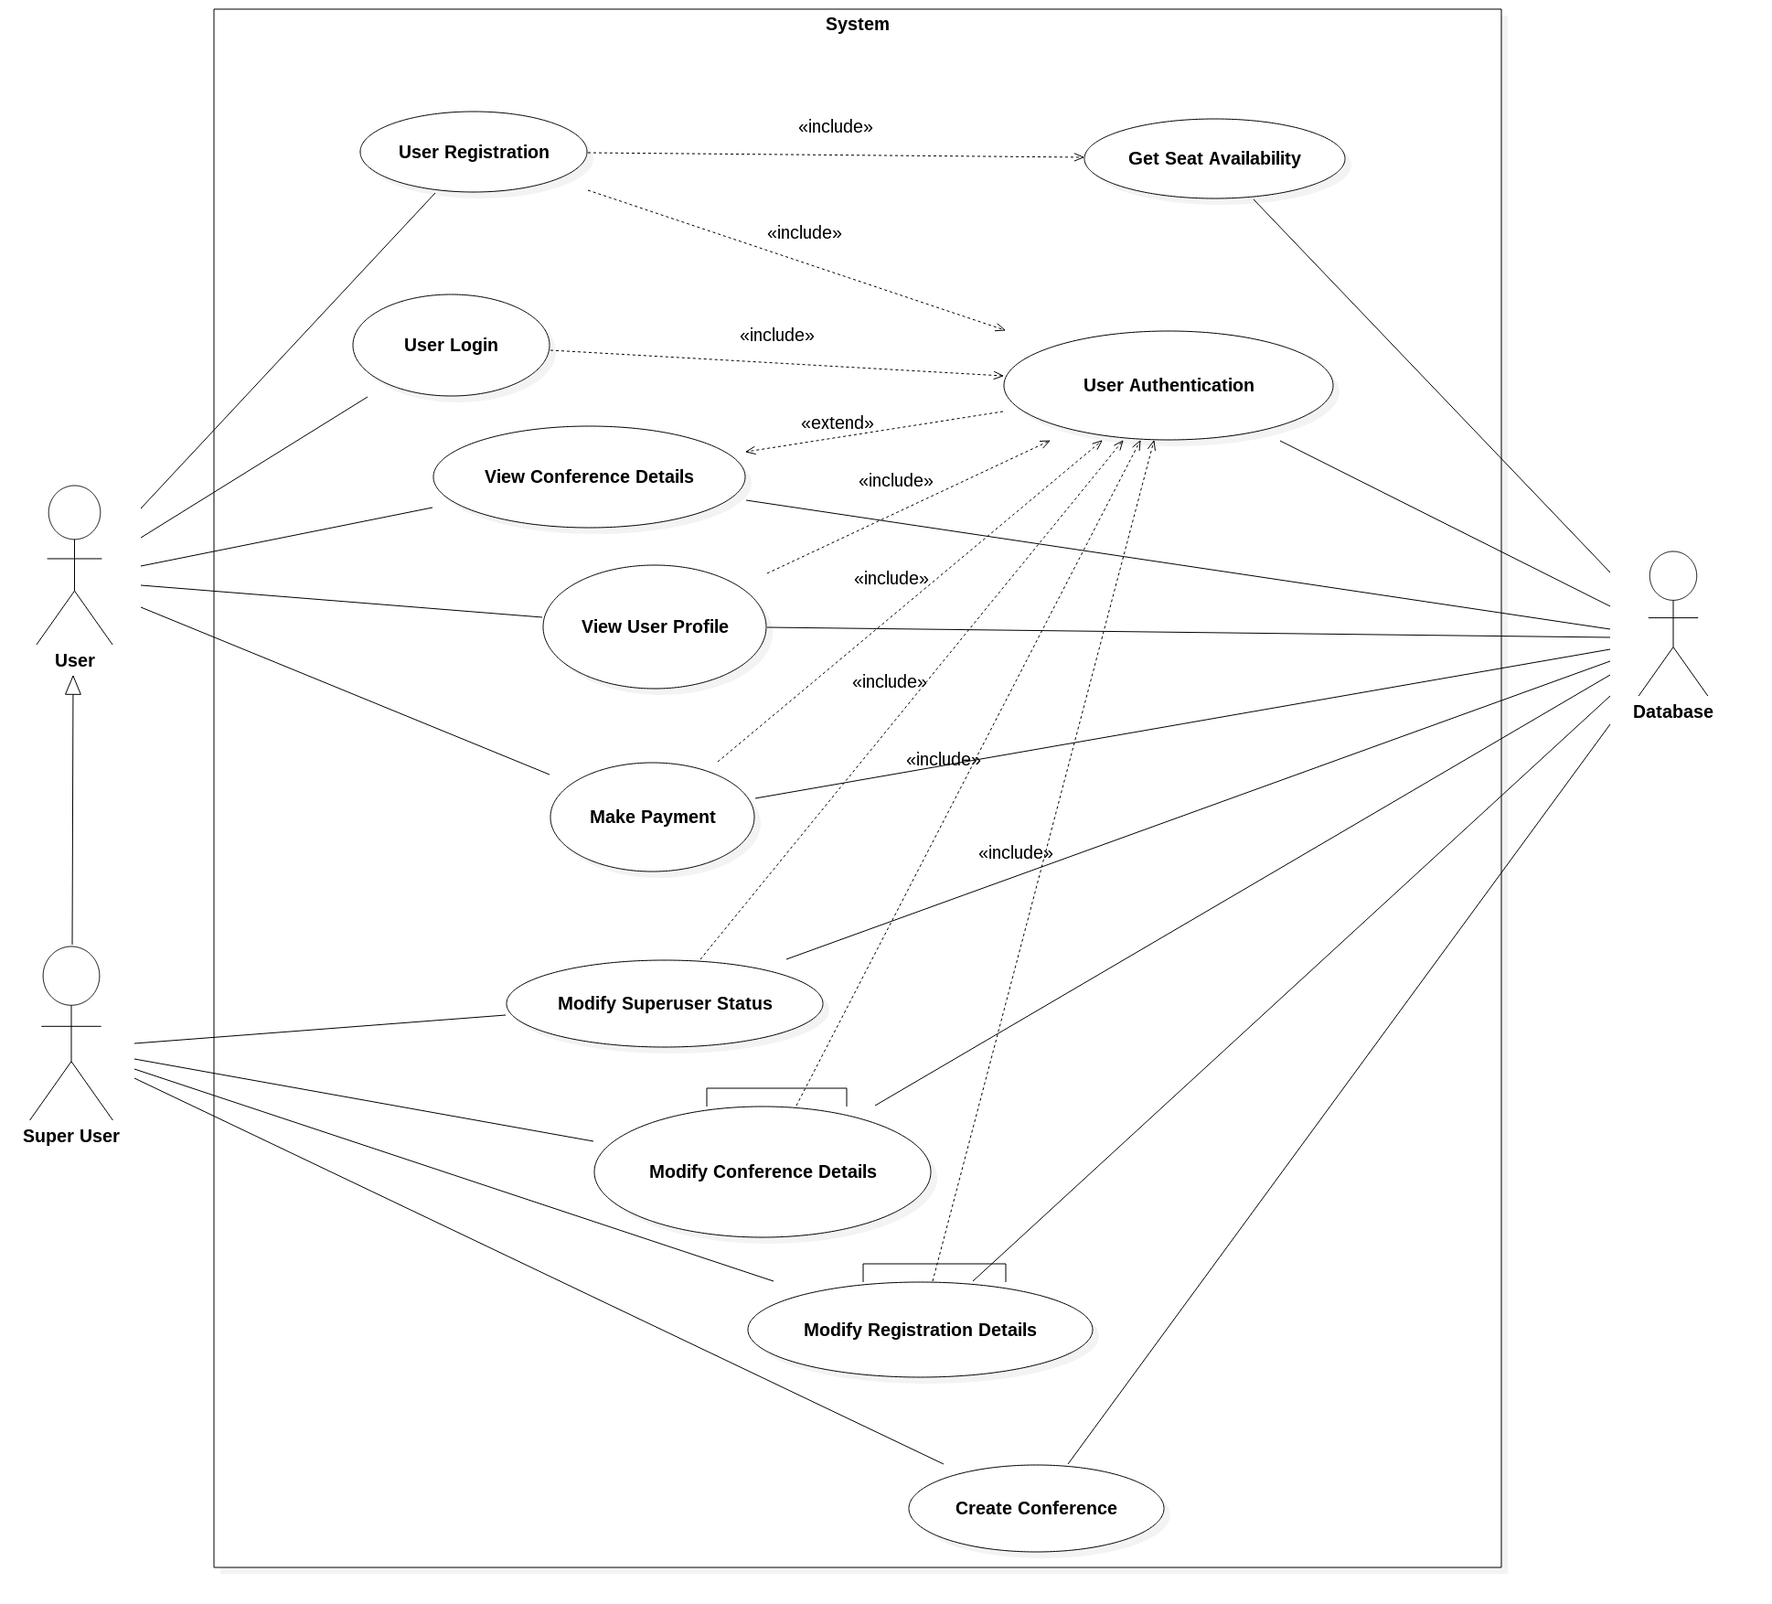

#### Class Diagram

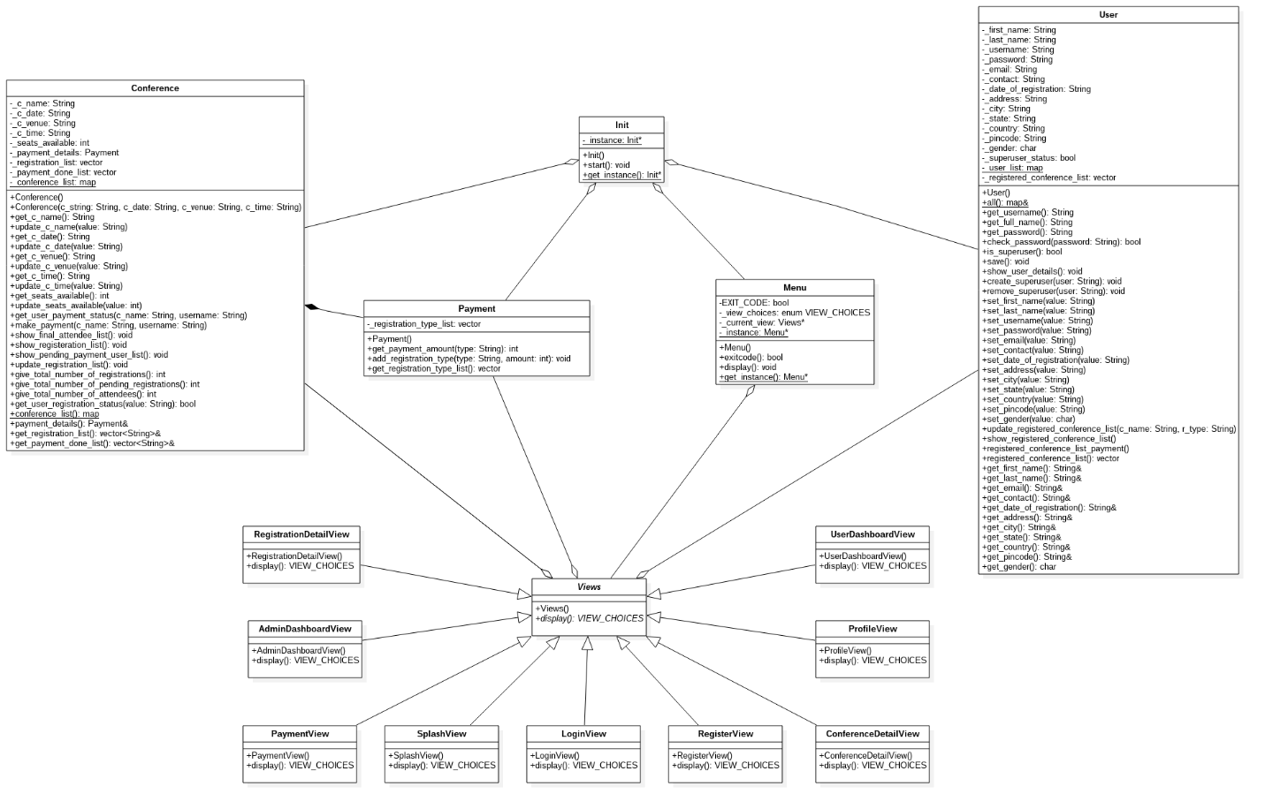

#### Sequence Diagram

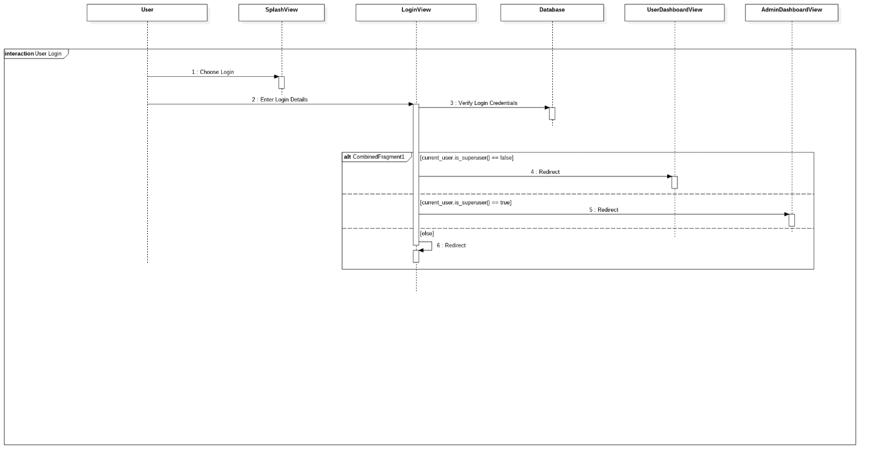

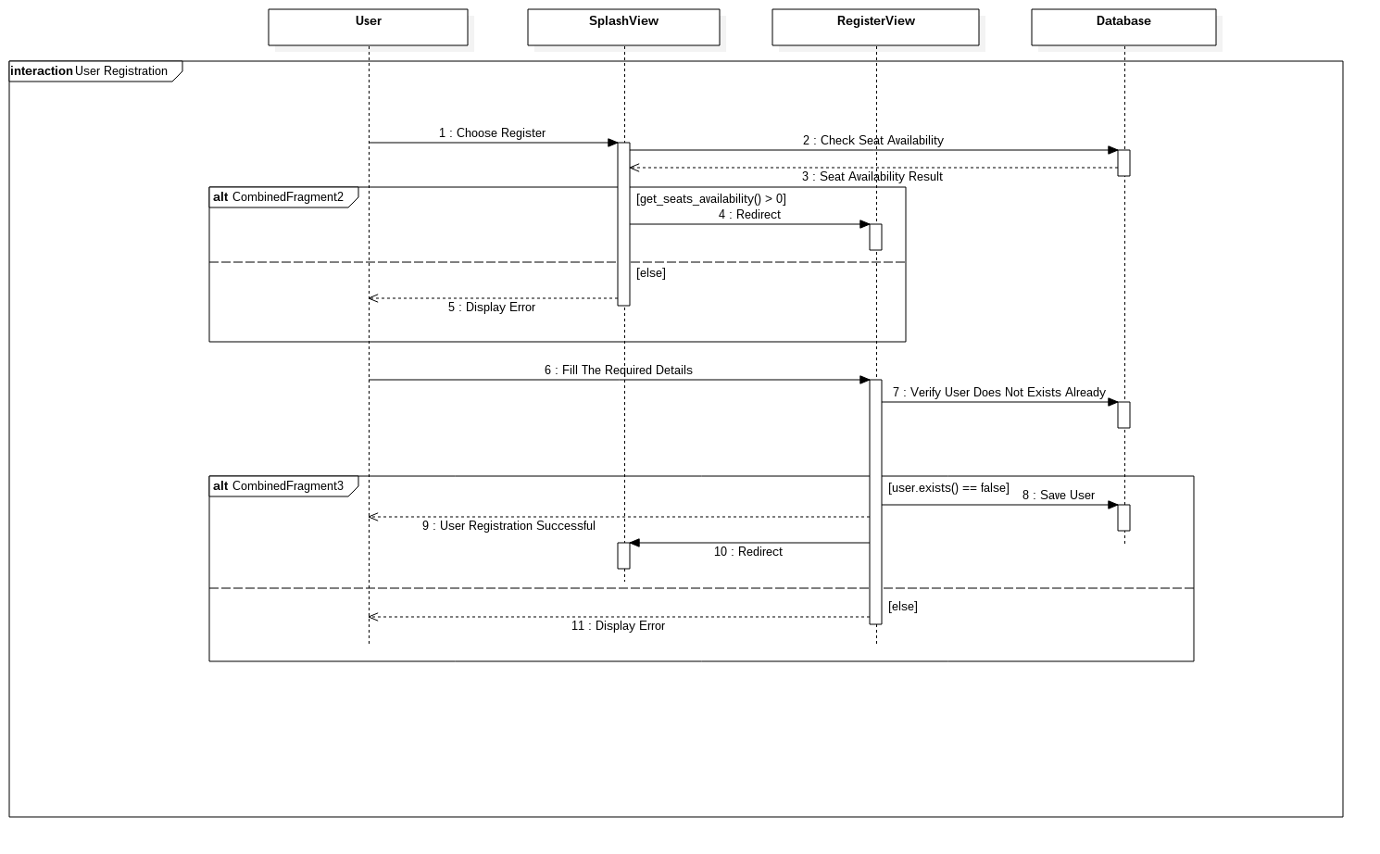

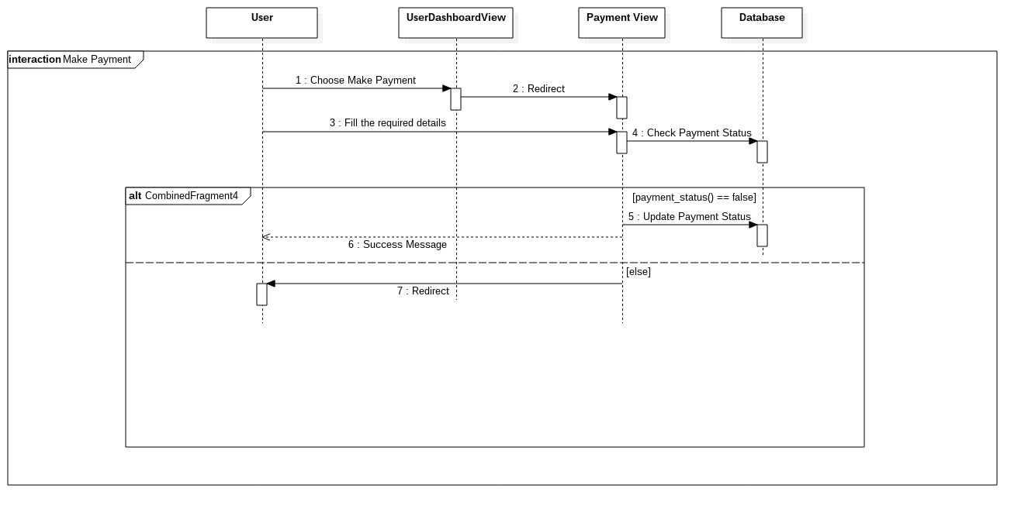

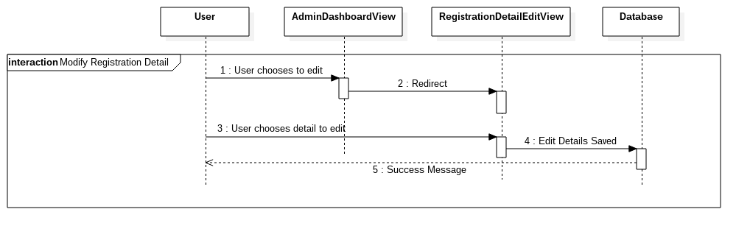

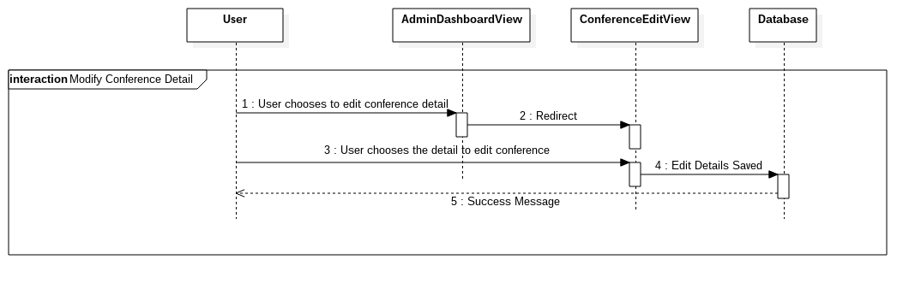

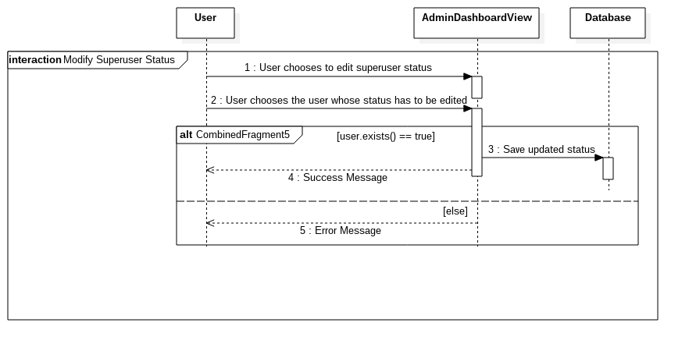

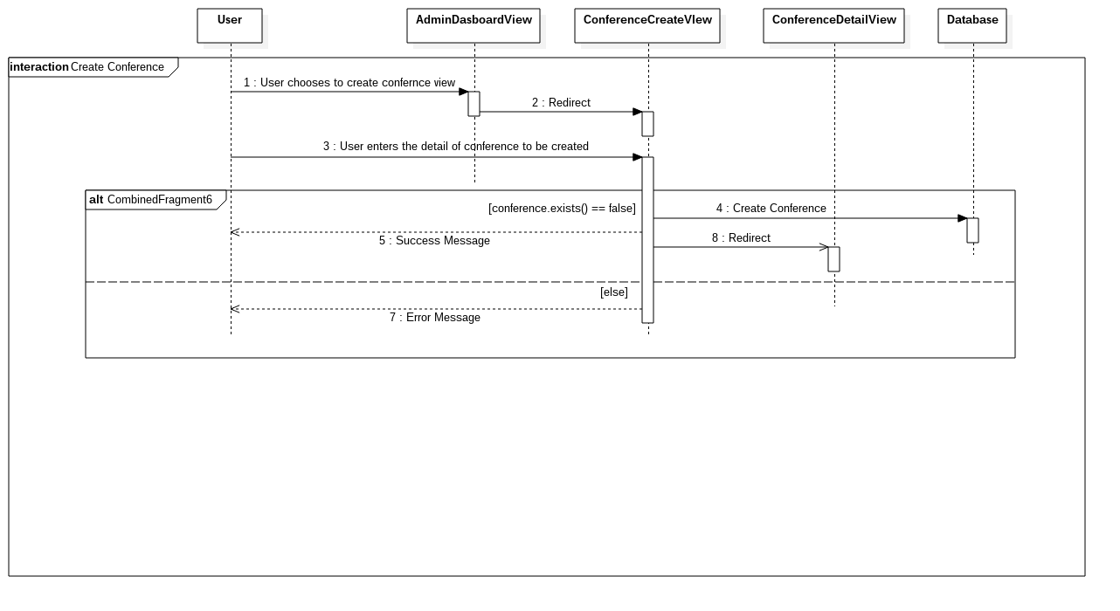

#### Activity Diagram

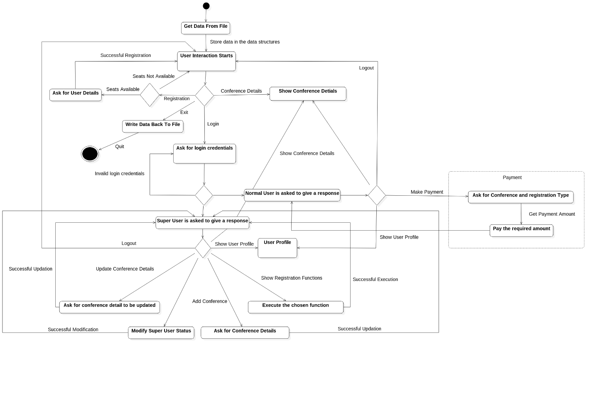

#### 

### Non-Functional Requirements

## User Characteristics

There are two types of users who will use this software, they include the organizers/admin or the super users and the attendees or the normal users.

The attendees will use the software to register and pay for the conference according to their registration types within 7 days of registration of the user. The user has to fill all the required details during registration.

The organizers will use this software to create any number of conferences and register the attendees on this software. They can also use it to view the registration list according to whether they have paid the fee or not, view the payment details and edit some of the details for smooth process of registration.

# Specific Requirements

## Use case description

### User Login

|  |  |
| --- | --- |
| Use Case Name | User Login |
| Actors | User, Database |
| Trigger | User selects the login option |
| Precondition | The User must be registered |
| Basic Path | User enters its user ID and password |
| Alternative Path | No alternative path. |
| Post Condition | The user is taken to Dashboard depending on the type of user |
| Exception Paths | Invalid username or password |
| Others | None |

### User Registration

|  |  |
| --- | --- |
| Use Case Name | User Registration |
| Actors | User, Database |
| Trigger | User selects the register option |
| Precondition | There must not be any user with the same username and seats must be available |
| Basic Path | User fills in the required details |
| Alternative Path | No alternative path. |
| Post Condition | Redirected to splash screen |
| Exception Paths | Username already exists  Seats are not available |
| Others | None |

### Make Payment

|  |  |
| --- | --- |
| Use Case Name | Make Payment |
| Actor | User, Database |
| Trigger | User chooses to pay |
| Precondition | The user must be logged in. |
| Basic Path | User selects the registration type and then pays accordingly. |
| Alternative Path | No alternative path. |
| Post Condition | Redirected to User Dashboard after giving a success message. |
| Exception Paths | Invalid registration type  Required amount not paid |
| Others | None |

### Modify Registration Details

|  |  |
| --- | --- |
| Use Case Name | Modify Registration Details |
| Actor | User, Database |
| Trigger | Super user choses to edit registration details. |
| Precondition | 1. The user must be logged in.  2. The user must be a super user. |
| Basic Path | User selects the detail to edit and edits the detail. |
| Alternative Path | No alternative path. |
| Post Condition | The edited details are saved and a success message is shown. |
| Exception Paths | The edited detail is not of the specified type or no detail is entered. |
| Others | None |

### Modify Conference Details

|  |  |
| --- | --- |
| Use Case Name | Modify Conference Details |
| Actor | User, Database |
| Trigger | Super user choses to edit conference details. |
| Precondition | 1. The user must be logged in.  2. The user must be a super user. |
| Basic Path | User selects the detail to edit and edits the detail. |
| Alternative Path | No alternative path. |
| Post Condition | The edited details are saved and a success message is shown. |
| Exception Paths | The edited detail is not of the specified type or no detail is entered. |
| Others | None |

### Modify Super User status

|  |  |
| --- | --- |
| Use Case Name | Update Super User |
| Actor | User, Database |
| Trigger | Super user choses to update super user status of another user.. |
| Precondition | 1. The user must be logged in.  2. The user must be a super user.  3. The user whose super user status has to be modified shall be already registered. |
| Basic Path | The user enters the username of the user whose super user status has to be modified and choses the change(Grant/revoke super user access) |
| Alternative Path | No alternative path. |
| Post Condition | A success message is shown and the super user returns to its dashboard |
| Exception Paths | The user whose super user status has to be modified is not already registered. |
| Others | None |

### Create Conference

|  |  |
| --- | --- |
| Use Case Name | Create Conference |
| Actor | User, Database |
| Trigger | Super user choses to create new conference |
| Precondition | 1. The user must be logged in.  2. The user must be a super user. |
| Basic Path | The user enters the details of the conference required to create new conference. |
| Alternative Path | No alternative path. |
| Post Condition | A success message is shown and the super user returns to its conference detail view. |
| Exception Paths | There is another conference with the same name show error message. |
| Others | None |

## Design Constraints

### Software Language

The language used in developing CRMS is C++.

3.5.2 Software Architecture

The architecture used in making of this software is the Model View Controller (MVC) architecture. It was used in this project to distribute the code and to prevent users from directly interacting with the models or database. One can easily add functions without changing models because the models are separate from the view and the controller.