JAVA Practicals
Day-01(13_08_2026)

1.Print Hello world
Output: -
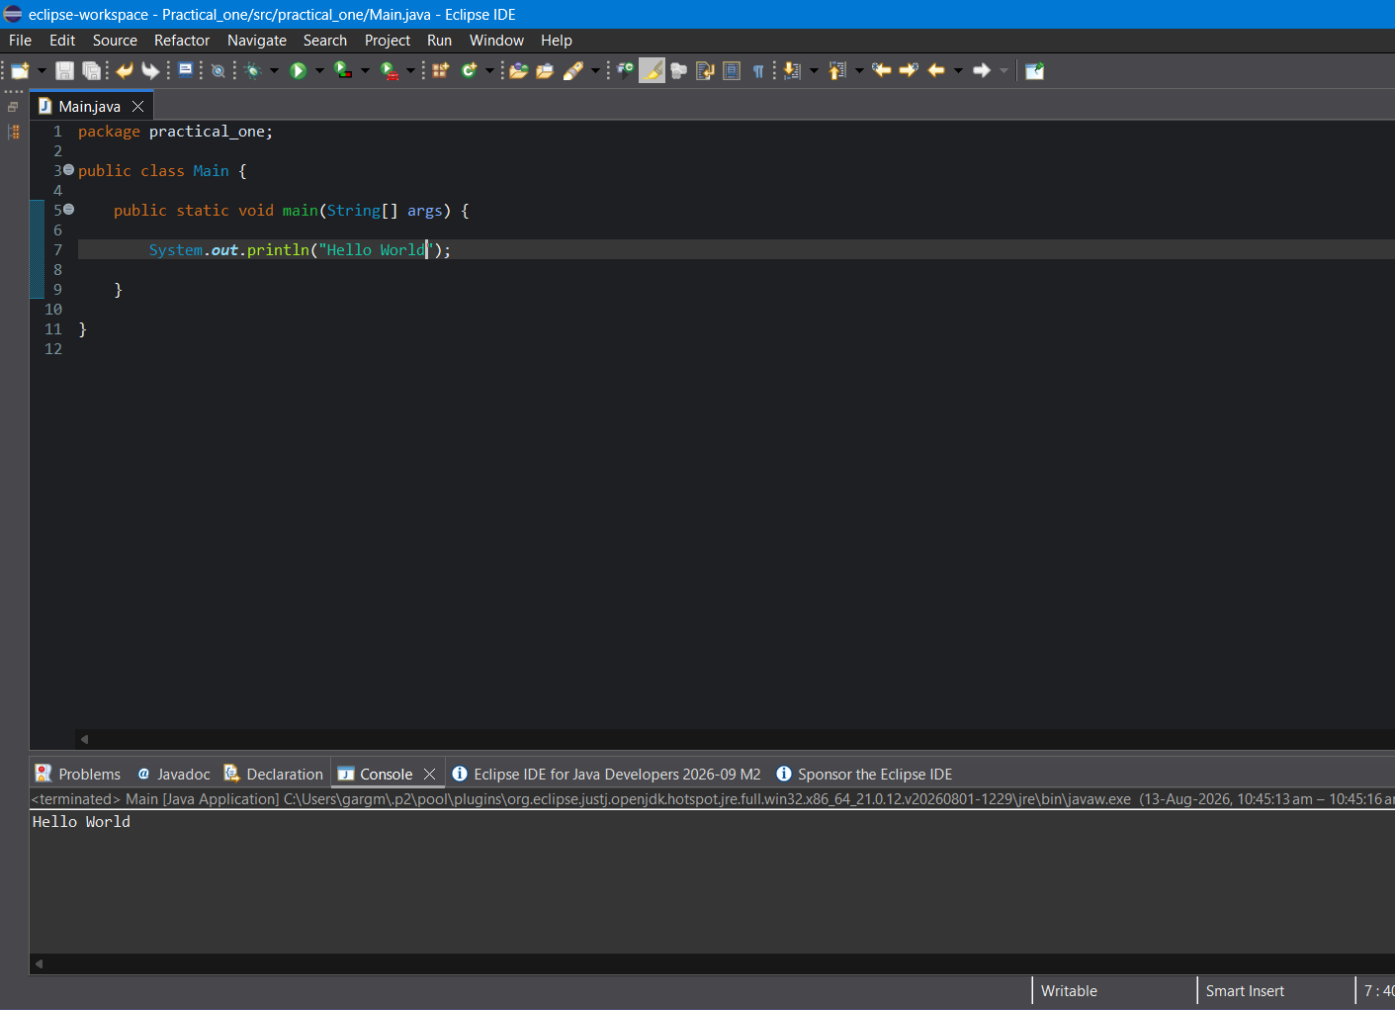

2.String Concatenation

Output: -
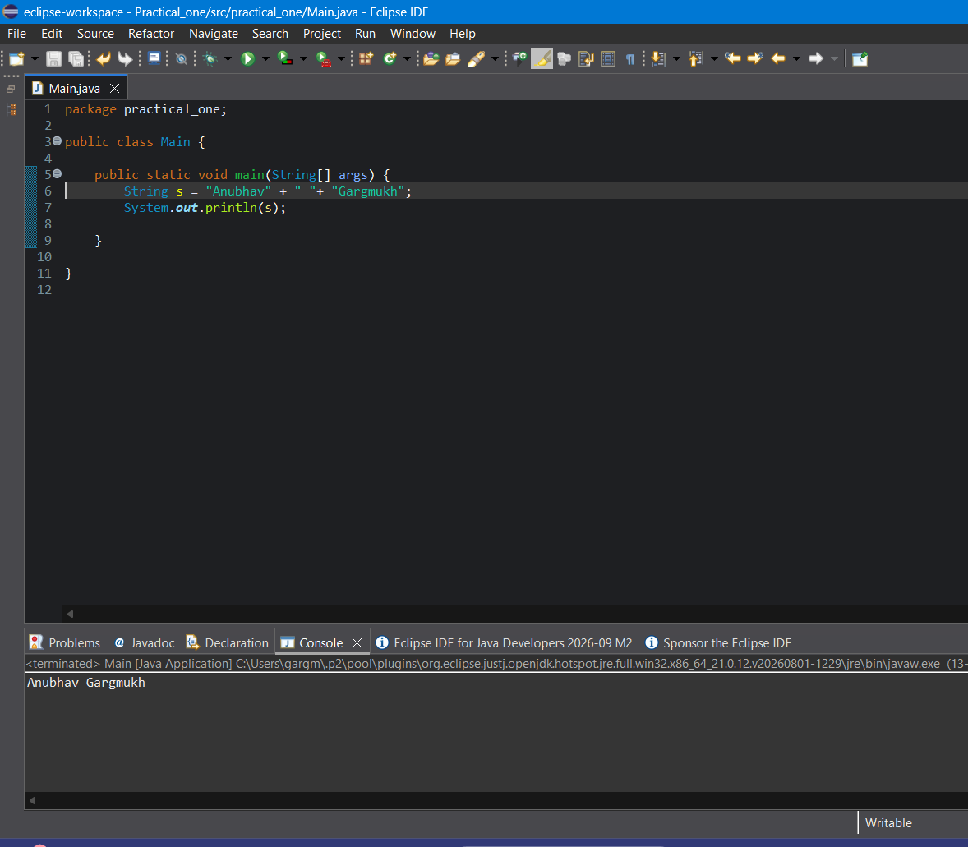

3. Task 1: Employee Information

Output: -
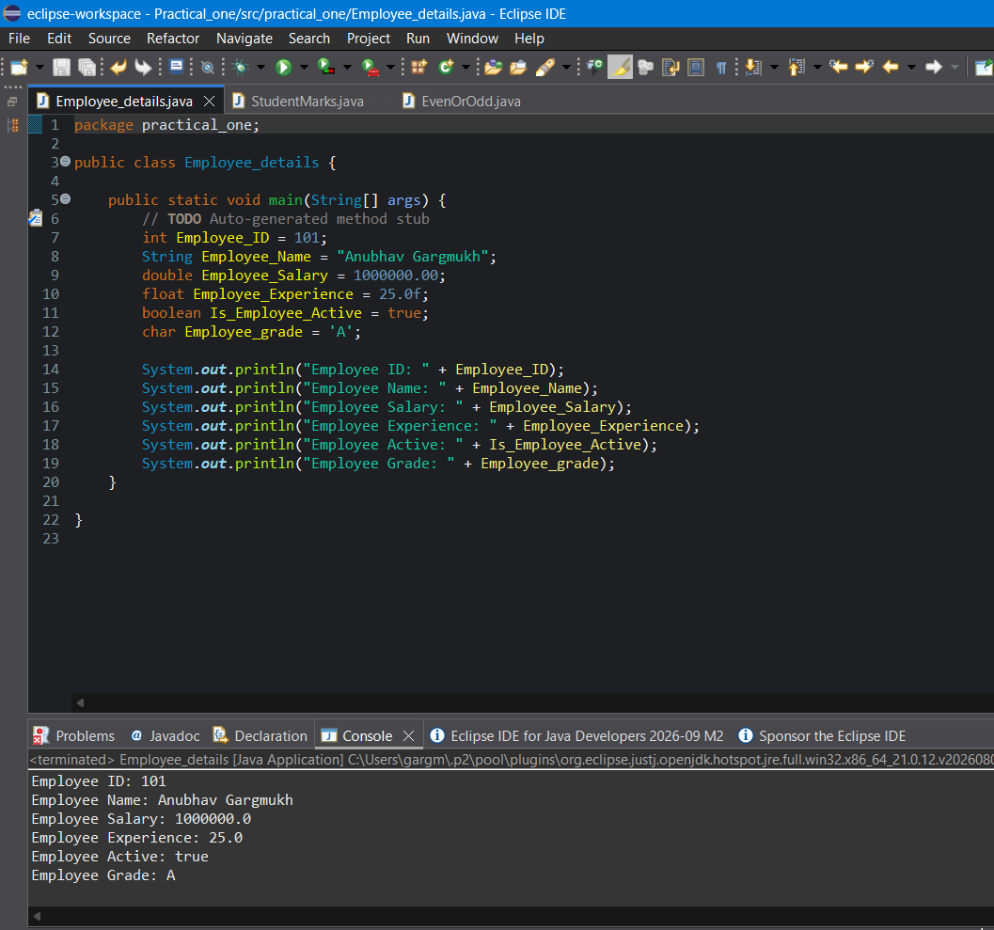

4. Task 2: Student Marks

Output: -
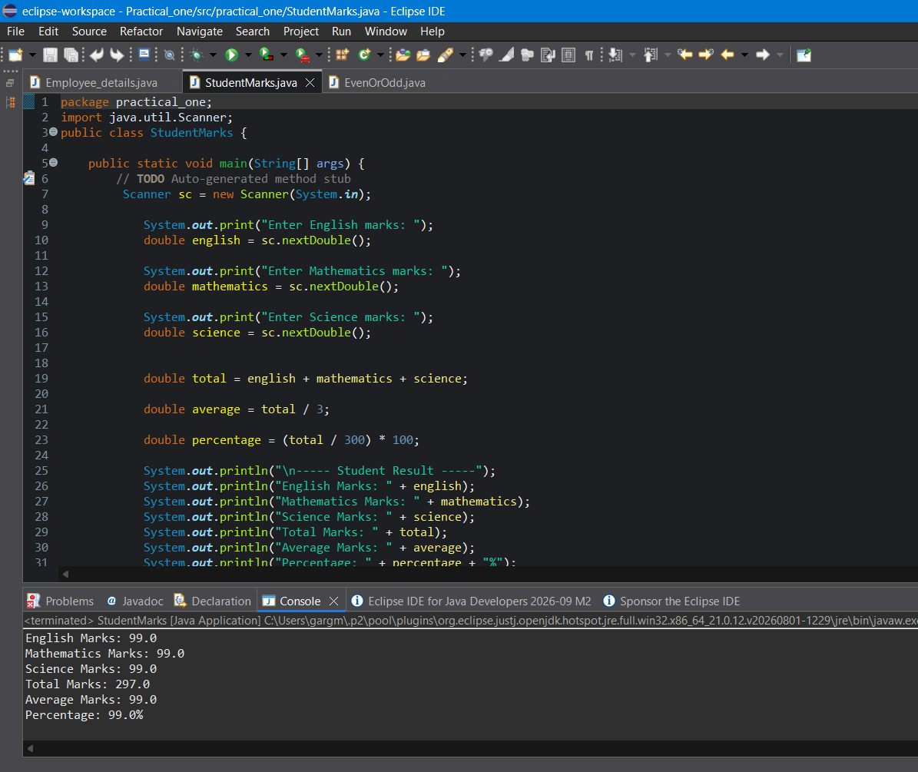

5.Check the given number is even or odd
Output: -
For num = 10
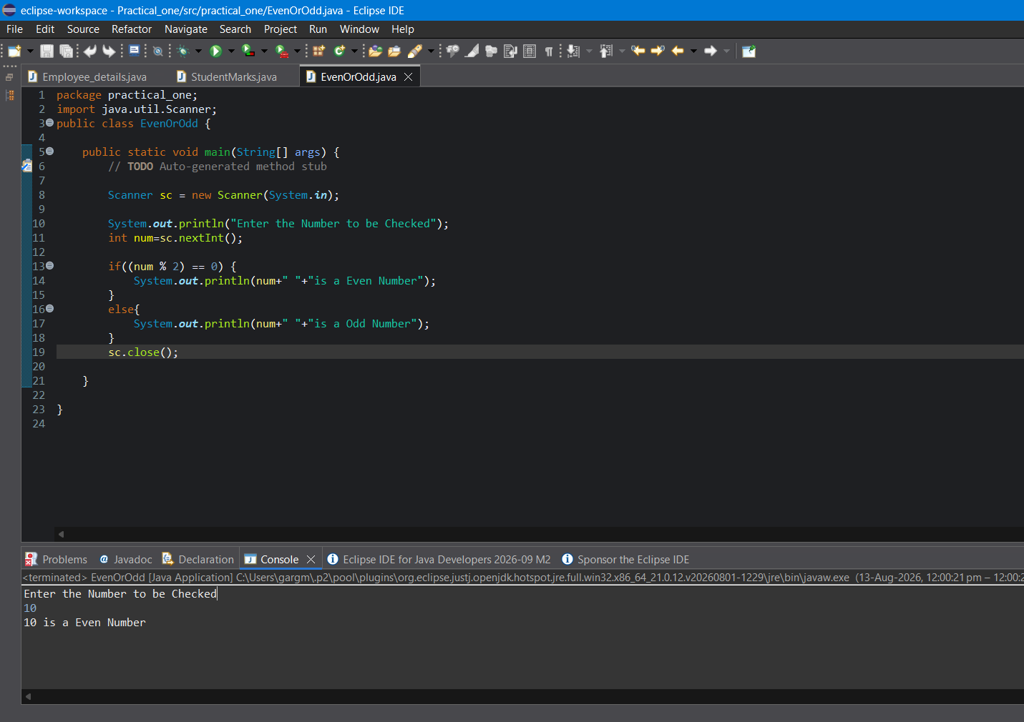

For num = 15
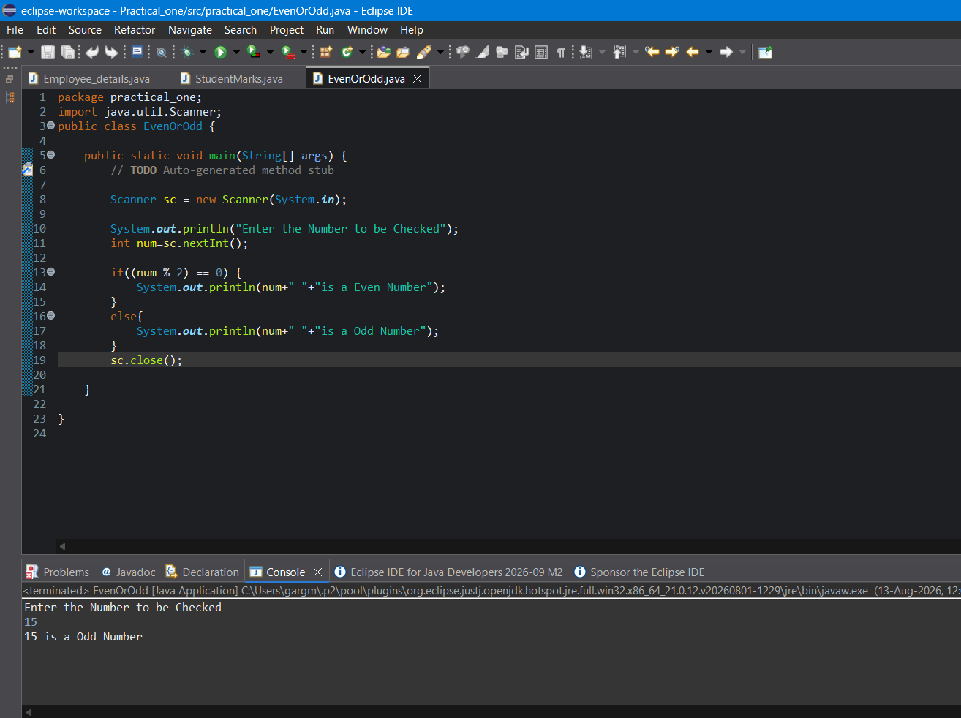
For num = 22
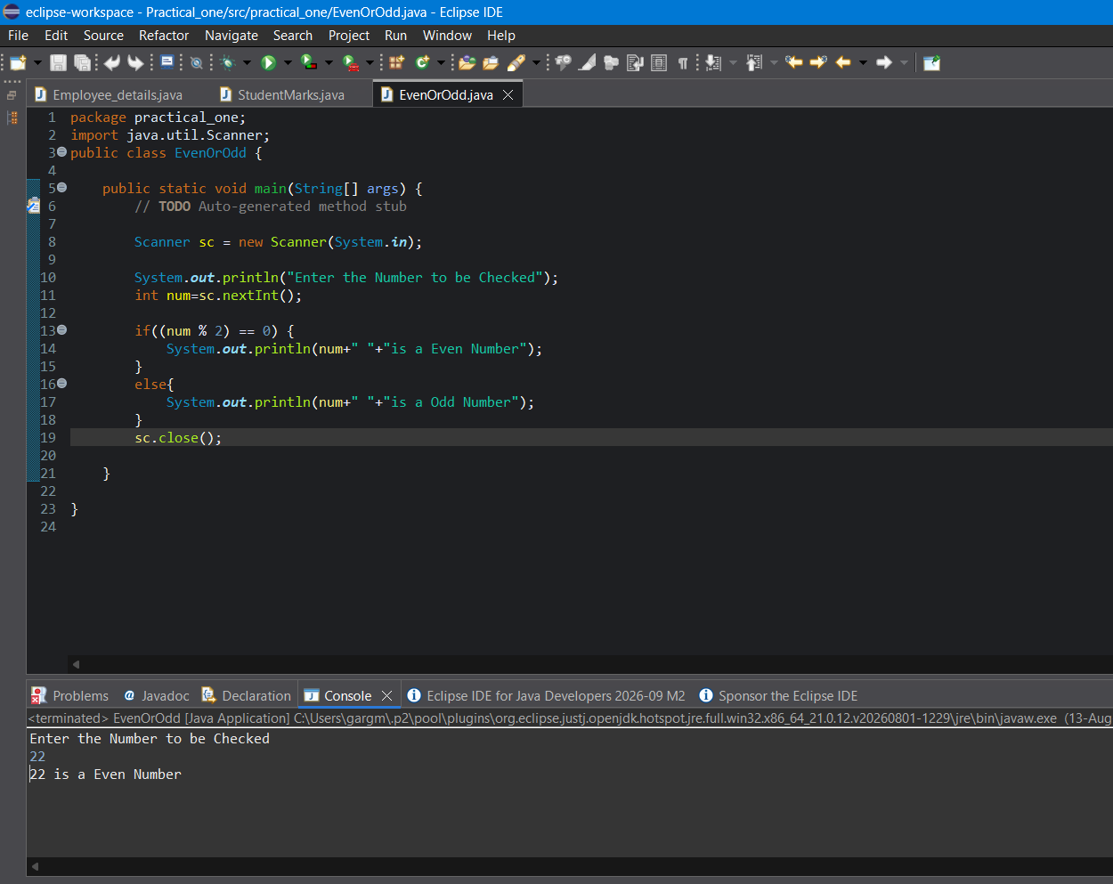

For num = 31
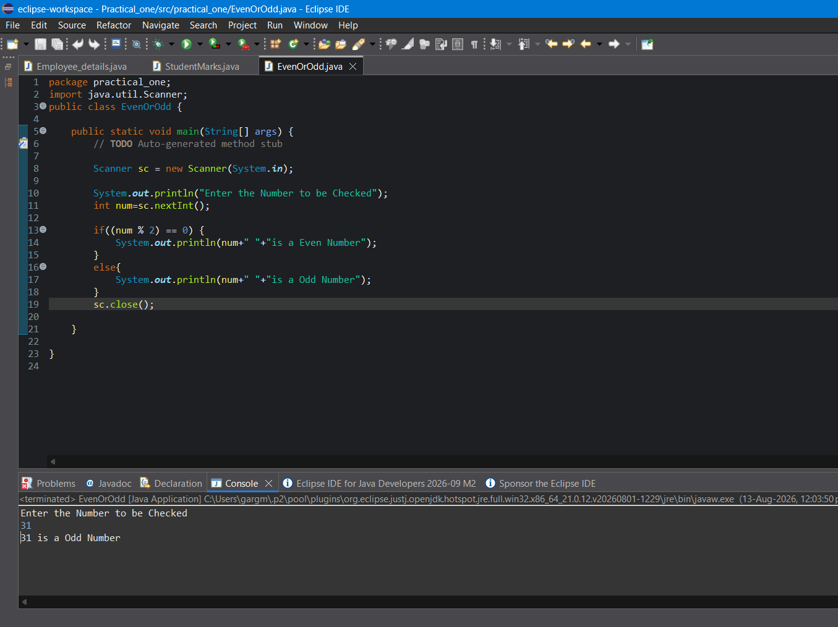
6. Exercise 1: Local Variables – Student Marks
Output: -

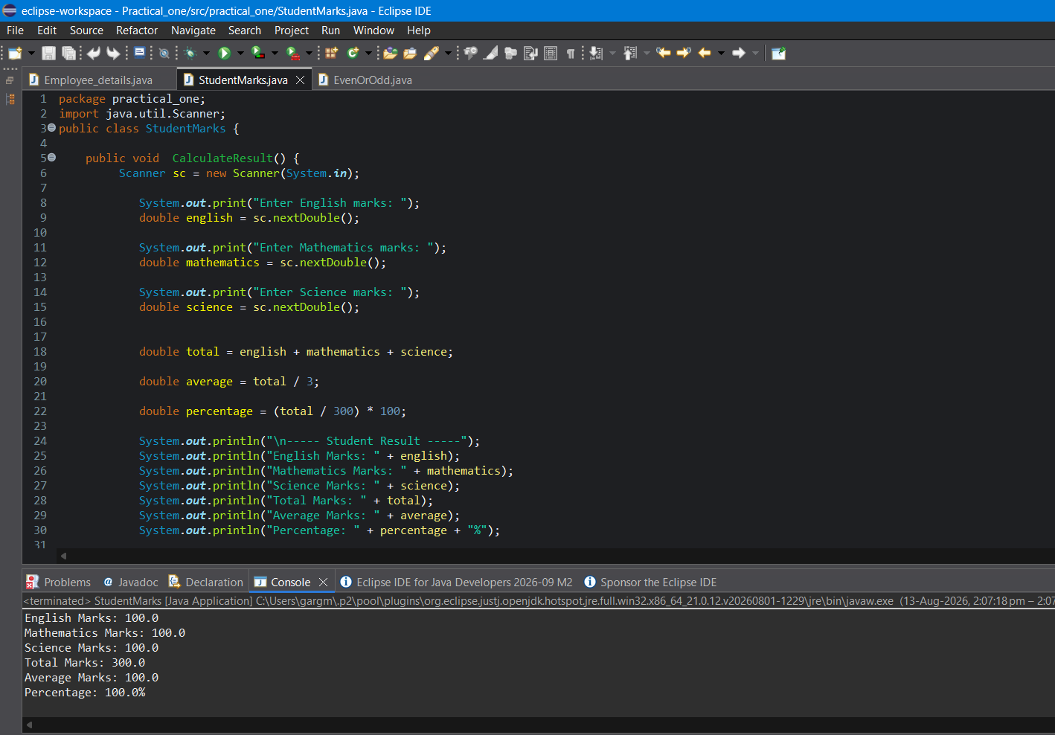

7. Exercise 2: Instance Variables – Car
Output: -

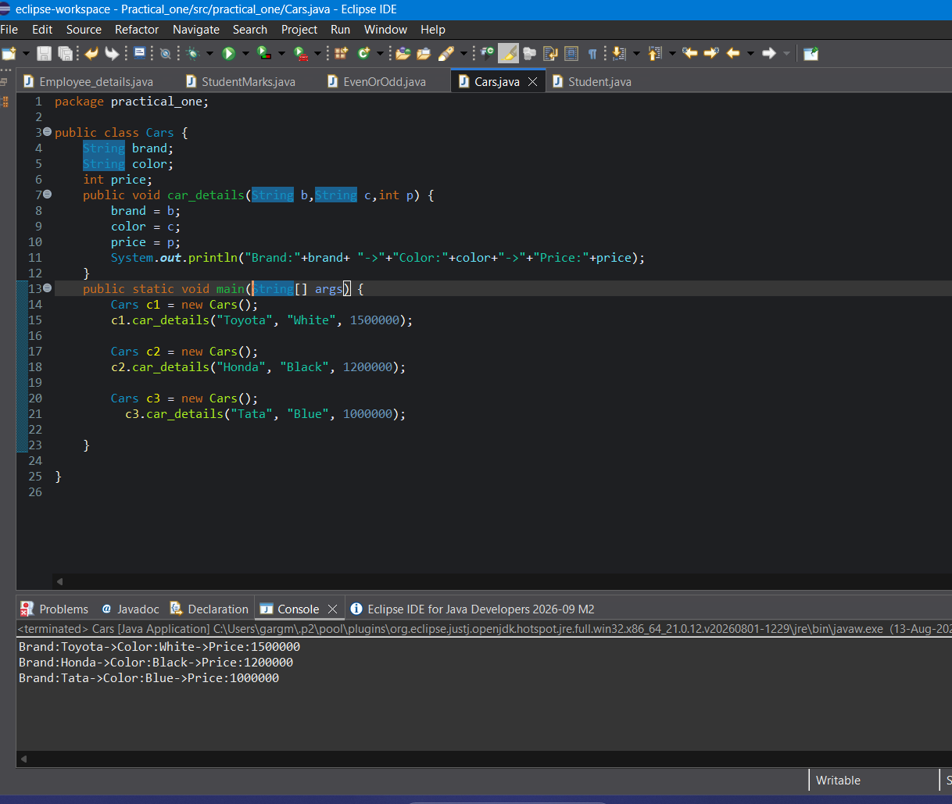

8. Create a student class.

Output: -


