Conclusion --- by Nish Garg

1. What are three conclusions we can make about Kickstarter campaigns given the provided data?
   1. Company has more starter projects in summer months. This is probably due to Summer vacations. Company should focus more on marketing efforts in March-April time frame to have the most impact in business.  
      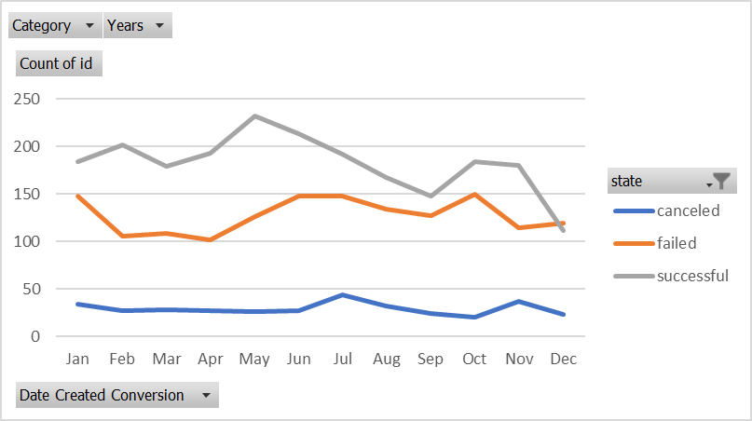
   2. Projects with smaller goals are more successful in general. Company should encourage more to break project into smaller goals to improve success rate.
   3. Company has most popularity in theater, music and film & video categories and they should focus on people working in the Art area.  
      
2. What are some of the limitations of this dataset?  
   There is no age information of the customer(s). It is going to be a good indicator if its more popular among young people. There is country information but there is no state. Having geographical information is very useful to focus on marketing efforts.  
   Sometimes projects are marked as failed due to change in idea. But then all the work of the project can be used to create new project. Project chaining is missing to get the complete picture. When project is failed what happened to the inventory/materials? Cost of waste per project is missing.
3. What are some other possible tables/graphs that we could create?
   1. Music has most success % and company should focus on increasing number of projects in this category.



* 1. If there are more than 20 backers then there is very high success rate. This parameter can be used for forecasting.

