Name: Gargoles, John Michael S.
Section: BSIT-2C
REVIART
Group 3 – “SOMEONE WAS HERE”

IV. Performance Task: Cinematic Self-Analysis
INSTRUCTIONS:
1. Rewatch your group trailer at least twice.
2. Take note of specific timestamps where cinematic techniques are clearly used.
3. Analyze how these techniques affect meaning, emotion, and audience interpretation.
4. Be specific. Avoid vague answers.
5. Support your analysis using concepts learned (shot types, angles, etc.).

Part A: Trailer Breakdown
For Three Scenes, complete the following:
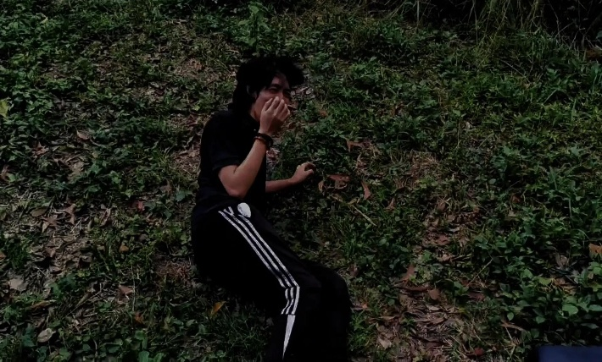
Scene 1
Time Stamp: 1:00 – 1:02
Shot Type: Wide Shot (WS)
Camera Angle: High Angle
Description (What is happening visually?):
- The character is lying on the grass after being pushed by someone unknown. The surroundings are visible, and he looks alone in the frame.
Analysis (How does this affect meaning/emotion?):
- The wide shot shows the environment, making the character look isolated. The high angle makes him appear weak and vulnerable. It also creates mystery since the person who pushed him is not shown.
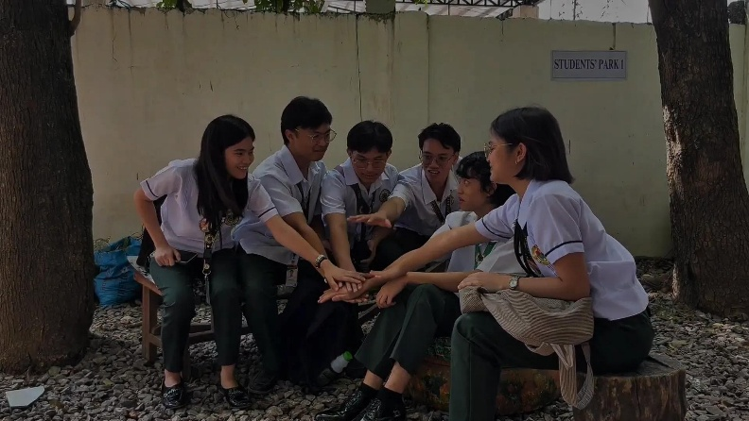
Scene 2
Time Stamp: 1:22 – 1:57
Shot Type: Full Shot (FS)
Camera Angle: Eye Level
Description (What is happening visually?):
- The group of friends are sitting and talking about their trip. They look relaxed and are interacting normally.
Analysis (How does this affect meaning/emotion?):
- The full shot shows the whole group, making their bonding and interaction clear. The eye-level angle makes the scene feel natural and normal, which builds contrast before the tension or horror starts.
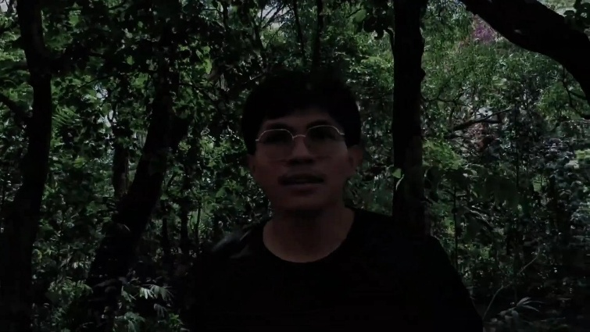
Scene 3
Time Stamp: 1:15 – 1:20
Shot Type: Medium Close Up Shot
Camera Angle: Shoulder Level (with shaky movement)

Description (What is happening visually?):
- A character says “Ikaw nagdala sa’tin dito,” then the group starts running together in panic.
Analysis (How does this affect meaning/emotion?):
- The close-up highlights the emotion and tension, especially blame and fear. Then the wide shot shows the group running, making the situation feel chaotic. The shoulder-level angle with shaky movement adds intensity and makes the scene feel more real and urgent.

Part B: Critical Evaluation
Answer in 2-3 sentences each:
- What is your MOST effective cinematic technique? Why?
- The most effective technique in our trailer is the use of close-up shots. It clearly shows the emotions of the characters, especially fear and tension. Because of this, the audience can easily feel what the characters are experiencing.

- What is your WEAKEST scene? Why is it ineffective?
- The weakest scene is the group planning scene. It feels too normal and does not give any hint of danger or suspense. Because of that, it becomes a bit boring and does not fully connect to the thriller theme.

- Did your trailer follow “show, don’t tell”? Explain.
- Yes, the trailer mostly follows “show, don’t tell” because the story is shown through actions like running, reacting, and expressions instead of long explanations. However, some dialogue like blaming each other slightly tells the situation directly. So it is not fully consistent.

- How well did your visuals communicate your theme?
- The visuals communicate the thriller and mystery theme fairly well. The use of dark scenes, running, and unknown threats creates suspense. But some parts still feel normal, so the theme is not always strong.

Part C: Improvement Plan
Answer in 3-5 sentences each:
- What specific shot/angle improvements will you make?
- I would improve the use of camera angles by adding more low angle and high angle shots in important scenes. This can make characters look more powerful or more vulnerable depending on the situation. I would also try to use more dynamic shots instead of static ones to avoid looking too simple.

- How will you improve visual storytelling?
- I will focus more on showing emotions and actions instead of relying on dialogue. For example, instead of explaining fear, I can show it through body language, facial expressions, and movement. I will also add more suspenseful transitions and pacing to make the story clearer.

- What will you change to make your message clearer?
- I will make the scenes more connected so the audience can understand the story better. Adding clearer hints about the danger or mystery earlier in the trailer will help. I will also adjust lighting and mood to match the theme more consistently.

