It ask to document my thought process and reasoning for each task.

From the beginning I thought to make a model and add the weight for each question and answer.

I defined not to obtain open answers to get the score in the store procedure and to add the option table with all possible answers for a specific question.

I thought it was important to save the user who is answering the survey but it was not necessary to add information to get a login and I did the next ER entity-relationship model.

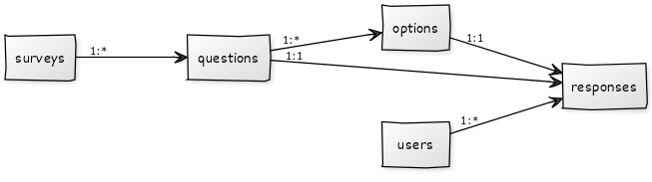

For the first basic query I made a join structure with multiple conditions to deal with this scenario where the response can be found in the options table.

For the advance query to calculate the average score for each survey I used the AVG function

For the advance query to find the top 3 users with the highest average response score across all surveys, I ordered descending and limited the answers to 3.

For the advance query determine the distribution of responses for each question in a specific survey I use the count function.

To create the store procedure to calculate the survey score I just used the question value and the function SUM and asked for the surveyID as a parameter.

And for the view I just asked for the value of each question related with all the responses.

All the queries were proved in my environment and its working

