Major Project Report
On
Place-O-Track: “Smart Placement Mentor”
Submitted in the partial fulfilment of the requirement for the award of degree of
Bachelor of Technology
in
Computer Science and Engineering
Batch (2022-2026)


Submitted to: Submitted by:
Er. Bindu Bansal Priyanshu Garg
12200768

DEPARTMENT OF COMPUTER SCIENCE AND ENGINEERING DAV UNIVERSITYJALANDHAR-PATHANKOT NATIONAL HIGHWAY, NH44, SARMASTPUR PUNJAB-14401
DECLARATION

I, PRIYANSHU GARG, hereby declare that the work which is being presented in this project/training titled “Place-O-Track: Smart Placement Mentor” by me, in partial fulfilment of the requirements for the award of Bachelor of Technology (B. Tech) Degree in “Computer Science and Engineering” is an authentic record of my own work carried out under the guidance of Er. Bindu Bansal (Project Mentor).

To the best of my knowledge, the matter embodied in this report has not been submitted to any other University/ Institute for the award of any degree or diploma.

Er. Bindu Bansal Priyanshu Garg
Assistant Prof. CSE 12200768

ABSTRACT

Place-O-Track is an intelligent and efficient placement preparation and tracking system that simplifies learning, practice, and performance monitoring for students during campus placements. Inspired by the idea of “tracking your progress”, this platform connects every student’s effort with real-time outcomes such as quiz scores, coding performance, and progress analytics—creating a transparent and motivating preparation environment.
Built using modern technologies like React.js, Node.js, Express.js, and MongoDB, Place-O-Track offers a secure and scalable solution for managing aptitude practice, coding challenges, and past interview records. It provides dedicated panels for admins, students, and guests, supports real-time data updates, and promotes continuous improvement through performance-based insights. Place-O-Track encourages not just preparation, but ownership and consistency by ensuring that every attempt, question practiced, and skill improved is accurately tracked and highlighted.
This system has three panels.
- Admin
- Student
- Company

ACKNOWLEDGEMENT

I would like to express my sincere gratitude to my project guide, Er. Bindu Bansal, for their valuable guidance, constructive feedback, and continuous support throughout the duration of this project. I am also thankful to Dr. Rahul Hans and the Department of B.Tech CSE for providing the necessary resources and an encouraging academic environment.
My appreciation extends to all faculty members and classmates whose suggestions and cooperation helped strengthen the quality of this work. Lastly, I am deeply grateful to my family for their constant encouragement and support, which motivated me to complete this project successfully.

Table of Content
CHAPTER 1: INRODUCTION
1.1 Introduction of Project Report
1.2 Introduction to Project
CHAPTER 2: PROJECT TITLE AND OVERVIEW
2.1 Project Title
2.2 Project Overview
2.3 Objectives
CHAPTER 3: TECHNOLOGIES USED
3.1 Frontend
3.2 Backend
3.3 Tools Used
CHAPTER 4: Software Development Life Cycle Model
4.1 Introduction to SDLC
4.2 SDLC Model Used
4.3 Phases of Sdlc
CHAPTER 5: System Design and Requirements
5.1 System Architecture
5.2 Data Flow diagram (DFD)
5.3 System Requirements
Chapter 6: Testing, Maintenance, and Results
6.1 Testing
6.2 Maintenance
6.3 Results
CHAPTER 7: Conclusion and References
7.1 Conclusion
7.2 References

CHAPTER 1-INRODUCTION
1.1 Introduction of Project Report
The project report is a comprehensive document that provides detailed information about the proposed platform, Place-O-Track. It serves as a blueprint for all system operations, clearly defining the goals, objectives, and strategies required to transform this placement preparation concept into a fully functional and productive platform. The report acts as a guiding framework that offers direction and clarity throughout the development and execution of the project.
Project reports hold significant importance for both development teams and stakeholders, as they present a transparent overview of the project’s progress and ensure consistent alignment with the original vision. Through such documentation, potential challenges can be identified early, enabling timely corrective measures. The report for Place-O-Track includes a structured breakdown of system modules, cost estimates, and expected outcomes, ensuring every stakeholder understands the scope, workflow, and long-term value of the platform. By offering these insights, the project report ensures that the design, development, and deployment of Place-O-Track remain efficient, well-planned, and goal-oriented.

Here are the points that validate the Importance of Project Report:

• A project report serves as a vital reference for developers and stakeholders, helping them monitor the ongoing progress of Place-O-Track and compare it with the initial development plan.

• It assists in identifying possible challenges early and enables the team to plan suitable corrective actions.

• The report simplifies the process of managing costs and ensures the project stays within the estimated budget.

• It becomes a reliable source of information for evaluating overall performance, identifying growth, stagnation, team efficiency, and the quality of work.

• A well-prepared project report ensures completeness and accuracy, covering every important aspect of the project and making the collected data more dependable.

• It helps the project team anticipate and handle upcoming risks during various stages of development.

• The report enhances visibility into the project’s workflow and offers clear insights into how effectively the project is progressing.

• It helps stakeholders and planners understand the exact initial requirements and resources needed to build and operate Place-O-Track efficiently.

Introduction to Project
In the rapidly changing environment of campus recruitment and skill development, students and institutions are increasingly searching for effective ways to practice aptitude, improve coding abilities, and prepare for interviews. Traditional preparation methods often lack structure, depth, and personalized progress tracking, making it difficult for learners to stay motivated and consistent. To overcome these challenges, Place-O-Track has been developed as a modern, real-time placement preparation and performance monitoring system.

CHAPTER 2- PROJECT TITLE AND OVERVIEW

2.1 Project Title – Place-O-Track: Smart Placement Mentor.

2.2 Project Overview –
Place-O-Track is a full-stack placement preparation and tracking system designed to streamline aptitude practice, coding exercises, interview preparation, and progress monitoring for students. The platform brings structure to learning workflows by offering role-based access for three key user types: Admins, Students, and Guests.
Developed using the MERN stack (MongoDB, Express.js, React.js, and Node.js), Place-O-Track delivers a responsive, scalable, and interactive experience for efficient preparation. Admins can upload and manage aptitude questions, coding problems, and interview experiences, while also tracking student performance through analytics. Students, on the other hand, can practice quizzes, solve coding problems with test case validation, access past interview records, and monitor their improvement over time.
The system includes secure JWT-based authentication, company/year-wise filtering, bulk data upload, and real-time API communication for smooth operation. By integrating performance-based insights and structured preparation tools, Place-O-Track enhances accountability, boosts learning outcomes, and supports a well-organized placement preparation ecosystem.
The platform consists of two primary user roles: Admin, Student and Company.
- Admin Panel:
The Admin Panel in Place-O-Track acts as the central control system for managing placement content, monitoring student performance, and maintaining the overall workflow of the platform. Admins have access to all essential functionalities, enabling them to:
• Add and manage aptitude questions, coding problems, and interview experiences with complete details such as category, difficulty level, company, and year.
• Monitor student activity and track their performance in quizzes and coding assessments in real time.
• Evaluate overall preparation trends based on quiz scores, coding attempts, and learning progress.
• Maintain platform quality by activating or deactivating user accounts and updating existing data when required.
• Manage user records, including adding new students or modifying existing student profiles.
• Access analytics, question statistics, and system data securely through paginated APIs and a protected backend.
The Admin Panel is designed to improve visibility, ensure accountability, and promote a productive work environment through transparent tracking and fair feedback mechanisms.

2. Employee Panel:
The Student Panel in Place-O-Track is designed to offer learners a simple, user-friendly, and efficient workspace to manage their placement preparation activities. It enables students to stay updated, organized, and motivated through a clean interface, structured practice modules, and detailed performance-tracking features.
Key functionalities include:
• Secure login to access a personalized student dashboard using robust authentication mechanisms.
• Viewing available aptitude quizzes, coding problems, and interview questions with complete details such as difficulty, topic, and company.
• Attempting quizzes and coding challenges, where progress and results are automatically updated in the system.
• Receiving instant feedback on performance, including quiz scores, coding outputs, and improvement suggestions.
• Monitoring overall preparation progress through analytics, helping students stay consistent and enhance their aptitude and coding accuracy.
The panel promotes transparency and accountability by allowing employees to actively engage with their daily goals. It supports self-management and fosters a performance-driven culture where every action contributes to their professional growth.

2.3 Objectives
• To design and develop a complete placement preparation and tracking system with a responsive and user-friendly interface.
• To streamline the process of managing aptitude questions, coding problems, and interview experiences for both admins and students.
• To provide role-based login functionality for secure and personalized access to the platform.
• To build a robust backend using Node.js, Express.js, and MongoDB for data storage, authentication, and API development.
• To develop an interactive frontend using React.js, enabling smooth navigation, conditional rendering, and real-time learning updates.
• To implement performance-based insights that help students evaluate their quiz results, coding accuracy, and preparation progress.
• To integrate filtering, pagination, and data management features for improved control, scalability, and smooth system operation.
• To ensure seamless API communication between frontend and backend using RESTful services and testing tools such as Postman.
• To validate user inputs and system operations on both frontend and backend to maintain data accuracy, consistency, and security.
• To deploy a full-stack solution that enhances learning efficiency, accountability, and structured preparation through a modern, scalable placement preparation workflow.

CHAPTER 3 – TECHNOLOGIES USED

3.1 Frontend:
- HTML: Hyper Text Markup Language

HTML (Hypertext Markup Language) is the standard language used to create and design webpages. It forms the backbone of all web content by structuring web pages with elements such as headings, paragraphs, images, links, tables, and lists. HTML is not a programming language in the traditional sense but a markup language used to define the structure of web content.

Key Points:
- Elements and Tags: HTML uses tags to define various parts of a webpage. Each element is enclosed in opening and closing tags (e.g., <h1> for headings, <p> for paragraphs).
- Hyperlinks: One of the main features of HTML is its ability to link web pages through hyperlinks using the <a> tag. This allows navigation between pages and websites, forming the web's "hypertext" structure.
- Multimedia Integration: HTML allows the integration of images, videos, audio, and other media types through tags like <img>, <video>, and <audio>, making webpages interactive and engaging.
- Forms and User Input: HTML forms are used to collect user input such as text, passwords, checkboxes, and radio buttons. These forms can be submitted to the server for processing and storage.
- Document Structure: HTML defines the overall structure of a webpage with essential components like the <head> (containing metadata, links to stylesheets, scripts) and <body> (containing the content to be displayed on the page).

Importance of HTML in Project:
In Place-O-Track, HTML is used to build the foundational structure of both the Admin and Student panels. It organizes all interface elements clearly, allowing users to navigate quizzes, view coding problems, and access interview sections with ease. When combined with CSS and React, HTML enables the platform to deliver a responsive, clean, and accessible user experience across all types of devices.

- CSS: Cascading Style Sheets

CSS (Cascading Style Sheets) is a style sheet language used to control the visual presentation of a web page written in HTML or XML. While HTML provides the structure of a webpage, CSS is responsible for styling it, including layouts, colors, fonts, and overall design. CSS allows developers to create visually appealing and responsive websites that adapt seamlessly to different screen sizes and devices.

Key Points:
- Styling Elements: CSS controls the appearance of HTML elements, such as changing font styles, sizes, colors, and spacing to improve readability and design.
- Layouts and Positioning: CSS enables precise control over the positioning and layout of elements on a page using properties like margin, padding, flexbox, and grid.
- Responsive Design: With features like media queries, CSS ensures that websites look good on devices of all sizes, from desktops to smartphones.
- Cascading Rules: CSS follows a "cascading" order of rules, meaning styles can be inherited, overridden, or specified using selectors and priorities.
- Animation and Interactivity: CSS supports animations and transitions, enabling developers to create interactive visual effects without relying on JavaScript.
- Separation of Concerns: CSS keeps styling separate from HTML content, improving maintainability and allowing developers to reuse styles across multiple pages.

Types of CSS:
- Inline CSS: Styles applied directly to an HTML element using the style attribute.
Example: <p style="color: red;">This is red text.</p>
- Internal CSS: Styles written inside a <style> tag within the HTML <head>.
Example: <style> p { color: blue; } </style>
- External CSS: Styles written in a separate .css file and linked to the HTML document.
Example: <link rel="stylesheet" href="styles.css">

Importance of CSS in Project:
In Place-O-Track, CSS is used to style various interface components such as buttons, forms, dashboards, and question cards across both the Admin and Student panels. It ensures consistent use of colors, typography, spacing, and layout, giving the platform a clean and polished look. With the help of CSS, the interface seamlessly adapts to different screen sizes, enhancing usability and readability on desktops, laptops, and mobile devices..

- Bootstrap:
Bootstrap is a popular open-source front-end framework used for developing responsive and mobile-first websites. It was initially developed by Twitter and is now maintained by the open-source community. Bootstrap combines HTML, CSS, and JavaScript components to create visually appealing and functional web pages with minimal effort. The server-side of web development involves handling business logic, database operations, and server communication.
Key Points:
- Responsive Design: Bootstrap is built on a mobile-first approach, ensuring that web pages are responsive and adapt seamlessly to various screen sizes, from desktops to smartphones.
- Pre-designed Components: It offers a wide range of reusable UI components like navigation bars, buttons, forms, modals, and carousels, which can be easily customized and integrated into projects.
- Grid System: The framework includes a powerful 12-column grid layout system for creating flexible and responsive layouts.
- Customizable Themes: Bootstrap allows developers to easily customize themes, colors, and typography to match the desired design.
- Cross-Browser Compatibility: Bootstrap ensures that web pages look and function consistently across different browsers.
- JavaScript Plugins: It includes built-in JavaScript plugins (e.g., tooltips, dropdowns, modals) to add interactivity without writing extensive custom scripts.

Importance of JavaScript in Project:
In the Place-O-Track project, Bootstrap plays an important role in creating a clean, structured, and responsive user interface for both the Admin and Student panels. Its powerful grid system allows quick layout adjustments and ensures that every page looks professional across different devices and screen sizes. With ready-made components, developers can focus more on core functionalities while maintaining a consistent visual experience throughout the application.

- JavaScript:
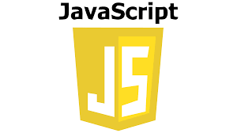
JavaScript (JS) is a high-level, versatile, and lightweight programming language primarily used to create dynamic and interactive web applications. It is one of the core technologies of the web, alongside HTML and CSS, enabling developers to enhance user experiences by adding interactivity to websites. JavaScript can run both on the client-side (in the browser) and server-side (using environments like Node.js).

Key Points:
- Interactivity: JavaScript allows developers to add interactivity to web pages, such as dropdown menus, sliders, pop-ups, and form validation.
- DOM Manipulation: JS can dynamically update and manipulate the HTML and CSS of a webpage, enabling features like live content updates without refreshing the page.
- Cross-Browser Compatibility: JavaScript works across all major web browsers, making it essential for building interactive web applications.
- Event Handling: JavaScript allows developers to respond to user actions like clicks, hover, and input using event listeners.
- Extensibility with Libraries and Frameworks: Popular libraries (e.g., jQuery) and frameworks (e.g., React, Angular, and Vue.js) extend JavaScript's capabilities, simplifying and accelerating development.
- Server-Side Programming: With platforms like Node.js, JavaScript can be used to build scalable server-side applications.
- Asynchronous Operations: JavaScript supports asynchronous programming using features like Promises, async/await, and AJAX, enabling smooth data fetching and background operations.

Importance of JavaScript in Project:
In Place-O-Track, JavaScript is used to manage events such as quiz submissions, coding problem attempts, form handling, and interactive button actions. It also enables smooth communication with backend APIs, ensuring that aptitude questions, coding data, and interview records are fetched, displayed, and updated without requiring a full page reload. JavaScript adds dynamism to the interface and significantly enhances the overall user experience.

- React.js + Vite:
React.js is a popular open-source JavaScript library used for building user interfaces, especially single-page applications (SPAs). Developed and maintained by Meta (formerly Facebook), React focuses on creating dynamic and responsive web applications with high performance and a seamless user experience. React's component-based architecture makes it easy for developers to build reusable and maintainable UI elements.
Vite is a modern build tool and development server that significantly improves the React development experience. Compared to traditional tools like Create React App (CRA), Vite offers faster startup time, instant hot module replacement (HMR), and lightweight build configurations.

Key Features of React.js + Vite:
- Fast Development Start-up: Vite offers significantly faster server initialization compared to traditional tools such as Create React App. This improves the development workflow and reduces waiting time during project setup.
- Hot Module Replacement (HMR): With HMR, changes made to the code reflect instantly in the browser without requiring a full page reload. This allows for seamless testing and debugging while preserving the application state.
- Optimized Production Builds: Vite uses Rollup as its build tool, producing compact, tree-shaken, and highly optimized bundles for deployment. This ensures that the application runs efficiently in production environments.
- Minimal Configuration: Vite comes with pre-configured settings, reducing the need for complex manual configurations. This enables developers to focus on core functionality rather than setup
- Lightweight and High Performance: The overall performance of applications built with Vite is enhanced due to smaller bundle sizes and faster reloading during both development and production stages.
- Rich Ecosystem: React has a vast ecosystem of libraries and tools, such as React Router for routing and Material-UI for pre-designed components.

Importance of React.js + Vite in Project:
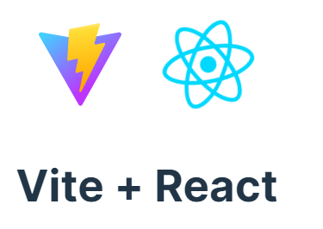
In Place-O-Track, React.js is used to develop both the Admin Panel and Student Panel with a clean separation of components such as quiz modules, coding problem cards, dashboards, and performance analytics. React’s virtual DOM ensures fast and efficient rendering, while hooks and props simplify state management and real-time UI updates. React also enables smooth integration with backend APIs, providing a responsive, scalable, and interactive frontend experience for students and admins.

3.2 Backend:
- Node.js:
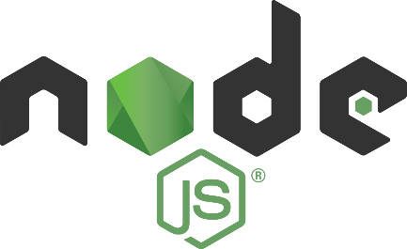
Node.js is an open-source, cross-platform runtime environment that allows developers to run JavaScript code on the server side. Built on Google Chrome’s V8 JavaScript engine, Node.js is lightweight, efficient, and designed for building scalable and high-performance network applications. It is particularly well-suited for real-time applications and APIs due to its non-blocking, event-driven architecture.

Key Points:
- Asynchronous and Event-Driven: Node.js operates on a non-blocking I/O model, meaning it can handle multiple requests simultaneously without waiting for one to complete.
- Single-Threaded Architecture: While single-threaded, Node.js uses an event loop to manage concurrent operations efficiently, making it highly scalable.
- Fast Execution: Powered by the V8 engine, Node.js executes JavaScript code at high speed, making it ideal for real-time applications.
- Cross-Platform: Node.js runs on Windows, Linux, macOS, and other platforms, making it versatile for various development environments.
- Built-In Modules: Node.js comes with a set of core modules, such as http, fs (file system), and path, that simplify backend development tasks.
- Package Ecosystem (npm): Node.js has the largest package ecosystem through npm (Node Package Manager), offering thousands of reusable libraries and tools.
- JSON Support: Node.js works seamlessly with JSON, making it an excellent choice for building RESTful APIs.

Importance of Node.js in Project:
In Place-O-Track, Node.js is used to develop RESTful APIs that handle critical operations such as user authentication, managing aptitude and coding questions, processing quiz submissions, and storing interview data. It provides a fast, reliable, and scalable backend environment to implement business logic, perform server-side validation, and ensure secure and consistent data flow throughout the platform.

- Express.js:

Express.js is a fast, unopinionated, and minimalist web application framework for Node.js, widely used for building server-side applications and RESTful APIs. It simplifies the process of managing server logic, handling routes, processing HTTP requests, and integrating middleware for authentication, validation, and error handling.

Key Points:
- Minimal and Lightweight: Express.js is a fast and minimal framework built on top of Node.js, making backend development simpler and cleaner.
- Easy Routing: Provides a simple way to define routes for different HTTP methods (GET, POST, PUT, DELETE).
- Middleware Support: Easily integrates middleware functions for tasks like validation, authentication, error handling, and more.
- RESTful API Creation: Ideal for building RESTful services that interact with databases and frontend apps.
- Integration Friendly: Works seamlessly with MongoDB (via Mongoose), React (frontend), and other Node packages.
- Scalable and Modular: Supports modular code architecture, allowing large applications to be split into smaller, manageable parts.
- Efficient Error Handling: Offers built-in mechanisms and custom middleware for managing errors gracefully.
- Template Engine Support: Supports view engines like EJS, Pug, or Handlebars if needed (optional in API-based apps).

Importance of Express.js in Project:
In the Place-O-Track project, Express.js is used to build the backend server, commonly known as the Express server. This server manages all essential backend operations, including question management, user authentication, data validation, and secure API communication. Express enables developers to define clean and modular routes, ensuring a well-structured codebase and smooth interaction between the frontend and backend systems.

- MongoDB:
MongoDB is a popular open-source, NoSQL database designed for high performance, scalability, and flexibility. Unlike traditional relational databases, MongoDB stores data in JSON-like documents using a flexible, schema-less model. This allows developers to work with dynamic and complex data structures more efficiently.

Key Points:
- NoSQL Database – MongoDB is a non-relational database that stores data in flexible, JSON-like documents instead of traditional tables.
- Schema-less Structure – Collections do not require a fixed schema, allowing dynamic fields and flexible data models.
- Document-Oriented – Each record is stored as a document (similar to a JavaScript object), making it intuitive for developers working with JavaScript/Node.js.
- High Performance – Designed for high-speed data operations, ideal for applications requiring fast reads and writes.
- Horizontal Scalability – Supports sharding, enabling the database to scale across multiple servers for large-scale applications.
- Integration with Mongoose – Easily integrates with Mongoose for schema validation, relationships, and advanced querying.
- Indexing Support – Offers powerful indexing features to speed up search queries and improve performance.
- Flexible Query Language – Allows complex queries, filtering, aggregation, and full-text search using JavaScript-like syntax.
- Cloud Support (MongoDB Atlas) – Offers a fully managed cloud solution for hosting MongoDB databases with automatic backups and scaling.
- Cross-Platform – Works seamlessly on Windows, macOS, Linux, and cloud platforms like AWS, Azure, and Google Cloud.

Importance of MongoDB in Project:
In the Place-O-Track project, MongoDB is used to store and manage all essential data, including user information, aptitude questions, coding problems, interview records, quiz results, and login credentials. Each document in MongoDB represents a real-world entity such as a student, a question, or an interview experience, making the database structure intuitive, scalable, and easy to maintain.

3.3 Tools Used:
- MongoDB Compass:
MongoDB Compass is the official graphical user interface (GUI) provided by MongoDB for visually exploring, managing, and analyzing the contents of a MongoDB database. It allows developers to interact with databases without writing complex queries manually, making it especially useful for testing, debugging, and development.

Key Points:
- GUI for MongoDB – Provides a graphical interface to interact with MongoDB databases without needing command-line queries.
- Visual Document Exploration – Allows viewing and editing of documents in a user-friendly format.
- Collection Management – Easily create, update, delete, and filter collections and documents.
- Real-Time Monitoring – Displays server performance statistics such as index usage, query performance, and database size.
- Aggregation Pipeline Support – Enables users to build and test complex aggregation stages visually.
- Index Management – Helps view and manage indexes to optimize database performance.
- Cross-Platform Tool – Available for Windows, macOS, and Linux.
- Ideal for Development – Makes testing, debugging, and inspecting data easier during the backend development phase.

Importance of MongoDB in Project:
In the Place-O-Track project, MongoDB Compass is used to view collections, inspect documents, monitor real-time stored data, and perform CRUD operations directly on the database. It also helps visualize relationships between users, questions, and results, apply filters, and run aggregation pipelines through an easy-to-use graphical interface.
- Postman:
Postman is a widely used API development and testing tool that provides a powerful and user-friendly interface to interact with backend services. It allows developers to send requests to APIs, inspect responses, and debug endpoints without building a frontend first.

Key Points:
- API Testing Tool – Allows developers to test, debug, and document RESTful APIs without needing a frontend.
- User-Friendly Interface – Provides an intuitive GUI to send HTTP requests (GET, POST, PUT, DELETE, etc.) and view responses.
- Supports Environment Variables – Enables the use of variables (e.g., base URLs, tokens) for easy testing across environments.
- JWT & Auth Integration – Supports various authentication methods, including JWT, OAuth, and API keys.
- Request Customization – Allows adding headers, body data (JSON, form-data), and query parameters.
- Collection & Folder Structure – Lets you organize related API requests into collections for better project management.
- Built-In Test Scripts – Provides scripting options for automated tests and response validation using JavaScript.
- Collaboration Friendly – Supports sharing APIs and environments with team members for collaborative development.

Importance of Postman in Project:
In the Place-O-Track project, Postman is used extensively to test the RESTful APIs developed with Node.js and Express.js. It helps verify that routes for user login, question management, quiz submission, coding evaluation, and interview data handling are working correctly. Postman also supports environment variables, custom headers, authorization tokens such as JWT, and query parameters, making it an ideal tool for secure, structured, and efficient API testing.

- Visual Studio Code:
Visual Studio Code (VS Code) is a free, open-source code editor developed by Microsoft. It is widely used by developers for writing, debugging, and managing code across a wide range of programming languages and frameworks. Known for its lightweight nature, speed, and extensive plugin support, VS Code has become a preferred tool for full-stack development.

Key Points:
- Lightweight and Fast – A powerful yet lightweight source-code editor that works smoothly across platforms.
- Multi-Language Support – Supports JavaScript, HTML, CSS, Node.js, React.js, and many other programming languages.
- Integrated Terminal – Allows running commands, scripts, and servers directly from the editor.
- Built-in Git Integration – Enables version control with Git and GitHub directly within the editor.
- Extension Marketplace – Offers thousands of extensions (e.g., Prettier, ESLint, MongoDB, REST Client) to enhance productivity.
- Smart Code Features – Provides IntelliSense (auto-completion), syntax highlighting, and error detection.
- Debugging Tools – Includes an integrated debugger for real-time error tracking and code inspection.
Importance of Visual Studio Code in Project:
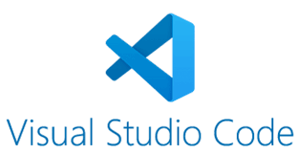
In the Place-O-Track project, VS Code is used to develop both the frontend (React.js) and backend (Node.js & Express.js) code. It offers smart code completion, syntax highlighting, integrated Git control, terminal access, and debugging tools—all in a single environment. With extensions like Prettier, MongoDB integration, and REST Client, VS Code enhances the development workflow and improves productivity.

- GitHub:
GitHub is a web-based platform that provides version control and collaborative development using Git, a distributed version control system. It enables developers to store code repositories online, manage changes, track revisions, and collaborate with team members in real time.

Key Points:
- Version Control Platform – Built on Git, GitHub helps track changes in code and manage multiple versions efficiently.
- Cloud-Based Code Hosting – Stores your code online, making it accessible from anywhere.
- Collaboration-Friendly – Supports real-time collaboration using branches, pull requests, and issue tracking.
- Code Backup & Recovery – Acts as a secure backup for your entire project, preventing data loss.
- Commit History Tracking – Maintains a full history of code changes, helping developers understand who changed what and why.
- Supports Open Source & Private Projects – Projects can be public for open-source contribution or private for internal use.
- Integrated with CI/CD Tools – Easily connects with deployment, testing, and automation tools for modern DevOps workflows.
- Community and Documentation – Offers a strong developer community and built-in tools like README files and Wikis for project documentation.
Importance of Visual Studio Code in Project:

In the Place-O-Track project, GitHub is used to host the source code for both frontend and backend components. It allows seamless version tracking, making it easy to review changes, revert errors, and maintain a history of development progress. Features like branches, pull requests, issues, and commit history improve collaboration and project management, especially during teamwork or code reviews.

CHAPTER 4 – Software Development Life Cycle (SDLC) Model

4.1 Introduction to SDLC:
The Software Development Life Cycle (SDLC) is a systematic process used for developing software that ensures quality, efficiency, and structure in the development workflow. It defines the stages involved in building software applications, from initial planning and requirement gathering to design, development, testing, deployment, and maintenance.
By following a well-defined SDLC model, teams can reduce project risk, improve resource management, and deliver a high-quality product within a specified time frame. Each phase in the SDLC has specific deliverables and documentation, making the process more manageable and transparent.
In the context of the In the Place-O-Track project, the SDLC model served as a guideline to execute the project step by step, ensuring proper planning, structured coding, and successful deployment of the full-stack web application.
4.2 SDLC Model Used:
For the development of the In the Place-O-Track project, the Waterfall Model of SDLC was followed. The Waterfall Model is a linear and sequential approach where each phase of the software development process flows logically into the next. This model is suitable for projects where requirements are clearly understood from the beginning and minimal changes are expected during development.
Each stage in the Waterfall Model must be completed before the next one begins, making it easy to manage and document progress. This model was chosen for Place-O-Track to ensure a structured and organized development process, with well-defined goals at every stage—from requirement gathering to deployment.
The Waterfall approach provided clarity and discipline during the development of the system's Admin and Employee panels, helping maintain a consistent flow of progress without overlaps or confusion.
4.3 Phases of SDLC:
The development of Place-O-Track was carried out in a structured sequence, following the key phases of the Waterfall SDLC model. Each phase contributed to building a stable, scalable, and maintainable employee task management system.
4.3.1 Requirement Analysis
In this phase, detailed discussions were held to understand the project's functional and non-functional requirements. The system needed to support role-based access (Admin and Employee), placement task and tracking, performance monitoring, leave handling, and secure login. Clear documentation of these requirements laid the foundation for the next phases.
4.3.2 System Design
Based on the gathered requirements, the overall architecture of the system was designed. This included:
- Designing the database schema using MongoDB and Mongoose
- Planning RESTful API routes in Express.js
- Structuring frontend components using React.js
- Designing the UI with responsiveness in mind using Bootstrap
4.3.3 Implementation
This phase involved the actual coding and development:
- Backend was developed using Node.js and Express.js
- Frontend was developed using React.js
- APIs were created for task management, user authentication, leave processing, and performance tracking
- MongoDB was used to store data, such as users, tasks, and rewards
The code was written in VS Code and version-controlled using GitHub.

4.3.4 Testing
After implementation, thorough testing was done using tools like:
- Postman for API testing
- Console debugging for frontend validation
- MongoDB Compass for checking data integrity
Manual and functional testing ensured that each module performed as expected and edge cases were handled.
4.3.5 Deployment
The system was prepared for deployment. Backend services and the frontend were tested on different machines to ensure cross-device functionality. The folder structure, port configuration, and environment variables were set for smooth running of the project on any system.
4.3.6 Maintenance
As part of the maintenance phase, minor changes and improvements were made based on testing feedback. The system allows for future scalability, such as adding customer roles, notifications, or advanced reporting features.

Chapter 5: System Design and Requirements

5.1 System Architecture
The architecture of Place-O-Track follows a MERN stack model (MongoDB, Express.js, React.js, Node.js), built using a client-server approach.
- Frontend (React.js): Handles the user interface for Admin and Employee panels using components and Bootstrap for responsiveness.
- Backend (Node.js + Express.js): Manages routing, business logic, API creation, and validation. It processes requests from the frontend and interacts with the database.
- Database (MongoDB): Stores all project data including users, tasks, performance records, and leave applications. Connected via Mongoose for schema management.
- API Communication: Frontend communicates with the backend using RESTful APIs. Tools like Postman are used to test these APIs.
- Development Tools: VS Code for coding, GitHub for version control, and MongoDB Compass for viewing database records.

5.2 Data Flow Diagrams (DFDs):
Data Flow Diagrams (DFDs) visually represent the flow of data through the system. For the Place-O-Track project, Level 2 DFDs are included to illustrate detailed processes within the Admin and Employee panels. These diagrams show how tasks, authentication, leaves, and performance data move between users, the system, and the database

5.2.1 Admin Panel
Admin Panel illustrating data flow for category, subcategory, project, team, task, and performance (reward/warning) management.
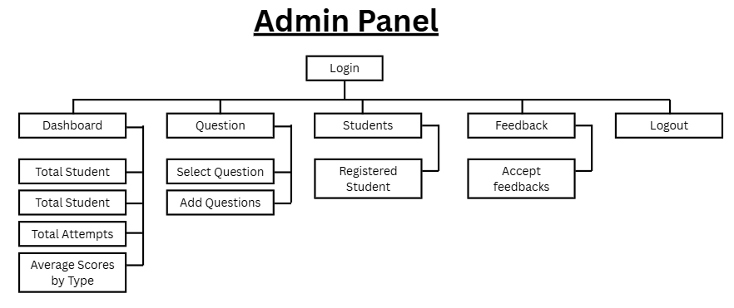

5.2.1 Student Panel
DFD of Student Panel showing the flow for task viewing, submission, profile management, and performance tracking.
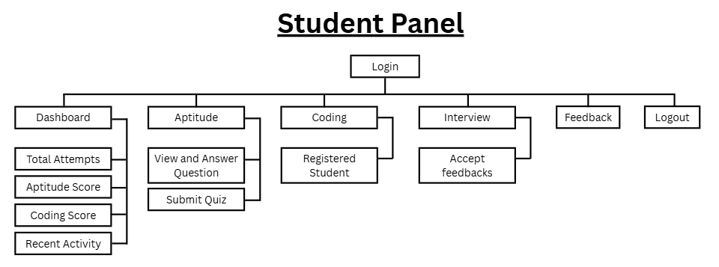

5.2.1 Company Panel
DFD of Company Panel showing the flow for task viewing, submission, profile management, and performance tracking.
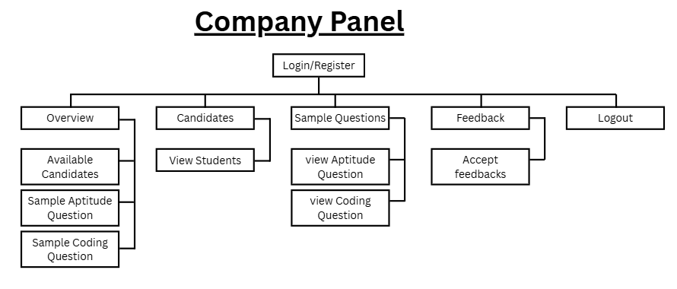
5.3 System Requirements:
The development and execution of the Place-O-Track project require specific hardware and software components to ensure smooth performance and compatibility. Below are the minimum and recommended requirements:
5.3.1 Hardware Requirements:
Component | Minimum Requirement | Recommended Requirement
Processor | Intel Core i3 | Intel Core i5 or above
RAM | 4 GB | 8 GB or more
Hard Disk | 100 GB (free space) | 256 GB SSD
Monitor | 1024 × 768 resolution | Full HD (1920 × 1080)
Input Devices | Keyboard and Mouse | Standard Input Devices
Internet Connection | Required for testing & deployment | Stable High-Speed Connection

5.3.2 Software Requirements:
Software | Details / Version
Operating System | Windows 10/11, Ubuntu 20+, or macOS
Code Editor | Visual Studio Code
Backend | Node.js (v16+) with Express.js
Frontend | React.js (with Vite or Create React App)
Database | MongoDB (Local or MongoDB Atlas)
Database GUI | MongoDB Compass
API Testing Tool | Postman
Version Control System | Git and GitHub
Browser | Google Chrome / Mozilla Firefox
Terminal/Command Line | Windows CMD / Bash / PowerShell

Chapter 6: Testing, Maintenance, and Results
6.1 Testing:
Testing ensures that all modules of the platform function correctly and meet the defined requirements. In the Place-O-Track project, multiple levels of testing were performed to validate system functionality, performance, and overall reliability.
6.1.1 API Testing with Postman
All backend APIs developed in Node.js and Express.js were tested using Postman. Each route (GET, POST, PUT, DELETE) was tested with valid and invalid inputs to verify:
- Data validation
- Status codes (200, 201, 400, 422, 500)
- Response structure
- Authentication using JWT tokens
6.1.2 Module Testing
Each panel (Admin and Employee) was tested separately to ensure the UI components and logic were working properly:
- Admin side: task creation, employee handling, warnings/coins
- Employee side: viewing tasks, submitting tasks, requesting leave

6.1.3 Validation Testing
Field validations were tested on both frontend and backend:
- Required fields (e.g., email, password, task title)
- Minimum password length
- Unique email/user check
- Date and time validations

6.1.4 Error Handling Tests
Test cases were created to simulate invalid requests and server errors. Custom error messages and proper HTTP status codes were returned for:
- Missing fields
- Unauthorized access
- Invalid data formats

6.2 Maintenance
Maintenance is an essential phase of the software development life cycle. It ensures that the system continues to operate smoothly, securely, and efficiently after deployment. The Place-O-Track project involves both basic and ongoing maintenance strategies to fix bugs, enhance existing features, and prepare the platform for future upgrades and improvements.

6.2.1 Bug Fixes and Enhancements
During testing, several bugs and functional issues were identified and resolved:
- Fixed API validation errors for login, task creation, and leave requests.
- Corrected UI alignment and responsiveness using Bootstrap.
- Handled duplicate entries and invalid task IDs using backend validation logic.
- Implemented better error handling in API responses to improve user understanding.

6.2.2 Future Scope and Scalability
To ensure the project can grow and adapt to future needs, the following enhancements are planned:
- Addition of a Customer Panel for future client interaction.
- Integration of Email or SMS notifications for task updates and approvals.
- Implementing real-time updates using technologies like Socket.IO.
- Role-based access enhancements (Team Leads, HR, etc.).
- Deployment on a live server or cloud environment for broader access.

6.3 Result

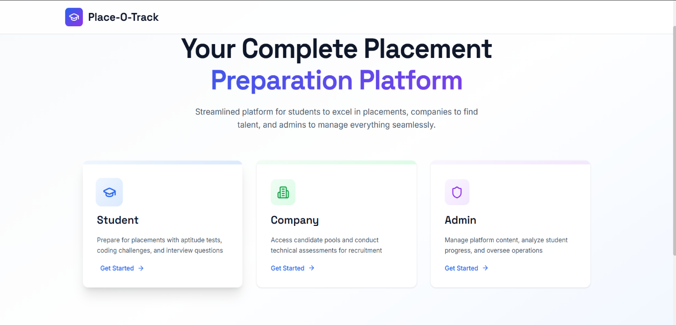
1. Landing Page:

2. Admin Login:
- User Id: admin@placetrack.com
- Password: admin123
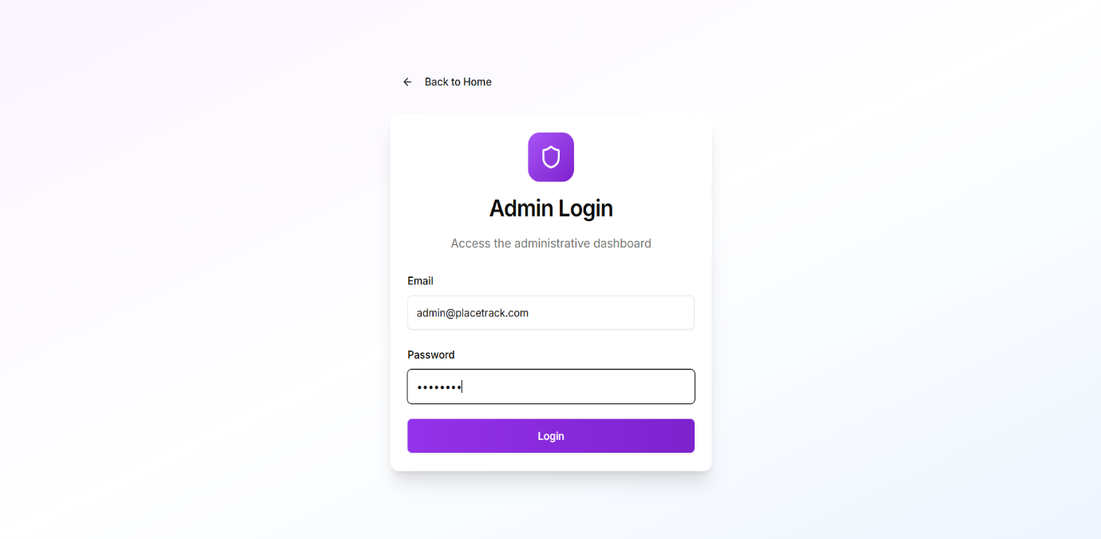

2.1. Admin Dashboard:
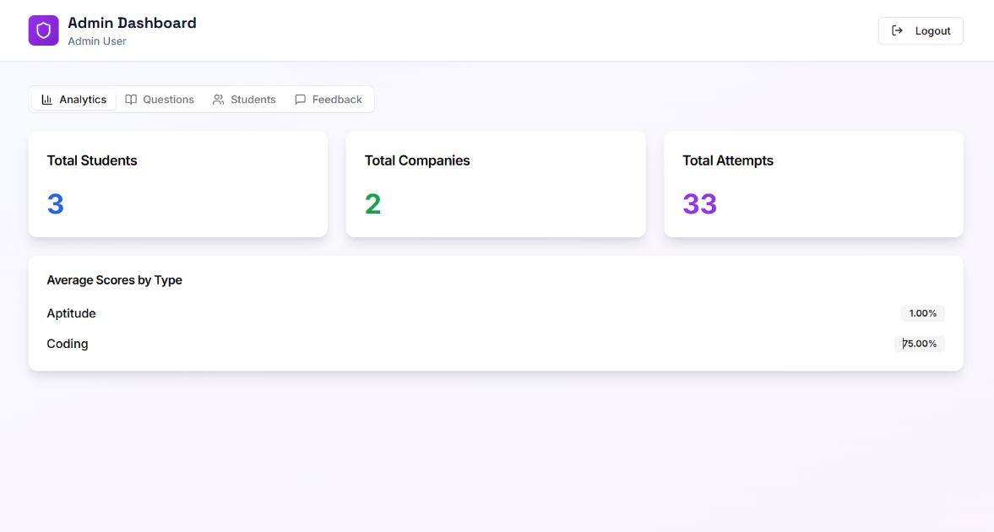

2.2 Question Model:
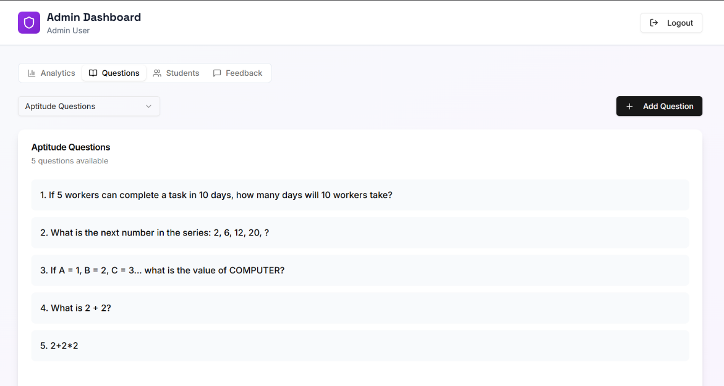

2.3 Student Model:
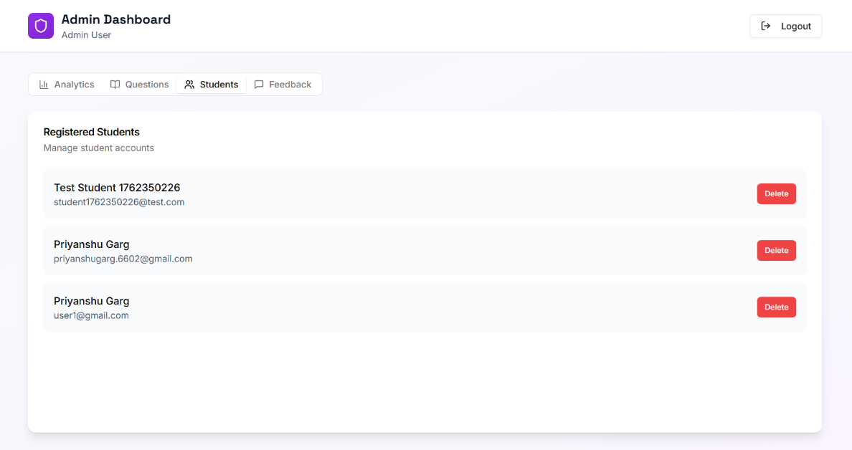

3. Company Panel
3.1 Company Register:
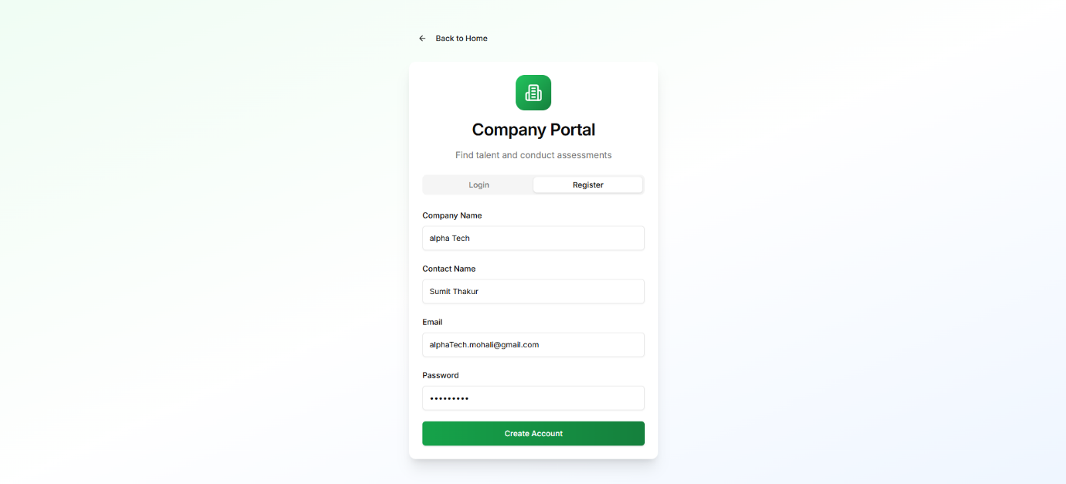

3.2 Login:
- User Id: alphaTech.mohali@gmail.com
- Password: ok.google

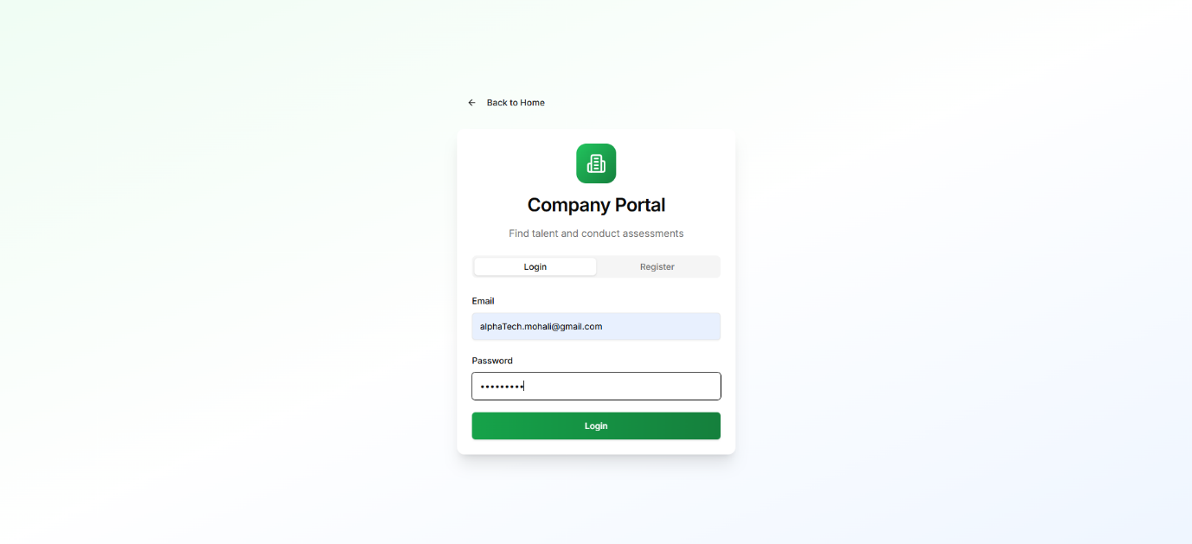

3.3 Dashboard:
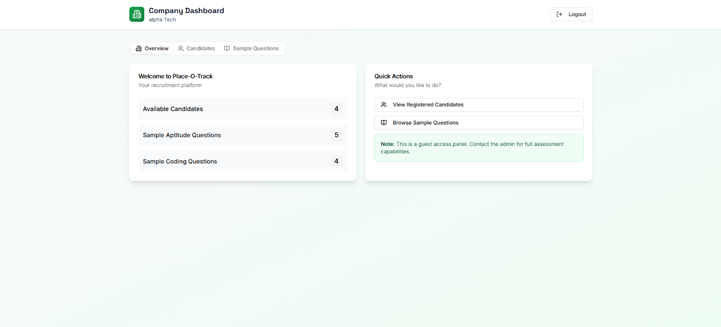

3.4 Candidates:
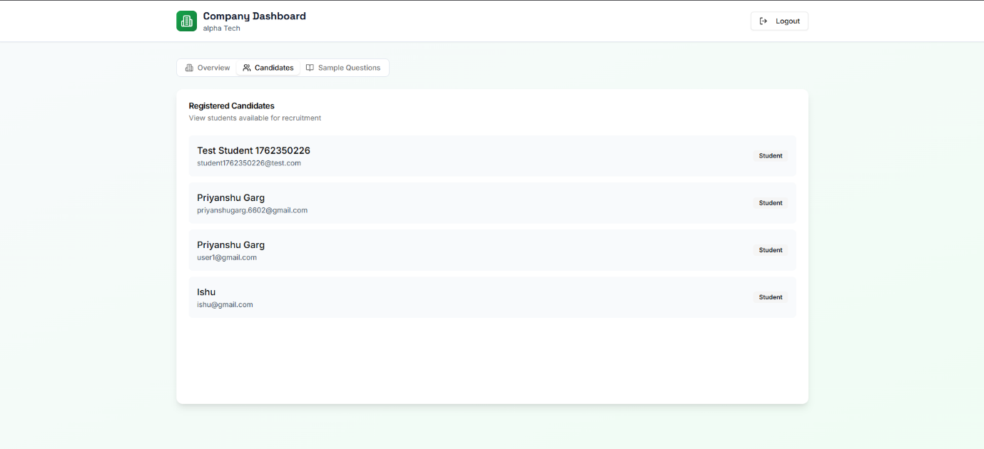

3.5 Sample Question:
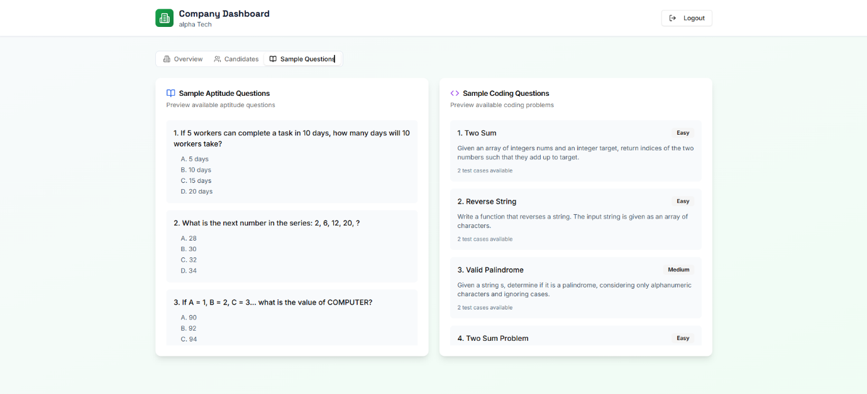

4. Student:
4.1 Student Register:
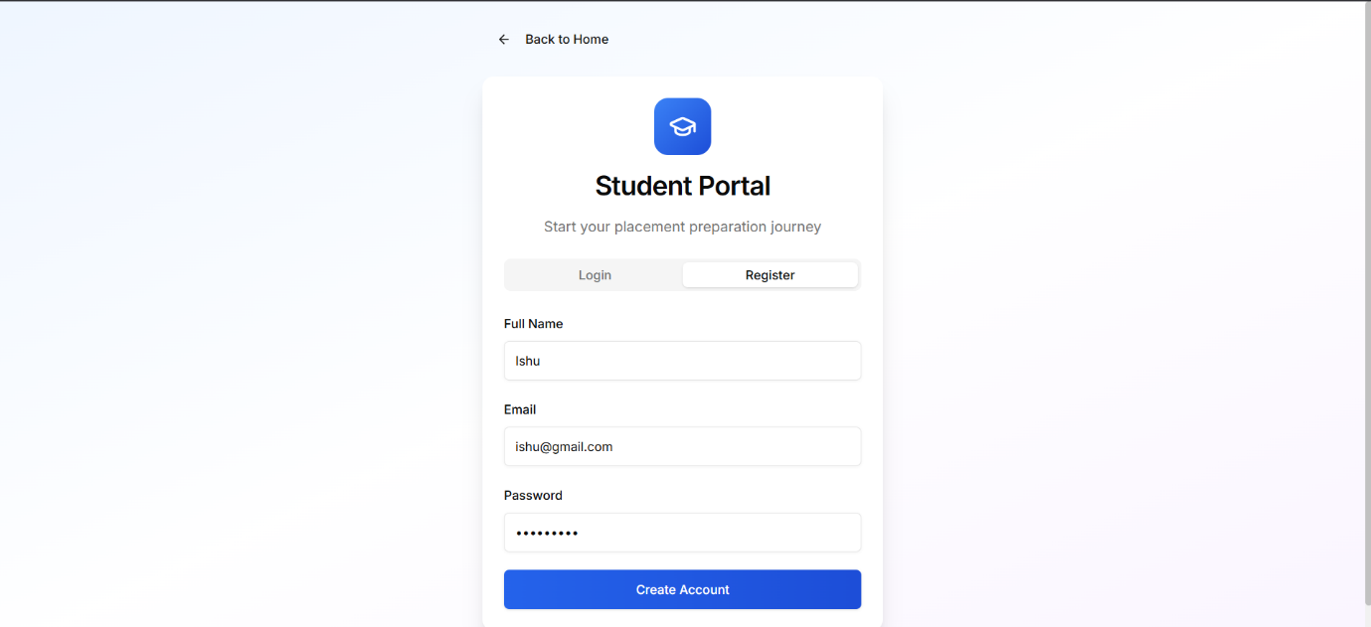

4.2 Student Login:
- User Id: student1@gmail.com
- Password: ok.google98

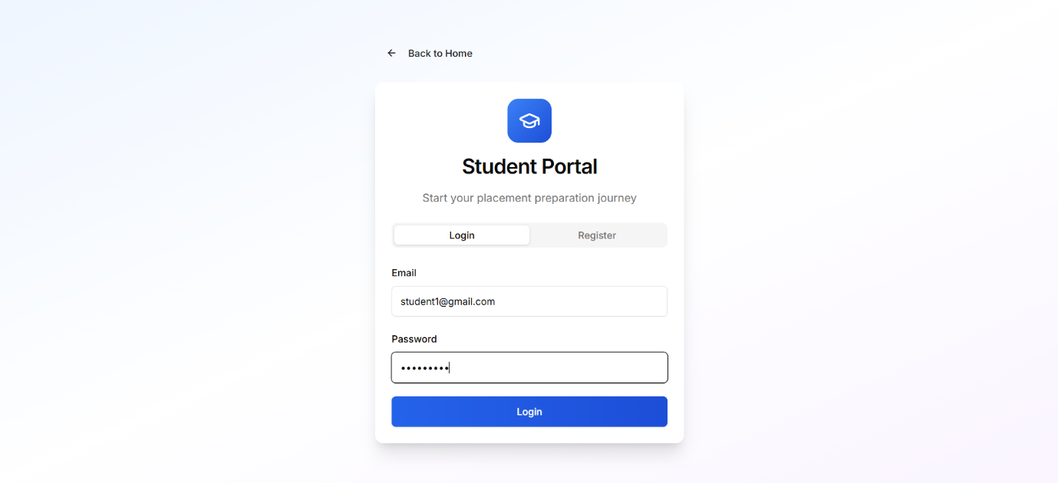

4.3 Student Dashboard:
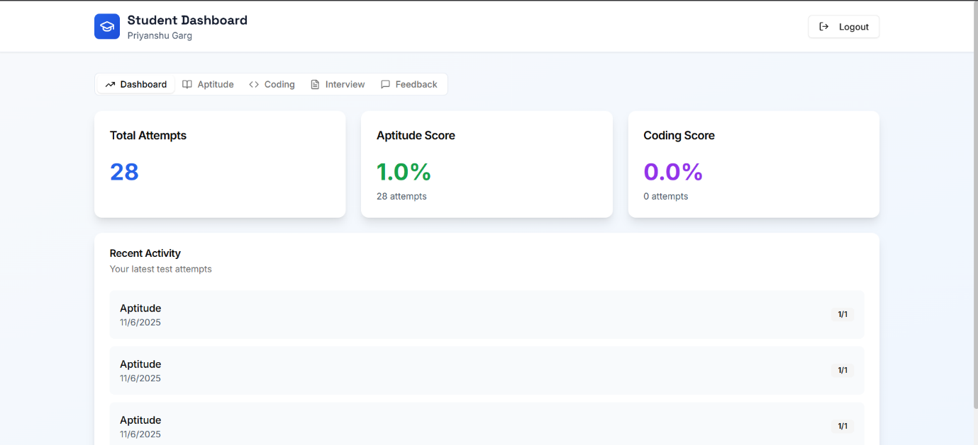

4.4 Student Aptitude:
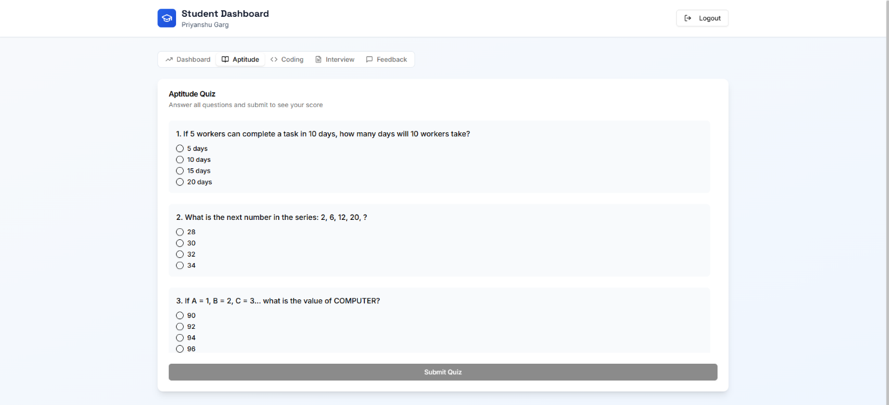

4.5 Student Coding:
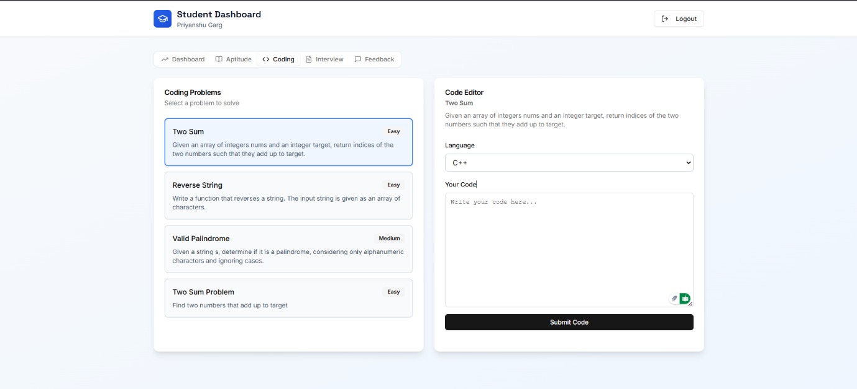

4.6 Student Interview:
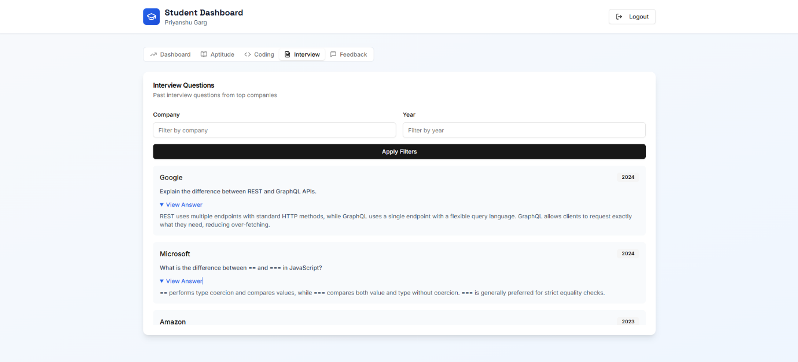

4.7 Student Feedback:
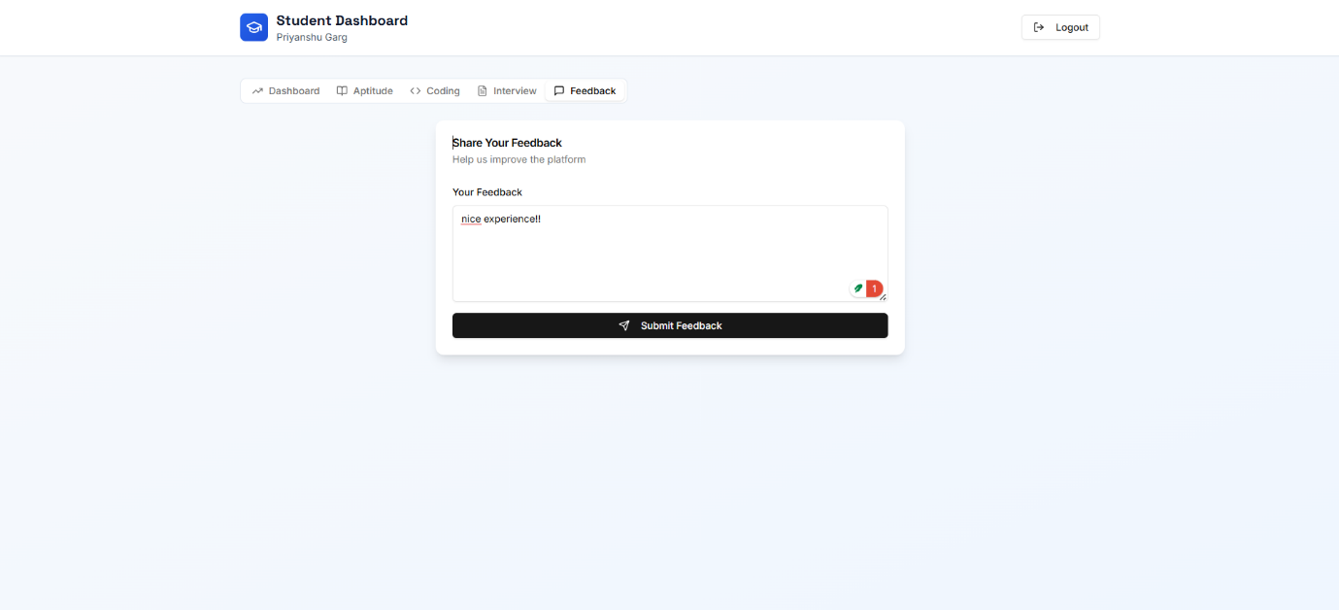

Chapter 7: Conclusion and References

7.1 Conclusion
The Place-O-Track project successfully delivers a structured and efficient system for managing placement preparation, student performance tracking, interview history access, and learning organization. Built using the MERN stack, it combines a responsive frontend, a powerful backend, and a scalable NoSQL database to provide secure role-based access and seamless workflows for both Admin and Student panels.
Throughout the development cycle, industry-standard practices such as modular coding, API testing, and real-time data validations were followed to ensure reliability, accuracy, and a smooth user experience. The platform can be easily extended in the future to include additional features such as AI-based recommendations, live mock tests, and integrations with external placement platforms.
Overall, Place-O-Track serves as a strong foundation for systematic placement preparation and demonstrates the effectiveness of full-stack web development in solving real-world academic and training challenges.

7.2 References
Here are some sources and tools referred to during the development of the project:
- Node.js Documentation
- Express.js Guide
- MongoDB Docs
- Mongoose Docs
- React.js Documentation
- Bootstrap Framework
- Postman API Testing
- MongoDB Compass
- GitHub
- W3Schools
- Stack Overflow

