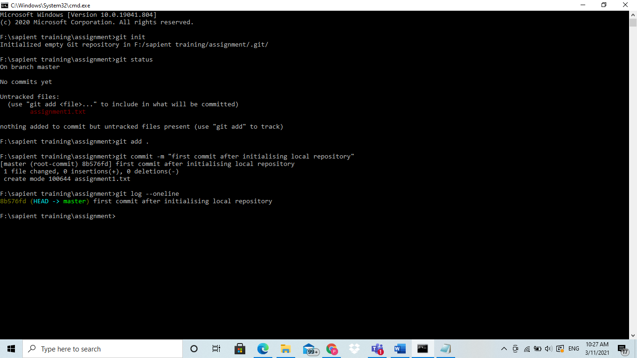

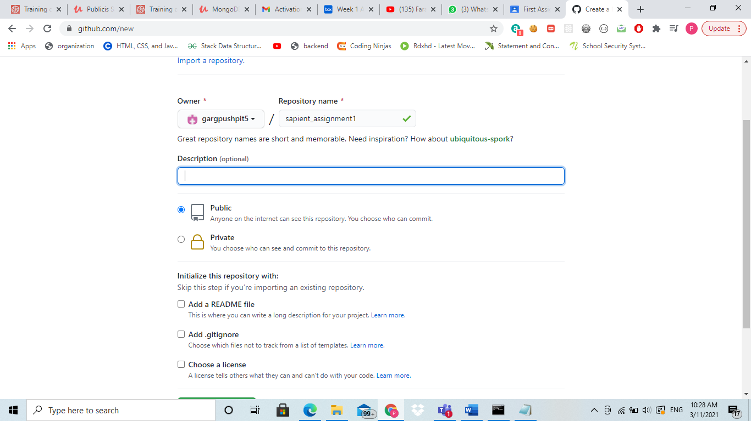

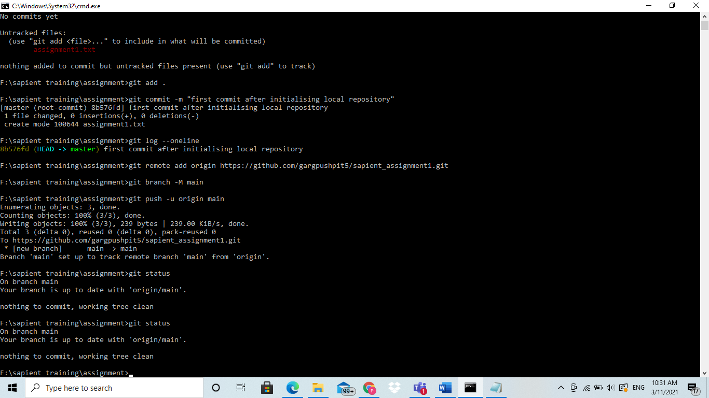

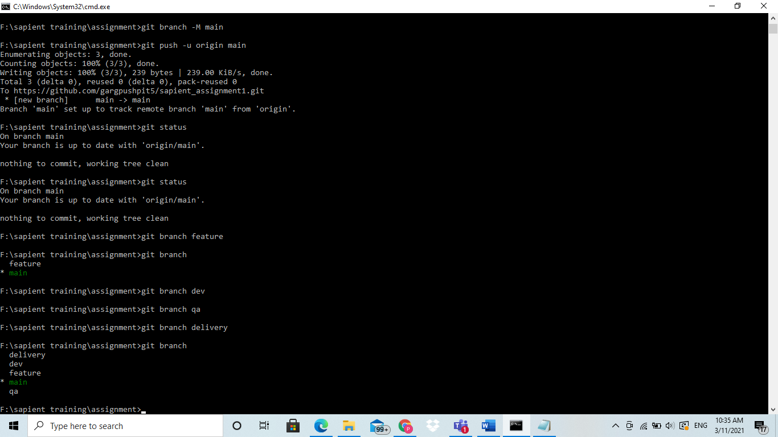

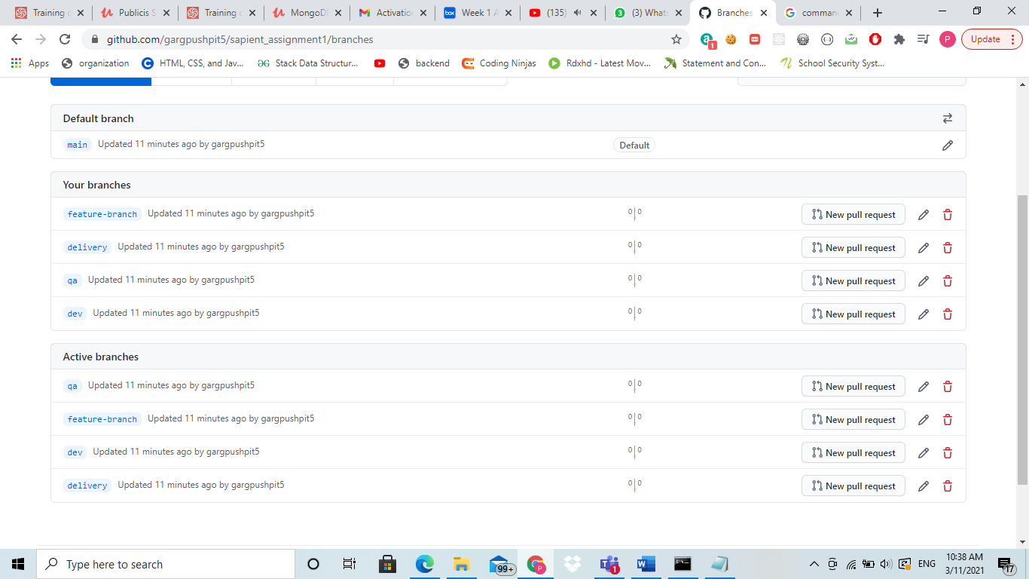

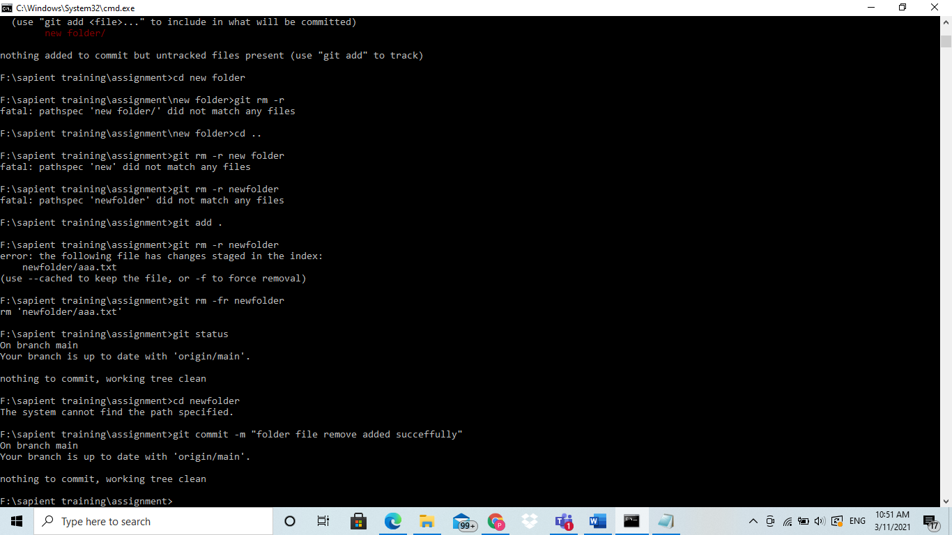

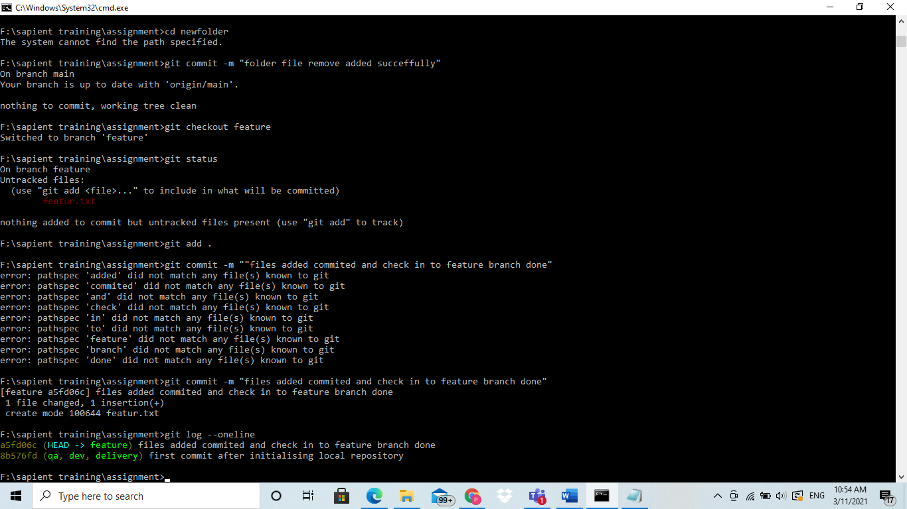

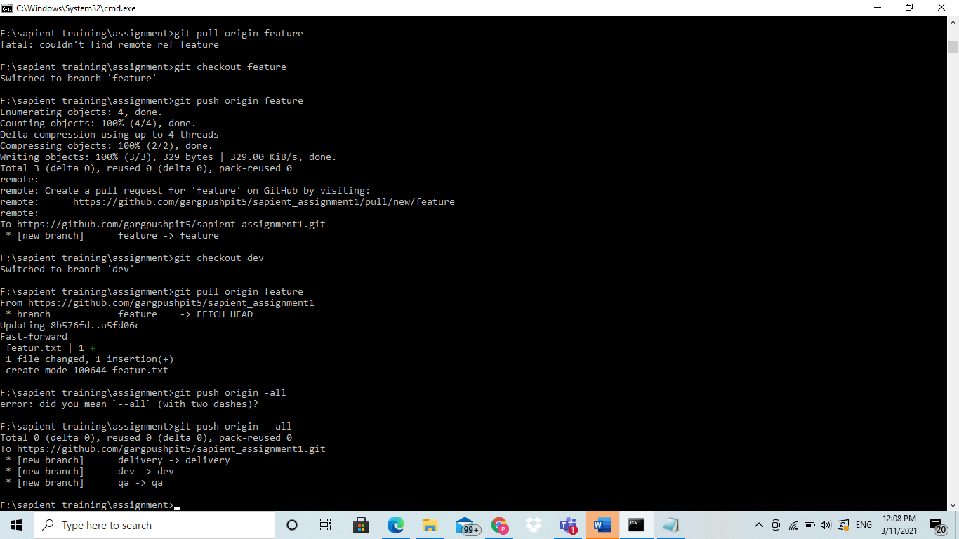

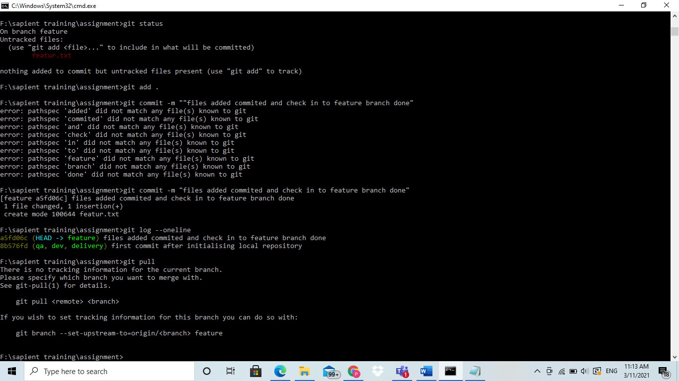

9.git pull command is to pull the code from remote repo to local repo

But checkout have different purpose its not to do with anything with remote repository. It is to make and switch to the new branch in local repository.

10.

Git status

Git log --merge => (this merge argument will produce a log with a list of commits that conflict between the merging branches)

Git diff =>help find differences between states of a repository file.This is useful in preventing and predicting merge conflicts.

11.

git fetch origin

git reset --hard origin/master

git clean -f -d

commands to synchronize all remote branches with local git repository branches.

Question 3

Command to reset to previous commit

$ Git reset xyzzz..(using an absolute SHA1 value of commit where we want to revert back)

--hard => flag can be used with this command that overwrites any local changes we haven’t commited . It resets the staging area and overwrites content in working directory with content of commit we reset to.

Another command that can be used is ($ git revert) it is quite similar to reset but the way it works is different it doesn’t take the pointer back in the chain to undo changes but instead add new commit to the chain with cancel changes.

2.git stash

3.git log –oneline

Git status

Git reflog