**CONTENT MANAGEMENT SYSTEM**

**Open Source Development Lab**

**14BCE029**

**ABSTRACT:**

Any computer application that helps to create and manage content digitally is called content management system. Commonly abbreviated as CMS, one of its type web content management system(WCMS) is used to help create and manage Web pages used in websites. They help in publishing, formatting, editing, indexing, searching and retrieving the content on the web. They are generally GUI based, which helps even the non technical persons to use them with ease. They are collaborative in the sense that multiple users can manage them at the same time. There are a number of CMS available online:

1. Wordpress

2. Tumblr

3. Blogspot

4. Wix

5. Droopal

6. Joomla

7. Radiant CMS

I have used wordpress.com to create a tech blog which has 5 posts namely :

1. Battle of the Standards : Bluetooth v/s Zigbee

2. Cloud Computing: Technology of the Future

3. Big Data Technologies: Hadoop V/S Spark

4. Computer Science and Engineering in India

5. IoT : Introduction and Opinions

Let us have a look at some of the features incorporated and a walkthrough of creating a blog and posting content.

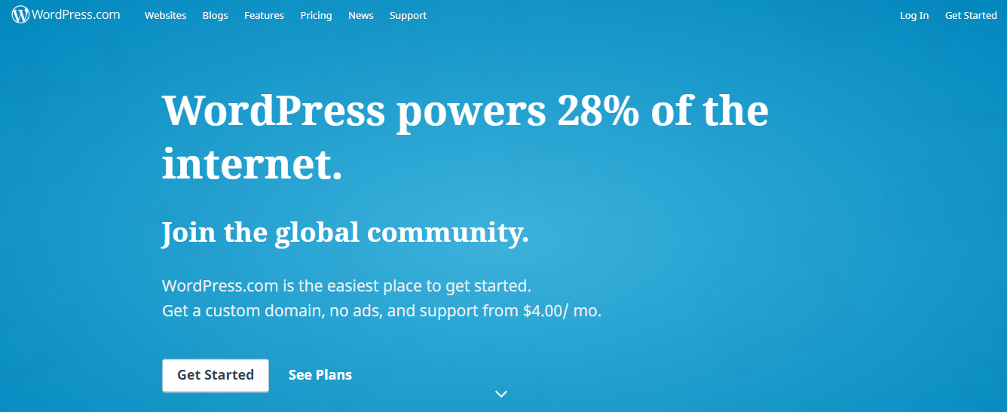

**Steps to create a blog:**

1. Choosing the topic of relevance:

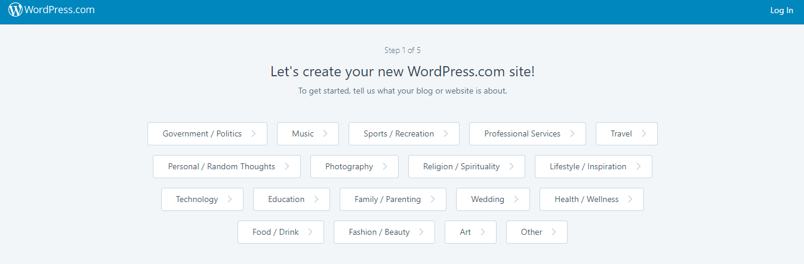

2. Based on what is your aim to create the following options are provided

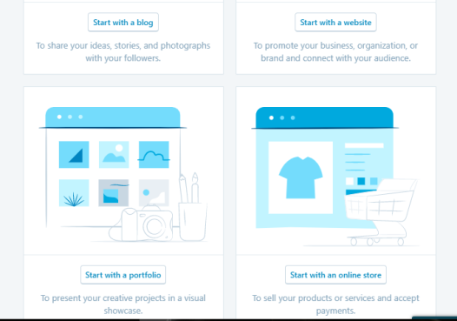

3. Onto with the NAMING process:

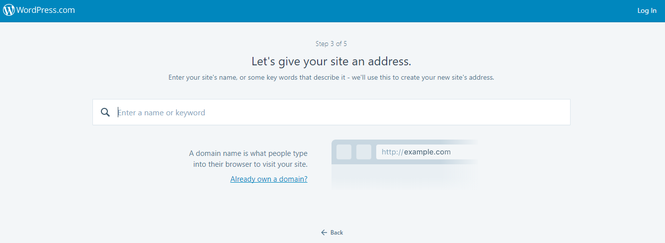

4.After assigning the chosen domain name, you are asked to choose from the existing plans

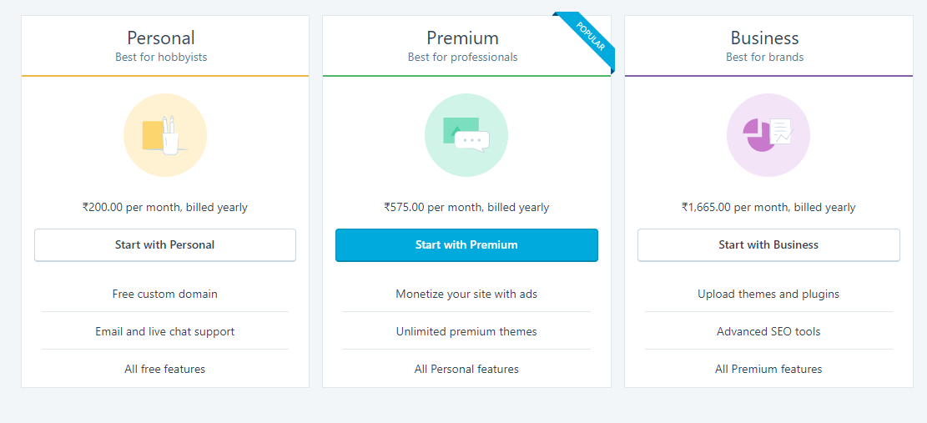

5.Finally on providing personal details the account is created and you can choose themes for your blogs

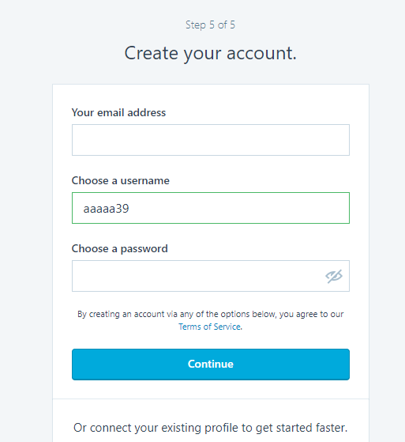

This is what my blog looks like from the admin perspective

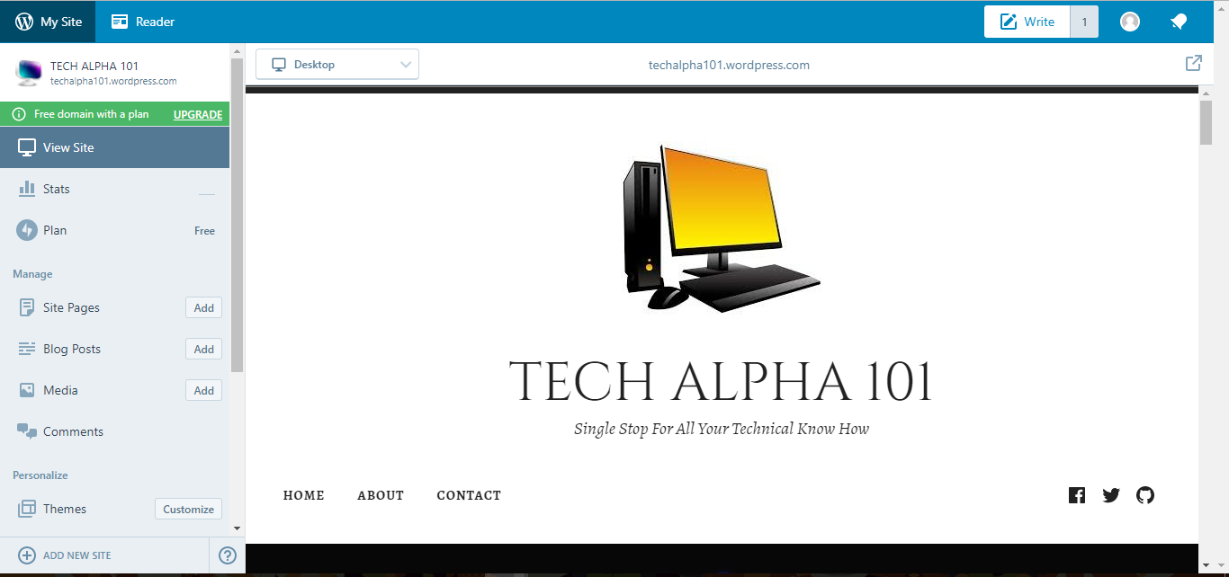

**Features:**

1. Choosing the Themes from side bar and clicking customize helps to select from the thousands of themes available where some of them are available and some of them are free.

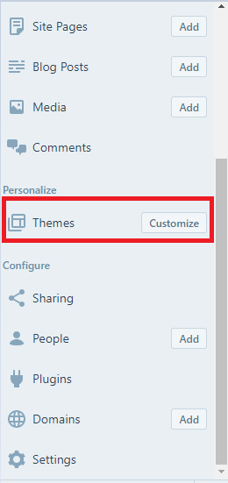

The following customizations are available

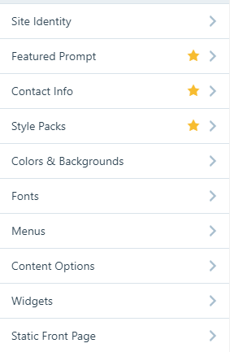

2. Setting the Site Identity

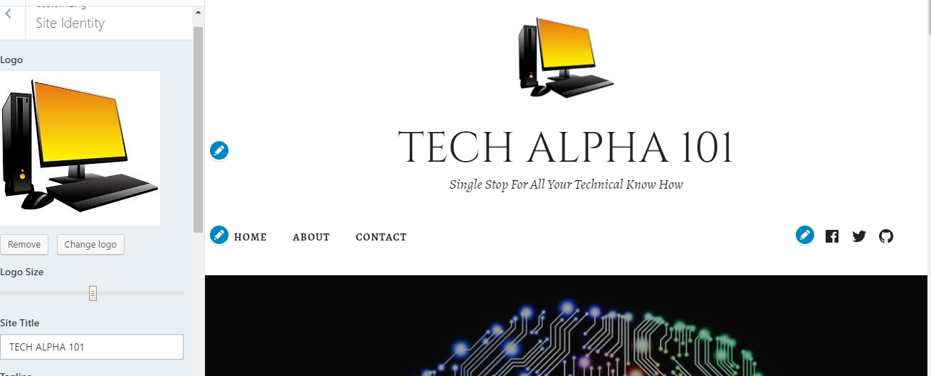

3. The Featured Prompt is a special feature of the theme I have used which appears like on visiting the blog:

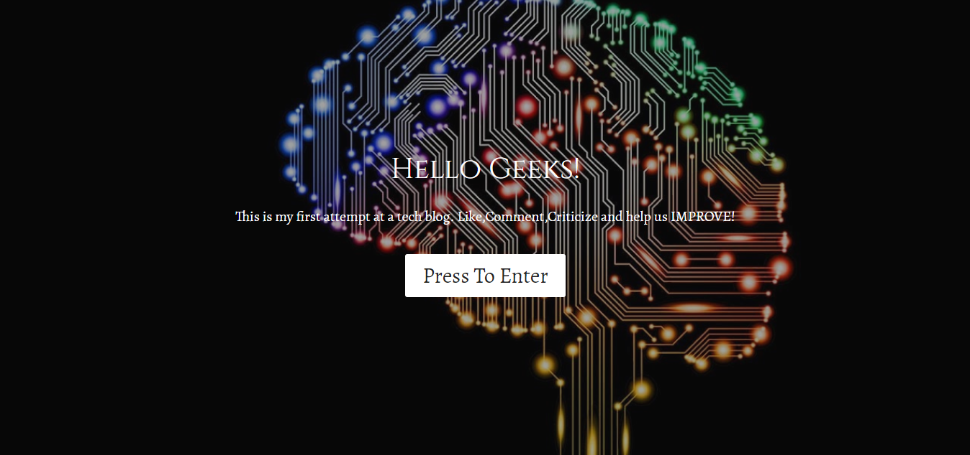

4. The Menus are



They can be positioned at the bottom of top of the blog. the Social Media Icons may or may not be used. They help in sharing the content on any of the sites e.g. Facebook, Twitter, GitHub

5. The Contact Info which is a unique feature of the them shows

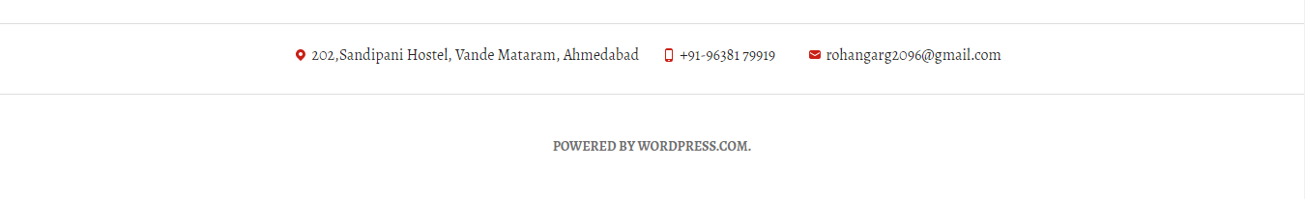

at the bottom of the blog. Clicking the location pin, opens up the location on Google Maps. The mail icon opens up the mail client with the "To:" field already filled up.

6. The Widgets used are

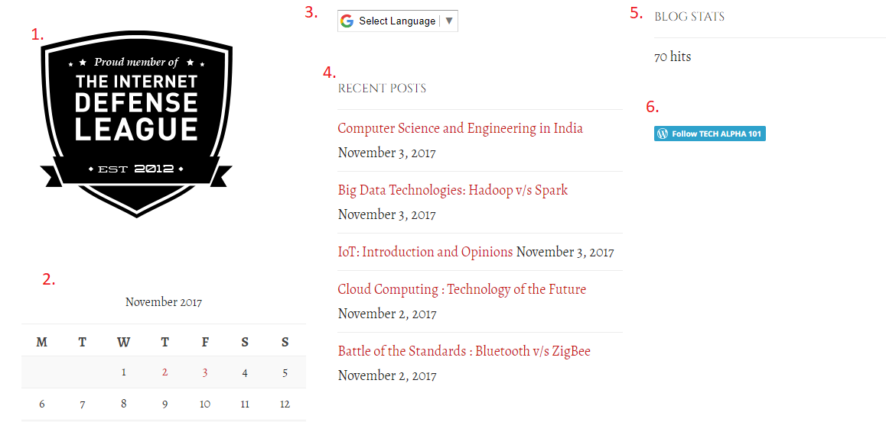

1. Internet Defense League support badge which is to show support for Net Neutrality. This causes a prompt to sign a petition to get displayed on visiting the blog.

2. Calendar which shows which are the days when the newer content is posted on the blog. Selecting any particular date would show only the posts made on that date.

3. Translator would translate the entire page into the selected language, thereby making it viewable in any language across the world.

4. Recent Posts lists the most from most recent to least recent ones in top down manner

5. Blog Hits stats shows the number of hits on the blog. Apart from this blog stats are viewable to the admin as follows:

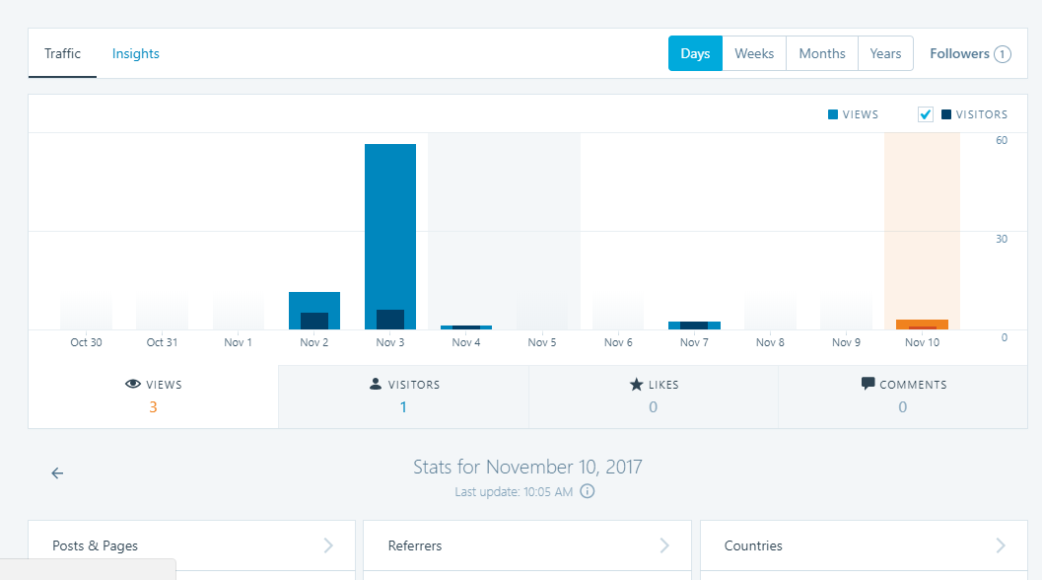

6.Follow button is a one click button to help the user follow my blog whenever he/she views it the first time. This gets changed to "Following" if clicked.

Apart from these, there are Google Maps, which help the user locate the position to visit the office, Search bar which helps user search through content on the site.

7. The blog posts can be added using

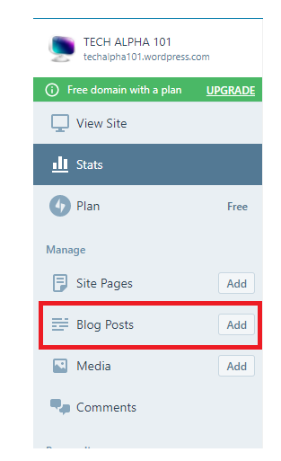

The content including images, videos and text can be added and formatted from the below tab that opens up.

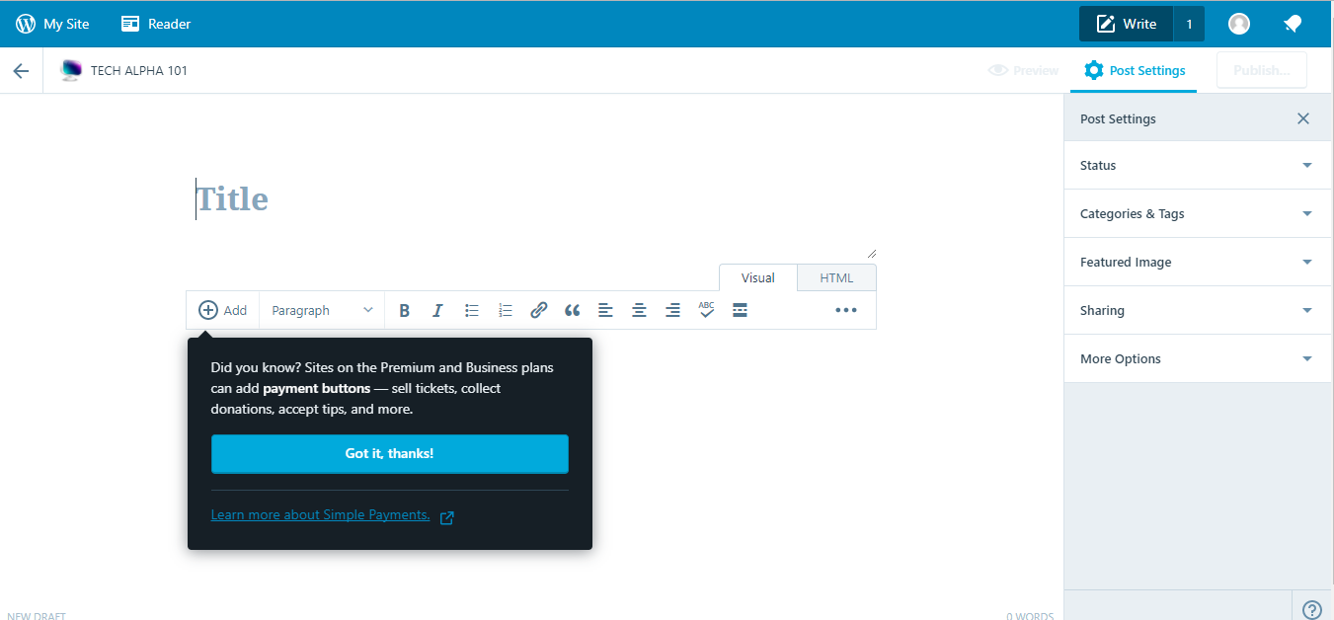

Each blog post can have its Featured Image which is the background behind the title of the blog as seen here.

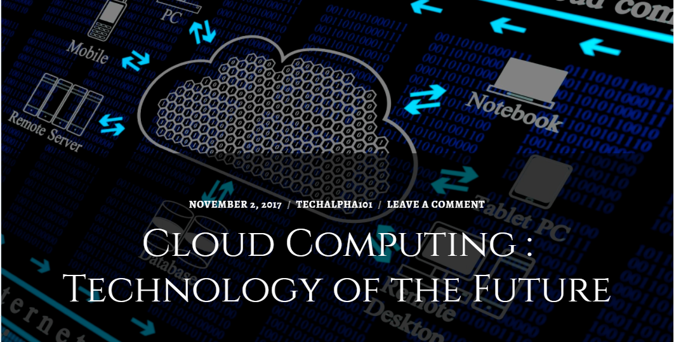

The categories and tags can be added for the improved searching and better stats and views on your blog.

8. The posts can be published or scheduled to be published as follow on Editing the blog post. Any existing post can be updated too using the "Edit" option:

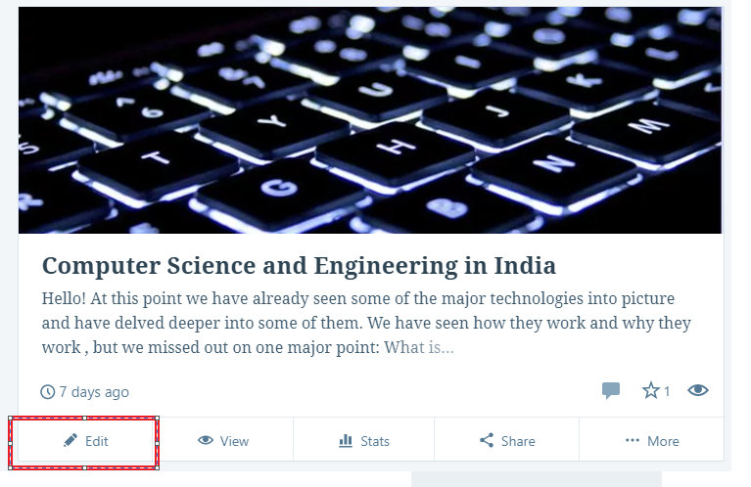

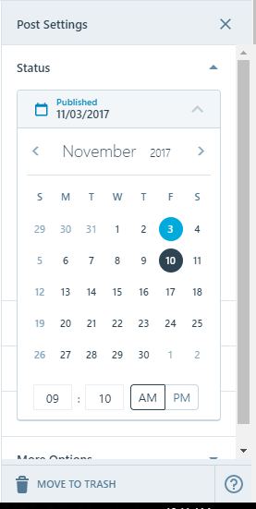

There are multiple other features such as "Comment Moderation", "Site Icon Settings" etc but covering them all is a humongous task. The overall blog looks like:

