GOVIND BALLAB PANT ENGINEERING COLLEGE PAURI



**COMPILER DESIGN LAB**

**PCS - 361**

**Summitted to: Submitted by:**

Mr. V. K. Tamta Shantnu Garg

(150250)

CSE 3rd year

**Table of Content**

|  |  |  |  |
| --- | --- | --- | --- |
| S. No. | Name of Practical | Page No. | Sign |
| 1. | STUDY OF LEX/YACC OF COMPILER WRITING. |  |  |
| 2. | TO CHECK WHETHER A STRING BELONGS TO THE GRAMMAR OR NOT. |  |  |
| 3. | WRITE A PROGRAM TO FIND LEADING TERMINALS. |  |  |
| 4. | WRITE A PROGRAM TO FIND TRAILING TERMINALS. |  |  |
| 5. | WRITE A PROGRAM TO COMPUTE FIRST OF NON-TERMINALS. |  |  |
| 6. | WRITE A PROGRAM FOR IMPLEMENTATION OF PREDICTIVE PARSER. |  |  |
| 7. | WRITE A PROGRAM TO DESIGN LALR BOTTOM UP PARSER. |  |  |
| 8. | PROGRAM TO FIND THE NUMBER OF WHITESPACE  AND NEWLINES CHARACTERS. |  |  |
| 9. | PROGRAM TO COMPUTE FOLLOW (A). |  |  |
| 10. | PROGRAM TO IMPLEMENT OPERATOR PRECEDENCE PARSING. |  |  |
| 11. | PROGRAM ON RECURSIVE DESCENDENT PARSING. |  |  |

**Software and Hardware Requirements:**

* **Hardware Requirements:**

1. Processor: Pentium I
2. RAM: 128MB
3. Hard Disk 40 GB
4. Floppy Drive 1.44MB

* **Software Requirements:**

1. Lex and Yacc tools. (A Linux Utility)
2. Language: C/C++

* **System Configuration on which lab is conducted**

1. Processor: PIV(1.8Ghz)
2. RAM 256MB
3. HDD 40GB
4. FDD 1.44MBMonitor 14’’Color
5. Keyboard Multimedia
6. Operating System Windows XP
7. Mouse Scroll

**Rationale behind CD LAB:**

Compiler is a **System Software** that converts High level language to low level lang.

We human beings can’t program in machine language (low level lang.) understood by Computers so we prog. In high level language and compiler is the software which bridges the gap between user and computer.

It’s a very complicated piece of software which took 18-man years to build first compiler

To build this S/w it is divided into six phases which are

1) Lexical Analysis

2) Syntax Analysis

3) Semantic Analysis

4) Intermediate Code Generation

5) Code Optimization

6) Code Generation.

In the lab sessions students implement Lexical Analysers and code for each phase to understand compiler software working and its coding in detail.

**Practical - 1**

**AIM:** Studyof Lex & Yacc Tools

**Lex -** A Lexical Analyzer Generator

**ABSTRACT**

Lex helps write programs whose control flow is directed by instances of regular expressions in the input stream. It is well suited for editor-script type transformations and for segmenting input in preparation for a parsing routine.

Lex source is a table of regular expressions and corresponding program fragments. The table is translated to a program which reads an input stream, copying it to an output stream and partitioning the input into strings which match the given expressions. As each such string is recognized the corresponding program fragment is executed. The recognition of the expressions is performed by a deterministic finite automaton generated by Lex. The program fragments written by the user are executed in the order in which the corresponding regular expressions occur in the input stream.

The lexical analysis programs written with Lex accept ambiguous specifications and choose the longest match possible at each input point. If necessary, substantial lookahead is performed on the input, but the input stream will be backed up to the end of the current partition, so that the user has general freedom to manipulate it.

Lex can generate analysers in either C or Ratfor, a language which can be translated automatically to portable Fortran. It is available on the PDP-11 UNIX, Honeywell GCOS, and IBM OS systems.

**1. Introduction.**

Lex is a program generator designed for lexical processing of character input streams. It accepts a high-level, problem-oriented specification for character string matching, and produces a program in a general-purpose language which recognizes regular expressions.

The regular expressions are specified by the user in the source specifications given to Lex.

The Lex written code recognizes these expressions in an input stream and partitions the input stream into strings matching the expressions. At the boundaries between strings program sections provided by the user are executed. The Lex source file associates the regular expressions and the program fragments. As each expression appears in the input to the program written by Lex, the corresponding fragment is executed.

The user supplies the additional code beyond expression matching needed to complete his tasks, possibly including code written by other generators. The program that recognizes the expressions is generated in the general-purpose programming language employed for the user's program fragments. Thus, a high-level expression language is provided to write the string expressions to be matched while the user's freedom to write actions is unimpaired. This avoids forcing the user who wishes to use a string manipulation language for input analysis to write processing programs in the same and often inappropriate string handling language.

Lex is not a complete language, but rather a generator representing a new language feature which can be added to different programming languages, called ``host languages.'' Just as general-purpose languages can produce code to run on different computer hardware, Lex can write code in different host languages. The host language is used for the output code generated by Lex and also for the program fragments added by the user. Compatible run-time libraries for the different host languages are also provided. This makes Lex adaptable to different environments and different users. Each application may be directed to the combination of hardware and host language appropriate to the task, the user's background, and the properties of local implementations. At present, the only supported host language is C, although Fortran (in the form of Ratfor [2] has been available in the past. Lex itself exists on UNIX, GCOS, and OS/370; but the code generated by Lex may be taken anywhere where appropriate compilers exist.

Lex turns the user's expressions and actions (called source in this pic) into the host general-purpose language; the generated program is named yylex. The yylex program will recognize expressions in a stream (called input in this pic) and perform the specified actions for each expression as it is detected.

+-------+

Source -> | Lex | -> yylex

+-------+

+-------+

Input -> | yylex | -> Output

+-------+

An overview of Lex

For a trivial example, consider a program to delete from the input all blanks or tabs at the ends of lines.

%%

[ ]+$ ;

is all that is required. The program contains a %% delimiter to mark the beginning of the rules, and one rule. This rule contains a regular expression which matches one or more instances of the characters blank or tab (written for visibility, in accordance with the C

language convention) just prior to the end of a line. The brackets indicate the character class made of blank and tab; the + indicates `òne or more ...''; and the $ indicates `ènd of line,'' as in QED. No action is specified, so the program generated by Lex (yylex) will ignore these characters. Everything else will be copied. To change any remaining string of blanks or tabs to a single blank, add another rule:

%%

[ ]+$ ;

[ ]+ printf(" ");

The finite automaton generated for this source will scan for both rules at once, observing at the termination of the string of blanks or tabs whether or not there is a newline character and executing the desired rule action. The first rule matches all strings of blanks or tabs at the end of lines, and the second rule all remaining strings of blanks or tabs.

Lex can be used alone for simple transformations, or for analysis and statistics gathering on a lexical level. Lex can also be used with a parser generator to perform the lexical analysis phase; it is particularly easy to interface Lex and Yacc [3]. Lex programs recognize only regular expressions; Yacc writes parsers that accept a large class of context free grammars but require a lower level analyser to recognize input tokens. Thus, a combination of Lex and Yacc is often appropriate. When used as a pre-processor for a later parser generator, Lex is used to partition the input stream, and the parser generator assigns structure to the resulting pieces. The flow of control in such a case (which might be the first half of a compiler, for example) is shown in Figure 2. Additional programs, written by other generators or by hand, can be added easily to programs written by Lex.

lexical grammar

rules

| |

v v

+---------+ +---------+

| Lex | | Yacc |

+---------+ +---------+

| |

v v

+---------+ +---------+

Input -> | yylex | -> | yyparse | -> Parsed input

+---------+ +---------+

Lex with Yacc

Yacc users will realize that the name yylex is what Yacc expects its lexical analyser to be named, so that the use of this name by Lex simplifies interfacing.

Lex generates a deterministic finite automaton from the regular expressions in the source.

The automaton is interpreted, rather than compiled, in order to save space. The result is still a fast analyser. In particular, the time taken by a Lex program to recognize and partition an input stream is proportional to the length of the input. The number of Lex rules or the complexity of the rules is not important in determining speed, unless rules which include forward context require a significant amount of rescanning. What does increase with the number and complexity of rules is the size of the finite automaton, and therefore the size of the program generated by Lex.

In the program written by Lex, the user's fragments (representing the actions to be performed as each regular expression is found) are gathered as cases of a switch. The automaton interpreter directs the control flow. Opportunity is provided for the user to insert either declarations or additional statements in the routine containing the actions, or to add subroutines outside this action routine.

Lex is not limited to source which can be interpreted on the basis of one character lookahead. For example, if there are two rules, one looking for ab and another for abcdefg, and the input stream is abcdefh, Lex will recognize ab and leave the input pointer just before cd. . . Such backup is costlier than the processing of simpler languages.

**2. Lex Source.**

The general format of Lex source is:

{definitions}

%%

{rules}

%%

{user subroutines}

where the definitions and the user subroutines are often omitted. The second %% is optional, but the first is required to mark the beginning of the rules. The absolute minimum Lex program is thus

%%

(no definitions, no rules) which translates into a program which copies the input to the output unchanged.

In the outline of Lex programs shown above, the rules represent the user's control decisions; they are a table, in which the left column contains regular expressions and the right column contains actions, program fragments to be executed when the expressions are recognized. Thus, an individual rule might appear

integer printf("found keyword INT");

to look for the string integer in the input stream and print the messagè`found keyword INT'' whenever it appears. In this example the host procedural language is C and the C

library function printf is used to print the string. The end of the expression is indicated by the first blank or tab character. If the action is merely a single C expression, it can just be given on the right side of the line; if it is compound, or takes more than a line, it should be enclosed in braces. As a slightly more useful example, suppose it is desired to change a number of words from British to American spelling. Lex rules such as

colour printf("color");

mechanise printf("mechanize");

petrol printf("gas");

would be a start. These rules are not quite enough, since the word petroleum would become gaseum; a way of dealing with this will be a bit more complex.

**3. Lex Regular Expressions.**

The definitions of regular expressions are very similar to those in QED [5]. A regular expression specifies a set of strings to be matched. It contains text characters (which match the corresponding characters in the strings being compared) and operator characters (which specify repetitions, choices, and other features). The letters of the alphabet and the digits are always text characters; thus, the regular expression

integer

matches the string integer wherever it appears and the expression a57D

looks for the string a57D.

Operators: The operator characters are

" [ ] ^ - ? . * + | ( ) $ / { } % < >

and if they are to be used as text characters, an escape should be used. The quotation mark operator (") indicates that whatever is contained between a pair of quotes is to be taken as text characters. Thus

xyz"++"

matches the string xyz++ when it appears. Note that a part of a string may be quoted. It is harmless but unnecessary to quote an ordinary text character; the expression

"xyz++"

is the same as the one above. Thus, by quoting every non-alphanumeric character being used as a text character, the user can avoid remembering the list above of current operator characters and is safe should further extensions to Lex lengthen the list.

An operator character may also be turned into a text character by preceding it with as in xyz

which is another, less readable, equivalent of the above expressions. Another use of the quoting mechanism is to get a blank into an expression; normally, as explained above, blanks or tabs end a rule. Any blank character not contained within [] must be quoted.

Several normal C escapes with are recognized: is new line, is tab, and **is backspace. To enter itself, use \. Since new line is illegal in an expression, must be used; it is not required to escape tab and backspace. Every character but blank, tab, new line and the list above is always a text character.**

Character classes: Classes of characters can be specified using the operator pair []. The construction [abc] matches a single character, which may be a, b, or c. Within square brackets, most operator meanings are ignored. Only three characters are special: these are

- and ^. The - character indicates ranges. For example,

[a-z0-9<>_]

indicates the character class containing all the lower-case letters, the digits, the angle brackets, and underline. Ranges may be given in either order. Using - between any pair of characters which are not both upper case letters, both lower case letters, or both digits is implementation dependent and will get a warning message. (E.g., [0-z] in ASCII is many more characters than it is in EBCDIC). If it is desired to include the character - in a character class, it should be first or last; thus

[-+0-9]

matches all the digits and the two signs.

In character classes, the ^ operator must appear as the first character after the left bracket; it indicates that the resulting string is to be complemented with respect to the computer character set. Thus

[^abc]

matches all characters except a, b, or c, including all special or control characters; or

[^a-zA-Z]

is any character which is not a letter. The character provides the usual escapes within character class brackets.

Arbitrary character. To match almost any character, the operator character. is the class of all characters except newline. Escaping into octal is possible although non-portable:

[0-76]

matches all printable characters in the ASCII character set, from octal 40 (blank) to octal 176 (tilde).

Optional expressions. The operator ? indicates an optional element of an expression. Thus ab?c

matches either ac or abc.

Repeated expressions. Repetitions of classes are indicated by the operators * and +.

a*

is any number of consecutive a characters, including zero; while

a+

is one or more instances of a. For example,

[a-z]+

is all strings of lower case letters. And

[A-Za-z][A-Za-z0-9]*

indicates all alphanumeric strings with a leading alphabetic character. This is a typical expression for recognizing identifiers in computer languages.

Alternation and Grouping. The operator | indicates alternation:

(ab|cd)

matches either ab or cd. Note that parentheses are used for grouping, although they are not necessary on the outside level;

ab|cd

would have sufficed. Parentheses can be used for more complex expressions: (ab|cd+)?(ef)*

matches such strings as abefef, efefef, cdef, or cddd; but not abc, abcd, or abcdef.

Context sensitivity. Lex will recognize a small amount of surrounding context. The two simplest operators for this are ^ and $. If the first character of an expression is ^, the expression will only be matched at the beginning of a line (after a newline character, or at the beginning of the input stream). This can never conflict with the other meaning of ^, complementation of character classes, since that only applies within the [] operators. If the very last character is $, the expression will only be matched at the end of a line (when immediately followed by newline). The latter operator is a special case of the / operator character, which indicates trailing context. The expression

ab/cd

matches the string ab, but only if followed by cd. Thus

ab$

is the same as

ab/

Left context is handled in Lex by start conditions as explained in section 10. If a rule is only to be executed when the Lex automaton interpreter is in start condition x, the rule should be prefixed by

<x>

using the angle bracket operator characters. If we considered ``being at the beginning of a line'' to be start condition ONE, then the ^ operator would be equivalent to

<ONE>

Start conditions are explained more fully later.

Repetitions and Definitions. The operators {} specify either repetitions (if they enclose numbers) or definition expansion (if they enclose a name). For example

{digit}

looks for a predefined string named digit and inserts it at that point in the expression. The definitions are given in the first part of the Lex input, before the rules. In contrast, a{1,5}

looks for 1 to 5 occurrences of a.

Finally, initial % is special, being the separator for Lex source segments.

**4. Lex Actions.**

When an expression written as above is matched, Lex executes the corresponding action.

This section describes some features of Lex which aid in writing actions. Note that there is a default action, which consists of copying the input to the output. This is performed on all strings not otherwise matched. Thus, the Lex user who wishes to absorb the entire input, without producing any output, must provide rules to match everything. When Lex is being used with Yacc, this is the normal situation. One may consider that actions are what is done instead of copying the input to the output; thus, in general, a rule which merely copies can be omitted. Also, a character combination which is omitted from the rules and which appears as input is likely to be printed on the output, thus calling attention to the gap in the rules.

One of the simplest things that can be done is to ignore the input. Specifying a C null statement, ; as an action causes this result. A frequent rule is

[ ] ;

which causes the three spacing characters (blank, tab, and new line) to be ignored.

Another easy way to avoid writing actions is the action character |, which indicates that the action for this rule is the action for the next rule. The previous example could also have been written

" "

""

""

with the same result, although in different style. The quotes around and are not required.

In more complex actions, the user will often want to know the actual text that matched some expression like [a-z]+. Lex leaves this text in an external character array named yytext. Thus, to print the name found, a rule like

[a-z]+ printf("%s", yytext);

will print the string in yytext. The C function printf accepts a format argument and data to be printed; in this case, the format is ``print string'' (% indicating data conversion, and s indicating string type), and the data are the characters in yytext. So, this just places the matched string on the output. This action is so common that it may be written as ECHO:

[a-z]+ ECHO;

is the same as the above. Since the default action is just to print the characters found, one might ask why give a rule, like this one, which merely specifies the default action? Such rules are often required to avoid matching some other rule which is not desired. For example, if there is a rule which matches read it will normally match the instances of read contained in bread or readjust; to avoid this, a rule of the form [a-z]+ is needed. This is explained further below.

Sometimes it is more convenient to know the end of what has been found; hence Lex also provides a count yyleng of the number of characters matched. To count both the number of words and the number of characters in words in the input, the user might write [a-zA-Z]+ {words++; chars += yyleng;} which accumulates in chars the number of characters in the words recognized. The last character in the string matched can be accessed by yytext[yyleng-1]

Occasionally, a Lex action may decide that a rule has not recognized the correct span of characters. Two routines are provided to aid with this situation. First, yymore() can be called to indicate that the next input expression recognized is to be tacked on to the end of this input. Normally, the next input string would overwrite the current entry in yytext.

Second, yyless (n) may be called to indicate that not all the characters matched by the currently successful expression are wanted right now. The argument n indicates the number of characters in yytext to be retained. Further characters previously matched are returned to the input. This provides the same sort of lookahead offered by the / operator, but in a different form.

Example: Consider a language which defines a string as a set of characters between quotation (") marks, and provides that to include a " in a string it must be preceded by a

The regular expression which matches that is somewhat confusing, so that it might be preferable to write

[^"]* {

if (yytext[yyleng-1] == '\')

yymore();

else

... normal user processing

}

which will, when faced with a string such as "abcdef" first match the five characters

"abc then the call to yymore() will cause the next part of the string, "def, to be tacked on the end. Note that the final quote terminating the string should be picked up in the code labelled ``normal processing''.

The function yyless() might be used to reprocess text in various circumstances. Consider the C problem of distinguishing the ambiguity of ``=-a''. Suppose it is desired to treat this as ``=- a'' but print a message. A rule might be

=-[a-zA-Z] {

printf("Op (=-) ambiguous");

yyless(yyleng-1);

... action for =- ...

}

which prints a message, returns the letter after the operator to the input stream, and treats the operator as ``=-''. Alternatively it might be desired to treat this as ``= -a''. To do this, just return the minus sign as well as the letter to the input:

=-[a-zA-Z] {

printf("Op (=-) ambiguous");

yyless(yyleng-2);

... action for = ...

}

will perform the other interpretation. Note that the expressions for the two cases might more easily be written

=-/[A-Za-z]

in the first case and

=/-[A-Za-z] 9

in the second; no backup would be required in the rule action. It is not necessary to recognize the whole identifier to observe the ambiguity. The possibility of ``=-3'', however, makes

=-/[^ ]

a still better rule.

In addition to these routines, Lex also permits access to the I/O routines it uses. They are: 1) input() which returns the next input character;

2) output(c) which writes the character c on the output; and

3) unput(c) pushes the character c back onto the input stream to be read later by input().

By default these routines are provided as macro definitions, but the user can override them and supply private versions. These routines define the relationship between external files and internal characters, and must all be retained or modified consistently. They may be redefined, to cause input or output to be transmitted to or from strange places, including other programs or internal memory; but the character set used must be consistent in all routines; a value of zero returned by input must mean end of file; and the relationship between unput and input must be retained or the Lex lookahead will not work. Lex does not look ahead at all if it does not have to, but every rule ending in + * ? or $ or containing

/ implies lookahead. Lookahead is also necessary to match an expression that is a prefix of another expression. See below for a discussion of the character set used by Lex. The standard Lex library imposes a 100 character limit on backup.

Another Lex library routine that the user will sometimes want to redefine is yywrap() which is called whenever Lex reaches an end-of-file. If yywrap returns a 1, Lex continues with the normal wrap-up on end of input. Sometimes, however, it is convenient to arrange for more input to arrive from a new source. In this case, the user should provide a yywrap which arranges for new input and returns 0. This instructs Lex to continue processing. The default yywrap always returns 1.

This routine is also a convenient place to print tables, summaries, etc. at the end of a program. Note that it is not possible to write a normal rule which recognizes end-of-file; the only access to this condition is through yywrap. In fact, unless a private version of input() is supplied a file containing nulls cannot be handled, since a value of 0 returned by input is taken to be end-of-file.

**5. Ambiguous Source Rules.**

Lex can handle ambiguous specifications. When more than one expression can match the current input, Lex chooses as follows:

1) The longest match is preferred.

2) Among rules which matched the same number of characters, the rule given first is preferred.

Thus, suppose the rules

integer keyword action ...;

[a-z]+ identifier action ...;

to be given in that order. If the input is integers, it is taken as an identifier, because [a-z]+

matches 8 characters while integer matches only 7. If the input is integer, both rules match 7 characters, and the keyword rule is selected because it was given first. Anything shorter

(e.g. int) will not match the expression integer and so the identifier interpretation is used.

The principle of preferring the longest match makes rules containing expressions like .*

dangerous. For example, '.*' might seem a good way of recognizing a string in single quotes. But it is an invitation for the program to read far ahead, looking for a distant single quote. Presented with the input

'first' quoted string here, 'second' here

the above expression will match

'first' quoted string here, 'second'

which is probably not what was wanted. A better rule is of the form

'[^']*'

which, on the above input, will stop after 'first'. The consequences of errors like this are mitigated by the fact that the . Operator will not match new line. Thus expressions like .*

stop on the current line. Don't try to defeat this with expressions like (.|)+ or equivalents; the Lex generated program will try to read the entire input file, causing internal buffer overflows.

Note that Lex is normally partitioning the input stream, not searching for all possible matches of each expression. This means that each character is accounted for once and only once. For example, suppose it is desired to count occurrences of both she and he in an input text. Some Lex rules to do this might be

she s++;

he h++;

|

. ;

Where the last two rules ignore everything besides he and she. Remember that . does not include new line. Since she includes ‘he’, Lex will normally not recognize the instances of he included in she, since once it has passed a she those characters are gone.

Sometimes the user would like to override this choice. The action REJECT means ``go do the next alternative.'' It causes whatever rule was second choice after the current rule to be executed. The position of the input pointer is adjusted accordingly. Suppose the user really wants to count the included instances of he:

she {s++; REJECT;}

he {h++; REJECT;}

|

. ;

these rules are one way of changing the previous example to do just that. After counting each expression, it is rejected; whenever appropriate, the other expression will then be counted. In this example, of course, the user could note that she includes he but not vice versa, and omit the REJECT action on he; in other cases, however, it would not be possible a priori to tell which input characters were in both classes.

Consider the two rules

a[bc]+ { ... ; REJECT;}

a[cd]+ { ... ; REJECT;}

If the input is ‘ab’, only the first rule matches, and on ‘ad’ only the second matches. The input string ‘accb’ matches the first rule for four characters and then the second rule for three characters. In contrast, the input ‘accd’ agrees with the second rule for four characters and then the first rule for three.

In general, REJECT is useful whenever the purpose of Lex is not to partition the input stream but to detect all examples of some items in the input, and the instances of these items may overlap or include each other. Suppose a digram table of the input is desired; normally the digrams overlap, that is the word the is considered to contain both th and he.

Assuming a two-dimensional array named digram to be incremented, the appropriate source is

%%

[a-z][a-z] {

digram[yytext[0]][yytext[1]]++;

REJECT;

}

. ;

;

where the REJECT is necessary to pick up a letter pair beginning at every character, rather than at every other character.

**6. Lex Source Definitions.**

Remember the format of the Lex source:

{definitions}

%%

{rules}

%%

{user routines}

So far only the rules have been described. The user needs additional options, though, to define variables for use in his program and for use by Lex. These can go either in the definitions section or in the rules section.

Remember that Lex is turning the rules into a program. Any source not intercepted by Lex is copied into the generated program. There are three classes of such things.

1) Any line which is not part of a Lex rule or action which begins with a blank or tab is copied into the Lex generated program. Such source input prior to the first %% delimiter will be external to any function in the code; if it appears immediately after the first %%, it appears in an appropriate place for declarations in the function written by Lex which contains the actions. This material must look like program fragments, and should precede the first Lex rule. As a side effect of the above, lines which begin with a blank or tab, and which contain a comment, are passed through to the generated program. This can be used to include comments in either the Lex source or the generated code. The comments should follow the host language convention.

2) Anything included between lines containing only %{ and %} is copied out as above.

The delimiters are discarded. This format permits entering text like pre-processor statements that must begin in column 1, or copying lines that do not look like programs.

3) Anything after the third %% delimiter, regardless of formats, etc., is copied out after the Lex output.

Definitions intended for Lex are given before the first %% delimiter. Any line in this section not contained between %{ and %}, and beginning in column 1, is assumed to define Lex substitution strings. The format of such lines is name translation and it causes the string given as a translation to be associated with the name. The name and translation must be separated by at least one blank or tab, and the name must begin with a letter. The translation can then be called out by the {name} syntax in a rule. Using {D} for the digits and {E} for an exponent field, for example, might abbreviate rules to recognize numbers: D [0-9]

E [DEde][-+]?{D}+

%%

{D}+ printf("integer");

{D}+"."{D}*({E})? |

{D}*"."{D}+({E})? |

{D}+{E}

Note the first two rules for real numbers; both require a decimal point and contain an optional exponent field, but the first requires at least one digit before the decimal point and the second requires at least one digit after the decimal point. To correctly handle the problem posed by a Fortran expression such as 35.EQ.I, which does not contain a real number, a context-sensitive rule such as

[0-9]+/"."EQ printf("integer");

could be used in addition to the normal rule for integers.

The definitions section may also contain other commands, including the selection of a host language, a character set table, a list of start conditions, or adjustments to the default size of arrays within Lex itself for larger source programs. These possibilities are discussed below under ``Summary of Source Format,'' section 12.

**7. Usage.**

There are two steps in compiling a Lex source program. First, the Lex source must be turned into a generated program in the host general purpose language. Then this program must be compiled and loaded, usually with a library of Lex subroutines. The generated program is on a file named lex.yy.c. The I/O library is defined in terms of the C standard library [6].

The C programs generated by Lex are slightly different on OS/370, because the OS

compiler is less powerful than the UNIX or GCOS compilers, and does less at compile time. C programs generated on GCOS and UNIX are the same.

UNIX. The library is accessed by the loader flag -ll. So an appropriate set of commands is lex source cc lex.yy.c -ll The resulting program is placed on the usual file a.out for later execution. To use Lex with Yacc see below. Although the default Lex I/O routines use the C standard library, the Lex automata themselves do not do so; if private versions of input, output and input are given, the library can be avoided.

**8. Lex and Yacc.**

If you want to use Lex with Yacc, note that what Lex writes is a program named yylex(), the name required by Yacc for its analyser. Normally, the default main program on the Lex library calls this routine, but if Yacc is loaded, and its main program is used, Yacc will call yylex(). In this case each Lex rule should end with

return(token);

where the appropriate token value is returned. An easy way to get access to Yacc's names for tokens is to compile the Lex output file as part of the Yacc output file by placing the line # include "lex.yy.c" in the last section of Yacc input. Supposing the grammar to be named ``good'' and the lexical rules to be named ``better'' the UNIX command sequence can just be:

yacc good

lex better

cc y.tab.c -ly -ll

The Yacc library (-ly) should be loaded before the Lex library, to obtain a main program which invokes the Yacc parser. The generations of Lex and Yacc programs can be done in either order.

**9. Examples.**

As a trivial problem, consider copying an input file while adding 3 to every positive number divisible by 7. Here is a suitable Lex source program

%%

int k;

[0-9]+ {

k = atoi(yytext);

if (k%7 == 0)

printf("%d", k+3);

else

printf("%d", k);

}

to do just that. The rule [0-9]+ recognizes strings of digits; atoi converts the digits to binary and stores the result in k. The operator % (remainder) is used to check whether k is divisible by 7; if it is, it is incremented by 3 as it is written out. It may be objected that this program will alter such input items as 49.63 or X7. Furthermore, it increments the absolute value of all negative numbers divisible by 7. To avoid this, just add a few more rules after the active one, as here:

%%

int k;

-?[0-9]+ {

k = atoi(yytext);

printf("%d",

k%7 == 0 ? k+3 : k);

}

-?[0-9.]+ ECHO;

[A-Za-z][A-Za-z0-9]+ ECHO;

Numerical strings containing à`.'' or preceded by a letter will be picked up by one of the last two rules, and not changed. The if-else has been replaced by a C conditional expression to save space; the form a?b:c means `ìf a then b else c''.

For an example of statistics gathering, here is a program which histograms the lengths of words, where a word is defined as a string of letters.

int lengs[100];

%%

[a-z]+ lengs[yyleng]++;

. |

;

%%

yywrap() {

int i;

printf("Length No. words");

for(i=0; i<100; i++)

if (lengs[i] > 0)

printf("%5d%10d",i,lengs[i]);

return(1);

}

This program accumulates the histogram, while producing no output. At the end of the input it prints the table. The final statement return(1); indicates that Lex is to perform wrapup. If yywrap returns zero (false) it implies that further input is available and the program is to continue reading and processing. To provide a yywrap that never returns true causes an infinite loop.

As a larger example, here are some parts of a program written by N. L. Schryer to convert double precision Fortran to single precision Fortran. Because Fortran does not distinguish upper and lower case letters, this routine begins by defining a set of classes including both cases of each letter:

a [aA]

b [bB]

c [cC]

...

z [zZ]

An additional class recognizes white space:

W [ ]*

The first rule changes ``double precision'' tò`real'', or ``DOUBLE PRECISION'' tò`REAL''.

{d}{o}{u}{b}{l}{e}{W}{p}{r}{e}{c}{i}{s}{i}{o}{n} {

printf(yytext[0]=='d'? "real" : "REAL");

}

Care is taken throughout this program to preserve the case (upper or lower) of the original program. The conditional operator is used to select the proper form of the keyword. The next rule copies continuation card indications to avoid confusing them with constants:

^" "[^ 0] ECHO;

In the regular expression, the quotes surround the blanks. It is interpreted as ``beginning of line, then five blanks, then anything but blank or zero.'' Note the two different meanings of ^. There follow some rules to change double precision constants to ordinary floating constants.

[0-9]+{W}{d}{W}[+-]?{W}[0-9]+ |

[0-9]+{W}"."{W}{d}{W}[+-]?{W}[0-9]+ |

"."{W}[0-9]+{W}{d}{W}[+-]?{W}[0-9]+ {

/* convert constants */

for(p=yytext; *p != 0; p++) {

if (*p == 'd' || *p == 'D')

*p=+ 'e'- 'd';

ECHO;

}

After the floating point constant is recognized, it is scanned by the for loop to find the letter d or D. The program than adds 'e'-'d', which converts it to the next letter of the alphabet. The modified constant, now single-precision, is written out again. There follow a series of names which must be respelled to remove their initial d. By using the array yytext the same action suffices for all the names (only a sample of a rather long list is given here).

{d}{s}{i}{n} |

{d}{c}{o}{s} |

{d}{s}{q}{r}{t} |

{d}{a}{t}{a}{n} |

...

{d}{f}{l}{o}{a}{t} printf("%s",yytext+1);

Another list of names must have initial d changed to initial a:

{d}{l}{o}{g} |

{d}{l}{o}{g}10 |

{d}{m}{i}{n}1 |

{d}{m}{a}{x}1 {

yytext[0] =+ 'a' - 'd';

ECHO;

}

And one routine must have initial d changed to initial r:

{d}1{m}{a}{c}{h} {yytext[0] =+ 'r' - 'd';

To avoid such names as dsinx being detected as instances of dsin, some final rules pick up longer words as identifiers and copy some surviving characters:

[A-Za-z][A-Za-z0-9]* |

[0-9]+ |

|

. ECHO;

Note that this program is not complete; it does not deal with the spacing problems in Fortran or with the use of keywords as identifiers.

**10. Left Context Sensitivity.**

Sometimes it is desirable to have several sets of lexical rules to be applied at different times in the input. For example, a compiler preprocessor might distinguish preprocessor statements and analyze them differently from ordinary statements. This requires sensitivity to prior context, and there are several ways of handling such problems. The ^

operator, for example, is a prior context operator, recognizing immediately preceding left context just as $ recognizes immediately following right context. Adjacent left context could be extended, to produce a facility similar to that for adjacent right context, but it is unlikely to be as useful, since often the relevant left context appeared some time earlier, such as at the beginning of a line. This section describes three means of dealing with different environments: a simple use of flags, when only a few rules change from one environment to another, the use of start conditions on rules, and the possibility of making multiple lexical analyzers all run together. In each case, there are rules which recognize the need to change the environment in which the following input text is analyzed, and set some parameter to reflect the change. This may be a flag explicitly tested by the user's action code; such a flag is the simplest way of dealing with the problem, since Lex is not involved at all. It may be more convenient, however, to have Lex remember the flags as initial conditions on the rules.

Any rule may be associated with a start condition. It will only be recognized when Lex is in that start condition. The current start condition may be changed at any time. Finally, if the sets of rules for the different environments are very dissimilar, clarity may be best achieved by writing several distinct lexical analyzers, and switching from one to another as desired.

Consider the following problem: copy the input to the output, changing the word magic to first on every line which began with the letter a, changing magic to second on every line which began with the letter b, and changing magic to third on every line which began with the letter c. All other words and all other lines are left unchanged.

These rules are so simple that the easiest way to do this job is with a flag: int flag;

%%

^a {flag = 'a'; ECHO;}

^b {flag = 'b'; ECHO;}

^c {flag = 'c'; ECHO;}

{flag = 0 ; ECHO;}

magic {

switch (flag) {

case 'a': printf("first"); break;

case 'b': printf("second"); break;

case 'c': printf("third"); break;

default: ECHO; break;

} }

should be adequate.

To handle the same problem with start conditions, each start condition must be introduced to Lex in the definitions section with a line reading

%Start name1 name2 ...

where the conditions may be named in any order. The word Start may be abbreviated to s or S. The conditions may be referenced at the head of a rule with the <> brackets:

<name1>expression

is a rule which is only recognized when Lex is in the start condition name1. To enter a start condition, execute the action statement

BEGIN name1;

which changes the start condition to name1. To resume the normal state,

BEGIN 0;

resets the initial condition of the Lex automaton interpreter. A rule may be active in several start conditions: <name1,name2,name3> is a legal prefix. Any rule not beginning with the <> prefix operator is always active. The same example as before can be written:

%START AA BB CC

%%

^a {ECHO; BEGIN AA;}

^b {ECHO; BEGIN BB;}

^c {ECHO; BEGIN CC;}

{ECHO; BEGIN 0;}

<AA>magic printf("first");

<BB>magic printf("second");

<CC>magic printf("third");

where the logic is exactly the same as in the previous method of handling the problem, but Lex does the work rather than the user's code.

**11. Character Set.**

The programs generated by Lex handle character I/O only through the routines input, output, and unput. Thus the character representation provided in these routines is accepted by Lex and employed to return values in yytext. For internal use a character is represented as a small integer which, if the standard library is used, has a value equal to the integer value of the bit pattern representing the character on the host computer. Normally, the letter a is represented as the same form as the character constant 'a'. If this interpretation is changed, by providing I/O routines which translate the characters, Lex must be told about it, by giving a translation table. This table must be in the definitions section, and must be bracketed by lines containing only ``%T''. The table contains lines of the form

{integer} {character string}

which indicate the value associated with each character. Thus the next example

%T

1 Aa

2 Bb

...

26 Zz

27

28 +

29 -

30 0

31 1

...

39 9

%T

Sample character table.

maps the lower and upper-case letters together into the integers 1 through 26, newline into 27, + and - into 28 and 29, and the digits into 30 through 39. Note the escape for newline.

If a table is supplied, every character that is to appear either in the rules or in any valid input must be included in the table. No character may be assigned the number 0, and no character may be assigned a bigger number than the size of the hardware character set.

**12. Summary of Source Format.**

The general form of a Lex source file is:

{definitions}

%%

{rules}

%%

{user subroutines}

The definitions section contains a combination of

1) Definitions, in the form ``name space translation''.

2) Included code, in the form ``space code''.

3) Included code, in the form

%{

code

%}

4) Start conditions, given in the form

%S name1 name2 ...

5) Character set tables, in the form

%T

number space character-string

...

%T

6) Changes to internal array sizes, in the form

%x nnn

where nnn is a decimal integer representing an array size and x selects the parameter as follows:

Letter Parameter

p positions

n states

e tree nodes

a transitions

k packed character classes

o output array size

Lines in the rules section have the form `èxpression action'' where the action may be continued on succeeding lines by using braces to delimit it.

Regular expressions in Lex use the following operators:

x the character "x"

"x" an "x", even if x is an operator.

an "x", even if x is an operator.

[xy] the character x or y.

[x-z] the characters x, y or z.

[^x] any character but x.

. any character but newline.

**PRACTICAL - 2**

**AIM:** TO CHECK WHETHER STRING BELONGS TO A GRAMMAR OR NOT

ALGORITHM

Start

Declare two character arrays str[], token[] and initialize integer variables a=0, b=0,c,d.

Input the string from the user.

Repeat steps 5 to 12 till str[a] =’’.

If str[a] =='(' or str[a] =='{' then token[b] =’4’, b++.

If str[a] ==')' or str[a] =='}’ then token[b] =’5’, b++.

Check if isdigit(str[a]) then repeat steps 8 till isdigit(str[a])

a++.

a--, token[b] =’6’, b++.

If str[a]=='+’ then token[b]='2', b++.

If(str[a]=='*') then token[b]=’3’, b++.

a++.

token[b]='';

then print the token generated for the string.

b=0.

Repeat step 22 to 31 till token[b]!=''

c=0.

Repeat step 24 to 30 till (token[b]=='6' and token[b+1]=='2' and token[b+2]=='6') or

(token[b]=='6' and token[b+1]=='3'and token[b+2]=='6') or (token[b]=='4' and

token[b+1]=='6' and token[b+2]=='5') or (token[c]!='').

token[c]='6';

c++;

Repeat step 27 to 28 till token[c]!=''.

token[c]=token[c+2].

c++.

token[c-2]=’’.

print token.

b++.

Compare token with 6 and store the result in d.

If d=0 then print that the string is in the grammar.

Else print that the string is not in the grammar.

Stop.

**PROGRAM TO CHECK WHEATHER A STRING BELONGS TO A GRAMMAR OR NOT**

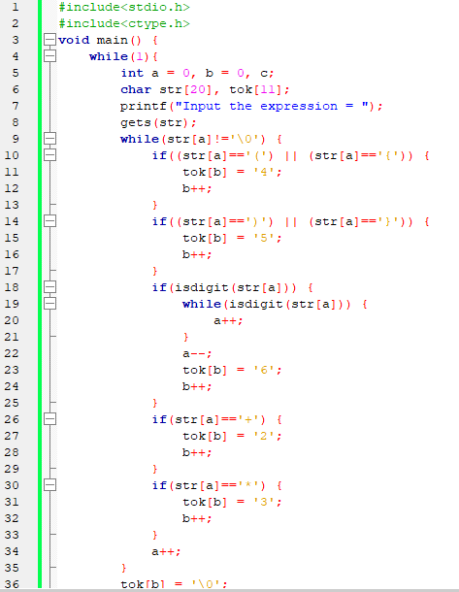 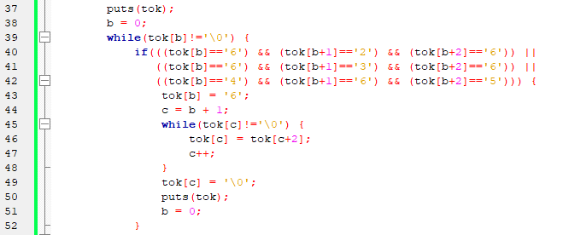

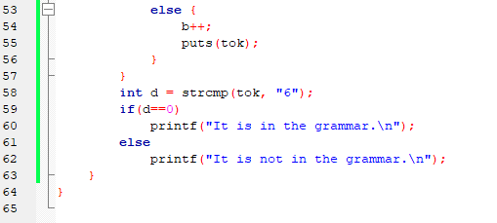

**OUTPUT:**

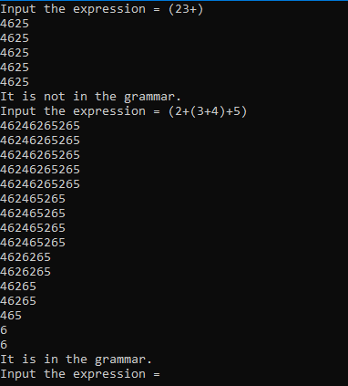

**PRACTICAL - 3**

**AIM:** TO CALCULATE LEADING OF NON-TERMINALS

**ALGORITHM**

1. Start
2. For each nonterminal A and terminal a **do** L (A, a) := **false;**
3. For each production of the form A->a or A->B **do** INSTALL (A, a);
4. **While STACK** not empty **repeat** step 5& 6
5. Pop top pair (B, a) from STACK;
6. For each production of the form A->B **do** INSTALL (A, a)
7. Stop

**Algorithm for INSTALL (A, a)**

1. Start
2. If L (A, a) not present do step 3 and 4.
3. Make L (A, a) = True
4. Push (A, a) onto stack
5. Stop

**PROGRAM IS TO CALCULATE LEADING FOR ALL THE NON-TERMINALS OF THE GIVEN GRAMMAR**

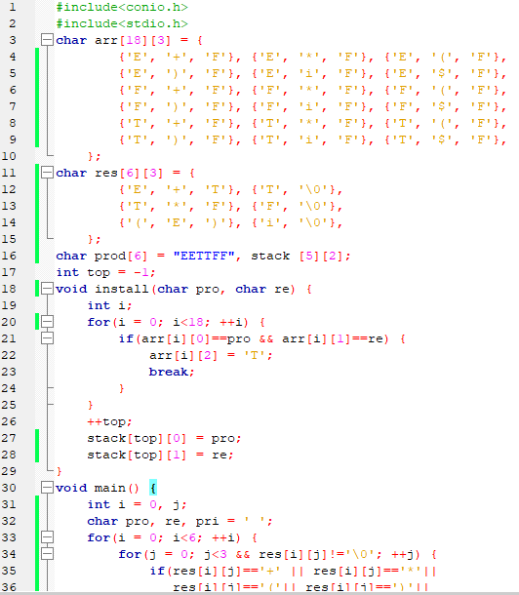 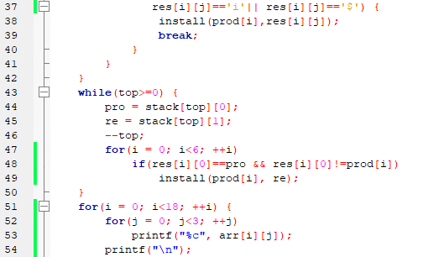

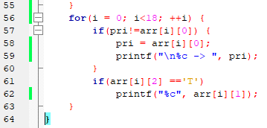

**OUTPUT:**

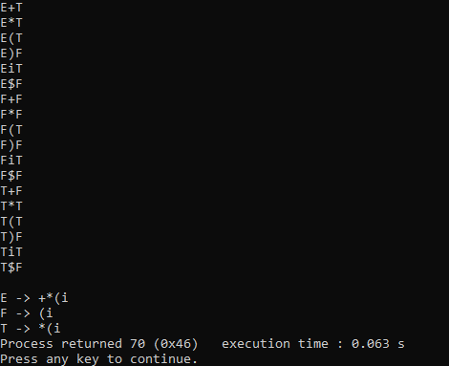

**PRACTICAL - 4**

**AIM:** TO CALCULATE TRAILING FOR ALL THE NON-TERMINALS OF THE GIVEN GRAMMMAR

**ALGORITHM**

1. Start
2. For each non terminal A and terminal a do L(A, a):= false;
3. For each production of the form A->a(alpha) or A-> Ba(alpha) do INSTALL(A, a)
4. While STACK not empty repeat 5 and 6
5. Pop top pair from stack
6. For each production of the form A-> B(alpha) do INSTALL(A, a)
7. Stop

**Algorithm For INSTALL(A, a)**

1. Start
2. If L [A, a] not present repeat step 3 and 4
3. Make L (A, a) = True
4. Push (A, a) onto stack
5. Stop

**PROGRAM IS TO CALCULATE TRAILING FOR ALL THE NON-TERMINALS OF THE GIVEN GRAMMMAR**

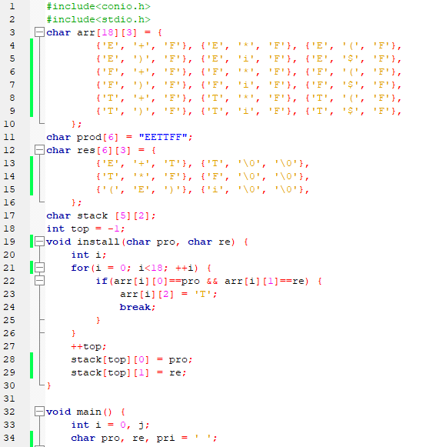 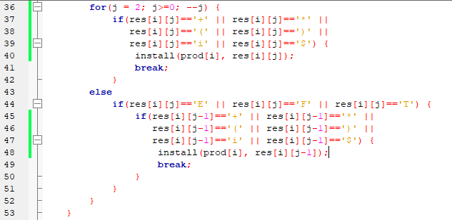 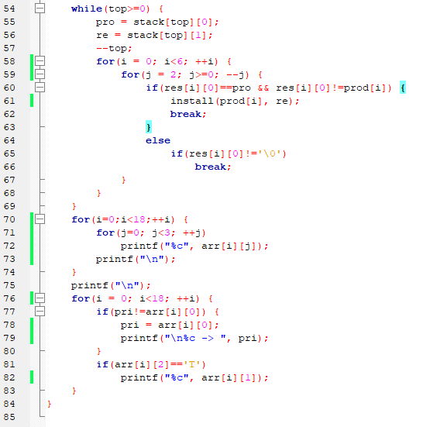**OUTPUT:**

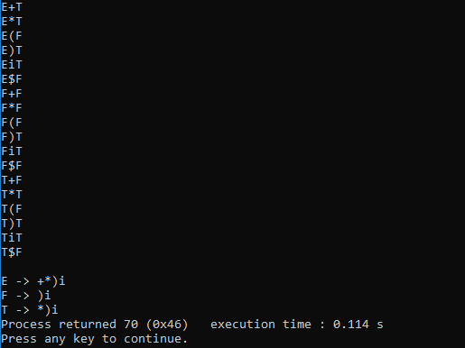

**PRACTICAL - 5**

**AIM:** PROGRAM FOR COMPUTATION OF FIRST

**ALGORITHM**

To compute FIRST(X) for all grammar symbols x, apply the following rules until no more terminals can be added to any FIRST set.

1. if X is terminal, then FIRST(X) is {X}.
2. if X is nonterminal and X-> aα is a production, then add a to FIRST(X). if X->€ to FIRST(X)
3. if -> Y1, Y2……. Yk is a production, then for all i such that all of Y1…. Yi-1 are nonterminals and FIRST(Yj) contains € for j=1, 2…… i-1, add every non-€ symbol in FIRST(Y1) to FIRST(x). if V is in FIRST(Yj) for j=1, 2………k, then add € to FIRST(X).

**PROGRAM FOR COMPUTATION OF FIRST**

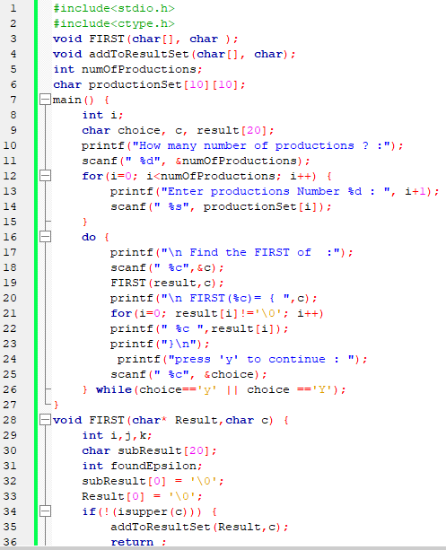 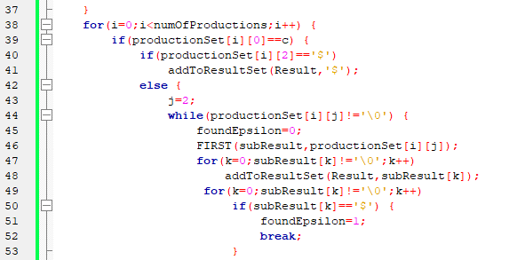 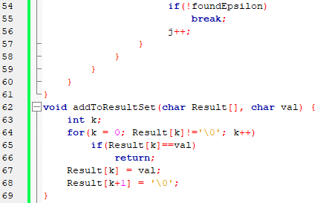

**OUTPUT:**

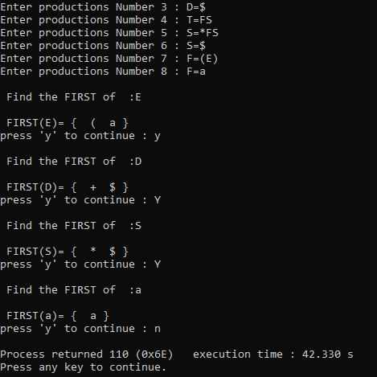

**PRACTICAL - 6**

**Program for Implementation of Predictive Parser.**

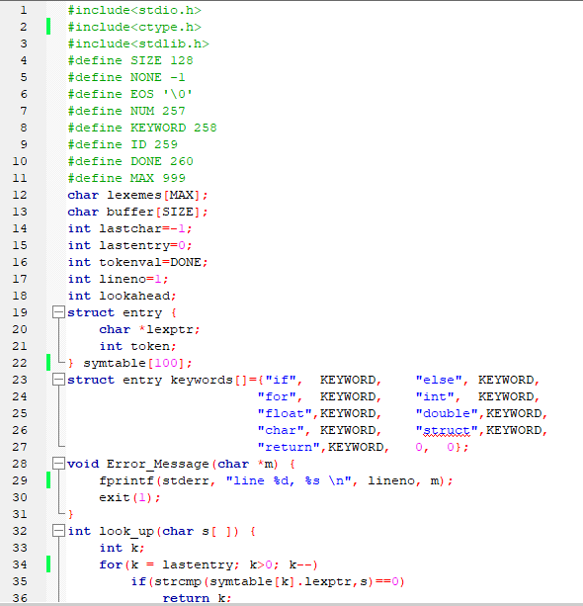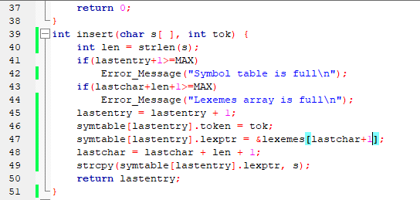

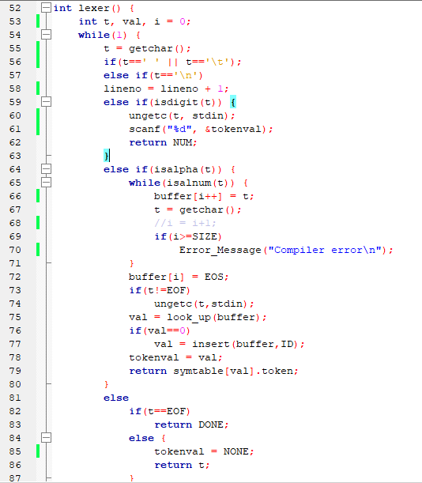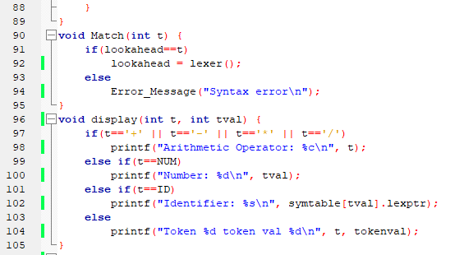

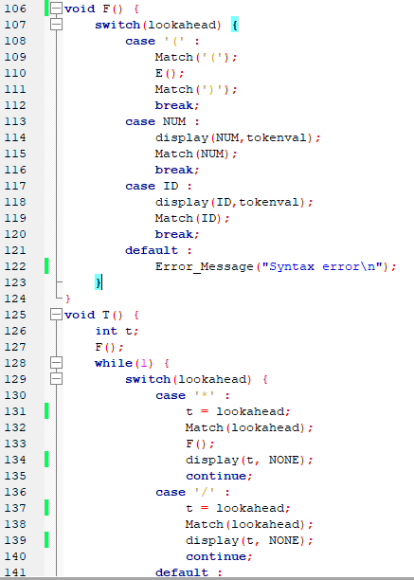 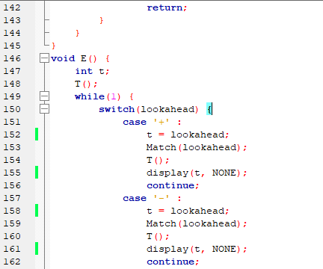

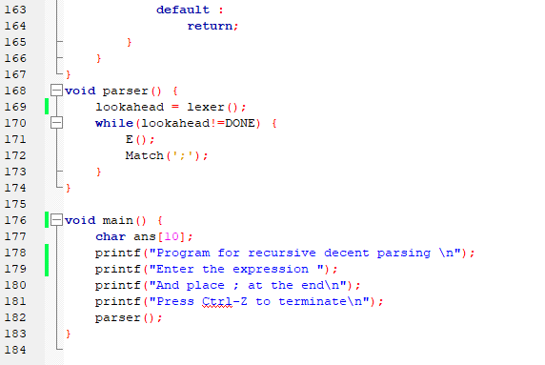

**OUTPUT:**

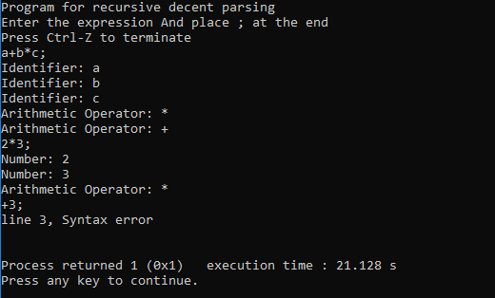

**PRACTICAL - 7**

Write a programme to design LALR Bottom up parser.

**Program:**

parser.y

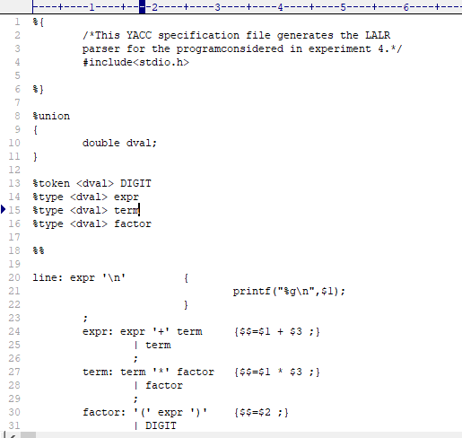

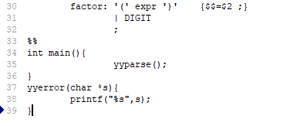

parser.l

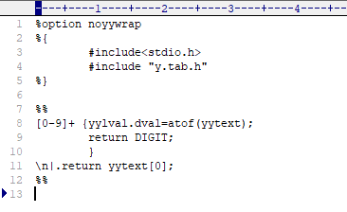

**OUTPUT:**

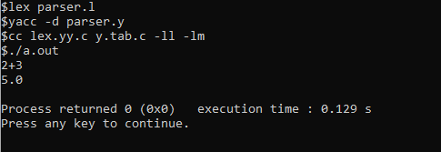**PRACTICAL - 8**

**PROGRAM TO FIND THE NUMBER OF WHITESPACES AND NEWLINES CHARACTERS**

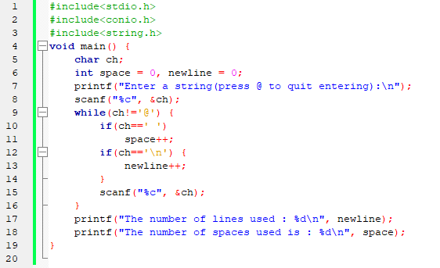

**OUTPUT:**

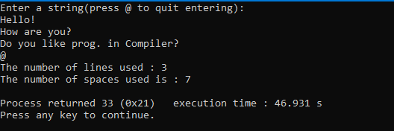

**PRACTICAL - 9**

**Write a program to compute FOLLOW (A)**

**ALGORITHM**

Step 1: Start

Step 2: Declare FILE *fp

Step 3: open the file in.txt in write mode

Step 4: Read the Productions

Step 5: Compute Follow function

Step 6: stop the productions.

**PROGRAM TO COMPUTE FOLLOW (A)**

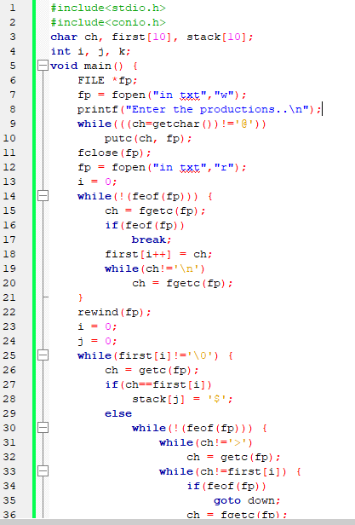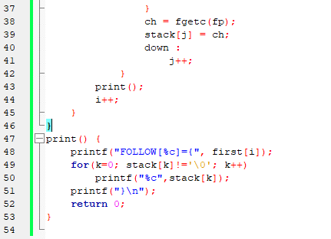

**OUTPUT:**

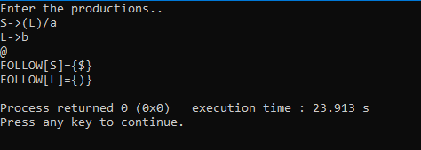

**PRACTICAL - 10**

**Program to implement operator precedence parsing.**

**ALGORITHM**

Step 1: start.

Step 2: Declare the prototypes for functions.

Step 3: Enter the String like id*id+id

Step 4: Read the string and analyze tokens, identifiers, variables.

Step 5: Display the operator precedence table.

Step 6: stop.

**Program to implement operator precedence parsing.**

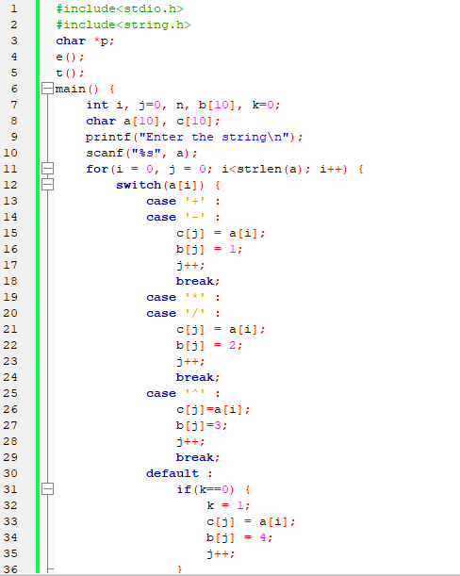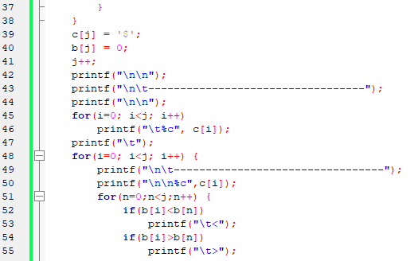

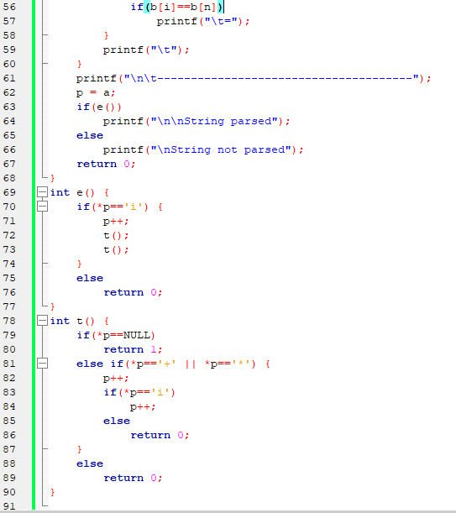

**OUTPUT:**

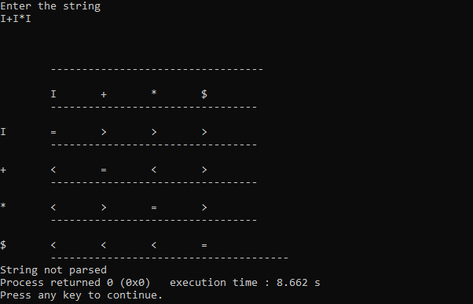

**PRACTICAL - 11**

**Program on recursive descendent parsing.**

**ALGORITHM**

Step 1: start.

Step 2: Declare the prototype functions E() , EP(),T(), TP(),F()

Step 3: Read the string to be parsed.

Step 4: Check the productions

Step 5: Compare the terminals and Non-terminals

Step 6: Read the parse string.

Step 7: stop the production

**Program on recursive descendent parsing.**

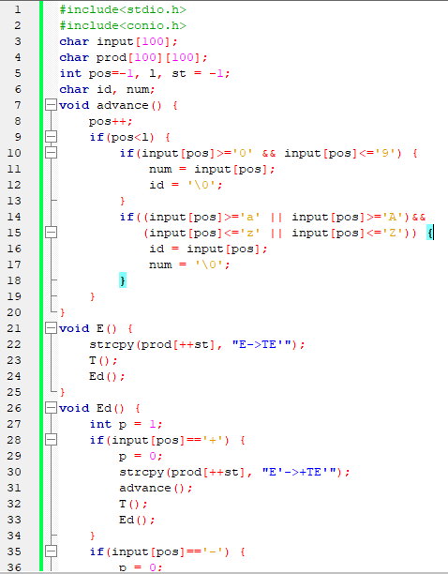 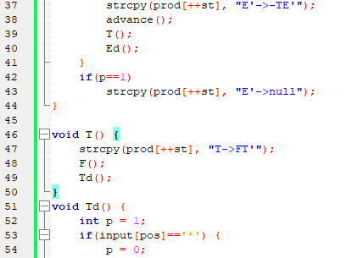 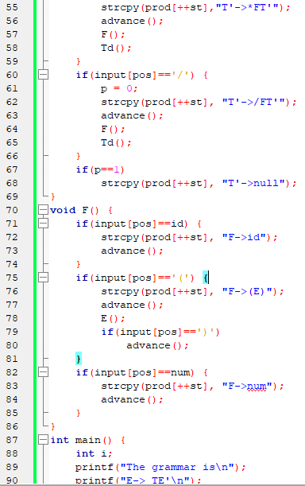 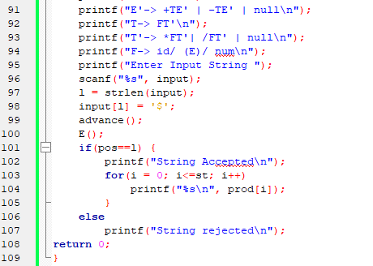

**OUTPUT:**

