Employee Absenteeism

*Chunnu Agrawal*

23rd December 2018

Table of Contents

1. Introduction 3

1.1 Problem Statement 3

1.2 Data Sets 3

2. Methodology 5

2.1 Data Preprocessing 5

2.1.1 Missing Value Analysis 5

2.1.2 Outlier Analysis 6

2.1.3 Data Visualization 7

2.1.4 Univariate Analysis **Error! Bookmark not defined.**

2.2 Feature Engineering **Error! Bookmark not defined.**

3. Modelling 8

3.1 Decision Tree 8

3.2 Random Forest 9

4. Conclusion 11

4.1 Model Evaluation 11

Appendix A 12

R Code 12

Python Code 18

# Introduction

## Problem Statement

XYZ is a courier company. As we appreciate that human capital plays an important role in collection, transportation and delivery. The company is passing through genuine issue of Absenteeism. The company has shared it dataset and requested to have an answer on the following areas:

**1.** What changes company should bring to reduce the number of absenteeism?

**2.** How much losses every month can we project in 2011 if same trend of

Absenteeism continues?

## Data Sets

Information is portrayed upon parameters, for example, the Reason for Absence, different things included, medical problem or outstanding burden would be the reason. The table speaks to an example of different fields accessible in the information.

**Table 1.1** Absenteeism at Work

|  |  |  |  |  |  |  |  |  |  |  |  |
| --- | --- | --- | --- | --- | --- | --- | --- | --- | --- | --- | --- |
| ID | Reason for absence | Month of absence | Day of the week | Seasons | Transportation expense | Distance from Residence to Work | Service time | Age | Work load Average/day | Hit target | Disciplinary failure |
| 11 | 26 | 7 | 3 | 1 | 289 | 36 | 13 | 33 | 239,554 | 97 | 0 |
| 36 | 0 | 7 | 3 | 1 | 118 | 13 | 18 | 50 | 239,554 | 97 | 1 |
| 3 | 23 | 7 | 4 | 1 | 179 | 51 | 18 | 38 | 239,554 | 97 | 0 |
| 7 | 7 | 7 | 5 | 1 | 279 | 5 | 14 | 39 | 239,554 | 97 | 0 |
| 11 | 23 | 7 | 5 | 1 | 289 | 36 | 13 | 33 | 239,554 | 97 | 0 |

|  |  |  |  |  |  |  |  |  |
| --- | --- | --- | --- | --- | --- | --- | --- | --- |
| Education | Son | Social drinker | Social smoker | Pet | Weight | Height | Body mass index | Absenteeism time in hours |
| 1 | 2 | 1 | 0 | 1 | 90 | 172 | 30 | 4 |
| 1 | 1 | 1 | 0 | 0 | 98 | 178 | 31 | 0 |
| 1 | 0 | 1 | 0 | 0 | 89 | 170 | 31 | 2 |
| 1 | 2 | 1 | 1 | 0 | 68 | 168 | 24 | 4 |

As should be obvious in the table underneath we have the accompanying 21 factors, utilizing which we need to accurately anticipate the Employee Absenteeism time in hour for our objective variable.

Synopsis of information is offered underneath to realize factors types and measurement of information.

**Fig 1.1** Summary of data

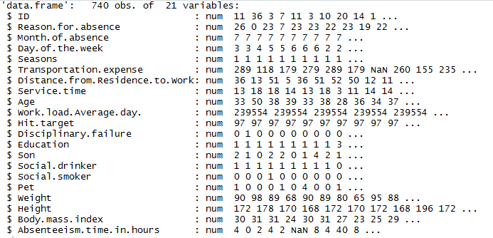

# Methodology

## 2.1 Data Preprocessing

### Information in genuine world is messy it of no utilization until the point when except if we apply information pre-processing on it. At the end of the day, Pre-preparing alludes to the changes connected to your information before encouraging it to the calculation. It's an information mining procedure which that includes changing crude information into a reasonable organization or we can state that it gets ready crude information to additionally preparing. There are such huge numbers of things that we do in information preprocessing like information cleaning, information reconciliation, information change, or information decrease.

### 2.1.1 Missing Value Analysis

Missing Values Analysis is using to fill NULL values in data with some imputation techniques but here in our Employee Absenteeism Data, we have null Values. By the way our data contain missing value. We will impute those values using KNN.

**Fig 2.1** Number of missing Values

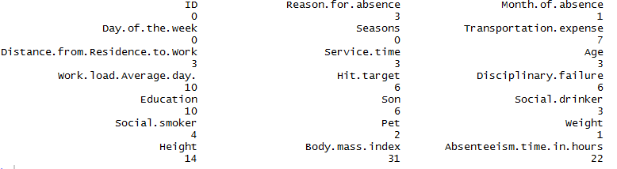

2.1.2 Outlier Analysis

The demonstrated boxplot Fig: 2.3 alludes anomalies on the indicator’s factors, we can see different exceptions related with the highlights. Even though, the information has significant measure of exceptions, the methodology is to hold each anomaly and snatch individual conduct all things considered. As appeared, there are critical measure of anomalies present in the objective variable, which demonstrates a pattern on Employee ' conduct, there can be design, we have to treat those exceptions.

**Fig 2.3** Outlier Values

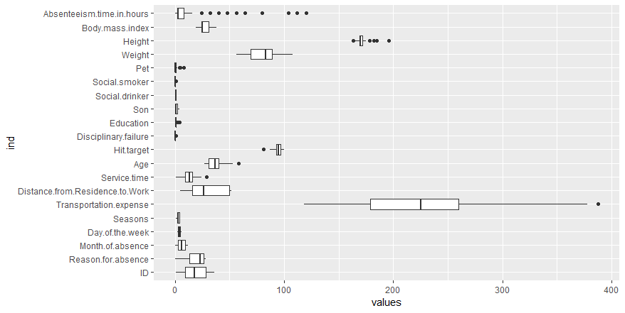

### 2.1.3 Data Visualization

Information Visualization is essential idea it will assist us with understanding information and will disclose to us reply of different inquiries likewise it will indicate connection between factors. Information perception alludes to the graphical portrayal of data and information. By utilizing visual components like outlines, diagrams, and maps, information perception is an available method to see and comprehend patterns, anomalies, and examples in information.

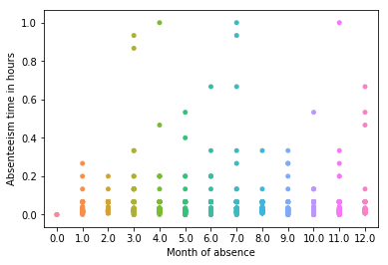 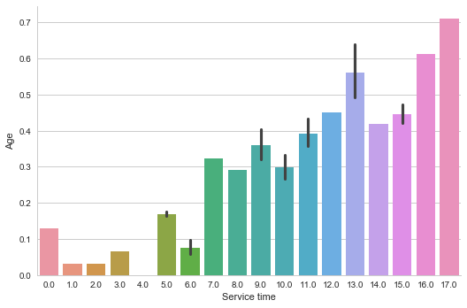

From above figure we can see that *Employees* absent in several months contain pattern, Employees are of more age have relation with Service time.

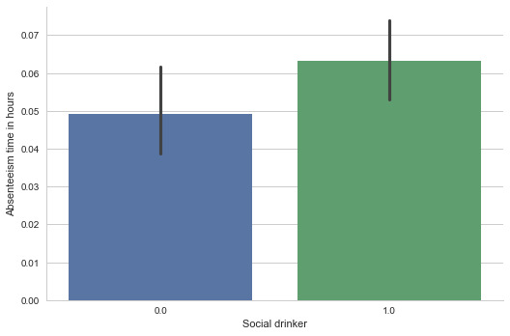 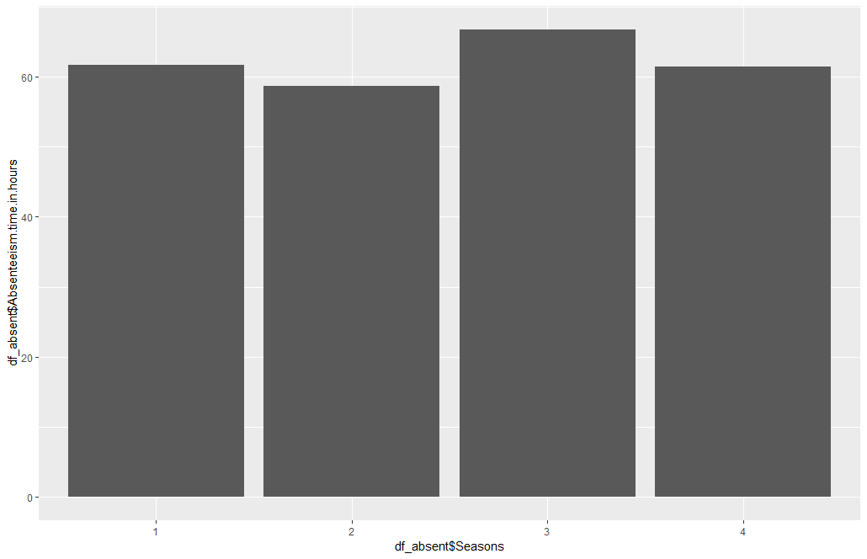

From above figure we can see that Drinkers took more leaves.

# Modelling

Absenteeism at work is a regression problem. Here according to the problem statement, we are supposed to predict the loss incurred by the company if the same pattern of absenteeism continues. Hence, we are selection the following two models,

1. Decision tree
2. Random forest model

Both training models Decision tree and random forest were implemented in R and python. After building an initial model, performance tuning was done using hyper parameter tuning for optimized parameters.

## 3.1 Decision Tree

Train data was divided into train dataset and validation set.

• Logistic regression models were trained on train dataset.

• Validation set, and AIC score was used to select the best models out of all trained models.

• Final test and prediction were performed on test data which was provided separately.

R implementation:

#decision tree analysis

#rpart for regression

fit = rpart(Absenteeism.time.in.hours ~ ., data = train, method = "anova")

#Predict for new test cases

predictions_DT = predict(fit, test[,-16])

#MAPE

#calculate MAPE

MAPE = function(y, yhat){

mean(abs((y - yhat)/y))*100

}

MAPE(test[,16], predictions_DT)

Python implementation:

*# Decision Tree*

*#Decision tree for regression*

fit_DT = DecisionTreeRegressor(max_depth=2).fit(train.iloc[:,0:9], train.iloc[:,9])

*#checking for any missing valuses that has leeked in*

np.where(Absenteeism_at_work.values >= np.finfo(np.float64).max)

np.isnan(Absenteeism_at_work.values.any())

test = test.fillna(train.mean())

*#Decision tree for regression*

fit_DT = DecisionTreeRegressor(max_depth=2).fit(train.iloc[:,0:15], train.iloc[:,15])

Absenteeism_at_work.shape

*#Apply model on test data*

predictions_DT = fit_DT.predict(test.iloc[:,0:15])

**def** rmse(predictions, targets):

**return** np.sqrt(((predictions - targets) ** 2).mean())

rmse(test.iloc[:,15], predictions_DT)

## 3.2 Random Forest

After decision tree, random forest was trained. It was implemented in both R and python. In both implementations random forest was first trained with default setting and the hyper parameters tuning was used to find the best parameters.

R Implementation:

#Random Forest

library(randomForest)

RF_model = randomForest(Absenteeism.time.in.hours ~ ., train, importance = TRUE, ntree = 1000)

#Extract rules fromn random forest

#transform rf object to an inTrees' format

library(RRF)

library(inTrees)

treeList <- RF2List(RF_model)

#Extract rules

exec = extractRules(treeList, train[,-16]) # R-executable conditions

ruleExec <- extractRules(treeList,train[,-16],digits=4)

#Make rules more readable:

readableRules = presentRules(exec, colnames(train))

readableRules[1:2,]

#Get rule metrics

ruleMetric = getRuleMetric(exec, train[,-16], train$Absenteeism.time.in.hours) # get rule metrics

#Predict test data using random forest model

RF_Predictions = predict(RF_model, test[,-16])

Python implementation:

*#Divide data into train and test*

X = Absenteeism_at_work.values[:, 0:15]

Y = Absenteeism_at_work.values[:,15]

X_train, X_test, y_train, y_test = train_test_split( X, Y, test_size = 0.2)

*#Random Forest*

**from** **sklearn.ensemble** **import** RandomForestClassifier

RF_model = RandomForestClassifier(n_estimators = 20).fit(X_train, y_train)

RF_Predictions = RF_model.predict(X_test)

# Conclusion

## 4.1 Model Evaluation

As we can see, we have applied all the possible preprocessing analysis to our dataset to make it suitable

For calculation.

We have also removed the missing values and outliers.

Now since our data is a regression model, we have applied suitable models

Such as decision tree and random forest.

The error metric results of both the models are as follows,

**Using R,**

**Rmse** value applying decision tree, **0.222542**

This means that our predictions vary from the actual value by about 0.222542

**Rmse** value using random forest, **0.2065729**

This means that our predictions vary from the actual value by about 0.2065729

**Using python,**

**Rmse** value applying decision tree, **0.22594499**

This means that our predictions vary from the actual value by about 0.22594499

**Rmse** value using random forest**, 0.2076225**

This means that our predictions vary from the actual value by about 0.20762259

Hence comparing R and python, since the error rate of R is comparatively better, we consider the code of R

AND on comparing the values of decision tree and random forest, since the error rate of random forest is comparatively better, we consider the value of random forest.

**Hence, finally, we are accepting the random forest model of R, which has an RMSE value of 0.2065729, which is negligible.**

# Appendix A

## R Code

#remove all the objects stored

rm(list=ls())

#set current working directory

setwd("F:/Edwisor/Data Science/Project Work/Employee-Absenteeism-master")

#Check workin directory path

getwd()

library(readxl)

library(dplyr)

library(corrplot)

library(ggplot2)

library(tidyverse)

library(randomForest)

library(data.table)

library(rpart)

## Read the data

absent_data <- read_excel("Absenteeism_at_work_Project.xls", sheet = 1)

## Changing the continous variables to categorical variables

##for getting ease performance of data

absent_data$Reason.for.absence = as.factor(absent_data$Reason.for.absence)

absent_data$Month.of.absence = as.factor(absent_data$Month.of.absence)

absent_data$Day.of.the.week = as.factor(absent_data$Day.of.the.week)

absent_data$Seasons = as.factor(absent_data$Seasons)

absent_data$Service.time = as.factor(absent_data$Service.time)

absent_data$Hit.target = as.factor(absent_data$Hit.target)

absent_data$Disciplinary.failure = as.factor(absent_data$Disciplinary.failure)

absent_data$Education = as.factor(absent_data$Education)

absent_data$Son = as.factor(absent_data$Son)

absent_data$Social.drinker = as.factor(absent_data$Social.drinker)

absent_data$Social.smoker = as.factor(absent_data$Social.smoker)

absent_data$Pet = as.factor(absent_data$Pet)

absent_data$Work.load.Average.day = as.numeric(absent_data$Work.load.Average.day)

## Outlier analysis

outlierKD <- function (dt, var) {

var_name <- eval(substitute(var), eval(dt))

na1 <- sum(is.na(var_name))

m1 <- mean (var_name, na.rm = T)

par (mfrow=c(2, 2), oma=c(0,0,3,0))

boxplot (var_name, main="With outliers")

hist (var_name, main="With outliers", xlab=NA, ylab=NA)

outlier <- boxplot.stats(var_name)$out

mo <- mean(outlier)

var_name <- ifelse(var_name %in% outlier, NA, var_name)

boxplot(var_name, main="Without outliers")

hist(var_name, main="Without outliers", xlab=NA, ylab=NA)

title("Outlier Check", outer=TRUE)

na2 <- sum(is.na(var_name))

cat("Outliers identified:", na2 - na1, "n")

cat("Propotion (%) of outliers:", round((na2 - na1) / sum(!is.na(var_name))*100, 1), "n")

cat("Mean of the outliers:", round(mo, 2), "n")

m2 <- mean(var_name, na.rm = T)

cat("Mean without removing outliers:", round(m1, 2), "n")

cat("Mean if we remove outliers:", round(m2, 2), "n")

response <- readline(prompt="Do you want to remove outliers and to replace with NA? [yes/no]: ")

if(response == "y" | response == "yes"){

dt[as.character(substitute(var))] <- invisible(var_name)

assign(as.character(as.list(match.call())$dt), dt, envir = .GlobalEnv)

cat("Outliers successfully removed", "n")

return(invisible(dt))

} else{

cat("Nothing changed", "n")

return(invisible(var_name))

}

}

outlierKD(absent_data,Absenteeism.time.in.hours)# outliers detected and replaced by NA

outlierKD(absent_data,Transportation.expense) #no outliers

outlierKD(absent_data,Distance.from.Residence.to.Work) #no outliers

outlierKD(absent_data,Service.time) #no outliers

outlierKD(absent_data,Age) #no outliers

outlierKD(absent_data,Work.load.Average.day.) # 1 found and replaced with NA

outlierKD(absent_data,Hit.target) # 1 found and replaced with NA

outlierKD(absent_data,Son) # no outliers

outlierKD(absent_data,Pet) # no outliers

outlierKD(absent_data,Weight) # no outliers

outlierKD(absent_data,Height) # no outliers

outlierKD(absent_data,Body.mass.index) #no outliers

################################## Missing value analysis ##################################

missing_val = data.frame(apply(absent_data,2,function(x){sum(is.na(x))}))

missing_val$Columns = row.names(missing_val)

names(missing_val)[1] = "Missing_percentage"

missing_val$Missing_percentage = (missing_val$Missing_percentage/nrow(absent_data)) * 100

missing_val = missing_val[order(-missing_val$Missing_percentage),]

row.names(missing_val) = NULL

missing_val = missing_val[,c(2,1)]

write.csv(missing_val, "Miising_perc.csv", row.names = F)

#ggplot analysis

ggplot(data = missing_val[1:3,], aes(x=reorder(Columns, -Missing_percentage),y = Missing_percentage))+

geom_bar(stat = "identity",fill = "grey")+xlab("Parameter")+

ggtitle("Missing data percentage (Train)") + theme_bw()

library(ggplot2)

#actual value =30

#absent_data[1,20]

#absent_data[1,20]= NA

# kNN Imputation=29.84314

#after various calculations, it is found that knn imputation method suits the best for the data. hence here we are applying knn imputation

################################## feature selection ##################################

library(corrgram)

## Correlation Plot - to check multicolinearity between continous variables

corrgram(absent_data[,numeric_index], order = F,

upper.panel=panel.pie, text.panel=panel.txt, main = "Correlation Plot")

absent_data$Absenteeism.time.in.hours = as.factor(absent_data$Absenteeism.time.in.hours)

## Chi-squared Test of Independence-to check the multicolinearity between categorical variables

factor_index = sapply(absent_data,is.factor)

factor_data = absent_data[,factor_index]

for (i in 1:12)

{

print(names(factor_data)[i])

print(chisq.test(table(factor_data$Absenteeism.time.in.hours,factor_data[,i])))

}

absent_data$Absenteeism.time.in.hours = as.numeric(absent_data$Absenteeism.time.in.hours)

################################### Feature reduction ##################################

## Dimension Reduction

absent_data = subset(absent_data,

select = -c(Weight,Hit.target,Education,Social.smoker,Pet))

#Feature Scaling

#Normality check

qqnorm(absent_data$Absenteeism.time.in.hours )

hist(absent_data$Absenteeism.time.in.hours )

str(absent_data)

#Normalisation

cnames = c("ID","Transportation.expense","Distance.from.Residence.to.Work","Height","Age","Work.load.Average.day","Body.mass.index",

"Absenteeism.time.in.hours")

for(i in cnames){

print(i)

absent_data[,i] = (absent_data[,i] - min(absent_data[,i]))/

(max(absent_data[,i] - min(absent_data[,i])))

}

########################## Univariate Distribution and Analysis ###############################

# function for univariate analysis for continous variables

# function inpus:

# 1. dataset - input dataset

# 2. variable - variable for univariate analysis

# 3. variableName - variable title in string

# example. univariate_analysis(absent_data,Absenteeism.time.in.hours,

# "Absenteeism.time.in.hours")

univariate_analysis <- function(dataset, variable,variableName){

var_name = eval(substitute(variable), eval(dataset))

if(is.numeric(var_name)){

print(summary(var_name))

ggplot(absent_data, aes(var_name)) +

geom_histogram(aes(y=..density..,binwidth=.5,colour="black", fill="white"))+

geom_density(alpha=.2, fill="#FF6666")+

labs(x = variableName, y = "count") +

ggtitle(paste("count of ",variableName)) +

theme(legend.position = "null")

}else{

print("This is categorical variable.")

}

}

# function for univariate analysis for categorical variables

# function inpus:

# 1. dataset - input dataset

# 2. variable - variable for univariate analysis

# 3. variableName - variable title in string

# example. univariate_analysis(absent_data,ID,

# "ID")

univariate_catogrical <- function(dataset,variable, variableName){

variable <- enquo(variable)

percentage <- dataset %>%

select(!!variable) %>%

group_by(!!variable) %>%

summarise(n = n()) %>%

mutate(percantage = (n / sum(n)) * 100)

print(percentage)

dataset %>%

count(!!variable) %>%

ggplot(mapping = aes_(x = rlang::quo_expr(variable),

y = quote(n), fill = rlang::quo_expr(variable))) +

geom_bar(stat = 'identity',

colour = 'white') +

labs(x = variableName, y = "count") +

ggtitle(paste("count of ",variableName)) +

theme(legend.position = "bottom") -> p

plot(p)

}

## Sampling

##Systematic sampling

#Function to generate Kth index

sys.sample = function(N,n)

{

k = ceiling(N/n)

r = sample(1:k, 1)

sys.samp = seq(r, r + k*(n-1), k)

}

lis = sys.sample(740, 300) #select the repective rows

# #Create index variable in the data

absent_data$index = 1:740

# #Extract subset from whole data

systematic_data = absent_data[which(absent_data$index %in% lis),]

################################### Model Development ##################################

#Clean the environment

library(DataCombine)

rmExcept("absent_data")

#Divide data into train and test using stratified sampling method

set.seed(1234)

absent_data$description = NULL

library(caret)

train.index = createDataPartition(absent_data$Absenteeism.time.in.hours, p = .80, list = FALSE)

train = absent_data[ train.index,]

test = absent_data[-train.index,]

#load libraries

library(rpart)

#decision tree analysis

#rpart for regression

fit = rpart(Absenteeism.time.in.hours ~ ., data = train, method = "anova")

#Predict for new test cases

predictions_DT = predict(fit, test[,-16])

#MAPE

#calculate MAPE

MAPE = function(y, yhat){

mean(abs((y - yhat)/y))*100

}

MAPE(test[,16], predictions_DT)

#Random Forest

RF_model = randomForest(Absenteeism.time.in.hours ~ ., train, importance = TRUE, ntree = 1000)

#Extract rules

exec = extractRules(treeList, train[,-16]) # R-executable conditions

ruleExec <- extractRules(treeList,train[,-16],digits=4)

#Make rules more readable:

readableRules = presentRules(exec, colnames(train))

readableRules[1:2,]

#Get rule metrics

ruleMetric = getRuleMetric(exec, train[,-16], train$Absenteeism.time.in.hours) # get rule metrics

#Predict test data using random forest model

RF_Predictions = predict(RF_model, test[,-16])

#rmse calculation

#install.packages("Metrics")

library(Metrics)

rmse(test$Absenteeism.time.in.hours, RF_Predictions)

#rmse value for random forest is 0.2065729

rmse(test$Absenteeism.time.in.hours, predictions_DT)

#rmse value for decision tree is 0.222542

## Python Code

*#Load libraries*

**import** **os**

**import** **pandas** **as** **pd**

**import** **numpy** **as** **np**

**import** **matplotlib.pyplot** **as** **plt**

**from** **scipy.stats** **import** chi2_contingency

**import** **seaborn** **as** **sns**

**from** **random** **import** randrange, uniform

**from** **sklearn.cross_validation** **import** train_test_split

**from** **sklearn.tree** **import** DecisionTreeRegressor

**from** **sklearn** **import** linear_model

**from** **sklearn.cross_validation** **import** train_test_split

*#Set working directory*

os.chdir("C:/Users/SHRAVYA/Desktop/edwisor/project 1")

*#Load data*

Absenteeism_at_work = pd.read_csv("Absenteeism_at_work_Project.csv")

*#----------------PRE-PROCESSING-EXPLORATORY DATA ANALYSIS--------------#*

*#Exploratory Data Analysis*

Absenteeism_at_work['Reason for absence']=Absenteeism_at_work['Reason for absence'].astype(object)

Absenteeism_at_work['Month of absence']=Absenteeism_at_work['Month of absence'].astype(object)

Absenteeism_at_work['Day of the week']=Absenteeism_at_work['Day of the week'].astype(object)

Absenteeism_at_work['Seasons']=Absenteeism_at_work['Seasons'].astype(object)

Absenteeism_at_work['Service time']=Absenteeism_at_work['Service time'].astype(object)

Absenteeism_at_work['Hit target']=Absenteeism_at_work['Hit target'].astype(object)

Absenteeism_at_work['Disciplinary failure']=Absenteeism_at_work['Disciplinary failure'].astype(object)

Absenteeism_at_work['Education']=Absenteeism_at_work['Education'].astype(object)

Absenteeism_at_work['Son']=Absenteeism_at_work['Son'].astype(object)

Absenteeism_at_work['Social drinker']=Absenteeism_at_work['Social drinker'].astype(object)

Absenteeism_at_work['Social smoker']=Absenteeism_at_work['Social smoker'].astype(object)

Absenteeism_at_work['Pet']=Absenteeism_at_work['Pet'].astype(object)

*#------------------------MISSING VALUE ANALYSIS--------------------------#*

*#Create dataframe with missing percentage*

missing_val = pd.DataFrame(Absenteeism_at_work.isnull().sum())

*#Reset index*

missing_val = missing_val.reset_index()

*#Rename variable*

missing_val = missing_val.rename(columns = {'index': 'Variables', 0: 'Missing_percentage'})

*#Calculate percentage*

missing_val['Missing_percentage'] = (missing_val['Missing_percentage']/len(Absenteeism_at_work))*100

*#descending order*

missing_val = missing_val.sort_values('Missing_percentage', ascending = **False**).reset_index(drop = **True**)

*#save output results*

missing_val.to_csv("Missing_perc.csv", index = **False**)

*#KNN imputation*

*#Assigning levels to the categories*

lis = []

**for** i **in** range(0, Absenteeism_at_work.shape[1]):

*#print(i)*

**if**(Absenteeism_at_work.iloc[:,i].dtypes == 'object'):

Absenteeism_at_work.iloc[:,i] = pd.Categorical(Absenteeism_at_work.iloc[:,i])

*#print(marketing_train[[i]])*

Absenteeism_at_work.iloc[:,i] = Absenteeism_at_work.iloc[:,i].cat.codes

Absenteeism_at_work.iloc[:,i] = Absenteeism_at_work.iloc[:,i].astype('object')

lis.append(Absenteeism_at_work.columns[i])

*#replace -1 with NA to impute*

**for** i **in** range(0, Absenteeism_at_work.shape[1]):

Absenteeism_at_work.iloc[:,i] = Absenteeism_at_work.iloc[:,i].replace(-1, np.nan)

*#Impute with median*

Absenteeism_at_work['Absenteeism time in hours'] = Absenteeism_at_work['Absenteeism time in hours'].fillna(Absenteeism_at_work['Absenteeism time in hours'].median())

Absenteeism_at_work['Body mass index'] = Absenteeism_at_work['Body mass index'].fillna(Absenteeism_at_work['Body mass index'].median())

Absenteeism_at_work['Height'] = Absenteeism_at_work['Height'].fillna(Absenteeism_at_work['Height'].median())

Absenteeism_at_work['Weight'] = Absenteeism_at_work['Weight'].fillna(Absenteeism_at_work['Weight'].median())

Absenteeism_at_work['Pet'] = Absenteeism_at_work['Pet'].fillna(Absenteeism_at_work['Pet'].median())

Absenteeism_at_work['Social smoker'] = Absenteeism_at_work['Social smoker'].fillna(Absenteeism_at_work['Social smoker'].median())

Absenteeism_at_work['Social drinker'] = Absenteeism_at_work['Social drinker'].fillna(Absenteeism_at_work['Social drinker'].median())

Absenteeism_at_work['Son'] = Absenteeism_at_work['Son'].fillna(Absenteeism_at_work['Son'].median())

Absenteeism_at_work['Education'] = Absenteeism_at_work['Education'].fillna(Absenteeism_at_work['Education'].median())

Absenteeism_at_work['Disciplinary failure'] = Absenteeism_at_work['Disciplinary failure'].fillna(Absenteeism_at_work['Disciplinary failure'].median())

Absenteeism_at_work['Hit target'] = Absenteeism_at_work['Hit target'].fillna(Absenteeism_at_work['Hit target'].median())

Absenteeism_at_work['Age'] = Absenteeism_at_work['Age'].fillna(Absenteeism_at_work['Age'].median())

Absenteeism_at_work['Service time'] = Absenteeism_at_work['Service time'].fillna(Absenteeism_at_work['Service time'].median())

Absenteeism_at_work['Distance from Residence to Work'] = Absenteeism_at_work['Distance from Residence to Work'].fillna(Absenteeism_at_work['Distance from Residence to Work'].median())

Absenteeism_at_work['Transportation expense'] = Absenteeism_at_work['Transportation expense'].fillna(Absenteeism_at_work['Transportation expense'].median())

Absenteeism_at_work['Month of absence'] = Absenteeism_at_work['Month of absence'].fillna(Absenteeism_at_work['Month of absence'].median())

Absenteeism_at_work['Reason for absence'] = Absenteeism_at_work['Reason for absence'].fillna(Absenteeism_at_work['Reason for absence'].median())

Absenteeism_at_work['Work load Average/day '] = Absenteeism_at_work['Work load Average/day '].fillna(Absenteeism_at_work['Work load Average/day '].median())

Absenteeism_at_work.isnull().sum()

Absenteeism_at_work = Absenteeism_at_work.dropna(how='all')

Absenteeism_at_work.isnull().sum()

cnames = ["ID", "Transportation expense", "Distance from Residence to Work", "Age", "Height", "Body mass index", "Absenteeism time in hours"]

*#-------------------FEATURE SELECTION-------------------------#*

*##Correlation analysis*

*#Correlation plot*

df_corr = Absenteeism_at_work.loc[:,cnames]

*#Set the width and hieght of the plot*

f, ax = plt.subplots(figsize=(7, 5))

*#Generate correlation matrix*

corr = df_corr.corr()

*#Plot using seaborn library*

sns.heatmap(corr, mask=np.zeros_like(corr, dtype=np.bool), cmap=sns.diverging_palette(220, 10, as_cmap=**True**),

square=**True**, ax=ax)

plt.savefig('correlation.png')

*#Chisquare test of independence*

*#Save categorical variables*

cat_names = ["Reason for absence", "Month of absence", "Day of the week", "Seasons", "Service time", "Hit target", "Disciplinary failure", "Education", "Son", "Social drinker","Social smoker","Pet"]

*#loop for chi square values*

**for** i **in** cat_names:

print(i)

chi2, p, dof, ex = chi2_contingency(pd.crosstab(Absenteeism_at_work['Absenteeism time in hours'], Absenteeism_at_work[i]))

print(p)

Reason for absence

7.262525646531397e-126

Month of absence

2.5138924624334413e-08

Day of the week

0.003021081110471532

Seasons

1.0699164671285167e-06

Service time

0.0005117811788141375

Hit target

0.0011492200973353258

Disciplinary failure

2.811327292697691e-103

Education

0.966890372726654

Son

1.548005892620854e-08

Social drinker

0.0023832329972678858

Social smoker

0.5104529781136267

Pet

0.12306376012607578

*#--------------------FEATURE SCALING--------------------------#*

*#feature reduction*

Absenteeism_at_work = Absenteeism_at_work.drop(['Weight', 'Hit target', 'Education', 'Social smoker', 'Pet'], axis=1)

*#Nomalisation*

**for** i **in** cnames:

print(i)

Absenteeism_at_work[i] = (Absenteeism_at_work[i] - min(Absenteeism_at_work[i]))/(max(Absenteeism_at_work[i]) - min(Absenteeism_at_work[i]))

ID

Transportation expense

Distance from Residence to Work

Age

Height

Body mass index

Absenteeism time in hours

*#--------------------------DATA SAMPLING------------------------------#*

*#Divide data into train and test*

train, test = train_test_split(Absenteeism_at_work, test_size=0.25, random_state=42)

*#------------------------------MODELLING----------------------------------#*

*# Decision Tree*

*#Decision tree for regression*

fit_DT = DecisionTreeRegressor(max_depth=2).fit(train.iloc[:,0:9], train.iloc[:,9])

*#checking for any missing valuses that has leeked in*

np.where(Absenteeism_at_work.values >= np.finfo(np.float64).max)

np.isnan(Absenteeism_at_work.values.any())

test = test.fillna(train.mean())

*#Decision tree for regression*

fit_DT = DecisionTreeRegressor(max_depth=2).fit(train.iloc[:,0:15], train.iloc[:,15])

Absenteeism_at_work.shape

*#Apply model on test data*

predictions_DT = fit_DT.predict(test.iloc[:,0:15])

**def** rmse(predictions, targets):

**return** np.sqrt(((predictions - targets) ** 2).mean())

rmse(test.iloc[:,15], predictions_DT)

*#rmse value using decision tree is 0.225944999314018*

*#Divide data into train and test*

X = Absenteeism_at_work.values[:, 0:15]

Y = Absenteeism_at_work.values[:,15]

X_train, X_test, y_train, y_test = train_test_split( X, Y, test_size = 0.2)

*#Random Forest*

**from** **sklearn.ensemble** **import** RandomForestClassifier

RF_model = RandomForestClassifier(n_estimators = 20).fit(X_train, y_train)

RF_Predictions = RF_model.predict(X_test)

*#---------------------PLOTS OF VARIABLES-------------------------------#*

*#plots*

**import** **matplotlib** **as** **mpl**

**import** **matplotlib.pyplot** **as** **plt**

**import** **seaborn** **as** **sns**

sns.set(style="whitegrid", color_codes=**True**)

np.random.seed(sum(map(ord, "categorical")))

Absenteeism_at_work.columns

sns.stripplot(x="Body mass index", y="Absenteeism time in hours", data=Absenteeism_at_work);

plt.savefig('Body mass index.png')

sns.stripplot(x="Reason for absence", y="Absenteeism time in hours", data=Absenteeism_at_work);

plt.savefig('Reason for absence.png')

sns.stripplot(x="Month of absence", y="Absenteeism time in hours", data=Absenteeism_at_work);

plt.savefig('Month of absence.png')

sns.stripplot(x="Day of the week", y="Absenteeism time in hours", data=Absenteeism_at_work);

plt.savefig('Day of the week.png')

sns.stripplot(x="Seasons", y="Absenteeism time in hours", data=Absenteeism_at_work);

plt.savefig('Seasons.png')

sns.stripplot(x="Transportation expense", y="Absenteeism time in hours", data=Absenteeism_at_work);

plt.savefig('Transportation expense.png')

sns.stripplot(x="Distance from Residence to Work", y="Absenteeism time in hours", data=Absenteeism_at_work);

plt.savefig('Distance from Residence to Work.png')

sns.stripplot(x="Service time", y="Absenteeism time in hours", data=Absenteeism_at_work);

plt.savefig('Service time.png')

sns.stripplot(x="Age", y="Absenteeism time in hours", data=Absenteeism_at_work);

plt.savefig('Age.png')

sns.stripplot(x="Disciplinary failure", y="Absenteeism time in hours", data=Absenteeism_at_work);

plt.savefig('Disciplinary failure.png')

sns.stripplot(x="Son", y="Absenteeism time in hours", data=Absenteeism_at_work);

plt.savefig('Son.png')

sns.stripplot(x="Social drinker", y="Absenteeism time in hours", data=Absenteeism_at_work);

plt.savefig('Social drinker.png')

sns.stripplot(x="Height", y="Absenteeism time in hours", data=Absenteeism_at_work);

plt.savefig('Height.png')