SMAI (CSE 471)
Spring-2019
Assignment-5

Suraj Garg
2018202003

1
1.1 Hyperparameters of the best performing Neural Network are as follows:

- Number of hidden layers: 1
- Size of hidden layers: 50 respectively
- Activation function used at hidden layer: Sigmoid
- Activation function used at output layer: Sigmoid
- Number epochs used in training: 20
- Batch size used in mini-batch gradient descent: 100
- Learning rate: 0.1

1.2 Effect of number of hidden layers

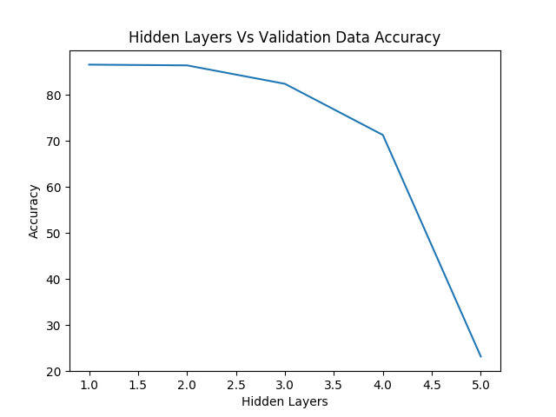

As we can clearly see at number of hidden layers = 1 the model gives the best performance and with increase of number of hidden layer leads to decrease in classification accuracy.
Also from the Prediction error vs Layers graph its evident that we get least prediction error at number of layers = 1

1.3 Effect of epochs on model training

Error vs Epochs
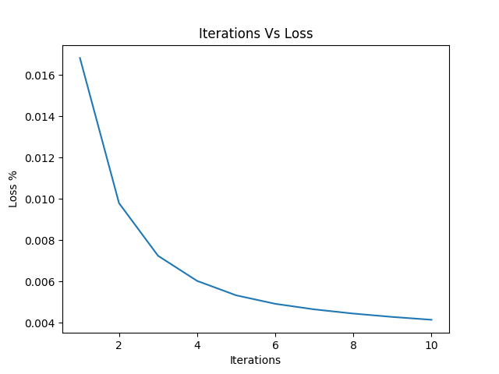

Accuracy vs Epochs:

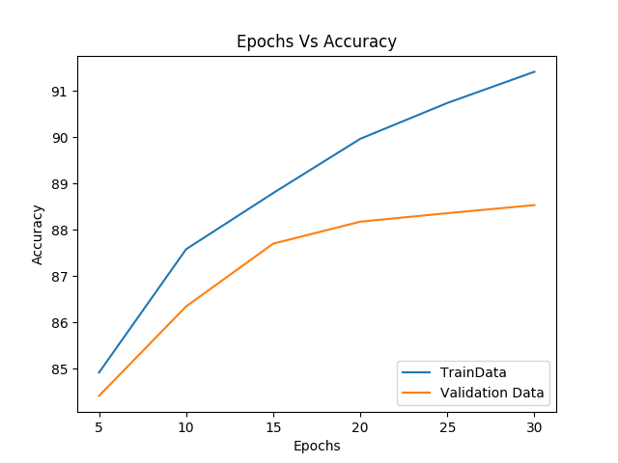

From above graph Error vs Epoch we can see that we increasing epoch the cross entropy loss decreases and it better fit the training data. From the graph Accuracy vs Epoch with increasing epochs we observe that model tries to overfit on training data which leads to decrease in accuracy on validation data.

2.

Predicting Sale price of house is a regression task. The neural network we built in first question was for classification task but it can be modified to perform regression task also.First we need to change loss function from cross entropy loss to mean square error. Secondly we need to change activation function of layers to some polynomial activation function. Third we need to have just one neuron/node at the output layer as we not doing any mulitclass classifcation here. Rest of the architecture remains mostly the same.

