1
1.1 Hyperparameters of the best performing Neural Network are as follows:

- Number of hidden layers: 1
- Size of hidden layers: 50 respectively
- Activation function used at hidden layer: Sigmoid
- Activation function used at output layer: Sigmoid
- Number epochs used in training: 20
- Batch size used in mini-batch gradient descent: 100
- Learning rate: 0.1

1.2 Effect of number of hidden layers
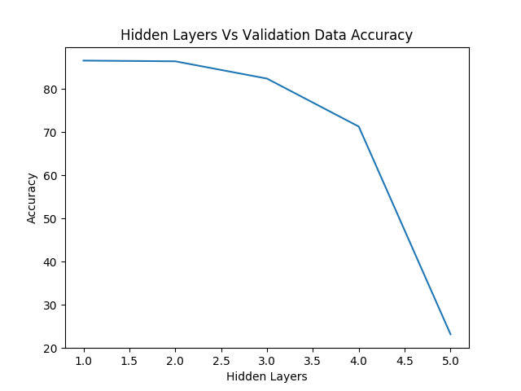

As we can clearly see at number of hidden layers = 1 the model gives the best performance and with increase of number of hidden layers leads to decrease in classification accuracy.
Also, from the Prediction error vs Layers graph its evident that we get least prediction error at number of layers = 1

1.3 Effect of epochs on model training
Error vs Epochs
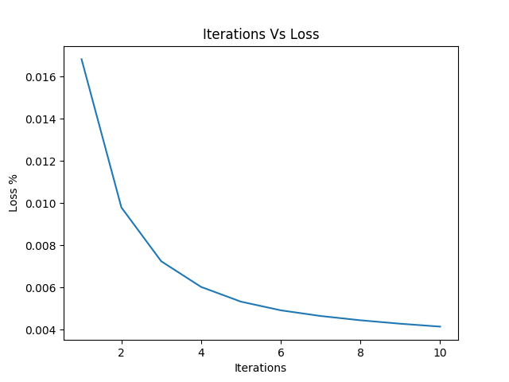

Accuracy vs Epochs:

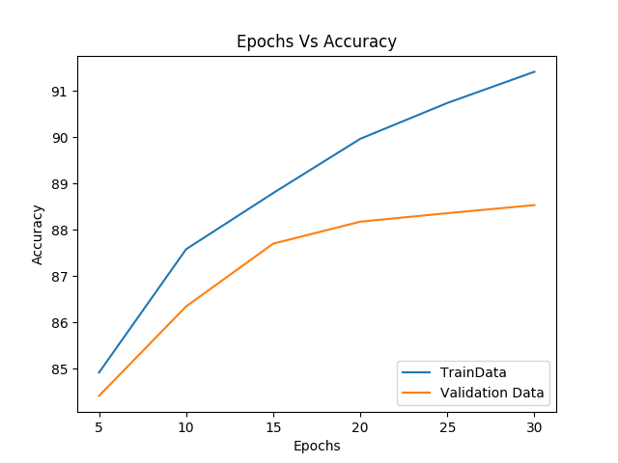

From above graph Error vs Epoch, we can see that we increasing epoch the cross-entropy loss decreases and it better fit the training data. From the graph Accuracy vs Epoch with increasing epochs we observe that model tries to overfit on training data which leads to decrease in accuracy on validation data.

