**Web_services**

**Twitter data analysis using curd operation and restful API**

**Results:**

**User tweets using curd operations in mongodb:**

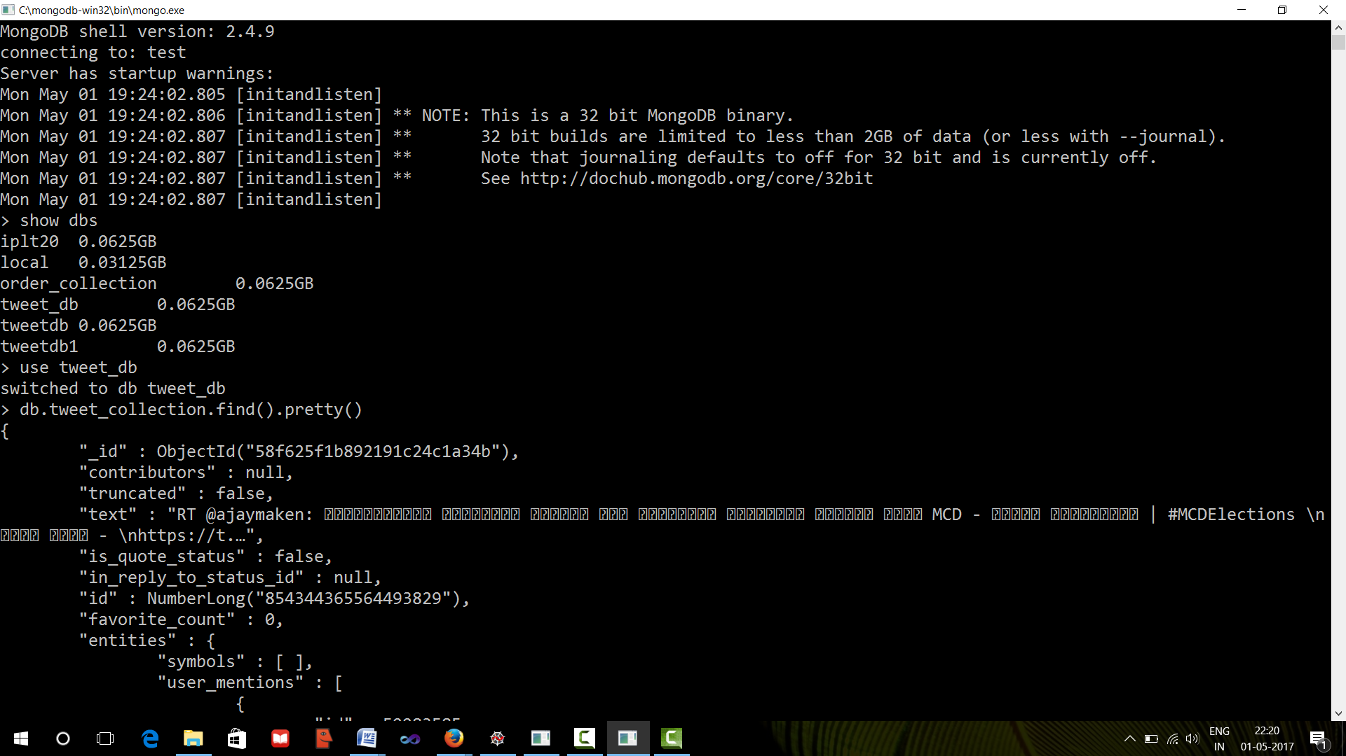

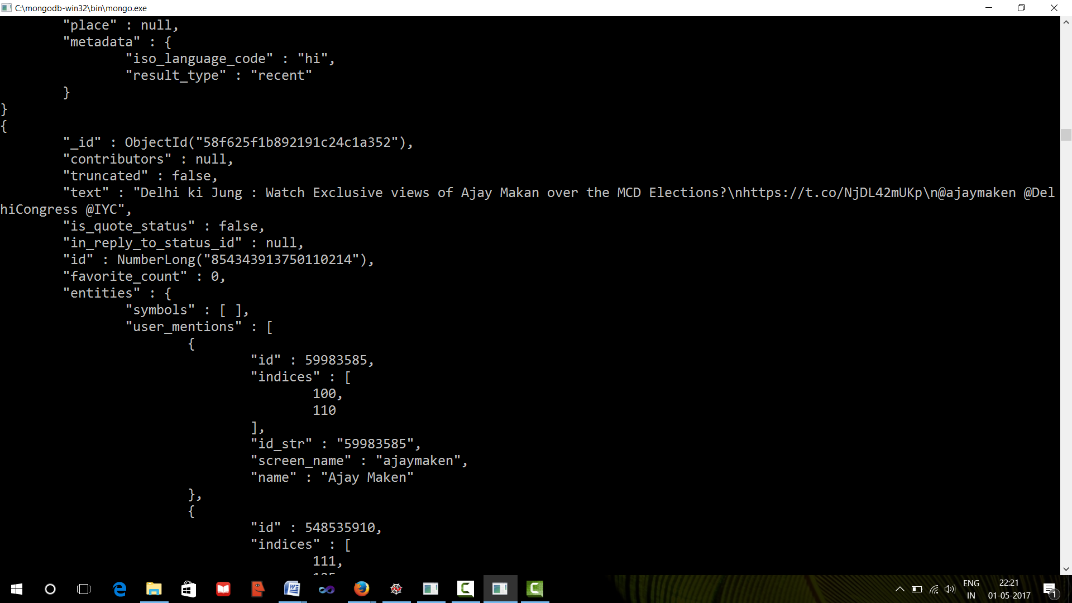

**Frequency term analysis using python:**

