Cryptographic Analysis

Christine Viets, Daniel Tyler
Computer Science Department, Rochester Institute of Technology
Rochester, New York, USA
cev5122@rit.edu, dht5977@rit.edu

Abstract—Cryptographic analysis of text is an important tool for decrypting ciphers and can provide valuable information about the given text. We developed a sequential program which computes character frequency, most common words, and n-grams, which are frequencies of n-letter combinations. After verifying the sequential program we adapted the algorithm to run on symmetric multiprocessing (SMP) hardware and cluster hardware. These programs are written in Parallel Java, which was developed by Alan Kaminsky of the Rochester Institute of Technology (RIT) and were tested on the parallel computers available at the Computer Science department of RIT.

Introduction
In the world of cryptography it is often very useful to be able to rapidly gather statistics about a given piece of text. The larger the text, the more accurate and applicable the data becomes. To this end, programs which can utilize all available resources to calculate statistics on word and character frequency along with the most common groupings of letters, can help a variety of applications including decryption, compression, and data encoding. By performing calculation of statistics in parallel, using symmetric multiprocessing or cluster computing, better answers can be determined much more efficiently. In order to store the statistics as they are processed, a number of classes were created to provide simple add methods which could be called from either the symmetric multiprocessor or cluster versions. For this project we have implemented a sequential, symmetric multiprocessor, and cluster version; each of which will be discussed in turn to highlight the associated challenges. Results, in the form of speedup and efficiency, will be presented and discussed, followed an attempt at explaining what might have caused the observed results. Finally we will discuss what impact can be taken away from this project and where those interested might be able to take this work.

Sequential Solution Design
The sequential solution to cryptographic analysis is somewhat complicated due to the desired generality of the program. We tried to add all the options someone who is analyzing text might want. We allowed options for ASCII versus Unicode and options to consider spaces or punctuation when calculating n-gram statistics. The program has options to calculate character frequency, most common words, and any most common n-grams. For instance, the program can be invoked to find the 10 most common digrams and trigrams if that is what is desired. Character frequency simply involves keeping track of each character read from a file. The total of each character is divided by the total character count to determine frequency. This frequency can be compared with the frequency of letters in a language to determine the probability that the text is written in that language. This is important in ciphertext where the base language is not known because it cannot be easily determined just by looking at the text. Word frequency is also quite simple. As each word is read, the count for that word is increased, and the program reports the top n words that occurred in the text, where n is a command line argument. This program does not find words that extend over two lines with a dash in between due to the possibility of adding non-words. This is trivial because, with most text, this will not affect the order of the most common words since only one or two words may not be counted. Computing n-gram frequency was more difficult than characters or words. As each character is read, it is added to a first in first out n-length queue and the string in the queue is counted as an n-length gram. Due to the issues with keeping track of limitless different n-grams, each n, as specified on the command line, is kept in a different "StarGram" object class. As text is read, it is added to each StarGram, and then each StarGram reports its most common n-grams after the program concludes. This added another complication because each n-gram queue must be cleared after each file is read. If the queue is not cleared, the last characters from one file will be counted as n-grams with the first characters from another file, which will negatively affect the statistics. The program reports its data on standard output.
The usage of this program is, via command line, "java projseq [-u] [-a] [-s] [-c] [-w topW] [-g n topG] files". The -u option specifies that Unicode characters should be counted rather than the default ASCII. This option cannot be used without the character counting option or with the apostrophe option. The -a option specifies that apostrophes should be left in when counting n-grams, and cannot be used without the n-gram option. This is useful for many common trigrams in the English language such as "n't". The -s option indicates that spaces should be considered in n-grams, and cannot be used without the n-gram option. The -c option specifies that character frequency should be reported. If used with the Unicode option, all characters with a count greater than zero will be reported. The -w option specifies that the user wants the top "topW" words reported. Word count does not consider punctuation. The -g option can be used as many times as desired, and reports the top "topG" n-grams. The SMP and cluster programs operate with the same command line arguments.

SMP Solution Design
The SMP implementation divides the work of the program in two. The first task is to read in the file and break it into chunks which can be processed. The second is to processes these chunks, determining the values for each requested attribute. The first task is handled by a single thread which reads in the file, one line at a time, and places it in a queue, specifically a BlockingLinkedQueue from the java concurrent library. The second task of actually processing the text is divided among identical threads in a ParallelTeam. The data aggregation classes were used to keep the processing of each string separate from the parallel logic involved in parsing the string and optionally computing each of the possible statistics. The final step is to aggregate all of the data in the separate threads to determine the final results. Each of the aggregation classes had a reduction method which took another instance of the same class and combined the two. This allowed us to collapse all of the separate data points into single objects for output to the user. This approach works well on our testing machine, until the number of processing threads reaches four. When using more than four processes the results drop off dramatically. One possible theory is that the processing threads are able to overwhelm the file-reading thread causing the queue that they share the empty and causing the processes threads to be forced to idle. Additionally, the program may start to be slowed down by the read capacity of Java to get the file data off of the disk.
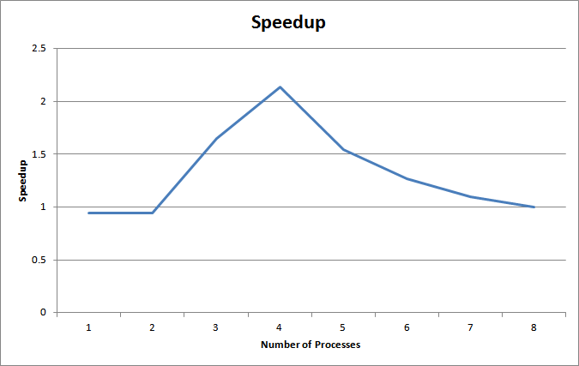
- SMP Speedup
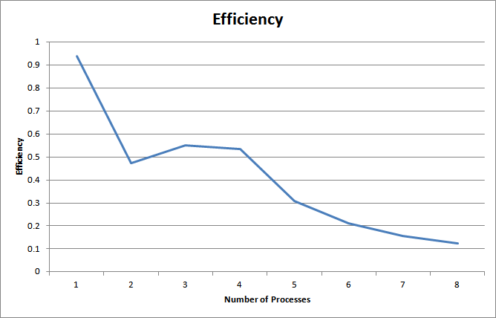
- SMP Efficiency
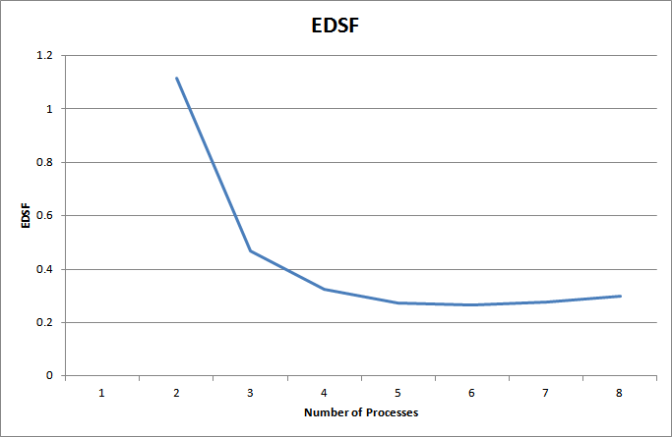
- SMP EDSF

Cluster Solution Design
The cluster implementation of the cryptographic analysis software distributes the workload evenly with a semi-master-worker implementation. The master splits the given text input files into equal parts - one for each processor, then each processor, including the master, processes its own text file. At the end of the program, gather is used to get all of the data back to the master process for reporting. This was judged to be the most appropriate load balancing algorithm because the program is input intensive. All of the calculations are done while the files are being read, and having one process reading all of the input would greatly unbalance the load. Splitting the text files into multiple pieces allows for the entire file to be read in parallel, where normally it would need to be read sequentially. The UNIX "split" command was used to split the files, and the program removes any files it creates when it completes. The cluster version of the cryptographic analysis software completes much slower than the sequential or SMP versions do. This is because of the structure of the paranoia cluster. It takes a lot of time to transport large amounts of data to all of the backend machines, even with the input files split into one piece per process. To demonstrate the statistics of the cluster version without this overhead, we are calculating speedup, efficiency, and experimentally determined sequential fraction (EDSF) based on the runtime of the sequential version on the paranoia cluster. This program gains in speedup until the number of processes reaches four. This could be due to hitting the maximum Java file reading speed since there are few sequential dependencies. The cluster version of this program does, however, shows good speedup and efficiency until the number of processes reaches four, although it may not be practical on all cluster setups.
The character and word frequency options were trivial to implement in cluster because there are no sequential dependencies. Both are counted separately by each process, and then reduced at the end. N-grams were far harder to implement because, if each process only calculated its own n-grams, the ones that occurred on the boundaries of one file part and another would be missed. Each process keeps track of the first and last bits of the file part it reads, and the master process gathers these pieces at the end and adds the necessary n-grams that were previously missed.
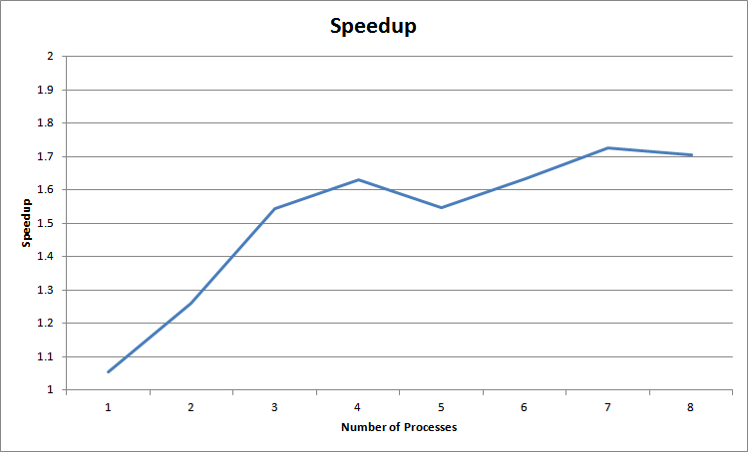
- Cluster Speedup
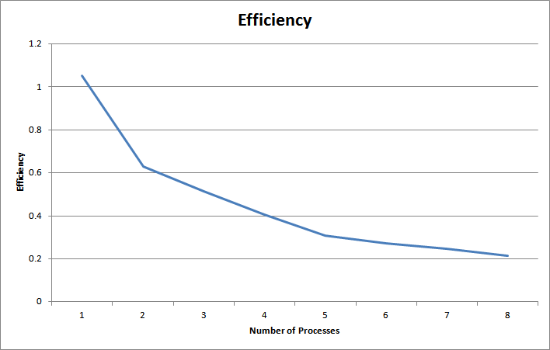
- Cluster Efficiency
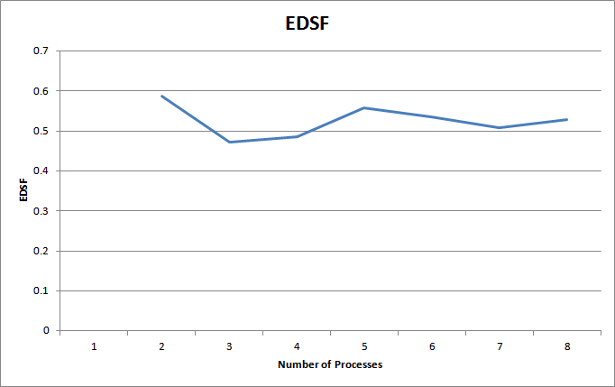
- Cluster EDSF

Results
From these results, we can clearly see that one of the big challenges of this project is getting the data into memory. The SMP solution is able to maintain an efficiency greater than one half when using up to 4 processes. There is a significant drop in speedup after 4 in the SMP, and a slight in the cluster implementation, smoothed slightly in the efficiency graph, but is still important point in our understanding how this program behaves. The EDSF values in the cluster program are consistent, while they drop off sharply in SMP.

Conclusions
These implementations show that a parallel approach to calculating cryptographically important statistics is viable and can produce a worthwhile speedup. They also highlighted the importance of properly handling the cost of simply getting the data into memory for processing. Overall, it provides a solid basis for further optimizations or adaptations for a variety of text-processing tasks.

Acknowledgment
We would like to thank Professor Minseok Kwon of the Computer Science department of RIT for input and guidance.

References

- Kaminsky, Alan. Building Parallel Programs. 1st ed. Boston, MA: Course Technology Ptr, 2010. Print.
- Kaminsky, Alan. "The Parallel Java Library." RIT Computer Science. Rochester Institute of Technology, 22 04 2010. Web. 16 May 2010.

