Optimization
Optimization is the process of improving a machine learning model by adjusting its parameters to reduce error and achieve the best performance.
A gradient is a vector that tells us two things about a function (like the loss function):
- Direction: which way the loss is increasing.
- Magnitude: how fast or how much the loss is increasing at that point.
Gradient Descent
Gradient descent is an optimization algorithm used to minimize a loss function (the measure of error) in machine learning and deep learning models. Its goal is to update the model’s parameters (weights and biases) so that predictions become more accurate.
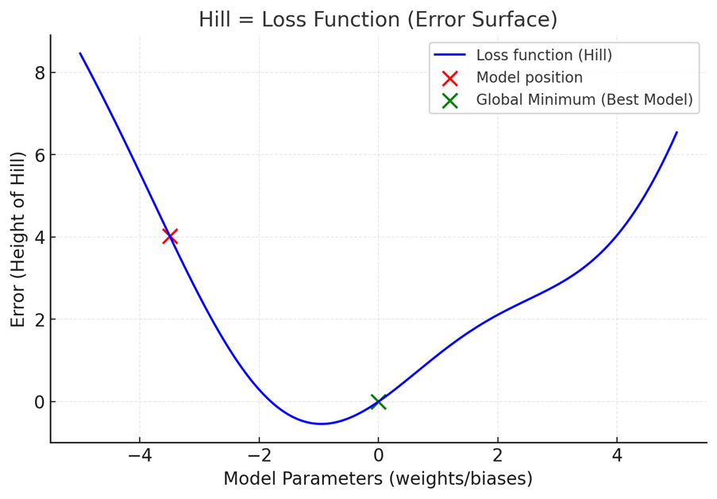
gradient descent numerical example:
$$\hat{y}=w⋅x$$
- Input $x=2$
- True output $y=4$
- Initial weight $w=1.0$
- Learning rate $α=0.1$
Prediction
$$\hat{y}=1.0⋅2=2$$
Gradient (slope)
$$\text{Gradient}=\left(wx-y\right)⋅x=\left(2-4\right)⋅2=-4$$
Update weight
$$w=w-α⋅\text{Gradient}=1.0-0.1⋅(-4)=1.4$$
- New weight: $w=1.4$
- New prediction: $\hat{y}=1.4⋅2=2.8$
- New loss: y actual- y pred= 1.2
Loss decreased from 2 → 0.72 → Gradient descent is working!
Gradient | Weight change | Effect on error | Explanation
Positive (↑) | Increase (↑) | Error ↑ | Moving with the slope, uphill → error increases
Positive (↑) | Decrease (↓) | Error ↓ | Moving opposite the slope, downhill → error decreases
Negative (↓) | Increase (↑) | Error ↓ | Moving opposite the negative slope, downhill → error decreases
Negative (↓) | Decrease (↓) | Error ↑ | Moving with the negative slope, uphill → error increases

SGD
Stochastic
- Meaning: “Random.”
- In SGD, instead of using the whole dataset, we pick random samples (one or a few data points) to update the model.
- This randomness makes the updates fast but noisy.
Gradient
- Meaning: “Slope” (mathematically, derivative).
- The gradient shows which way the error will grow the fastest if we move in that direction.
- Since we want to reduce error, we go in the opposite direction of the gradient.
Descent
- Meaning: “Going down.”
- Just like walking downhill to the lowest point.
- Here it means reducing the loss (error) step by step until we (hopefully) reach the minimum.
For large datasets, computing the gradient using all data points can be slow and memory-intensive. This is where SGD comes into play. Instead of using the full dataset to compute the gradient at each step, SGD uses only one random data point (or a small batch of data points) at each iteration. This makes the computation much faster.
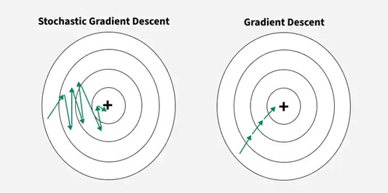

RMSProp (Root Mean Square Propagation) is an adaptive learning rate optimization algorithm designed to improve the performance and speed of training deep learning models.
ADAM optimizer
Adaptive Moment Estimation
- Adaptive → Change according to the situation
- Moment → keeps track of past movement
- Estimation → Calculating or approximating something
Adam (Adaptive Moment Estimation) optimizer combines the advantages of Momentum and RMSprop techniques to adjust learning rates during training. It works well with large datasets and complex models because it uses memory efficiently and adapts the learning rate for each parameter automatically.
Method/Optimizer | Data Used per Update | Typical Use
Batch Gradient Descent | Entire dataset | Small datasets or when exact gradient needed
Stochastic Gradient Descent (SGD) | One sample at a time | Large datasets, online learning
Mini-Batch Gradient Descent | Small batches (e.g., 32–256 samples) | Most deep learning applications
ADAM (Adaptive Moment Estimation) | Usually mini-batches | Deep learning models
Gradient Descent (General Term) | Depends on variant (batch, mini-batch, or SGD) | Basis of most optimizers

