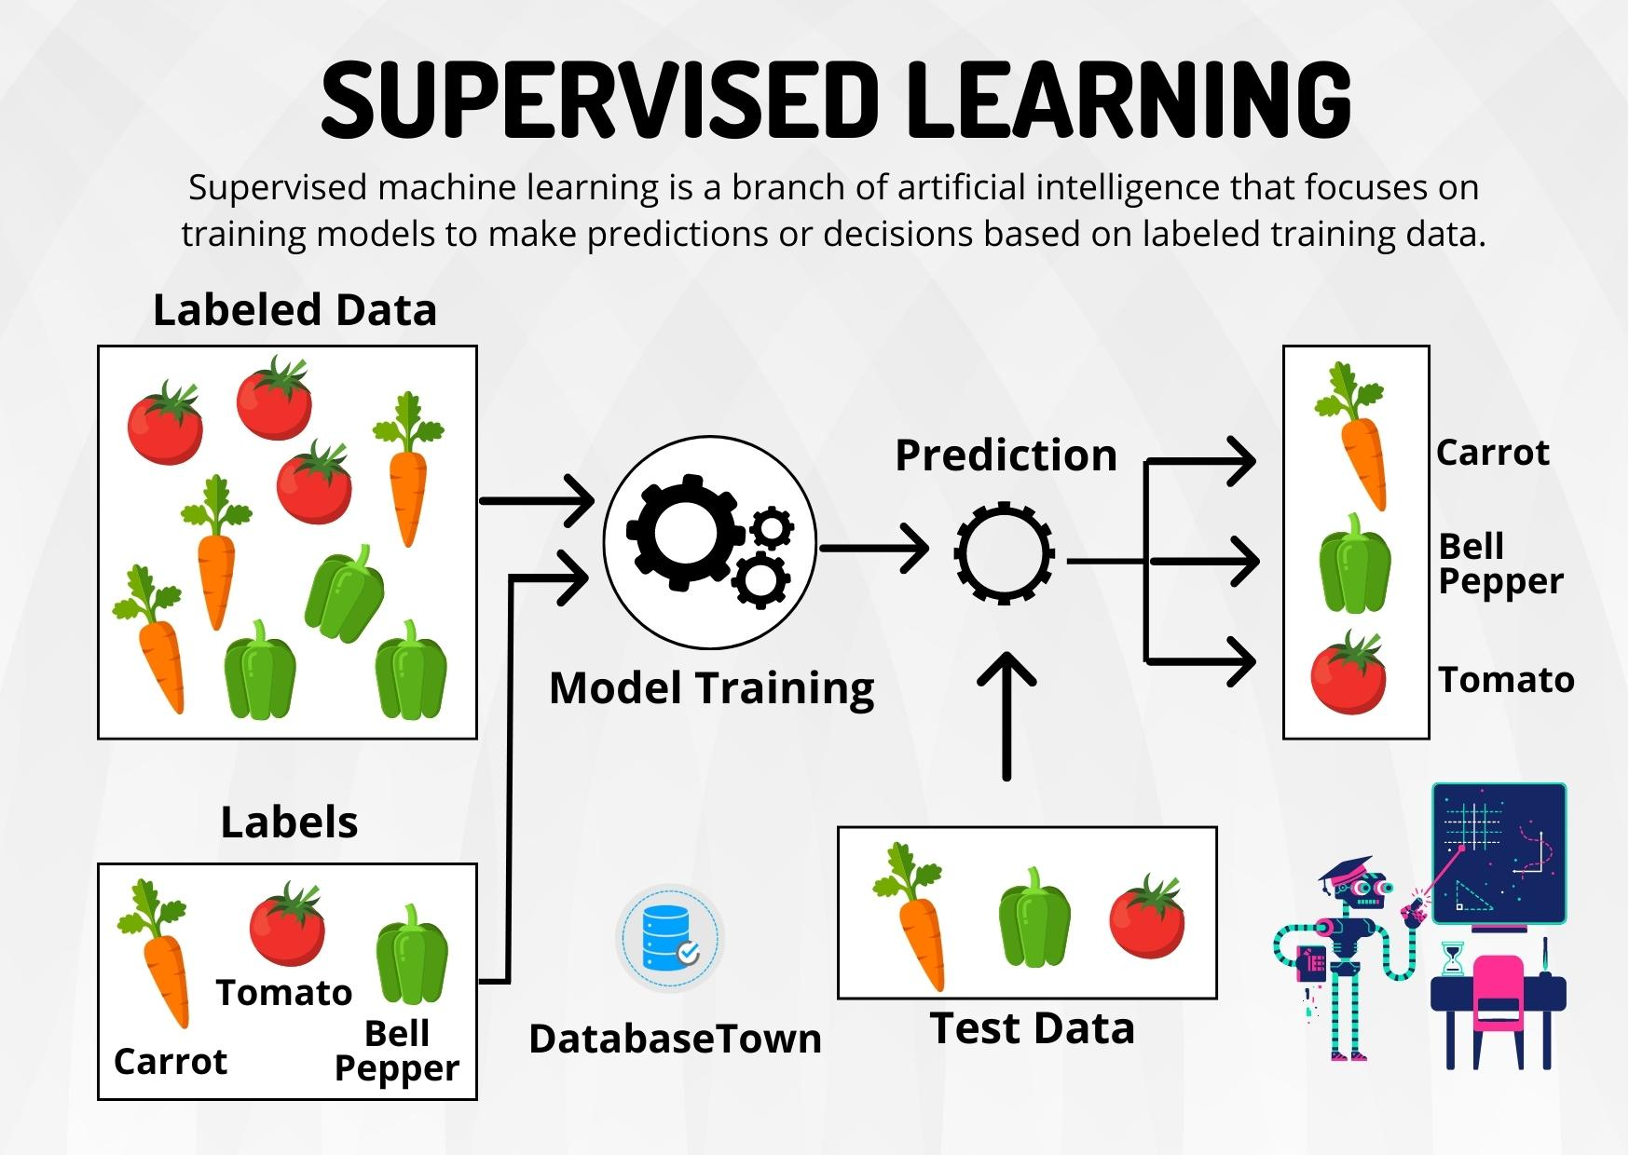
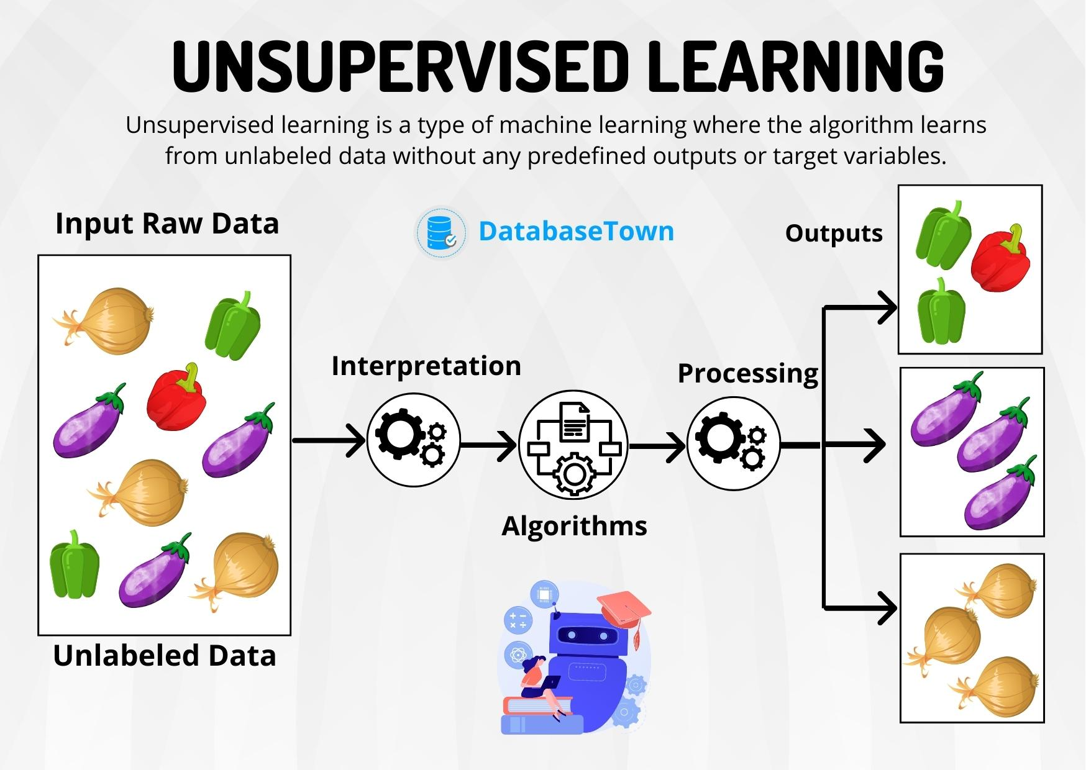

Decision Tree
A decision tree is a supervised learning algorithm, which is utilized for both classification and regression tasks. It has a hierarchical, tree structure, which consists of a root node, branches, internal nodes and leaf nodes.
The goal is to create a model that predicts the value of a target variable by learning simple decision rules inferred from the data features.
It works like a flowchart help to make decisions step by step where:
- Internal nodes represent attribute tests
- Branches represent attribute values
- Leaf nodes represent final decisions or predictions.
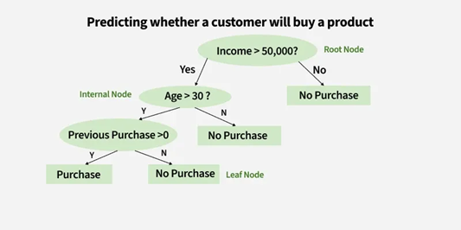
Let’s consider a decision tree for predicting whether a customer will buy a product based on age, income and previous purchases: Here's how the decision tree works:
1. Root Node (Income)
First Question: "Is the person’s income greater than $50,000?"
- If Yes, proceed to the next question.
- If No, predict "No Purchase" (leaf node).
2. Internal Node (Age):
If the person’s income is greater than $50,000, ask: "Is the person’s age above 30?"
- If Yes, proceed to the next question.
- If No, predict "No Purchase" (leaf node).
3. Internal Node (Previous Purchases):
- If the person is above 30 and has made previous purchases, predict "Purchase" (leaf node).
- If the person is above 30 and has not made previous purchases, predict "No Purchase" (leaf node).
Gini Index is a metric to measure how often a randomly chosen element would be incorrectly identified. It means an attribute with a lower Gini index should be preferred. Sklearn supports “Gini” criteria for Gini Index and by default it takes “gini” value.
For example if we have a group of people where all bought the product (100% "Yes") the Gini Index is 0 indicate perfect purity. But if the group has an equal mix of "Yes" and "No" the Gini Index would be 0.5 show high impurity or uncertainty. Formula for Gini Index is given by :
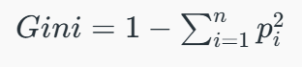
Lower Gini → purer node → lower probability of misclassification
Higher Gini → more mixed node → higher probability of misclassification
Let’s compute the Gini reduction (or Gini Gain) at each split to show exactly why the Decision Tree chooses each attribute.

Dataset

Outlook | Windy | PlayTennis
Sunny | False | Yes
Sunny | True | No
Overcast | False | Yes
Rain | False | Yes
Rain | True | No
Sunny | False | Yes
Overcast | True | Yes
Rain | False | No
- Total samples = 8
- Yes = 5, No = 3

Step 1: Gini at Root Node
$p_{Yes}=5/8=0.625,p_{No}=3/8=0.375$ $Gini_{root}=1-\left({0.625}^{2}+{0.375}^{2}\right)=0.4688$

Step 2: Weighted Gini for Outlook Split

Splitting by Outlook:
- Sunny (3 samples) → Yes=2, No=1
$$Gini_{Sunny}=1-(2/3)^{2}-(1/3)^{2}=0.444$$
- Overcast (2 samples) → Yes=2, No=0
$$Gini_{Overcast}=1-1^{2}-0^{2}=0$$
- Rain (3 samples) → Yes=1, No=2
$$Gini_{Rain}=1-(1/3)^{2}-(2/3)^{2}=0.444$$

Weighted Gini for Outlook:
$$Gini_{Outlook}=\frac{3}{8}⋅0.444+\frac{2}{8}⋅0+\frac{3}{8}⋅0.444=0.333$$

Gini Reduction (Gain) for Outlook:
$$Gain=Gini_{root}-Gini_{Outlook}=0.4688-0.333=0.1358$$

Step 3: Weighted Gini for Windy Split

Splitting by Windy:
- Windy = False (5 samples) → Yes=4, No=1
$$Gini_{False}=1-(4/5)^{2}-(1/5)^{2}=0.32$$
- Windy = True (3 samples) → Yes=1, No=2
$$Gini_{True}=1-(1/3)^{2}-(2/3)^{2}=0.444$$

Weighted Gini for Windy:
$$Gini_{Windy}=\frac{5}{8}⋅0.32+\frac{3}{8}⋅0.444=0.371$$

Gini Reduction (Gain) for Windy:
$$Gain=Gini_{root}-Gini_{Windy}=0.4688-0.371=0.0978$$

Step 4: Choose Root Split
Attribute | Weighted Gini | Gini Gain
Outlook | 0.333 | 0.136
Windy | 0.371 | 0.098
Root Node: Outlook (highest Gini Gain)

Step 5: Further Splits

1. Sunny Node (3 samples: Yes=2, No=1) → Split by Windy
- Sunny & Windy=False: Yes=2, No=0 → Gini = 0 (pure)
- Sunny & Windy=True: Yes=0, No=1 → Gini = 0 (pure)
No further split needed.

2. Overcast Node (2 samples: Yes=2, No=0)
- Already pure → No split needed.

3. Rain Node (3 samples: Yes=1, No=2) → Split by Windy
- Rain & Windy=False: 2 samples → Yes=1, No=1
$$Gini=1-\left({0.5}^{2}+{0.5}^{2}\right)=0.5$$
- Rain & Windy=True: 1 sample → Yes=0, No=1
$$Gini=1-\left(0^{2}+1^{2}\right)=0$$

Weighted Gini for Rain Node:
$$\text{Weighted Gini}=\frac{2}{3}⋅0.5+\frac{1}{3}⋅0=0.333$$
- Splitting by Windy reduces impurity, but Windy=False branch still contains mixed outcomes.
- Leaf nodes:
  - Windy=False → mixed (Yes=1, No=1)
  - Windy=True → pure (No=1)
Rain node requires further splitting or can be left as partially mixed if allowed.

Step 6: Corrected Decision Tree
Outlook
/ | \
Sunny Overcast Rain
/ \ | / \
Windy=False Windy=True Yes Windy=False Windy=True
Yes No ? No
(Yes/No)
- Sunny branch: pure
- Overcast branch: pure
- Rain branch: partly mixed under Windy=False

K fold cross validation
K-fold cross-validation is a method used in machine learning to check how well a model will perform on new data. Instead of testing the model just once, the dataset is split into k equal parts (called folds). The model is trained on k−1 folds and tested on the remaining fold. This process is repeated k times, each time using a different fold for testing. Finally, the results from all k runs are averaged to get a more reliable estimate of the model’s performance.
In simple terms, it’s like giving the model multiple exams with different sets of questions and then averaging its scores to see how good it really is.

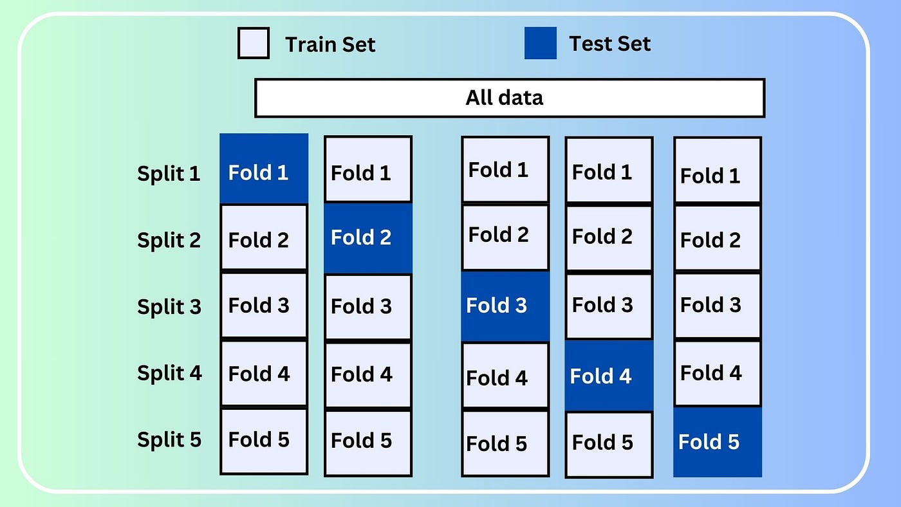
1. All Data
- At the very top, the “All data” box represents the entire dataset that we have available.
2. Folds
- The dataset is divided into 5 equal parts, called folds (Fold 1, Fold 2, Fold 3, Fold 4, Fold 5).
- Each fold will take turns being the test set, while the remaining folds are used for training.
3. Splits / Iterations
- Split 1: Fold 1 is the test set (blue), and Folds 2–5 are the training set (white).
- Split 2: Fold 2 is the test set, Folds 1, 3–5 are the training set.
- Split 3: Fold 3 is the test set, Folds 1, 2, 4, 5 are training.
- Split 4: Fold 4 is the test set, others are training.
- Split 5: Fold 5 is the test set, others are training.
Each split is one iteration of training and testing.

Facts
1. Without k-fold (single train-test split)
- You split the dataset once, say 80% train / 20% test.
- Train on 80%, test on 20%.
- Suppose accuracy = 75%.
This number depends heavily on how you split.
- If the split was lucky (easy test data), accuracy might look high.
- If unlucky (harder test data), accuracy might look low.
- The result is sensitive to randomness.
So, 75% here may or may not reflect true generalization ability.
2. With k-fold cross-validation
- Dataset is split into k folds, e.g. k=5.
- Each fold gets a chance to be test data, and the model is trained k times.
- Final accuracy = average across k test folds = 75%.
This number is based on all data being tested once.
- Reduces dependence on one lucky/unlucky split.
- More stable and reliable estimate.
- Especially useful for small or imbalanced datasets.
3. Difference in meaning
- Single split (75%): Model achieved 75% on that particular test set.
- k-fold CV (75%): On average, across multiple train/test splits, the model achieved 75%.
So, k-fold accuracy is a better approximation of expected performance on unseen data.
4. Which is better?
- For research and scientific reporting → k-fold CV is always preferred.
- For very large datasets → a single 80:20 split can be fine, because the test set is already representative.
- If dataset is small → k-fold CV is much better, because it uses all data for both training and testing (in different rounds).

Feature $X$ | Class
High | Yes
High | Yes
High | Yes
Low | Yes
Low | No
Low | No
Class counts: Yes=4, No=2

1. Root entropy $H(S)$
H(S)=-c∈{Yes,No}​p(c)log2p(c).
Compute probabilities:
$$p_{Yes}=\frac{4}{6}=\frac{2}{3}≈0.6666667,p_{No}=\frac{2}{6}=\frac{1}{3}≈0.3333333.$$
Compute logs (base 2):
$$\log_{2} \left(\frac{2}{3}\right)=-0.5849625,\log_{2} \left(\frac{1}{3}\right)=-1.5849625.$$
Add them:
$$H(S)≈0.3899750+0.5283208=0.9182958\text{ bits}.$$
(That value $0.9183$ is the standard entropy for class proportions $2/3$ and $1/3$.)

2. Split on feature $X$ (values High and Low)
Counts per branch:
- High: 3 examples → Yes = 3, No = 0.
$\left.p_{Yes}=1, p_{No}=0⇒H\left(\text{High}\right)=0\right.$ (pure node).
- Low: 3 examples → Yes = 1, No = 2.
$p_{Yes}=\frac{1}{3}, p_{No}=\frac{2}{3}$. This is the mirror of the root proportions, so its entropy equals the root entropy:
- $H\left(\text{Low}\right)=0.9182958\text{ bits}.$
Weighted (post-split) entropy:
$$H(S∣X)=\frac{∣High∣}{∣S∣}H(High)+\frac{∣Low∣}{∣S∣}H(Low)=\frac{3}{6}⋅0+\frac{3}{6}⋅0.9182958=0.5×0.9182958=0.4591479\text{ bits}.$$

3. Information Gain
$$IG(S,X)=H(S)-H(S∣X)=0.9182958-0.4591479=0.4591479\text{ bits}.$$

