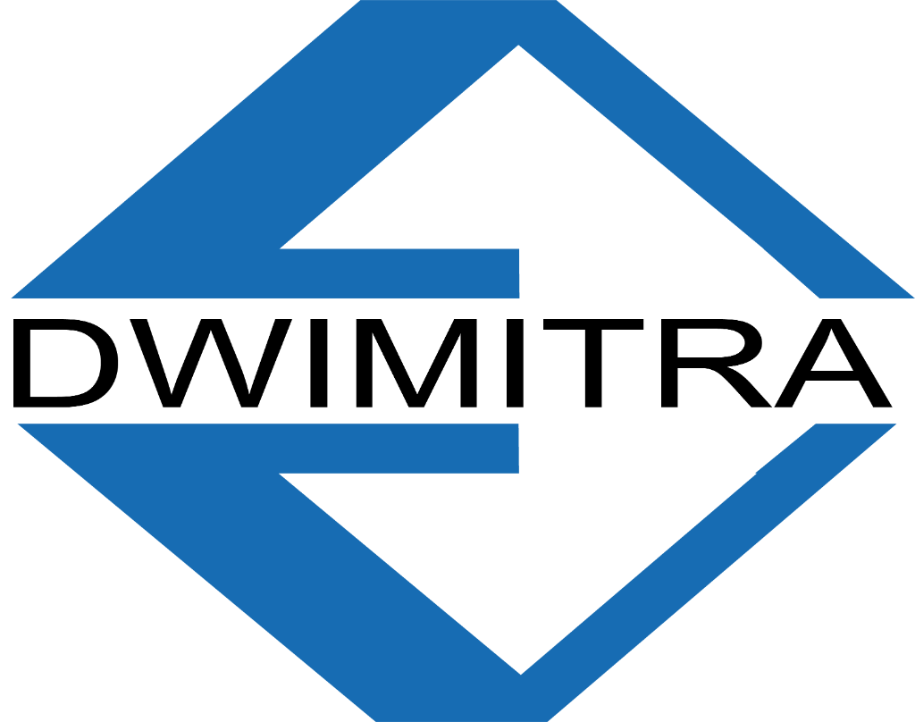 | LAPORAN INSPEKSI SISTEM  DwimitraSystem  PT Dwimitra Ekatama Mandiri  Neutra DC Cikarang | 7 Agustus 2026 | 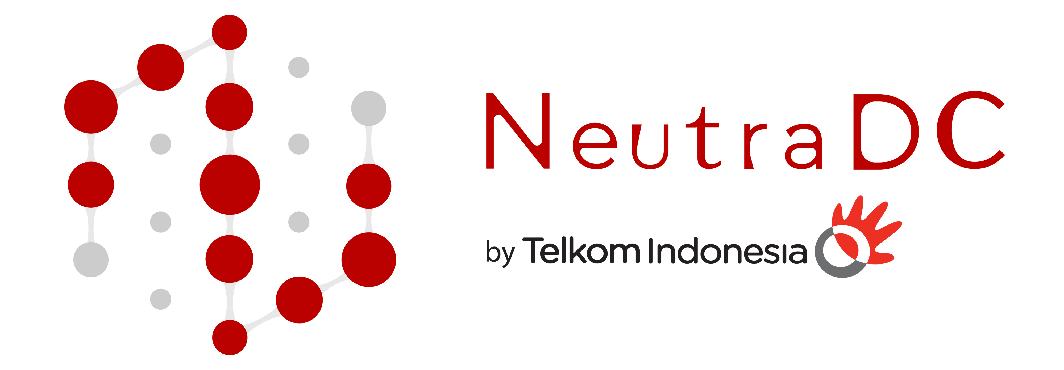

A. INFORMASI DOKUMEN

Nama Sistem | DwimitraSystem — Sistem Pemeliharaan Data Center
Klien | PT United Transworld Trading (UTT)
Lokasi | Neutra DC Cikarang, Jawa Barat
Domain Aktif | https://dwimitrasystem.com/
Tanggal Inspeksi | 7 Agustus 2026
Versi Sistem | Frontend: React 18.3 + Vite 6.3.5 | Backend: Go 1.24
Database | Cloud Firestore (Firebase) + Firebase Auth
AI Engine | Google Gemini 3.1 Flash-Lite (via OpenAI-compatible endpoint)
Tujuan Inspeksi | Audit lengkap seluruh fitur per role, arsitektur keamanan, dan alur sistem

B. SISTEM ROLE & HAK AKSES (16 Role)
Sistem menggunakan Role-Based Access Control (RBAC). Role ditentukan dari dokumen Firestore users/{uid}.role dan dikonfirmasi via onSnapshot real-time listener.
No | Role | Dashboard | Tab Default | Level Akses
1 | admin | AdminDashboard + MainApp | Dashboard | Full access — semua fitur
2 | engineer | MainApp | Buat Laporan | Laporan PM + PTW + Temuan + Files
3 | standby_engineer | MainApp | Corrective Maint. | CM + Arsip + Temuan (terbatas)
4 | tde | MainApp | Arsip Dokumen | Read-only CM + Temuan + Archive
5 | cbre | MainApp | Arsip Dokumen | Identik dengan TDE
6 | DME | MainApp | Arsip Dokumen | Archive + PM Schedule (terbatas)
7 | hse | HSEApp | Buat Inspeksi HSE | HSE only — inspeksi + arsip HSE
8 | site_manager | SiteManagerDashboard | Progress Dashboard | Monitoring + kelola progress
9 | manager | SiteManagerDashboard | Progress Dashboard | Identik dengan site_manager
10 | pmo | DivisionApp | File Divisi PMO | File vault PMO divisi sendiri
11 | sales | DivisionApp | File Divisi Sales | File vault Sales divisi sendiri
12 | presales | DivisionApp | File Divisi Presales | File vault Presales divisi sendiri
13 | purchasing | DivisionApp | File Divisi Purchasing | File vault Purchasing divisi sendiri
14 | dirut | DivisionApp (Executive) | Registri Eksekutif | Read-only semua divisi + HSE
15 | direksiSDM | DivisionApp (Executive) | Registri Eksekutif | Identik dengan Dirut
16 | DireksiKeuangan | DivisionApp (Executive) | Registri Eksekutif | Identik dengan Dirut
— | PUBLIC (tanpa login) | HSEReportViewer | Langsung buka laporan | View-only laporan HSE via URL

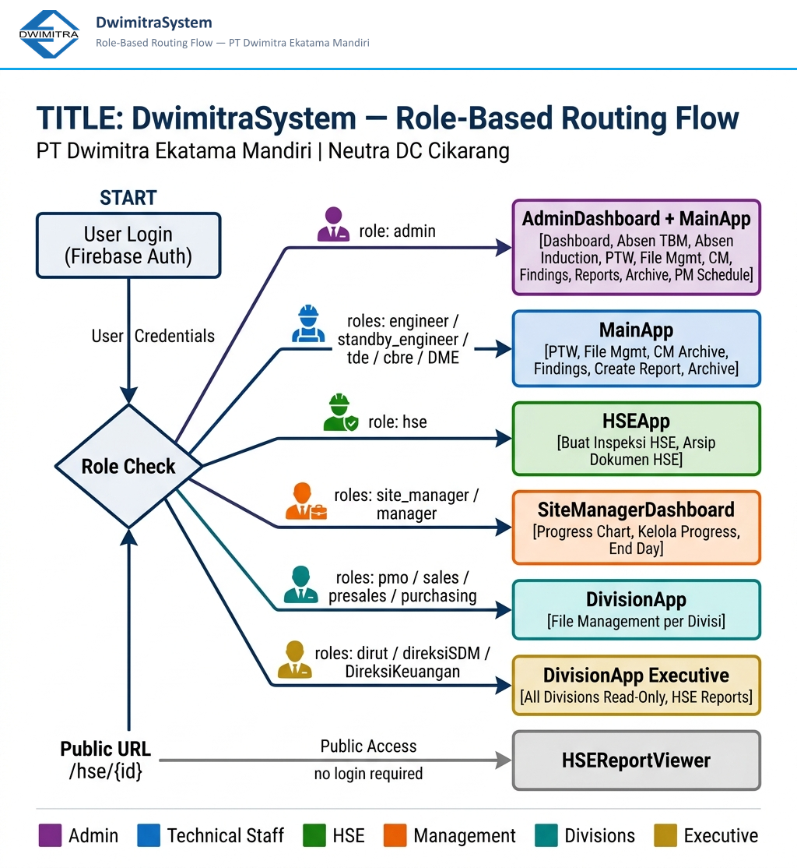
Gambar B.1 — Alur routing setiap role dari login Firebase ke dashboard yang sesuai

 | LAPORAN INSPEKSI SISTEM  DwimitraSystem  PT Dwimitra Ekatama Mandiri  Neutra DC Cikarang | 7 Agustus 2026 | 

C. FEATURE ACCESS MATRIX
Keterangan kolom: ADM=Admin, ENG=Engineer, SBY=Standby, TDE=TDE/CBRE, DME=DME, HSE=HSE, MGR=Site Manager/Manager, DIV=Divisi (PMO/Sales/dll), DIR=Direktur, PUB=Public
✅ Full access 🔒 Read-only ⚡ Terbatas/Kondisional ❌ Tidak ada akses
FITUR | ADM | ENG | SBY | TDE | DME | HSE | MGR | DIV | DIR | PUB
📋 LAPORAN PREVENTIVE MAINTENANCE
Buat Laporan PM (ATS/FCU/CT/PDU/PJU/Gen/AC/Trafo) | ✅ | ✅ | ❌ | ⚡ | ⚡ | ❌ | ❌ | ❌ | ❌ | ❌
Arsip Dokumen (Excel & PDF) | ✅ | ✅ | ❌ | 🔒 | 🔒 | ❌ | ❌ | ❌ | ❌ | ❌
AI Photo Analysis (Gemini Vision) | ✅ | ✅ | ❌ | ❌ | ❌ | ❌ | ❌ | ❌ | ❌ | ❌
AI Chat Widget (JARVIS) | ✅ | ✅ | ✅ | ✅ | ✅ | ✅ | ✅ | ✅ | ✅ | ❌
Voice Agent (JARVIS WebSocket) | ✅ | ✅ | ✅ | ✅ | ✅ | ❌ | ❌ | ❌ | ❌ | ❌
Export PDF Service Report | ✅ | ✅ | ❌ | ✅ | ✅ | ❌ | ❌ | ❌ | ❌ | ❌
Export Excel Service Report | ✅ | ✅ | ❌ | ✅ | ✅ | ❌ | ❌ | ❌ | ❌ | ❌
Preview Service Report (A4) | ✅ | ✅ | ❌ | ✅ | ✅ | ❌ | ❌ | ❌ | ❌ | ❌
Kamera + GPS Watermark | ✅ | ✅ | ✅ | ✅ | ❌ | ✅ | ❌ | ❌ | ❌ | ❌
🔧 MANAJEMEN PEMELIHARAAN
Permit to Work / PTW (buat) | ✅ | ✅ | ❌ | ❌ | ❌ | ❌ | ❌ | ❌ | ❌ | ❌
Corrective Maintenance (buat) | ✅ | ❌ | ✅ | ❌ | ❌ | ❌ | ❌ | ❌ | ❌ | ❌
Corrective Maintenance (lihat) | ✅ | ❌ | ✅ | 🔒 | ❌ | ❌ | ❌ | ❌ | ❌ | ❌
Arsip Standby / Corrective Archive | ✅ | ✅ | ✅ | 🔒 | ✅ | ❌ | ❌ | ❌ | ❌ | ❌
Input Temuan (Finding) | ✅ | ✅ | ✅ | ✅ | ❌ | ❌ | ❌ | ❌ | ❌ | ❌
Arsip Temuan (Export PDF/Word) | ✅ | ✅ | ✅ | ✅ | ❌ | ❌ | ❌ | ❌ | ❌ | ❌
PM Schedule (Jadwal PM) | ✅ | ❌ | ❌ | ❌ | ✅ | ❌ | ❌ | ❌ | ❌ | ❌
Manajemen File (upload) | ✅ | ✅ | ❌ | ❌ | ❌ | ❌ | ❌ | ✅ | ❌ | ❌
Manajemen File (lihat) | ✅ | ✅ | ❌ | ❌ | ❌ | ❌ | ❌ | ✅ | 🔒 | ❌
🦺 ABSENSI & INSPEKSI K3
Absen TBM (Tool Box Meeting) | ✅ | ❌ | ❌ | ❌ | ❌ | ❌ | ❌ | ❌ | ❌ | ❌
Absen Induction | ✅ | ❌ | ❌ | ❌ | ❌ | ❌ | ❌ | ❌ | ❌ | ❌
Inspeksi HSE / Laporan K3 (buat) | ✅ | ❌ | ❌ | ❌ | ❌ | ✅ | ❌ | ❌ | ❌ | ❌
Arsip Dokumen HSE | ✅ | ❌ | ❌ | ❌ | ❌ | ✅ | ❌ | ❌ | 🔒 | ❌
HSE Report Viewer (public) | ✅ | ✅ | ✅ | ✅ | ✅ | ✅ | ✅ | ✅ | ✅ | ✅
⚙️ ADMIN & MONITORING
User Management (CRUD role) | ✅ | ❌ | ❌ | ❌ | ❌ | ❌ | ❌ | ❌ | ❌ | ❌
Audit Logs (trail aktivitas) | ✅ | ❌ | ❌ | ❌ | ❌ | ❌ | ❌ | ❌ | ❌ | ❌
Maintenance Progress Dashboard | ✅ | ❌ | ❌ | ❌ | ❌ | ❌ | ✅ | ❌ | ❌ | ❌
Kelola Progress (CRUD) | ✅ | ❌ | ❌ | ❌ | ❌ | ❌ | ✅ | ❌ | ❌ | ❌
Sistem Notifikasi | ✅ | ✅ | ✅ | ✅ | ✅ | ✅ | ✅ | ✅ | ✅ | ❌
🏢 DIVISI & EKSEKUTIF
PMO File Vault | ✅ | ❌ | ❌ | ❌ | ❌ | ❌ | ❌ | ⚡ | 🔒 | ❌
Sales File Vault | ✅ | ❌ | ❌ | ❌ | ❌ | ❌ | ❌ | ⚡ | 🔒 | ❌
Presales File Vault | ✅ | ❌ | ❌ | ❌ | ❌ | ❌ | ❌ | ⚡ | 🔒 | ❌
Purchasing File Vault | ✅ | ❌ | ❌ | ❌ | ❌ | ❌ | ❌ | ⚡ | 🔒 | ❌
Executive Registry (semua divisi) | ✅ | ❌ | ❌ | ❌ | ❌ | ❌ | ❌ | ❌ | ✅ | ❌

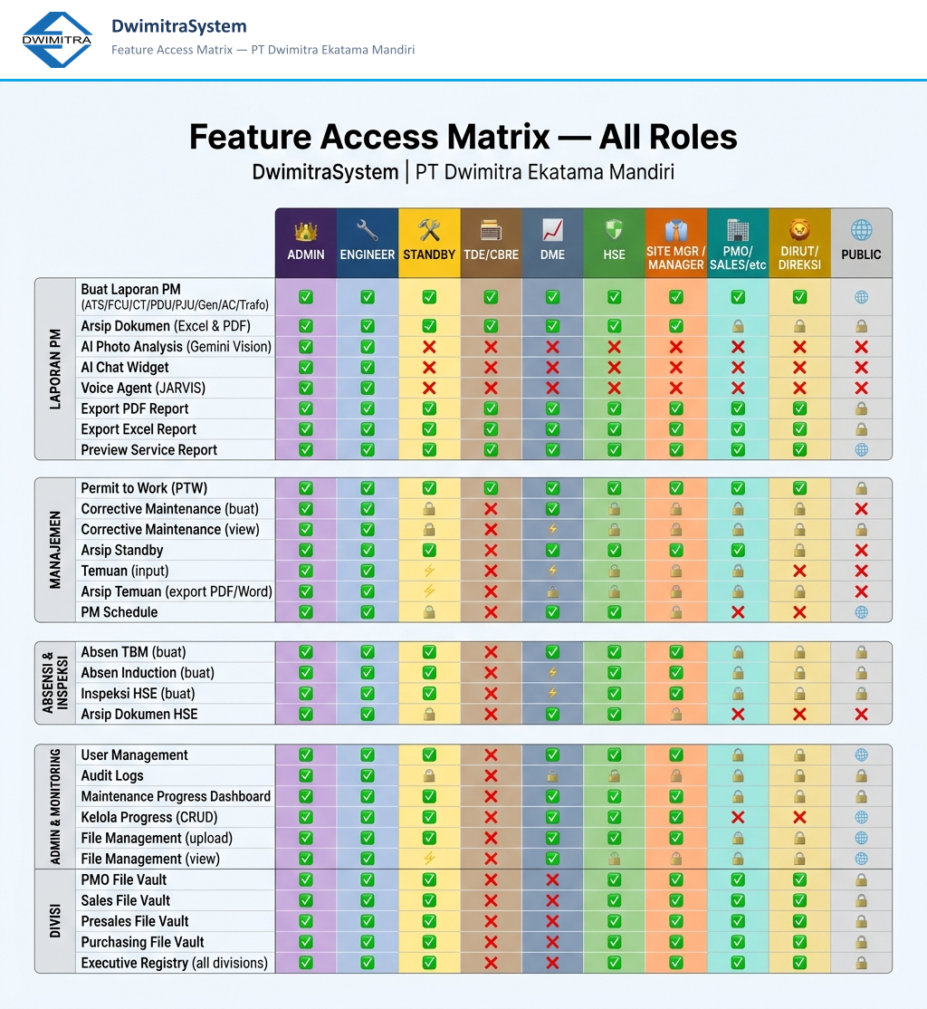
Gambar C.1 — Feature Access Matrix lengkap: semua fitur × semua role

 | LAPORAN INSPEKSI SISTEM  DwimitraSystem  PT Dwimitra Ekatama Mandiri  Neutra DC Cikarang | 7 Agustus 2026 | 

D. ARSITEKTUR KEAMANAN (10 Layer)
Sistem diproteksi dengan 10 lapisan keamanan berlapis mulai dari edge (Cloudflare WAF) hingga database (Firestore Rules) dan sanitasi input.
Layer | Nama | Teknologi | Detail
1 | Cloudflare WAF | Cloudflare Pro | Geo-block Indonesia only, bot management, UA filtering, DDoS protection, host header validation
2 | Firebase Authentication | Firebase Auth SDK | ID Token JWT validation, Bearer token di Authorization header, browserLocalPersistence, signInWithEmailAndPassword
3 | Go Middleware Pipeline | net/http + custom chain | Pipeline: RequestID → Logger → PanicRecovery → SecurityHeaders → CORS → RateLimiter → FirebaseAuth → RouteHandler
4 | HTTP Security Headers | Go SecurityHeaders MW | HSTS 1yr, X-Frame-Options DENY, nosniff, CSP strict, Referrer-Policy, Permissions-Policy, no Server/X-Powered-By header
5 | Rate Limiting | Token Bucket (in-memory) | Standard: 20 rps (reads), Heavy: 5 rps (AI endpoints/writes), per-IP, auto-cleanup 10 menit, Retry-After header
6 | CORS Whitelist | Go CORSMiddleware | Hanya: dwimitrasystem.com, web.app, firebaseapp.com, localhost:5173. Tidak ada wildcard *
7 | Firestore Security Rules | Firebase Rules v2 | RBAC per koleksi, isAdminSafe(), isEngineer(), hasAcceptableFieldCount(), isValidString(), owner-only writes
8 | Input Sanitization | Go sanitizer pkg | XSS prevention, DOMPurify-based. crypto/subtle.ConstantTimeCompare untuk API Secret (anti timing attack)
9 | Error Masking | helpers.SendError() | Internal error messages tidak pernah diexpose ke client. Semua error response menggunakan generic message
10 | API Secret Validation | X-API-Secret header | Dual auth: Firebase Token + X-API-Secret. Fail-closed: jika BACKEND_API_SECRET kosong, semua request ditolak

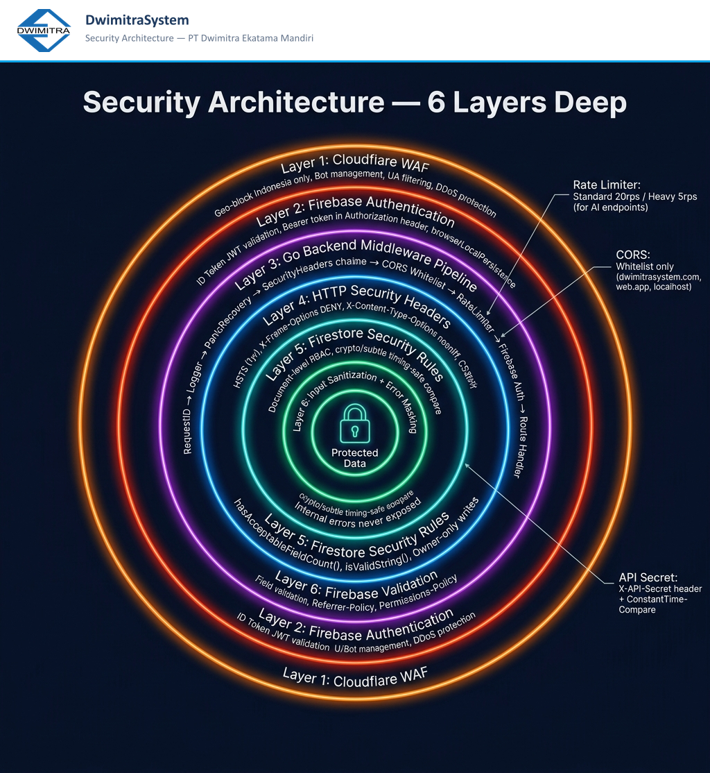
Gambar D.1 — Visualisasi 6 lapisan keamanan DwimitraSystem (Cloudflare WAF → Input Sanitization)

E. AI ENDPOINT & INTEGRASI GEMINI (16 Endpoint)
Semua endpoint AI menggunakan rate limiter Heavy (5 rps per IP) dan wajib melewati Firebase Auth + X-API-Secret validation. AI model: Google Gemini 3.1 Flash-Lite via OpenAI-compatible endpoint. Sistem round-robin multi-key untuk manajemen kuota.
No | Endpoint | Equipment | Rate Limit | Keterangan
1 | POST /api/ai/ats-report | ATS (Auto Transfer Switch) | Heavy 5rps | Analisis foto visual + cleaning + pengukuran
2 | POST /api/ai/fcu-report | FCU (Fan Coil Unit) | Heavy 5rps | Inspeksi filter + coil + drainage
3 | POST /api/ai/pju-report | PJU (Lampu Jalan/Taman) | Heavy 5rps | Kondisi lampu, kabel, panel kontrol
4 | POST /api/ai/pdu-report | Panel PDU | Heavy 5rps | Beban arus, kondisi MCB, labeling
5 | POST /api/ai/ct-report | Cooling Tower | Heavy 5rps | Fill media, basin, motor, fan blade
6 | POST /api/ai/generator-report | Generator / Genset | Heavy 5rps | Level bahan bakar, battery, exhaust
7 | POST /api/ai/trafo-report | Transformator | Heavy 5rps | Suhu, oil level, bushing, grounding
8 | POST /api/ai/acsplit-report | AC Split Wall | Heavy 5rps | Filter, kondensor, evaporator, freon
9 | POST /api/ai/busduct-report | Busduct | Heavy 5rps | Joint, isolasi, koneksi, suhu
10 | POST /api/ai/door-report | Rolling Door | Heavy 5rps | Motor, limit switch, track, sensor
11 | POST /api/ai/capacitorbank-report | Capacitor Bank | Heavy 5rps | Kondisi kapasitor, panel, kontaktor
12 | POST /api/ai/ldbrdb-report | Panel LDB/RDB | Heavy 5rps | MCB, label, beban, kondisi busbar
13 | POST /api/ai/digitize-paper-report | Digitasi Laporan Kertas | Heavy 5rps | OCR foto laporan fisik ke digital
14 | POST /api/ai/analyze-card | Single Card Analysis | Heavy 5rps | Analisis satu foto/card individual
15 | POST /api/ai/chat | AI Chat (JARVIS) | Heavy 5rps | Chatbot konteks maintenance sistem
16 | WS /api/voice/ws | Voice Agent (JARVIS) | Custom | WebSocket real-time voice commands

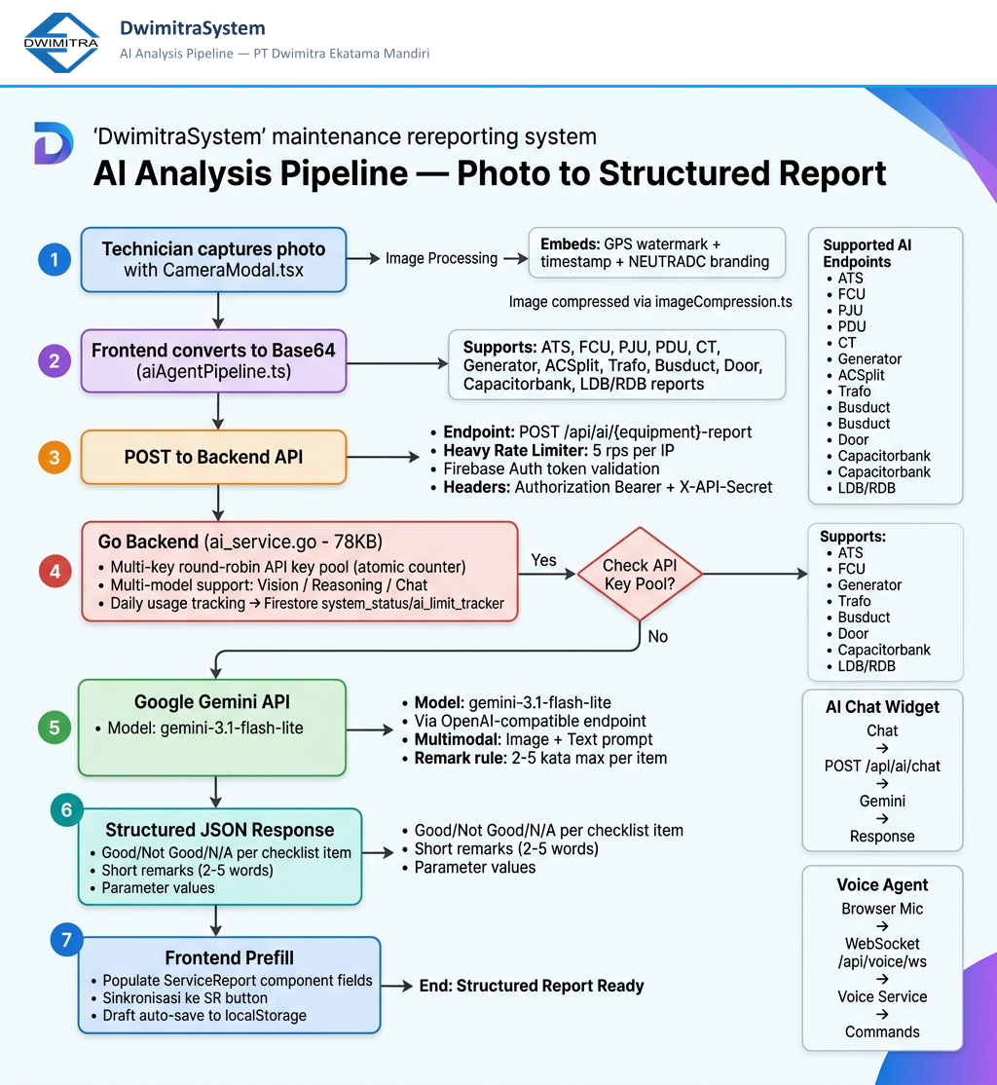
Gambar E.1 — Alur AI Analysis Pipeline: foto → Gemini Vision → structured JSON → prefill form laporan

 | LAPORAN INSPEKSI SISTEM  DwimitraSystem  PT Dwimitra Ekatama Mandiri  Neutra DC Cikarang | 7 Agustus 2026 | 

F. TECH STACK LENGKAP
Kategori | Teknologi | Versi | Fungsi
Frontend | React | 18.3.1 | UI Framework utama
Frontend | TypeScript | 6.0+ | Type safety
Frontend | Vite | 6.3.5 | Build tool & dev server
Frontend | Tailwind CSS | v4.1.12 | Styling utility-first
Frontend | Framer Motion | 12.x | Animasi & transisi
Frontend | Firebase SDK | 12.8.0 | Auth, Firestore, Storage
Frontend | jsPDF + autotable | 2.5.2 | Export PDF laporan
Frontend | ExcelJS | 4.4.0 | Export Excel laporan
Frontend | Recharts | 2.15.2 | Chart & visualisasi data
Frontend | Tesseract.js | 7.0.0 | OCR (baca teks dari gambar)
Backend | Go (Golang) | 1.24.0 | API server utama
Backend | Google Gemini API | 3.1 Flash-Lite | AI multimodal model
Backend | Firebase Admin SDK | v4.13.0 | Server-side auth & Firestore
Backend | Gorilla WebSocket | 1.5.3 | WebSocket untuk voice agent
Infra | Firebase Hosting | - | Static hosting + SSL
Infra | Cloud Firestore | - | NoSQL realtime database
Infra | Cloudflare CDN | - | DNS, edge caching, WAF
Infra | PWA | - | Offline support, installable

G. KESIMPULAN INSPEKSI

1. Sistem terdiri dari 16 role pengguna dengan hak akses yang terdefinisi jelas dan diimplementasikan di 3 lapisan (frontend routing, backend middleware, Firestore rules).
2. Keamanan dibangun berlapis 10 layer mulai dari Cloudflare WAF hingga error masking, dengan pendekatan fail-closed pada setiap titik kritis.
3. AI terintegrasi dalam 16 endpoint (14 equipment + chat + voice) menggunakan Google Gemini 3.1 Flash-Lite dengan sistem multi-key round-robin untuk manajemen kuota.
4. Rate limiting diterapkan secara berbeda: 20rps untuk operasi baca (standard) dan 5rps untuk AI/write (heavy), per IP address.
5. Firestore Security Rules mengimplementasikan field validation (isValidString, hasAcceptableFieldCount) sebagai perlindungan tambahan di level database.
6. Sistem mendukung mode offline via PWA dan auto-save draft ke localStorage untuk resiliensi koneksi yang buruk di lapangan.
7. Seluruh teks user-facing dan laporan menggunakan Bahasa Indonesia, sementara kode dan dokumentasi teknis menggunakan Bahasa Inggris.

Diperiksa oleh:  _______________________  Gari Iriana  System Developer  PT Dwimitra Ekatama Mandiri |  | Disetujui oleh:  _______________________  Site Manager / Manager  PT Dwimitra Ekatama Mandiri  Neutra DC Cikarang

© 2026 PT Dwimitra Ekatama Mandiri — DwimitraSystem Inspection Report — CONFIDENTIAL

