Programs Offered

* Robotics/tinkering
* Computer Hardware
* Mobile Repairing
* Cooking /Hospitality
* Beauty Wellness
* Stitching & Cutting
* Electrical Troubleshooting
* Two – Wheeler Repairing
* Mobile Journalism
* Computer Science
* Call Center /BPO
* Logistics
* Data Digitization
* Natural Farming Market Connect
* Banking

Literacy India Community COLLEGE (LICC)

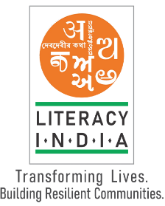

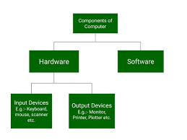



[www.literacy](http://www.literacy) .com

SESSION START FROM JANUARY

CONTACT NO- 8899445533

REGISTER NOW