**DOCUMENTATION (PwC ASSIGNMENT)**

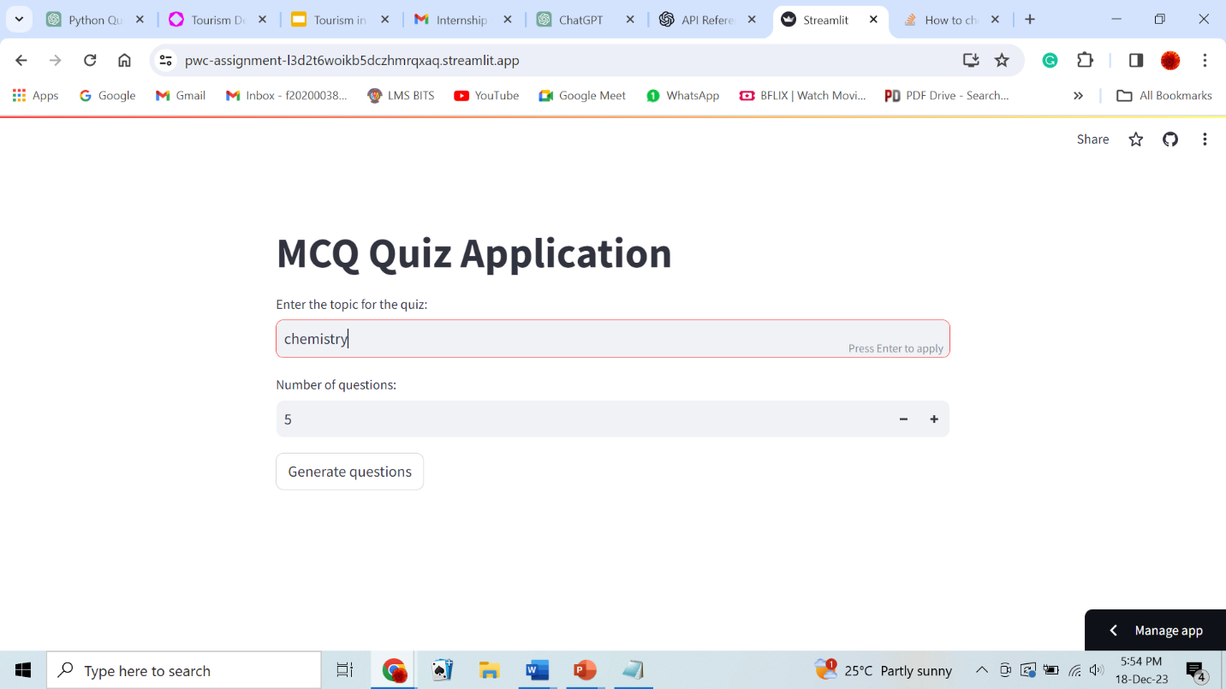

The above image is the initial display of the MCQ Quiz Application. Here, the user has to input the topic and the number of questions.

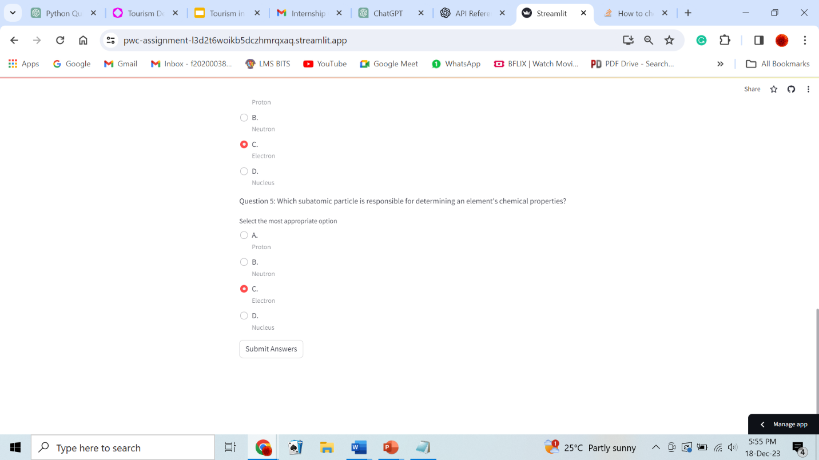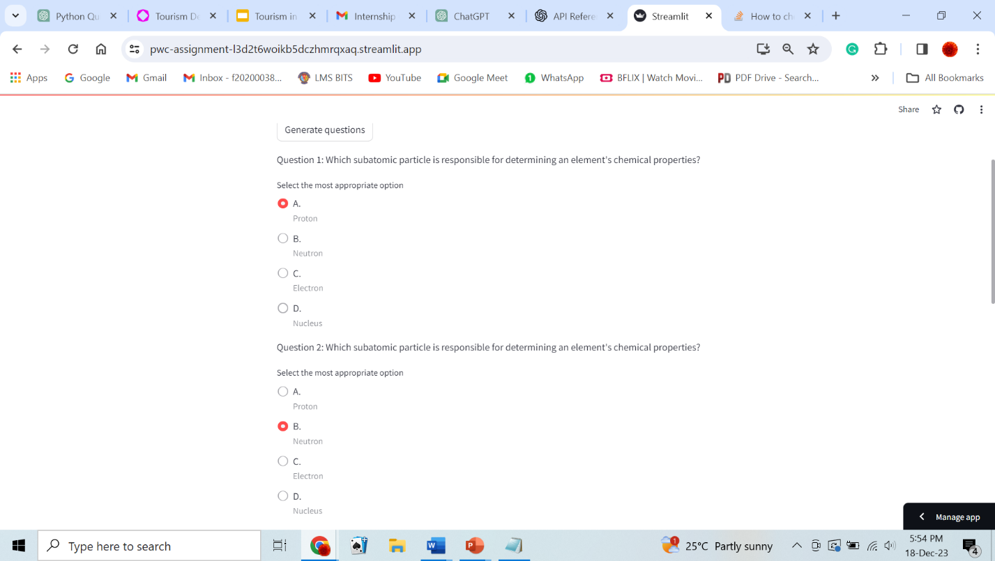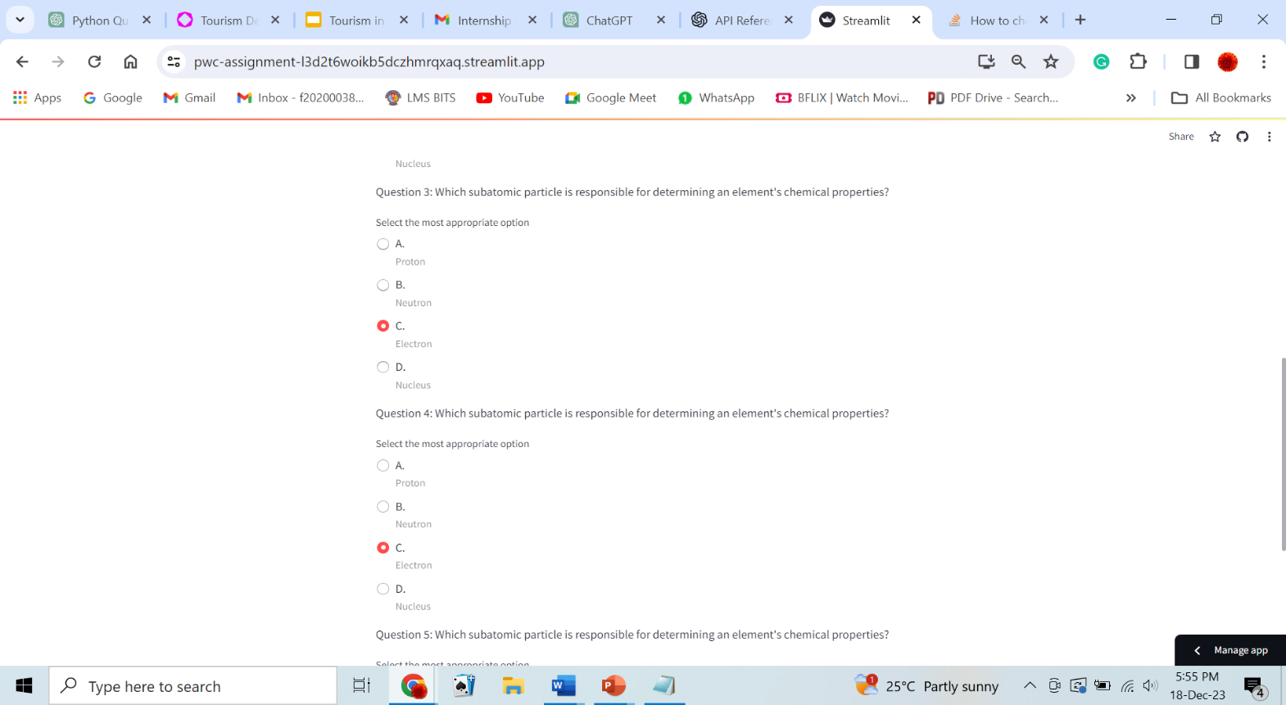 The 3 images below are the questions that are generated by the OpenAI. The user has to select an option for each question and submit the answers.

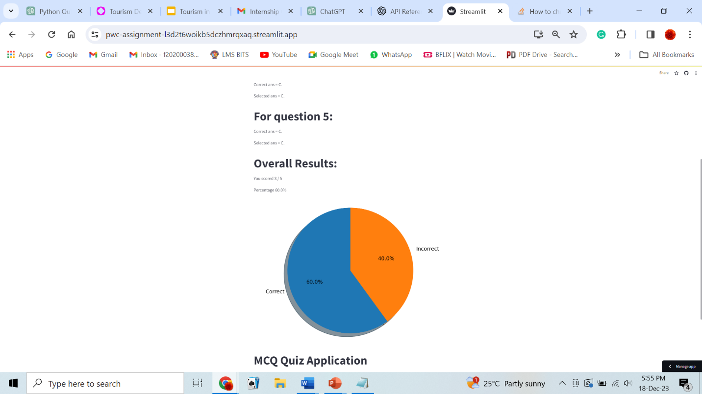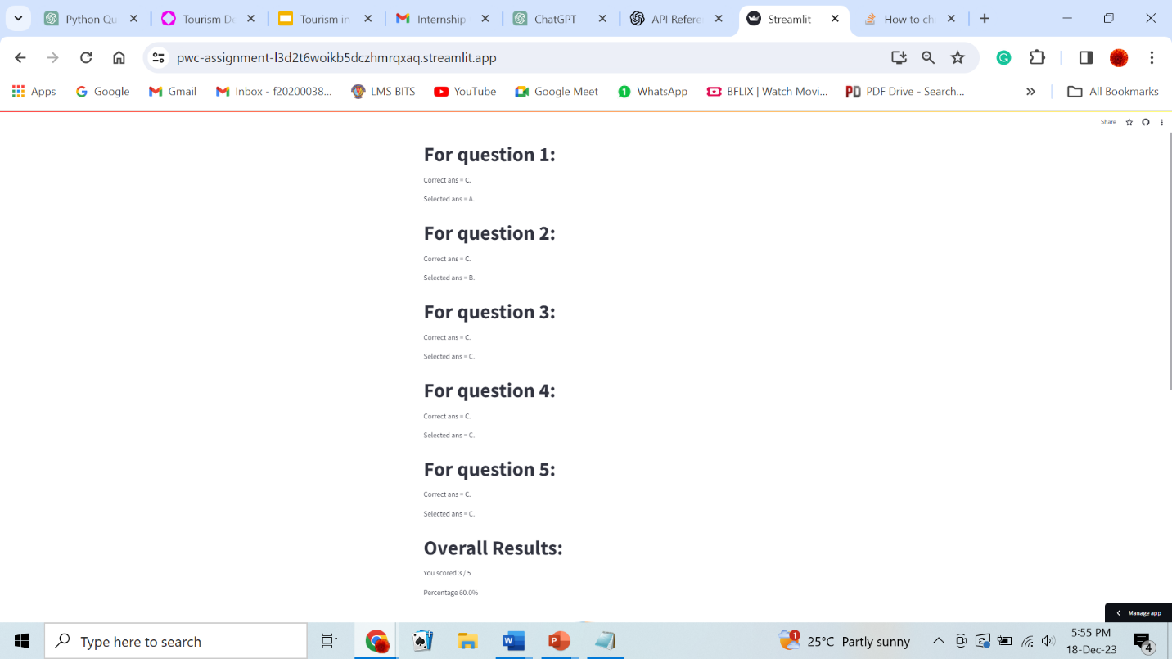

The 2 images above describes the overall results of the quiz and a pie chart has been created to showcase the final result in the form of percentages.