Internship Report
On
HR PROFESSIONAL PRACTICES
Submitted
To
School of Computer Science and Engineering
IILM University, Greater Noida, U.P.
In partial fulfilment of the requirement of degree of
B.Tech CSE

By
Name of Student: GARIMA SHUKLA
Roll Number of Student: 25SCS1003003110
Section: 2CSE19
Batch: 2026-27

CANDIDATE'S DECLARATION
I, GARIMA SHUKLA, do hereby declare that the internship report titled "HR PROFESSIONAL PRACTICES" has been completed by me to fulfil the requirement for the award of the degree of Bachelor of Technology in CSE. All the references have been quoted and I have not taken as such any material from any other source. I affirm that this report is my own and has not been submitted to any other institute for any degree/diploma requirement, and further I shall be solely responsible for any kind of copyright violation in this regard.
Signature: ______________________
Student Name: GARIMA SHUKLA
Roll No.: 25SCS1003003110
Section: 2CSE19

ACKNOWLEDGEMENT
I am using this opportunity to express my gratitude to everyone who supported me throughout the Internship Program. I am thankful for their aspiring guidance, invaluably constructive criticism and friendly advice during this work. I am sincerely grateful to them for sharing their truthful and illuminating views on a number of issues related to this work.
I would like to thank the organisation for providing me the opportunity to undergo this internship and complete the HR Professional programme successfully. I also express my sincere gratitude to my faculty mentors at the School of Computer Science and Engineering, IILM University, for their continuous guidance and support throughout this internship.
I express my gratitude to my parents for their blessings.
Signature: ______________________
Student Name: GARIMA SHUKLA
Roll No.: 25SCS1003003110

TABLE OF CONTENTS
Chapter No. | Chapter Name | Page Nos.
 | Cover Page | ---
1. | Candidate's Declaration | i
2. | Acknowledgement | ii
3. | Internship Completion Certificate | iii
4. | Project Description | 1
 | 4.1 Introduction | 1
 | 4.2 Organization Profile | 1
 | 4.3 Problem Statement | 2
 | 4.4 Project Objectives | 2
 | 4.5 Scope of the Project | 2
 | 4.6 Technologies and Tools Used | 3
 | 4.7 System Architecture | 3
 | 4.8 Methodology | 4
 | 4.9 Expected Outcomes | 4
 | 4.10 Certificate of Completion | 5
5. | Bibliography/References | 6

3. Internship Completion Certificate
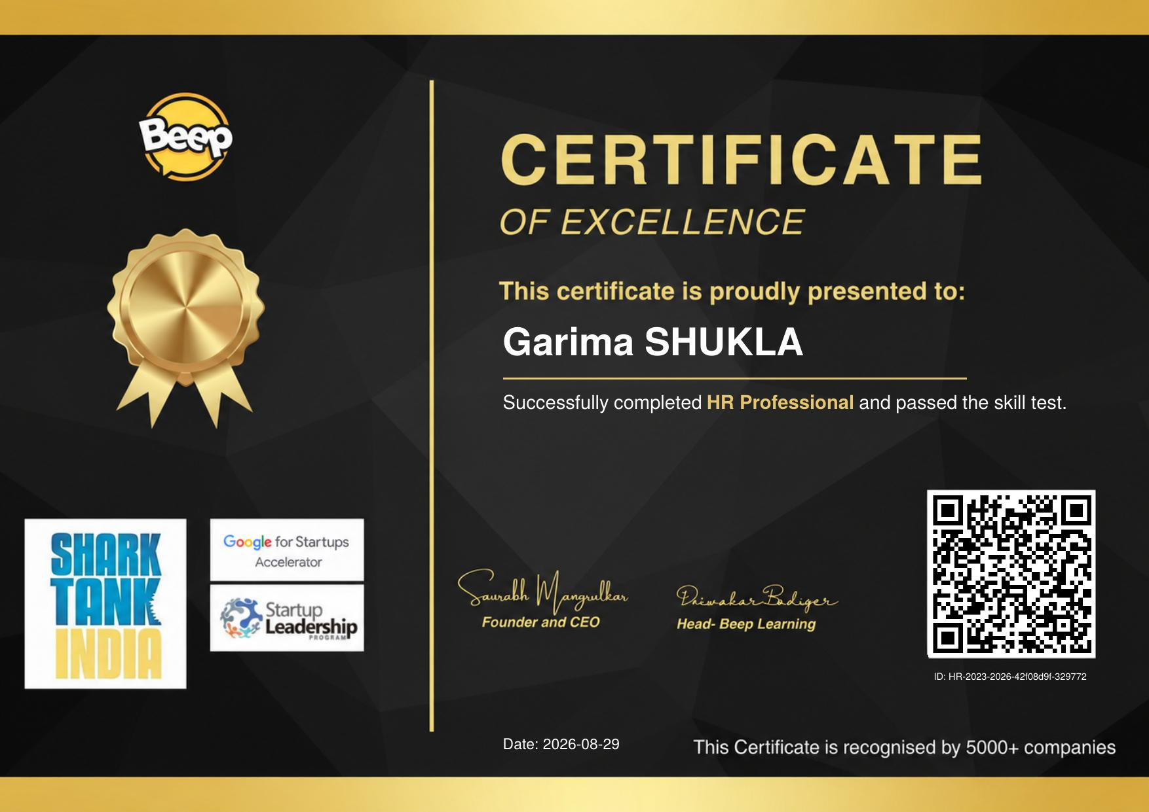

4. Project Description

4.1 Introduction
This report presents the details of the internship undertaken in the domain of Human Resource (HR) Management, under the "HR PROFESSIONAL PRACTICES" programme. Human Resource Management is a core functional area of any organisation, dealing with the recruitment, training, development, and overall management of employees so that organisational goals can be achieved efficiently. The internship was designed to provide practical exposure to the fundamental concepts and real-world practices followed by HR professionals in the industry, including recruitment and selection, employee onboarding, performance management, compensation and benefits, and statutory compliance.
During the course of the internship, a structured curriculum was followed which combined theoretical learning with practical assessments, culminating in a skill test that validated the competencies acquired. This report documents the organisation profile, the problem statement addressed by the internship, its objectives, scope, the tools and technologies used, the methodology followed, and the outcomes achieved.

4.2 Organization Profile
The internship/training programme was conducted by Beep Learning, an ed-tech and skill-development platform that offers industry-oriented certification programmes across multiple professional domains, including Human Resources. Beep Learning is recognised by a number of companies for its skill-based certification model and is supported by initiatives such as Google for Startups Accelerator, the Startup Leadership Program, and has been featured on Shark Tank India.
The organisation focuses on bridging the gap between academic knowledge and industry requirements by providing learners with hands-on, competency-based training modules followed by a skill assessment test, enabling students to gain a certification that is recognised by prospective employers.

4.3 Problem Statement
Fresh graduates and students entering the corporate workforce often possess strong theoretical knowledge but lack practical, hands-on exposure to real HR functions such as recruitment workflows, employee engagement practices, HR documentation, and compliance procedures. This gap between academic learning and industry expectation makes it difficult for new entrants to adapt quickly to HR roles. The internship was undertaken to address this gap by providing structured, practice-oriented training in core HR processes.

4.4 Project Objectives
- To understand the fundamental functions and responsibilities of an HR professional in an organisational setup.
- To gain practical knowledge of recruitment and selection processes, including sourcing, screening, and onboarding of candidates.
- To learn about performance appraisal systems, employee engagement strategies, and compensation management.
- To understand statutory and legal compliance requirements relevant to HR functions.
- To successfully complete the skill assessment test and obtain the HR Professional certification.

4.5 Scope of the Project
The scope of this internship was limited to the core functional areas of Human Resource Management as covered under the HR Professional training curriculum. It encompassed the study of recruitment and selection procedures, HR policies, employee lifecycle management, and the skills required to perform effectively as an HR professional in a corporate environment. The internship did not extend to specialised areas such as HR analytics using advanced software tools or international labour law, which may be explored in future advanced-level training.

4.6 Technologies and Tools Used
- Applicant Tracking and HR Management concepts as taught in the curriculum.
- MS Office (Word, Excel, PowerPoint) for documentation, data organisation, and presentations.
- Online learning management system (LMS) provided by Beep Learning for course delivery and the skill test.
- Communication tools for coordination and discussion during the training programme.

4.7 System Architecture
As this internship was training and knowledge-based rather than software-development based, the "system architecture" here refers to the structure of the training and assessment programme, which was organised in a sequential manner: (1) Module-wise theoretical learning covering HR concepts, (2) Practical exercises and case-based discussions, (3) A comprehensive skill assessment test, and (4) Certification upon successful completion. This structured flow ensured a systematic progression from concept understanding to practical application and final evaluation.

4.8 Methodology
- Module 1: Study of HR fundamentals, roles, and responsibilities.
- Module 2: Recruitment and selection process — sourcing, interviewing, and onboarding.
- Module 3: Performance management, employee engagement, and compensation and benefits.
- Module 4: Statutory compliance and HR documentation practices.
- Final Stage: Skill assessment test to evaluate the knowledge and competencies acquired during the programme.

4.9 Expected Outcomes
Upon successful completion of the internship, the following outcomes were achieved:
- A clear understanding of the core functions and processes involved in Human Resource Management.
- Practical familiarity with recruitment, onboarding, and employee management procedures.
- Enhanced ability to apply HR concepts to real-world organisational scenarios.
- Successful completion of the HR Professional skill test and award of the Certificate of Excellence, recognised by industry partners.

4.10 Certificate of Completion
The certificate of completion issued upon successfully passing the HR Professional skill test is attached in Chapter 3 of this report (Internship Completion Certificate).

5. Bibliography/References
1. Beep Learning – HR Professional Certification Programme, Course Material, 2026.
2. Dessler, G., Human Resource Management, Pearson Education.
3. Aswathappa, K., Human Resource Management: Text and Cases, McGraw Hill Education.
4. Official Certificate of Excellence, Beep Learning, Certificate ID: HR-2023-2026-42f08d9f-329772.

