

**UNIVERSITY OF PETROLEUM AND ENERGY STUDIES**

**School of Computer** **Science**

**2020-21**

**GRAPHICS AND ANIMATION TOOLS LAB**

**Faculty: Dr. DURGANSH SHARMA**

**Assistant Professor**

**Department of Cybernetics.**

**School of Computer Science, UPES**

**Submitted By:**

**Name- Garima Dhall**

**Roll no-R100217025**

**Batch-B1**

**Semester- 7**

**Course-B.tech. CSE-OSOS**

**Sap Id- 500062498**

**PROJECT**

**Aim** :- Design of 3D Room using Blender.

**Objective** :- To Design a 3D Room using features of Blender 2.8.

**STEPS TO MAKE DESIGN A 3D Room:-**

1. Open Blender workspace and add a plan then go in the edit mode and select the vertex and extrude them in z axis and give some depth to the extruded edges

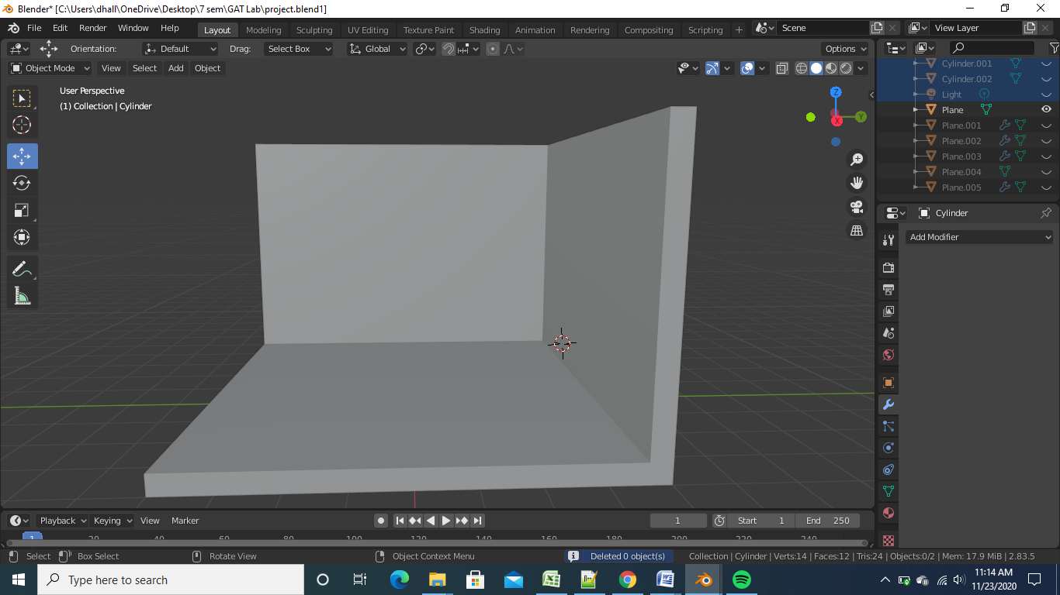

1. Then we will add another plane we will extrude it in z axis and add loop cuts

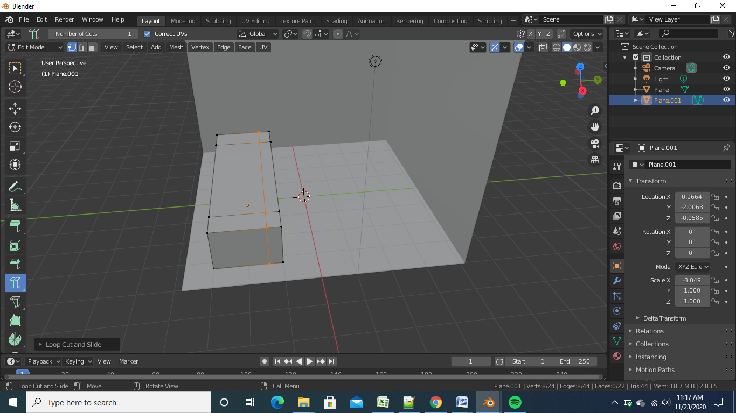

1. After doing the above step we will extrude along the loop cuts and then will shade smooth and then will adjust the loop cuts to make it look like a sofa and then we will rotate it 180 degrees

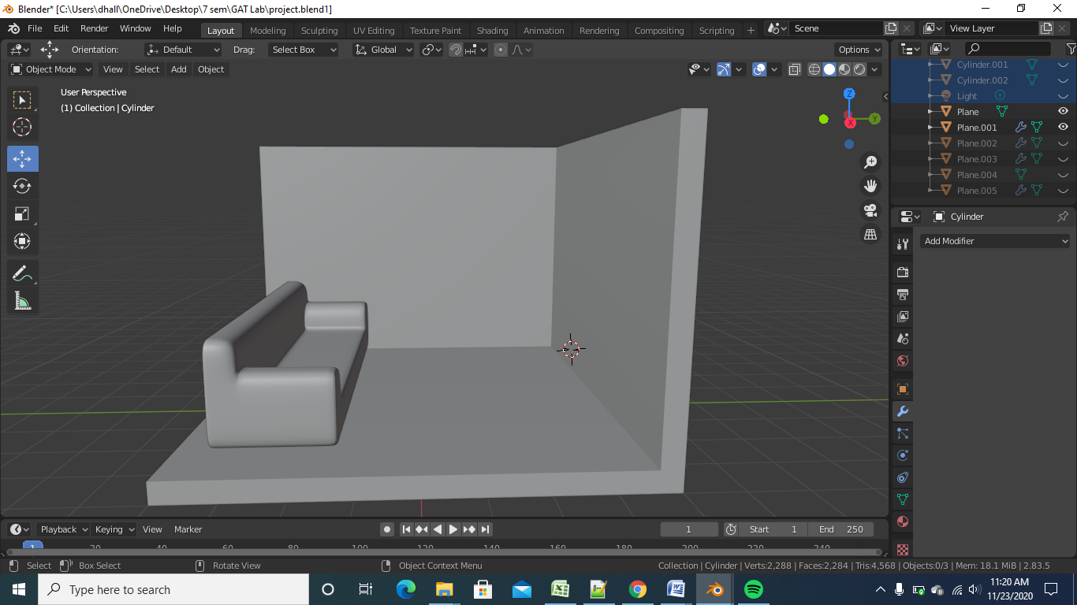

1. After the above step we will add another plane and make the seats for sofa and we will make 3 loop cuts horizontally and 3 loop cuts vertically and we will click on poke faces and after that we will take the vertices and press ‘G’ to extrude them little inwards

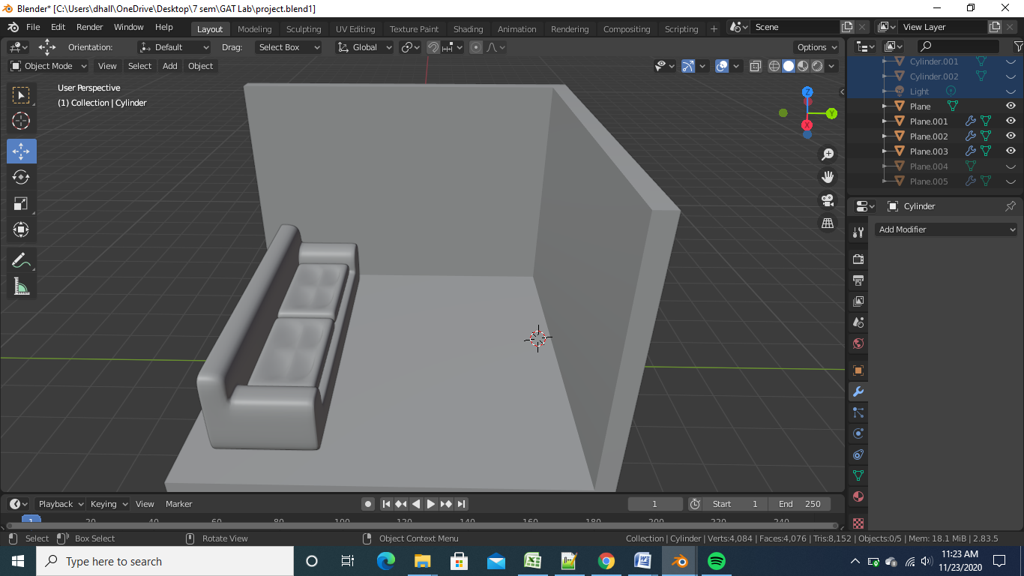

1. After the above step we will add another plane and extrude it and then insert face and then shade smooth in order to look it like T.V

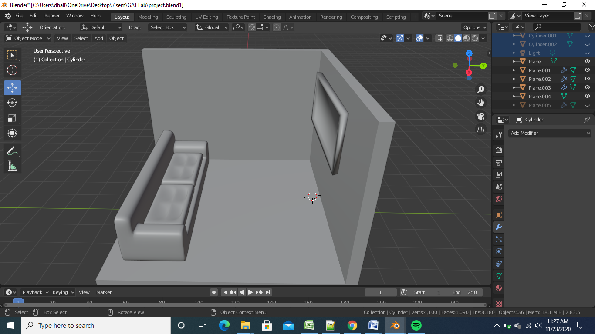

1. After the above step we will add the cylinder just under the sofa in order to make it the base for sofa

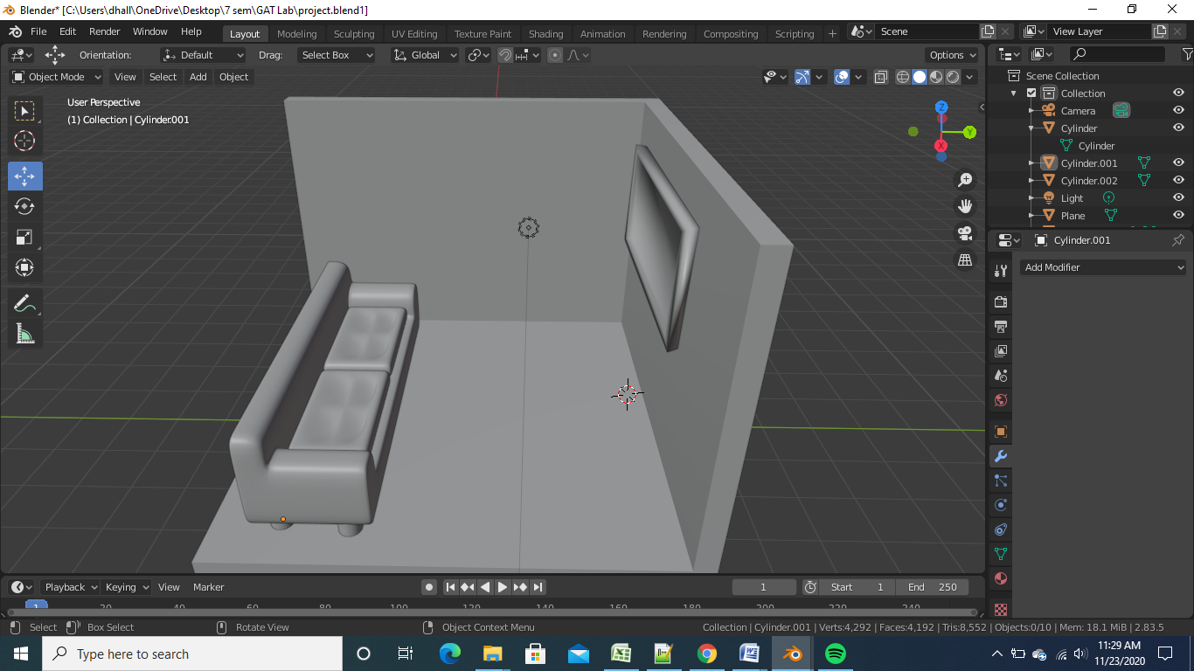

1. After the above step we will add another plane and extrude it in z axis and insert face and then extrude it inwards in order to make it look like table

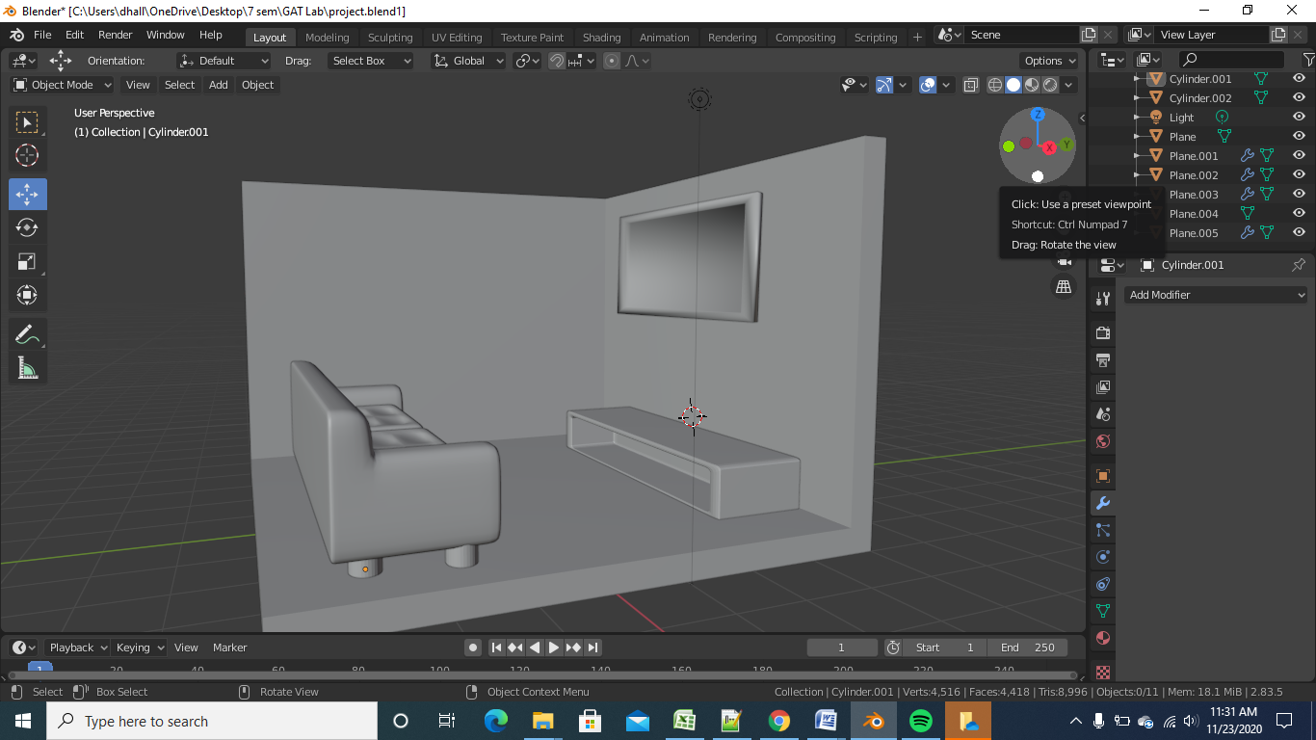

1. After the above step we will shade the elements in shading mode and we will add the painting on the wall and adding a spot light

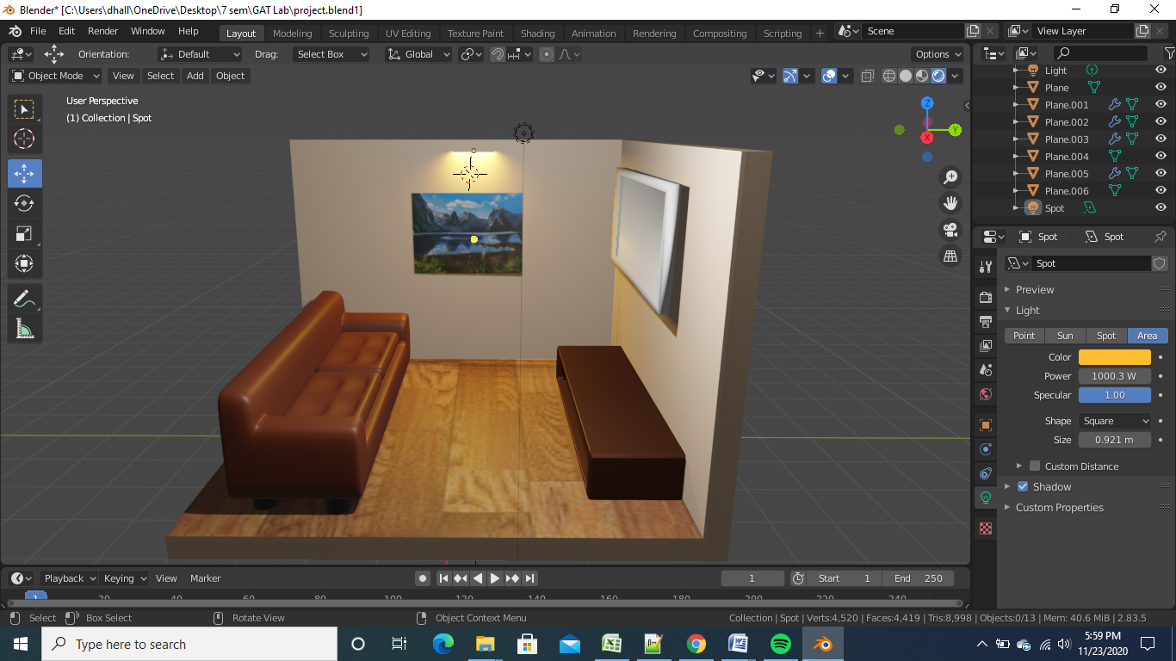

1. After the above step we will add the necessary lights and

