ASSIGNMENT-1

My inspiration to make this avatar is that I am music enthusiast and recently I have start listening to the K POP music so I want my avatar to look like a K-POP artist.

**Steps to create My Avatar in secondlife.com**

**Step 1:-** To make an avatar first you have to create an account on secondlife.com.After creating your account on second life you have to download its software.

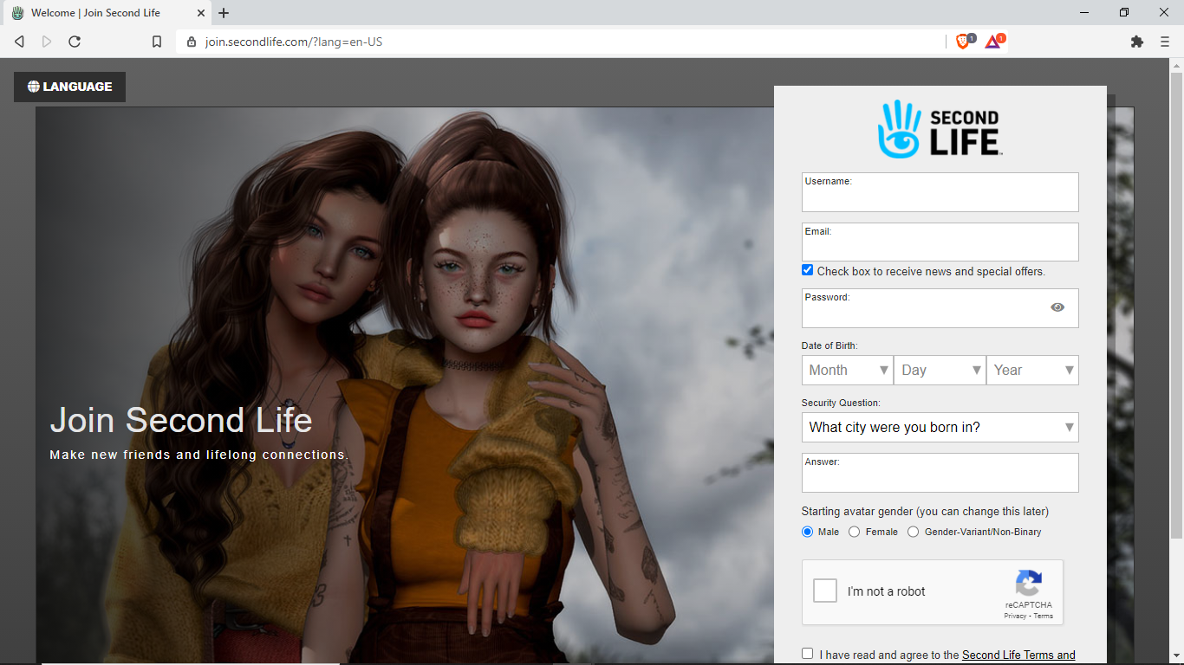

**Step 2:-** After successful download of software you have to log in

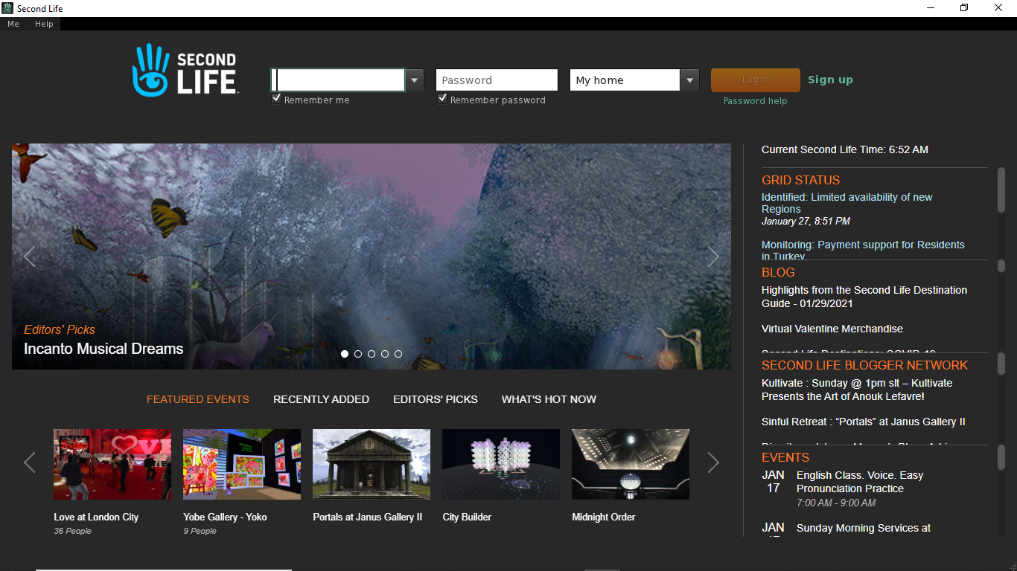

**Step 3:-** After that you will enter into a default environment

**Step 4:-** After that on the screen on the left hand side you can see some icons the first icon is for creating an avatar

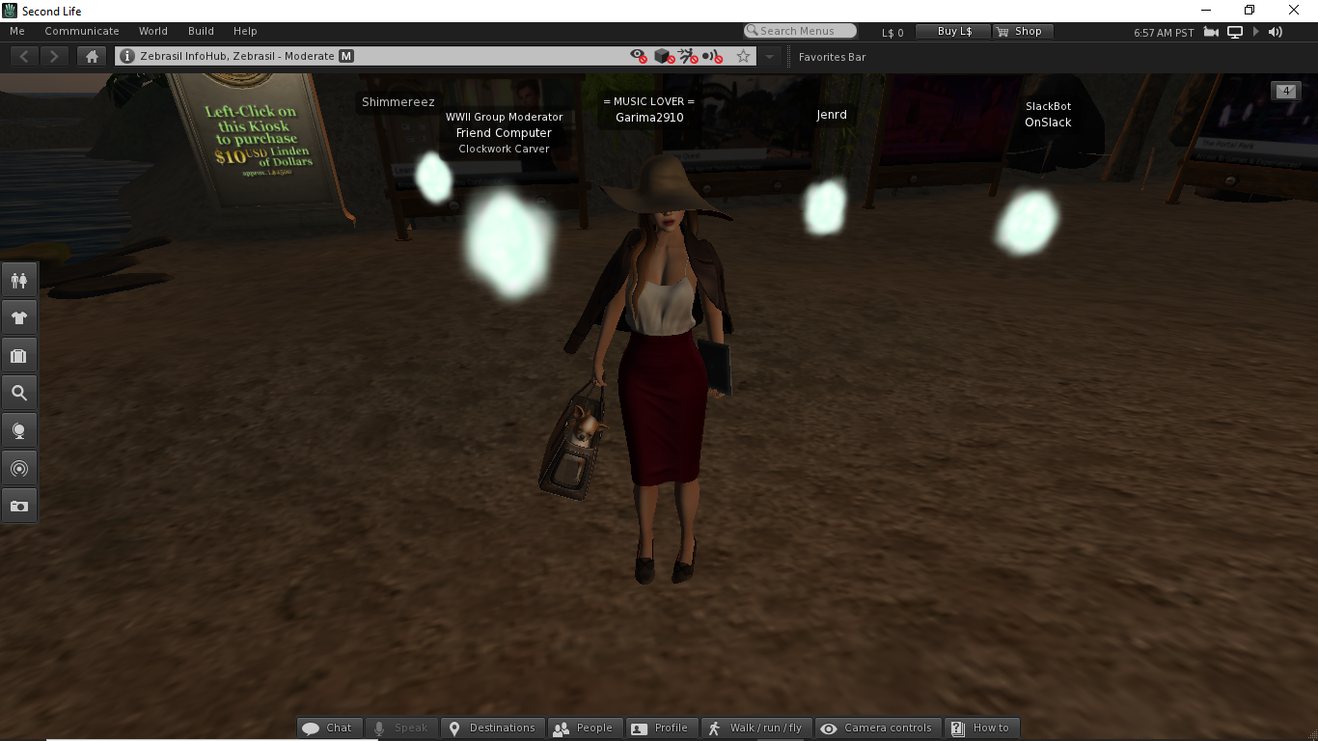

**Step 5:-** After clicking on that icon we can see some avatar we can choose any out of that of our own choice I have opted for this avatar according to my passion for music

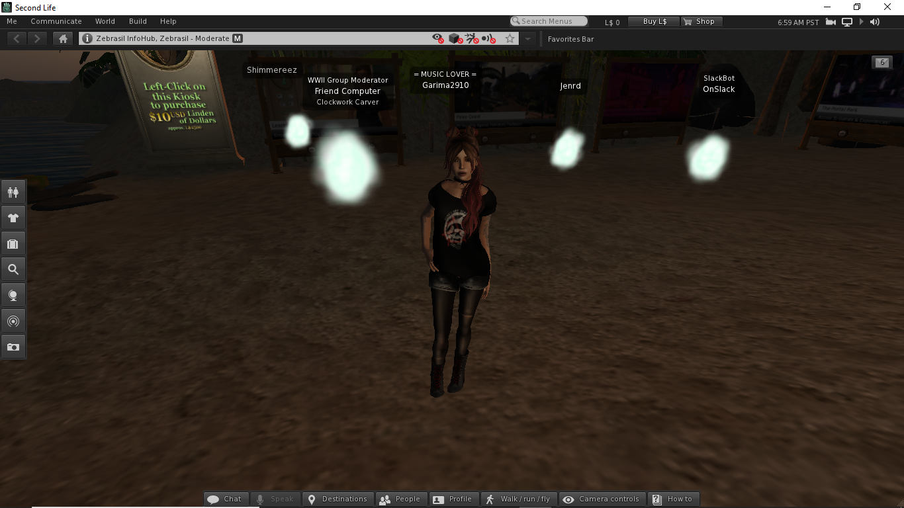

My experience with second life: - In Second Life phrasing, an encounter is a bunch of symbol co operations made by one scripted objects. With an encounter key, makers can construct their avatars