ALGO: MY LANGUAGE
- Compiler vs Interpreter: If a translator translates a source program into machine language, it is a compiler. If a translator processes and executes the source program without translating it into machine language first, it is an interpreter. Visually, it looks something like this:

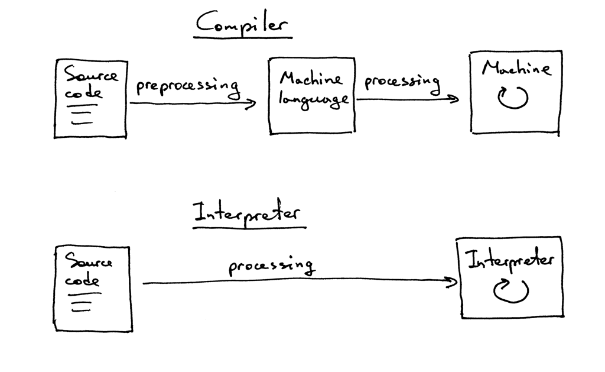

- The process of breaking the input string into tokens is called lexical analysis. The part of the interpreter that performs this task is called a lexical analyser, or lexer for short. You may also encounter other names for the same component, such as scanner or tokeniser. They all mean the same: the part of your interpreter or compiler that turns the input of characters into a stream of tokens.

ALGO:
A lightweight, human-readable algorithm description language designed for clarity, learning, and structured reasoning.

🌱 Core Philosophy
- Algorithms over syntax: The language focuses on expressing logic, not code.
- Human-readable: Programs look like academic algorithms, not traditional programming syntax.
- Flexible wording: Multiple synonyms map to the same operation.
- Noise-tolerant: Extra words are ignored, allowing natural phrasing.
- Minimal rules: Only essential keywords matter; everything else is treated as comments.
- Interpreter-based: Executes step-by-step logic through a Python backend.
- Educational: Ideal for learning, testing, and explaining algorithms.

🌾 Key Features
1. Natural Algorithmic Syntax
Programs are written in plain, structured English-like steps:
1. Create an empty list
2. Loop through the numbers
3. If the number is even, then add it to the list
4. Print the list
2. Synonym-Based Understanding
The interpreter recognises multiple expressions for the same action:
- “loop”, “iterate”, “go through” → LOOP
- “add”, “append”, “insert”, “put” → ADD
- “print”, “show”, “display” → OUTPUT
This makes the language flexible without needing AI.
3. Noise-Word Ignorance
Words like “the”, “then”, “just”, “basically”, “now”, “do this”, etc.
are automatically ignored.
This allows natural phrasing without breaking the program.
4. Step-Based Execution Model
Each line represents a logical step.
The interpreter processes steps in order, just like academic algorithms.
5. Minimal Data Types
- Numbers
- Strings
- Lists
- Booleans
Simple and sufficient for algorithmic reasoning.
6. Core Operations
- Variable creation
- List creation
- Adding/removing items
- Loops (for-each style)
- Conditionals (if/else)
- Printing/output
- Basic arithmetic
7. Deterministic Behaviour
No randomness, no hidden state, no side effects.
Every program behaves predictably.
8. Python Backend
The interpreter is implemented in Python, making it:
- easy to extend
- easy to debug
- easy to integrate
- fast enough for algorithmic tasks

🌼 What Makes It Unique
- It’s not a Python clone.
- It’s not a general-purpose language.
- It’s a Domain-Specific Language (DSL) for expressing algorithms in human terms.
- It bridges the gap between pseudocode and real execution.
- It’s perfect for:
  - learning
  - interviews
  - teaching
  - assessments
  - algorithm visualization
  - personal reasoning

🌙 One-Sentence Summary
A natural-language-inspired algorithm description language that executes human-readable steps using synonym-based parsing and a simple, deterministic interpreter.

python interpreter.py program.garima

