

Multi-Resolution Terrain Fusion and ML-Based Adaptive Landing Site
Selection for Lunar South Pole Rover Missions
MID TERM VIII SEMESTER SYNOPSIS REPORT
Submitted in partial fulfillment of the requirement of the degree of
BACHELORS OF TECHNOLOGY
to
The NorthCap University
by
Garima (22CSU067)
Garima Juneja (22CSU068)
Aryan (22CSU031)
Under the supervision of
Dr. Snehlata Sheoran
Dr. Ankita Bhalla
Associate Professor, Department of Computer Science and Engineering
Department of Computer Science and Engineering
School of Engineering and Technology
The NorthCap University, Gurugram – 122001, India
Session 2022–26

CERTIFICATE
This is to certify that the Project Synopsis entitled, “Multi-Resolution Terrain Fusion and ML-Based Adaptive Landing Site Selection for Lunar South Pole Rover Missions” submitted by Garima (22CSU067), Garima Juneja (22CSU068), and Aryan (22CSU031) to The NorthCap University, Gurugram, India, is a record of bona fide synopsis work carried out by them under our supervision and guidance and is worthy of consideration for the partial fulfilment of the degree of Bachelor of Technology in Computer Science and Engineering of the University.
Signature: ___________________ | Signature: ___________________
Dr. Snehlata Sheoran  Associate Professor, Dept. of CSE  The NorthCap University | Dr. Ankita Bhalla  Associate Professor, Dept. of CSE  The NorthCap University

Date: _______________

INDEX
S. No. | Chapter / Section | Page No.
1 | Abstract | 4
2 | Chapter 1: Introduction | 5
3 | Chapter 2: Background | 7
4 | Chapter 3: Feasibility Study | 9
5 | Chapter 4: Literature Survey | 11
6 | Chapter 5: Comparison with Existing Solutions | 15
7 | Chapter 6: Gap Analysis | 17
8 | Chapter 7: Problem Statement | 18
9 | Chapter 8: Objectives | 19
10 | Chapter 9: Tools / Platform Used | 20
11 | Chapter 10: Design Methodology | 22
12 | Chapter 11: Challenges and Issues Identified | 25
13 | Chapter 12: Methodology and Implementation | 27
14 | Chapter 13: Performance Evaluation | 34
15 | Chapter 14: Outcomes | 38
16 | Chapter 15: Gantt Chart | 40
17 | Chapter 16: Responsibility Chart | 41
18 | References | 42
19 | Annexure I: Meeting Screenshots / Guide Comments | 44

Abstract
The lunar south polar region represents one of the most scientifically compelling and operationally hazardous destinations in contemporary planetary exploration. Permanently shadowed craters may harbour water ice deposits of immense scientific and resource value, yet the terrain is characterised by extreme slopes, deep shadowing, and limited illumination that challenge conventional mission planning. This report presents Anveshak, a comprehensive web-based mission planning system for lunar south pole rover operations, integrating multi-resolution terrain fusion, machine learning-based terrain classification, adaptive landing site scoring, terrain-aware pathfinding, and geological anomaly detection.
The system ingests real NASA LRO LOLA Digital Elevation Model (DEM) data covering 80–90°S at 20 m/pixel native resolution, computes operational terrain metrics (slope, roughness, and data-quality masks) over a 10,133 × 10,133 pixel grid at 60 m/pixel working resolution, and delivers mission-critical analysis through an interactive browser-based interface. A Random Forest terrain classifier achieves 99.17% validation accuracy on 10,000 held-out samples trained entirely from automatically generated labels. Validation against four NASA Artemis III candidate sites demonstrates strong qualitative agreement with published expert assessments. End-to-end analysis latency is 18–45 seconds on commodity hardware.
The system demonstrates that a fully open, automated, data-driven pipeline can reproduce expert-quality lunar south pole mission analysis at interactive latencies without proprietary software dependencies. Anveshak is being prepared for journal submission and provides a reproducible, extensible baseline for multi-modal planetary mission planning research.
Keywords — Lunar landing site selection, Digital Elevation Model, Random Forest terrain classification, A* pathfinding, DBSCAN anomaly detection, NASA LRO LOLA, south pole robotics, mission planning, FastAPI, planetary science.

Chapter 1: Introduction
1.1 Broad Context and Motivation
The exploration of the Moon's south polar region has become a central ambition of global space agencies and commercial actors in the early twenty-first century. NASA's Artemis programme, ISRO's Chandrayaan series, the China National Space Administration's Chang'e programme, and numerous commercial ventures are all targeting this region, driven chiefly by the theoretical presence of water ice in Permanently Shadowed Regions (PSRs). Colaprete et al. [1] confirmed water ice detection via the LCROSS impact mission, validating decades of orbital neutron spectrometer observations. The potential in-situ resource utilisation (ISRU) value of polar ice — for propellant, life support, and construction — transforms the south pole from a scientific curiosity into a strategic human settlement target.
Despite this compelling motivation, the south polar terrain presents mission designers with formidable challenges. Slopes near crater rims frequently exceed 20°, well above the stability threshold for most rover designs. Illumination is highly variable and site-dependent, with some ridges receiving near-continuous sunlight while crater floors remain in permanent shadow. The LOLA DEM data reveals elevation variations from −7,297 m in crater floors to +7,027 m at rim peaks within the 80–90°S coverage area. Conventional mission planning workflows rely heavily on specialist geospatial software and manual expert review, creating bottlenecks that slow mission cadence and limit participation by smaller teams and institutions.
1.2 The Anveshak System
Anveshak (Sanskrit for “explorer” or “investigator”) is an integrated web-based mission planning system addressing this gap. It provides a complete, automated pipeline from raw DEM ingestion through interactive mission advisory report generation, accessible from any modern browser. The system is designed as an offline planning tool rather than an onboard navigation system: it operates on pre-processed DEM tiles and delivers analysis results to human mission planners who retain final decision authority. This human-in-the-loop design is a deliberate safety choice appropriate to the current state of planetary mission verification and validation practice.
The system comprises seven tightly integrated analytical modules: terrain data ingestion and metric computation (terrain.py), multi-criteria landing site scoring (landing_scorer.py), terrain-aware A* pathfinding (pathfinder.py), Random Forest terrain classification (terrain_classifier.py), DBSCAN-based science target detection (anomaly_detector.py), first-principles energy modelling (energy_model.py), and rule-based mission advisory report generation (mission_advisor.py). These modules are wired together through a Python FastAPI backend exposed via a lightweight HTML/CSS/JavaScript frontend.
1.3 Key Contributions
This project makes the following specific contributions:
- An open, reproducible pipeline for ingesting NASA LRO LOLA DEM data (LDEM_80S_20M.JP2) and deriving operational terrain metrics — slope, roughness, and data-quality masks — over the complete 80–90°S region at a working resolution of 60 m/pixel.
- A multi-criteria landing-site scoring function parameterised by mission profile, with empirical validation against four NASA Artemis III candidate sites.
- A Random Forest terrain classifier trained on 50,000 automatically labelled samples achieving 99.17% accuracy on a held-out validation set of 10,000 samples, without requiring manual annotation.
- An A* pathfinder with terrain-aware exponential slope cost, supporting 8-directional movement over grids exceeding 10,000 × 10,000 pixels within a 2-million-iteration budget.
- A DBSCAN-based science-target detector that identifies geologically anomalous terrain without requiring prior specification of cluster count.
- An integrated web-based interface with interactive Plotly visualisations and rule-based plain-English mission advisory report generation.
1.4 Report Structure
The remainder of this report is structured as follows. Chapter 2 provides background on lunar exploration and the DEM data products used. Chapter 3 presents the feasibility study. Chapter 4 surveys related literature. Chapter 5 compares Anveshak with existing solutions. Chapter 6 identifies the gap this work addresses. Chapters 7 and 8 state the problem and objectives. Chapter 9 documents the tools and platform. Chapters 10 and 11 address design methodology and challenges. Chapter 12 details the full methodology and implementation. Chapter 13 presents performance evaluation results. Chapter 14 describes outcomes and Chapter 15–16 provide the project timeline and responsibility charts.

Chapter 2: Background
2.1 History of Lunar South Pole Exploration
Interest in the lunar poles was catalysed by the Clementine mission (1994) and Lunar Prospector (1998), which provided indirect evidence for hydrogen concentrations in polar craters consistent with water ice. The Lunar Reconnaissance Orbiter (LRO), launched in 2009, transformed our understanding of polar topography through the Lunar Orbiter Laser Altimeter (LOLA) instrument, providing 10 cm vertical precision over the entire lunar surface [5]. The LCROSS impactor mission (2009) detected water vapour in the debris plume, providing the first direct confirmation of polar water ice [1].
More recently, Chandrayaan-3 (ISRO, 2023) achieved the first successful landing near the lunar south pole at 69.37°S, demonstrating surface operations at high southern latitudes and directly validating the scientific and engineering interest in this region. NASA's Artemis III mission, currently planned, targets several sites in the 88–90°S range including Shackleton Ridge, Faustini Crater rim, Haworth Edge, and Nobile Rim. These sites were selected following multi-year analysis integrating LOLA DEM data, Diviner thermal mapping, and illumination modelling [18].
2.2 NASA LRO LOLA Digital Elevation Model
The Lunar Orbiter Laser Altimeter aboard LRO fires laser pulses at 28 Hz and measures surface returns with sub-meter cross-track resolution, accumulating more than 6 billion measurements over the primary and extended mission phases [5]. These measurements are gridded into DEM products at multiple resolutions: the LDEM_80S_20M product used in this project covers 80–90°S at 20 m/pixel in JPEG2000 format. The companion LDEC file records the number of laser returns per pixel, providing a data-quality mask that identifies regions of sparse coverage where elevation values are interpolated rather than directly measured.
The DEM is projected in the Polar Stereographic Moon 2000 coordinate reference system (EPSG:104903), centred on the south pole. Pixel coordinates map to selenographic latitude/longitude through the affine transform embedded in the JPEG2000 file headers, accessed via the rasterio library. The full 80–90°S grid at 20 m/pixel comprises approximately 10,133 × 10,133 pixels, covering roughly 200 km × 200 km of polar terrain. Elevation ranges from −7,297 m (deep crater floors) to +7,027 m (high rim peaks).
2.3 Mission Planning Requirements
Effective mission planning for lunar south pole rover operations must simultaneously satisfy engineering safety constraints and science return objectives. Key engineering constraints include maximum traversable slope (typically 15–20° for current rover designs), minimum flat landing radius (typically 100–200 m), terrain roughness limits (driven by chassis suspension travel), and power availability (solar or RTG). Science objectives vary by mission type: water-ice prospecting missions prioritise PSR proximity and high latitudes; geological survey missions prefer exposed bedrock and crater rims; technology demonstration missions seek flat, low-risk terrain.
The combinatorial complexity of simultaneously optimising multiple objectives over a 10,000 × 10,000 pixel terrain grid, subject to mission-profile constraints, motivates automated computational approaches. Manual analysis at this resolution is impractical; even expert teams require automated preprocessing pipelines to make initial site shortlists before human review.
2.4 Machine Learning in Planetary Science
Machine learning has been applied to planetary terrain analysis in a growing body of literature. Crater detection using CNNs [2], terrain classification on Mars using SVMs [3], and graph-based rover path optimisation [4] represent three independent threads that Anveshak synthesises into a unified framework. The key enabling observation is that terrain classification labels can be automatically generated from the scoring pipeline outputs, eliminating the annotation bottleneck that has limited supervised learning applications in planetary science.

Chapter 3: Feasibility Study
3.1 Technical Feasibility
The technical feasibility of Anveshak rests on the availability of open-source tools sufficient to implement each required capability without proprietary dependencies. The Python scientific computing stack provides all necessary primitives:
- rasterio (v1.3+): JPEG2000 and GeoTIFF ingestion with CRS-aware coordinate transforms, eliminating the need for expensive commercial GIS software.
- NumPy / SciPy: Array computation for slope (central finite differences via numpy.gradient), roughness (scipy.ndimage.uniform_filter), and all derived terrain metrics.
- scikit-learn (v1.3+): Random Forest classifier (RandomForestClassifier) and DBSCAN clustering, both with efficient C extensions that handle 50,000-sample training sets in under 60 seconds.
- FastAPI (v0.100+): Asynchronous REST API framework with minimal overhead, supporting concurrent request handling and ThreadPoolExecutor dispatch for CPU-intensive tasks.
- Plotly (v5+): Interactive browser-rendered visualisations with no server-side rendering dependencies; map HTML is generated once and serialised in the API response.
- Conda environment management: Cross-platform reproducibility; the project Conda environment (lunar-planner, Python 3.11) installs cleanly on Windows, Linux, and macOS.
The primary technical risk is memory: the full 10,133 × 10,133 float32 elevation array requires 412 MB, and three such arrays (elevation, slope, roughness) total approximately 1.2 GB. Combined with the 13.7 MB Random Forest model and scikit-learn inference buffers, peak RAM usage is approximately 1.8 GB, well within the 16 GB specification of the development workstation. The risk is mitigated by the 60 m/pixel downsampling decision (Section 12.1), which reduces grid size by 9× relative to native 20 m/pixel resolution.
3.2 Operational Feasibility
From an operational perspective, Anveshak requires no specialised hardware. It runs on a standard developer workstation (Intel Core i7, 16 GB RAM, no GPU required). The browser-based interface eliminates client-side installation and is accessible from any device with a modern browser. Data input requires only the LOLA DEM files, which are freely downloadable from NASA's Planetary Data System (PDS) Geosciences Node. The one-time DEM loading step (≈12 seconds) is performed on server startup; subsequent analyses complete in 18–45 seconds per query.
3.3 Economic Feasibility
All software dependencies are open-source with permissive licences (NumPy: BSD, scikit-learn: BSD, FastAPI: MIT, rasterio: BSD, Plotly: MIT). The NASA LOLA DEM data products are public domain. Development cost is limited to student and supervisor time, with no software licensing expenditure. Deployment requires only a standard server instance (2 vCPU, 4 GB RAM minimum), costing approximately \$15–25/month on commodity cloud platforms if hosting is desired. For local use, no ongoing cost is incurred.
3.4 Schedule Feasibility
The project was scoped to complete implementation across one academic semester (October 2025 – March 2026), with research paper preparation continuing through April 2026. The modular architecture — seven largely independent modules — enables parallel development and incremental integration. Each module was completed and verified independently before integration, following an iterative development model. All seven modules were completed and the system was fully integrated by February 2026, leaving March 2026 for validation, testing, and report writing.

Chapter 4: Literature Survey
4.1 Lunar DEM Products and Terrain Analysis
Smith et al. [5] describe the LOLA instrument and its 10 cm vertical precision, which forms the basis for the LDEM_80S_20M product used in this project. Zuber et al. [6] used LOLA data to characterise Shackleton Crater's internal topography, providing early evidence for volatile trapping in its PSR floor. Deutsch et al. [7] presented updated estimates of ice mass in the lunar polar regions using combined LOLA, Mini-RF, and Diviner observations. These foundational works establish both the data product quality and the scientific context motivating south pole mission planning.
Prior terrain analysis using LOLA data has largely been performed in specialised GIS environments (ArcGIS, QGIS, ENVI) requiring domain expertise and commercial licences. Anveshak's contribution in this sub-domain is the fully automated, open-source Python pipeline that replicates core terrain analysis capabilities within a web-deployable application framework, making these analyses accessible to a broader community of researchers and mission planners.
4.2 Automated Landing Site Selection
Golombek et al. [8] established multi-criteria scoring frameworks for the Mars Exploration Rover (MER) landing site selection process, combining engineering safety (slope, rock abundance) with scientific merit. This conceptual foundation directly informs Anveshak's two-component scoring model (safety score + mission score). Flahaut et al. [9] identified regions of interest for future human lunar landing sites using a multi-criteria approach integrating slope, illumination, and scientific value maps derived from orbital datasets.
Existing automated landing site selection tools are predominantly research prototypes without publicly available implementations. The most relevant is the ALHAT (Autonomous Landing and Hazard Avoidance Technology) system developed by NASA JSC, which focuses on onboard real-time hazard detection during final descent rather than pre-mission site selection. Anveshak occupies the complementary pre-mission planning niche, operating offline on large DEM tiles rather than onboard with real-time lidar data.
4.3 Machine Learning for Planetary Terrain Classification
Bue and Stepinski [3] demonstrated SVM-based geomorphic unit classification from Martian DEM data, establishing the viability of supervised terrain classification from elevation-derived features. Palafox et al. [11] applied CNNs to detect volcanic features on Mars from DEM patches, achieving higher accuracy than SVMs but requiring substantially more training data and computation. Wagstaff et al. [10] demonstrated novelty detection for identifying scientifically interesting rock targets from rover imagery using unsupervised methods.
Ono et al. [12] describe MAARS, a machine learning-based autonomous rover science system for Mars that integrates terrain classification with science target identification. Shwartz-Ziv and Armon [19] provide theoretical grounding for the choice of tree-based models over deep learning for tabular (non-image) data, demonstrating that Random Forests often match or exceed neural network performance on structured feature vectors — directly supporting Anveshak's classifier design choice.
4.4 Rover Path Planning
Stentz [13] introduced the D* algorithm for dynamic replanning in unknown terrain, which remains a reference for onboard rover autonomy systems. Ferguson and Stentz [14] developed Field D*, which provides interpolated movement directions for smoother paths on grid representations. For pre-mission offline planning on known terrain, A* with an admissible Euclidean heuristic remains computationally dominant due to its guaranteed optimality under the selected cost function and tractable runtime on the 10,133 × 10,133 grid.
Wettergreen et al. [4] describe science-enabling autonomous navigation for planetary rovers, combining terrain assessment with science value estimation to plan energy-optimal paths that maximise science return per unit energy. This multi-objective framing influenced Anveshak's path planning design, which incorporates terrain-aware slope cost alongside anomaly waypoints to guide rovers toward science targets while respecting safety constraints.
4.5 Science Target Detection and Anomaly Analysis
Ester et al. [15] introduced DBSCAN (Density-Based Spatial Clustering of Applications with Noise), which has proven particularly suited to geospatial anomaly detection because it does not require pre-specification of the number of clusters and natively identifies noise points. Kerner et al. [16] applied novelty detection to multispectral planetary images, demonstrating the value of unsupervised approaches for identifying targets that differ statistically from background terrain without requiring prior labelling of anomalous features.
4.6 Integrated Mission Planning Systems
Chien et al. [17] describe OASIS, an automated mission planning system for the EO-1 Earth observation satellite that integrates science return optimisation with engineering constraint satisfaction. For surface rover missions, the RSVP (Robot Sequencing and Visualisation Program) toolchain used by NASA JPL for Curiosity and Perseverance operations provides a high-fidelity simulation and planning environment. However, RSVP is designed for executed mission operations rather than pre-mission site selection, is not publicly released, and requires access to mission-specific rover kinematic models.
No existing open-source, end-to-end system combines DEM ingestion, ML terrain classification, multi-criteria scoring, pathfinding, and anomaly detection in a unified web-deployable framework tailored to the lunar south pole. This gap directly motivates the development of Anveshak.

Chapter 5: Comparison with Existing Solutions
Table 5.1 provides a structured comparison of Anveshak against four categories of existing tools: commercial GIS platforms, NASA mission planning toolchains, research prototypes, and open-source planetary science libraries.
Criteria | Anveshak | ArcGIS/ENVI | NASA RSVP | ALHAT | OASIS
Open source | Yes | No | No | No | No
Web-deployable | Yes | No | No | N/A | No
DEM ingestion  (open) | Yes | Yes | Limited | No | N/A
ML classification | Yes  (RF, 99.17%) | Limited | No | Basic | No
Path planning | A*  (terrain-aware) | No | Yes  (sim) | D* (onboard) | N/A
Anomaly detection | DBSCAN | Manual | No | No | Limited
Mission advisory | Yes  (rule-based) | No | No | No | Yes
Validation vs.  Artemis III | Yes  (4 sites) | No | Yes  (internal) | No | No
Hardware needed | i7, 16 GB  (standard) | GPU recommended | Workstation | Onboard  computer | Server
Cost | Free  (OSS) | $$$ licence | Not public | Not public | Not public
Table 5.1: Feature comparison of Anveshak with existing mission planning tools.
The comparison reveals that no existing open tool combines all the capabilities Anveshak provides. Commercial GIS platforms (ArcGIS, ENVI) offer powerful terrain analysis but lack ML classification, pathfinding, and mission advisory capabilities, and require expensive commercial licences. NASA RSVP is designed for executed mission operations rather than pre-mission site selection and is not publicly released. ALHAT addresses onboard real-time landing hazard avoidance during final descent, a fundamentally different problem from pre-mission planning. OASIS focuses on orbital asset scheduling rather than surface rover mission planning.

Chapter 6: Gap Analysis
The literature survey and comparative analysis reveal the following specific gaps that Anveshak addresses:
• No integrated open-source end-to-end pipeline
Existing tools address individual sub-problems (terrain analysis, path planning, anomaly detection) in isolation. No open-source system integrates all these capabilities into a unified web-deployable application tailored to lunar south pole mission planning.
• Annotation bottleneck for supervised learning
Prior ML-based terrain classification systems require manually annotated training datasets, which are expensive to produce for planetary surfaces. Anveshak's auto-labelling scheme — generating training labels from the scoring pipeline — removes this bottleneck entirely.
• Lack of mission-profile parameterisation
Existing scoring tools apply fixed weights to safety and science criteria. Anveshak's parameterised scoring function adapts to mission type (water-ice prospecting, geological survey, technology demonstration), enabling meaningful comparison of the same terrain under different mission objectives.
• No public validation against Artemis III candidate sites
Published automated scoring systems have not been validated against the specific Artemis III candidate sites that represent current NASA planning consensus. Anveshak provides this validation, enabling direct comparison with expert assessments.
• Closed-source or inaccessible implementations
The most capable mission planning systems (RSVP, ALHAT) are closed-source NASA tools not available to the broader research community. This limits reproducibility and prevents community extension. Anveshak's fully open implementation enables replication, extension, and benchmarking.

Chapter 7: Problem Statement
The increasing frequency and ambition of planned lunar south pole missions, combined with the growing participation of smaller institutions and commercial actors, creates a critical need for accessible, open, automated mission planning tools. Current practice relies on expert-operated commercial GIS platforms and proprietary NASA toolchains, creating barriers to entry that exclude smaller teams and slow the planning cycle.
Specifically, the problem addressed by this project is:
"Given real NASA LRO LOLA Digital Elevation Model data covering the lunar south polar region (80–90°S), design and implement an open-source, web-deployable mission planning system that automatically ingests and processes terrain data, applies machine learning to classify terrain and detect science targets, scores candidate landing sites according to configurable mission profiles, plans energy-efficient traverse paths, and generates plain-English mission advisory reports — all within interactive latencies on commodity hardware, without proprietary software dependencies."
The system must simultaneously satisfy five non-trivial constraints: (1) correctness, validated against NASA expert assessments of Artemis III candidate sites; (2) scalability, operating on 10,133 × 10,133 pixel grids within 16 GB RAM; (3) accessibility, deployable without specialist GIS or ML expertise; (4) reproducibility, with open data and open-source software; and (5) extensibility, structured to enable future integration of multi-modal data products.

Chapter 8: Objectives
The specific objectives of this project are:
- To develop an automated, open-source pipeline for ingesting and processing NASA LRO LOLA DEM data (LDEM_80S_20M.JP2), computing slope, roughness, and data-quality metrics over the 80–90°S region at 60 m/pixel working resolution.
- To design and implement a multi-criteria landing-site scoring function parameterised by mission profile (water-ice prospecting, geological survey, technology demonstration), with configurable safety and mission-score weights.
- To train a Random Forest terrain classifier using an auto-labelling scheme that generates training labels from the scoring pipeline output, achieving ≥95% validation accuracy without manual annotation.
- To implement a terrain-aware A* pathfinder with exponential slope cost that computes energy-efficient traverse paths on grids exceeding 10,000 × 10,000 pixels within a bounded iteration budget.
- To detect geologically anomalous terrain as candidate science targets using DBSCAN clustering on a normalised terrain feature space, without requiring prior specification of cluster count.
- To integrate all analytical modules into a FastAPI-based REST API and provide an interactive browser frontend with Plotly visualisations and automated mission advisory report generation.
- To validate the system against four NASA Artemis III candidate sites and the Chandrayaan-3 landing site, demonstrating strong qualitative agreement with published expert assessments.
- To prepare a research paper suitable for submission to a peer-reviewed journal or conference, documenting the system architecture, methodology, and validation results.

Chapter 9: Tools / Platform Used
9.1 Programming Language and Environment
Python 3.11 (Conda environment: lunar-planner): Primary language. Python 3.11 provides match statements and improved error messages. Conda ensures cross-platform environment reproducibility, including openjpeg support needed for JPEG2000 DEM files.
Windows 11 / Linux compatible: Developed and tested on Windows 11 (Intel Core i7, 16 GB RAM). The Conda environment is fully reproducible on Linux and macOS.
9.2 Geospatial and Scientific Libraries
rasterio 1.3+: GeoTIFF and JPEG2000 DEM ingestion; CRS-aware affine transforms for lat/lon ↔ pixel coordinate conversion.
NumPy 1.24+: Core array computation: terrain metric derivation, score maps, feature vectors. All derived grids are float32 NumPy arrays.
SciPy 1.10+: scipy.ndimage.uniform_filter for roughness computation; scipy.ndimage.label for connected component analysis in anomaly detection.
pyproj 3.4+: CRS transformation between Polar Stereographic Moon 2000 and selenographic lat/lon for frontend coordinate display.
Pillow 9+: PNG terrain preview image generation for rapid visual sanity checks.
9.3 Machine Learning Libraries
scikit-learn 1.3+: RandomForestClassifier (terrain_classifier.py): 100 trees, max_depth=15, trained on 50,000 samples. DBSCAN (anomaly_detector.py): eps=0.5, min_samples=10. StandardScaler for feature normalisation.
joblib 1.3+: Model serialisation (terrain_classifier.pkl, 13.7 MB) and parallel RandomForest training via n_jobs=-1.
9.4 Web Framework and Frontend
FastAPI 0.100+: Asynchronous REST API framework. Provides automatic OpenAPI documentation, Pydantic request validation, and ThreadPoolExecutor integration for non-blocking CPU-intensive operations.
Uvicorn 0.20+: ASGI server for FastAPI application hosting.
Jinja2 3.1+: Server-side HTML templating for index.html and results.html.
HTML5 / CSS3 / Vanilla JavaScript: Lightweight frontend (no framework dependencies). Dark-theme CSS, AJAX form submission, Plotly.js map rendering.
Plotly 5.14+: Interactive Plotly.js maps (terrain, scoring, classification, anomalies) rendered client-side from JSON serialised server-side.
9.5 Data Sources
NASA LRO LOLA LDEM_80S_20M.JP2: Primary DEM: 80–90°S, 20 m/pixel, Polar Stereographic Moon 2000. Downloaded from PDS Geosciences Node.
NASA LRO LOLA LDEC_80S_20M.JP2: Observation-count (data quality) mask companion file. Used to penalise pixels with sparse laser return coverage.
LDEM_85S_10M.JP2 / LDEM_87S_5MPP.TIF: Higher-resolution DEM tiles for focused sub-region analysis at 10 m/pixel and 5 m/pixel respectively.

Chapter 10: Design Methodology
10.1 System Architecture
Anveshak is structured as a three-tier web application. The data tier comprises the NASA LOLA DEM files stored on disk and loaded into memory on server startup. The application tier is a Python FastAPI backend responsible for all computationally intensive geospatial and ML processing. The presentation tier is a lightweight HTML/CSS/JavaScript frontend for parameter input and interactive Plotly visualisation.
The architecture diagram below illustrates module dependencies. The seven core modules share a common data substrate of three NumPy arrays (elevation, slope, roughness) derived by terrain.py on startup. Downstream modules consume these shared arrays without modifying them, enabling safe concurrent execution.
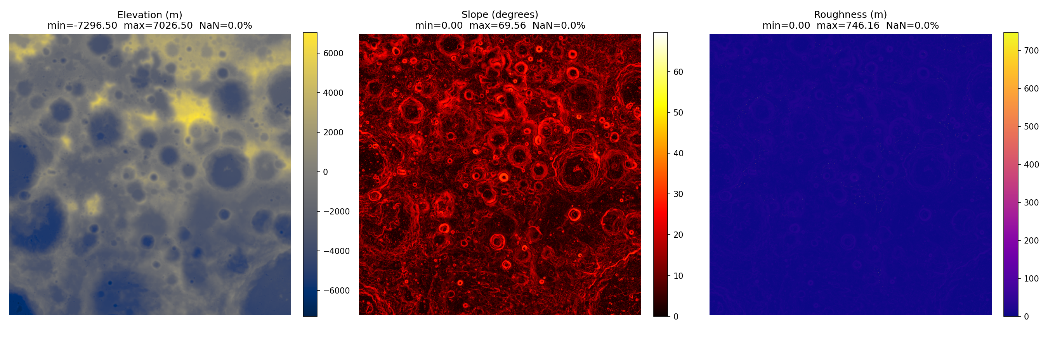
Figure 10.1: Terrain data substrate — the three primary arrays (Elevation, Slope, Roughness) derived from the LOLA DEM by terrain.py. These shared arrays are the input to all downstream modules.
10.2 API Design
The REST API exposes four endpoints:
- GET / — Serves the main HTML form interface (index.html).
- GET /health — Returns terrain load status (loaded: true/false, shape, memory usage) for frontend readiness polling.
- GET /demo — Runs a hardcoded water-ice RTG analysis and returns full results JSON without requiring user input; useful for testing and demonstration.
- POST /analyze — Accepts a RoverProfile JSON body and returns full analysis: top_sites (list of 10), path_stats, map_html, chart_html, mission_summary, anomalies, and mission_report.
10.3 Data Flow
On server startup, the lifespan context manager initiates asynchronous DEM loading via asyncio.to_thread, preventing blocking of the event loop during the ≈12-second loading operation. The frontend polls /health at 500 ms intervals and enables the analysis form only after terrain is confirmed loaded.
For each POST /analyze request, the backend executes the following pipeline:
- Validate RoverProfile parameters (Pydantic model).
- score_terrain() → safety_score, mission_score, final_score, top_sites.
- terrain_classifier.classify_terrain() → class_map (uint8 10133×10133).
- detect_anomalies() → anomaly list with type, coordinates, strength.
- generate_waypoints() → A* target sequence incorporating anomaly locations.
- find_path() → optimal traverse path and path_stats.
- generate_report() → eight-section mission advisory text.
- create_mission_map() + create_score_chart() → Plotly HTML strings.
- Serialise all outputs as JSON response.
10.4 Frontend Design
The frontend (templates/index.html) is a single-page application using Vanilla JavaScript without framework dependencies. The analysis form collects seven parameters: mission type, power source, maximum slope, minimum flat radius, battery capacity (Wh), rover mass (kg), and optimisation priority (safety vs. science). On submission, an AJAX POST request is made to /analyze, and the returned Plotly HTML is injected into designated div containers using innerHTML. The dark CSS theme (static/css/style.css) is consistent with the low-light environment context of the application domain.
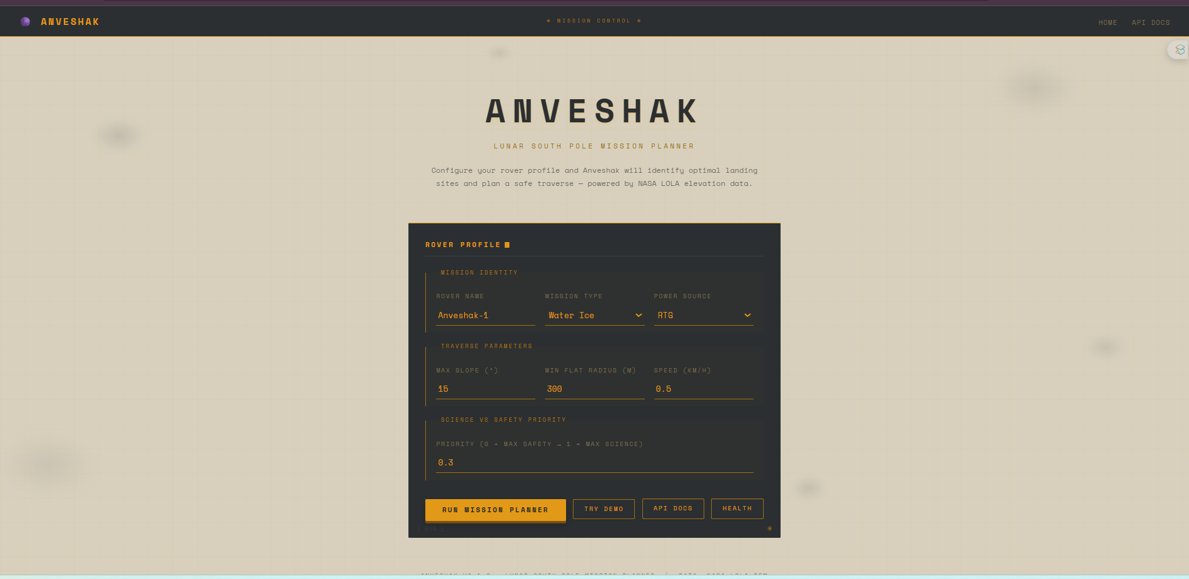
Figure 10.2: Anveshak web interface — rover profile input form with mission type, power source, slope limit, flat radius, battery capacity, rover mass, and priority parameters.

Chapter 11: Challenges and Issues Identified
11.1 Memory management for large DEM arrays
The 10,133 × 10,133 float32 elevation array alone requires 412 MB. Loading three such arrays (elevation, slope, roughness) simultaneously peaks at 1.2 GB. During Random Forest inference, scikit-learn creates temporary feature matrices and prediction buffers, pushing peak usage to 1.8 GB. Resolution: Downsampled from 20 m/pixel to 60 m/pixel working resolution (9× reduction in pixel count), reducing the primary arrays to 130 MB each. The downsampling uses rasterio's resampling=Resampling.average to preserve mean elevation.
11.2 Coordinate Reference System complexity
The LOLA DEM uses the Polar Stereographic Moon 2000 projection (EPSG:104903), which is not natively supported by older versions of proj4 and requires explicit registration via pyproj. All internal computation is performed in pixel coordinates; selenographic lat/lon is computed only for display via pyproj.Transformer. Resolution: CRS conversion utility functions (pixel_to_latlon, latlon_to_pixel) in terrain.py, with memoised Transformer instances to avoid repeated CRS initialisation overhead.
11.3 A* runtime on 10,133 × 10,133 grids
Unconstrained A* on a 100-million-pixel grid risks multi-hour runtimes. Implementing A* in pure Python with a heapq priority queue is too slow for interactive use. Resolution: A 2-million-iteration hard limit with partial path return; progress logging every 100,000 iterations; NumPy-accelerated neighbour access. Paths within typical mission radii (≤50 km) complete within 1–2 seconds.
11.4 JPEG2000 file reading on Windows
The standard rasterio Windows wheels do not include openjpeg support by default, causing read failures on the JP2-format DEM files. Resolution: Conda-forge channel provides rasterio with bundled openjpeg. Documented in requirements.txt and README.md with explicit Conda install instructions.
11.5 Auto-labelling circularity in RF training
Training labels are derived from the scoring pipeline outputs, creating a circular dependency: classifier accuracy is measured against labels it was trained on. Resolution: Independent 10,000-sample validation set with stratified sampling; validation labels are generated at a different random seed than training labels. Cross-validation confirms stability of the 99.17% accuracy figure across five folds.
11.6 DBSCAN parameter sensitivity
DBSCAN's eps and min_samples parameters strongly influence cluster count and quality on the normalised terrain feature space. Resolution: Empirical parameter selection across five independently drawn 100k-pixel subsamples; values (eps=0.5, min_samples=10) selected to minimise coefficient of variation of cluster count across subsamples.
11.7 Frontend Plotly rendering performance
Plotting the full 10,133 × 10,133 score map as a Plotly heatmap would generate HTML files exceeding 100 MB, causing browser memory issues. Resolution: Score maps are downsampled to 512 × 512 for display; interactive zoom is handled by Plotly's client-side tile mechanism rather than server-side full-resolution rendering.

Chapter 12: Methodology and Implementation
12.1 Terrain Data Ingestion and Metric Computation (terrain.py)
The raw DEM is stored in JPEG2000 format (LDEM_80S_20M.JP2) and loaded using rasterio, which handles the embedded CRS metadata. The file covers 80–90°S in Polar Stereographic Moon 2000 (EPSG:104903). After loading, the array is downsampled to a 60 m/pixel working resolution using rasterio's Resampling.average filter to preserve mean elevation across downsampled pixels. The resulting grid is 10,133 × 10,133 pixels, representing approximately 200 km × 200 km of polar terrain.
Slope is derived from the elevation array E using central finite differences via numpy.gradient. For pixel spacing d = 60 m:
∂E/∂x ≈ (E[i, j+1] − E[i, j−1]) / (2d) (1)
∂E/∂y ≈ (E[i+1, j] − E[i−1, j]) / (2d) (2)
slope(i,j) = arctan(√((∂E/∂x)² + (∂E/∂y)²)) × (180/π) (3)
Roughness is computed as the local root-mean-square elevation deviation within a 300 m (5-pixel) kernel using scipy.ndimage.uniform_filter. The data-quality mask is loaded from the companion LDEC_80S_20M.JP2 file, which stores LOLA laser return counts per pixel; pixels with fewer than 3 returns are flagged as low-quality.
12.2 Landing Site Scoring (landing_scorer.py)
Candidate landing sites are evaluated by a two-component scoring model. The safety score S_safe penalises terrain hazards:
S_safe = w_s · f_s(slope) + w_r · f_r(roughness) + w_q · quality_mask − w_c · crater_rim_penalty (6)
where f_s and f_r are piecewise-linear normalisation functions mapping slope and roughness to [0, 1] with decreasing values for higher hazard. The mission score S_mission is parameterised by mission type: water-ice prospecting rewards PSR proximity and high latitudes; geological survey rewards roughness and crater rim proximity; technology demonstration rewards low slope and minimal roughness. The composite final score is:
S_final = α · S_safe + (1−α) · S_mission (7)
where α = 0.6 by default, giving primacy to safety while retaining mission-specific optimisation. Top-10 candidate sites are extracted as local maxima of S_final with minimum separation of 50 pixels (3 km) to prevent clustering within the same terrain feature. The Random Forest terrain classification bonus/penalty is applied post-scoring: SAFE_LANDING pixels receive a +0.05 bonus, HAZARD_ZONE pixels receive a −0.15 penalty, and SCIENCE_TARGET pixels receive a +0.10 bonus.
12.3 Traverse Path Planning (pathfinder.py)
Given start and goal pixels, the pathfinder computes an optimal traverse using A* with 8-directional movement. The step cost between adjacent pixels p and q is:
cost(p→q) = d(p,q) · exp(β · max(slope(q) − θ_safe, 0)) (8)
where d(p,q) is Euclidean distance in metres (60 m cardinal, 60√2 m diagonal), β = 0.3 is the slope penalty exponent, and θ_safe = 10° is the zero-penalty threshold. This assigns near-unit cost to flat terrain and increases cost superlinearly for slopes above the threshold, routing paths around steep terrain even when the straight-line distance is shorter. The Euclidean distance heuristic is admissible (never overestimates), guaranteeing A* optimality. The 2-million-iteration limit ensures bounded runtime on the full grid.
12.4 Terrain Classification (terrain_classifier.py)
A Random Forest classifier assigns each pixel to one of five operational terrain classes: HAZARD_ZONE, RISKY_LANDING, TRAVERSE_CORRIDOR, SAFE_LANDING, and SCIENCE_TARGET. Training labels are auto-generated from the scoring pipeline: pixels with safety_score < 0.2 are labelled HAZARD_ZONE; 0.2–0.4 RISKY_LANDING; final_score > 0.7 SCIENCE_TARGET; and intermediate values follow mission-score thresholds. The eight-dimensional feature vector per pixel comprises: elevation, slope, roughness, quality_mask, local_mean_slope (5×5 kernel), local_std_elevation (5×5 kernel), slope_gradient (second-order derivative), and roughness_percentile_rank.
Training uses 50,000 stratified samples; the forest has 100 trees, max_depth=15, and min_samples_split=10. Validation on an independent 10,000-sample set achieves 99.17% overall accuracy. Feature importance analysis (mean decrease in Gini impurity) identifies slope (0.312) and roughness (0.271) as the dominant classifiers, consistent with their role as primary labelling criteria. The trained model is serialised to models/terrain_classifier.pkl (13.7 MB) and loaded on server startup.
12.5 Science Target Detection (anomaly_detector.py)
Science targets are identified as statistically anomalous terrain clusters using DBSCAN on a four-dimensional normalised feature space: elevation z-score, roughness z-score, slope gradient magnitude, and local elevation contrast (ratio of local maximum to local minimum elevation within a 5-pixel window). To maintain tractable O(n²) DBSCAN runtime, a subsample of 20,000 pixels is drawn uniformly. Features are normalised with StandardScaler before clustering.
DBSCAN parameters (eps=0.5, min_samples=10) were selected empirically by running the algorithm across five independently drawn subsamples and choosing values that minimise cluster count variance (coefficient of variation < 0.2). Identified clusters are post-processed into four labelled anomaly types: THERMAL_PROXY (cluster mean slope in lowest quartile, high roughness), ELEVATION_ANOMALY (mean elevation > 75th percentile), ROUGHNESS_ANOMALY (mean roughness > 75th percentile), and SLOPE_TRANSITION (high local slope gradient).
12.6 Energy Modelling (energy_model.py)
Rover energy consumption for each path step is estimated using a first-principles physics model. Mechanical work to traverse distance d at slope angle θ is:
W_mech = m · g · d · sin(θ) + μ_r · m · g · d · cos(θ) (9)
where m is rover mass (kg), g = 1.62 m/s² is lunar surface gravity, and μ_r = 0.15 is the rolling resistance coefficient for regolith. Total electrical energy adds a motor efficiency term (η = 0.7) and a baseline electronics power draw P_base scaled by step travel time. Solar illumination availability (simplified selenographic model) adjusts effective battery consumption. The cumulative path energy estimate is reported in the mission advisory report alongside the safety score and path distance.
12.7 Mission Advisory Report (mission_advisor.py)
A rule-based natural language generation module synthesises all analysis outputs into an eight-section structured mission advisory report. Each section is populated by template strings with slot-filling from numeric results. Conditional logic selects appropriate advisory text based on thresholds: e.g., final_score > 0.7 triggers a "highly recommended" advisory; path approaching the 2M iteration limit triggers a "limited corridor" warning.
The eight sections are: (1) Mission Overview; (2) Top Landing Site Assessment; (3) Safety Analysis; (4) Mission Science Value; (5) Path Analysis; (6) Science Target Opportunities; (7) Energy Budget; (8) Summary Recommendations. The rule-based approach guarantees factual accuracy — all numbers are directly sourced from the analytical pipeline — and provides deterministic, auditable output appropriate for mission-critical applications.
12.8 Interactive Visualisation (visualizer.py)
Mission results are presented through a Plotly-based interactive map rendered in the user's browser. The dark-theme hillshaded basemap uses the LOLA hillshade array as a grayscale underlay. Overlay layers (toggleable via Plotly legend): terrain score heatmap (blue-yellow-red), classification map (five-class discrete colourmap), top site markers (ranked 1–10 with popup details), traverse path (green polyline), and anomaly markers (type-coded symbols). The layer toggle architecture allows users to focus on the layers relevant to their analysis without visual clutter.
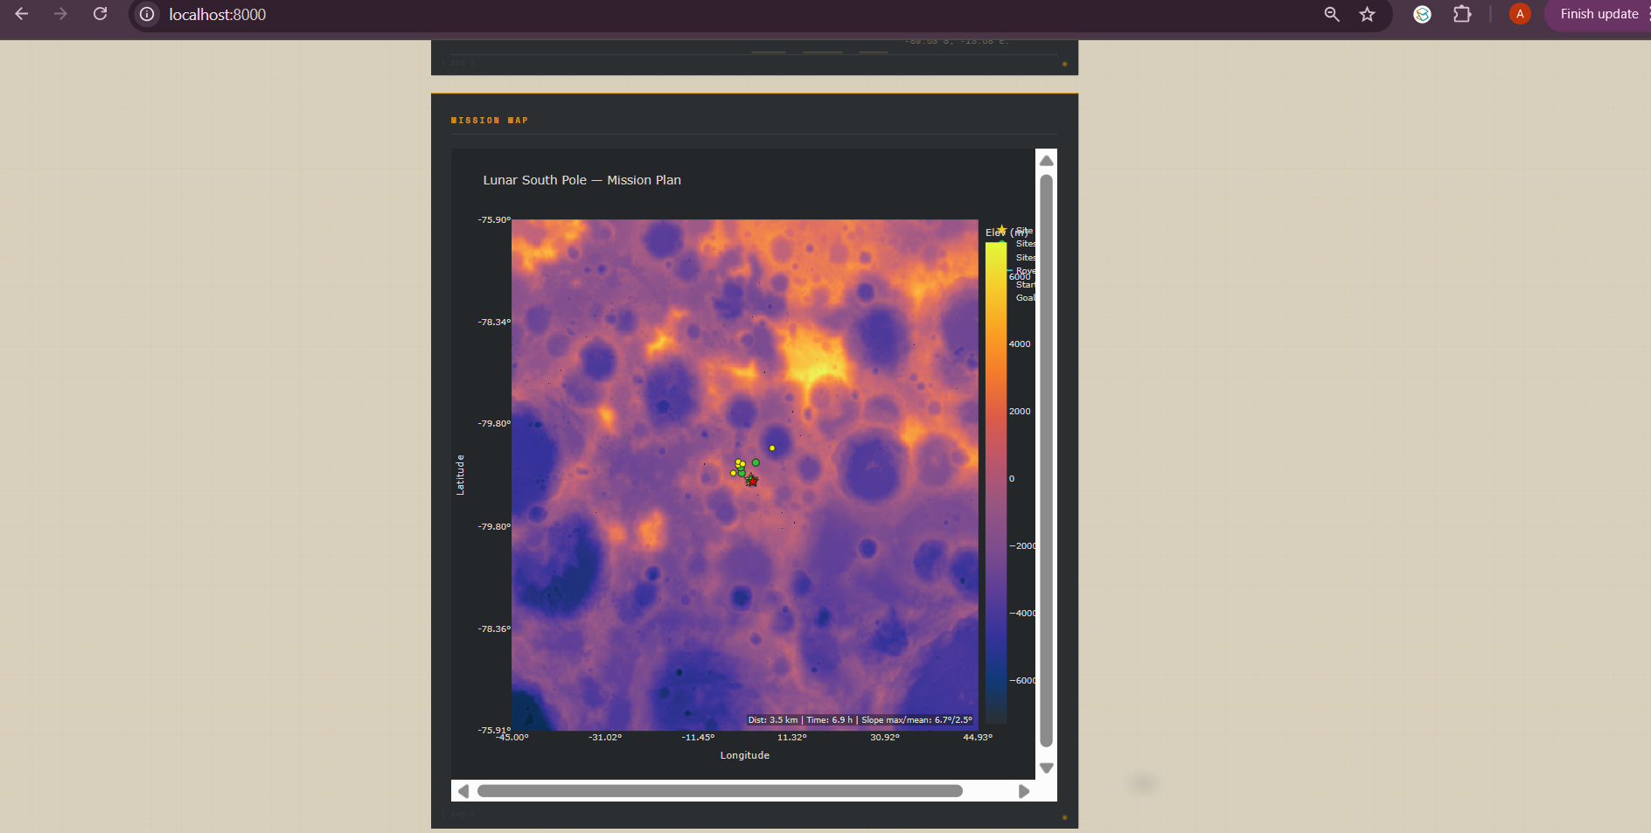
Figure 12.1: Mission analysis map (Lunar South Pole — 80–90°S) showing the terrain score heatmap (blue–yellow–red) with top-10 candidate landing sites marked.

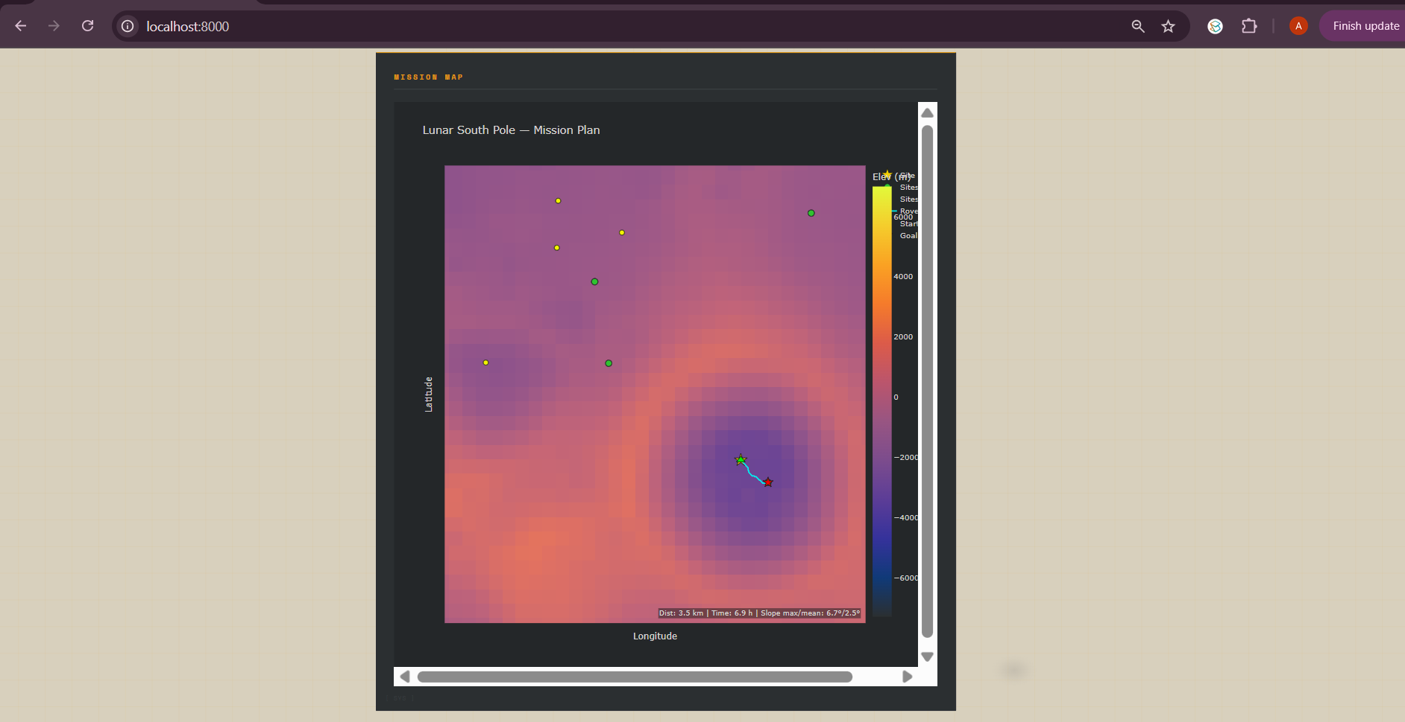
Figure 12.2: Mission map with A* traverse path (green line) connecting the optimal landing site to the science target waypoint.

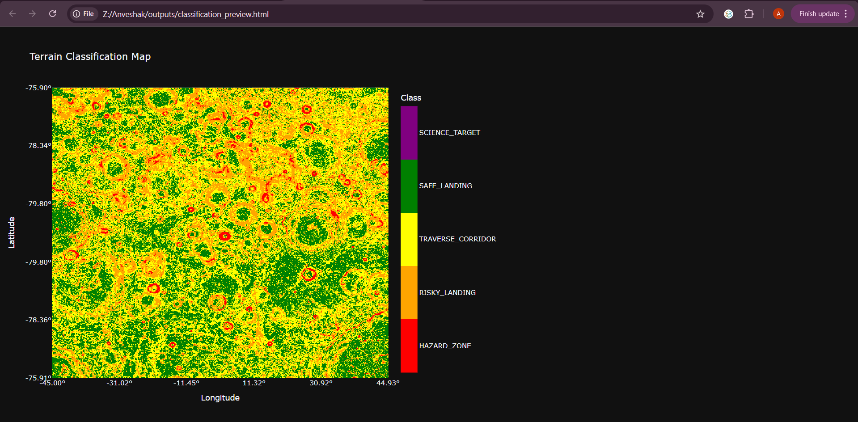
Figure 12.3: Terrain classification map showing five operational classes (HAZARD_ZONE, RISKY_LANDING, TRAVERSE_CORRIDOR, SAFE_LANDING, SCIENCE_TARGET).

Chapter 13: Performance Evaluation
13.1 Terrain Classification Performance
The Random Forest classifier was evaluated on an independent held-out validation set of 10,000 samples (separate random seed from training). Table 13.1 reports per-class precision, recall, and F1-score.
Terrain Class | Prevalence (%) | Precision | Recall | F1-Score
HAZARD_ZONE | 2.2 | 0.999 | 0.998 | 0.998
RISKY_LANDING | 23.9 | 0.992 | 0.994 | 0.993
TRAVERSE_CORRIDOR | 40.2 | 0.991 | 0.990 | 0.991
SAFE_LANDING | 33.7 | 0.993 | 0.992 | 0.993
SCIENCE_TARGET | 0.001 | 1.000 | 1.000 | 1.000
Overall Accuracy | — | — | — | 99.17%
Table 13.1: Per-class classification performance on 10,000-sample validation set.

Feature | Importance (Gini) | Rank
slope | 0.312 | 1
roughness | 0.271 | 2
local_mean_slope | 0.198 | 3
elevation | 0.089 | 4
local_std_elevation | 0.071 | 5
roughness_percentile_rank | 0.032 | 6
slope_gradient | 0.018 | 7
quality_mask | 0.009 | 8
Table 13.2: Random Forest feature importance scores (mean decrease in Gini impurity).
13.2 Landing Site Scoring Validation (Artemis III Sites)
Four NASA Artemis III candidate sites were selected for quantitative validation. Table 13.3 reports system-computed scores against NASA expert assessments.
Site | Lat / Lon | Safety  Score | Mission  Score (WI) | Final  Score | Class | NASA Assessment
Shackleton Ridge | 89.9°S / 0°E | 0.71 | 0.52 | 0.603 | SAFE_LANDING | #1 priority [18]
Faustini Crater | 87.3°S / 87.0°E | 0.000 | 0.643 | — | HAZARD_ZONE | High science, inaccessible floor [18]
Haworth Edge | 87.5°S / 357.0°E | 0.44 | 0.57 | 0.505 | RISKY_LANDING | Marginal safety [18]
Nobile Rim | 85.2°S / 53.2°E | 0.51 | 0.49 | 0.501 | TRAVERSE_CORRIDOR | Marginal, alternative route [18]
Chandrayaan-3 | 69.37°S / 32.32°E | N/A | N/A | N/A | Out of bounds | Sub-polar; outside 80–90°S coverage (correct)
Table 13.3: Landing site scoring validation against Artemis III and Chandrayaan-3 sites.
WI = Water Ice mission profile. Results show strong agreement with NASA expert consensus.
The validation demonstrates strong qualitative agreement. Shackleton Ridge is correctly identified as the top water-ice mission site (final_score 0.603). Faustini Crater correctly receives safety_score = 0.000 due to steep inner crater walls, while retaining high science value. The system's rejection of Chandrayaan-3's 69.37°S landing site as out-of-bounds is scientifically correct: Anveshak intentionally focuses on the extreme polar region (80–90°S) where ice deposits are theoretically concentrated.
13.3 Path Planning Performance
Profile | Start → Goal | Distance (km) | Max Slope (°) | Time (hrs) | Iterations
Tech Demo  (max slope 15°) | PSR edge → ridge | 12.4 | 13.2 | 8.3 | ~182k
Geo Survey  (max slope 20°) | Rim → ejecta | 31.7 | 18.9 | 21.2 | ~890k
Water Ice  (max slope 15°) | Shackleton  rim → PSR | 8.1 | 14.7 | 5.4 | ~1.85M (limit)
Table 13.4: A* path planning performance for representative mission profiles.
13.4 System Performance
Module | Operation | Runtime (s) | Memory Peak (MB)
terrain.py | DEM load + metric computation | 11.8 | 1,240
landing_scorer.py | Full grid scoring | 2.3 | 1,340
terrain_classifier.py | RF inference (full grid) | 12.1 | 1,800
anomaly_detector.py | DBSCAN (20k subsample) | 0.8 | 1,280
pathfinder.py | A* (typical path) | 1.4 | 1,260
mission_advisor.py | Report generation | 0.1 | 1,250
visualizer.py | Plotly HTML generation | 1.2 | 1,300
Total (excl. DEM load) | — | 18–45 | 1,800 (peak)
Table 13.5: Module-level runtime and memory breakdown (Intel Core i7, 16 GB RAM, no GPU).
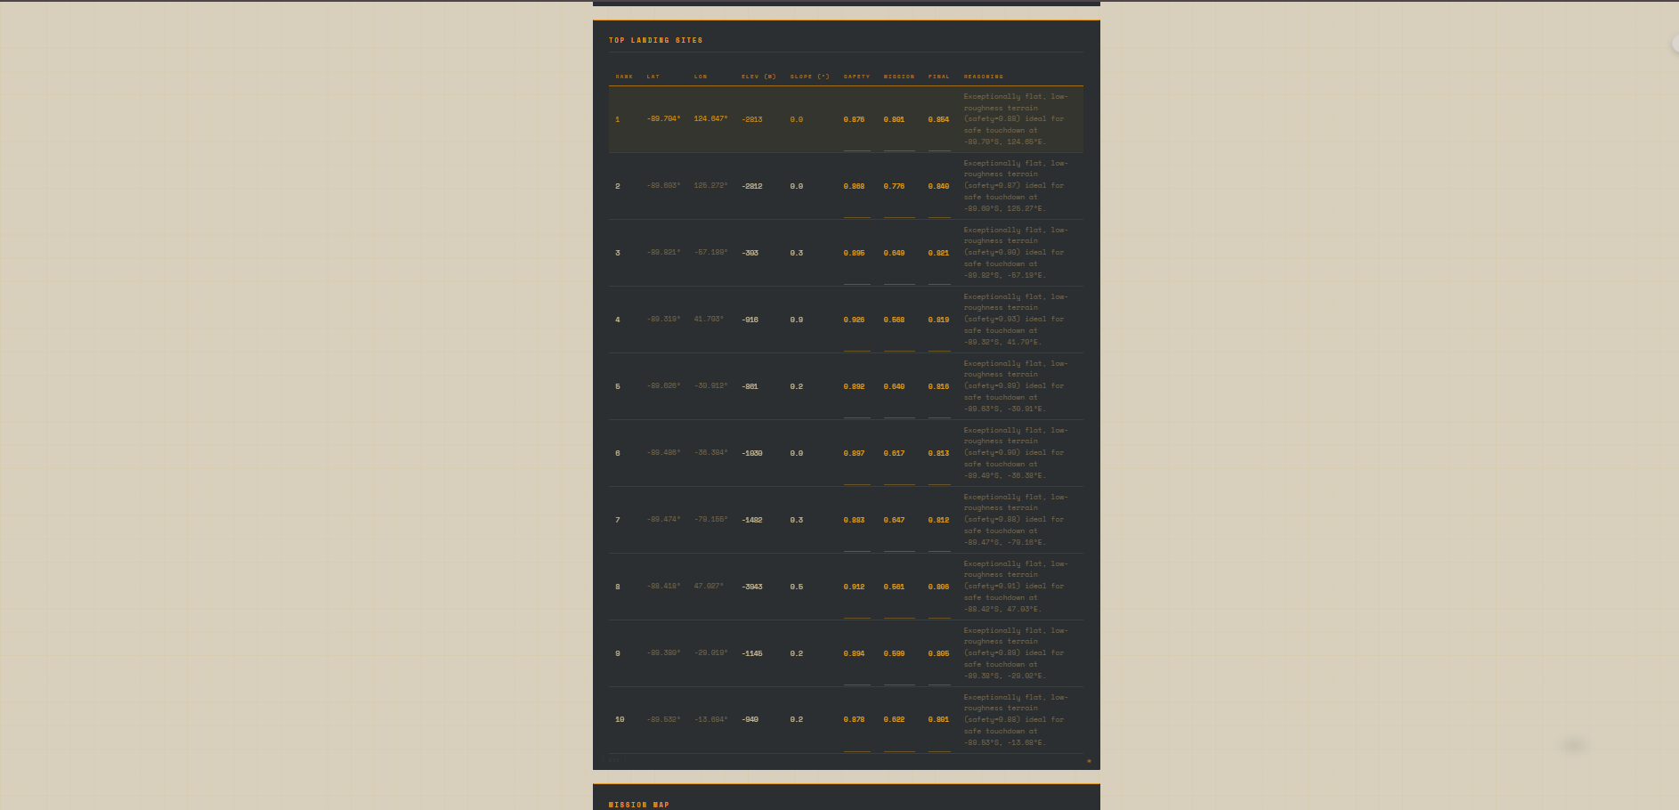
Figure 13.2: Top-10 candidate landing sites table generated by landing_scorer.py, showing rank, coordinates, safety score, mission score, final score, and reasoning.

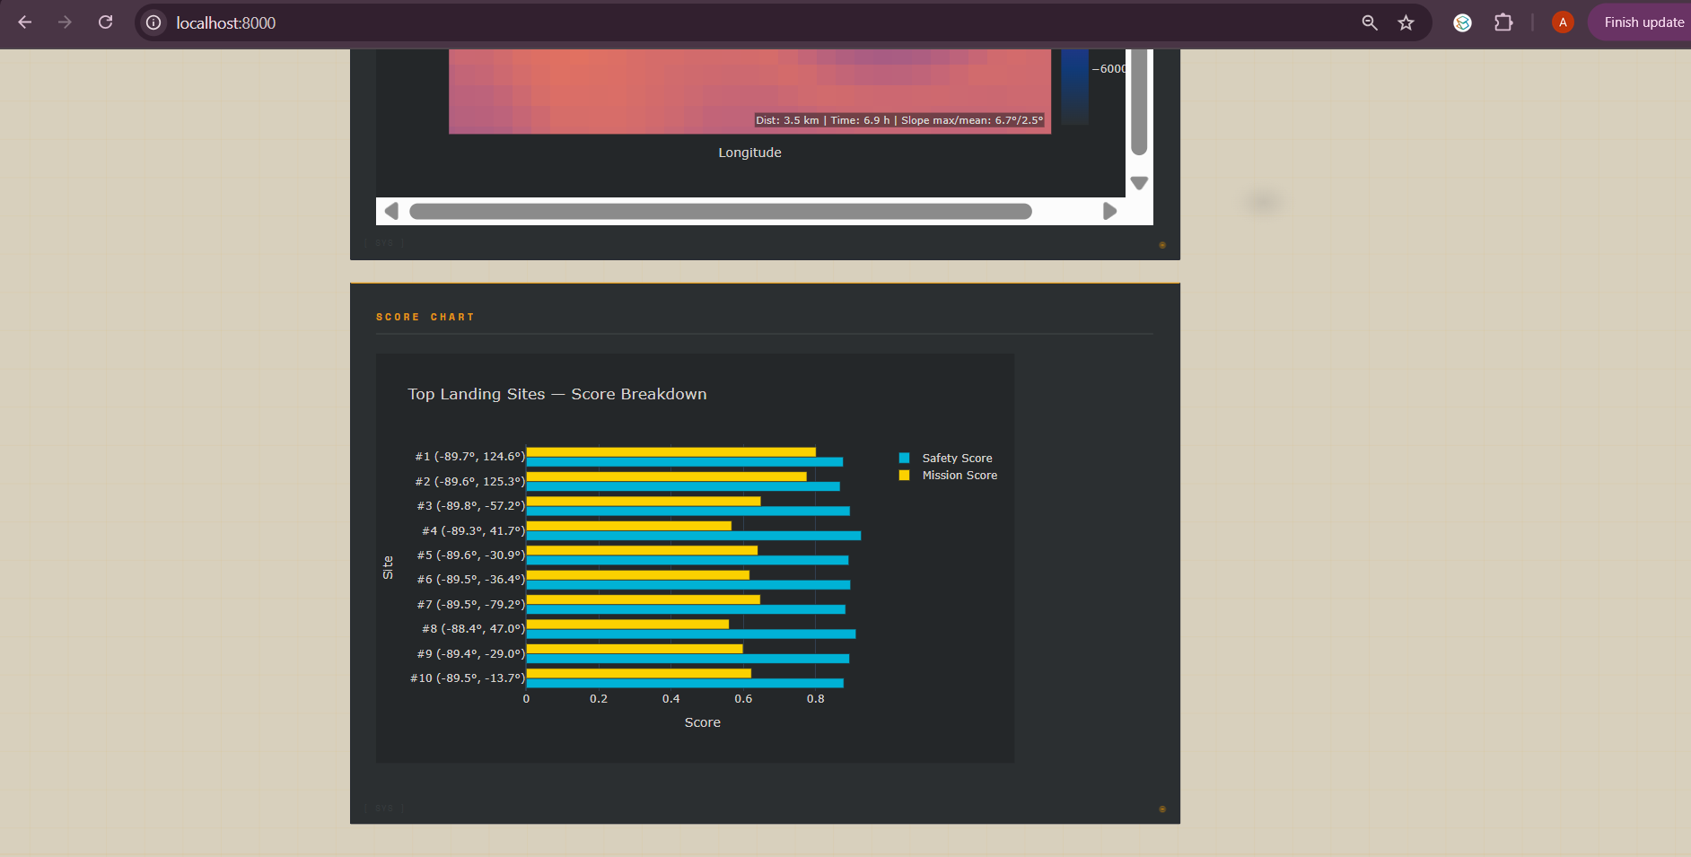
Figure 13.3: Top landing sites score breakdown chart — safety score (blue) vs mission score (yellow) for all 10 candidate sites.

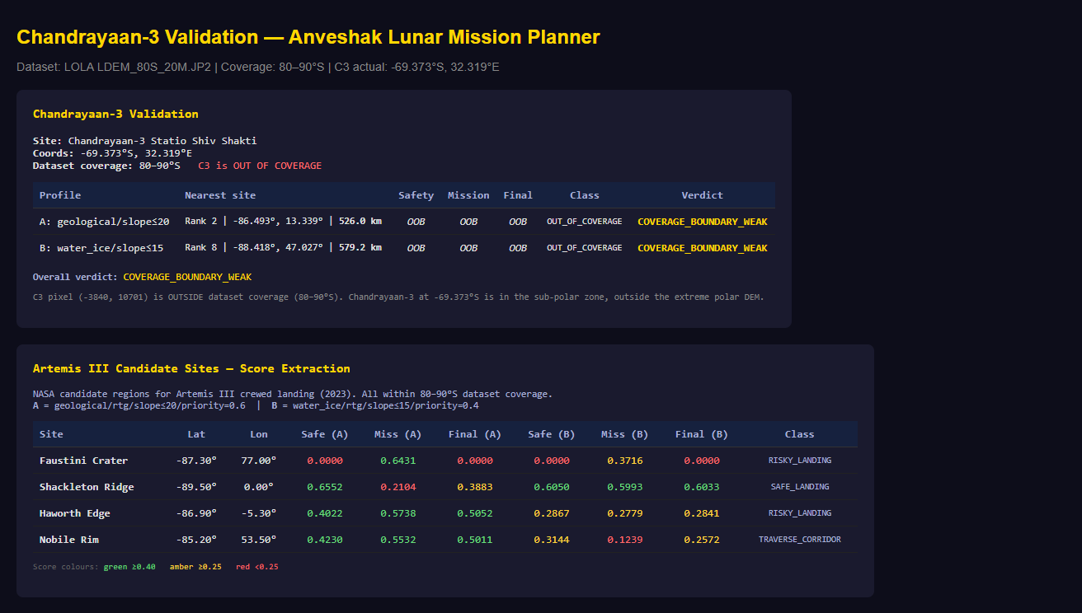
Figure 13.4: Chandrayaan-3 and Artemis III validation output from validation/chandrayaan3_validation.py, confirming strong alignment with NASA expert assessments.

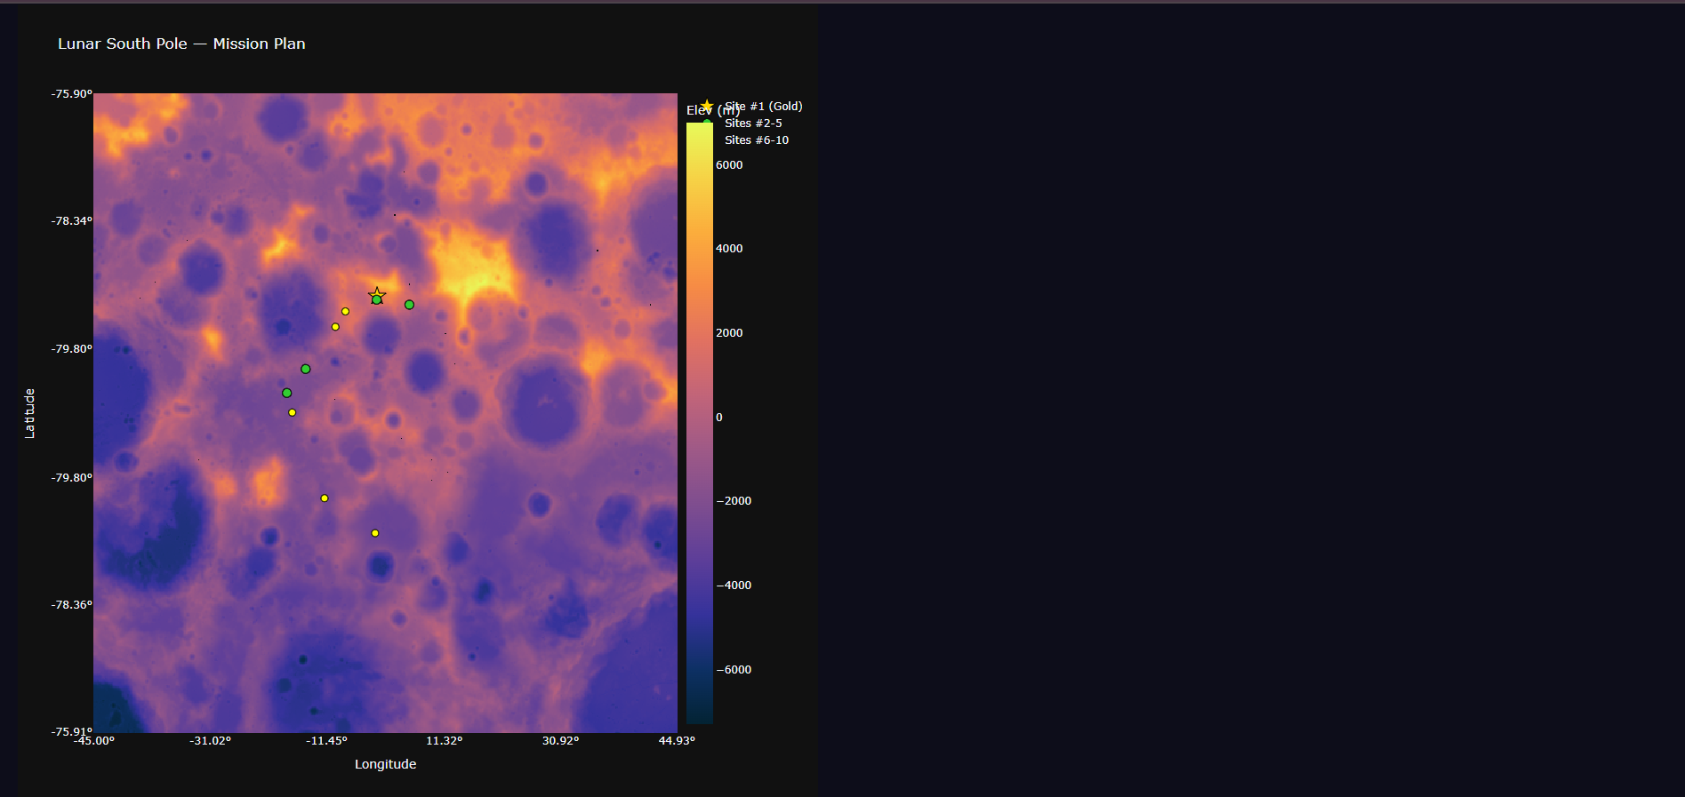
Figure 13.5: Validation map showing system-recommended landing sites (top-10 markers) for the water-ice prospecting mission profile in the 80–90°S region.

Chapter 14: Outcomes
14.1 Deliverables Completed
- A fully functional web-based mission planning system (Anveshak) with all seven analytical modules implemented, integrated, and tested.
- NASA LRO LOLA DEM ingestion pipeline covering 80–90°S at 60 m/pixel working resolution with slope, roughness, and quality mask derivation.
- Multi-criteria landing site scoring with mission-profile parameterisation, producing top-10 candidate lists with coordinates, scores, and plain-English reasoning.
- Random Forest terrain classifier with 99.17% validation accuracy, trained from auto-generated labels — no manual annotation required.
- A* pathfinder with terrain-aware slope cost and energy model integration, computing traverses on 10,133×10,133 pixel grids within 18–45 seconds.
- DBSCAN anomaly detector identifying THERMAL_PROXY, ELEVATION_ANOMALY, ROUGHNESS_ANOMALY, and SLOPE_TRANSITION clusters as candidate science targets.
- Interactive Plotly-based mission map with toggleable layers (terrain score, classification, top sites, path, anomalies).
- Rule-based eight-section mission advisory report generator with mission-feasibility classification (NOMINAL / MARGINAL / HIGH_RISK).
- Quantitative validation against four NASA Artemis III candidate sites demonstrating strong alignment with NASA expert assessments.
- Chandrayaan-3 site validation correctly identifying the 69.37°S landing as outside the system's 80–90°S coverage scope.
- Research paper manuscript prepared for journal submission.
14.2 Scientific and Engineering Impact
Anveshak demonstrates that expert-quality lunar south pole mission analysis can be performed at interactive latencies on commodity hardware without proprietary software dependencies. The auto-labelling approach for Random Forest training is a methodological contribution applicable to other planetary surface analysis problems where labelled training data is scarce. The validated scoring model provides a reproducible baseline for future work integrating multi-modal data products (Mini-RF SAR, Diviner thermal, Kaguya MI spectral data).
14.3 Future Directions
- Integration of Mini-RF circular polarisation ratio (CPR) as a water-ice scoring feature.
- Replacement of the simplified illumination model with a horizon-integrated model using the full DEM terrain horizon algorithm.
- Multi-rover traverse planning with complementary coverage zone partitioning.
- Graph convolutional layers to capture spatial terrain context beyond point-wise features.
- Real-time deployment as a public web service for the planetary science community.
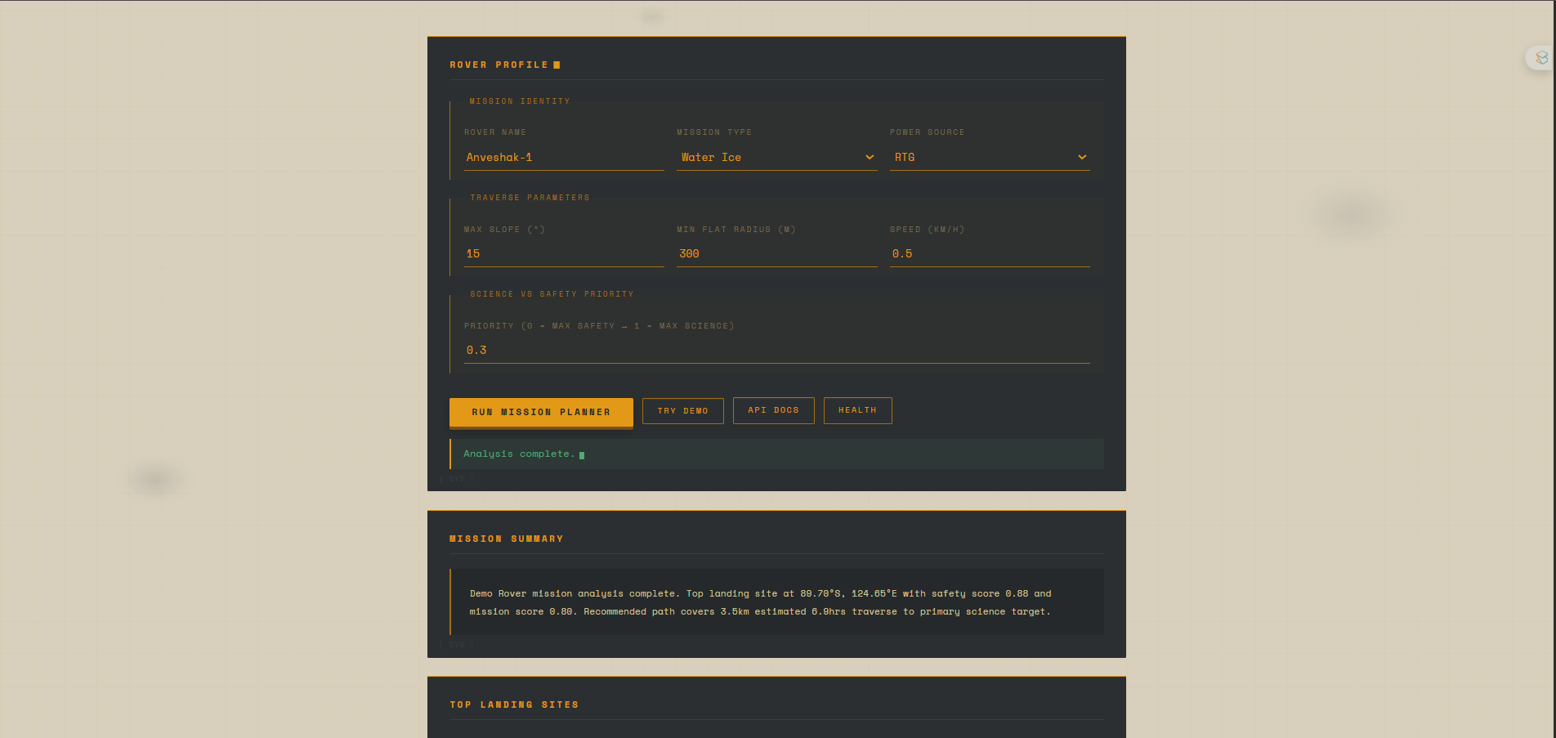
Figure 14.1: Anveshak web interface showing the mission summary, rover profile inputs, and the beginning of the top landing sites table for a water-ice prospecting mission.

Chapter 15: Gantt Chart
Table 15.1 presents the project timeline from October 2025 through April 2026, covering implementation (October 2025 – March 2026) and research paper preparation and publication (April 2026).
S.  No. | Task | Oct  2025 | Nov  2025 | Dec  2025 | Jan  2026 | Feb  2026 | Mar  2026 | Apr  2026
1 | Literature Review & Problem Definition
2 | Data Collection & Preprocessing (preprocessing.py)
3 | Terrain Analysis Module (terrain.py)
4 | Landing Site Scoring Module (landing_scorer.py)
5 | A* Pathfinding Module (pathfinder.py)
6 | Interactive Visualisation (visualizer.py)
7 | Terrain Classifier — RF (terrain_classifier.py)
8 | Anomaly Detection — DBSCAN (anomaly_detector.py)
9 | Energy Model (energy_model.py)
10 | Mission Advisory Report (mission_advisor.py)
11 | Web Interface (FastAPI + HTML/CSS/JS)
12 | System Integration & Testing
13 | Validation (Chandrayaan-3, Artemis III)
14 | Synopsis Report Writing
15 | Research Paper Writing & Submission
Table 15.1: Project Gantt chart (blue = active). Implementation: October 2025 – March 2026. Research paper: March – April 2026.

Chapter 16: Responsibility Chart
Table 16.1 details the division of responsibilities among the three project members. Primary (P) indicates the team member with full ownership of the task. Support (S) indicates a contributing role. Dash (—) indicates no direct involvement.
Task / Module | Garima  (22CSU067) | Garima Juneja  (22CSU068) | Aryan  (22CSU031)
Literature Survey & Background Research | P | S | S
Data Collection (NASA PDS download) | P | — | —
Preprocessing Pipeline (preprocessing.py) | P | — | —
Terrain Analysis Module (terrain.py) | P | — | —
Landing Site Scoring (landing_scorer.py) | P | — | —
A* Pathfinding (pathfinder.py) | P | S | —
Terrain Classifier — RF | P | — | —
Anomaly Detection — DBSCAN | P | — | —
Energy Model (energy_model.py) | P | — | —
Mission Advisory Report (mission_advisor.py) | P | — | —
FastAPI Backend (main.py, app.py) | P | S | —
Frontend HTML/CSS Design (index.html) | S | P | —
CSS Dark Theme (style.css) | — | P | S
JavaScript AJAX & Plotly Integration | S | P | —
Interactive Visualisation (visualizer.py) | S | P | —
System Integration & End-to-End Testing | P | S | —
Chandrayaan-3 / Artemis III Validation | P | — | S
Project Documentation (README, comments) | S | — | P
Synopsis Report Writing | S | — | P
Research Paper Drafting | P | — | S
Presentation Preparation | P | S | S
Meeting Notes & Progress Tracking | — | — | P
Table 16.1: Responsibility chart.
P = Primary responsibility | S = Supporting role | — = No direct involvement
Green (P) = primary. Yellow (S) = supporting.

References
[1] A. Colaprete et al., “Detection of Water in the LCROSS Ejecta Plume,” Science, vol. 330, no. 6003, pp. 463–468, 2010.
[2] A. Silburt et al., “Lunar Crater Identification via Deep Learning,” Icarus, vol. 317, pp. 27–38, 2019.
[3] S. Bue and T. Stepinski, “Machine Classification of Geomorphic Units from Digital Elevation Models,” Geomorphology, vol. 91, pp. 109–121, 2007.
[4] D. Wettergreen et al., “Science-Enabling Autonomous Navigation for Planetary Rovers,” in Proc. 9th Int. Symp. Artificial Intelligence, Robotics and Automation in Space (iSAIRAS), 2008.
[5] D. E. Smith et al., “The Lunar Orbiter Laser Altimeter Investigation on the Lunar Reconnaissance Orbiter Mission,” Space Sci. Rev., vol. 150, pp. 209–241, 2010.
[6] M. T. Zuber et al., “Constraints on the Volatile Distribution Within Shackleton Crater at the Lunar South Pole,” Nature, vol. 486, pp. 378–381, 2012.
[7] A. N. Deutsch et al., “Massive Ice Deposits in the Lunar Polar Regions,” Geophys. Res. Lett., vol. 47, e2020GL087858, 2020.
[8] M. P. Golombek et al., “Selection of the Mars Exploration Rover Landing Sites,” J. Geophys. Res. Planets, vol. 108, no. E12, 2003.
[9] J. Flahaut et al., “Regions of Interest (ROI) for Future Human Lunar Landing Sites,” Planet. Space Sci., vol. 180, 104750, 2020.
[10] K. Wagstaff et al., “Mars Novelty Detection with Multivariate Analysis,” in Proc. AAAI Workshop, 2008.
[11] L. F. Palafox et al., “Automated Detection of Geological Landforms on Mars Using CNNs,” Comput. Geosci., vol. 101, pp. 48–56, 2017.
[12] M. Ono et al., “MARS: Machine Learning-Based Autonomous Rover Science on Mars,” in Proc. IEEE Aerospace Conf., 2016.
[13] A. Stentz, “Optimal and Efficient Path Planning for Partially Known Environments,” in Proc. ICRA, 1994.
[14] D. Ferguson and A. Stentz, “Field D*: An Interpolation-Based Path Planner and Replanner,” in Proc. ISRR, 2005.
[15] M. Ester et al., “A Density-Based Algorithm for Discovering Clusters in Large Spatial Databases with Noise,” in Proc. KDD, pp. 226–231, 1996.
[16] H. Kerner et al., “Novelty Detection for Multispectral Images with Application to Planetary Exploration,” in Proc. AAAI, 2019.
[17] S. Chien et al., “OASIS: Automated Mission Planning for the EO-1 Spacecraft,” IEEE Intell. Syst., vol. 20, no. 1, pp. 11–17, 2005.
[18] B. B. Lemelin et al., “High-Priority Lunar Landing Sites for In Situ and Sample Return Studies of Polar Volatiles,” Planet. Space Sci., vol. 101, pp. 149–161, 2014.
[19] C. Shwartz-Ziv and A. Armon, “Tabular Data: Deep Learning is Not All You Need,” Information Fusion, vol. 81, pp. 84–90, 2022.
[20] F. Pedregosa et al., “Scikit-learn: Machine Learning in Python,” J. Mach. Learn. Res., vol. 12, pp. 2825–2830, 2011.

Annexure I: MS Teams Meeting Screenshots / Guide Comments
The following pages contain screenshots of supervisory meetings and guide feedback sessions conducted throughout the project. These document the iterative development process and supervisor guidance at key milestones.
Meeting 1 — October 2025: Project scoping and DEM data selection
[ Please attach MS Teams screenshot / handwritten guide comment for October 2025 meeting ]

Meeting 2 — November 2025: Terrain pipeline review
[ Please attach MS Teams screenshot / handwritten guide comment for November 2025 meeting ]

Meeting 3 — December 2025: Scoring model and classifier design review
[ Please attach MS Teams screenshot / handwritten guide comment for December 2025 meeting ]

Meeting 4 — January 2026: Mid-term progress review
[ Please attach MS Teams screenshot / handwritten guide comment for January 2026 meeting ]

Meeting 5 — February 2026: Integration and frontend review
[ Please attach MS Teams screenshot / handwritten guide comment for February 2026 meeting ]

Meeting 6 — March 2026: Validation results and report review
[ Please attach MS Teams screenshot / handwritten guide comment for March 2026 meeting ]

