PROJECT REPORT
Cryptocurrency Market Analysis System
A Data Science System for Digital-Asset Market Analytics,
Risk Assessment, Market-Cycle Identification, and Forecasting

Submitted for the IBM Data Science Internship

Field | Detail
Author | Akarsh
Programme | B.Tech, Computer Science & Engineering (Data Science)
Institution | UPES, Dehradun
Domain | Data Science / Financial Analytics
Deliverable | Interactive analytics dashboard + analysis pipeline
Date | August 2026

Table of Contents

1. Abstract 3
2. Introduction 3
2.1 Background 3
2.2 Problem Statement 3
2.3 Objectives 3
2.4 Scope 4
3. System Overview and Architecture 4
3.1 Data Flow 4
3.2 Design Principles 5
4. Technology Stack 5
5. Data Sources and Ingestion 5
5.1 Ingestion and Caching 6
5.2 Offline Fallback 6
5.3 The Fear & Greed Index as a Sentiment Signal 6
6. Module Design and Functionalities 6
6.1 Data Layer 7
6.2 Analysis Layer 7
6.3 Visualisation and Application Layers 7
7. Algorithms and Methods 7
7.1 Returns and Volatility 7
7.2 Risk Metrics 7
7.3 Market-Cycle Phase Identification 8
7.4 Correlation Analysis 9
7.5 Time-Series Forecasting (ARIMA) 9
8. Dashboard Walkthrough 9
9. Results and Observations 10
10. Limitations 10
11. Future Scope 10
12. Conclusion 10
13. References 11

1. Abstract
The Cryptocurrency Market Analysis System is a data-science application that analyses digital-asset markets and presents actionable insight through an interactive dashboard. It ingests cryptocurrency price and trading-volume history, market-sentiment signals, blockchain on-chain activity, and traditional macroeconomic asset prices, then applies statistical analytics, financial risk modelling, and time-series forecasting to characterise market behaviour.
Four analytical capabilities sit at the core of the system: volatility and risk assessment (annualised volatility, Value-at-Risk, drawdown, and risk-adjusted return ratios), market-cycle phase identification (Accumulation, Markup, Distribution, Markdown), correlation analysis between digital and traditional assets, and short-horizon price forecasting using an ARIMA model. The results are surfaced through a six-tab Streamlit dashboard supported by Plotly visualisations, enabling investors to make informed, data-driven decisions.
The system is engineered with a clean layered architecture, live data ingestion with a transparent offline fallback, and an on-disk cache for responsiveness. Every analytical method is implemented as a pure, independently testable function, and the forecasting component deliberately emphasises honest uncertainty quantification over unrealistic price prediction, reflecting the near-random-walk nature of crypto returns.

2. Introduction

2.1 Background
Digital-asset markets are highly volatile, trade continuously (365 days a year), and are influenced by a broad set of drivers ranging from on-chain network activity and social sentiment to the behaviour of traditional financial markets. Investors therefore need tools that consolidate these heterogeneous signals and translate them into interpretable, decision-relevant metrics.

2.2 Problem Statement
This project focuses on analysing cryptocurrency price history, trading-volume data, blockchain transaction records, social-media sentiment, and macroeconomic indicators to identify patterns and trends in digital-asset markets. Using data analytics, visualisation, and time-series modelling, the system provides insight on volatility-risk assessment, market-cycle phase identification, and correlation analysis between digital and traditional assets. Dashboards help crypto investors make informed, data-driven digital-asset investment decisions.

2.3 Objectives
- Consolidate multiple market data sources (price, volume, sentiment, on-chain, macro) into a single, coherent analytical pipeline.
- Quantify volatility and downside risk for each tracked asset using standard financial risk measures.
- Identify the prevailing market-cycle phase from price structure and momentum, using transparent, explainable rules.
- Measure the relationship between digital and traditional assets through static and rolling correlation and beta.
- Provide a short-horizon price forecast with rigorous out-of-sample validation and honest uncertainty bounds.
- Deliver all of the above through an interactive, self-service dashboard suitable for non-technical users.

2.4 Scope
The system tracks six major cryptocurrencies (BTC, ETH, SOL, BNB, XRP, ADA) and five traditional/macro assets (S&P 500, Gold, US Dollar Index, US 10-Year Yield, Crude Oil). It operates on daily data over a configurable window of up to 365 days. It is intended for educational and analytical use and does not constitute financial advice.

3. System Overview and Architecture
The system follows a strict layered architecture in which each layer depends only on the layer beneath it: external data sources feed a data-access layer, which is assembled by an orchestration layer into a single data bundle, which the analysis layer consumes, and which the presentation layer finally visualises. This separation keeps analytical logic free of I/O concerns and makes each component independently testable.
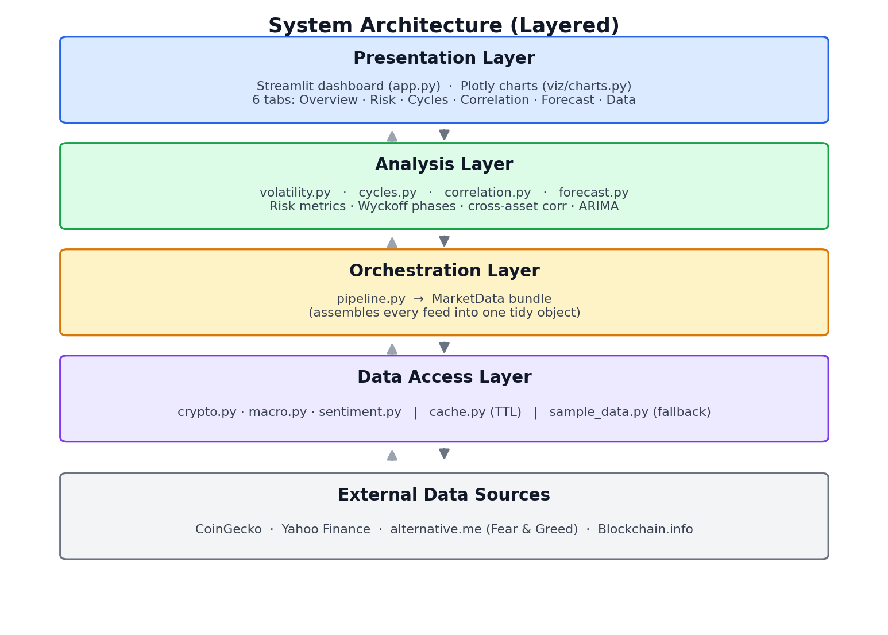
Figure 1. Layered system architecture.

3.1 Data Flow
At runtime the dashboard requests data for a chosen history window. The orchestration layer (pipeline.py) invokes each data loader, which first attempts a live API call, transparently falling back to a deterministic synthetic dataset on any failure, and caching successful responses on disk for six hours. The assembled MarketData bundle is then passed to the four analysis modules, whose outputs populate the dashboard tabs.
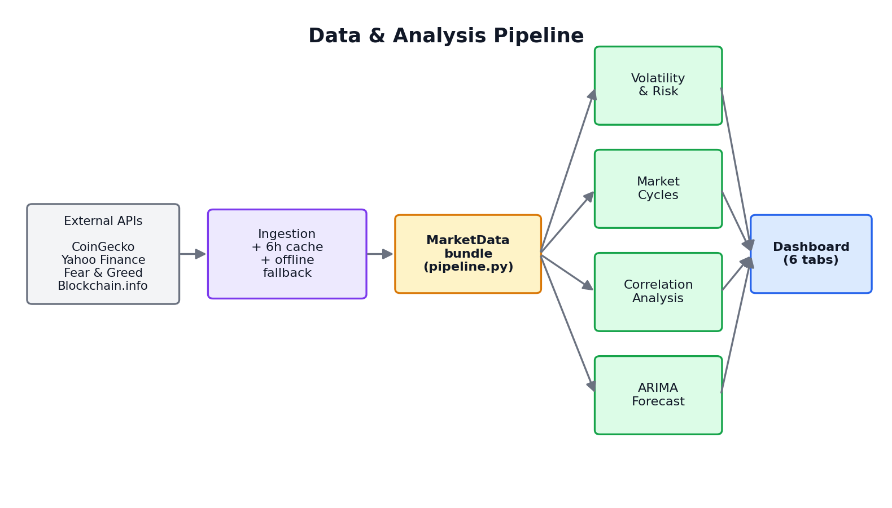
Figure 2. Data ingestion and analysis pipeline.

3.2 Design Principles
- Separation of concerns. Data, analysis, visualisation, and application logic live in distinct modules.
- Pure analytical functions. Every metric is computed by a side-effect-free function operating on pandas objects, so it can be unit-tested in isolation.
- Fail-open resilience. No network failure can crash the dashboard; the sidebar always reports whether each feed is live or sample.
- Explainability. Market-cycle labels and forecasts are produced by transparent, documented rules and models rather than opaque heuristics.

4. Technology Stack
The system is built entirely on open-source Python libraries, with no proprietary dependencies, which makes it portable to any standard Python environment including Streamlit Community Cloud, containers, or IBM Cloud Code Engine.
Layer | Technology | Purpose
Language | Python 3.10+ | Core implementation language
Data handling | pandas, NumPy | Time-series manipulation and vectorised numerics
Statistics / modelling | statsmodels, SciPy | ARIMA forecasting and statistical functions
Data ingestion | requests, yfinance | REST API calls and market-data download
Dashboard | Streamlit | Interactive web application and caching
Visualisation | Plotly | Interactive financial charts
Notebook | Jupyter | Reproducible methodology walkthrough

5. Data Sources and Ingestion
The system integrates four external data sources, each mapped to a component of the project brief. All sources are used on their free tier and, except for an optional CoinGecko key, require no authentication.
Source | Data provided | Brief component
CoinGecko API | Crypto price, trading volume, market capitalisation | Price history & trading volume
Blockchain.info | Bitcoin transaction count & active addresses | Blockchain transaction records
alternative.me | Crypto Fear & Greed index (0–100) | Social-media sentiment
Yahoo Finance | S&P 500, Gold, US Dollar Index, 10Y Yield, Oil | Macroeconomic indicators

5.1 Ingestion and Caching
Each loader returns a tuple of (data, source-label), where the label is “live” or “sample”. Successful responses are pickled to an on-disk cache keyed by request parameters, with a six-hour time-to-live, so repeated dashboard interactions do not re-hit rate-limited APIs. The cache fails open: any read or write error is treated simply as a cache miss.

5.2 Offline Fallback
If any API is unreachable, the corresponding loader substitutes a deterministic synthetic series generated from a fixed random seed. Crypto prices are simulated with Geometric Brownian Motion using asset-specific drift and volatility, volume is scaled to the magnitude of returns, and sentiment and on-chain series follow bounded mean-reverting walks. This guarantees the dashboard is always demonstrable, and the data-source badges make the substitution explicit to the user.

5.3 The Fear & Greed Index as a Sentiment Signal
The crypto Fear & Greed index is a composite indicator that blends volatility, market momentum and volume, social-media activity, surveys, and Bitcoin dominance into a single 0–100 score. It therefore serves as a practical, freely available proxy for the social-media sentiment component of the brief without requiring paid social-media data feeds.

6. Module Design and Functionalities
The codebase is organised into a configuration module, a data-access package, an orchestration module, an analysis package, a visualisation package, and the Streamlit application. The table below summarises each module; the algorithms it implements are detailed in Section 7.
Module | Responsibility
config.py | Central configuration: tracked assets, API endpoints, cache and analysis parameters
src/data/crypto.py | CoinGecko price/volume/market-cap ingestion and daily resampling
src/data/macro.py | Traditional-asset price download via yfinance
src/data/sentiment.py | Fear & Greed index and Bitcoin on-chain metrics
src/data/sample_data.py | Deterministic synthetic data generator (offline fallback)
src/data/cache.py | On-disk TTL cache with fail-open semantics
src/pipeline.py | Assembles all feeds into a single MarketData bundle
src/analysis/volatility.py | Returns, volatility, VaR/CVaR, drawdown, Sharpe/Sortino, risk regime
src/analysis/cycles.py | Moving averages, RSI, and market-cycle phase classification
src/analysis/correlation.py | Correlation matrix, rolling correlation, and beta
src/analysis/forecast.py | ARIMA model selection, validation, and forecasting
src/viz/charts.py | Plotly figure builders for every chart in the dashboard
app.py | Streamlit dashboard: layout, caching, and the six analytical tabs

6.1 Data Layer
The data package isolates every external dependency. Loaders share a common contract, attempting a live fetch, logging and recovering from failures, caching results, and reporting their source. The pipeline module is the single place that knows about all loaders, exposing one function, load_market_data(days), that returns a MarketData dataclass containing the per-coin frames, a wide price matrix, macro prices, sentiment, on-chain metrics, and a per-feed source map.

6.2 Analysis Layer
The four analysis modules are the analytical heart of the system. Each accepts plain pandas Series or DataFrames and returns either scalar metrics, labelled series, or small dataclasses summarising the result for display. Because they carry no I/O or UI dependencies, they are reused unchanged by both the dashboard and the accompanying Jupyter notebook.

6.3 Visualisation and Application Layers
All figure construction is centralised in the visualisation module, which returns styled Plotly figures with a consistent palette. The Streamlit application composes these figures with cached data and analysis calls into six tabs, applying st.cache_data to both data loading and the comparatively expensive ARIMA fit so the interface stays responsive.

7. Algorithms and Methods
This section documents the mathematical methods underpinning each analytical capability. Throughout, Pₜ denotes the closing price on day t, rₜ a daily return, and T = 365 the number of trading days used for annualisation (crypto trades every day).

7.1 Returns and Volatility
Two return definitions are used. Simple returns drive the risk metrics; log returns feed the time-series model.
simple return rₜ = (Pₜ − Pₜ₋₁) / Pₜ₋₁
log return rₜ = ln(Pₜ / Pₜ₋₁)
Volatility is the standard deviation of daily returns, annualised by the square root of time. A 30-day rolling version tracks how volatility evolves.
annualised vol σₐ = std(r) × √T
rolling vol σₐ(t) = std(r; window=30) × √T

7.2 Risk Metrics

Value-at-Risk (VaR) and Conditional VaR
Historical one-day VaR at confidence c is the loss that is not expected to be exceeded with probability c, estimated non-parametrically from the empirical return distribution. Conditional VaR (also Expected Shortfall) is the average loss in the tail beyond the VaR threshold, capturing how severe the worst days are.
VaRᴄ = − percentile(r, (1−c) × 100)
CVaRᴄ = − mean( r | r ≤ threshold )
The system reports VaR at both the 95% and 99% confidence levels and CVaR at 95%.

Maximum Drawdown
Maximum drawdown is the largest peak-to-trough decline over the window, computed from the running maximum of the price series. The full drawdown series is also plotted as an “underwater” curve.
drawdown(t) = Pₜ / cummax(P)ₜ − 1
max drawdown = minₜ drawdown(t)

Risk-Adjusted Return: Sharpe and Sortino
The Sharpe ratio measures excess return per unit of total volatility; the Sortino ratio replaces total volatility with downside deviation, penalising only harmful (negative) movements. Both are annualised.
Sharpe = mean(r − rf/T) / std(r) × √T
Sortino = mean(r − rf/T) / std(r | r<0) × √T
The annual risk-free rate rf is configurable (default 4%).

Volatility Regime
The current 30-day rolling volatility is compared against its own historical distribution over the window. If it sits at or below the 33rd percentile it is labelled Low, at or above the 66th percentile High, and otherwise Elevated. This gives an at-a-glance read on whether the market is currently calm or stressed relative to its recent norm.

7.3 Market-Cycle Phase Identification
Markets are described using the classic four-phase Wyckoff cycle: Accumulation → Markup (bull) → Distribution → Markdown (bear). The system infers the prevailing phase from three transparent signals rather than a black-box classifier, so every label is explainable.
- Trend structure — the price relative to its 50-day and 200-day simple moving averages.
- Momentum — the 14-day Relative Strength Index (RSI), using Wilder’s exponential smoothing.
- Drawdown — how far price sits below its running peak.
RSI is computed from average gains and losses:
RS = avg_gain / avg_loss RSI = 100 − 100 / (1 + RS)
The classification rules are applied as follows, where an uptrend means price > MA₅₀ > MA₂₀₀ and a downtrend means price < MA₅₀ < MA₂₀₀:
Condition | Momentum / Drawdown | Assigned phase
Uptrend | RSI ≥ 55 | Markup (Bull)
Uptrend | RSI < 55 | Distribution
Downtrend | RSI ≤ 45 and drawdown < −25% | Markdown (Bear)
Downtrend | otherwise | Accumulation
Sideways / mixed | drawdown < −30% and RSI < 50 | Accumulation
Sideways / mixed | drawdown > −10% and RSI > 55 | Distribution
Sideways / mixed | otherwise | Transition
The dashboard reports the current phase together with RSI, price relative to the 200-day MA, and drawdown from the all-time high, and colours the historical price line by inferred phase.

7.4 Correlation Analysis
To assess whether crypto is trading as a risk-on asset or a hedge, the system aligns crypto and traditional-asset returns on common dates and computes the Pearson correlation matrix. Because these relationships are unstable, a rolling correlation over a configurable window (30 or 90 days) is also provided.
ρ(X,Y) = cov(X,Y) / (σₓ · σᵧ)
Sensitivity is quantified by beta, the slope of an asset’s returns against a benchmark. A beta above one indicates the asset amplifies the benchmark’s moves.
β = cov(asset, benchmark) / var(benchmark)

7.5 Time-Series Forecasting (ARIMA)
Short-horizon price forecasting uses an ARIMA (AutoRegressive Integrated Moving Average) model fitted to the log-price series. Modelling the logarithm keeps forecasts positive and stabilises variance. The workflow is the honest one appropriate for a report rather than a black-box prediction:
- Split the series into a training set and a held-out test set (last 15%).
- Search a small grid of orders — (p, 1, q) with p, q ∈ {0, 1, 2} — and select the order with the lowest AIC on the training set.
- Measure out-of-sample accuracy on the test set using RMSE, MAE, and MAPE.
- Refit the chosen model on the full history and forecast the horizon ahead with an 80% confidence interval.
The error metrics are defined on back-transformed (price-scale) values:
RMSE = √ mean(e²) MAE = mean(|e|) MAPE = mean(|e / actual|) × 100
Because cryptocurrency returns are close to a random walk, the model frequently selects a low-order specification and the forecast is best interpreted as a quantification of near-term uncertainty (the widening confidence band) rather than a directional price target. This honesty about model limits is a deliberate design choice.

8. Dashboard Walkthrough
The Streamlit application presents the analysis through six tabs, with a sidebar controlling the history window, the primary asset, a manual refresh, and live-versus-sample data-source badges.
Tab | Contents
Overview | Headline price, 24h and 30-day change, annualised volatility, and Fear & Greed; price with moving averages, volume; risk and cycle snapshot tables across all assets
Volatility & Risk | VaR/CVaR, max drawdown, Sharpe/Sortino metrics; rolling-volatility and drawdown charts with an explanatory glossary
Market Cycles | Current phase, RSI, price-vs-200MA, drawdown; phase-coloured price ribbon and time-in-phase distribution
Correlation | Correlation heatmap across crypto and macro assets; crypto-to-macro summary table; interactive rolling correlation and beta
Forecast | Selected ARIMA order and out-of-sample RMSE/MAE/MAPE; forecast chart with an 80% uncertainty band and adjustable horizon
Data & Sources | Fear & Greed history, Bitcoin on-chain activity, feed-status table, and raw data preview

9. Results and Observations
The system produces a coherent, cross-sectional view of the market. The risk table ranks assets by volatility and tail risk, supporting position sizing; the cycle labels contextualise where each asset sits in its market cycle; the correlation view reveals whether crypto is currently co-moving with equities or behaving independently; and the forecast quantifies near-term uncertainty.
During validation the analysis pipeline was exercised end-to-end on both live and fallback data, and the Streamlit application was verified across all six tabs without runtime errors. A representative observation is that on near-random-walk data the ARIMA order selection collapses to a low-order model with a flat central forecast and a widening interval — exactly the behaviour one should expect, and a useful illustration of why crypto price prediction must be treated with caution.

10. Limitations
- Free-tier APIs constrain history to roughly one year of daily data; higher-frequency or longer histories require paid tiers.
- Sentiment is approximated by the composite Fear & Greed index rather than direct social-media text analysis.
- On-chain metrics are limited to Bitcoin, as provided by the free Blockchain.info charts.
- ARIMA is a linear model; it captures autocorrelation but not regime shifts or non-linear dynamics, and crypto’s random-walk character bounds achievable forecast accuracy.
- The system is analytical and educational; it is not investment advice and does not execute trades.

11. Future Scope
- Add alternative forecasters (Prophet, exponential smoothing, or an LSTM) behind the same result interface for comparison.
- Introduce a portfolio-level view with correlation-weighted Value-at-Risk across multiple holdings.
- Incorporate direct social-media sentiment via NLP on news and social feeds.
- Extend on-chain analytics to additional networks and richer metrics (exchange flows, realised cap).
- Deploy the dashboard to a managed cloud service with scheduled data refresh and alerting.

12. Conclusion
The Cryptocurrency Market Analysis System demonstrates an end-to-end data-science workflow — from multi-source ingestion, through financial and statistical analysis, to interactive visualisation — addressing every component of the project brief. Its layered, testable architecture and its emphasis on transparent, explainable methods make it both a practical analytical tool and a solid engineering foundation that can be extended along the directions outlined above.

13. References
CoinGecko API documentation — https://www.coingecko.com/en/api
Alternative.me Crypto Fear & Greed Index — https://alternative.me/crypto/fear-and-greed-index/
Blockchain.com Charts API — https://www.blockchain.com/explorer/charts
Yahoo Finance via the yfinance library — https://github.com/ranaroussi/yfinance
Box, G. E. P., & Jenkins, G. M. Time Series Analysis: Forecasting and Control.
Wyckoff, R. D. The Richard D. Wyckoff Method of Trading and Investing in Stocks.
Streamlit, Plotly, statsmodels, pandas — official library documentation.

