SOFTWARE REQUIREMENTS SPECIFICATION
Cryptocurrency Market Analysis System
A Data Science System for Digital-Asset Market Analytics,
Risk Assessment, Market-Cycle Identification, and Forecasting

Prepared in accordance with the IEEE 830 SRS guidelines

Field | Detail
Author | Akarsh
Programme | B.Tech, Computer Science & Engineering (Data Science)
Institution | UPES, Dehradun
Context | IBM Data Science Internship Project
Document version | 1.0
Date | August 2026

Revision History
Version | Date | Description | Author
1.0 | Aug 2026 | Initial SRS baseline | Akarsh

Table of Contents

1. Introduction 3
1.1 Purpose 3
1.2 Document Conventions 3
1.3 Intended Audience and Reading Suggestions 3
1.4 Product Scope 3
1.5 Definitions, Acronyms, and Abbreviations 3
1.6 References 3
2. Overall Description 4
2.1 Product Perspective 4
2.2 Product Functions 4
2.3 User Classes and Characteristics 4
2.4 Operating Environment 4
2.5 Design and Implementation Constraints 5
2.6 Assumptions and Dependencies 5
3. External Interface Requirements 5
3.1 User Interfaces 5
3.2 Hardware Interfaces 5
3.3 Software Interfaces 5
3.4 Communications Interfaces 5
4. System Features (Functional Requirements) 5
4.1 Data Ingestion and Resilience 6
4.2 Volatility and Risk Assessment 6
4.3 Market-Cycle Phase Identification 7
4.4 Correlation Analysis 7
4.5 Time-Series Forecasting 7
4.6 Sentiment and On-chain Monitoring 7
4.7 Interactive Dashboard 7
5. Non-functional Requirements 8
5.1 Performance 8
5.2 Reliability and Availability 8
5.3 Usability 8
5.4 Security and Privacy 8
5.5 Maintainability 8
5.6 Portability 8
5.7 Scalability 9
6. Other Requirements 9
6.1 Data Requirements 9
6.2 Legal and Compliance 9
Appendix A. Analysis Model – Use Cases 9

1. Introduction

1.1 Purpose
This Software Requirements Specification (SRS) defines the functional and non-functional requirements of the Cryptocurrency Market Analysis System. The system analyses cryptocurrency price and volume history, blockchain on-chain activity, market sentiment, and traditional macroeconomic asset prices, and presents volatility-risk assessment, market-cycle identification, cross-asset correlation, and price forecasting through an interactive dashboard. This document is intended to serve as the agreed reference for design, implementation, testing, and evaluation.

1.2 Document Conventions
Functional requirements are identified as FR-x.y and non-functional requirements as NFR-x. The key words “shall” and “must” denote mandatory requirements; “should” denotes recommended behaviour. Each system feature is assigned a priority of High, Medium, or Low.

1.3 Intended Audience and Reading Suggestions
The document is written for the project evaluator and internship mentor, the developer, and testers. Readers seeking a high-level understanding should read Sections 1 and 2; developers and testers should focus on Sections 3 to 5, which contain the detailed interface, functional, and quality requirements.

1.4 Product Scope
The system is a self-contained analytics application. It ingests data from public financial and blockchain APIs, computes a defined set of financial and statistical metrics, and visualises them. It tracks six major cryptocurrencies and five traditional/macro assets over a configurable window of up to 365 days of daily data. It is an analytical and educational tool: it does not place trades, manage funds, or provide personalised financial advice.

1.5 Definitions, Acronyms, and Abbreviations
Term | Meaning
ARIMA | AutoRegressive Integrated Moving Average – a time-series forecasting model
VaR / CVaR | Value-at-Risk / Conditional VaR – measures of downside / tail risk
RSI | Relative Strength Index – a momentum oscillator (0–100)
MA | Moving Average (50-day and 200-day are used)
OHLCV | Open-High-Low-Close-Volume market data
On-chain | Data recorded directly on a blockchain (e.g. transaction counts)
Fear & Greed | Composite crypto market-sentiment index (0–100)
TTL | Time-To-Live – validity duration of a cache entry
API | Application Programming Interface

1.6 References
- IEEE Std 830-1998, Recommended Practice for Software Requirements Specifications.
- CoinGecko API, alternative.me Fear & Greed Index, Blockchain.info Charts API, Yahoo Finance.
- Box & Jenkins, Time Series Analysis: Forecasting and Control.
- Cryptocurrency Market Analysis System – Project Report (companion document).

2. Overall Description

2.1 Product Perspective
The system is a new, standalone product built on a layered architecture. External data sources feed a data-access layer; an orchestration layer assembles the feeds into a single data bundle; an analysis layer computes metrics; and a presentation layer renders them in a web dashboard. Each layer depends only on the layer beneath it, isolating analytical logic from input/output concerns.
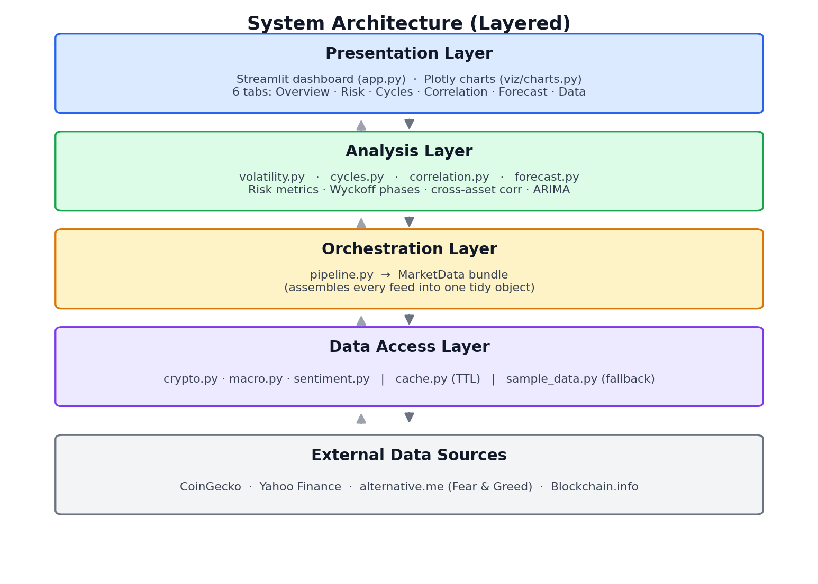
Figure 1. Layered product architecture.

2.2 Product Functions
- Ingest crypto, macro, sentiment, and on-chain data with caching and an offline fallback.
- Compute volatility and downside-risk metrics per asset.
- Identify the prevailing market-cycle phase from price structure and momentum.
- Measure static and rolling correlation and beta between digital and traditional assets.
- Produce a validated short-horizon price forecast with uncertainty bounds.
- Present all outputs through an interactive, multi-tab dashboard.

2.3 User Classes and Characteristics
User class | Characteristics and needs
Retail crypto investor | Non-technical; needs clear risk and cycle read-outs to inform decisions
Financial analyst / student | Understands markets; needs correlation, forecasting, and exportable insight
Developer / maintainer | Extends assets, metrics, or models; needs a clean, modular codebase

2.4 Operating Environment
- Runs on any platform with Python 3.10+ (Windows, macOS, Linux).
- Accessed through a modern web browser via the Streamlit server (local or cloud).
- Requires internet access for live data; degrades gracefully to sample data when offline.

2.5 Design and Implementation Constraints
- Implemented in Python using open-source libraries only (no proprietary dependencies).
- Bound by free-tier API rate limits and a history window of up to 365 days of daily data.
- On-chain metrics are limited to Bitcoin, as provided by the free data source.
- Analytical functions must remain pure (side-effect-free) to preserve testability.

2.6 Assumptions and Dependencies
- Public APIs (CoinGecko, Yahoo Finance, alternative.me, Blockchain.info) remain available and stable in schema.
- The user provides a working Python environment with the listed dependencies installed.
- Historical daily data is a sufficient granularity for the intended analyses.

3. External Interface Requirements

3.1 User Interfaces
The user interface is a browser-based Streamlit dashboard with a control sidebar and six tabbed views (Overview, Volatility & Risk, Market Cycles, Correlation, Forecast, and Data & Sources). The sidebar provides a history-window selector, a primary-asset selector, a manual data-refresh control, and live/sample status indicators for each data feed. Charts are interactive (hover, zoom, pan).

3.2 Hardware Interfaces
The system has no direct hardware interfaces. It runs on standard commodity hardware; a modern CPU and 4 GB of RAM are sufficient. No GPU is required.

3.3 Software Interfaces
Interface | Type | Purpose
CoinGecko REST API | HTTPS / JSON | Crypto price, volume, market capitalisation
Blockchain.info Charts | HTTPS / JSON | Bitcoin transaction count and active addresses
alternative.me FNG | HTTPS / JSON | Crypto Fear & Greed sentiment index
Yahoo Finance (yfinance) | Library / HTTPS | Traditional and macroeconomic asset prices
Python runtime & libraries | In-process | pandas, NumPy, statsmodels, Streamlit, Plotly

3.4 Communications Interfaces
All external communication uses HTTPS over the public internet. Requests carry a configurable timeout, and successful responses are cached on disk for six hours to limit outbound traffic and respect API rate limits.

4. System Features (Functional Requirements)
This section specifies the functional requirements for each system feature. The data-flow context below shows how ingested data becomes the four analytical outputs surfaced in the dashboard.
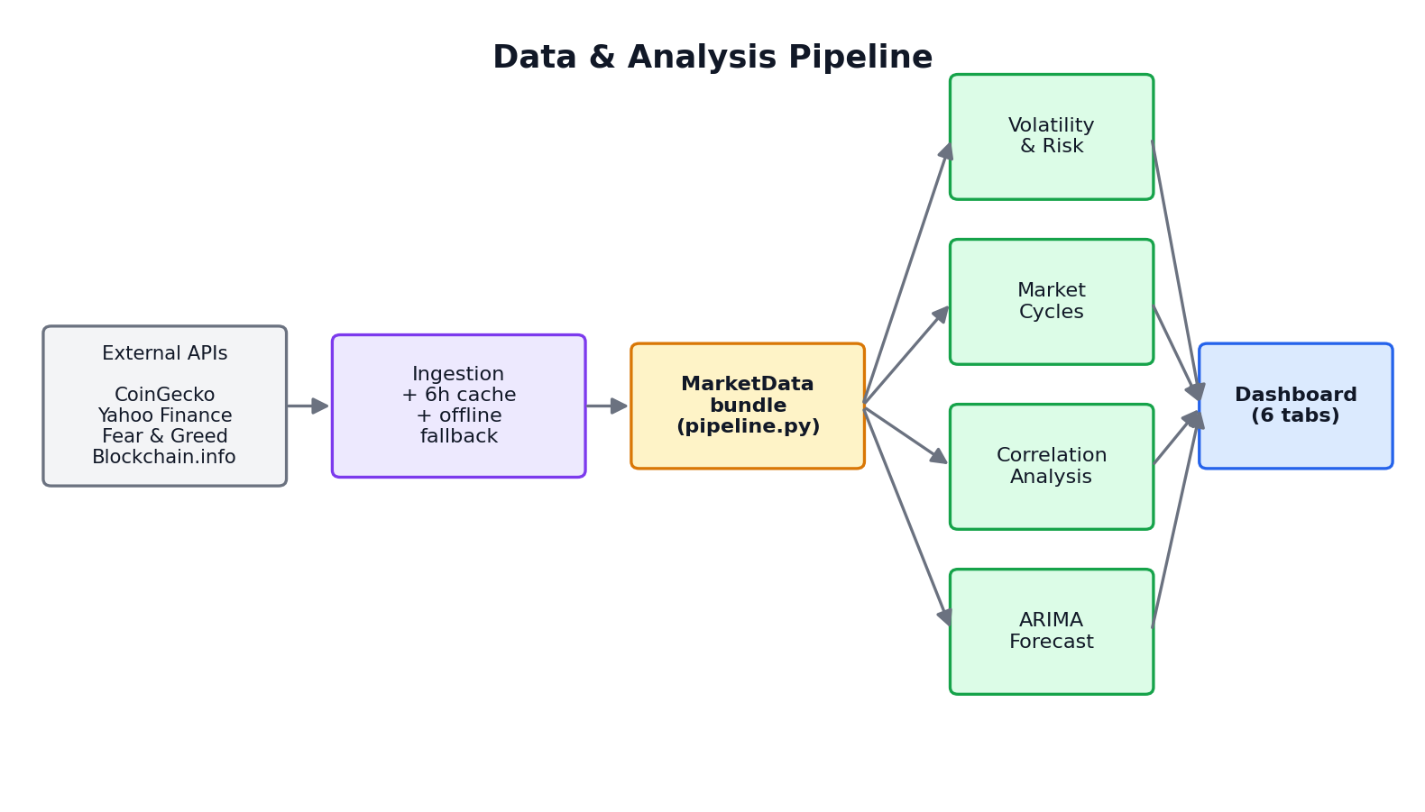
Figure 2. Data-flow context of the system features.

4.1 Data Ingestion and Resilience
Priority: High. Description: The system acquires market data from external sources, caches it, and remains operational when sources are unavailable.
ID | Requirement
FR-1.1 | The system shall fetch daily crypto price, volume, and market-cap data for each configured asset over the selected window.
FR-1.2 | The system shall fetch sentiment (Fear & Greed), Bitcoin on-chain metrics, and macro-asset prices.
FR-1.3 | The system shall cache successful responses on disk with a six-hour TTL and reuse them within that period.
FR-1.4 | On any fetch failure, the system shall substitute deterministic sample data and continue without error.
FR-1.5 | The system shall report, per feed, whether the data in use is live or sample.
FR-1.6 | The user shall be able to force a data refresh that clears the cache.

4.2 Volatility and Risk Assessment
Priority: High. Description: The system quantifies volatility and downside risk for each asset.
ID | Requirement
FR-2.1 | The system shall compute annualised and 30-day rolling volatility from daily returns.
FR-2.2 | The system shall compute historical Value-at-Risk at the 95% and 99% confidence levels and Conditional VaR at 95%.
FR-2.3 | The system shall compute maximum drawdown and the full drawdown series.
FR-2.4 | The system shall compute the annualised Sharpe and Sortino ratios using a configurable risk-free rate.
FR-2.5 | The system shall classify the current volatility regime as Low, Elevated, or High relative to its own history.

4.3 Market-Cycle Phase Identification
Priority: High. Description: The system infers the prevailing market-cycle phase using transparent rules.
ID | Requirement
FR-3.1 | The system shall compute the 50-day and 200-day moving averages and the 14-day RSI.
FR-3.2 | The system shall classify each day into Accumulation, Markup, Distribution, Markdown, or Transition using price-vs-MA trend, RSI, and drawdown.
FR-3.3 | The system shall report the current phase together with RSI, price-vs-200MA, and drawdown from the all-time high.
FR-3.4 | The system shall visualise historical price coloured by inferred phase and the time spent in each phase.

4.4 Correlation Analysis
Priority: Medium. Description: The system measures the relationship between digital and traditional assets.
ID | Requirement
FR-4.1 | The system shall align crypto and macro returns on common dates and compute the correlation matrix.
FR-4.2 | The system shall compute rolling correlation over a configurable window (30 or 90 days) between a chosen crypto and a chosen macro asset.
FR-4.3 | The system shall compute the beta of a crypto asset to a selected benchmark.
FR-4.4 | The system shall present a crypto-to-macro correlation summary and a correlation heatmap.

4.5 Time-Series Forecasting
Priority: Medium. Description: The system produces a validated short-horizon price forecast.
ID | Requirement
FR-5.1 | The system shall fit an ARIMA model on the log-price series, selecting the order by AIC over a defined grid.
FR-5.2 | The system shall evaluate the model out-of-sample on a held-out test split and report RMSE, MAE, and MAPE.
FR-5.3 | The system shall forecast a user-selected horizon (7–60 days) and present an 80% confidence interval.
FR-5.4 | The system shall present the forecast alongside recent history and the selected model order.

4.6 Sentiment and On-chain Monitoring
Priority: Low. Description: The system surfaces market sentiment and Bitcoin network activity.
ID | Requirement
FR-6.1 | The system shall display the historical Fear & Greed index with sentiment bands.
FR-6.2 | The system shall display Bitcoin daily transaction count and active-address trends.

4.7 Interactive Dashboard
Priority: High. Description: The system presents all analyses through an interactive web application.
ID | Requirement
FR-7.1 | The system shall organise outputs into six tabs and allow selection of the primary asset and history window.
FR-7.2 | The system shall show cross-asset risk and cycle summary tables on the overview.
FR-7.3 | The system shall cache expensive computations (data load and model fit) to keep the interface responsive.
FR-7.4 | The system shall display a persistent disclaimer that outputs are not financial advice.

5. Non-functional Requirements

5.1 Performance
- NFR-1.1: With warm cache, tab interactions shall render within about two seconds on commodity hardware.
- NFR-1.2: A cold data load of all feeds for the full 365-day window shall complete within about 30 seconds under normal API conditions.
- NFR-1.3: Repeated requests within the cache TTL shall not trigger new external API calls.

5.2 Reliability and Availability
- NFR-2.1: No single external-source failure shall crash the application; the fallback path shall keep every feature functional.
- NFR-2.2: Cache read/write errors shall be treated as a cache miss and never propagate to the user.

5.3 Usability
- NFR-3.1: The dashboard shall be usable by a non-technical investor without training, using plain-language metric labels and inline explanations.
- NFR-3.2: The current data source (live vs sample) shall be visible at all times.

5.4 Security and Privacy
- NFR-4.1: The system shall not collect, store, or transmit any personal user data.
- NFR-4.2: Any optional API key shall be read from an environment variable and never hard-coded or logged.
- NFR-4.3: All external communication shall use HTTPS.

5.5 Maintainability
- NFR-5.1: Analytical logic shall be implemented as pure functions, independently unit-testable without I/O.
- NFR-5.2: Configuration (assets, endpoints, parameters) shall be centralised in a single module.
- NFR-5.3: A new forecasting model shall be addable behind the existing result interface without changing the dashboard.

5.6 Portability
- NFR-6.1: The system shall run unchanged on Windows, macOS, and Linux with Python 3.10+.
- NFR-6.2: The system shall be deployable to Streamlit Cloud, a container, or IBM Cloud Code Engine without code changes.

5.7 Scalability
- NFR-7.1: Adding a tracked crypto or macro asset shall require only a configuration change, not code changes.

6. Other Requirements

6.1 Data Requirements
- The system shall operate on daily-frequency time series indexed by date and aligned across assets.
- Missing values shall be forward-filled or dropped as appropriate before analysis.

6.2 Legal and Compliance
- The system shall present outputs for educational and analytical use only and shall not constitute financial advice.
- Use of third-party data shall respect the terms of the respective providers.

Appendix A. Analysis Model – Use Cases
The use-case diagram below summarises the primary interactions between the actors (an Investor/Analyst and the External Data Providers) and the system.
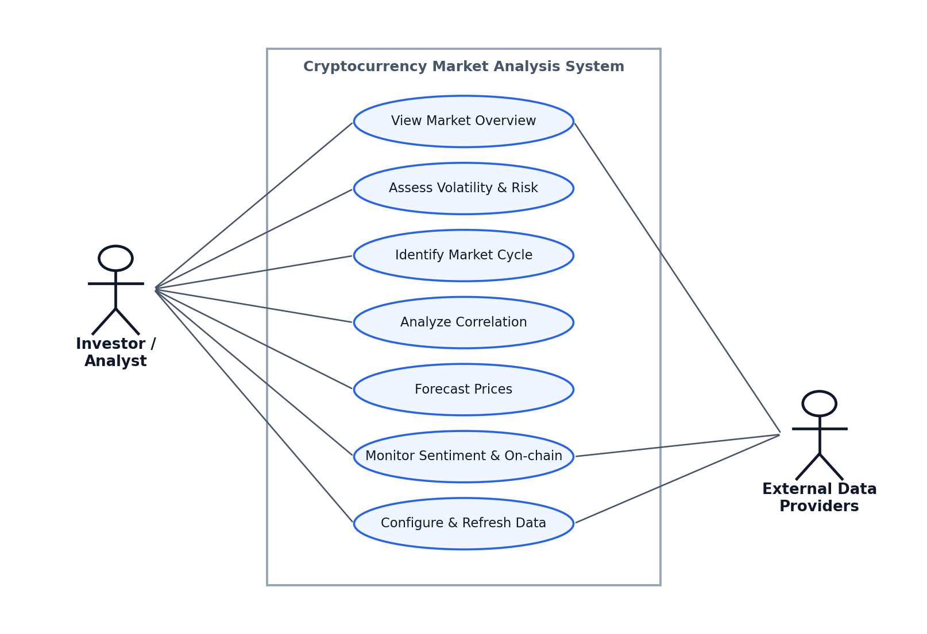
Figure 3. Use-case diagram.
Primary use cases: view the market overview; assess volatility and risk; identify the market cycle; analyse correlation; forecast prices; monitor sentiment and on-chain activity; and configure and refresh data. The External Data Providers actor supplies the market, sentiment, and on-chain data consumed during ingestion.

