SOFTWARE REQUIREMENTS SPECIFICATION
Cryptocurrency Market Analysis System
A Data Science System for Digital-Asset Market Analytics,
Risk Assessment, Market-Cycle Identification, and Forecasting
Prepared in accordance with the IEEE 830 guidelines
Field | Detail
Author | Garima Aishwarya
Programme | B.Tech, Computer Science & Engineering (AI/ML)
Institution | UPES, Dehradun
Context | IBM Data Science Internship Project
Denomination | Indian Rupees (INR)
Date | August 2026

Revision History
Version | Date | Description
1.0 | August 2026 | Initial baseline
2.0 | August 2026 | Adds preprocessing, GARCH, direction classification, INR denomination, offline distribution and the automated test suite

Table of Contents
1. Introduction 4
1.1 Purpose 4
1.2 Document Conventions 4
1.3 Intended Audience 4
1.4 Product Scope 4
1.5 Definitions and Abbreviations 4
1.6 References 5
2. Overall Description 6
2.1 Product Perspective 6
2.2 Product Functions 6
2.3 User Classes and Characteristics 7
2.4 Operating Environment 7
2.5 Design and Implementation Constraints 7
2.6 Assumptions and Dependencies 7
3. External Interface Requirements 9
3.1 User Interfaces 9
3.2 Hardware Interfaces 9
3.3 Software Interfaces 9
3.4 Communications Interfaces 9
4. System Features (Functional Requirements) 10
4.1 Data Ingestion and Resilience 10
4.2 Data Preprocessing and Quality 10
4.3 Currency Denomination 10
4.4 Volatility and Risk Assessment 10
4.5 Market-Cycle Phase Identification 11
4.6 Correlation Analysis 11
4.7 Time-Series Forecasting 11
4.8 Next-Day Direction Classification 12
4.9 Data Source Transparency 12
4.10 Interactive Dashboard 12
5. Non-functional Requirements 13
5.1 Performance 13
5.2 Reliability and Availability 13
5.3 Usability 13
5.4 Security and Privacy 13
5.5 Maintainability and Testability 13
5.6 Portability 13
5.7 Scalability 13
6. Other Requirements 14
6.1 Data Requirements 14
6.2 Legal and Compliance 14
Appendix A. Object-Oriented Analysis and Design 15
A.1 Use-Case Model 15
A.2 Domain Model 15
A.3 Design Model 16
A.4 Sequence Model 17

1. Introduction

1.1 Purpose
This document specifies the requirements for the Cryptocurrency Market Analysis System, a data-science application that consolidates cryptocurrency market data, sentiment, blockchain activity, macroeconomic asset prices and foreign-exchange rates into a single analytical pipeline, and presents the results through an interactive dashboard. It defines the system's scope, its functional and non-functional requirements, its external interfaces, and the constraints under which it operates.

1.2 Document Conventions
Functional requirements are identified as FR-x.y and non-functional requirements as NFR-x.y. The keyword shall denotes a mandatory requirement. Where a requirement states a numeric threshold, that value is defined in the system's central configuration module and is read from there by every component that depends on it, so specification and implementation cannot diverge.

1.3 Intended Audience
The document is written for project evaluators and academic supervisors assessing scope and completeness; for developers extending or maintaining the system; and for analysts who need to understand the assumptions behind the figures the dashboard reports. Readers seeking implementation detail should consult the accompanying project report; readers seeking the reasoning behind specific engineering decisions should consult the engineering log.

1.4 Product Scope
The system tracks six cryptocurrencies (BTC, ETH, SOL, BNB, XRP, ADA) against five traditional or macroeconomic series (S&P 500, Gold, US Dollar Index, US 10-Year Treasury Yield, Crude Oil), together with the USD/INR exchange rate. It operates on daily observations over a configurable window of up to 365 days.
The system produces volatility and risk metrics, market-cycle phase labels, cross-asset correlation measured under both calm and stressed conditions, a short-horizon price forecast, and a next-day direction classification. It is intended for educational and analytical use and does not constitute financial advice, execute trades, or hold user funds.

1.5 Definitions and Abbreviations
Term | Definition
VaR | Value-at-Risk — the loss not expected to be exceeded at a stated confidence level
CVaR | Conditional VaR — the mean loss given that the VaR threshold has been breached
Drawdown | Decline from a running peak, measured within the loaded window
RSI | Relative Strength Index, a momentum oscillator bounded between 0 and 100
ARIMA | Autoregressive Integrated Moving Average time-series model
GARCH | Generalised Autoregressive Conditional Heteroskedasticity volatility model
Base rate | Accuracy obtained by always predicting the majority class
Skill score | One minus the ratio of model error to baseline error
Wyckoff cycle | Accumulation → Markup → Distribution → Markdown market phase framework
TTL | Time-to-live; the period for which a cached response remains valid

1.6 References
- IEEE Std 830-1998, Recommended Practice for Software Requirements Specifications.
- CoinGecko API documentation — cryptocurrency market data.
- Yahoo Finance market data, accessed through the yfinance library.
- Alternative.me Crypto Fear & Greed Index.
- Blockchain.com Charts API — Bitcoin network statistics.
- Bollerslev, T. (1986). Generalized Autoregressive Conditional Heteroskedasticity.

2. Overall Description

2.1 Product Perspective
The system is a self-contained analytical application with no dependency on any existing product. It follows a strict layered architecture in which each layer depends only on the layer beneath it, with no circular dependencies. External data sources feed a data-access layer; a preprocessing stage cleans every dataset and records what it did; an orchestration layer assembles the results into a single bundle; the analysis layer computes metrics and models; and the presentation layer renders them.
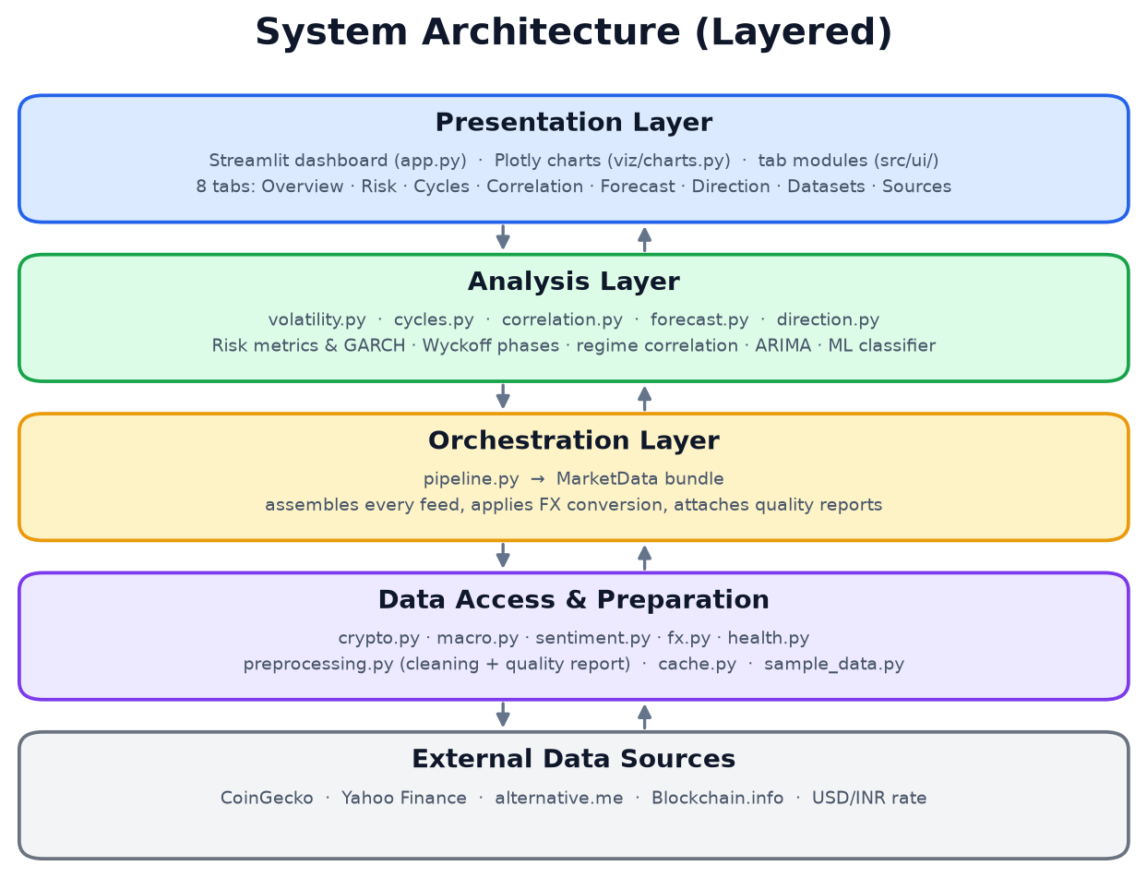
Figure 1. Layered system architecture.

2.2 Product Functions
At runtime the dashboard requests data for a chosen history window. Each loader consults the on-disk cache before attempting a network call. Responses are cleaned, converted into the display currency where appropriate, and assembled into a single bundle that the five analysis modules consume independently.
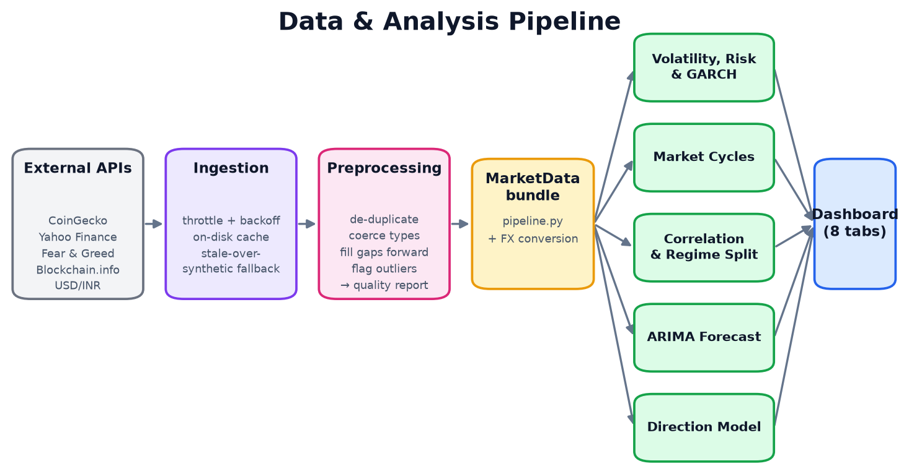
Figure 2. Data ingestion and analysis pipeline.

2.3 User Classes and Characteristics
User class | Characteristics and needs
Retail investor | Limited quantitative background. Needs headline risk figures, a plain-language reading of market conditions, and explicit statements of what the system cannot establish.
Analyst | Comfortable with financial statistics. Needs correlation structure, regime behaviour, validation methodology, and access to the underlying data.
Evaluator | Assessing the system as an academic deliverable. Needs the system to run without configuration, and needs every figure traceable to its source and method.
Developer | Extending or maintaining the system. Needs modular boundaries, documented assumptions, and an automated test suite.

2.4 Operating Environment
- Python 3.12 or later on Windows, macOS, or Linux.
- A modern web browser for the dashboard interface.
- Approximately 500 MB of disk space including dependencies.
- Network access is optional. The system ships with cached responses and operates fully offline.

2.5 Design and Implementation Constraints
- Price history is limited to 365 days by the free tier of the primary data provider.
- On-chain metrics are available for Bitcoin only, a constraint of the free charts API.
- The keyless tier of the price provider is rate limited to approximately ten to thirty requests per minute, shared per IP address. Request spacing is set against the worst documented case.
- Sentiment is available as a composite index rather than as raw social-media text, which would require a paid feed.
- All monetary values are denominated in Indian rupees; index levels and interest rates are not converted.

2.6 Assumptions and Dependencies
- Daily closing observations are sufficient granularity for the analyses performed; intraday behaviour is out of scope.
- The composite Fear & Greed index is accepted as a proxy for market sentiment.
- Log-price series are assumed to require first-order differencing; this is defensible but is not established by a formal stationarity test.
- External providers may change or withdraw their interfaces; the system degrades to cached and then to generated data rather than failing.

3. External Interface Requirements

3.1 User Interfaces
The system presents a single-page web application organised into eight tabs, with a persistent sidebar providing history-window selection, primary-asset selection, a data-refresh control, and a live status indicator for each feed.
Tab | Purpose
Overview | Headline price and volatility, price with moving averages, volume, and cross-asset summaries
Volatility & Risk | Risk metrics, rolling volatility, drawdown, and GARCH conditional volatility
Market Cycles | Phase ribbon, phase distribution, and the rule table used to assign labels
Correlation | Correlation matrix, regime split, rolling correlation and beta
Forecast | ARIMA projection, walk-forward backtest, and skill score
Direction Model | Classifier performance against the base rate, and feature-block ablation
Datasets | Per-feed status, connection test, data preview, and preprocessing report
Data & Sources | Sentiment and on-chain series, feed status, and cache state

3.2 Hardware Interfaces
The system requires no specialised hardware. It runs on any machine meeting the operating-environment requirements and interacts with hardware only through the operating system's filesystem and network stack.

3.3 Software Interfaces
Interface | Protocol and purpose
CoinGecko REST API | HTTPS/JSON. Daily price, volume and market capitalisation, requested directly in INR
Yahoo Finance | HTTPS via the yfinance library. Macroeconomic asset prices and the USD/INR rate
alternative.me REST API | HTTPS/JSON. Fear & Greed index values
Blockchain.info Charts API | HTTPS/JSON. Bitcoin transaction counts and active addresses
Local filesystem | Serialised cache of API responses under data/cache/

3.4 Communications Interfaces
All external communication uses HTTPS on port 443. Requests carry no user data. An optional API credential, when present, is transmitted as a request header and is never written to any log or persisted output. Request timeouts, retry counts, and inter-request spacing are configurable.

4. System Features (Functional Requirements)

4.1 Data Ingestion and Resilience
FR-1.1 The system shall ingest daily price, volume and market-capitalisation data for each configured cryptocurrency.
FR-1.2 The system shall ingest daily closing prices for each configured macroeconomic asset, the Fear & Greed index, Bitcoin on-chain metrics, and the USD/INR exchange rate.
FR-1.3 The system shall space consecutive requests to the price provider by a configurable interval, and shall retry a rate-limited response with exponential backoff, honouring any Retry-After header.
FR-1.4 The system shall cache successful responses on disk and shall not cache failed responses.
FR-1.5 The system shall never propagate a network failure to the user interface. Where a feed is unavailable it shall fall back, in order of preference, to an expired cached response and then to deterministically generated data.
FR-1.6 The system shall report the origin of every feed, distinguishing a live fetch, a deliberate simulation, and an unexpected failure, and shall name the individual assets affected by any partial failure.
FR-1.7 The system shall provide a control that clears both the in-memory and on-disk caches and triggers a refetch.
FR-1.8 The system shall report progress while fetching, identifying how many assets have been retrieved.

4.2 Data Preprocessing and Quality
FR-2.1 The system shall remove duplicate timestamps from every ingested series, retaining the most recent observation.
FR-2.2 The system shall coerce non-numeric values to numeric types where they represent quantities, and shall preserve genuinely categorical columns unchanged.
FR-2.3 The system shall collapse intraday observations to one observation per day.
FR-2.4 The system shall fill gaps in forward direction only, so that no later observation is propagated into an earlier period.
FR-2.5 The system shall identify outlying returns and shall report them without removing them from the dataset.
FR-2.6 The system shall not resample non-continuously-traded assets onto a daily grid.
FR-2.7 The system shall produce a quality report for every dataset, stating row counts, coverage, corrections applied, and remaining missing values.

4.3 Currency Denomination
FR-3.1 The system shall present all monetary values in Indian rupees, applying that currency's digit-grouping convention.
FR-3.2 The system shall request cryptocurrency prices directly in the display currency where the provider supports it, rather than converting after retrieval.
FR-3.3 The system shall convert dollar-quoted macroeconomic assets using the daily exchange rate, and shall not convert index levels or interest rates.
FR-3.4 The system shall fall back to a configured fixed exchange rate if the rate feed is unavailable.

4.4 Volatility and Risk Assessment
FR-4.1 The system shall compute annualised volatility using a 365-day year.
FR-4.2 The system shall compute historical Value-at-Risk at 95% and 99% confidence, estimated non-parametrically.
FR-4.3 The system shall compute Conditional VaR at 95% confidence.
FR-4.4 The system shall compute maximum drawdown within the loaded window and shall label it as a window measure rather than an all-time measure.
FR-4.5 The system shall compute Sharpe and Sortino ratios, the latter using downside deviation measured across all observations against the risk-free target.
FR-4.6 The system shall classify the current volatility regime against its own prior distribution, excluding the current observation.
FR-4.7 The system shall fit a GARCH(1,1) model, reporting conditional volatility, persistence, and the long-run volatility level where the process is stationary.

4.5 Market-Cycle Phase Identification
FR-5.1 The system shall assign each day a cycle phase from trend structure, momentum, and drawdown.
FR-5.2 The system shall select moving-average windows appropriate to the available history, preserving their ratio, and shall report the windows in use alongside every label.
FR-5.3 The system shall withhold a label for any day on which an input is undefined, rather than assigning a default.
FR-5.4 The system shall present the complete rule set used to assign phases.

4.6 Correlation Analysis
FR-6.1 The system shall align cryptocurrency and traditional-asset series on their common trading dates before computing returns.
FR-6.2 The system shall difference interest-rate series in percentage points and percent-change all other series.
FR-6.3 The system shall exclude any series too sparsely populated to correlate before discarding observations, and shall name any excluded series.
FR-6.4 The system shall compute correlation using both linear and rank methods.
FR-6.5 The system shall compute rolling correlation and beta against a selected benchmark.
FR-6.6 The system shall compute correlation separately for calm and stressed market conditions, where stress is defined by a configurable quantile of benchmark performance.

4.7 Time-Series Forecasting
FR-7.1 The system shall fit an ARIMA model to the logarithm of price, selecting model order by information criterion on a training split.
FR-7.2 The system shall validate the model one step ahead, revealing each actual observation before the next prediction, with parameters held fixed at their training values.
FR-7.3 The system shall score a naive random-walk baseline on the same held-out observations.
FR-7.4 The system shall report a skill score relative to that baseline and shall state in plain language whether the model outperforms it.
FR-7.5 The system shall present a forecast interval and shall not present the point forecast as a price target.

4.8 Next-Day Direction Classification
FR-8.1 The system shall construct features from price technicals, sentiment, on-chain activity, and macroeconomic context, each computed only from information available at the close of its own day.
FR-8.2 The system shall predict the sign of the following day's return.
FR-8.3 The system shall validate using time-ordered splits only, and shall not use any randomised split.
FR-8.4 The system shall report accuracy against the majority-class base rate measured on the same held-out observations.
FR-8.5 The system shall report the change in performance obtained by adding each feature block, so that the contribution of each data source can be assessed.
FR-8.6 The system shall state when no feature set achieves a reliable improvement.

4.9 Data Source Transparency
FR-9.1 The system shall provide a view listing every data source with its current status.
FR-9.2 The system shall allow the user to test the connection to each source individually and shall report the outcome and latency.
FR-9.3 The system shall display row counts, covered date ranges, and a sample of the underlying data for each source.
FR-9.4 The system shall display the preprocessing report for each dataset.
FR-9.5 The system shall permit export of any dataset in a portable format.

4.10 Interactive Dashboard
FR-10.1 The system shall present its analyses across eight tabs as defined in section 3.1.
FR-10.2 The system shall allow selection of the history window and the primary asset under analysis.
FR-10.3 The system shall explain the method behind each analysis within the interface itself.
FR-10.4 The system shall state that its output is for educational purposes and does not constitute financial advice.

5. Non-functional Requirements

5.1 Performance
NFR-1.1 The system shall render the dashboard within two seconds when operating from cached data.
NFR-1.2 The system shall complete a full cold data load within forty seconds without an API credential, and within fifteen seconds with one.
NFR-1.3 Individual analytical computations shall complete within six seconds and shall display progress while running.

5.2 Reliability and Availability
NFR-2.1 The system shall remain operable when any or all external data sources are unavailable.
NFR-2.2 The system shall not present generated data as measured data under any circumstance.
NFR-2.3 The failure of one data source shall not prevent analysis of the remaining sources.

5.3 Usability
NFR-3.1 Each analysis shall be accompanied by an explanation of its method and its limitations.
NFR-3.2 Numerical output shall be formatted according to the conventions of the display currency and locale.
NFR-3.3 The interface shall use a consistent, restricted colour scheme in which colour carries meaning.

5.4 Security and Privacy
NFR-4.1 The system shall collect, store, and transmit no personal data.
NFR-4.2 API credentials shall be read from a location excluded from version control and shall never appear in logs or output.
NFR-4.3 The system shall require no authentication, holding no user state.

5.5 Maintainability and Testability
NFR-5.1 Every analytical function shall be free of side effects and independently testable.
NFR-5.2 The system shall maintain an automated test suite that executes without network access.
NFR-5.3 Statement coverage of the analysis layer shall be no less than ninety per cent.
NFR-5.4 Configurable values shall be defined in one location and read from there by all dependent components.

5.6 Portability
NFR-6.1 The system shall depend only on open-source libraries with no proprietary components.
NFR-6.2 All dependencies shall be pinned to exact versions.
NFR-6.3 The system shall be deployable as a container image without modification.

5.7 Scalability
NFR-7.1 Additional assets shall be addable through configuration alone, without code modification.
NFR-7.2 An additional analytical model shall be addable as a new module without modification to existing analysis modules.

6. Other Requirements

6.1 Data Requirements
- Daily granularity across a window of 90 to 365 days, selectable by the user.
- Cached responses persisted locally in a serialised format, retained for a configurable period.
- Generated fallback data reproducible across processes and executions, and carrying a realistic cross-asset correlation structure.
- Every dataset accompanied by a machine-readable quality report.

6.2 Legal and Compliance
- All data sources are used within the terms of their free access tiers.
- The system presents analysis only and issues no trading recommendation.
- A disclaimer stating that output does not constitute financial advice is displayed persistently.
- No personal data is processed, so no data-protection obligations arise in respect of end users.

Appendix A. Object-Oriented Analysis and Design

A.1 Use-Case Model
The system has two actors. The investor or analyst initiates every analysis and configures the parameters under which it runs. External data providers are secondary actors, supplying the observations on which those analyses depend.
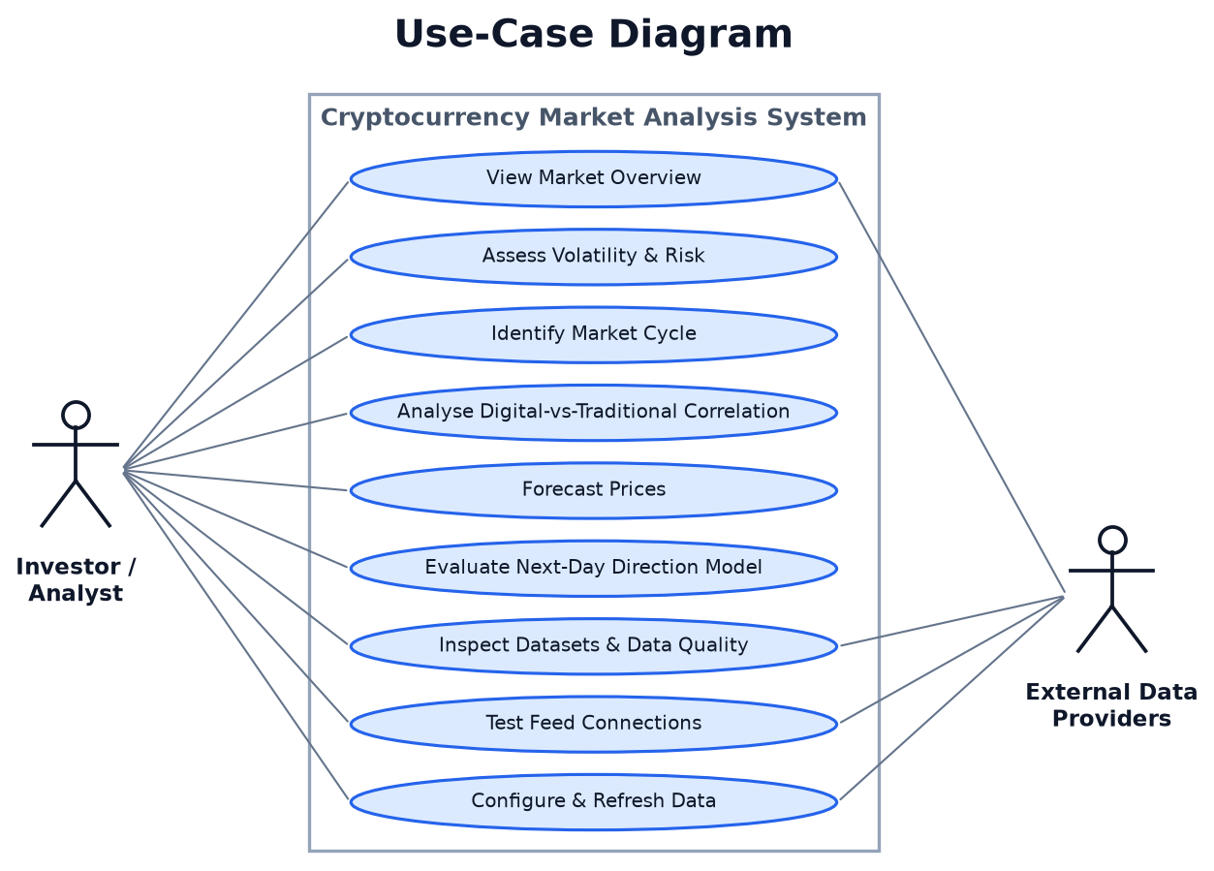
Figure 3. Use-case diagram.

A.2 Domain Model
Analytical results are represented as immutable value objects. Each is constructed once by a pure function and is read-only thereafter, which keeps analytical state from being modified by the presentation layer and makes each object straightforward to test in isolation.
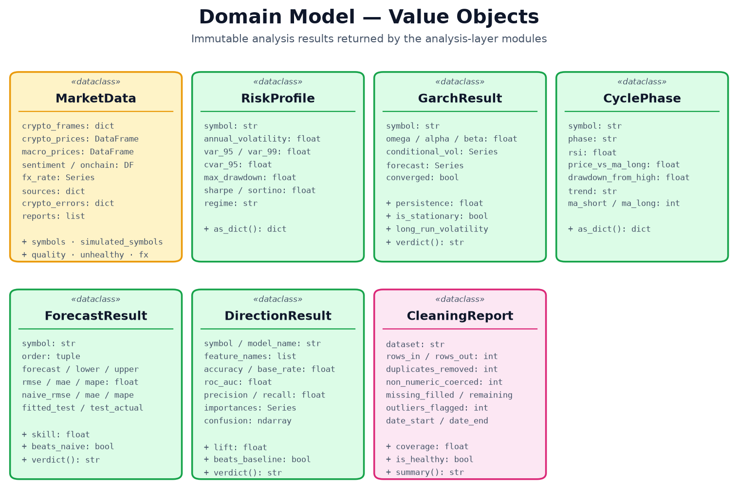
Figure 4. Domain model — analysis result value objects.

A.3 Design Model
Modules are organised so that dependencies flow in one direction only. The presentation layer depends on orchestration; orchestration depends on data access and preprocessing; the analysis modules depend on neither and are called with plain data structures. No circular dependency exists, and the configuration module is read by every layer without depending on any.
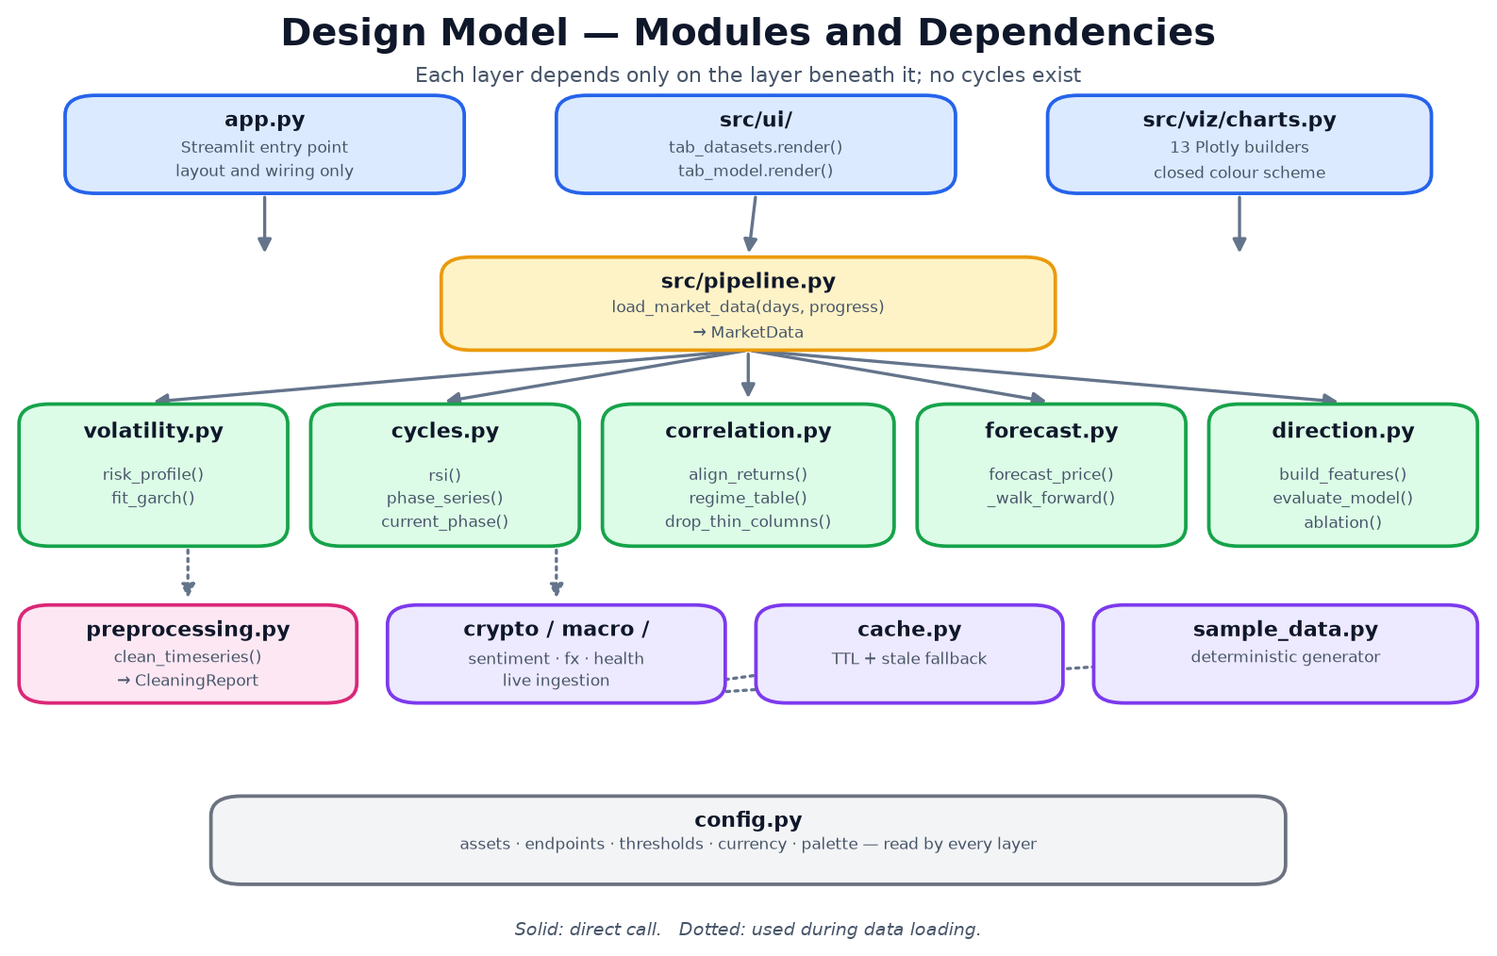
Figure 5. Design model — modules and dependencies.

A.4 Sequence Model
The sequence below traces a single user interaction: selecting a history window, through cache resolution and any necessary network retrieval, preprocessing and currency conversion, to the rendering of every analysis. A warm cache short-circuits the network entirely.
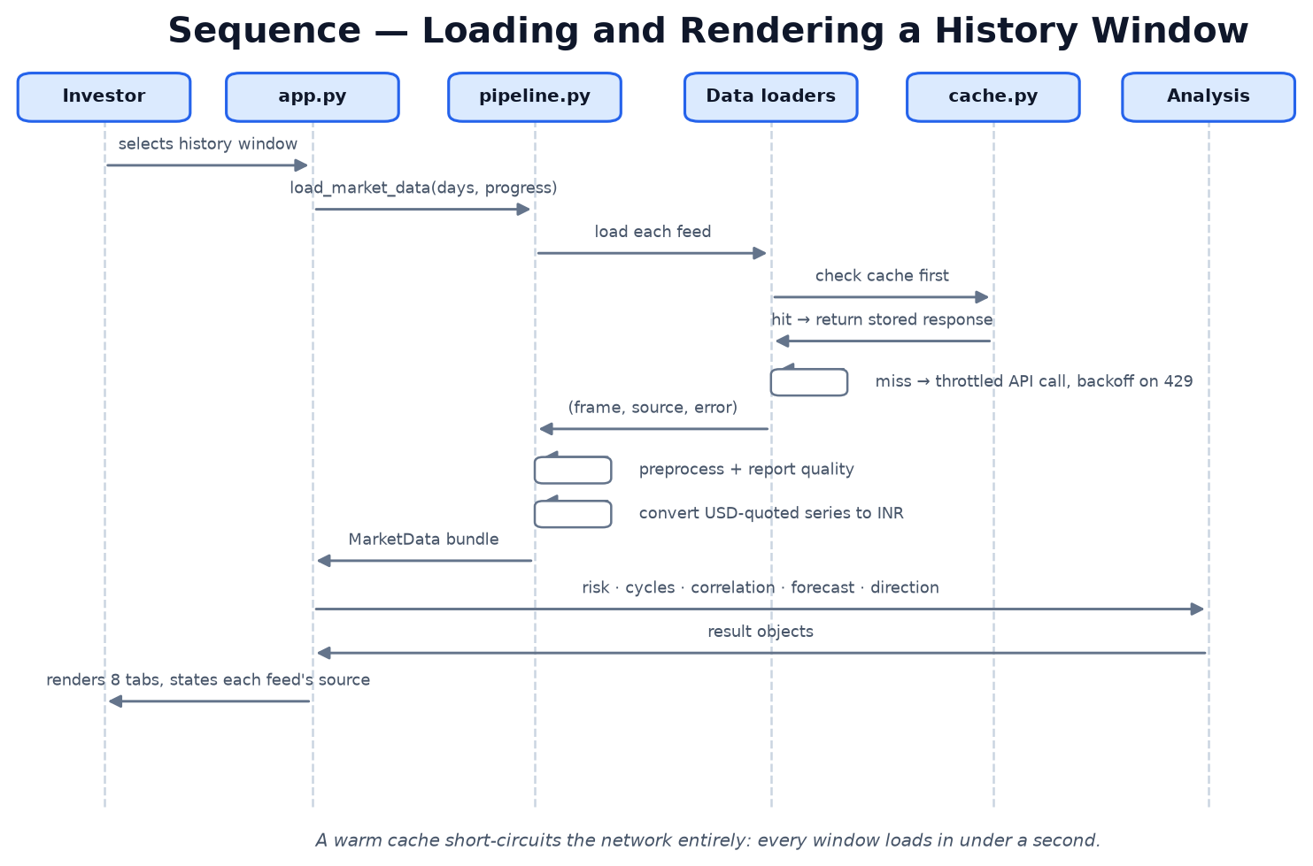
Figure 6. Sequence diagram — loading and rendering a history window.

