**Step 1: Use a MVC Architecture**

In figure 1,Weather Update : the city text field is "San Jose" and State is "CA" and temp is 56 and weather is 56.

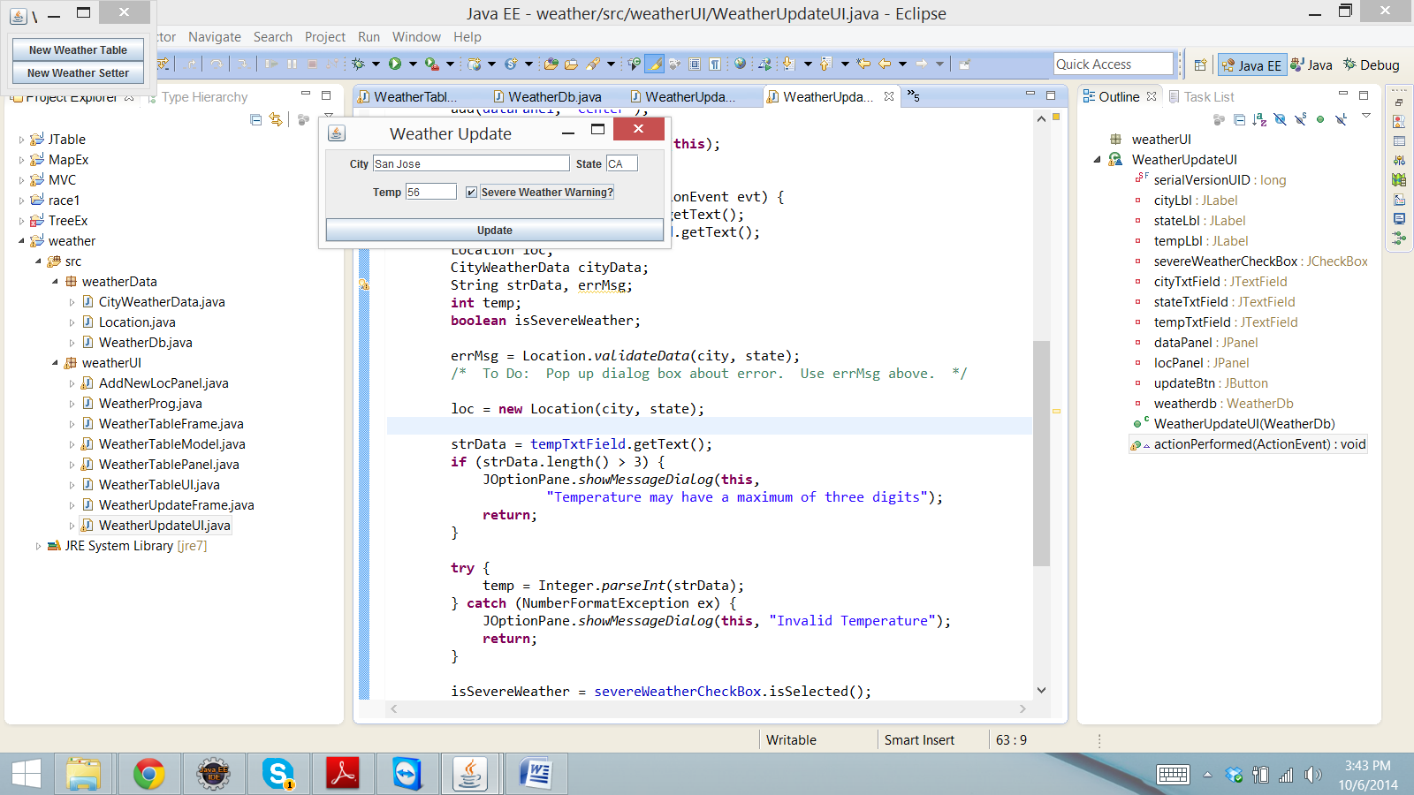

Fig. 1

In Fig.2 when inserting City Text field "San Jose" and state is "CA" and on click of "ADD" button the temperature is displayed in figure 3.

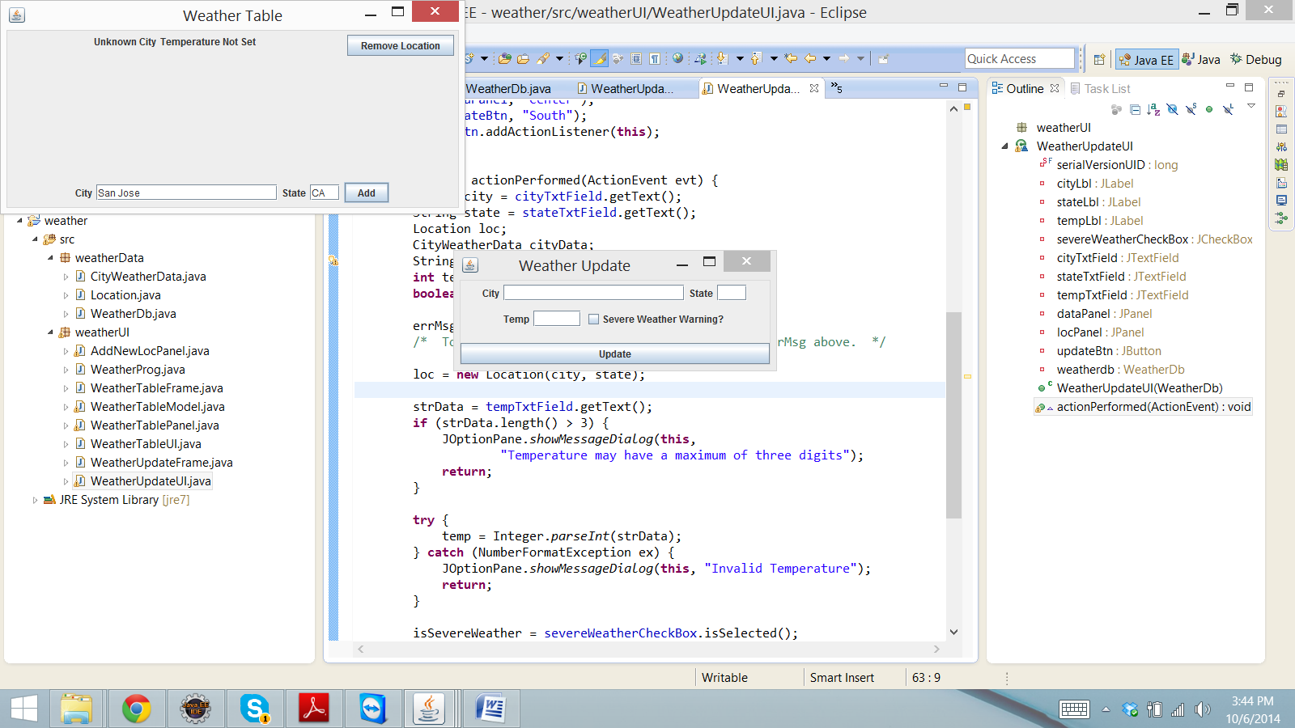

Fig. 2

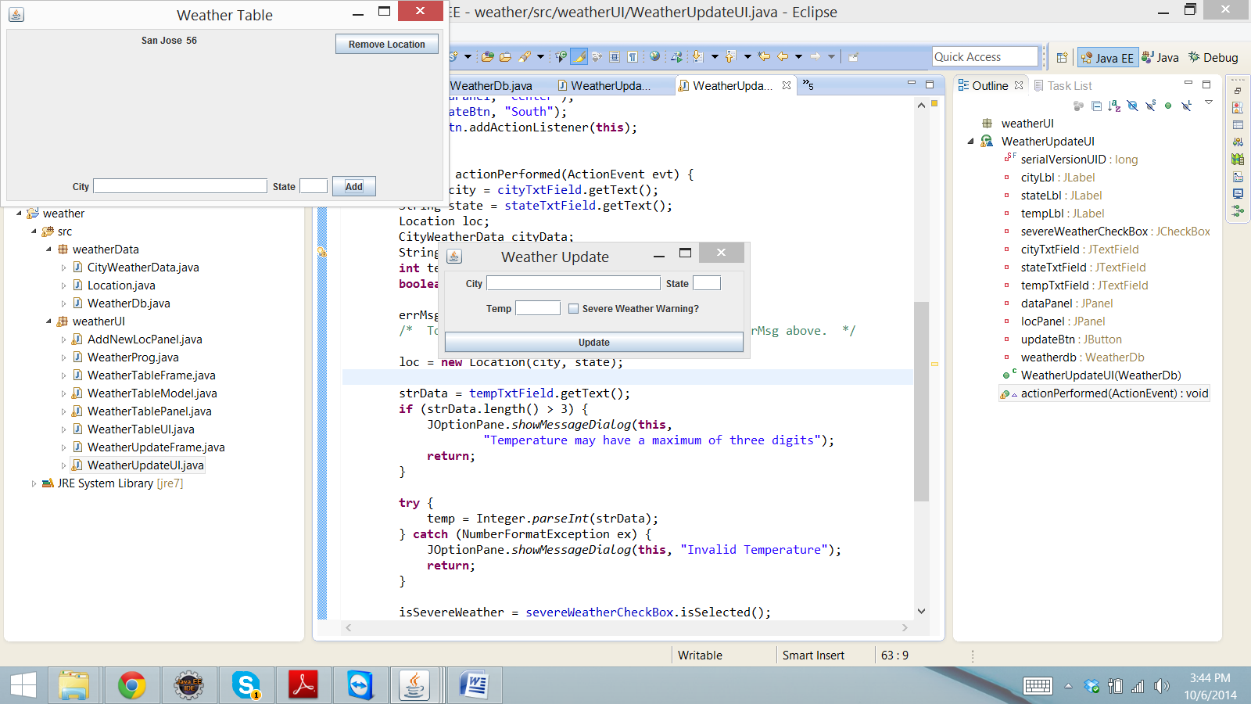

Fig. 3

In Fig 4 The weather tempertaure is now changed to 90 and on click of update button the temperature is now changed to 90 in fig. 5

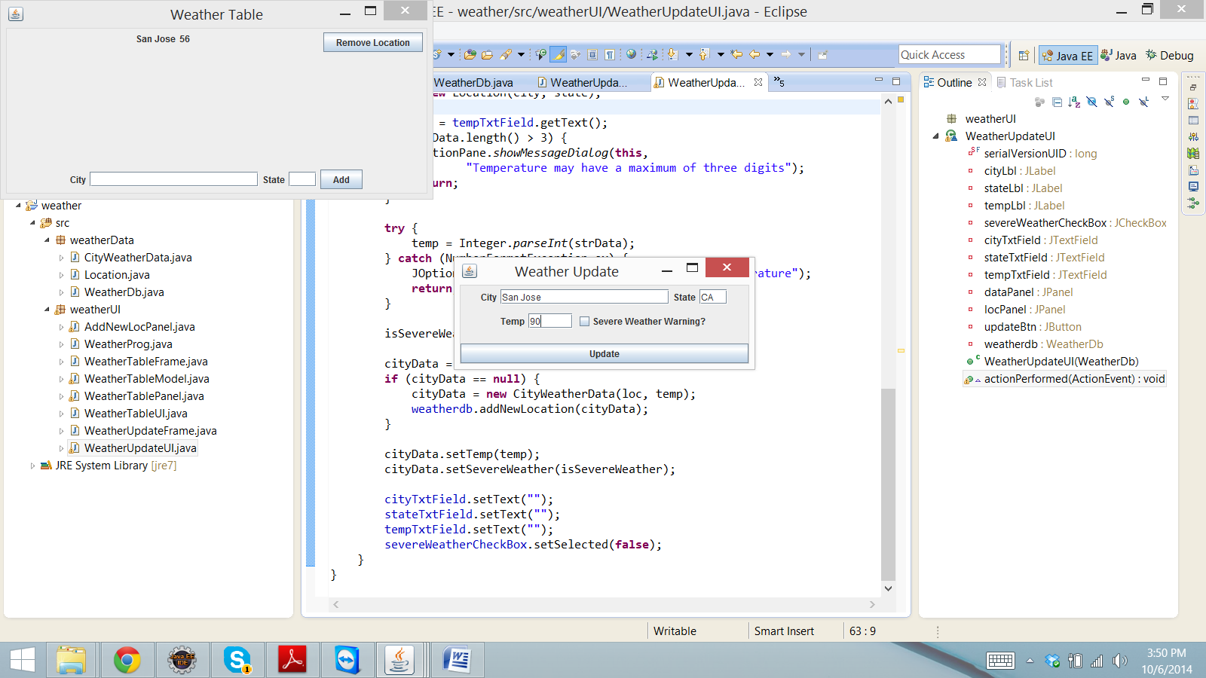

Fig. 4

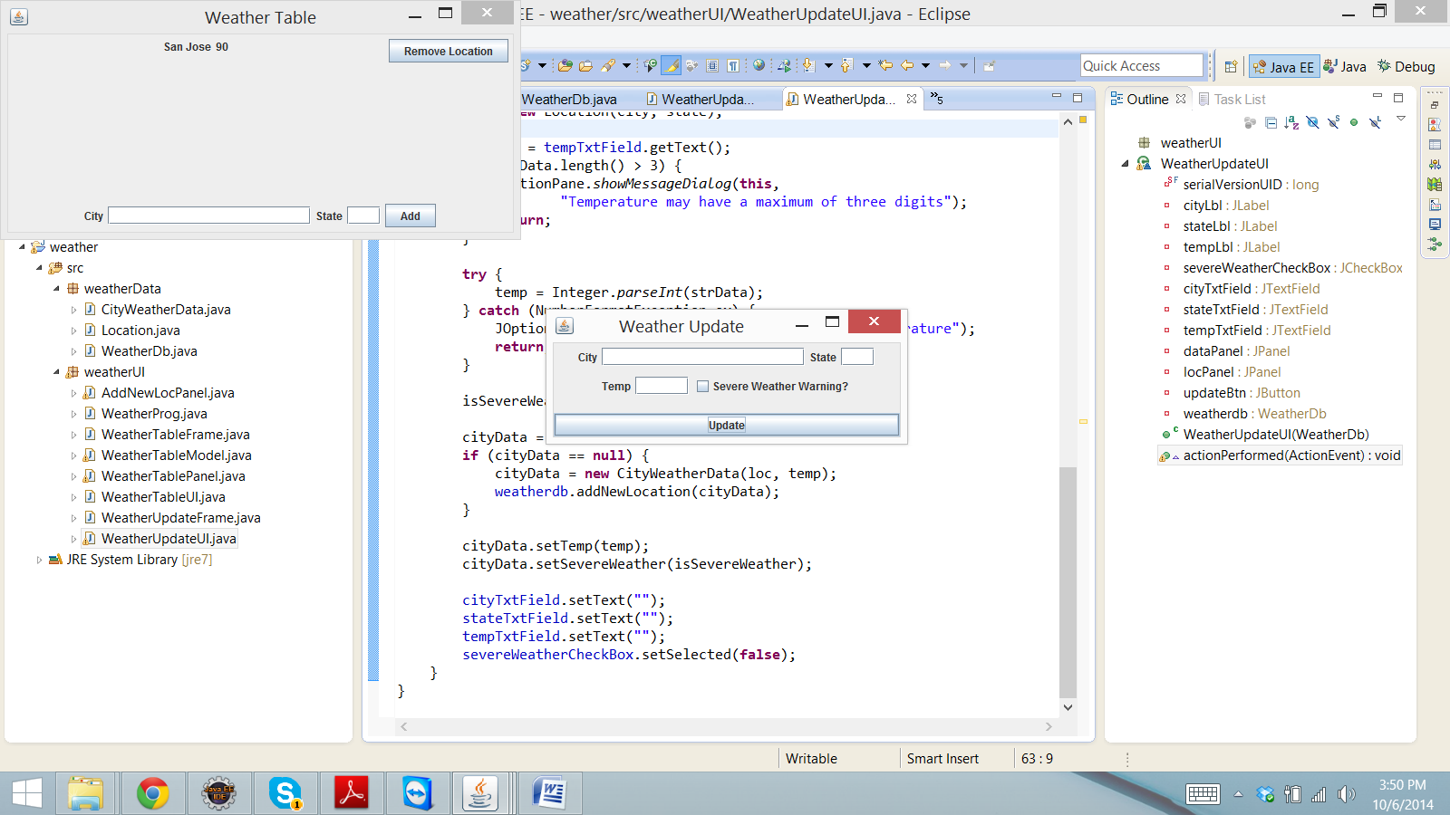

Fig. 5

On opening of multiple windows, the temperature of city Fremont is 56 on all windows in figure 6 and in figure 7 the temperature is now changing to 23 in figure 7.

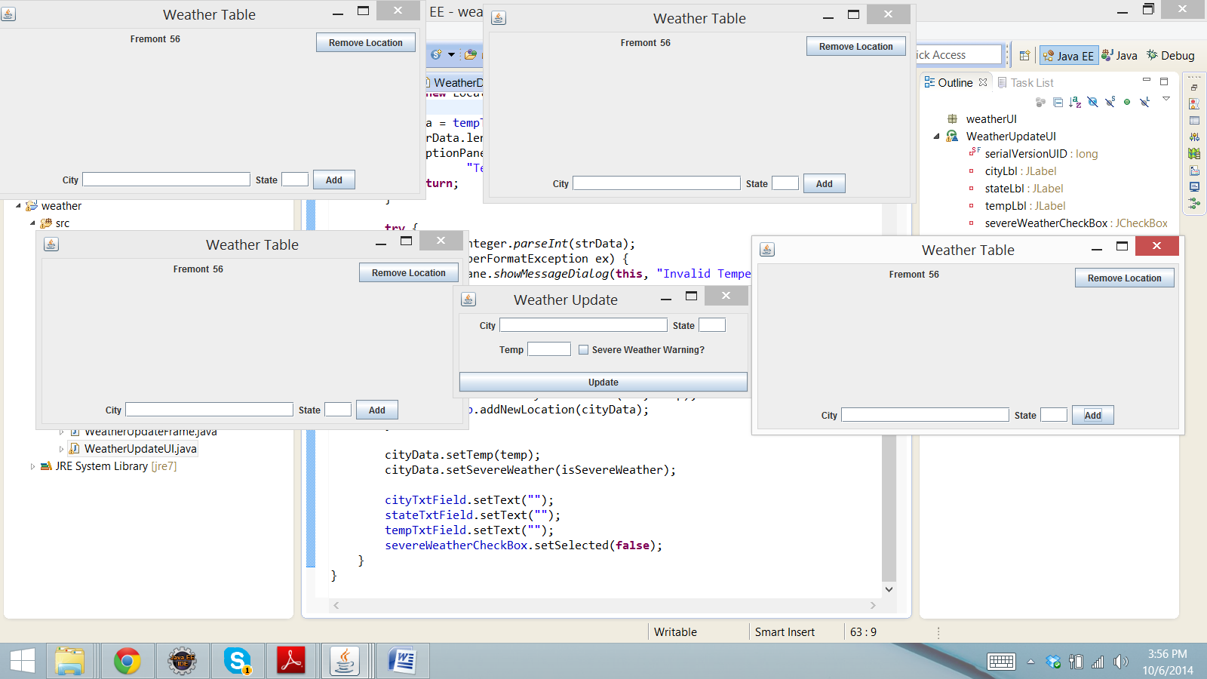

Fig. 6

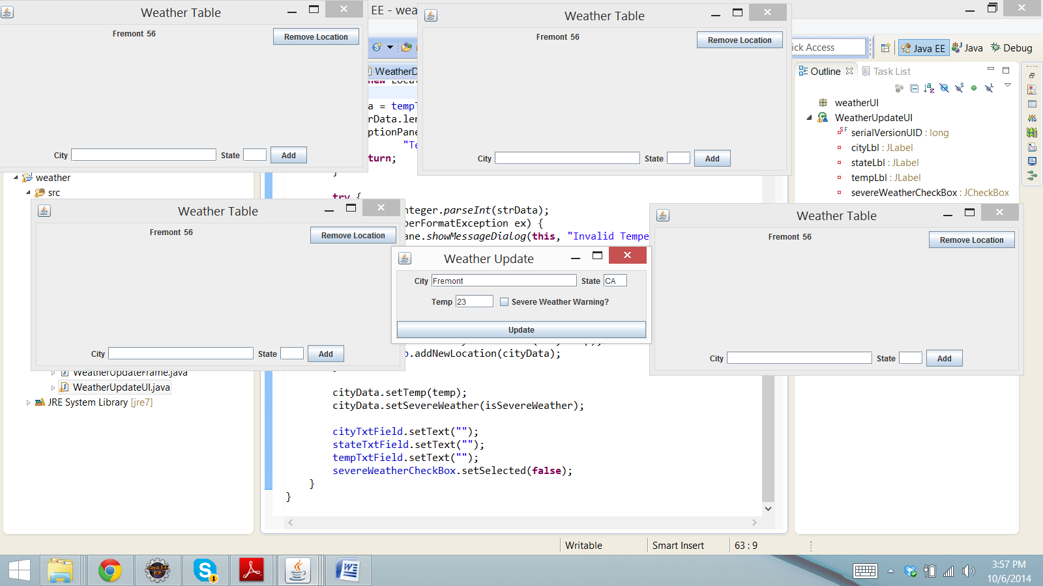

Fig. 7

Multiple windows are updated its temperature.

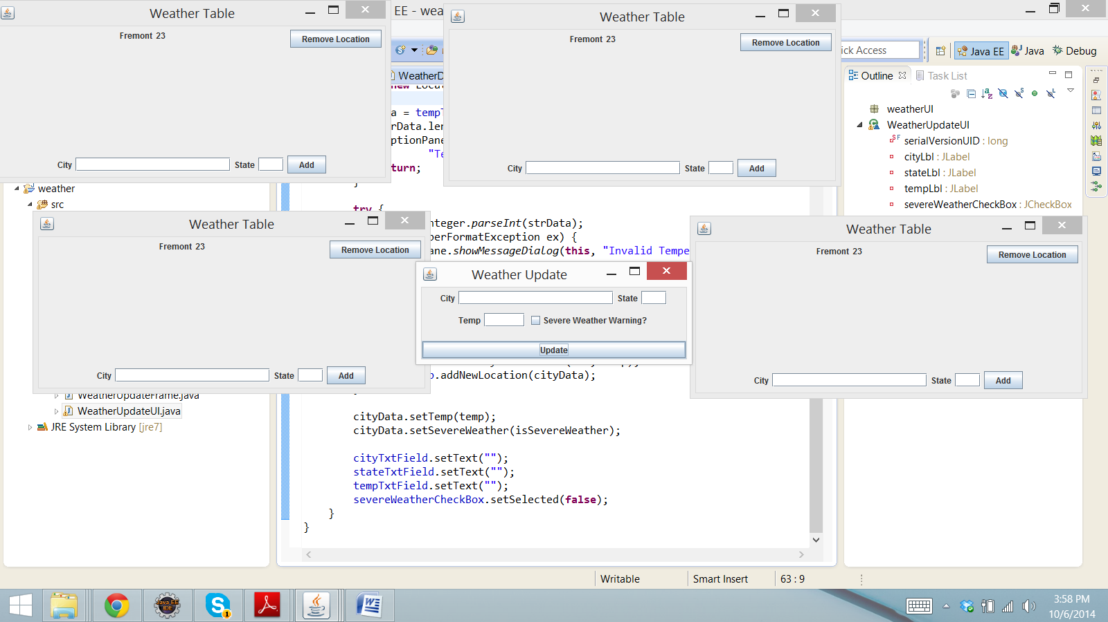

Fig. 8