**Step 2: Use a JTable**

when user enter wrong city and state (i.e. when user enters the digits instead of characters)

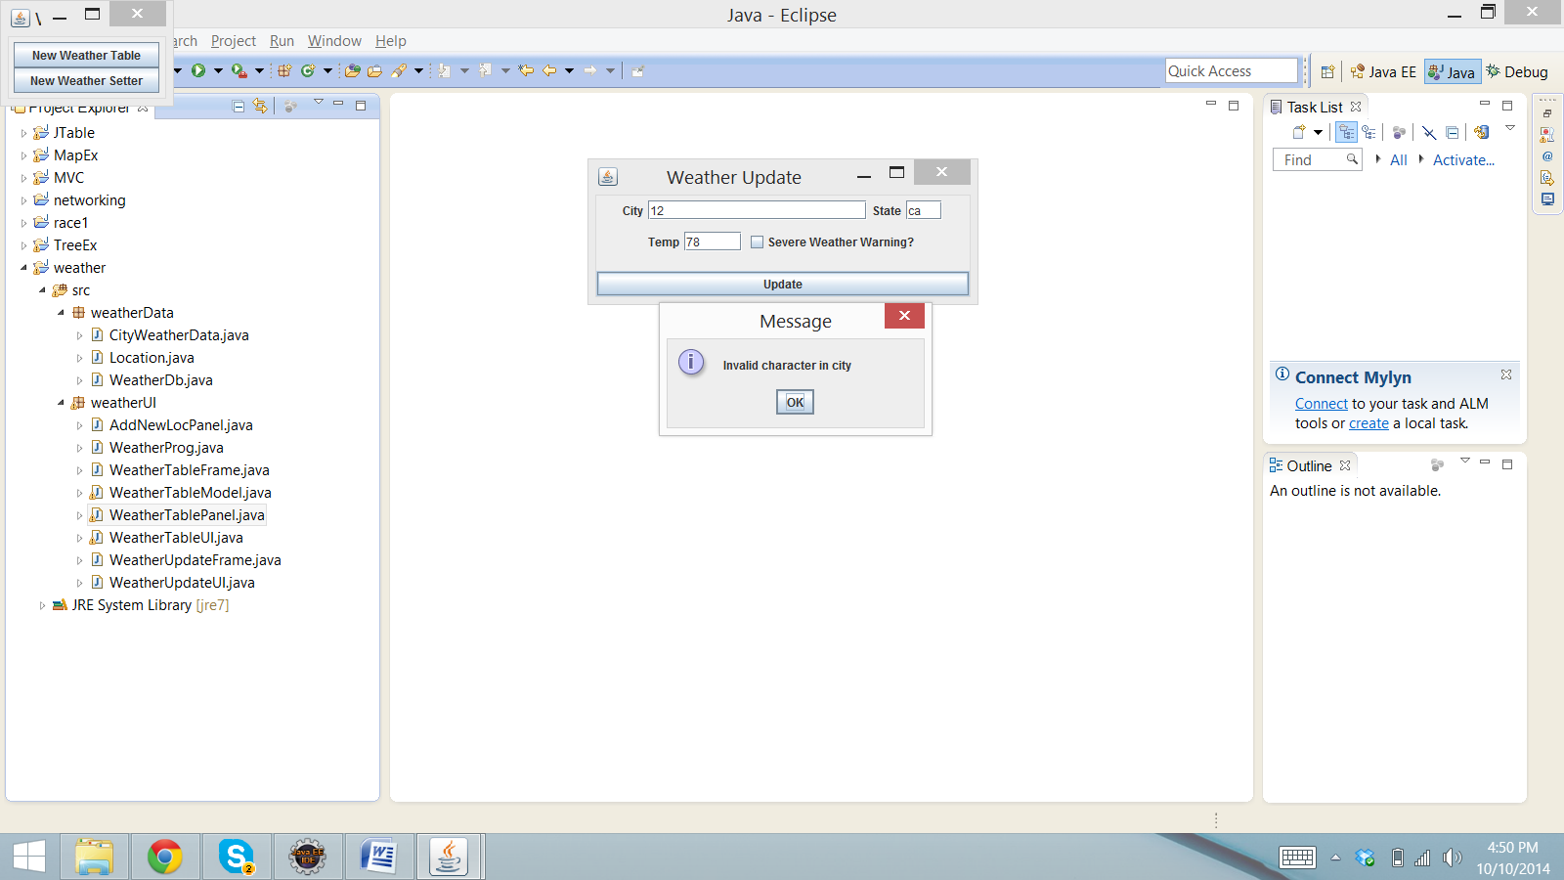

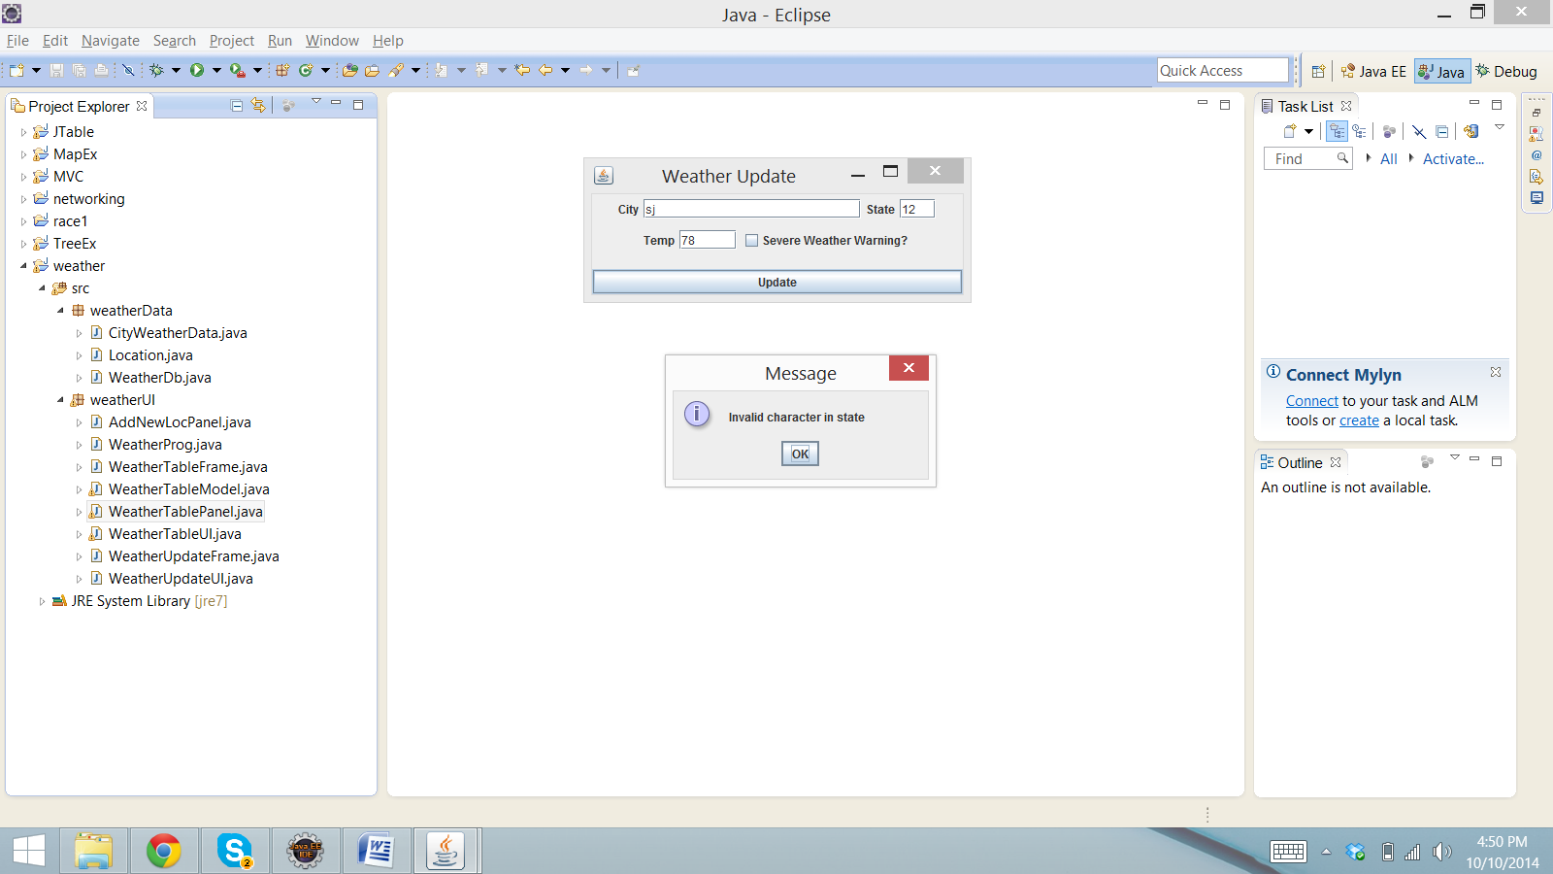

When entering the characters in the temperature text box, the message box is displayed.

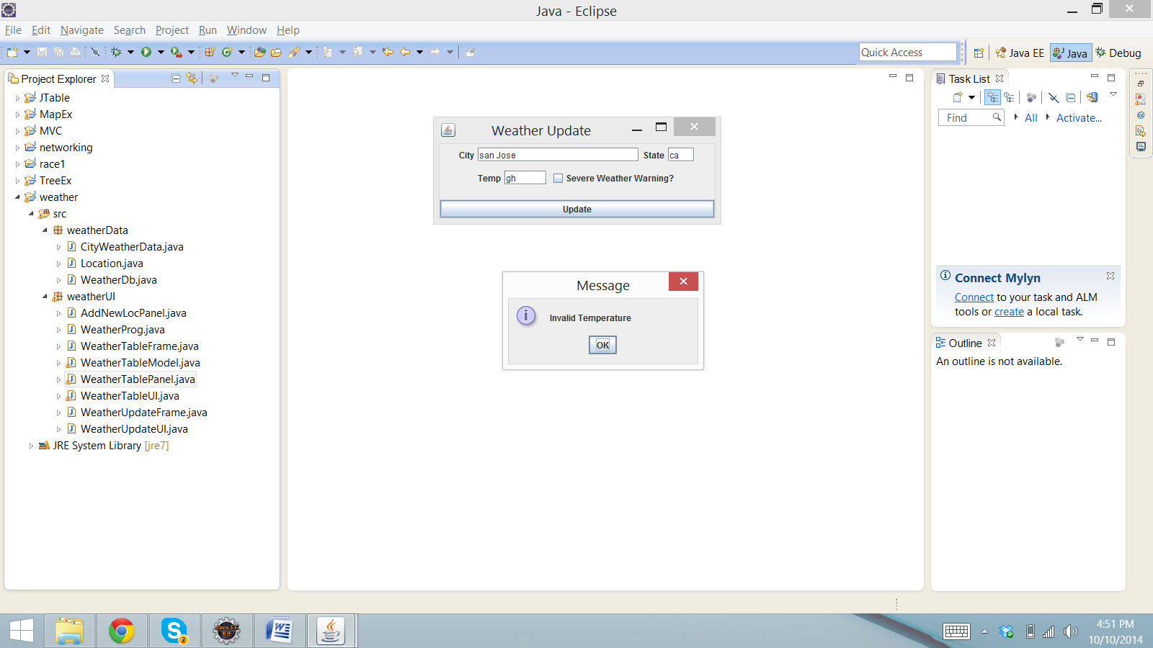

when user try to enter the city and state Null or blank, then the message box is shown.

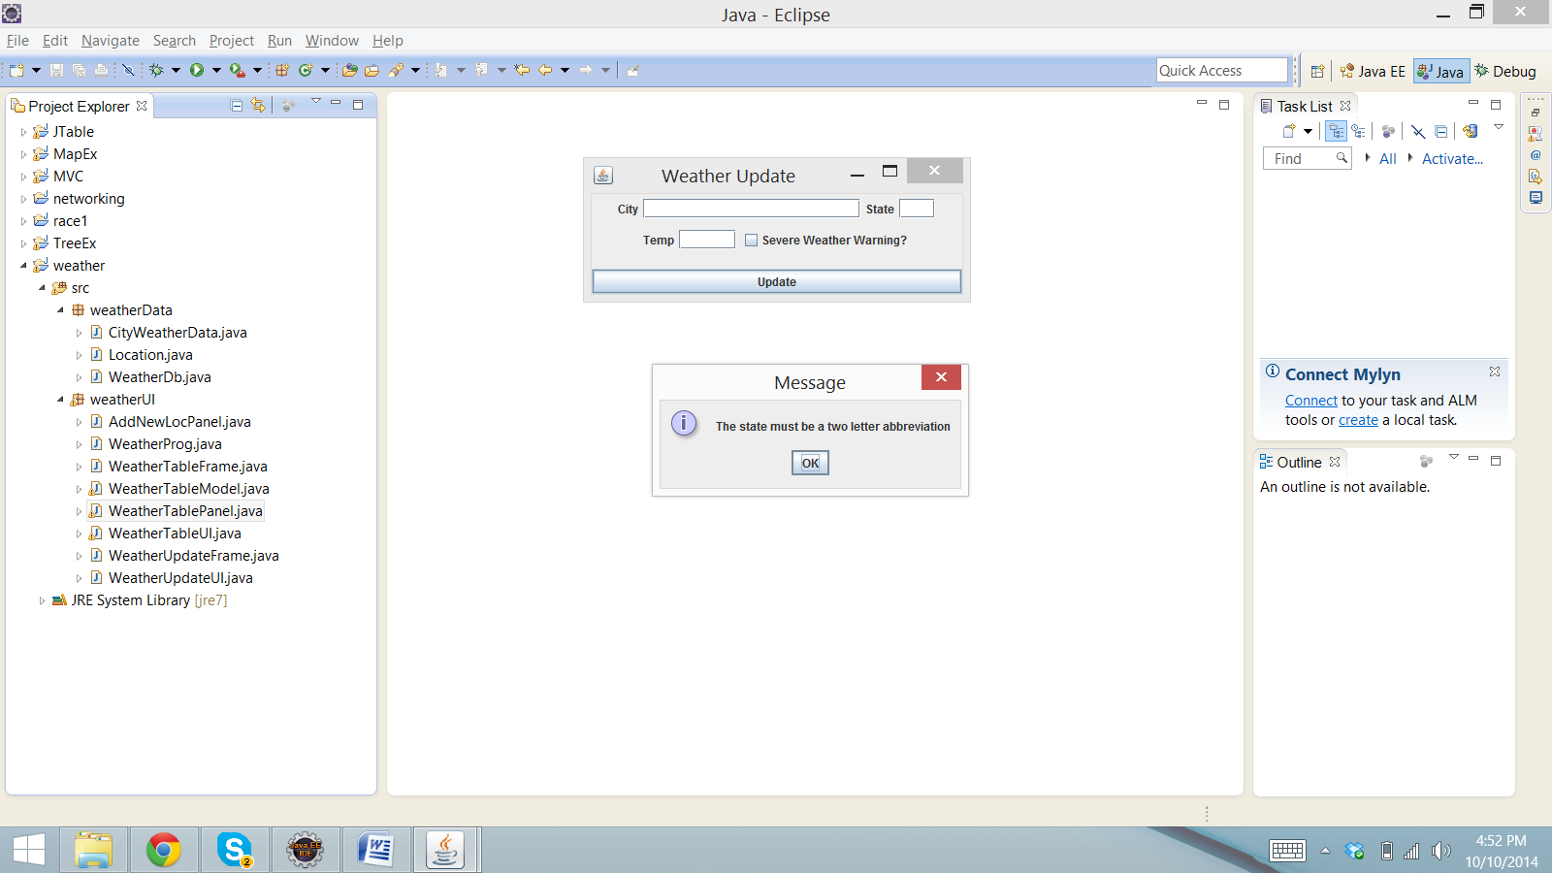

If the city and state is not in database, and want to search for that Location, then message box will be displayed.

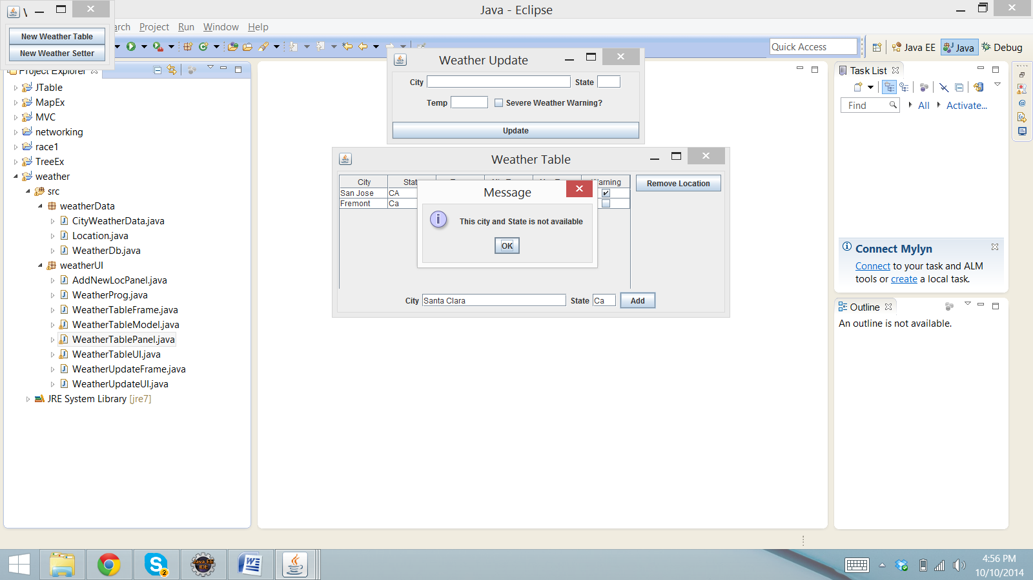

Now, everything is in correct format and after clicking on update button. The record is updated sucessfully.

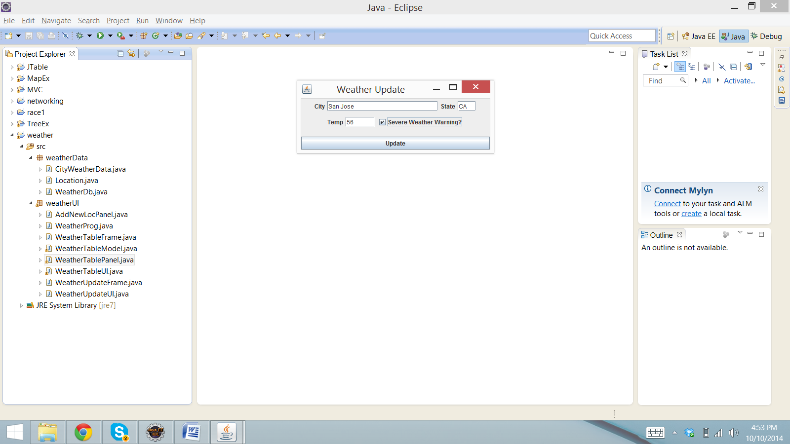

When the record is updated then the minimum and maximum temperature is updated accordingly.

(I) In starting, when the Location is entered for the first time, all the temperatures will be the same.

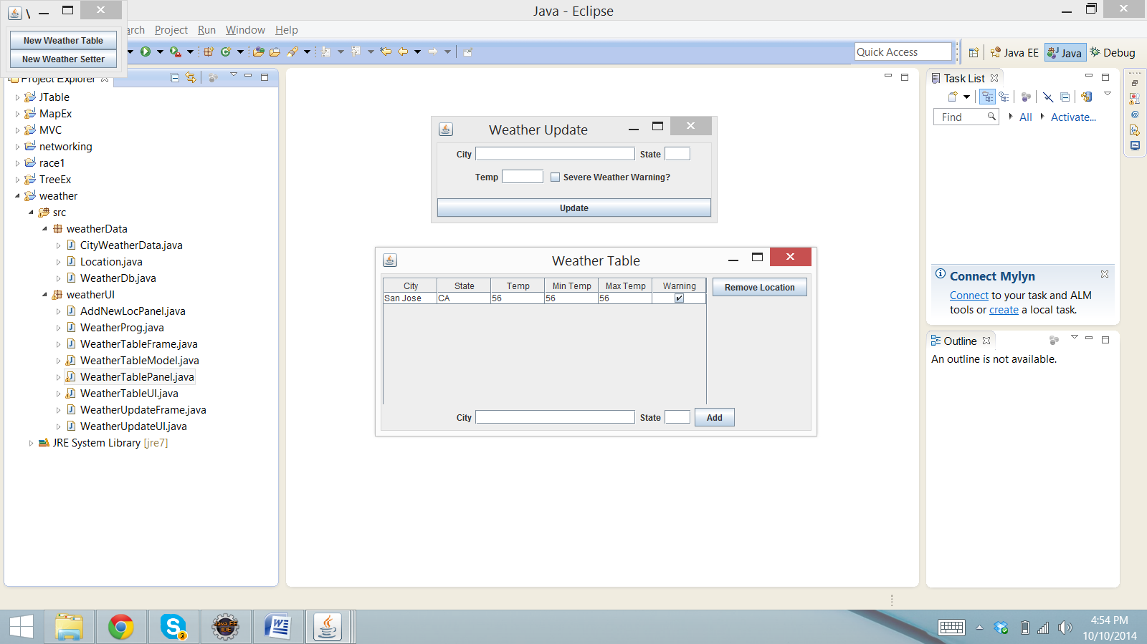

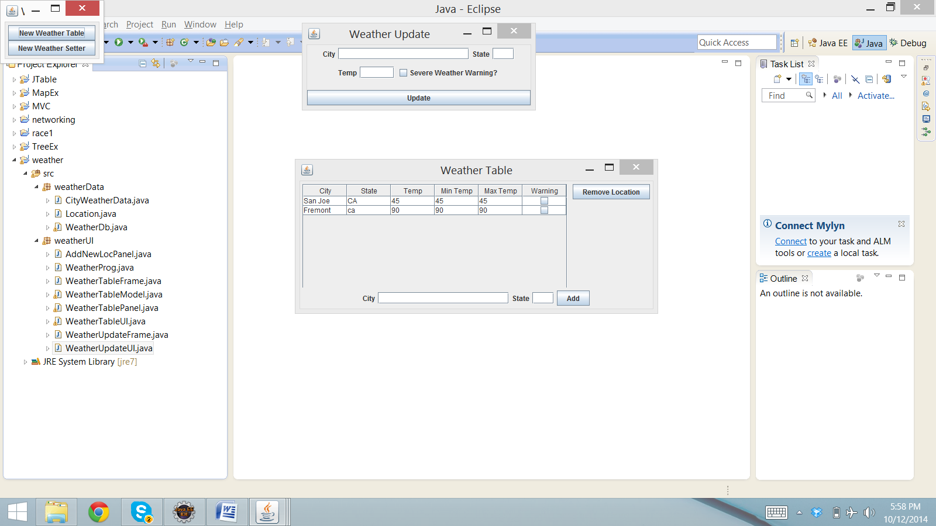

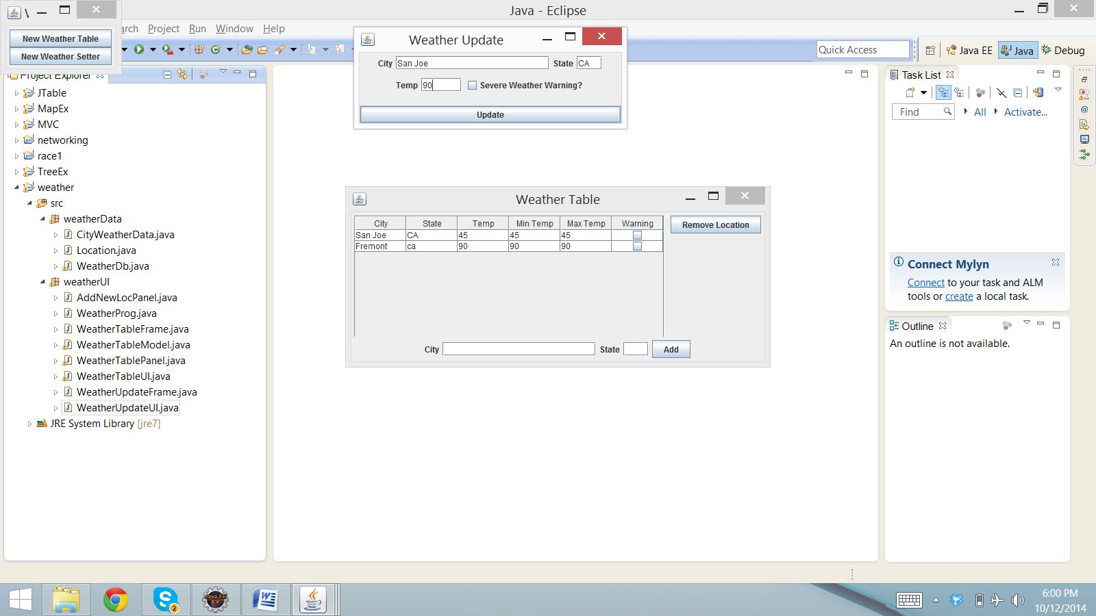

Changes in the maximum temperature:

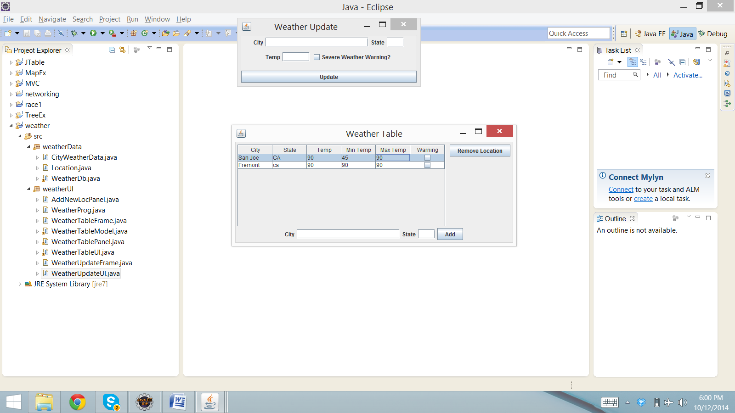

Changes in the minimum temperature:

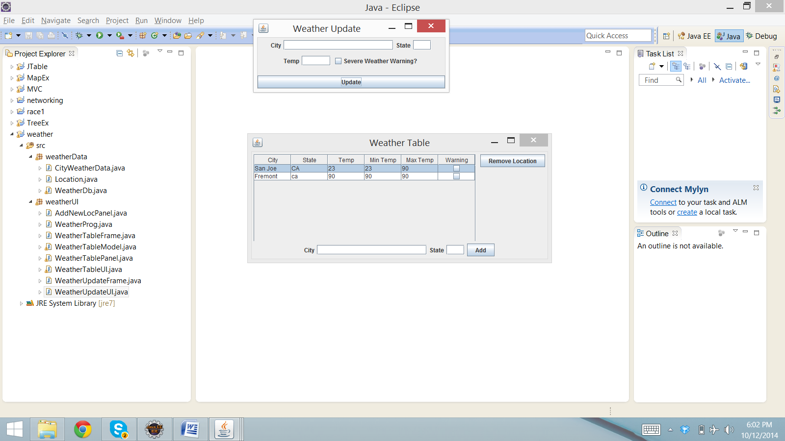

To remove a location, select a row which user wants to delete.

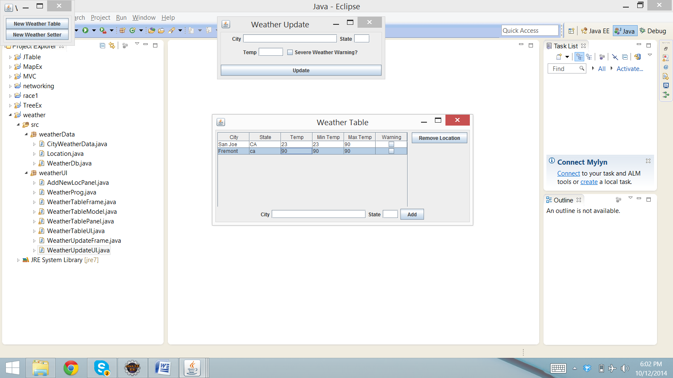

Row Removed:

