ANDROID
APPLICATION
DEVELOPMENT LAB

MCA II B (1)
Garima Chauhan 25/SCA/MCAN/041
Submitted to: Urvashi Sangwan Ma’am

INDEX

S.  No. | Name of the Program | Date
1 | Create an application that takes the name from a text box and shows hello message along with the name entered in text box, when the user clicks the OK button
2 | Create a screen that has input boxes for User Name, Password, Address, Gender (radio buttons for male and female), Age (numeric), Date of Birth (Date Picket), State (Spinner) and a Submit button. On clicking the submit button, print all the data below the Submit Button. Use 1.  Linear Layout 2. Relative Layout and 3.  Grid Layout or Table Layout.
3 | Develop an application that inserts some notifications into Notification area and whenever a notification is inserted, it should show a toast with details of the notification.
4 | Develop an application that uses a menu with 3 options for dialing a number, opening a website and to send an SMS. On selecting an option, the appropriate action should be invoked using intents.
5 | Create an application that uses a text file to store user names and passwords (tab separated fields and one record per line) When the user submits a login name and password through a screen, the details should be verified with the text file data and if they match, show a dialog saying that login is successful. Otherwise, show the dialog with Login Failed message.
6 | Create an activity to navigate to different activities through Intents- Implicit and Explicit
7 | Create an activity to create option Menu
8 | Create an activity using Button Controls- CheckBox,  RadioButtons, Radio Groups

Program 1: Create an application that takes the name from a text box and shows hello message along with the name entered in text box, when the user clicks the OK button.

activity_main.xml:
<?xml version="1.0" encoding="utf-8"?>
<LinearLayout xmlns:android="http://schemas.android.com/apk/res/android" android:layout_width="match_parent" android:layout_height="match_parent" android:orientation="vertical" android:padding="16dp">

<EditText android:id="@+id/et1" android:layout_width="match_parent" android:layout_height="wrap_content" android:hint="Enter text here" android:inputType="text" />

<Button android:id="@+id/btn1" android:layout_width="match_parent" android:layout_height="wrap_content" android:text="Click Me"
android:layout_marginTop="16dp" />

<TextView android:id="@+id/tv1" android:layout_width="wrap_content" android:layout_height="wrap_content" android:text="Hello Android!" android:textSize="16sp"
android:layout_marginTop="16dp" />

</LinearLayout>

MainActivity.java:
package com.example.enter_username;

import android.os.Bundle; import android.view.View; import android.widget.Button; import android.widget.EditText; import android.widget.TextView;
import android.widget.Toast;

import androidx.appcompat.app.AppCompatActivity;

public class MainActivity extends AppCompatActivity {

Button btn;
EditText et;
TextView tv;

@Override protected void onCreate(Bundle savedInstanceState) { super.onCreate(savedInstanceState); setContentView(R.layout.activity_main);

btn = findViewById(R.id.btn1); et = findViewById(R.id.et1); tv = findViewById(R.id.tv1);

btn.setOnClickListener(new View.OnClickListener() {
@Override public void onClick(View v) {

String text = et.getText().toString();

String message = "Hello " + text;

tv.setText(message);

Toast.makeText(MainActivity.this, message, Toast.LENGTH_SHORT).show(); } });
} }

Output:
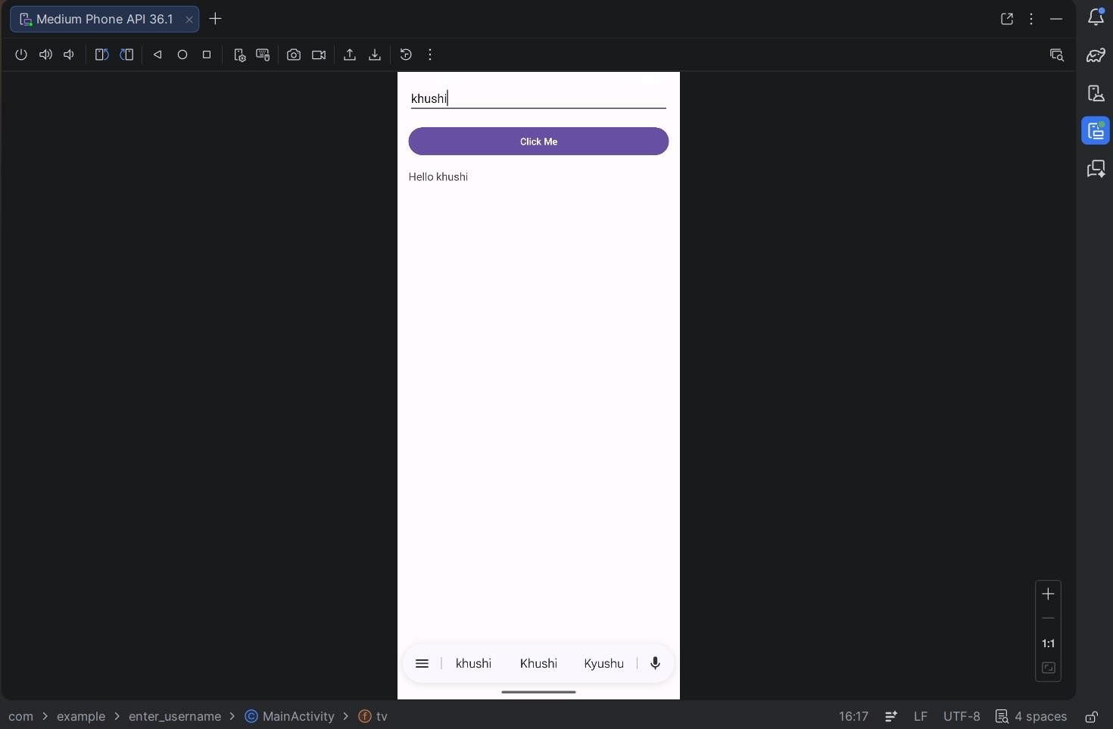

Program 2: Create a screen that has input boxes for User Name, Password, Address, Gender (radio buttons for male and female), Age (numeric), Date of Birth (Date Picket), State (Spinner) and a Submit button. On clicking the submit button, print all the data below the Submit Button. Use 1. Linear Layout 2. Relative Layout and 3. Grid Layout or Table Layout.
activity_main.xml:
<?xml version="1.0" encoding="utf-8"?<ScrollView xmlns:android="http://schemas.android.com/apk/res/android"
android:layout_width="match_parent" android:layout_height="match_parent">

<LinearLayout android:layout_width="match_parent" android:layout_height="wrap_content" android:orientation="vertical" android:padding="16dp">

<!-- TABLE LAYOUT --> <TableLayout android:layout_width="match_parent" android:layout_height="wrap_content">

<!-- Username -->
<TableRow>
<TextView android:text="Username:"/> <EditText android:id="@+id/etName" android:layout_width="match_parent" android:inputType="text"/>
</TableRow>

<!-- Password -->
<TableRow>
<TextView android:text="Password:"/>
<EditText android:id="@+id/etPassword" android:layout_width="match_parent" android:inputType="textPassword"/> </TableRow>

<!-- Address -->
<TableRow>
<TextView android:text="Address:"/> <EditText android:id="@+id/etAddress" android:layout_width="match_parent" android:inputType="textMultiLine"/>
</TableRow>

<!-- Gender -->
<TableRow>
<TextView android:text="Gender:"/>
<RadioGroup
android:id="@+id/radioGroup">

<RadioButton android:id="@+id/rbMale" android:text="Male"/>

<RadioButton android:id="@+id/rbFemale" android:text="Female"/>
</RadioGroup>
</TableRow>

<!-- Age -->
<TableRow>
<TextView android:text="Age:"/> <EditText android:id="@+id/etAge" android:layout_width="match_parent" android:inputType="number"/>
</TableRow>

<!-- DOB --> <TableRow> de<TextView android:text="DOB:"/>
<DatePicker android:id="@+id/datePicker" android:layout_width="wrap_content"/>
</TableRow>

<!-- State -->
<TableRow>
<TextView android:text="State:"/>
<Spinner android:id="@+id/spinnerState"/>
</TableRow>

</TableLayout>

<!-- SUBMIT BUTTON --> <Button android:id="@+id/btnSubmit" android:layout_width="match_parent" android:layout_height="wrap_content" android:text="Submit"
android:layout_marginTop="20dp"/>

<!-- OUTPUT --> <TextView android:id="@+id/tvResult" android:layout_width="match_parent" android:layout_height="wrap_content" android:layout_marginTop="20dp"
android:textSize="16sp"/>

</LinearLayout>

</ScrollView>

MainActivity.java:
package com.example.formapp;

import android.os.Bundle; import android.view.View;
import android.widget.*;

import androidx.appcompat.app.AppCompatActivity;

public class MainActivity extend AppCompatActivity {
EditText etName, etPassword, etAddress, etAge;
RadioGroup radioGroup;
Spinner spinner;
DatePicker datePicker;
Button btnSubmit;
TextView tvResult;

String[] states = {"Haryana", "Delhi", "Punjab", "UP", "Rajasthan"};

@Override

protected void onCreate(Bundle savedInstanceState) { super.onCreate(savedInstanceState); setContentView(R.layout.activity_main);

etName = findViewById(R.id.etName); etPassword = findViewById(R.id.etPassword); etAddress = findViewById(R.id.etAddress); etAge = findViewById(R.id.etAge); radioGroup = findViewById(R.id.radioGroup); spinner = findViewById(R.id.spinnerState); datePicker = findViewById(R.id.datePicker); btnSubmit = findViewById(R.id.btnSubmit); tvResult = findViewById(R.id.tvResult);

// Spinner setup
ArrayAdapter<String> adapter = new ArrayAdapter<>( this,
android.R.layout.simple_spinner_item, states
);
adapter.setDropDownViewResource(android.R.layout.simple_spinner_dropdown_item); spinner.setAdapter(adapter);

btnSubmit.setOnClickListener(new View.OnClickListener() {
@Override public void onClick(View v) {

String name = etName.getText().toString();
String pass = etPassword.getText().toString();
String address = etAddress.getText().toString(); String age = etAge.getText().toString();

int selectedId = radioGroup.getCheckedRadioButtonId();
RadioButton rb = findViewById(selectedId);
String gender = (rb != null) ? rb.getText().toString() : "Not Selected";

int day = datePicker.getDayOfMonth(); int month = datePicker.getMonth() + 1; int year = datePicker.getYear();

String dob = day + "/" + month + "/" + year;

String state = spinner.getSelectedItem().toString();

String result =
"Name: " + name + "\n" +

"Password: " + pass + "\n" +
"Address: " + address + "\n" +
"Gender: " + gender + "\n" +
"Age: " + age + "\n" +
"DOB: " + dob + "\n" +
"State: " + state;

tvResult.setText(result);
}
}); }
}
Output:
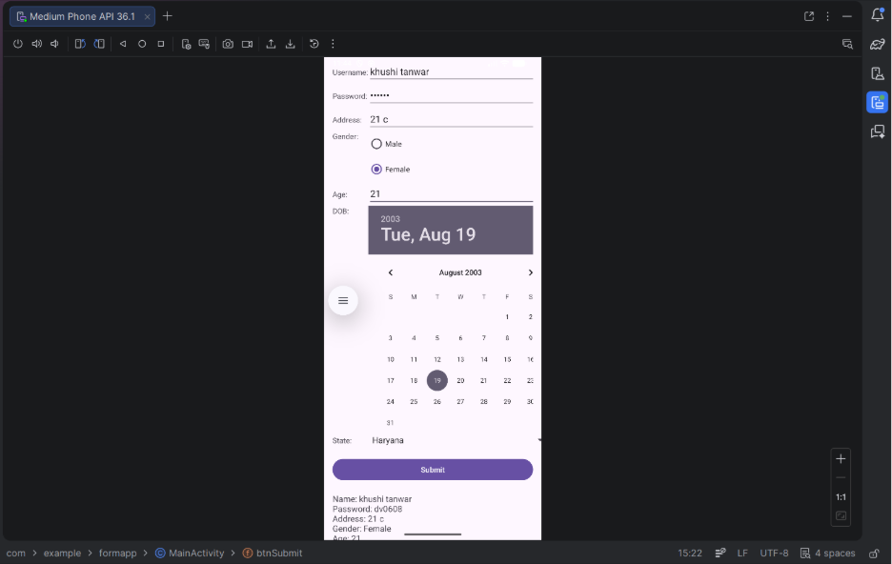

Program 3: Develop an application that inserts some notifications into Notification area and whenever a notification is inserted, it should show a toast with details of the notification. activity_main.xml:
<?xml version="1.0" encoding="utf-8"?>
<LinearLayout xmlns:android="http://schemas.android.com/apk/res/android" android:layout_width="match_parent" android:layout_height="match_parent" android:gravity="center" android:orientation="vertical" android:padding="20dp">

<TextView android:layout_width="wrap_content" android:layout_height="wrap_content" android:text="Notification App" android:textSize="22sp" android:textStyle="bold"
android:layout_marginBottom="30dp"/>

<Button android:id="@+id/btnNotify" android:layout_width="wrap_content" android:layout_height="wrap_content" android:text="Show Notification"/>

</LinearLayout>

MainActivity.java:
package com.example.notificationapp;

import android.app.NotificationChannel; import android.app.NotificationManager; import android.os.Build; import android.os.Bundle; import android.widget.Button;
import android.widget.Toast;

import androidx.appcompat.app.AppCompatActivity; import androidx.core.app.NotificationCompat;

public class MainActivity extends AppCompatActivity {

Button btnNotify;
String CHANNEL_ID = "my_channel";

@Override protected void onCreate(Bundle savedInstanceState) { super.onCreate(savedInstanceState); setContentView(R.layout.activity_main);

btnNotify = findViewById(R.id.btnNotify);

btnNotify.setOnClickListener(v -> {

String title = "Hello User";
String message = "This is your notification";

// Toast showing notification details
Toast.makeText(this,
"Notification: " + title + " - " + message,
Toast.LENGTH_LONG).show();

NotificationManager manager =
(NotificationManager) getSystemService(NOTIFICATION_SERVICE);

// For Android 8+ if (Build.VERSION.SDK_INT >= Build.VERSION_CODES.O) {
NotificationChannel channel = new
NotificationChannel( CHANNEL_ID,
"My Channel",
NotificationManager.IMPORTANCE_DEFAULT);

manager.createNotificationChannel(channel); }

NotificationCompat.Builder builder = new NotificationCompat.Builder(this, CHANNEL_ID) .setContentTitle(title)
.setContentText(message)
.setSmallIcon(android.R.drawable.ic_dialog_info) .setAutoCancel(true);

manager.notify(1, builder.build());
}); }
}

Output:
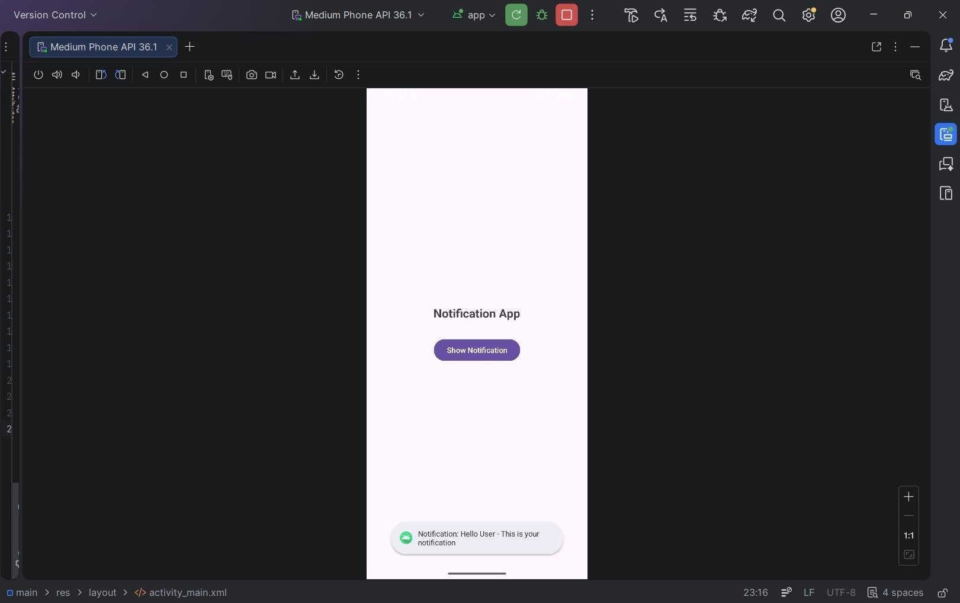

Program 4: Develop an application that uses a menu with 3 options for dialing a number, opening a website and to send an SMS. On selecting an option, the appropriate action should be invoked using intents. activity_main.xml:
<?xml version="1.0" encoding="utf-8"?>
<LinearLayout xmlns:android="http://schemas.android.com/apk/res/android" android:layout_width="match_parent" android:layout_height="match_parent" android:gravity="center" android:orientation="vertical">

<TextView android:layout_width="wrap_content" android:layout_height="wrap_content" android:text="Menu Intent App" android:textSize="22sp"
android:textStyle="bold"/>

</LinearLayout>
menu_main.xml:
<?xml version="1.0" encoding="utf-8"?>
<menu xmlns:android="http://schemas.android.com/apk/res/android">

<item android:id="@+id/menu_call" android:title="Dial Number"/>

<item android:id="@+id/menu_web"
android:title="Open Website"/>

<item android:id="@+id/menu_sms" android:title="Send SMS"/>

</menu>

MainActivity.java:
package com.example.intentmenu;

import android.content.Intent; import android.net.Uri; import android.os.Bundle;

import android.view.Menu;
import android.view.MenuItem;

import androidx.appcompat.app.AppCompatActivity;

public class MainActivity extends AppCompatActivity {

@Override protected void onCreate(Bundle savedInstanceState) { super.onCreate(savedInstanceState); setContentView(R.layout.activity_main);
}

// Create menu @Override public boolean onCreateOptionsMenu(Menu menu) {
getMenuInflater().inflate(R.menu.menu_main, menu); return true;
}

// Handle menu clicks
@Override public boolean onOptionsItemSelected(MenuItem item) {

int id = item.getItemId();

// Dial Number
if (id == R.id.menu_call) {
Intent intent = new Intent(Intent.ACTION_DIAL); intent.setData(Uri.parse("tel:9876543210")); startActivity(intent); return true;
}

// Open Website if (id == R.id.menu_web) {
Intent intent = new Intent(Intent.ACTION_VIEW); intent.setData(Uri.parse("https://www.google.com")); startActivity(intent); return true;
}

// Send SMS
if (id == R.id.menu_sms) {
Intent intent = new Intent(Intent.ACTION_VIEW); intent.setData(Uri.parse("sms:9876543210")); intent.putExtra("sms_body", "Hello from my app!");
startActivity(intent); return true;
}

return super.onOptionsItemSelected(item);
} }

Output:
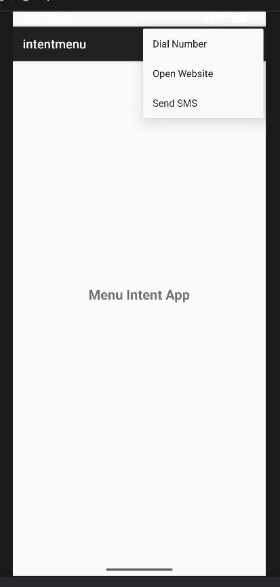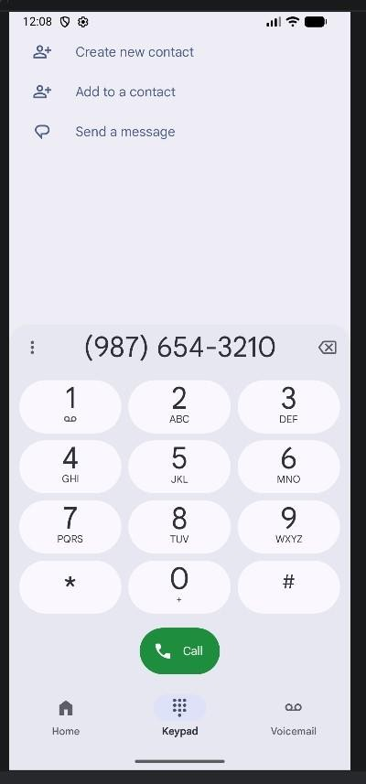
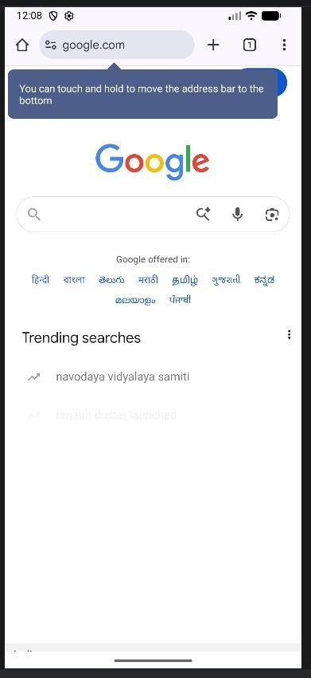

Program 5: Create an application that uses a text file to store user names and passwords (tab separated fields and one record per line) When the user submits a login name and password through a screen, the details should be verified with the text file data and if they match, show a dialog saying that login is successful. Otherwise, show the dialog with Login Failed message.

activity_main.xml:
<?xml version="1.0" encoding="utf-8"?>
<LinearLayout xmlns:android="http://schemas.android.com/apk/res/android" android:layout_width="match_parent" android:layout_height="match_parent" android:gravity="center" android:orientation="vertical" android:padding="20dp">
<TextView android:layout_width="wrap_content" android:layout_height="wrap_content" android:text="Login System" android:textSize="22sp" android:textStyle="bold"
android:layout_marginBottom="30dp"/>

<EditText android:id="@+id/etUser" android:layout_width="match_parent" android:layout_height="wrap_content"
android:hint="Enter Username"/>

<EditText android:id="@+id/etPass" android:layout_width="match_parent" android:layout_height="wrap_content" android:hint="Enter Password" android:inputType="textPassword"
android:layout_marginTop="10dp"/>

<Button android:id="@+id/btnLogin" android:layout_width="match_parent" android:layout_height="wrap_content" android:text="Login"
android:layout_marginTop="20dp"/>

</LinearLayout>
MainActivity.java:
package com.example.filelogin;

import android.app.AlertDialog; import android.os.Bundle; import android.widget.Button;
import android.widget.EditText;

import androidx.appcompat.app.AppCompatActivity;

import java.io.BufferedReader;
import java.io.InputStreamReader;

public class MainActivity extends AppCompatActivity {

EditText etUser, etPass;
Button btnLogin;

@Override protected void onCreate(Bundle savedInstanceState) { super.onCreate(savedInstanceState); setContentView(R.layout.activity_main);

etUser = findViewById(R.id.etUser); etPass = findViewById(R.id.etPass); btnLogin = findViewById(R.id.btnLogin);

btnLogin.setOnClickListener(v -> {

String inputUser = etUser.getText().toString();
String inputPass = etPass.getText().toString();

boolean isValid = false;

try {
BufferedReader reader = new BufferedReader( new InputStreamReader(getAssets().open("users.txt")) );

String line;

while ((line = reader.readLine()) != null) {

String[] parts = line.split("\t");

if (parts.length == 2) {
String fileUser = parts[0];
String filePass = parts[1];

if (inputUser.equals(fileUser) && inputPass.equals(filePass)) { isValid = true; break;
}
}
}

reader.close();

} catch (Exception e) {
e.printStackTrace(); }
if (isValid) { showDialog("Login Successful"); } else { showDialog("Login Failed");
}

});
}

private void showDialog(String message) { new AlertDialog.Builder(this)
.setTitle("Result")
.setMessage(message)
.setPositiveButton("OK", null)
.show();
}
}

Users.txt:
dev 123 shweta 456 raghav 789 krishna 1011 khushi 1022

Output:
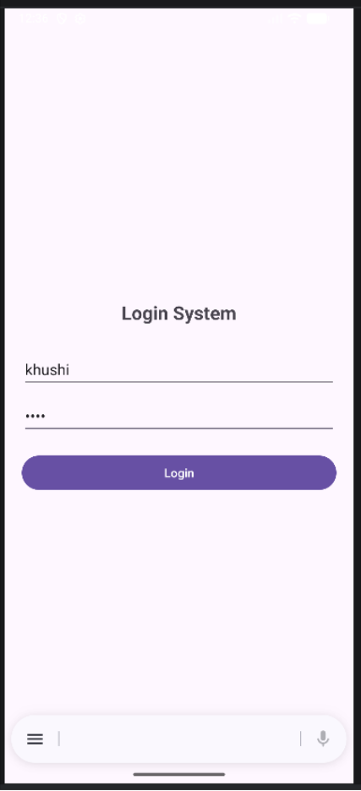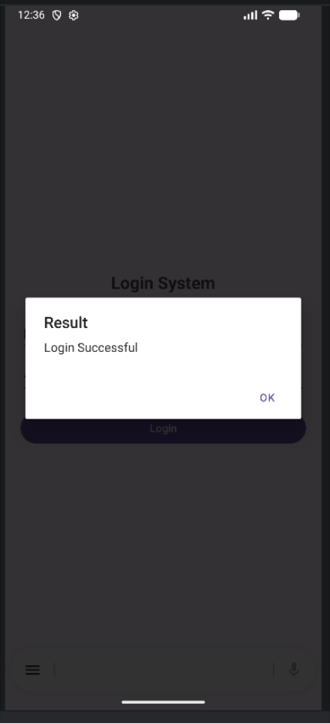

Program 6: Create an activity to navigate to different activities through Intents- Implicit and Explicit
activity_main.xml:
<?xml version="1.0" encoding="utf-8"?>
<LinearLayout xmlns:android="http://schemas.android.com/apk/res/android" android:layout_width="match_parent" android:layout_height="match_parent" android:gravity="center" android:orientation="vertical" android:padding="20dp">

<TextView android:layout_width="wrap_content" android:layout_height="wrap_content" android:text="Intent Demo" android:textSize="22sp" android:textStyle="bold"
android:layout_marginBottom="30dp"/>

<Button android:id="@+id/btnExplicit" android:layout_width="match_parent" android:layout_height="wrap_content" android:text="Go to Second Activity" android:layout_marginBottom="15dp"/>

<Button android:id="@+id/btnWebsite" android:layout_width="match_parent" android:layout_height="wrap_content" android:text="Open Website"
android:layout_marginBottom="15dp"/>

<Button android:id="@+id/btnDial" android:layout_width="match_parent" android:layout_height="wrap_content" android:text="Dial Number"/>

</LinearLayout>

MainActivity.java:
package com.example.intentdemo;

import com.example.intentdemo.SecondActivity; import android.content.Intent; import android.net.Uri; import android.os.Bundle; import android.widget.Button;

import androidx.appcompat.app.AppCompatActivity;

public class MainActivity extends AppCompatActivity {

Button btnExplicit, btnWebsite, btnDial;

@Override protected void onCreate(Bundle savedInstanceState) { super.onCreate(savedInstanceState); setContentView(R.layout.activity_main);

btnExplicit = findViewById(R.id.btnExplicit); btnWebsite = findViewById(R.id.btnWebsite); btnDial = findViewById(R.id.btnDial);

// 🔹 EXPLICIT INTENT
btnExplicit.setOnClickListener(v -> {
Intent intent = new Intent(MainActivity.this, SecondActivity.class); startActivity(intent);
});

// 🔹 IMPLICIT INTENT - OPEN WEBSITE btnWebsite.setOnClickListener(v -> {
Intent intent = new Intent(Intent.ACTION_VIEW); intent.setData(Uri.parse("https://www.google.com")); startActivity(intent);
});

// 🔹 IMPLICIT INTENT - DIAL btnDial.setOnClickListener(v -> {
Intent intent = new Intent(Intent.ACTION_DIAL); intent.setData(Uri.parse("tel:9876543210")); startActivity(intent);
}); }
}

activity_second.xml:
<?xml version="1.0" encoding="utf-8"?>
<LinearLayout xmlns:android="http://schemas.android.com/apk/res/android" android:layout_width="match_parent" android:layout_height="match_parent" android:gravity="center" android:orientation="vertical">

<TextView android:layout_width="wrap_content" android:layout_height="wrap_content" android:text="This is Second Activity" android:textSize="20sp"
android:textStyle="bold"/>

</LinearLayout>

SecondActivity.java:
package com.example.intentdemo;

import android.os.Bundle;
import androidx.appcompat.app.AppCompatActivity;

public class SecondActivity extends AppCompatActivity {

@Override protected void onCreate(Bundle savedInstanceState) { super.onCreate(savedInstanceState); setContentView(R.layout.activity_second);
}
}

Output:
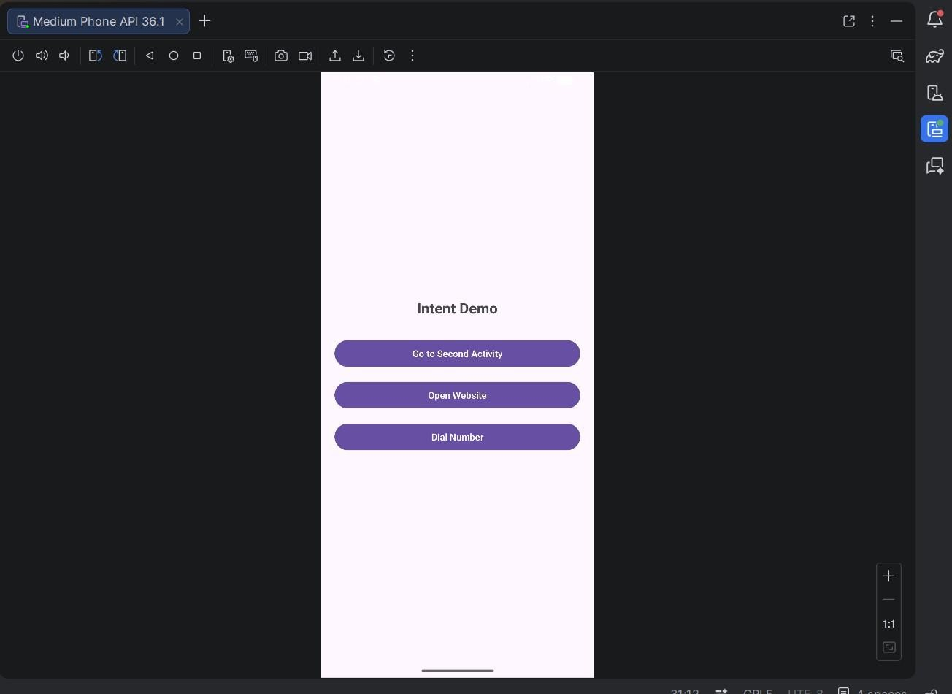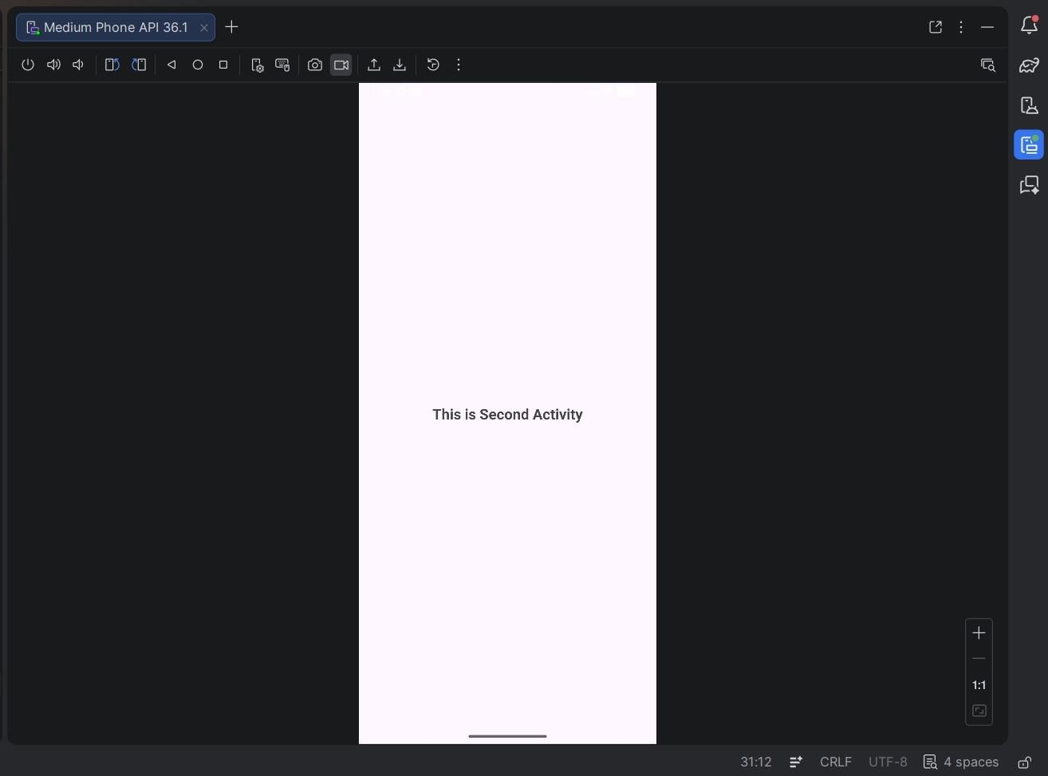

Program 7: Create an activity to create option Menu. activity_main.xml:
<?xml version="1.0" encoding="utf-8"?>
<RelativeLayout xmlns:android="http://schemas.android.com/apk/res/android" xmlns:tools="http://schemas.android.com/tools" android:layout_width="match_parent"
android:layout_height="match_parent" tools:context=".MainActivity">

<TextView android:id="@+id/textView" android:layout_width="wrap_content" android:layout_height="wrap_content" android:text="Option Menu" android:textSize="22sp" android:textStyle="bold"
android:layout_centerInParent="true" />

</RelativeLayout>

MainActivity.java:
package com.example.optionmenu;

import android.os.Bundle; import android.view.Menu; import android.view.MenuItem; import android.widget.Toast;
import androidx.appcompat.app.AppCompatActivity;

public class MainActivity extends AppCompatActivity {

@Override protected void onCreate(Bundle savedInstanceState) { super.onCreate(savedInstanceState); setContentView(R.layout.activity_main);
}

// Step 1: Create Option Menu
@Override public boolean onCreateOptionsMenu(Menu menu) {
menu.add(0, 1, 0, "Settings"); menu.add(0, 2, 0, "Profile");
menu.add(0, 3, 0, "Logout"); return true;
}

// Step 2: Handle Menu Clicks
@Override public boolean onOptionsItemSelected(MenuItem item) {

switch (item.getItemId()) { case 1:
Toast.makeText(this, "Settings Clicked", Toast.LENGTH_SHORT).show(); return true;

case 2:
Toast.makeText(this, "Profile Clicked", Toast.LENGTH_SHORT).show(); return true;

case 3:
Toast.makeText(this, "Logout Clicked", Toast.LENGTH_SHORT).show(); return true;

default:
return super.onOptionsItemSelected(item);
}
} }

Output:
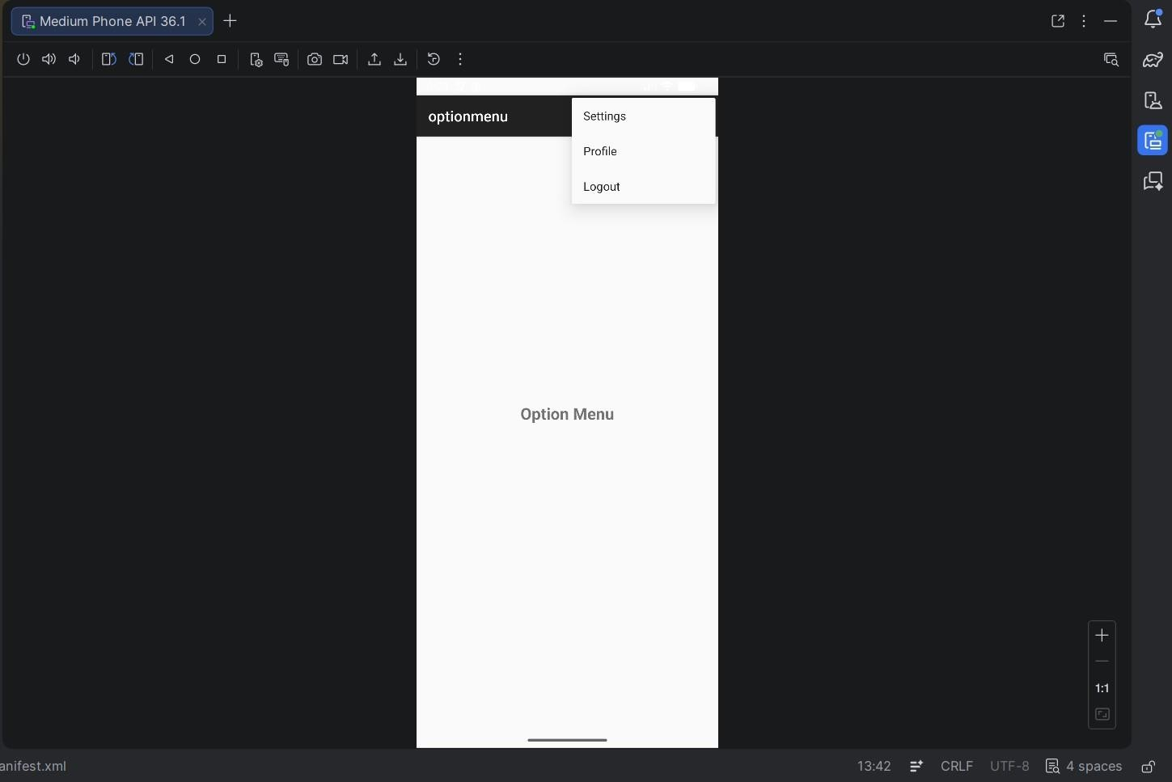

Program 8: Create an activity using Button Controls- CheckBox, RadioButtons, Radio Groups

activity_main.xml:
<?xml version="1.0" encoding="utf-8"?>
<LinearLayout xmlns:android="http://schemas.android.com/apk/res/android" android:layout_width="match_parent" android:layout_height="match_parent" android:orientation="vertical"
android:padding="20dp">

<!-- CheckBox -->
<CheckBox
android:id="@+id/checkBox" android:layout_width="wrap_content" android:layout_height="wrap_content"
android:text="Accept Terms and Conditions" />

<!-- RadioGroup --> <RadioGroup android:id="@+id/radioGroup" android:layout_width="wrap_content" android:layout_height="wrap_content" android:layout_marginTop="20dp">

<RadioButton android:id="@+id/radioMale" android:layout_width="wrap_content" android:layout_height="wrap_content" android:text="Male" />

<RadioButton android:id="@+id/radioFemale" android:layout_width="wrap_content" android:layout_height="wrap_content" android:text="Female" />

</RadioGroup>

<!-- Button --> <Button android:id="@+id/btnSubmit" android:layout_width="wrap_content" android:layout_height="wrap_content" android:text="Submit"
android:layout_marginTop="20dp"/>

</LinearLayout>

MainActivity.java:
package com.example.buttoncontrols;

import android.os.Bundle; import android.view.View;
import android.widget.Button; import android.widget.CheckBox; import android.widget.RadioButton; import
android.widget.RadioGroup; import android.widget.Toast;
import androidx.appcompat.app.AppCompatActivity;

public class MainActivity extends AppCompatActivity {

CheckBox checkBox;
RadioGroup radioGroup;
Button btnSubmit;

@Override protected void onCreate(Bundle savedInstanceState) { super.onCreate(savedInstanceState); setContentView(R.layout.activity_main);

checkBox = findViewById(R.id.checkBox); radioGroup = findViewById(R.id.radioGroup); btnSubmit = findViewById(R.id.btnSubmit);

btnSubmit.setOnClickListener(new View.OnClickListener() {
@Override public void onClick(View v) {

// CheckBox state boolean isChecked = checkBox.isChecked();

// RadioButton selected int selectedId = radioGroup.getCheckedRadioButtonId();

if (selectedId == -1) {
Toast.makeText(MainActivity.this, "Select Gender",
Toast.LENGTH_SHORT).show(); return;
}

RadioButton selectedRadio = findViewById(selectedId); String gender = selectedRadio.getText().toString();

// Show result
String message = "Accepted: " + isChecked + "\nGender: " + gender;

Toast.makeText(MainActivity.this, message, Toast.LENGTH_LONG).show(); }
}); }
}

Output:
