Supplementary 1: Supervised Land Use Land Cover Classification
Purpose: To create a random forest classifier to identify active aquaculture ponds, dry aquaculture ponds, and other land uses on a Landsat Satellite imagery. We use field observations and high-resolution Sentinel 2 imagery for reference data. This supplementary includes the code used, and the accuracy results of the supervised classification.
Code: (Google Earth Engine) - 1_LULCClassification_Code.txt

Landsat 8
Hyperparameter tuning for Random Forest Classifier
Selected 65 trees

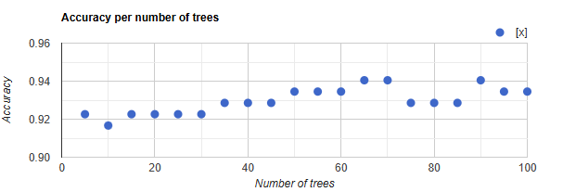

Confusion matrix:
[68,1,0],[5,49,1],[3,1,40]]
0: [68,1,0]
1: [5,49,1]
2: [3,1,40]

Overall Accuracy:
0.9345238095238095

Producers Accuracy:
0: [0.9855072463768116]
1: [0.8909090909090909]
2: [0.9090909090909091]

Consumers Accuracy:
0: 0.8947368421052632
1: 0.9607843137254902
2: 0.975609756097561

Kappa:
0.8994066735615917

Landsat 5
Hyperparameter tuning for Random Forest Classifier
Selected 40 trees

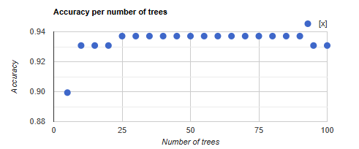

Confusion matrix:
[[72,0,0],[4,29,5],[0,1,48]]
0: [72,0,0]
1: [4,29,5]
2: [0,1,48]

Overall Accuracy:
0.9371069182389937

Producers Accuracy:
[[1],[0.7631578947368421],[0.9795918367346939]]
0: [1]
1: [0.7631578947368421]
2: [0.9795918367346939]

Consumers Accuracy:
0: 0.9473684210526315
1: 0.9666666666666667
2: 0.9056603773584906

Kappa:
0.9010701841712295

Comparing accuracy outputs with alternate pixel reducers
The accuracy results with the 30th percentile (listed in the previous section in more detail) are the best among the various reducers tested, closely followed by the geometric median. For the CoSal-SA model, we have employed the geomedian.
We preferred geomedian reducer over percentile for three reasons (Roberts et al. 2017): (1) it enables stacking multiple images of varying quality to a high-quality pixel composite while reducing spatial noise, (2) in contrast to a median reducer, a geomedian also helps maintain spectral relationship between bands and consistency across scene boundaries, and (3) it is a recommended method to maintain spectral relationships between bands when further analysis on the composite image is required, such as applying a machine learning algorithm. We have also adopted geomedian reducer to qualify using the machine-learning based model developed by Perikamana et al. (2025) to harmonise Landsat 5 TM images with Landsat 8 OLI.
Accuracy measure | Percentile (30) | Geometric median (adopted) | Median/Percentile (50) | Percentile (70)
Overall accuracy | 0.96 | 0.94 | 0.92 | 0.90
Kappa | 0.93 | 0.91 | 0.88 | 0.84
Producers accuracy | 0: [0.95]  1: [0.95]  2: [0.98] | 0: [0.95]  1: [0.93]  2: [0.94] | 0: [0.97]  1: [0.85]  2: [0.90] | 0: [0.95]  1: [0.80]  2: [0.90]
Consumers accuracy | 0: [0.96]  1: [0.91]  2: [1] | 0: [0.95]  1: [0.93]  2: [0.94] | 0: [0.92]  1: [0.85]  2: [0.98] | 0: [0.91]  1: [0.86]  2: [0.91]

Supplementary 2: Surface Reflectance measures of 28 Parameters and Indices
- 6 Surface Reflectance bands – Blue, Green, Red, NIR, SWIR1, SWIR2
- 11 Normalized Band Combinations
# Blue and Red: NBR <- (Blue-Red)/(Blue+Red)
# Blue and green: NBG <- (Blue-Green)/(Blue+Green)
# Blue and NIR: NBNIR <- (Blue-NIR)/(Blue+NIR)
# Blue and SWIR1: NBSWIR1 <- (Blue-SWIR1)/(Blue+SWIR1)
# Blue and SWIR2: NBSWIR2 <- (Blue-SWIR2)/(Blue+SWIR2)
# Red and SWIR1: NRSWIR1 <- (Red-SWIR1)/(Red+SWIR1)
# Red and SWIR2: NRSWIR2 <- (Red-SWIR2)/(Red+SWIR2)
# Green and SWIR1: NGSWIR1 <- (Green-SWIR1)/(Green+SWIR1)
# Green and SWIR2: NGSWIR2 <- (Green-SWIR2)/(Green+SWIR2)
# NIR and SWIR1: NNIRSWIR1 <- (NIR-SWIR1)/(NIR+SWIR1)
# NIR and SWIR2: NNIRSWIR2 <- (NIR-SWIR2)/(NIR+SWIR2)

- 11 Widely used salinity and other indices
# Salinity Index 1 = sqrt(green^2+red^2)
SI1 <- sqrt((Green)^2 + (Red)^2)
Sources: (Douaoui, Nicolas, and Walter 2006; Nguyen et al. 2020)

# Salinity Index 2 = sqrt(green x red)
SI2 <- sqrt(Green * Red)
Sources: (Douaoui, Nicolas, and Walter 2006; Nguyen et al. 2020)

# Salinity Index 3 = sqrt(blue x red)
SI3 <- sqrt(Blue * Red)
Source: (Khan et al. 2001; Nguyen et al. 2020)

# Salinity index 4 = red x NIR / green
SI4 <- (Red * NIR / Green)
Source: (Abbas and Khan 2007; Abbas et al. 2013; Nguyen et al. 2020)

# Salinity index 5 = blue/red
SI5 <- (Blue / Red)
Source: (Abbas and Khan 2007; Abbas et al. 2013; Nguyen et al. 2020)

# Soil Adjusted Vegetation Index (SAVI) = ((1.5)x NIR) - (red/0.5) + NIR + Red
SAVI <- (1.5 * NIR) - (0.5 * Red) + NIR + Red
Source: (Alhammadi and Glenn 2008; Nguyen et al. 2020)

# Vegetation Soil Salinity Index (VSSI) = (2 x green) - 5 x (red + NIR)
VSSI <- (2 * Green) - 5 * (Red + NIR)
Source: (Dehni and Lounis 2012; Nguyen et al. 2020)

# Normalised Difference Salinity Index 1 (NDSI)
NDSI1 <- (SWIR1-SWIR2)/(SWIR1+SWIR2)
Source: (Al-Khaier et al. 2003; Henrich et al. 2012)

# Normalised Difference Salinity Index 2 (NDSI2)
NDSI2 <- (Red-NIR)/(Red+NIR)
Source: (Khan et al. 2001; Nguyen et al. 2020)

# Normalised Difference Vegetation Index (NDVI) or Green-Red Vegetation Index (GRVI)
NDVI <- (Red-Green)/(Red+Green)
Source: (Li et al. 2023; Wang et al. 2007)

# NDWI
NDWI <- (Green-NIR)/(Green+NIR)
Source: (Yousefian et al. 2019; McFEETERS 1996)

References
Abbas, Akhtar, and Shahbaz Khan. 2007. “Using Remote Sensing Techniques for Appraisal of Irrigated Soil Salinity,” 2632–38.
Abbas, Akhtar, Shahbaz Khan, Nisar Hussain, Munir A. Hanjra, and Saud Akbar. 2013. “Characterizing Soil Salinity in Irrigated Agriculture Using a Remote Sensing Approach.” Physics and Chemistry of the Earth (2002) 55–57 (January): 43–52.
Alhammadi, M. S., and E. P. Glenn. 2008. “Detecting Date Palm Trees Health and Vegetation Greenness Change on the Eastern Coast of the United Arab Emirates Using SAVI.” International Journal of Remote Sensing 29 (6): 1745–65.
Al-Khaier, Andrew D. Richardson, Shane P. Duigan, and Graeme P. Berlyn. 2003. “Index: Normalized Difference Salinity Index.” Index Database. 2003. https://www.indexdatabase.de/db/i-single.php?id=57.
Dehni, Abdellatif, and Mourad Lounis. 2012. “Remote Sensing Techniques for Salt Affected Soil Mapping: Application to the Oran Region of Algeria.” Procedia Engineering 33: 188–98.
Douaoui, Abd El Kader, Hervé Nicolas, and Christian Walter. 2006. “Detecting Salinity Hazards within a Semiarid Context by Means of Combining Soil and Remote-Sensing Data.” Geoderma 134 (1–2): 217–30.
Henrich, Verena, Gunther Krauss, Christian Götze, and Christopher Sandow. 2012. “IDB - Index DataBase.” Index DataBase. 2012. https://www.indexdatabase.de/.
Khan, N., V. V. Rastoskuev, E. Shalina, and Yohei Sato. 2001. “Mapping Salt-Affected Soils Using Remote Sensing Indicators-A Simple Approach with the Use of GIS IDRISI -.” https://acrs-aars.org/proceeding/ACRS2001/Papers/AGS-05.pdf.
Li, Wangchao, Rui Chen, Dujuan Ma, Changjing Wang, Yajie Yang, Cong Wang, Huai Chen, and Gaofei Yin. 2023. “Tracking Autumn Photosynthetic Phenology on Tibetan Plateau Grassland with the Green–Red Vegetation Index.” Agricultural and Forest Meteorology 339 (109573): 109573.
McFEETERS, S. K. 1996. “The Use of the Normalized Difference Water Index (NDWI) in the Delineation of Open Water Features.” International Journal of Remote Sensing 17 (7): 1425–32.
Nguyen, Kim-Anh, Yuei-An Liou, Ha-Phuong Tran, Phi-Phung Hoang, and Thanh-Hung Nguyen. 2020. “Soil Salinity Assessment by Using Near-Infrared Channel and Vegetation Soil Salinity Index Derived from Landsat 8 OLI Data: A Case Study in the Tra Vinh Province, Mekong Delta, Vietnam.” Progress in Earth and Planetary Science 7 (1): 1–16.
Perikamana, K.K., Parath, N., & Balakrishnan, K. 2025. “An Improved Method for Harmonizing Landsat 5-TM and Landsat 8-OLI Data.” (Manuscript in Preparation).
Richards, John A., and Jia Xiuping. 2005. Remote Sensing Digital Image Analysis: An Introduction. PDF. 4th ed. Berlin, Germany: Springer.
Roy, D. P., V. Kovalskyy, H. K. Zhang, E. F. Vermote, L. Yan, S. S. Kumar, and A. Egorov. 2016. “Characterization of Landsat-7 to Landsat-8 Reflective Wavelength and Normalized Difference Vegetation Index Continuity.” Remote Sensing of Environment 185 (Iss 1): 57–70.
Shang, Rong, and Zhe Zhu. 2019. “Harmonizing Landsat 8 and Sentinel-2: A Time-Series-Based Reflectance Adjustment Approach.” Remote Sensing of Environment 235 (111439): 111439.
Suharyadi, R., Deha Agus Umarhadi, Disyacitta Awanda, and Wirastuti Widyatmanti. 2022. “Exploring Built-up Indices and Machine Learning Regressions for Multi-Temporal Building Density Monitoring Based on Landsat Series.” Sensors (Basel, Switzerland) 22 (13): 4716.
Wang, Fu-Min, Jing-Feng Huang, Yan-Lin Tang, and Xiu-Zhen Wang. 2007. “New Vegetation Index and Its Application in Estimating Leaf Area Index of Rice.” Rice Science 14 (3): 195–203.
Yousefian, F., M. Sahebi, M. Shokri, and M. Moradi. 2019. “A Novel Water Index (Swi) for Salty Water from Landsat 8 Oli/TIRs.” ISPRS - International Archives of the Photogrammetry Remote Sensing and Spatial Information Sciences XLII-4/W18 (October): 1097–1105.

Correlation matrix

Regression model fit results with EC

Table 1: Regression coefficients of univariate relationships between EC and various parameters starting with the highest explanatory powers
Band/Index | Fit | β₀ | SE (β₀) | β₁ | SE(β₁) | β2 | SE (β2) | R2 | Adj R2 | AIC | BIC | RMSE
NDWI | Quadratic | 0.277*** | (0.038) | 2.275*** | (0.347) | 1.342*** | (0.347) | 0.419 | 0.405 | 65.0 | 74.6 | 0.34
NDSI2 | Quadratic | 0.277*** | (0.040) | 2.010*** | (0.361) | 1.477*** | (0.361) | 0.374 | 0.359 | 71.2 | 80.9 | 0.35
NRSWIR1 | Quadratic | 0.277*** | (0.041) | 2.162*** | (0.373) | 0.894** | (0.373) | 0.329 | 0.312 | 76.9 | 86.6 | 0.37
NDWI | Linear | 1.641*** | (0.229) | 3.333*** | (0.551) |  |  | 0.311 | 0.303 | 77.2 | 84.4 | 0.37
NBNIR | Quadratic | 0.277*** | (0.042) | 1.921*** | (0.379) | 1.206*** | (0.379) | 0.309 | 0.292 | 79.4 | 89.0 | 0.37
NIR | Quadratic | 0.277*** | (0.042) | -2.051*** | (0.379) | 0.954** | (0.379) | 0.308 | 0.290 | 79.6 | 89.2 | 0.37
NRSWIR1 | Linear | 1.909*** | (0.293) | 3.977*** | (0.707) |  |  | 0.281 | 0.272 | 80.7 | 87.9 | 0.38
NIR | Linear | 2.202*** | (0.370) | -8.908*** | (1.701) |  |  | 0.253 | 0.244 | 83.9 | 91.1 | 0.39
NRSWIR1 | Log-Linear | 10.873*** | (0.802) | 9.884*** | (1.934) |  |  | 0.244 | 0.235 | 1379.4 | 1386.7 | 1.04
NDSI2 | Linear | 1.091*** | (0.165) | 2.083*** | (0.408) |  |  | 0.243 | 0.234 | 85.0 | 92.2 | 0.39
SAVI | Quadratic | 0.277*** | (0.044) | -1.853*** | (0.399) | 0.691* | (0.399) | 0.235 | 0.216 | 87.8 | 97.5 | 0.39
NDWI | Log-Linear | 9.905*** | (0.649) | 7.548*** | (1.560) |  |  | 0.224 | 0.215 | 1381.5 | 1388.8 | 1.05
NBNIR | Linear | 1.886*** | (0.338) | 2.698*** | (0.561) |  |  | 0.222 | 0.212 | 87.3 | 94.5 | 0.39
SAVI | Linear | 2.155*** | (0.411) | -3.194*** | (0.696) |  |  | 0.207 | 0.197 | 88.9 | 96.2 | 0.40
NBSWIR1 | Quadratic | 0.277*** | (0.045) | 1.764*** | (0.406) | 0.554 | (0.406) | 0.206 | 0.186 | 91.0 | 100.7 | 0.40
NGSWIR2 | Quadratic | 0.277*** | (0.045) | 0.550 | (0.410) | -1.705*** | (0.410) | 0.193 | 0.173 | 92.3 | 102.0 | 0.40
NBSWIR1 | Linear | 2.790*** | (0.584) | 4.106*** | (0.951) |  |  | 0.187 | 0.177 | 90.9 | 98.1 | 0.40
NRSWIR2 | Quadratic | 0.277*** | (0.045) | 1.359*** | (0.412) | -1.110*** | (0.412) | 0.185 | 0.165 | 93.1 | 102.8 | 0.40
NIR | Log-Linear | 11.090*** | (1.038) | -19.769*** | (4.769) |  |  | 0.175 | 0.165 | 1386.6 | 1393.9 | 1.08
NBSWIR1 | Log-Linear | 13.292*** | (1.569) | 10.578*** | (2.556) |  |  | 0.175 | 0.164 | 1386.7 | 1393.9 | 1.09

Supplementary 3: LASSO Regression Results
LASSO regressions are regressions that penalize adding more variables into the model and decrease coefficient values of variables that contribute less to the model. Two LASSO penalized regressions were run in R with the package ‘glmnet’ to reduce dimensionality of predictors. The first regression was used to determine the best lambda value for penalizing adding more predictors. The second regression was used to select predictors to retain in the model.
Step 1: Initial LASSO regression to determine lambda value
(1) Code:
cvmodel <- cv.glmnet(x, y, alpha=1, family='binomial')
(2) Cross-validation error plot:
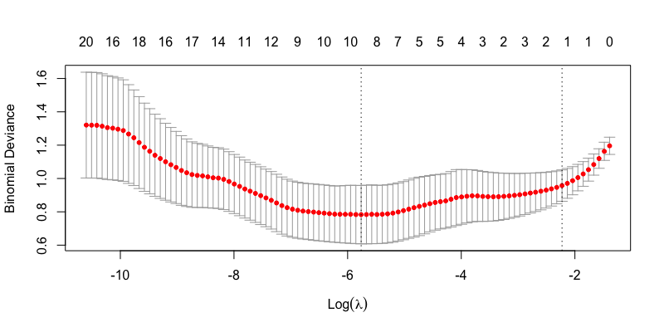
(3) Best lambda value with the lowest error: 0.002567295
Step 2: Final LASSO regression to select variables
(1) Code:
bestlasso <- glmnet(x, y, alpha=1, lambda=best_lambda, family='binomial')
(2) Coefficients:

Table 1: LASSO regression coefficients
Predictor | Coefficient values
(Intercept) | 12.746899
Blue
Green
Red | 14.440849
NIR
SWIR1
SWIR2 | -34.093366
NDVI
NDWI
NDSI1
NDSI2
SI1
SI2
SI3
SI4 | -9.024859
SI5
SAVI
VSSI | -7.410690
NBR
NBG
NBNIR | 16.084767
NBSWIR1
NBSWIR2 | -11.205443
NRSWIR1
NRSWIR2 | -5.315038
NGSWIR1 | -1.603849
NGSWIR2
NNIRSWIR1
NNIRSWIR2

(3) Retained predictors (with non-zero coefficient values): Red, SWIR2, SI4, VSSI, NBNIR, NBSWIR2, NRSWIR2, NGSWIR1.

Supplementary 4: Validation process
We included two validation steps in the analysis (see flowchart below). We performed internal validation directly using a held out set (referred to as the test set in the paper) from the Jagatsinghpur dataset, and external validation on the Bangladesh data set. We clarify how these were performed as follows.
Steps to ensure model robustness and stability (train test split and cross validation)
In the model building process (Step 4), we trained the nine models individually, and then applied ensemble stacking to improve model robustness and performance (see the left part of the flowchart below). First, we applied a single stratified random sampling to derive a train set (80%, N=85) and a test set (20%, N=21).
Second, using the train set, we trained individual models for the nine selected models (e.g., random forest, neural networks, etc.) to (1) understand individual model performance, and (2) tune hyperparameters to create relatively more stable and robust base models for ensemble stacking. For each of the nine models, we ran 5-fold cross validations to evaluate combinations of hyperparameters, selected the best combination, and fit one model using the best parameters. Specifically, the cross-validation process randomly partitioned the test set into five folds. Repeated five times for each combination of hyperparameters, each model was trained on data from the four folds and validated on the other. The best combination of hyperparameters for each model was used to train a model for each of the nine so that there were nine trained models at the end of this process.
Third, we applied ensemble stacking on the nine base models from the prior step to derive a single final model. The ensemble process was based on 5-fold cross validation and a random forest (RF) meta-classifier. Repeated five times, the RF meta-classifier was trained on predictions from the nine base models of the four folds and validated on the other one fold. The entire cross-validation process was again performed on all combinations of parameters, so that the best parameters for the RF meta-classifier were chosen to reduce overfitting and improve performance. Finally, we fit a single model using the determined parameters from the CV process on the entire test set with the RF meta-classifier.
Internal validation process
We applied the final ensemble model on the held out test set (N=21) for internal validation.
External validation process
In step 5, we applied the final ensemble model on the Bangladesh dataset (N=92) for external validation.
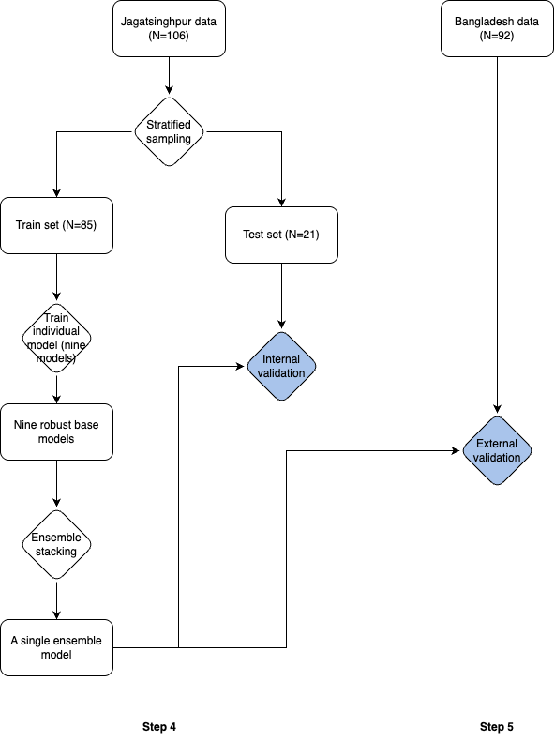

Model validation metrics
For each model as they use a different subset of data—training, and internal and external testing data sets—we calculated the confusion matrix of true positives (TP), true negatives (TN), false positives (FP), and false negatives (FN), and derived the four metrics to evaluate the model comprehensively:
- Accuracy = correct classifications / total classifications = (TP + TN)/(TP+TN+FP+FN)
Accuracy involves all four components of the confusion matrix, and usually serves as a coarse measure of overall model quality. In case of imbalanced data, such as ours where there are fewer high salinity points (30 out of 106) than there are for lower salinity (70 out of 106), there is a possibility of getting a relatively high accuracy even if all the high salinity points are incorrectly classified as low (accuracy would still be 70% because TN=70 even when FN=30). We, therefore, also consider the following three metrics in tandem.

- Precision = correctly classified positives / all classified as positive = TP / (TP+FP)
Precision improves when false positives decrease, that is, high saline data is not classified as low.

- Recall = correctly classified positives / all actual positives = TP / (TP+FN)
Recall, or sensitivity or true positive rate, improves when false negatives reduce (that is fewer low saline points are classified as high).

- F1-score = 2 * (precision * recall) / (precision + recall)
F1 score is the harmonic mean of precision and recall, and higher score suggests a more balanced model.

Supplementary 5: Band Mean-variance normalization comparisons
We tested normalization of Landsat 5 bands using Landsat 8 (2024) composite as a reference. The following are reflectance distributions of original Landsat 5 composite, matched-normalized band reflectance, and the reference Landsat 8 histogram (Richards and Xiuping 2005). However, we have adopted a more novel machine-learning based approach of harmonizing Landsat 5 TM images with Landsat 8 OLI images, with very high accuracies, developed by (Perikamana, K.K., Parath, N., & Balakrishnan, K. 2025)(forthcoming). This process is summarized later in this supplementary.
1995
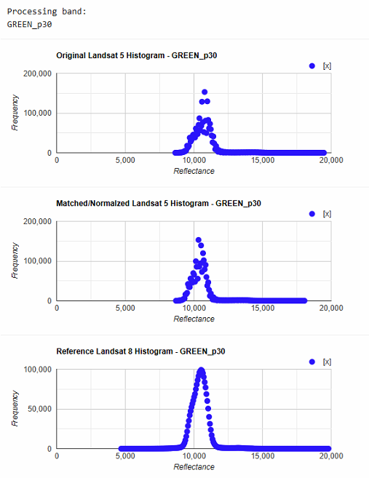 | 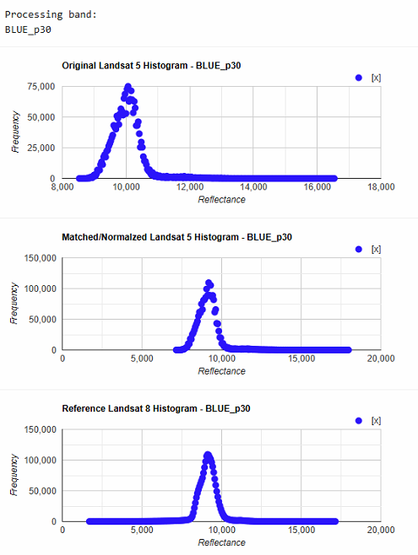 | 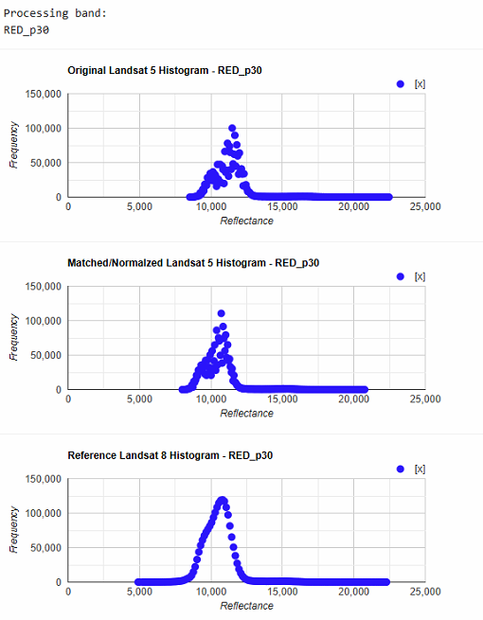
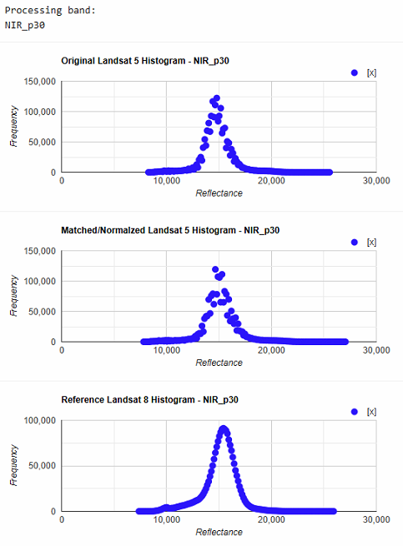 | 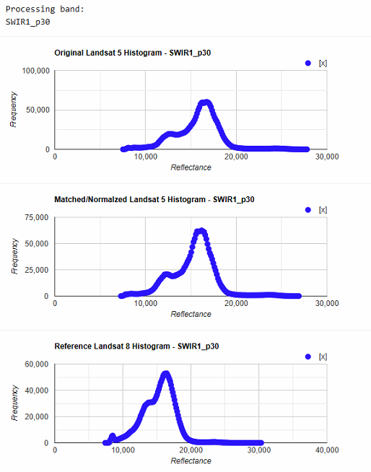 | 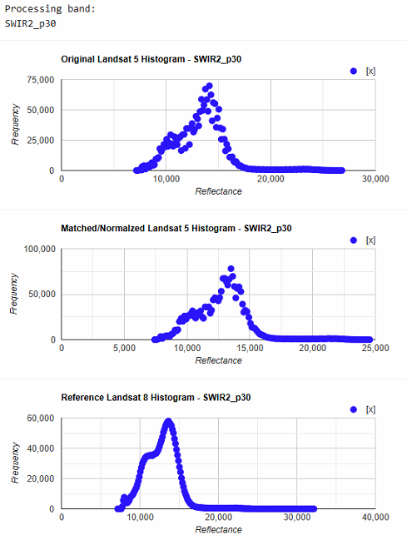

2001
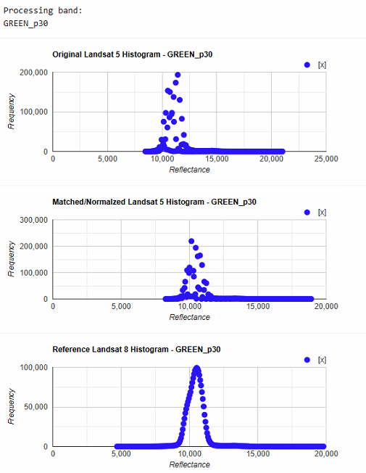 | 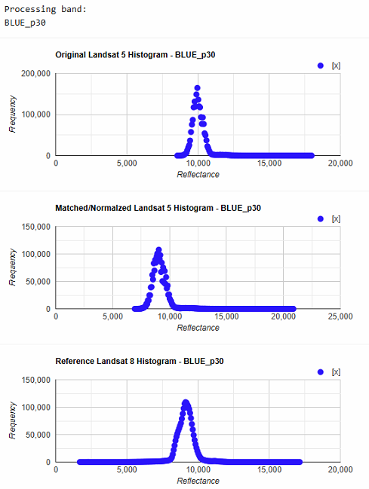 | 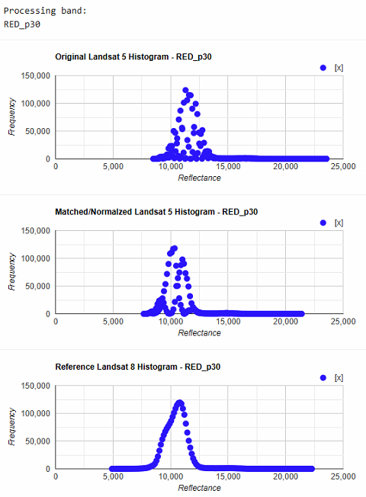
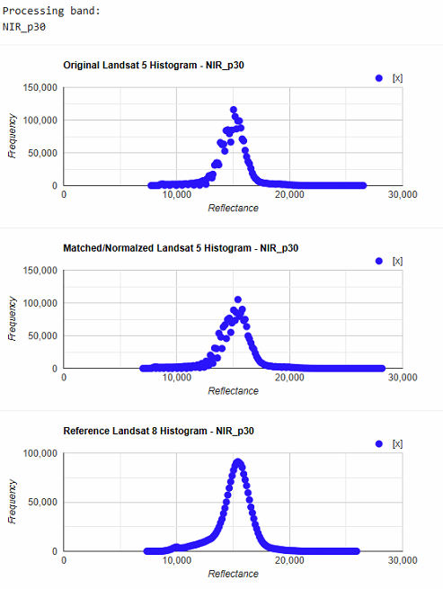 | 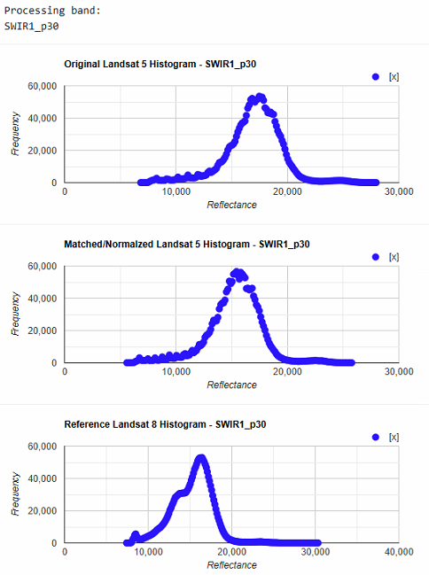 | 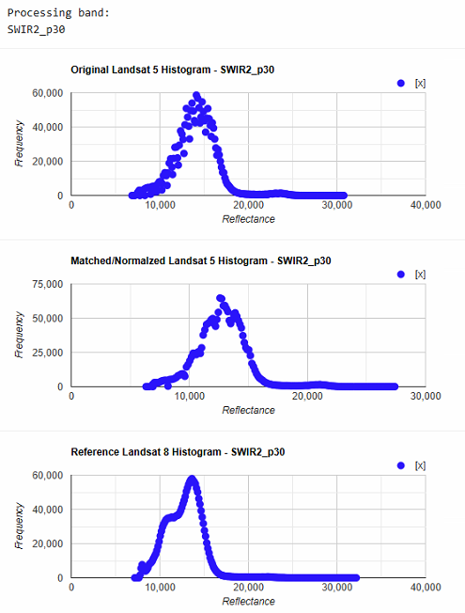

2005
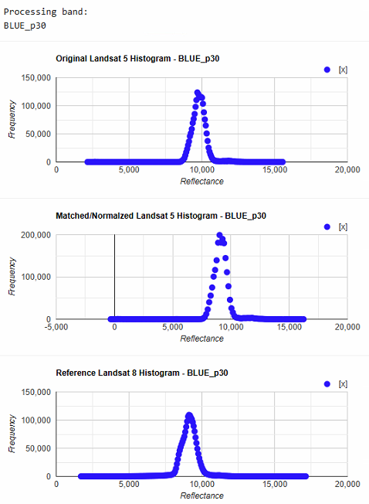 | 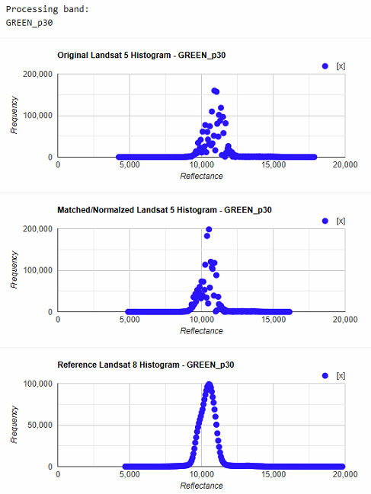 | 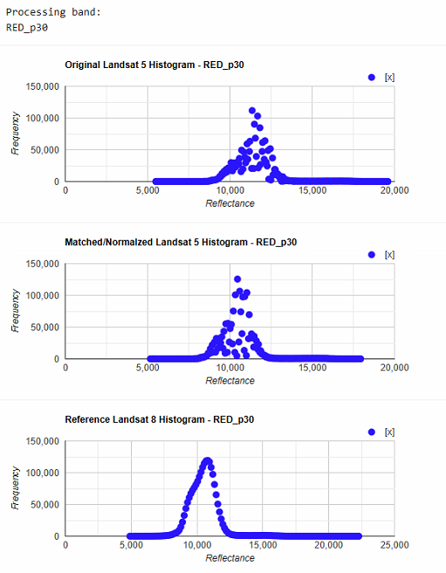
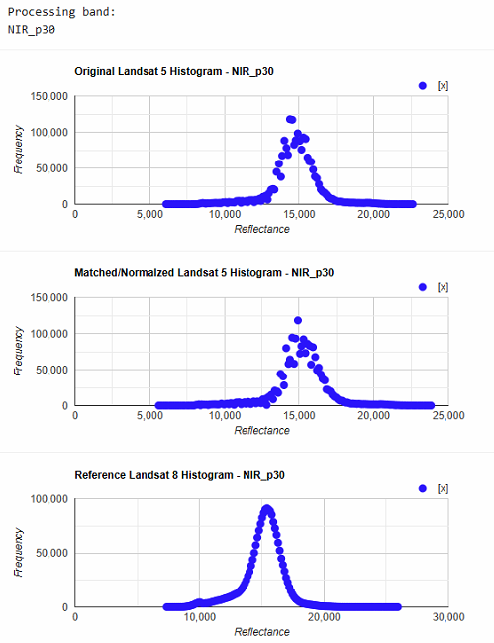 | 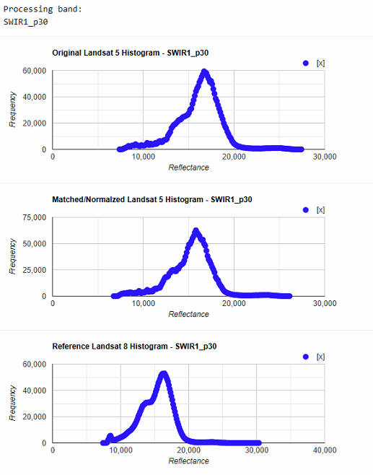 | 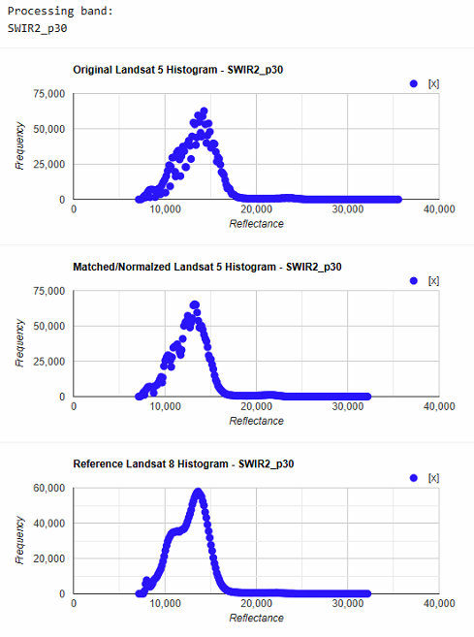

2010
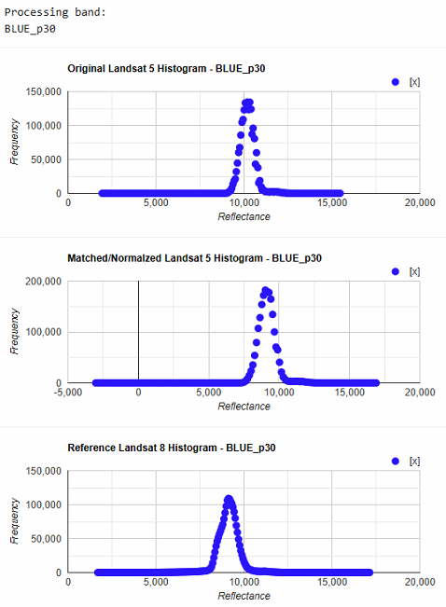 | 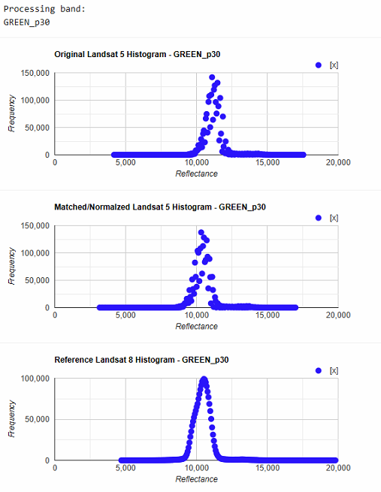 | 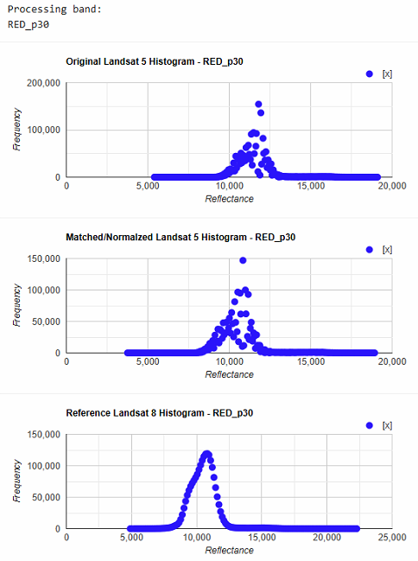
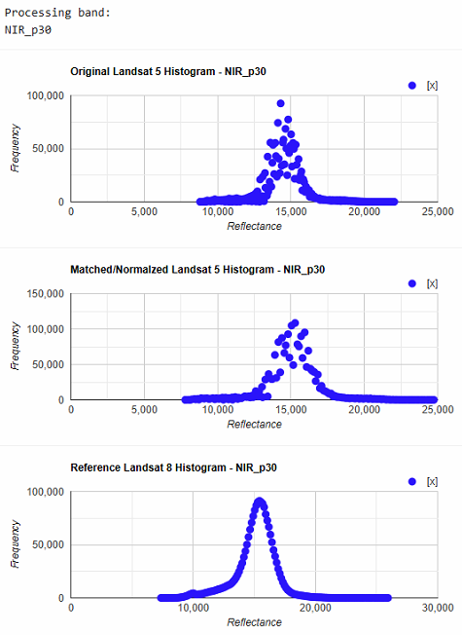 | 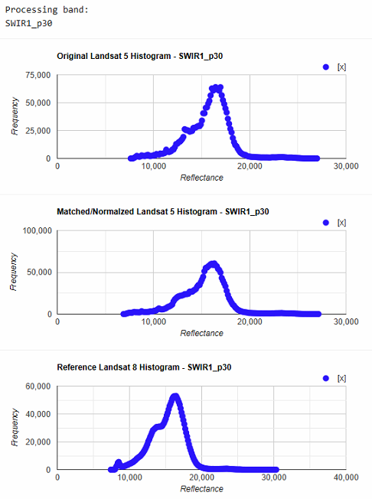 | 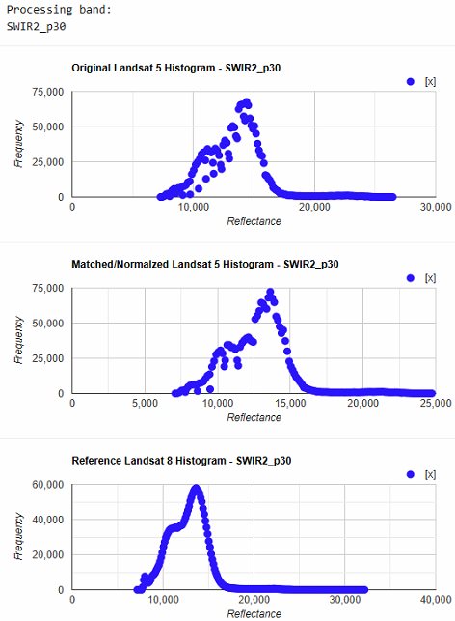

Summary of Landsat 5 and Landsat 8 harmonization
Cite: Perikamana, K.K., Parath, N., & Balakrishnan, K. (2025). An improved method for harmonizing Landsat 5-TM and Landsat 8-OLI data. Manuscript in preparation.
Several researchers have demonstrated linear regression-based approaches for harmonizing across Landsat sensors and across Landsat and Sentinel sensors (eg: Roy et al., (2016); Shang and Zhu, (2019) ). Roy et al. (2016), provides regression coefficients for harmonizing Landsat 7 ETM+ with Landsat 8 OLI data. This is based on OLS and RMA regression of each band of Landsat 7 ETM+ with corresponding band from Landsat 8 OLI data. But such an approach is unable to account for non-linearities in band-to-band relationships across sensors. Since each band pair is treated separately, it also cannot leverage information from other bands in the harmonization process. Nevertheless, the Roy et al. (2016) approach has been used to harmonize Landsat 5TM with Landsat 8 OLI also (Suharyadi et al. 2022).
Instead of a linear regression-based approach, we use Random Forest (RF) models to harmonize Landsat 5 TM data with Landsat 8 OLI data since RF models can account for non-linear relationships. Harmonization between Landsat 5 TM and Landsat 8 OLI is complicated by the fact that there is no temporal overlap between these sensors. But both Landsat 5TM and Landsat 8 OLI have temporal overlap with Landsat 7 ETM+. During their period of temporal overlap, both Landsat 5 and 7 and Landsat 7 and 8 orbited the earth with a gap of approximately 8 days.
Based on this, we do a two-step harmonization using two separate sets of RF models. The first set of RF models take six Landsat 5TM bands as input and predict corresponding Landsat 7 ETM+ bands as output. The second set of RF models take these predicted Landsat 5 ETM+ outputs and predict the corresponding Landsat 8 OLI bands.
In each harmonization step, each RF model takes all the bands from the input sensor and predicts one band of the output sensor. In this way, we use all the available information across input sensor bands rather than relying on information only from one band like in the case of Roy et al. (2016). Therefore, a total of 12 RF models were prepared such that the six Landsat 5 TM bands can be converted into corresponding six Landsat 7 ETM+ bands and further converted to the corresponding six Landsat 8 OLI bands.
Our original focus while training the RF models was to analyze urban areas in India. Therefore, our training data consisted of Landsat scenes across the largest 100 cities in India based on contiguous built-up area.
Based on cloud cover and quality assessment band thresholds, the best 25 Landsat 5 and 7 pairs which were 8 days apart were selected. These scenes were from the period from 1 January 1999 to 1 May 2003. This ensured that the Landsat 7 ETM+ scenes do not have the scanline corrector error which starts from 31 May 2003.
Similarly, 25 best Landsat 7 ETM+ and Landsat 8 OLI scenes were selected from the period from 1 January 2013 to 1 January 2017. The Landsat 7 ETM+ data from this period has the scanline corrector error. The cells with unusable data were therefore set to ‘No Data’.
Each Landsat 7 ETM+ scene was reprojected to the UTM zone in which majority of the scene fell. After this each corresponding Landsat 5 TM scene and Landsat 8 OLI scene were reprojected with the Landsat 7 ETM+ scene as reference so that cell alignment is ensured.
For each harmonization step, we trained and validated the model with 100million cells from 22 pairs of scenes and used 3 scenes for testing.
The accuracy metrics (average across three test scenes) for the L5 TM to L7 ETM+ harmonization is given in the table below:
Metric | Band 1 | Band 2 | Band 3 | Band 4 | Band 5 | Band 6
RMSE | 163.20 | 158.77 | 164.99 | 171.23 | 167.12 | 171.40
R² | 0.94 | 0.97 | 0.98 | 0.98 | 0.99 | 0.99
SSIM | 0.90 | 0.93 | 0.94 | 0.94 | 0.94 | 0.95

The accuracy metrics (average across three test scenes) for the L7 ETM+ to L8 OLI harmonization step is given in the table below:
Metric | Band 1 | Band 2 | Band 3 | Band 4 | Band 5 | Band 6
RMSE | 145.01 | 146.47 | 152.34 | 172.08 | 167.78 | 166.26
R² | 0.91 | 0.94 | 0.97 | 0.99 | 0.99 | 0.99
SSIM | 0.94 | 0.93 | 0.92 | 0.90 | 0.91 | 0.94

References
Roy, D. P., V. Kovalskyy, H. K. Zhang, E. F. Vermote, L. Yan, S. S. Kumar, and A. Egorov. 2016. “Characterization of Landsat-7 to Landsat-8 Reflective Wavelength and Normalized Difference Vegetation Index Continuity.” Remote Sensing of Environment 185 (Iss 1): 57–70.
Shang, Rong, and Zhe Zhu. 2019. “Harmonizing Landsat 8 and Sentinel-2: A Time-Series-Based Reflectance Adjustment Approach.” Remote Sensing of Environment 235 (111439): 111439.
Suharyadi, R., Deha Agus Umarhadi, Disyacitta Awanda, and Wirastuti Widyatmanti. 2022. “Exploring Built-up Indices and Machine Learning Regressions for Multi-Temporal Building Density Monitoring Based on Landsat Series.” Sensors (Basel, Switzerland) 22 (13): 4716.

Supplementary 6: 100 Iteration average results of individual machine learning and regression models under varying model specifications
- Testing a variety of linear and non-linear machine learning and regression models
EC | Continuous
Variables | All
Train-Test | 70-30
Row Labels | Average of R2_Train | Average of R2_Test
Bagging | 0.883958695 | 0.390130017
RandomForest | 0.886629656 | 0.38153062
Quadratic_correlated | 0.493063218 | 0.075613038
Stepwise | 0.667250327 | -0.4812077
OLS | 0.684766378 | -0.881249685
ANN | 0.899084686 | -1.589536008
Quadratic_all | 0.883570262 | -66.78533693
Log-Linear | 0.480977049 | -9.34509E+19

EC | Continuous
Variables | All
Train-Test | 70-30
Random Forest maxnodes = 6 (reduced depth to avoid overfitting in small dataset)
Row Labels | Average of R2_Train | Average of R2_Test
Bagging | 0.740572046 | 0.40654547
RandomForest | 0.761469885 | 0.402998112
Quadratic_correlated | 0.485572096 | 0.075818915
Stepwise | 0.65584359 | -0.519069914
OLS | 0.674089184 | -0.821922951
ANN | 0.889559236 | -4.73293199
Quadratic_all | 0.875804963 | -69.9171603
Log-Linear | 0.465514807 | -2.5877E+14

EC | Continuous
Variables | Pure bands and highly correlated
Train-Test | 80-20
Parameter adjustments for small data (maxnodes = 6)
Row Labels | Average of R2_Train | Average of R2_Test
RandomForest | 0.729574484 | 0.444587276
Bagging | 0.745901662 | 0.432524444
Lasso | 0.385876678 | 0.301727259
Ridge | 0.336485852 | 0.273195735
OLS | 0.519148023 | 0.270856197
Quadratic_correlated | 0.546587506 | 0.247986491
Stepwise | 0.504797542 | 0.235174696
Quadratic_all | 0.606914335 | -0.234295277
Log-Linear | -0.113285846 | -6.731768748
ANN | -6.586192881 | -179.2320997

EC | Continuous
Variables | PCA (3)
Train-Test | 80-20 (random)
Row Labels | Average of R2_Train | Average of R2_Test
Bagging | 0.454671094 | 0.191897586
Ridge | 0.271008882 | 0.167371934
Quantile Regression | 0.294190471 | 0.156754325
OLS | 0.339315496 | 0.151301889
Lasso | 0.336095118 | 0.145802083
Log-Linear | 0.226656671 | 0.145261048
RandomForest | 0.362814088 | 0.140630829
Stepwise | 0.332848696 | 0.127901676
ANN | -5.770963851 | -30.57203946

- Testing variable selection with random sampling
EC | Binary
Variables | All
Train-Test | 80-20 (random)
Row Labels | Average of Accuracy_Train | Average of Accuracy_Test
Random Forest | 0.992857143 | 0.847272727
ANN | 0.954166667 | 0.787272727
Logistic | 0.956785714 | 0.762727273

EC | Binary
Variables | Lasso
Train-Test | 80-20 (random)
Row Labels | Average of Accuracy_Train | Average of Accuracy_Test
Logistic | 0.889166667 | 0.848181818
Random Forest | 0.992857143 | 0.841363636
ANN | 0.960595238 | 0.789090909

EC | Binary
Variables | Pure bands and highly correlated
Train-Test | 80-20 (random)
Row Labels | Average of Accuracy_Train | Average of Accuracy_Test
Random Forest | 0.992857143 | 0.838181818
Logistic | 0.901071429 | 0.833181818
ANN | 0.96 | 0.775909091

EC | Categorical
Variables | All
Train-Test | 80-20 (random)
Row Labels | Average of Accuracy_Train | Average of Accuracy_Test
Random Forest | 0.995364489 | 0.76482743
ANN | 0.899229683 | 0.671691396

EC | Categorical
Variables | Pure bands and highly correlated
Train-Test | 80-20 (random)
Row Labels | Average of Accuracy_Train | Average of Accuracy_Test
Random Forest | 0.995541963 | 0.74184358
ANN | 0.886974731 | 0.667993751

EC | Categorical
Variables | Lasso variables
Train-Test | 80-20 (random)
Row Labels | Average of Accuracy_Train | Average of Accuracy_Test
Random Forest | 0.947499565 | 0.730831604
ANN | 0.780972881 | 0.709749143

- Testing Variable selection with stratified sampling
EC | Binary
Variables | All
Train-Test | 80-20 (stratified)
Row Labels | Average of Accuracy_Train | Average of Accuracy_Test
Random Forest | 0.992352941 | 0.844285714
ANN | 0.954705882 | 0.798571429
Logistic | 0.947294118 | 0.754761905

EC | Binary
Variables | Lasso
Train-Test | 80-20 (stratified)
Row Labels | Average of Accuracy_Train | Average of Accuracy_Test
Logistic | 0.890470588 | 0.843809524
Random Forest | 0.992352941 | 0.834761905
ANN | 0.956352941 | 0.810952381

EC | Binary
Variables | Pure bands and highly correlated
Train-Test | 80-20 (stratified)
Row Labels | Average of Accuracy_Train | Average of Accuracy_Test
Logistic | 0.900941176 | 0.830952381
Random Forest | 0.992352941 | 0.826190476
ANN | 0.960117647 | 0.798095238

EC | Categorical
Variables | All
Train-Test | 80-20 (stratified)
Row Labels | Average of Accuracy_Train | Average of Accuracy_Test
Random Forest | 0.99173913 | 0.78800641
ANN | 0.900927668 | 0.686840798

EC | Categorical
Variables | Pure bands and highly correlated
Train-Test | 80-20 (stratified)
Row Labels | Average of Accuracy_Train | Average of Accuracy_Test
Random Forest | 0.992463768 | 0.76102381
ANN | 0.881891211 | 0.710176005

EC | Categorical
Variables | Lasso variables
Train-Test | 80-20 (stratified)
Row Labels | Average of Accuracy_Train | Average of Accuracy_Test
Random Forest | 0.931594203 | 0.752554487
ANN | 0.781774522 | 0.707827381

Supplementary 7: Threshold Test Results
The sensitivity of the final ensemble model to threshold values for converting predicted probabilities to binary values was tested. 81 possible threshold values were tested ranging from 0.1 to 0.9 at 0.01 increments. In each iteration, the threshold was used to convert predicted probabilities to binary values and compute accuracy for the training set and the internal testing set. Mean accuracy for the training set was 0.91 (±0.025) and mean accuracy for the testing set was 0.82 (±0.056). Differences between the training and testing sets were low for all threshold values, with a mean value of 0.090 (±0.045). These results suggest low possibility of overfitting and relatively low sensitivity of model performance to changing threshold values. The final threshold used is 0.45, owing to high overall training and testing accuracies and low differences between these accuracies.
Table 1: Accuracy results for different threshold values.
Threshold | Train accuracy | Test accuracy | Difference in accuracy
0.1 | 0.892857 | 0.55 | 0.342857
0.11 | 0.916667 | 0.65 | 0.266667
0.12 | 0.916667 | 0.65 | 0.266667
0.13 | 0.928571 | 0.65 | 0.278571
0.14 | 0.928571 | 0.65 | 0.278571
0.15 | 0.940476 | 0.7 | 0.240476
0.16 | 0.964286 | 0.7 | 0.264286
0.17 | 0.964286 | 0.7 | 0.264286
0.18 | 0.964286 | 0.7 | 0.264286
0.19 | 0.964286 | 0.7 | 0.264286
0.2 | 0.952381 | 0.7 | 0.252381
0.21 | 0.952381 | 0.7 | 0.252381
0.22 | 0.952381 | 0.8 | 0.152381
0.23 | 0.952381 | 0.8 | 0.152381
0.24 | 0.940476 | 0.85 | 0.090476
0.25 | 0.940476 | 0.85 | 0.090476
0.26 | 0.928571 | 0.85 | 0.078571
0.27 | 0.904762 | 0.85 | 0.054762
0.28 | 0.904762 | 0.85 | 0.054762
0.29 | 0.904762 | 0.85 | 0.054762
0.3 | 0.916667 | 0.85 | 0.066667
0.31 | 0.928571 | 0.85 | 0.078571
0.32 | 0.928571 | 0.85 | 0.078571
0.33 | 0.928571 | 0.85 | 0.078571
0.34 | 0.928571 | 0.85 | 0.078571
0.35 | 0.928571 | 0.85 | 0.078571
0.36 | 0.928571 | 0.85 | 0.078571
0.37 | 0.928571 | 0.85 | 0.078571
0.38 | 0.928571 | 0.85 | 0.078571
0.39 | 0.928571 | 0.85 | 0.078571
0.4 | 0.928571 | 0.9 | 0.028571
0.41 | 0.928571 | 0.9 | 0.028571
0.42 | 0.928571 | 0.9 | 0.028571
0.43 | 0.916667 | 0.9 | 0.016667
0.44 | 0.916667 | 0.9 | 0.016667
0.45 | 0.916667 | 0.9 | 0.016667
0.46 | 0.916667 | 0.9 | 0.016667
0.47 | 0.916667 | 0.9 | 0.016667
0.48 | 0.916667 | 0.9 | 0.016667
0.49 | 0.916667 | 0.9 | 0.016667
0.5 | 0.916667 | 0.9 | 0.016667
0.51 | 0.916667 | 0.9 | 0.016667
0.52 | 0.928571 | 0.9 | 0.028571
0.53 | 0.928571 | 0.9 | 0.028571
0.54 | 0.928571 | 0.9 | 0.028571
0.55 | 0.928571 | 0.9 | 0.028571
0.56 | 0.928571 | 0.85 | 0.078571
0.57 | 0.928571 | 0.85 | 0.078571
0.58 | 0.928571 | 0.85 | 0.078571
0.59 | 0.928571 | 0.85 | 0.078571
0.6 | 0.928571 | 0.85 | 0.078571
0.61 | 0.916667 | 0.85 | 0.066667
0.62 | 0.916667 | 0.85 | 0.066667
0.63 | 0.916667 | 0.85 | 0.066667
0.64 | 0.916667 | 0.85 | 0.066667
0.65 | 0.916667 | 0.85 | 0.066667
0.66 | 0.916667 | 0.85 | 0.066667
0.67 | 0.916667 | 0.85 | 0.066667
0.68 | 0.916667 | 0.85 | 0.066667
0.69 | 0.916667 | 0.85 | 0.066667
0.7 | 0.916667 | 0.85 | 0.066667
0.71 | 0.916667 | 0.85 | 0.066667
0.72 | 0.916667 | 0.85 | 0.066667
0.73 | 0.916667 | 0.85 | 0.066667
0.74 | 0.916667 | 0.85 | 0.066667
0.75 | 0.916667 | 0.85 | 0.066667
0.76 | 0.916667 | 0.85 | 0.066667
0.77 | 0.916667 | 0.85 | 0.066667
0.78 | 0.916667 | 0.85 | 0.066667
0.79 | 0.916667 | 0.85 | 0.066667
0.8 | 0.916667 | 0.85 | 0.066667
0.81 | 0.916667 | 0.85 | 0.066667
0.82 | 0.916667 | 0.85 | 0.066667
0.83 | 0.916667 | 0.85 | 0.066667
0.84 | 0.916667 | 0.85 | 0.066667
0.85 | 0.916667 | 0.85 | 0.066667
0.86 | 0.916667 | 0.85 | 0.066667
0.87 | 0.916667 | 0.85 | 0.066667
0.88 | 0.916667 | 0.85 | 0.066667
0.89 | 0.916667 | 0.85 | 0.066667
0.9 | 0.916667 | 0.85 | 0.066667

Supplementary 8: Relationship between predictor variables and Electrical Conductivity and Soil Moisture
Relationship of predictor with EC | Relationship of predictor with soil moisture
Normalized Blue and NIR (NBNIR)  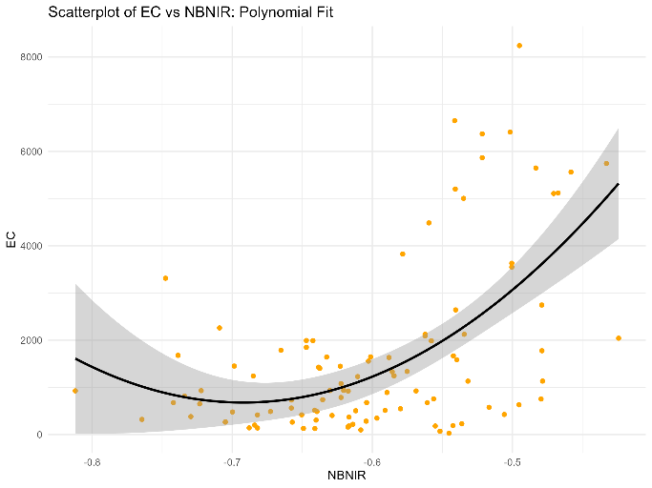 | 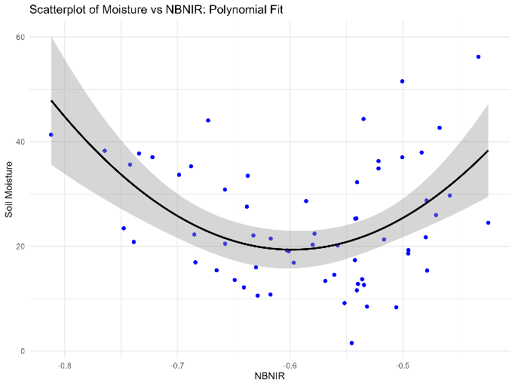
Normalized Red and SWIR2 (NRSWIR2)  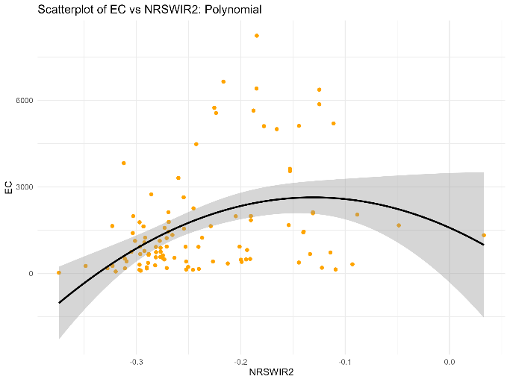 | 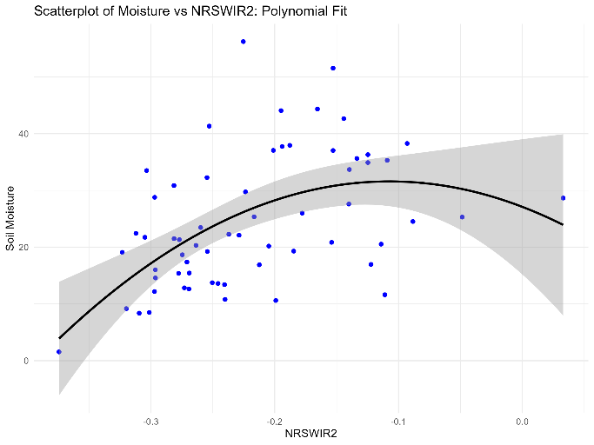
Salinity Index 4 (SI4)  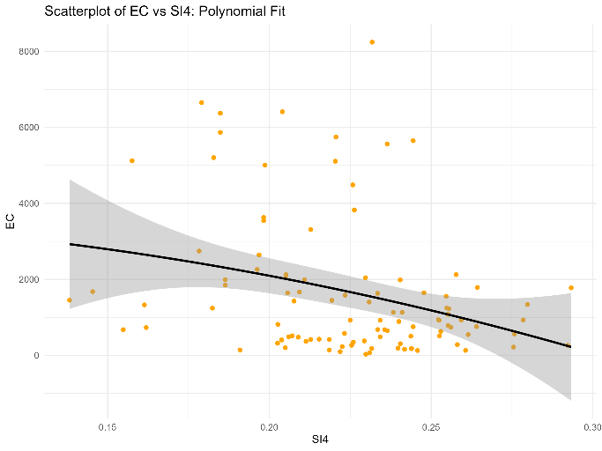 | 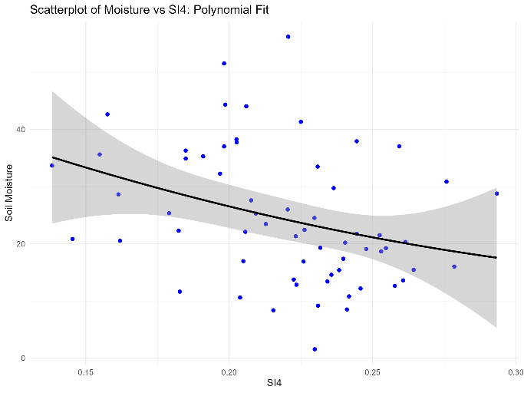
Normalized Green and SWIR1 (NGSWIR1)  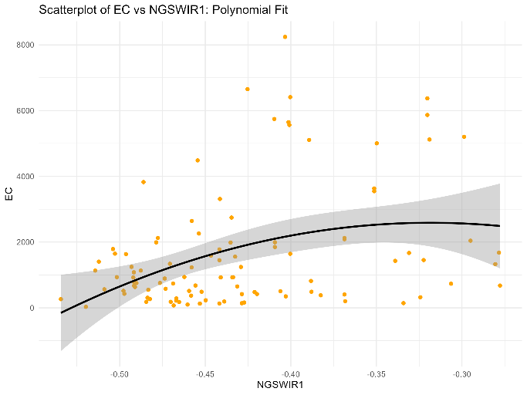 | 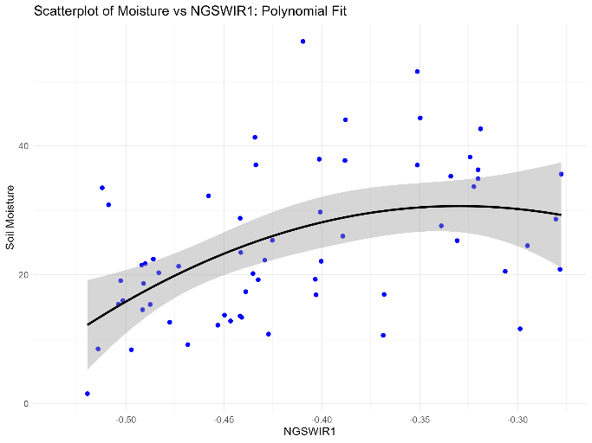
Red  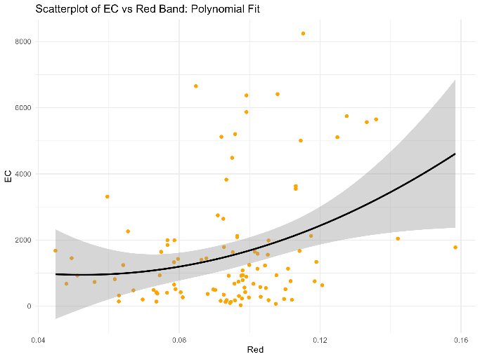 | 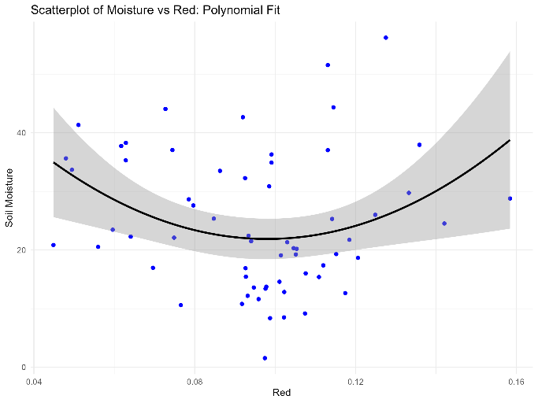
Vegetation Soil Salinity Index (VSSI)  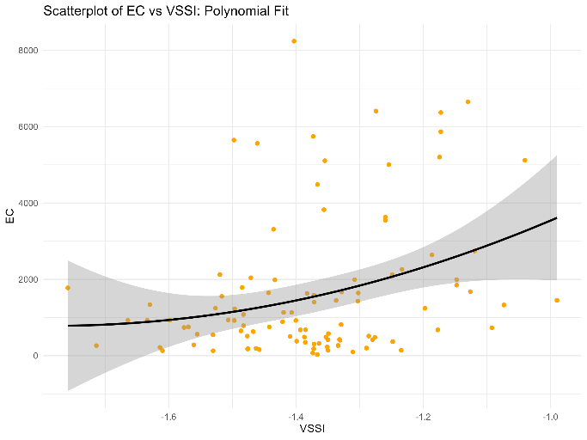 | 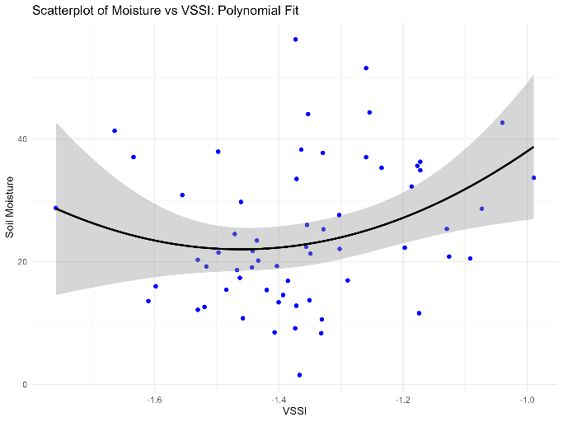
Normalized Blue and SWIR2 (NBSWIR2)  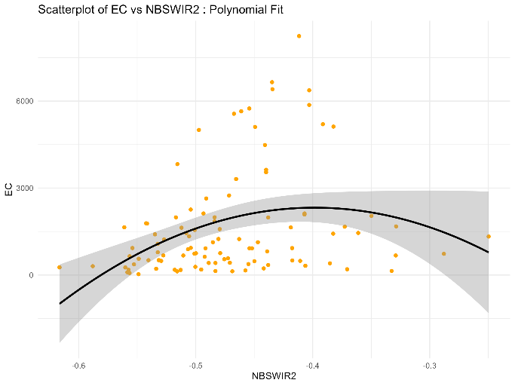 | 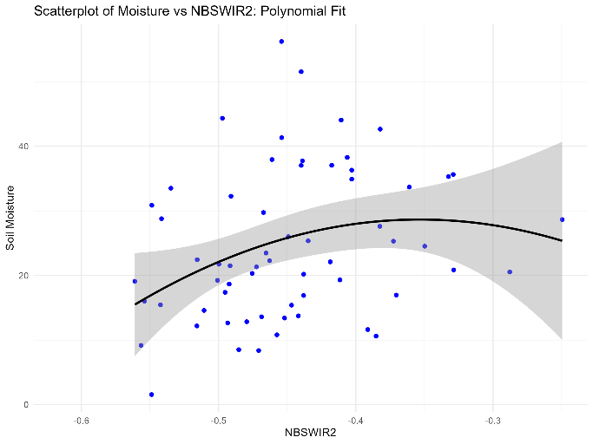
SWIR2  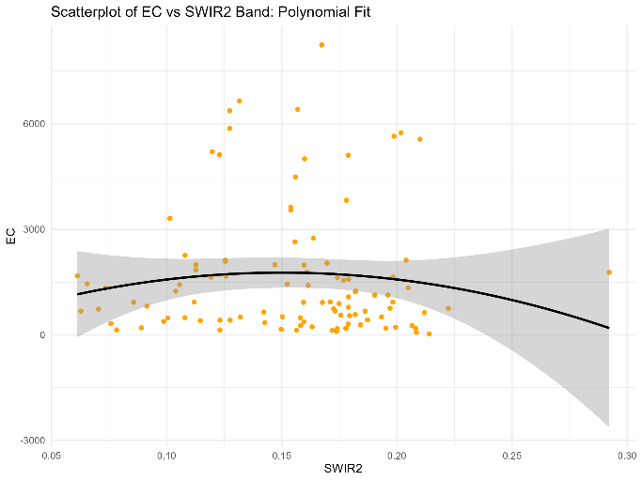 | 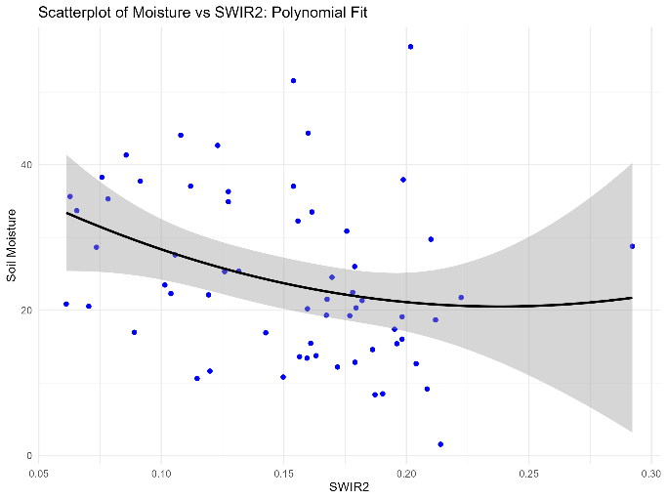
Relationships between indices, featuring high in the CoSal-SA model, with EC and moisture. Different indices detect salinity and moisture in varying ways: Indices, such as VSSI, increase for higher levels of EC as well as moisture; SWIR2 and Red only detect water or salinity respectively; other indices such as NRSWIR2, have a non-linear relationship with salinity but a positive relationship with moisture. See Supplementary 8 for all index comparisons.

Supplementary 9: Accuracies of Training and Testing Sets
We tested different conditions for creating the ensemble model. Model 1 used glm to combine the results of the 9 machine learning models into the ensemble, whereas Model 2, 3, and 4 tested different validation methods for RF. Model 2 used bootstrap with replacement, whereas Model 3 and 4 used cross validation with 5-folds. Model 1, 2 and 3 all used percentile reducers in the composite creation (Step 2 of Cosal), whereas Model 4, we used a geomedian reducer (see Supplementary 1 for accuracy comparisons of different reducers). We finally adopt Model 4 since it has the highest accuracy, as well as an overall improvement in the precision, recall, and F-scores.

Table 1: Model ensemble methods, sampling strategies, and corresponding accuracy metrics for the training set and testing sets (one internal and one external).
 | Model 4 (final) | Model 3 | Model 2 | Model 1
Ensemble method | RF (geomedian reducer) | RF (percentile reducer) | RF (percentile reducer) | Glm (percentile reducer)
Sampling | Cross validation with k-fold (5) | Cross validation with k-fold (5) | Bootstrap 0.632 (with replacement) | Cross validation with k-fold (5)
Training
Accuracy | 0.92 | 0.92 | 0.91 | 0.82
Precision | 0.94 | 1 | 0.86 | 0.65
Recall | 0.73 | 0.71 | 0.79 | 0.79
F1-Score | 0.82 | 0.83 | 0.83 | 0.72
Testing (Internal)
Accuracy | 0.9 | 0.86 | 0.81 | 0.76
Precision | 0.8 | 0.8 | 0.6 | 0.55
Recall | 0.8 | 0.67 | 1 | 1
F1-Score | 0.8 | 0.73 | 0.75 | 0.71
Testing (External)
Accuracy | 0.64 | 0.69 | - | -
Precision | 0.75 | 0.71 | - | -
Recall | 0.60 | 0.82 | - | -
F1-Score | 0.677 | 0.76 | - | -

