Flask_Mongodb Project

1. Create a Flask application with an /api route. When this route is accessed, it should return a JSON list. The data should be stored in a backend file, read from it, and sent as a response.
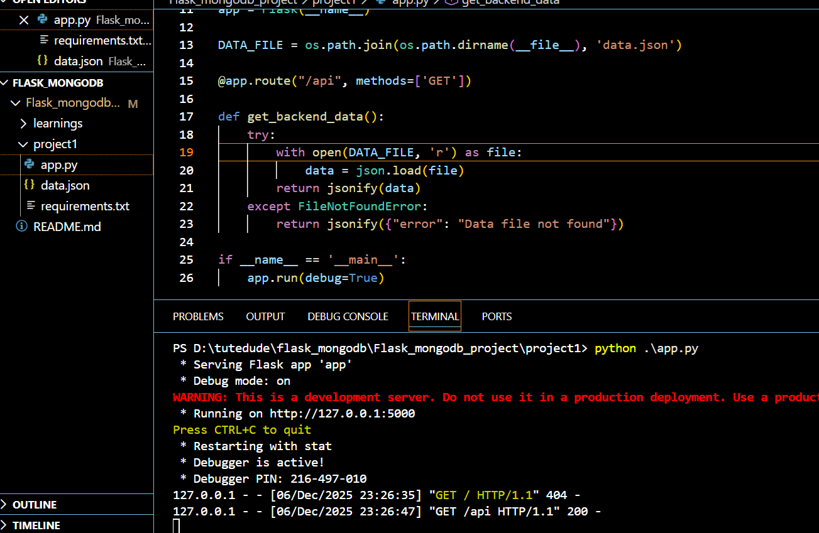

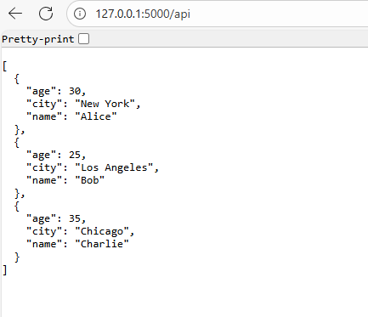

2. Create a form on the frontend that, when submitted, inserts data into MongoDB Atlas. Uponsuccessful submission, the user should be redirected to another page displaying the message "Data submitted successfully". If there's an error during submission, display the error on the same page without redirection.

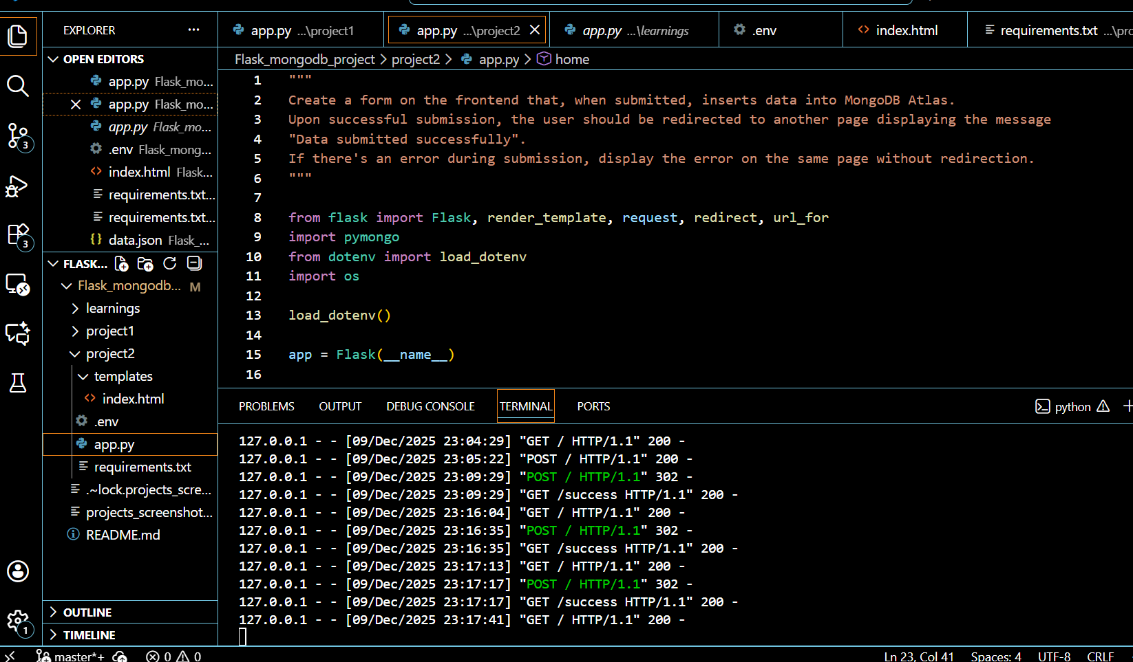
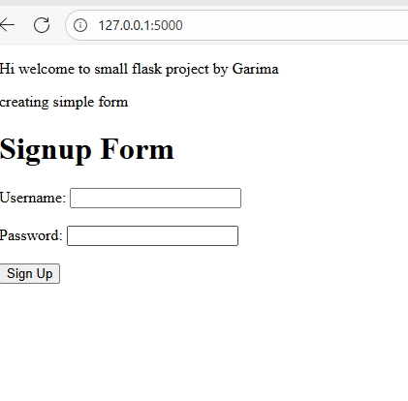

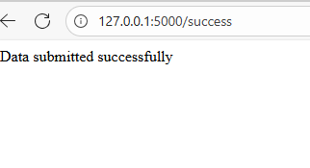

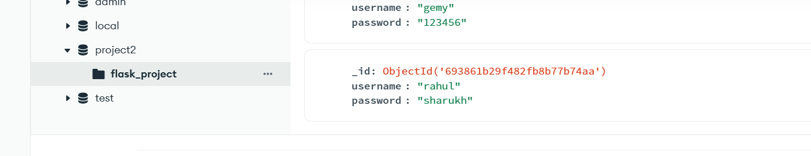

All the project and steps are in git link and screenshots are pasted here.

Git link - garimas007/Flask_mongodb_project: This repo contains my learning of Flask and Mongodb and have a project done for devops practices
Submission Guidelines -: Attach Screenshots or command along with explanation and submit in doc(google doc or microsoft doc) format also attach github repo link

