1. Create a new GitHub repository.
- Clone the repository to your local machine using SSH (generate an SSH key if needed, add the public key to your GitHub account).
- https://github.com/garimas007/versioncontrolgit
- Create a new branch named after your username (e.g., Tutedude).
  - git branch tutedude_Garima
  - git branch
    - feature1
    - feature2
    - * main
    - tutedude_Garima
- Add your Flask project files to this branch.
  - git checkout tutedude_Garima
  - git add .\assignment\
  - git push --set-upstream origin tutedude_Garima
- Commit the changes and merge the branch into the main branch.
  - git checkout main
  - git merge tutedude_Garima

2. Create a new branch named <your_name>_new (e.g., Tutedude_new).
- git checkout -b garima_new
- Update the content of the JSON file used for the /api route in this branch.
  - nano data.json
  - git add .
  - git commit -m 'update json'
- Merge the <your_name>_new branch into the main branch.
  - git checkout main
  - git merge garima_new
- If there are conflicts during the merge, resolve them by accepting the changes from the <your_name>_new branch.
  - Removed marker
- Add the resolved changes to the staging area, commit them, and push the updates to the remote repository.
  - git add .
  - git commit -m "Resolved merge conflicts"
  - git push

3. Branch Creation:
- Create two branches: master_1 and master_2 from the main branch.
  - git branch master1
  - git branch master2
  - git branch
    - garima_new
    - * main
    - master1
    - master2
    - tutedude_Garima
- Feature Development in master_1:
- In the master_1 branch, create a To-Do Page in the frontend.
  - git checkout master1
- The page should contain a form with the following fields:
    - Item Name
    - Item Description
  - git add .
  - git commit -m "adding frontend page in master1"
- Backend API in master_2:
  - git checkout master2
- In the master_2 branch, create a backend route named /submittodoitem.
- This route will:
- Accept itemName and itemDescription via a POST request.
- Store these details in a MongoDB database.
  - git add .
  - git commit -m "adding backend page in master2"
- Merging Changes:
- Merge the changes from both master_1 and master_2 into the main branch.
  - git checkout main
  - git merge master1
Updating e0cae86..bd07708
Fast-forward
frontendform.txt | 5 +++++
1 file changed, 5 insertions(+)
create mode 100644 frontendform.txt
  - git merge master2
Merge made by the 'ort' strategy.
backendfl.txt | 2 ++
1 file changed, 2 insertions(+)
create mode 100644 backendfl.txt

4. Enhancing the To-Do Form in master_1:
git checkout master1
- In the master_1 branch, add the following fields to the To-Do form:
  - Item ID
  - Item UUID
  - Item Hash
- Committing in Sequence:
- Add and commit each field separately in the following order:
  - First commit: Add Item ID field.
  - Second commit: Add Item UUID field.
  - Third commit: Add Item Hash field.
    - git add .\frontendform.txt
    - git commit -m "add item id in frontend"
[master1 1a6e56b] add item id in frontend
1 file changed, 1 insertion(+), 1 deletion(-)
    - git add .\frontendform.txt
    - git commit -m "add item uuid in frontend"
[master1 b2cfc79] add item uuid in frontend
1 file changed, 2 insertions(+), 1 deletion(-)
    - git add .\frontendform.txt
    - git commit -m "add item hash in frontend"
[master1 e7969e9] add item hash in frontend
1 file changed, 2 insertions(+), 1 deletion(-)
- Merging to main:
- Merge the master_1 branch into the main branch.
  - git checkout main
  - git merge master1
    - Merge made by the 'ort' strategy.
    - frontendform.txt | 4 +++-
    - 1 file changed, 3 insertions(+), 1 deletion(-)

- Git Reset and Commit Deletion:
- In the main branch, use Git Reset to roll back to the commit where only the Item ID field was added.
  - git log
commit c1adecb9ba0dd2aa7ae63e6f6d97306ee112aa6f (HEAD -> main)
Merge: 317771d e7969e9
Author: garimas007 <singhgarima54@gmail.com>
Date: Sat Apr 11 16:24:01 2026 +0530

Merge branch 'master1'

commit e7969e9f1378dfda2222550ff1e2a43530ffd25d (master1)
Author: garimas007 <singhgarima54@gmail.com>
Date: Sat Apr 11 16:17:53 2026 +0530

add item hash in frontend

commit b2cfc7986fb7d77672e53307f5c0991380c6036a
Author: garimas007 <singhgarima54@gmail.com>
Date: Sat Apr 11 16:16:42 2026 +0530

add item uuid in frontend

commit 1a6e56bdf4303f6a7f4d1ff50383ddc8388cc0e0
Author: garimas007 <singhgarima54@gmail.com>
Date: Sat Apr 11 16:16:00 2026 +0530

add item id in frontend
- Use git reset --soft to ensure changes remain staged.
  - git reset --soft 1a6e56bdf4303f6a7f4d1ff50383ddc8388cc0e0
- Re-commit this state to the main branch.
  - git commit -m "Realigned main to item id"
[main cf5c1a2] Realigned main to item id
2 files changed, 5 insertions(+), 1 deletion(-)
create mode 100644 backendfl.txt
- Merge this updated state to the main branch.
  - The above steps were done in main branch so there is nothing to merge
  - git push
Enumerating objects: 11, done.
Counting objects: 100% (11/11), done.
Delta compression using up to 8 threads
Compressing objects: 100% (10/10), done.
Writing objects: 100% (10/10), 977 bytes | 977.00 KiB/s, done.
Total 10 (delta 5), reused 0 (delta 0), pack-reused 0 (from 0)
remote: Resolving deltas: 100% (5/5), completed with 1 local object.
To https://github.com/garimas007/versioncontrolgit.git
e0cae86..cf5c1a2 main -> main

- Rebasing Changes:
- Rebase the updated changes in the main branch to the master_1 branch.
Clarification:
  - During rebasing, preserve individual commits to maintain the commit history for each change (i.e., do not squash commits).
  - Use git rebase main master_1 to integrate changes from the main branch back into the master_1 branch.
    - git rebase main master1
Auto-merging frontendform.txt
CONFLICT (content): Merge conflict in frontendform.txt
error: could not apply b2cfc79... add item uuid in frontend
hint: Resolve all conflicts manually, mark them as resolved with
hint: "git add/rm <conflicted_files>", then run "git rebase --continue".
hint: You can instead skip this commit: run "git rebase --skip".
hint: To abort and get back to the state before "git rebase", run "git rebase --abort".
Could not apply b2cfc79... add item uuid in frontend

- git push origin master1 --force

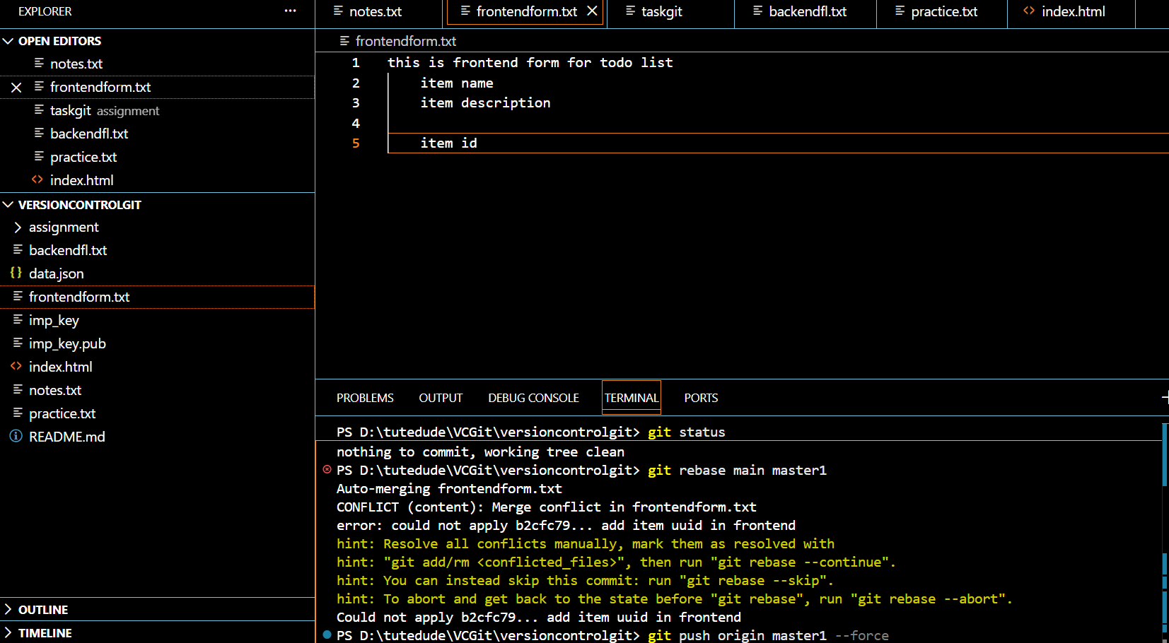

Submission Guidelines -: Attach Screenshots or command along with explanation and submit in doc(google doc or microsoft doc) format , also share link of your github repo

