Week 5 Task: Reflection and Optimization Strategy
Reflective Report on My Virtual Programming Internship
Virtual Programming Explorer Internship | Yuva Intern
Name: Garima Singh
Date: 31 October 2026

1. Introduction
This is the final task of my five-week Virtual Programming Explorer Internship. In this report I look back at all five tasks, describe what I achieved, explain the challenges I met and how I handled them, assess my strengths and weaknesses honestly, and present a plan to make my future programming projects better. The report is written in plain language so that a non-programmer can also use it as an example of how to learn from one's own work.

2. Overview of the Five Weeks and Key Milestones
I used one everyday problem, tracking daily expenses, through the whole internship. Each week I moved the same idea one step further, from a plan to working code, then to debugging, testing and finally this reflection.
Week | Task | What I produced | Result
1 | Strategic Programming Planning | A plan for an expense tracker: problem analysis, three solution ideas, four-week timeline, risk table and learning resources. I also created my GitHub repository. | Evaluated: 61.6 out of 100 (minimum 30)
2 | Coding Execution for Everyday Problems | A Python expense tracker with comments that saves data in a CSV file and shows a summary and budget warning. | Program ran correctly: total 600 and 4400 left in my test run
3 | Debugging and Collaborative Problem Solving | A faulty copy of the program with four errors of four different types, the corrected version, and a report with before and after code. | All four errors found and fixed
4 | Functional Testing and Evaluation | A testing plan, 17 test cases, a test script, a bug list with severity levels, and an improved version of the program. | 12 passed and 5 failed at first; 17 of 17 passed after the fixes
5 | Reflection and Optimization Strategy | This report. | Final task

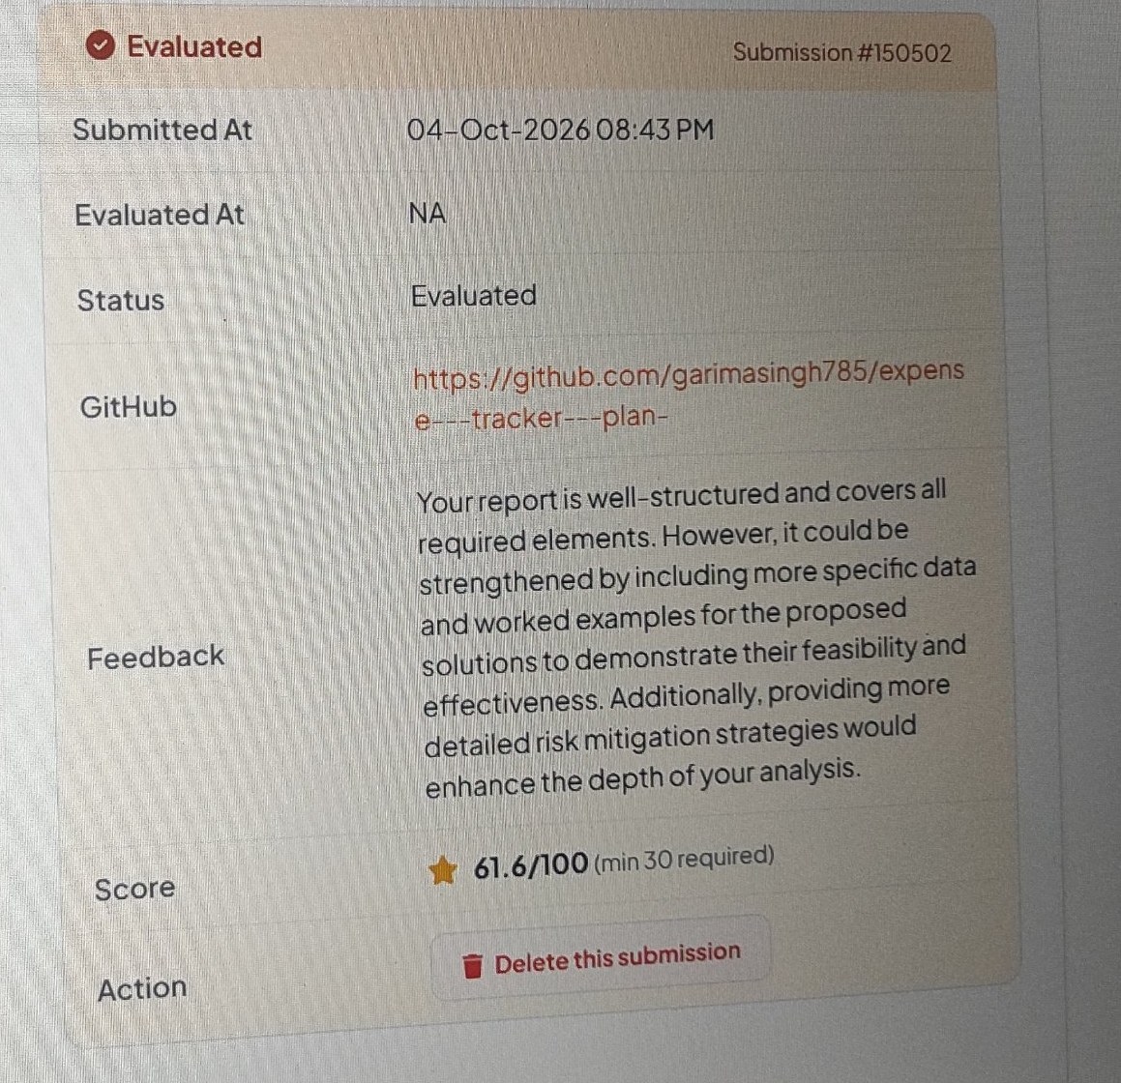
Figure 1: Evaluation result of my Week 1 submission (61.6/100) with the evaluator's feedback

3. Challenges Encountered in Each Task
Week | Challenge | How I handled it | What stayed difficult
1 | I did not know at first that the GitHub link is compulsory for a technical internship. I also got a file in use error when uploading while the document was still open in Word. | I created a GitHub repository, uploaded my files through the website and closed Word before uploading. | Understanding what Git and a repository really are
1 | The evaluator said the report needed more specific data and worked examples, and more detailed risk mitigation. | I treated this as a lesson and used concrete numbers, tables and examples in the later reports. | Deciding how much detail is enough
2 | VS Code showed Python was not found, because Python was not installed on my laptop (Figure 2). | I installed Python from python.org with the PATH option, restarted VS Code and ran the file from the terminal. | Remembering which tool does which job (editor versus Python)
2 | My summary showed 800 instead of 600 and a category named 50. | I found that I had typed a number in the category question and that old test data was still stored in expenses.csv. I deleted the file and ran the test again. | Keeping test data clean
3 | The code I pasted lost its indentation and Python reported an IndentationError. At one point the file name also had extra characters in front of it, and the program was run from the wrong panel. | I used the original file, saved it with Ctrl+S and ran it in the Terminal, which accepts typed input. | Depending less on copy and paste
4 | Thinking of tests beyond normal inputs. | I listed positive, negative and boundary tests. They revealed five bugs I had not noticed. | Designing tests before writing code
Repo | GitHub refused to create a file that already existed, and a file name was typed with a dot too many. | I checked the repository list and uploaded files directly instead of retyping names. | Reading error messages calmly the first time

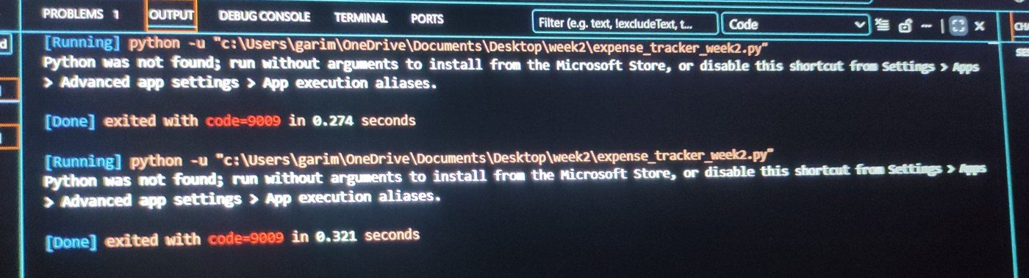
Figure 2: The Python was not found message in VS Code before I installed Python

4. Honest Self-Assessment

4.1 My strengths
- Persistence: I did not stop when Python was missing, when errors appeared or when GitHub refused a file. Each problem was solved one step at a time.
- Building one project step by step: Instead of five separate projects I improved one program over five weeks. This showed me how a plan becomes code, then a debugged and tested product.
- Documentation: I used screenshots, tables and before and after code, so another person can follow what I did.
- Using feedback: After the Week 1 feedback I added concrete numbers and tables in the later reports, for example the total of 600 and 4400 left.
- Learning to test: Writing tests showed me weaknesses that normal use never revealed.

4.2 My weaknesses
- Environment setup: Installing Python, understanding PATH, saving files and choosing the right panel cost me a lot of time.
- Time management: My work was not spread evenly. Week 2 was finished on 10 October, but Week 3 was started only on 20 October and finished on 27 October, so Weeks 3, 4 and 5 were squeezed into the end.
- Dependence on help: I do not yet write code from a blank file confidently. I depended on pasted code and on step-by-step help, and I still need more independent practice.
- Version control: I used Git only through the website upload button and not from VS Code.
- Planning and testing too late: I wrote tests after the program instead of planning them first, and my Week 1 report lacked specific data.

5. How Each Task Improved My Understanding of Programming as a Problem-Solving Tool
Week | What I learned
1 | A problem must be described clearly (who is affected, what is the impact) before any code is written. A plan with a timeline and risks makes a big task smaller.
2 | Variables, lists, loops, conditions and files are simple building blocks that together solve a real problem. Running code is the only way to find out whether the idea works.
3 | Errors are information, not failure. Syntax and name errors point to a line, but a logic error gives no message and needs careful checking with a known example.
4 | Testing means asking what could go wrong. Unusual inputs such as an empty category, nan, or a damaged file showed that working in normal use is not the same as being reliable.
5 | Reflection turns experience into a plan. Looking back at my mistakes showed me exactly which habits to change.

6. Success Stories
- From plan to program: My plan from Week 1 passed with 61.6 out of 100, and its idea became the working program of Week 2.
- The first correct run: After installing Python, the tracker ran, and the output matched my hand calculation (100 + 50 + 300 + 150 = 600 and 5000 - 600 = 4400).
- Test, fix, retest: In Week 4, 17 test cases found five bugs. Three small fixes made all 17 tests pass in the retest.

7. Lessons Learned
- Set up the tools and check them (for example with py --version) before starting a task.
- Read error messages from the bottom upwards. They usually name the problem and the line.
- Never paste code blindly. Check indentation, save the file, and run it in the Terminal.
- Change one thing at a time and run the program after each change.
- Calculate the expected result by hand first, then compare it with the output.
- Keep test data and real data apart, and keep every version on GitHub.
- Start each task early and work in small daily sessions instead of one long session at the end.

8. Strategic Plan for Optimizing My Future Programming Projects

8.1 Guiding approach
I will follow one simple cycle for every project: Plan, Set up, Build in small steps, Test, Save on GitHub, Reflect. The workflow enhancements, resources and goals below follow from the weaknesses identified in Section 4.

8.2 Workflow enhancements
Stage | What I will do | Problem it solves
Before coding | Write the problem in two sentences, list inputs and outputs, check Python and VS Code, create a GitHub repository with a README and one folder per task. | Setup delays and unclear goals
While coding | Write a few lines, save, run, and repeat. Write comments as I go. Run programs in the Terminal. Type or download code instead of pasting it. | Indentation errors and hidden mistakes
Testing | Write 5 to 10 test cases before finishing the code, including wrong and edge inputs, and keep a test script. | Late discovery of bugs
After coding | Save a version on GitHub with a clear message, update the README, and write four lines of reflection. | Lost work and forgotten lessons
Time | Plan small daily sessions of 45 to 60 minutes and finish a first version at least two days before a deadline. | Last-minute pressure

8.3 Resource suggestions
Resource | Use | Link
The Python Tutorial | Language basics, errors and exceptions | docs.python.org/3/tutorial
Automate the Boring Stuff with Python | Practical beginner projects | automatetheboringstuff.com
Harvard CS50P | Structured course with exercises | cs50.harvard.edu/python
freeCodeCamp | Free coding practice | freecodecamp.org
Python in Visual Studio Code | Editor skills, running and debugging | code.visualstudio.com/docs/python/python-tutorial
GitHub Docs and GitHub Skills | Git and repository workflow | docs.github.com and skills.github.com
Python unittest documentation | Proper automatic tests | docs.python.org/3/library/unittest.html
PEP 8 | Readable code style | peps.python.org/pep-0008

8.4 Personal development goals
Time | Goal | How I will measure it
30 days | Finish the Python Tutorial chapters on basics, loops, functions and errors, or the first weeks of CS50P. Set up Git on my laptop and commit from VS Code. | Exercises completed and at least 10 commits
90 days | Build two new small projects, for example an attendance tracker and a study timetable, each with comments, a README and a test script. Write a weekly reflection note. | Two repositories on GitHub and 12 notes
6 months | Add a simple screen to the expense tracker (web page or window) and learn unittest, so that other people can use and test the program. | A working demo that another person can try

8.5 Risks to the plan and how I will handle them
Risk | How I will handle it
I lose motivation or time | Keep sessions short, track progress on a simple checklist, and start with the easiest goal.
I copy code without understanding it | Explain every new line in my own words in a comment before moving on, and rebuild small parts from memory.
Setup problems block me again | Keep a personal setup note with the exact steps that worked (Python, PATH, VS Code, Git).
I get stuck on an error | Read the message, search the exact words, check the official documentation, and ask in a community with a short example.

9. How Non-Programmers Can Keep Improving Through Reflective Practice
Reflection helps people with no programming background just as much as experienced programmers, because it turns every small mistake into a lesson. The following routine can be used by anyone.
- Practise small and often. Pick one very small everyday task (a bill calculator, a to-do list) and write a short program in 30 to 45 minutes.
- Use a four-question journal. After every session answer four questions: What did I try? What went wrong? What did I learn? What is my next step?
- Collect your errors. Treat each error message as a clue and write down what it meant in simple words.
- Explain your code aloud. Once a week, explain one program to a friend or family member. If you cannot explain a line, study it again.
- Revisit and rebuild. Rebuild an old program from memory after a week and compare it with the first version.
- Climb a project ladder. Move from a small script to a tested program with a simple screen, one step at a time.
Date | What I tried | What went wrong | What I learned | Next step
Example | Added a budget check | Warning showed at the wrong time | Check the comparison symbol | Test with known numbers

10. Tools and Support Used
To be honest about my process: I used Python, Visual Studio Code, GitHub and the Yuva Intern platform for the work itself. I also used an AI assistant for explanations, step-by-step guidance and help with drafting the reports. I ran the programs and took the screenshots in this report myself. Because I relied on this help, building my independent coding practice is the first goal of my plan above.

11. Conclusion
Over five weeks I moved from a written plan to a working, debugged and tested Python program, and I learned that programming is a way of solving everyday problems step by step. My main strengths are persistence and the habit of documenting my work. My main weaknesses are setup knowledge, time management and depending on pasted code or outside help. The strategy in this report, with a clear workflow, learning resources, measurable goals and a regular reflection routine, is designed to improve exactly these weaknesses in my next projects.

12. References
- Python Software Foundation. The Python Tutorial. https://docs.python.org/3/tutorial/
- Al Sweigart. Automate the Boring Stuff with Python. https://automatetheboringstuff.com/
- Harvard University. CS50's Introduction to Programming with Python. https://cs50.harvard.edu/python/
- Microsoft. Python in Visual Studio Code. https://code.visualstudio.com/docs/python/python-tutorial
- GitHub Docs. https://docs.github.com/
- Python Software Foundation. unittest, Unit testing framework. https://docs.python.org/3/library/unittest.html

