Week 2 Task: Coding Execution for Everyday Problems
A Python Daily Expense Tracker
Virtual Programming Explorer Internship | Yuva Intern
Name: Garima Singh
Date: 10 October 2026

1. Introduction and Problem
In Week 1, I created a strategic plan for tracking daily expenses using basic programming. In Week 2, I moved from planning to execution and built a working Python program based on that plan.
The everyday problem is simple: many students and families do not know where their money goes each month. Small purchases are rarely written down, so the money finishes before the month ends. A small program can record each expense, save it, and show a clear summary.

2. Choice of Language and Environment
Language: Python. It reads almost like English, needs very little setup and is widely recommended for beginners.
Editor: Visual Studio Code with the official Python extension from Microsoft.
Environment setup: I installed Python, opened a project folder in VS Code, created the file expense_tracker_week2.py and ran it from the Run button and the built-in terminal.

3. The Code (with Comments)
The complete script is below. Every important line has a comment that explains what it does, so a non-programmer can follow it.
# ---------------------------------------------------------------
# Daily Expense Tracker (Week 2: Coding Execution)
# Problem : People forget where their money goes every month.
# Solution: A small Python program that records each expense,
# saves it in a file and shows a summary with a budget warning.
# ---------------------------------------------------------------

import csv # lets us read and write CSV (spreadsheet-like) files
import os # lets us check if a file already exists
from datetime import date # gives us today's date

FILE_NAME = "expenses.csv" # the file where all expenses are saved
BUDGET = 5000 # monthly budget in rupees (change as needed)

def load_expenses():
"""Step 1: Read old expenses from the file so nothing is lost."""
expenses = [] # an empty list to hold all expenses
if os.path.exists(FILE_NAME): # condition: only read if file exists
with open(FILE_NAME, newline="") as f: # open the file for reading
for row in csv.reader(f): # loop: go through each saved line
# each row = [date, category, amount]
expenses.append((row[0], row[1], float(row[2])))
return expenses # give the list back to the caller

def save_expense(day, category, amount):
"""Step 2: Add one new expense at the end of the file."""
with open(FILE_NAME, "a", newline="") as f: # "a" means append (add at end)
csv.writer(f).writerow([day, category, amount])

def show_summary(expenses):
"""Step 3: Show the total, the total per category and a budget message."""
total = sum(item[2] for item in expenses) # add up every amount
print("\n--- Summary ---")
print("Total spent:", total)

totals = {} # dictionary: category -> money spent
for _, category, amount in expenses: # loop through all expenses
totals[category] = totals.get(category, 0) + amount
for category, amount in totals.items(): # print each category total
print(f" {category}: {amount}")

if total > BUDGET: # condition: compare with budget
print("Warning: Budget limit crossed!")
else:
print("Money left in budget:", BUDGET - total)

def main():
"""Step 4: The main program that talks to the user."""
expenses = load_expenses() # start with old data
print("Daily Expense Tracker (type q to quit)")

while True: # loop: keep asking until user quits
category = input("\nCategory (Food/Travel/Bills/Fun/Other) or q: ").strip().title()
if category == "Q": # user typed q -> stop the loop
break

try:
amount = float(input("Amount: ")) # convert the typed text to a number
except ValueError: # runs if user typed letters
print("Please enter a number, for example 120")
continue # go back and ask again

if amount <= 0: # input check: no zero or negative
print("Amount must be more than 0")
continue

today = str(date.today()) # today's date as text
expenses.append((today, category, amount)) # add to the list
save_expense(today, category, amount) # and save to the file
print("Saved!")

show_summary(expenses) # show results after quitting

if __name__ == "__main__": # run main() only when file is run directly
main()

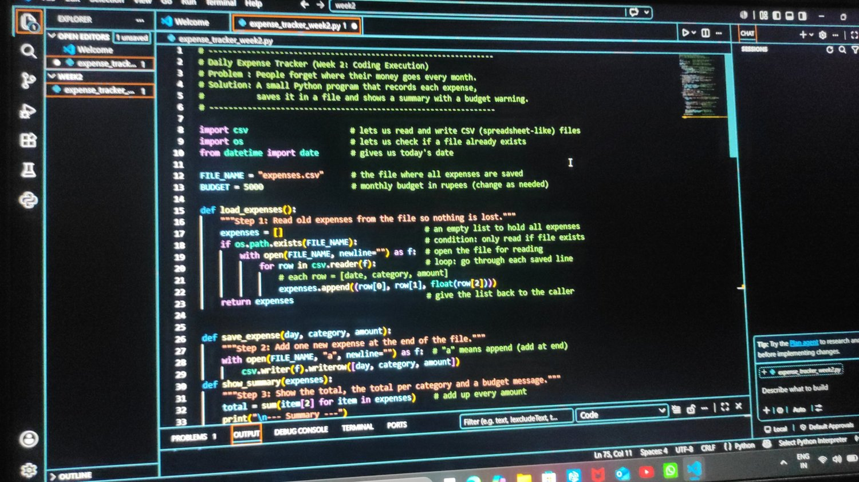
Figure 1: The script open in Visual Studio Code

4. Step-by-Step Explanation of the Coding Process
Step | What I did | Why I did it
1. Plan | Listed what the program must do: take an amount and category, save it, show totals, warn about the budget. | A clear list avoids confusion while writing code.
2. Variables and constants | Created FILE_NAME and BUDGET at the top. | Keeping settings in one place makes them easy to change.
3. Lists | Stored all expenses in a list called expenses. | A list can hold many items and grow as the user adds more.
4. Loop | Used a while loop to keep asking for expenses until the user types q. | The user can add any number of expenses without restarting.
5. Conditions | Used if statements to check the budget, quit command and invalid amounts. | The program should make decisions, such as showing a warning.
6. Input checks | Used try/except to catch letters typed instead of numbers. | Stops the program from crashing on wrong input.
7. File saving | Saved each expense to expenses.csv using the csv module. | Data stays safe even after the program is closed.
8. Summary | Added a function that totals the money overall and by category. | The user can see which habit costs the most.

5. Testing and Output
I ran the program from the VS Code terminal with the command py expense_tracker_week2.py and entered four sample expenses: Food 100, Travel 50, Bills 300 and Fun 150. After typing q, the program printed the total spent, the total for each category and the money left in the budget.
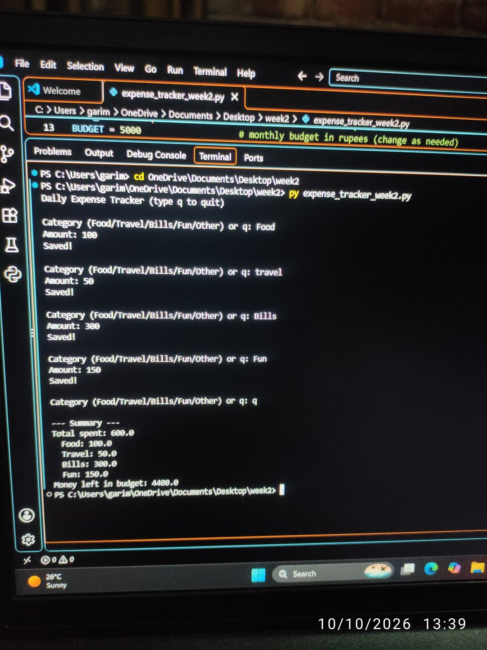
Figure 2: Terminal output with the final summary
Test | Result
Entered Food 100, Travel 50, Bills 300, Fun 150, then q | Total spent: 600. Each category total was shown. Money left in budget: 4400.
Typed travel in small letters | The program saved it as Travel, so the category name stays neat.
Expenses saved to expenses.csv | On the next run the old entries were loaded again, so data is not lost.
The program also checks wrong input. If the user types letters instead of an amount, or an amount of zero or less, it shows a message and asks again.

6. Challenges and Reflection

Challenge 1: Python was not found
When I first ran the file in VS Code, the Output panel showed the message Python was not found. I realised that VS Code is only an editor and that Python must be installed separately on the laptop. I downloaded Python from python.org, installed it with the option Add Python to PATH selected, restarted VS Code and ran the program again from the terminal. After that it worked.
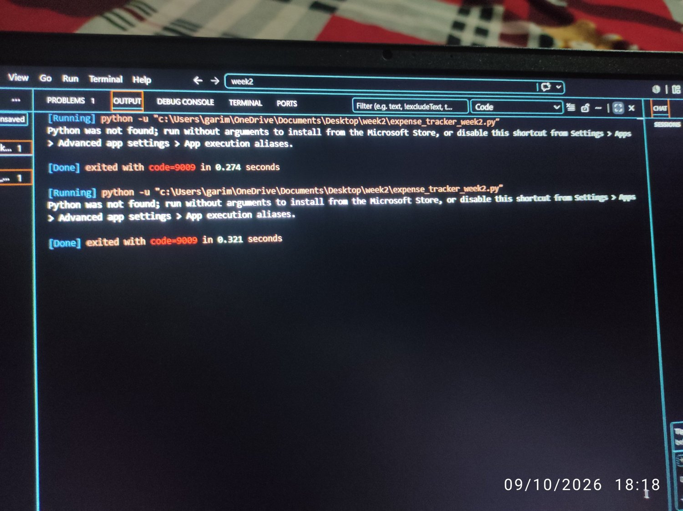
Figure 3: The error shown before Python was installed

Challenge 2: Old test data changed the total
In one of my test runs the summary showed a total of 800 and a strange category named 50, although I had entered only 600 rupees. I understood that the program saves every expense in expenses.csv, so my earlier test entries were loaded again, and one number had been typed in the category question by mistake. I deleted the CSV file and ran the program again with clean entries, and the total became 600, which was correct.

What I learned
- A list can collect many entries and a while loop can keep asking until the user types q.
- A dictionary can add up the money for each category.
- Saving data in a CSV file keeps it safe after the program closes, but old test data must be cleared before a clean demonstration.
- Comments make code easier to read, both for others and for me later.
The hardest part for me was setting up the environment, and the easiest part was seeing the summary appear after the code finally ran. Next, I would like to add a chart of spending by category and a simple screen so that people who do not use a terminal can use the tracker.

7. Conclusion
This task helped me move from an idea to a working program. A small script with variables, lists, loops, conditions and a file can already solve a real everyday problem. In the next steps I can improve the program by adding charts and a simple screen so that other people can use it easily.

8. References
- Python Software Foundation. The Python Tutorial. https://docs.python.org/3/tutorial/
- Python Software Foundation. csv module documentation. https://docs.python.org/3/library/csv.html
- Al Sweigart. Automate the Boring Stuff with Python. https://automatetheboringstuff.com/
- Microsoft. Python in Visual Studio Code. https://code.visualstudio.com/docs/python/python-tutorial

