Week 4 Task: Functional Testing and Evaluation
Testing Report: Python Daily Expense Tracker
Virtual Programming Explorer Internship | Yuva Intern
Name: Garima Singh
Date: 27 October 2026

1. Introduction
Functional testing checks whether a program does what it is supposed to do. The tester gives the program inputs, writes down what should happen, compares it with what really happens, and records every difference. This report applies that process to the Daily Expense Tracker I built in Week 2 (expense_tracker_week2.py).
The report is written in plain language so that a beginner can use it as a step-by-step guide to testing a small program. It contains a testing plan, 17 test cases with expected and actual results, a list of bugs with severity levels, proposed improvements with reasons, and a retest of the improved program.

2. The Program Under Test
The tracker is a command-line program with these functions:
- It asks for a category (for example Food) and an amount, and keeps asking until the user types q.
- It rejects letters, zero and negative amounts with a friendly message.
- It saves every valid expense in a file called expenses.csv, and loads old expenses when it starts again.
- At the end it prints the total spent, the total for each category, and either the money left or a warning if the budget of 5000 is crossed.

3. Testing Strategy

3.1 Key functional areas
Area | What is checked | Test cases
Input handling | Valid and invalid categories and amounts | TC02-TC06, TC11-TC15
Calculation | Totals and decimal numbers are added correctly | TC01, TC10
Budget logic | Warning appears only when the total is above 5000 | TC07, TC08
Data storage | Expenses are saved, loaded again, and damaged files are handled | TC16, TC17
Summary output | Summary is correct even with no entries | TC09

3.2 Types of tests used
- Positive tests: Normal, correct inputs. The program should work.
- Negative tests: Wrong or strange inputs. The program should refuse them politely and not crash.
- Boundary tests: Values at the edge of a rule, such as a total exactly equal to the budget or no entries at all.

3.3 How the tests were run
Every test case was run from the command line with prepared inputs, using Python 3.12. A small test script (test_expense_tracker.py, included in my GitHub repository) types the inputs into the program, reads the output, compares it with the expected result and prints PASS or FAIL. Using a script means the same tests can be repeated after every change. I also did manual runs in the VS Code terminal, shown in Figures 1 and 2.

4. Test Cases and Results
Each row shows the test case, what should happen (expected), what the program really did (actual) and the status. Status is PASS when actual matches expected and FAIL when it does not.
ID | Test case | Expected | Actual result | Status
TC01 | Normal entries | Total 150.0 and 4850.0 left | Saved! x2 | Total spent: 150.0 | Money left in budget: 4850.0 | PASS
TC02 | Category typed in small letters | Saved as Travel | Saved! x1 | Total spent: 50.0 | Money left in budget: 4950.0 | PASS
TC03 | Category typed with extra spaces | Saved as Food | Saved! x1 | Total spent: 20.0 | Money left in budget: 4980.0 | PASS
TC04 | Letters instead of an amount | Friendly message, nothing saved | Please enter a number, for example 120 | Total spent: 0 | Money left in budget: 5000 | PASS
TC05 | Amount is zero | Message: amount must be more than 0 | Amount must be more than 0 | Total spent: 0 | Money left in budget: 5000 | PASS
TC06 | Negative amount | Message: amount must be more than 0 | Amount must be more than 0 | Total spent: 0 | Money left in budget: 5000 | PASS
TC07 | Total above the budget | Budget warning is shown | Saved! x1 | Total spent: 6000.0 | Warning: Budget limit crossed! | PASS
TC08 | Total exactly equal to the budget | 0.0 left and no warning | Saved! x1 | Total spent: 5000.0 | Money left in budget: 0.0 | PASS
TC09 | Quit without entering anything | Total 0 and 5000 left | Total spent: 0 | Money left in budget: 5000 | PASS
TC10 | Decimal amounts | Food total 100.0 | Saved! x2 | Total spent: 100.0 | Money left in budget: 4900.0 | PASS
TC11 | Amount typed with a comma (1,000) | Friendly message (comma is not a number) | Please enter a number, for example 120 | Total spent: 0 | Money left in budget: 5000 | PASS
TC12 | Empty category (only Enter pressed) | Entry rejected | Saved! x1 | Total spent: 100.0 | Money left in budget: 4900.0 | FAIL
TC13 | Number typed as the category | Entry rejected | Saved! x1 | Total spent: 100.0 | Money left in budget: 4900.0 | FAIL
TC14 | Amount typed as nan | Entry rejected | Saved! x1 | Total spent: nan | Money left in budget: nan | FAIL
TC15 | Amount typed as inf | Entry rejected | Saved! x1 | Total spent: inf | Warning: Budget limit crossed! | FAIL
TC16 | Damaged line in expenses.csv | Program starts without crashing | Crash: IndexError: list index out of range | FAIL
TC17 | Data is kept between two runs | Total 150.0 in the second run | Saved! x1 | Total spent: 150.0 | Money left in budget: 4850.0 | PASS

Summary: 17 test cases were run. 12 passed and 5 failed (TC12, TC13, TC14, TC15 and TC16).
Area | Passed | Failed | Comment
Input handling | 6 of 10 | 4 | Strange categories and nan/inf amounts are accepted
Calculation | 2 of 2 | 0 | Totals and decimals are correct
Budget logic | 2 of 2 | 0 | Warning and the limit case work
Data storage | 1 of 2 | 1 | A damaged file crashes the program
Summary output | 1 of 1 | 0 | Empty summary is correct

4.1 Manual runs in the VS Code terminal
In the first manual run I entered Food 100, Travel 50, Bills 300 and Fun 150. The expected total is 100 + 50 + 300 + 150 = 600 and the expected money left is 5000 - 600 = 4400. The program printed exactly these values, so this test passed. It also shows that the category travel typed in small letters became Travel.
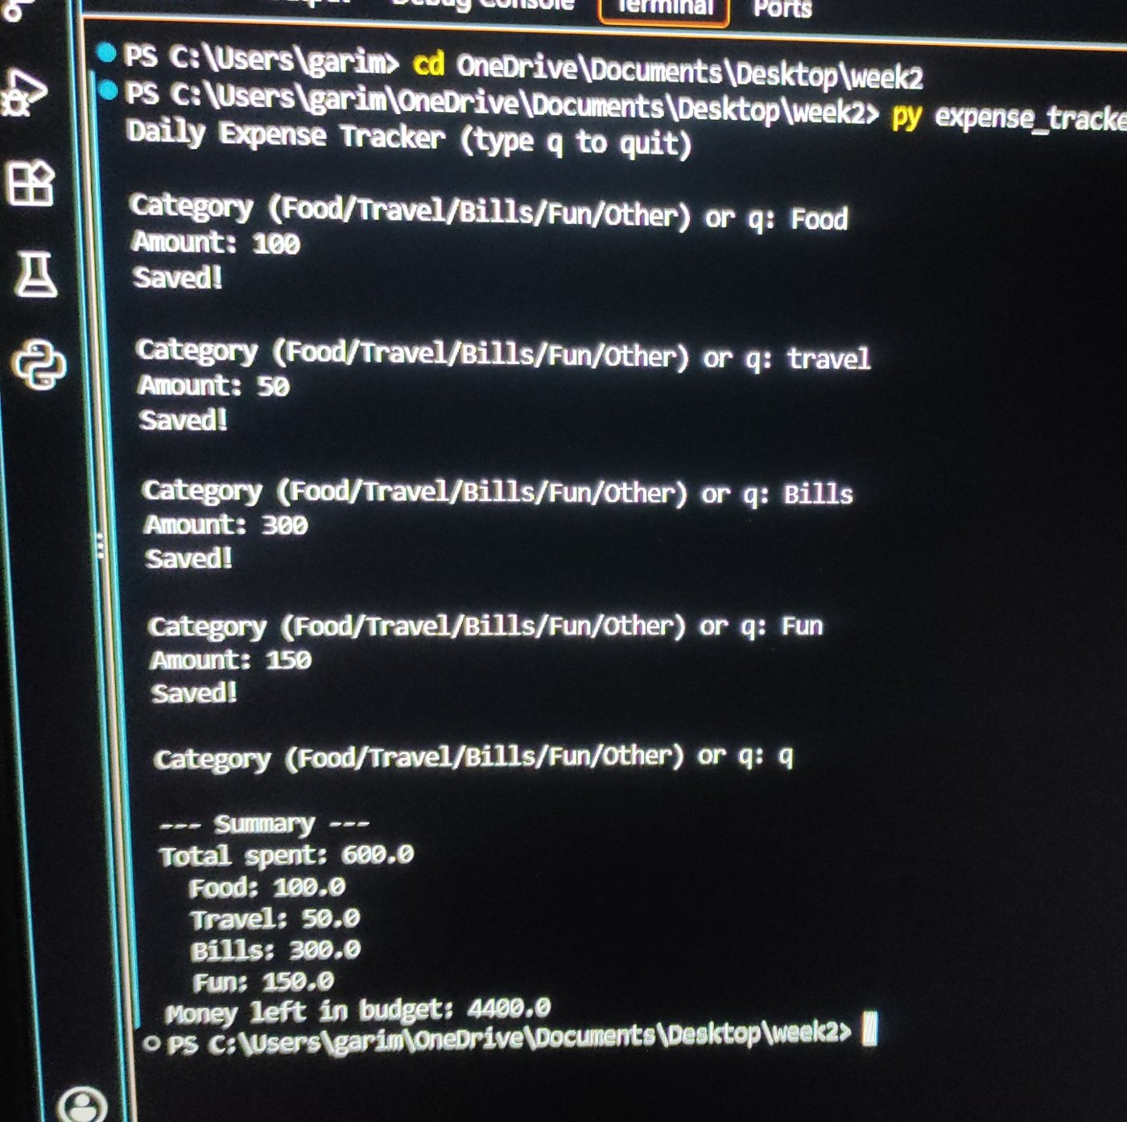
Figure 1: Manual test run with the correct total of 600 and 4400 left
In an earlier manual run with the same four entries the summary showed a total of 800.0, a category named 50 and Money left 4200.0. This was a discrepancy between expected (600) and actual (800) and it was investigated:
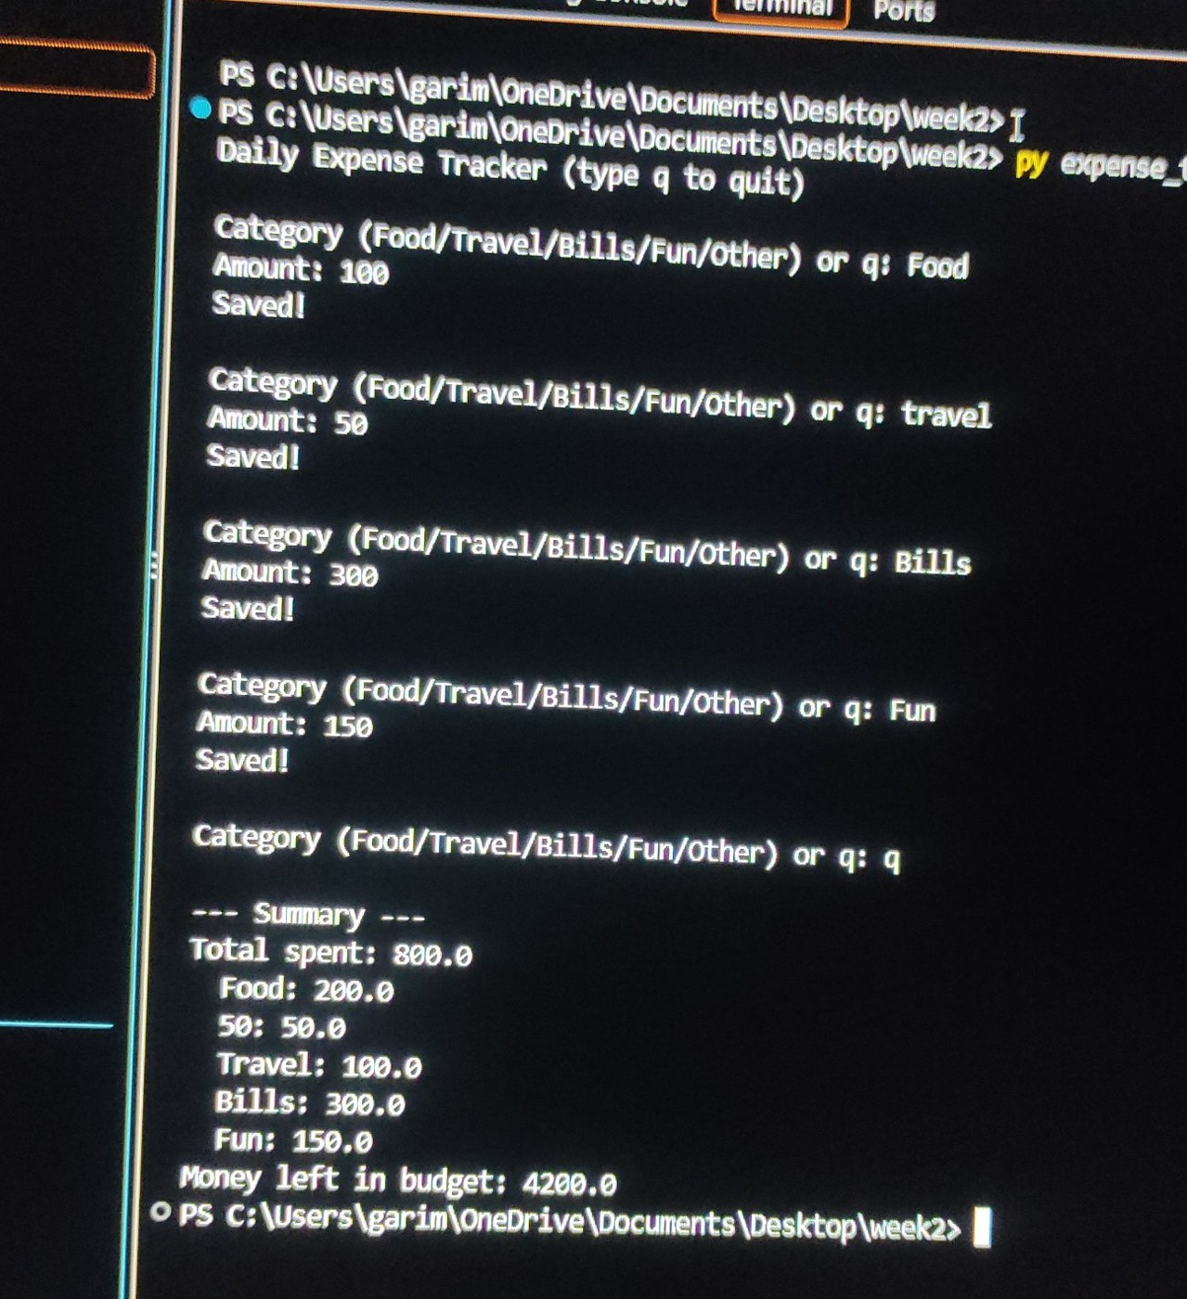
Figure 2: Discrepancy found in an earlier run (total 800 instead of 600)
- Cause 1: The number 50 had been typed at the category question, so the program saved a category called 50. This is the same problem as test case TC13 (BUG-02).
- Cause 2: Food 100 and Travel 50 from earlier test runs were still stored in expenses.csv, because the program loads old data on purpose. This is correct behaviour, but it surprised the tester, so it is listed as an observation (O-1) with an improvement proposal.

5. Bugs Found

5.1 Severity levels used
Severity | Meaning
High | The program crashes or data cannot be used.
Medium | The program accepts wrong data or shows wrong results.
Low | Unlikely input or a small problem in how the result is shown.

5.2 Bug list
Bug ID | Title | Severity | Steps to reproduce | Expected vs actual
BUG-01 | Empty category accepted (TC12) | Medium | Run the program, press Enter at the category question, enter 100. | Expected: rejected. Actual: Saved! with an empty category name.
BUG-02 | Number accepted as category (TC13) | Medium | Type 50 at the category question, then 100. | Expected: rejected. Actual: Saved!, and the summary shows a category named 50.
BUG-03 | Amount nan accepted (TC14) | Medium | Category Food, amount nan. | Expected: rejected. Actual: Saved! and the total becomes nan, so the budget warning can never appear.
BUG-04 | Amount inf accepted (TC15) | Low | Category Food, amount inf. | Expected: rejected. Actual: Saved! and the total becomes inf.
BUG-05 | Crash with a damaged data file (TC16) | High | Put the line 2026-10-01,Food (no amount) in expenses.csv and start the program. | Expected: program starts. Actual: crash with IndexError: list index out of range.
O-1 | Old test data is added to new totals | Low | Run the program twice with the same entries. | Expected by a new user: 600 each time. Actual: 800, because stored data is loaded again (works as designed).

6. Proposed Improvements with Justification
Improvement | Fixes | Justification | Effort and feasibility
1. Accept only names made of letters as category | BUG-01, BUG-02 | A clean category list makes the summary reliable. Strange names such as 50 would split or confuse the totals. | Low. Two lines of code. Implemented.
2. Reject nan and inf amounts using math.isfinite() | BUG-03, BUG-04 | A total must always be a real number, otherwise the budget warning stops working without any message. | Low. Three lines. Implemented.
3. Skip damaged lines when loading the file and tell the user | BUG-05 | A program must not crash because of one bad line. Skipping the line keeps the rest of the data usable. | Low. A try and except block. Implemented.
4. Add a command to clear old data or choose a month | O-1 | Testers and users can start with a clean sheet without deleting a file by hand. | Medium. Not implemented yet.
5. Show amounts with two decimals and a rupee sign | Presentation | 150.0 is less clear than Rs 150.00 for people who are not programmers. | Low. Not implemented yet.
6. Move the checks to Python's unittest module | Maintenance | Standard tools give clearer reports and let other people run the tests easily. | Medium. Future step.

Before and after code for the implemented improvements
Improvement 1 and 2: input checks (before)
if amount <= 0:
print("Amount must be more than 0")
continue
Improvement 1 and 2: input checks (after)
if not category.replace(" ", "").isalpha():
print("Please enter a category name using letters only, for example Food")
continue
...
if not math.isfinite(amount):
print("Please enter a number, for example 120")
continue
if amount <= 0:
print("Amount must be more than 0")
continue
Improvement 3: loading the file (before)
for row in csv.reader(f):
expenses.append((row[0], row[1], float(row[2])))
Improvement 3: loading the file (after)
for row in csv.reader(f):
try:
expenses.append((row[0], row[1], float(row[2])))
except (IndexError, ValueError):
skipped += 1

7. Retest After the Improvements
The corrected program was saved as expense_tracker_improved.py and the complete test script was run again, so that the old tests still pass (this is called regression testing).
ID | Test case | Before | After | Result of fix
TC12 | Empty category (only Enter pressed) | FAIL | PASS | Bug fixed
TC13 | Number typed as the category | FAIL | PASS | Bug fixed
TC14 | Amount typed as nan | FAIL | PASS | Bug fixed
TC15 | Amount typed as inf | FAIL | PASS | Bug fixed
TC16 | Damaged line in expenses.csv | FAIL | PASS | Bug fixed
TC01-TC11, TC17 | All other test cases | PASS | PASS | Still working

Final result: 17 of 17 test cases passed on the improved program.

8. Tracking and Recording Test Cases
Good records make testing repeatable. The methods used in this project are:
- Test case table: Every test case has an ID (TC01, TC02), a description, the input, the expected result, the actual result and a status. The table in Section 4 is this record. The same columns can be kept in an Excel sheet.
- Status values: Not run, PASS, FAIL or Blocked (cannot be run yet).
- Bug list: Every bug has an ID (BUG-01), a severity, steps to reproduce and expected versus actual result, so that another person can repeat it.
- Issue tracking: Bugs can also be written as GitHub Issues and closed when they are fixed.
- Automatic re-testing: The script test_expense_tracker.py repeats all tests in a few seconds, so it can be run after every change.

9. A Beginner's Guide: How to Test Your Own Program
- List the functions. Write down what the program should do in simple sentences.
- Pick the areas to test. Choose areas such as input, calculation and saving data.
- Design test cases. For each area, write at least one normal case, one wrong input and one edge case.
- Write the expected result first. Before running, write what you expect, with a number you can calculate by hand (for example 100 + 50 = 150).
- Run and record the actual result. Run the program and copy exactly what it prints. Take a screenshot if possible.
- Compare and report. If the two results are different, write a bug with steps to repeat it and give it a severity.
- Fix and retest. Fix one bug at a time and run all tests again.

10. Conclusion
Testing the expense tracker with 17 test cases showed that its main functions work well: calculations, budget warning, saving and loading. It also found five real weaknesses that appear only with unusual inputs: empty and numeric categories, the values nan and inf, and a damaged data file. Three small improvements fixed all of them, and after the retest all 17 test cases passed. The work shows that a program that seems correct in normal use can still fail in special cases, and that a written plan, expected results and a repeatable test script make such problems easy to find and fix.

11. References
- Python Software Foundation. unittest, Unit testing framework. https://docs.python.org/3/library/unittest.html
- Python Software Foundation. math.isfinite. https://docs.python.org/3/library/math.html#math.isfinite
- Python Software Foundation. csv, CSV file reading and writing. https://docs.python.org/3/library/csv.html
- GitHub Docs. About issues. https://docs.github.com/en/issues/tracking-your-work-with-issues/about-issues

