**EXPERIMENT NO:- 14**

**AIM:-** To play an audio file with certain duration

1) Play first 2 seconds of audio signal.

2) Add pause of 5 seconds

3) Play the last 1/3rd part of the audio

**TOOL USED:-**  MATLAB 11

**THEORY:**

Clipping of the audio signal is also possible using MATLAB. We can select (or clip) a certain portion of the full length audio signal. The pause is added by using following command:

pause (time duration);

Pause (time duration) pauses execution for n seconds before continuing; where n can be any real number. The resolution of the clock is platform specific. A fractional pause of 0.01 seconds should be supported on most platforms.

**STEPS FOLLOWED:-**

1. Read, play and plot the original audio file.
2. Calculate the total duration of the audio signal.
3. Find the number of samples present in first 2 seconds.
4. Play and plot the audio file up to that number of samples.
5. Add a pause of say 5 seconds
6. Calculate total number of samples in full length signal.
7. Play and plot last 1/3rd number of samples.

**RESULT:**

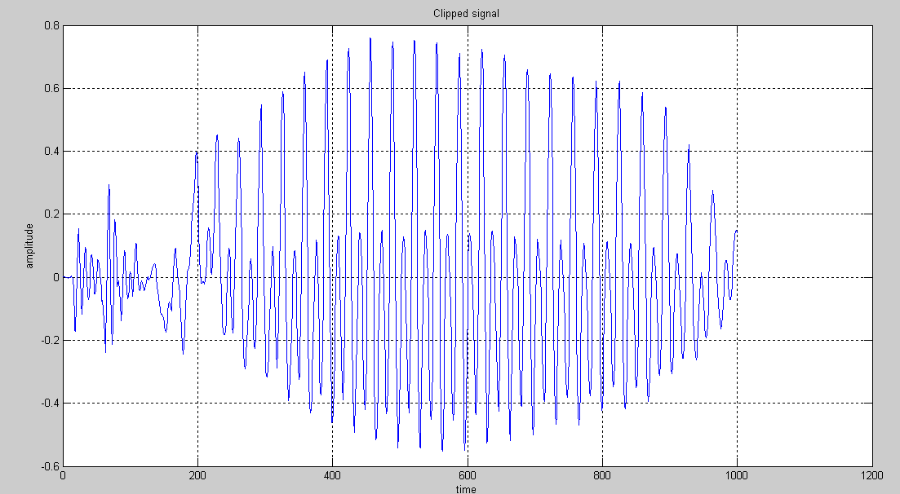

**Last 1/3rd part:**

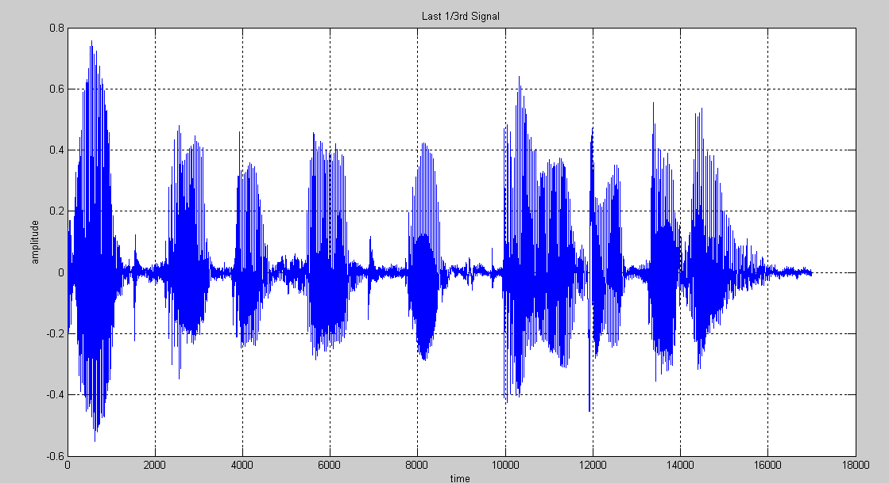

The audio signal is clipped successfully. The clipped signal is played and plotted. The results are verified according to the human auditory system.