**EXPERIMENT NO:- 15**

**AIM:-** Write a MATLAB program to

a) Separate voiced and unvoiced portion of signal

b) Perform STFT on voiced and unvoiced signal

**TOOL USED:-**  MATLAB 11.

**THEORY:**

**Voiced sound**: These are produced by the vibration of vocal cords. Since they are produced by the regular vibration of the vocal cords, you can observe the fundamental periods in a frame. Moreover, due to the existence of the fundamental period, you can also perceive a stable pitch.

**Unvoiced sound**: These are not produced by the vibration of vocal cords. Instead, they are produced by the rapid flow of air through the mouse, the nose, or the teeth. Since these sounds are produced by the noise-like rapid air flow, we can not observe the fundamental period and no stable pitch can be perceived

It is very easy to distinguish between these two types of sound. When you pronounce an utterance, just put your hand on your throat to see if you feel the vibration of your vocal cords. If yes, it is voiced; otherwise it is unvoiced. You can also observe the waveforms to see if you can identify the fundamental periods. If yes, it is voiced; otherwise, it is unvoiced.

The STFT is a Fourier-related transform used to determine the sinusoidal frequency and phase content of local sections of a signal as it changes over time. In STFT, the signal is divided into small enough segments, where these segments (portions) of the signal can be assumed to be stationary window function "w" is chosen. The width of this window must be equal to the segment of the signal where its stationarity is valid

**STEPS FOLLOWED:-**

1. Read and plot the original signal.

2. Select the window width at 160.

3. Choose the value of nfft at 256.

4. Set the value of voiced index at 33500 and unvoiced index at 23000.

5. Plot a segment of voiced portion of the speech using few parameters.

6. Plot a segment of unvoiced portion of speech.

2. Perform STFT using hamming window.

4. Plot a STFT Segment of Voiced Portion of Speech.

5. Plot a STFT Segment of Unvoiced Portion of Speech.

**Result:-**

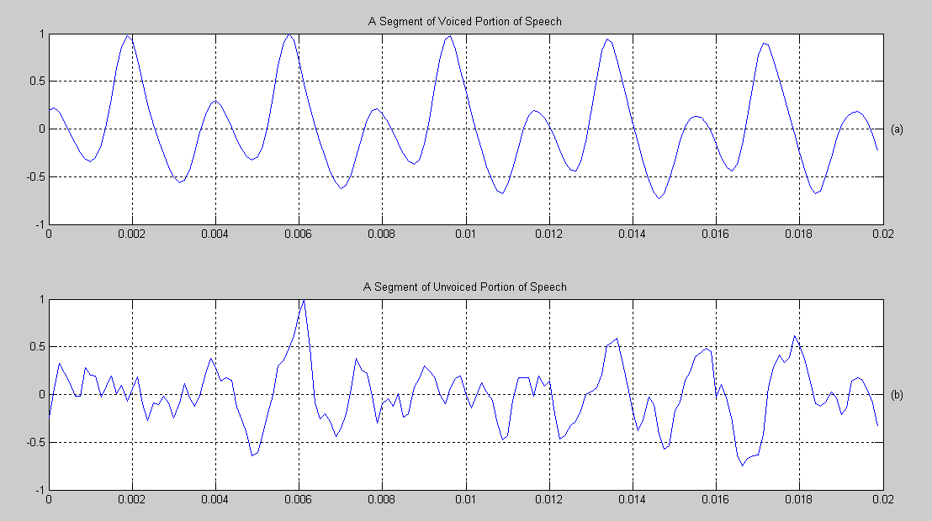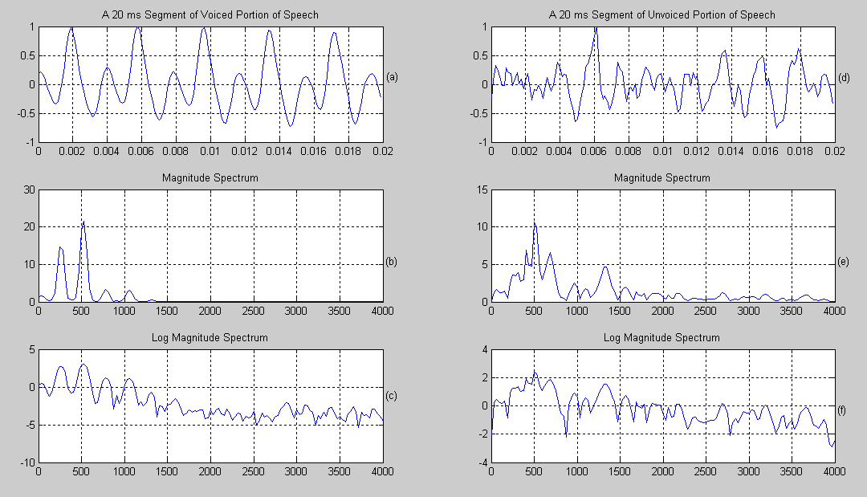

The voiced and unvoiced signals separated and STFT is plotted successfully.