**Experiment No. - 6**

**AIM: -** Write a MATLAB code for analysis of audio signals using Short-term Fourier Transform (STFT) in the Time-frequency domain.

**TOOL USED: -** MATLAB 11

**THEORY:-**

The STFT is a Fourier-related transform used to determine the sinusoidal frequency and phase content of local sections of a signal as it changes over time. In STFT, the signal is divided into small enough segments, where these segments (portions) of the signal can be assumed to be stationary window function "w" is chosen. The width of this window must be equal to the segment of the signal where its stationarity is valid. The STFT is given by:



Where *w*(*t*) is the window function. One of the downfalls of the STFT is that it has a fixed resolution. The width of the windowing function relates to how the signal is represented—it determines whether there is good frequency resolution (frequency components close together can be separated) or good time resolution (the time at which frequencies change). A wide window gives better frequency resolution but poor time resolution. A narrower window gives good time resolution but poor frequency resolution. These are called narrowband and wideband transforms, respectively.

**STEPS FOLLOWED:-**

1. Read the audio signal and get its sampling rate and bit resolution.

2. Play the audio signal at 11025 Hz.

3. Plot the original audio signal.

4. Perform and plot FFT on the signal.

5. Perform the window techniques (Block window, Hamming window, Hanning window) on the signal.

6. Place the window initially at origin.

7. Shift the window over the entire signal.

8. Get the STFT of the windowed selected function.

9. Plot STFT for all three window functions.

**RESULT: -**

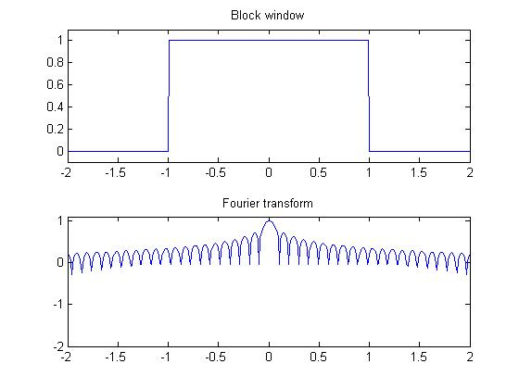

**STFT using block window**

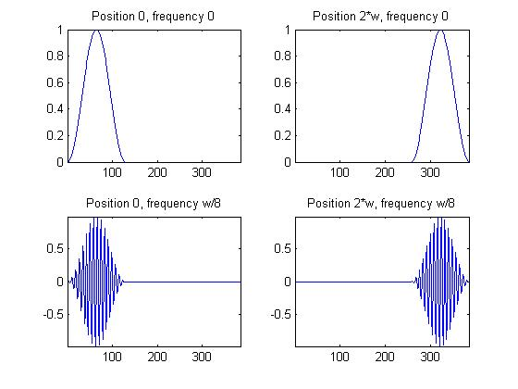

**Shifting of window function**

The experiment was performed successfully and the STFT for block, hamming and hanning window are plotted successfully.