**EXPERIMENT NO:- 6**

**AIM:-** To play an audio file with certain duration

1)Play 1st 2 seconds of audio

2)Add pause of 5 seconds

3)Play the last 1/3rd part of the audio

**Apparatus used:-**  MATLAB software

**Program Code:-**

[y,Fs]=wavread('C:\Documents and Settings\user\Desktop\shefi\sample');

soundsc(y,Fs)

plot(y)

grid on;

xlabel('time');

ylabel('amplitude');

title('original signal');

duration=numel(y)/Fs %gives Number of elements in array

nsamples=20*Fs;

[y2,Fs]=wavread('C:\Documents and Settings\user\Desktop\shefi\sample',[4000 5000]); %reads the first 2 sec of the sample

soundsc(y2,Fs)

wavwrite(y2,'C:\Documents and Settings\user\Desktop\shefi\sample_2sec');

figure(2);

plot(y2)

xlabel('time');

ylabel('amplitude');

title('Clipped signal');

pause(5) %Halt execution temporarily

sizeinfo=wavread('C:\Documents and Settings\user\Desktop\shefi\sample','size');

total_samples=sizeinfo(1)

x=50000/3

y=50000

[y3,Fs]= wavread('C:\Documents and Settings\user\Desktop\shefi\sample',[33000 50000]); %reads the last 1/3rd portion of the signal

soundsc(y3,Fs);

figure(3);

wavwrite(y3,'C:\Documents and Settings\user\Desktop\shefi\sample_last1third');

plot(y3);

xlabel('time');

ylabel('amplitude');

title('Last 1/3rd Signal');

**Steps Followed:-**

1. A ‘Sample’ file of .wav extension is chosen.
2. This file is read by using wavread command which gives the value of sampling frequency and no. of bits.
3. Then the files were written at different sampling rates & at different bits per sample.
4. Further this file is played using wavplay command at different frequencies

**Figures:-**

Original Signal

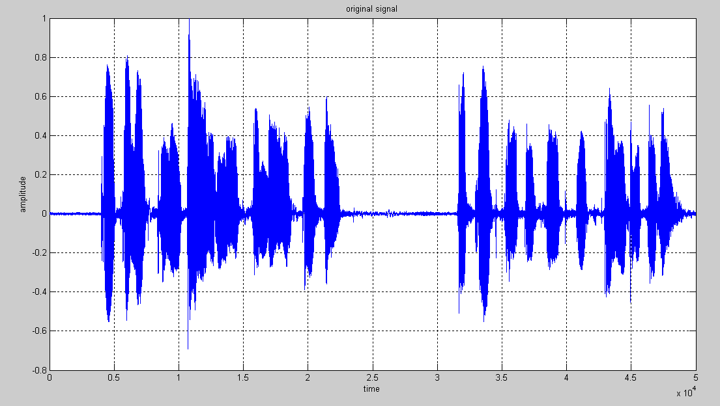

Clipped Signal

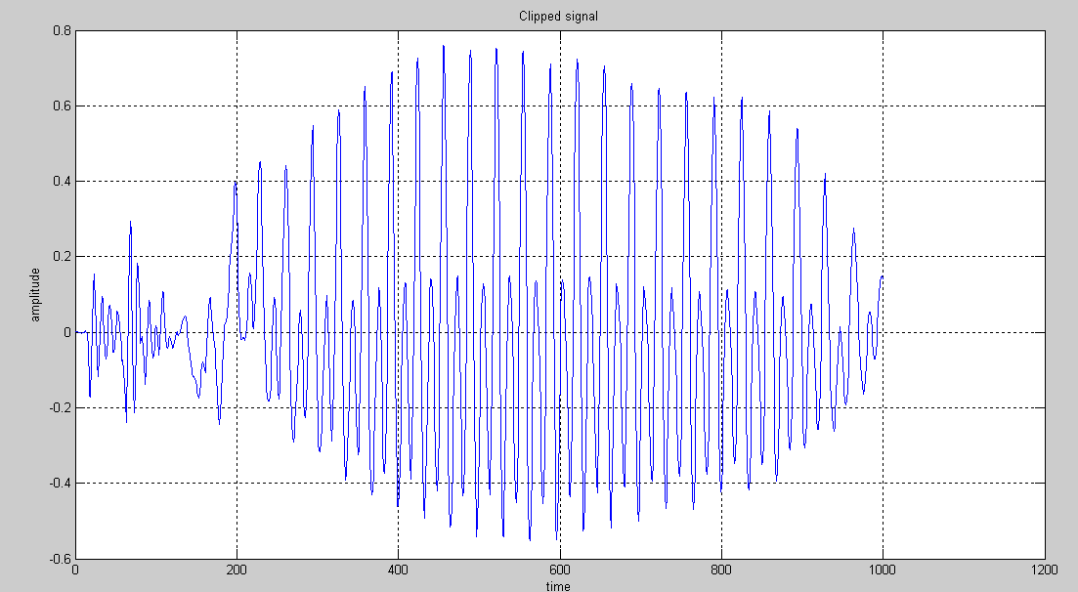

Last 1/3rd Signal

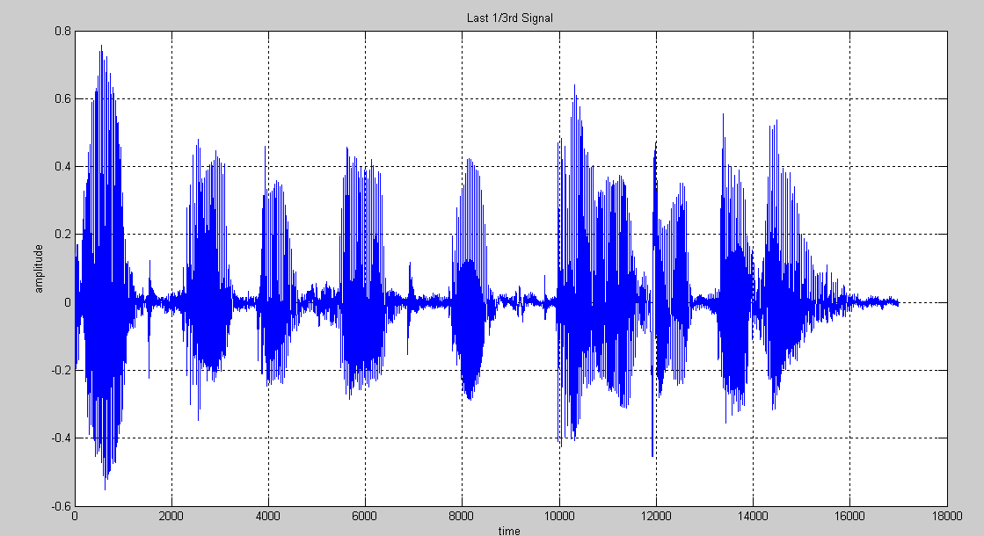

**Result:-**

The audio file is read,played & written at different frequencies at different bits per sample.